MICROBIAL FERMENTATION OF DEOILED SILKWORM PUPAE FOR NUTRITIONAL ENHANCEMENT AND SUSTAINABLE AQUAFEED FORMULATION

Abstract
This study presents a comprehensive compositional analysis of three types of aquaculture feeds—control feed (no silkworm pupae), deoiled silkworm pupae (SWP)-based feed, and fermented silkworm pupae (FSWP)-based feed. With the rising cost and ecological burden of traditional fishmeal, sustainable alternatives are increasingly necessary. Silkworm pupae, a nutrient-dense byproduct of the sericulture industry, offer high protein content and essential amino acids, making them a viable candidate for feed substitution. Furthermore, microbial fermentation of SWP significantly enhances its nutritional profile. This paper compares the proximate compositions, ingredient profiles, and biochemical characteristics of these three feed categories. The findings support FSWP as the most nutritionally potent and sustainable alternative.
Keywords
Waste management, economic use, fermentation, feed, sericulture

1. Introduction
Aquaculture—the controlled cultivation of aquatic organisms—has emerged as one of the fastest-growing food production sectors globally. With increasing population growth, rising consumer demand for animal protein, and overexploitation of wild fish stocks, aquaculture is increasingly vital to food and nutritional security (FAO, 2020). In India alone, fish production has reached over 17.5 million metric tons annually, positioning the country as the third-largest producer of fish in the world (NFDB, 2023).
However, a major constraint in aquaculture growth is the high cost of feed, which can constitute up to 60% of total production expenses ^{1,2}. Fishmeal—a traditional protein source derived from wild-caught marine species—has been the cornerstone of aquafeed due to its favorable amino acid profile and digestibility ³. But increasing demand, environmental concerns, and declining fishmeal availability have driven up costs and created pressure to identify sustainable, affordable protein alternatives ⁴.
One promising solution is the use of insect-based feed ingredients, particularly silkworm pupae (SWP), a nutrient-dense byproduct of the sericulture industry. SWP are rich in crude protein (46–60%), essential amino acids like lysine and methionine, beneficial lipids including omega-3 and omega-6 fatty acids, and key minerals such as calcium, iron, and phosphorus ^{5, 6}. India, as the second-largest silk producer, generates over 40,000 metric tons of SWP annually (CSB, 2023), much of which is discarded, despite its nutritional potential.
Nevertheless, raw or deoiled SWP pose challenges including unpleasant odor, poor digestibility, and anti-nutritional factors, which limit their direct use in feed ⁷. To overcome these issues, microbial fermentation has been investigated as a method to improve the nutritional quality of insect-based feed. Fermentation using strains such as Saccharomyces cerevisiae and Lactobacillus casei enhances protein content, improves amino acid bioavailability, and breaks down anti-nutritional compounds, while also improving palatability ⁸⁻¹⁰. It was demonstrated that fermentation can raise protein content in deoiled SWP from 66.15% to 79.38% ^{11,12}.
This study aims to comparatively analyze three types of formulated feeds used in aquaculture: (1) a control feed with no silkworm pupae, (2) a feed incorporating deoiled, non-fermented silkworm pupae, and (3) a feed incorporating fermented silkworm pupae. The primary focus of this comparison is to examie their proximate composition, ingredient profiles, and functional attributes, excluding fish growth and performance metrics. By isolating feed composition, this research contributes to a clearer understanding of the nutritional quality and formulation potential of silkworm pupae in aquaculture feed systems.

2. Materials and Methods
2.1. Feed Preparation:
Fish feed used in the experiment was formulated using a mixture of fermented mulberry silkworm pupae (SWP), fish meal, groundnut oil cake, rice bran, along with vitamin and mineral premixes (Fig 1). The objective was to develop diets containing 40% crude protein by progressively replacing fish meal with fermented SWP at inclusion levels of 15% (T1), 20% (T2), 25% (T3), 30% (T4), and 35% (T5). Another diet was prepared using fish meal, along with one version containing 20% de-oiled SWP substitution (T6), and the third variant with no pupal powder (T7). The exact composition of ingredients in both control and test diets is provided in Table 1, ensuring all formulations maintained equal protein content.
Feed preparation involved accurate measurement and thorough mixing of all ingredients with water to form a dough. This dough was then pressure-cooked for 20 minutes and allowed to cool. Vitamin and mineral premixes were added post-cooking, followed by extrusion of the dough into pellets using a pelletizer. These pellets were then sun-dried until their moisture content dropped below 10% (Fig 2). The resulting experimental feed pellets were stored appropriately for later use (Fig 3).
Fermentation was conducted using Saccharomyces cerevisiae and Lactobacillus casei in a microaerophilic setup for 48 hours.
2.2. Proximate composition:
Proximate compositions such as Crude Protein, Crude Fat, Crude Fiber, Ash Content, and Moisture were measured for different feed ingredients and also for different feed prepared. The proximate composition of the samples was analyzed using widely accepted standard methods. Crude protein content was determined spectrophotometrically by following the well-established procedure¹³. To measure ash content, samples were incinerated in a muffle furnace at 600°C until a constant weight was achieved, in accordance with AOAC method 942.05 (2005). Crude fiber content was quantified by performing dilute acid and alkali hydrolysis, as specified in AOAC method 978.10 (2005). Lipid content was evaluated through Soxhlet extraction using n-hexane as the solvent. The nitrogen-free extract (NFE) was then calculated by subtracting the combined values of moisture, crude protein, crude lipid, ash, and crude fiber from 100%. All analyses were conducted in triplicate, and the results were presented as mean ± standard deviation (SD).
2.3. Statistical analysis:
All measurements were carried out in triplicate, and results were expressed as mean values along with their corresponding standard deviations (±SD). The data were analyzed using one-way analysis of variance (ANOVA), followed by Tukey’s Honestly Significant Difference (HSD) post hoc test to determine significant differences among group means. Statistical significance was considered at p<0.05. All analyses were performed using IBM SPSS version 23 software. Additionally, Duncan’s Multiple Range Test (DMRT) was conducted to identify the most effective sample among the treatments.

3. Results
3.1. Proximate composition of the feed ingredients:
The proximate composition of the feed ingredients, including fish meal, groundnut oilcake, rice bran, and various forms of silkworm pupae (SWP), is presented in Tables 2. Among all ingredients, fermented SWP showed the highest crude protein content (69.88%), followed by fish meal (64.23%) and deoiled SWP (59.01%), while rice bran had the lowest (18.79%). Non-deoiled SWP recorded the highest fat content (27.35%), while fermented SWP (3.81%) and deoiled SWP (4.16%) had significantly lower fat levels. Groundnut oilcake also showed relatively high fat content (7.81%). Moisture content was below 11% in all ingredients, with non-deoiled SWP showing the highest (7.59%) and deoiled SWP the lowest (4.10%). Ash content varied, with fish meal (16.16%) and fermented SWP (6.58%) being the highest among their respective groups, while non-deoiled SWP (4.10%) had the lowest. Crude fiber was highest in rice bran (10.63%) and deoiled SWP (6.33%), whereas fish meal (0.68%) and fermented SWP (3.02%) had the lowest. These results highlight the high protein potential of fermented and deoiled SWP and support their inclusion as viable alternatives to conventional protein sources in fish feed.
3.2. Proximate composition of the experimental diets:
The proximate composition of diets with varying levels of fermented and de-oiled silkworm pupae (SWP) is shown in Table 3. Crude protein ranged from 35.48% to 39.93%, with the highest in T5 (35% fermented SWP), significantly greater than other treatments. Fat content increased with fermented SWP, peaking in T5 (9.35%). Ash content decreased from T7 (control) to T5, which had the lowest (9.91%). Crude fiber was highest in T5 and lowest in T6 (20% de-oiled SWP). Moisture levels were stable across diets, with no significant differences except slightly lower moisture in T6. Overall, higher fermented SWP inclusion improved protein and fiber while lowering ash, highlighting its potential as a fish meal alternative.
4. Discussion
Fermented silkworm pupae (FSWP) exhibit the highest nutritional density. The fermentation process not only increases protein content but also enhances digestibility and palatability by breaking down complex molecules. The proximate analysis of silkworm pupae and feed ingredients revealed key nutritional values essential for experimental diet formulation.
Fish meal recorded the highest protein content (64.23%), followed by silkworm pupae (58.8%), groundnut oilcake (41.39%), and rice bran (18.79%). These findings are consistent with different findings for fish meal ^{14,15}, and for groundnut oilcake ¹⁶. Silkworm pupae showed comparable protein levels to fish meal, making them a promising alternative protein source ¹⁷ .
Groundnut oilcake had the highest fat content (7.81%), followed by silkworm pupae (6.9%), fish meal (5.07%), and rice bran (2.6%). These values align with different research findings for fish meal ¹⁸ and for rice bran ^{[19]}. The fat content in silkworm pupae supports its role as a good energy source ¹⁷.
Moisture levels were 10.46% in fish meal, 10.21% in rice bran, 8.21% in groundnut oilcake, and 5.3% in silkworm pupae, indicating better shelf stability for pupae ^{16,20}.
Ash was highest in fish meal (16.16%), followed by rice bran (7.67%), groundnut oilcake (5.71%), and silkworm pupae (4.8%) ^{17,21}.
Rice bran had the highest fiber (10.63%), followed by groundnut oilcake (4.47%), silkworm pupae (3.2%), and fish meal (0.68%). Fiber content in pupae supports digestive benefits ^{22, 23}.
These results support the inclusion of silkworm pupae as a nutritionally viable and sustainable feed ingredient in aquafeeds.

6. Conclusion
The comparative analysis of aquaculture feeds demonstrated that fermented silkworm pupae (FSWP)-based diets offer significant nutritional advantages over both deoiled SWP and conventional control feeds. FSWP exhibited the highest crude protein content, reduced fat, and favorable ash and fiber profiles, indicating its superior compositional quality. These improvements are attributed to microbial fermentation, which enhanced protein bioavailability and reduced anti-nutritional factors. The findings strongly support the use of fermented SWP as a sustainable and effective substitute for fishmeal in aquafeed, promoting not only cost reduction and performance benefits but also environmental sustainability through the valorization of sericulture waste. Future studies may expand on digestibility and performance trials across species to establish broader applicability in commercial aquaculture systems.

7. References
- Jayasankar,P., Present status of freshwater aquaculture in India–A review. Indian J Fish, 65(4), (2018), 157.
- Pandian,T.J., Intake and conversion of food in the fish Limanda limanda exposed to different temperatures. Mar Biol, 5, (1970), 1.
- Trushenski,J.T., Kasper,C.S. & Kohler,C.C., Challenges and opportunities in finfish nutrition. N Am J Aquac, 68(2), (2006), 122.
- Tacon,A.G. & Metian,M., Global overview on the use of fish meal and fish oil in industrially compounded aquafeeds: Trends and future prospects. Aquaculture, 285(1–4), (2008), 146.
- Ji,H., Zhang,J.L., Huang,J.Q., Cheng,X.F. & Liu,C., Effect of replacement of dietary fish meal with silkworm pupae meal on growth performance, body composition, intestinal protease activity and health status in juvenile Jian carp (Cyprinus carpio var. Jian). Aquac Res, 46(5), (2015), 1209.
- Kim,H.W., Setyabrata,D., Lee,Y.J., Jones,O.G. & Kim,Y.H.B., Pre-treated mealworm larvae and silkworm pupae as a novel protein ingredient in emulsion sausages. Innov Food Sci Emerg Technol, 38, (2016), 116.
- Zhou,J.S., Chen,Y.S., Ji,H. & Yu,E.M., The effect of replacing fish meal with fermented meal mixture of silkworm pupae, rapeseed and wheat on growth, body composition and health of mirror carp (Cyprinus carpio var. Specularis). Aquac Nutr, 23(4), (2017), 741.
- Yadav,H., Jain,S., Rastamanesh,R., Bomba,A., Catanzaro,R. & Marotta,F., Fermentation technology in the development of functional foods for human health: where we should head. Ferment Technol, 1, (2011), 1.
- Srivastava,R.K., Enhanced shelf life with improved food quality from fermentation processes. J Food Technol Preserv, 2(3), (2018), 1.
- Agyei,D., Owusu-Kwarteng,J., Akabanda,F. & Akomea-Frempong,S., Indigenous African fermented dairy products: Processing technology, microbiology and health benefits. Crit Rev Food Sci Nutr, 60(6), (2020), 991.
- Kang,S. & Chung,C.H., Characteristics of Tenebrio molitor larvae and Bombyx mori pupae sequentially fermented with Aspergillus oryzae and Bacillus subtilis. Korean J Food Sci Technol, 54(1), (2022), 94.
- Cha,J.Y., Kim,Y.S., Ahn,H.Y., Kang,M.J., Heo,S.J. & Cho,Y.S., Biological activity and biochemical properties of silkworm (Bombyx mori L.) powder fermented with Bacillus subtilis and Aspergillus kawachii. J Life Sci, 21(1), (2011), 81.
- Lowry,O.H., Rosebrough,N.J., Farr,A.L. & Randall,R.J., Protein measurement with the Folin phenol reagent. J Biol Chem, 193(1), (1951), 265.
- Janbakhsh,S., Shekarabi,S.P.H. & Shamsaie Mergan,M., Nutritional value and heavy metal content of fishmeal from the Southwest Caspian Sea. Caspian J Environ Sci, 16(4), (2018), 307.
- Kaiser,F., Harbach,H. & Schulz,C., Rapeseed proteins as fishmeal alternatives: A review. Rev Aquac, 14(4), (2022), 1887.
- Ghosh,K. & Mandal,S., Nutritional evaluation of groundnut oil cake in formulated diets for rohu, Labeo rohita (Hamilton) fingerlings after solid state fermentation with a tannase producing yeast, Pichia kudriavzevii (GU939629) isolated from fish gut. Aquac Rep, 2, (2015), 82.
- Sogbesan,A.O. & Ugwumba,A.A.A., Nutritional values of some non-conventional animal protein feedstuffs used as fishmeal supplement in aquaculture practices in Nigeria. Turk J Fish Aquat Sci, 8(1), (2008), 159.
- Kirimi,J.G., Musalia,L.M. & Munguti,J.M., Effect of replacing fish meal with blood meal on chemical composition of supplement for Nile tilapia (Oreochromis niloticus). East Afr Agric For J, 82(1), (2017), 1.
- Zhuang,X., Yin,T., Han,W. & Zhang,X., Nutritional ingredients and active compositions of defatted rice bran. In: Rice Bran and Rice Bran Oil. Elsevier, (2019), 247.
- De Koning,A.J., Quantitative quality tests for fish meal. II. An investigation of the quality of South African fish meals and the validity of a number of chemical quality indices. Int J Food Prop, 5(3), (2002), 495.
- Cho,J.H. & Kim,I.H., Fish meal–nutritive value. J Anim Physiol Anim Nutr, 95(6), (2011), 685.
- Wang,L., Duan,W., Zhou,S., Qian,H., Zhang,H. & Qi,X., Effect of rice bran fibre on the quality of rice pasta. Int J Food Sci Technol, 53(1), (2018), 81.
- Gopalakrishna,A.G., Rajan,R.G.R. & Bhatnagar,A.S., Rice bran: chemistry, production and applications–a review. Beverage Food World, 39(5), (2012), 31.

Table 1: Composition of ingredients in the experimental diets formulated
Ingredients | T1 | T2 | T3 | T4 | T5 | T6 | T7
Fish meal | 38.25 | 36 | 33.75 | 31.5 | 29.25 | 39 | 45
SWP | 6.75 | 9 | 11.25 | 13.5 | 15.75 | 6 | -
Ricebran | 25 | 25 | 25 | 25 | 25 | 25 | 25
Groundnut oil cake | 26 | 26 | 26 | 26 | 26 | 26 | 26
Vitamin premix | 2 | 2 | 2 | 2 | 2 | 2 | 2
Mineral premix | 2 | 2 | 2 | 2 | 2 | 2 | 2

Table 2: Proximate composition of feed ingredients used in the experimental diet
Feed Ingredient | Crude Protein (%) | Crude Fat (%) | Moisture (%) | Ash (%) | Crude Fiber (%)
Fish meal | 64.23 ± 0.04 | 5.07 ± 0.02 | 10.46 ± 0.60 | 16.16 ± 0.60 | 0.68 ± 0.16
Groundnut oilcake | 41.39 ± 0.60 | 7.81 ± 0.15 | 8.21 ± 0.57 | 5.71 ± 0.59 | 4.47 ± 0.16
Rice bran | 18.79 ± 0.17 | 2.65 ± 0.17 | 10.21 ± 0.01 | 7.67 ± 0.27 | 10.63 ± 0.33
SWP (Non-deoiled) | 46.51 ± 0.63 | 27.35 ± 0.07 | 7.59 ± 0.06 | 4.10 ± 0.18 | 3.03 ± 0.02
SWP (Deoiled) | 59.01 ± 1.39 | 4.16 ± 0.82 | 4.10 ± 0.11 | 6.28 ± 0.56 | 6.33 ± 0.11
SWP (Fermented) | 69.88 ± 0.42 | 3.81 ± 0.72 | 5.16 ± 0.04 | 6.58 ± 0.35 | 3.02 ± 0.02
Values are expressed in mean ± SD with three replications (n=6).

Table 3: Proximate Composition (%) of Experimental Diets Containing Fermented and De-oiled Silkworm Pupae
Diet | Crude Protein (%) | Fat (%) | Total Ash (%) | Crude Fibre (%) | Moisture (%)
T1 | 38.92 ± 0.20ᶜ | 9.17 ± 0.03ᶜ | 13.22 ± 0.06ᵇ | 6.29 ± 0.08ᶜ | 9.50 ± 0.05ᵃᵇ
T2 | 38.93 ± 0.04ᶜ | 9.26 ± 0.08ᵇ | 12.01 ± 0.54ᶜ | 6.67 ± 0.07ᵇ | 9.49 ± 0.06ᵃᵇ
T3 | 39.01 ± 0.09ᵇᶜ | 9.28 ± 0.07ᵃᵇ | 11.44 ± 0.01ᵈ | 6.82 ± 0.04ᵇ | 9.44 ± 0.05ᵃᵇ
T4 | 39.26 ± 0.09ᵇ | 9.29 ± 0.02ᵃᵇ | 11.10 ± 0.08ᵈ | 6.87 ± 0.02ᵇ | 9.43 ± 0.19ᵃᵇ
T5 | 39.93 ± 0.06ᵃ | 9.35 ± 0.01ᵃ | 9.91 ± 0.11ᵉ | 7.21 ± 0.01ᵃ | 9.42 ± 0.07ᵃᵇ
T6 | 35.48 ± 0.64ᵈ | 7.97 ± 0.28ᵈ | 11.17 ± 0.05ᵈ | 4.92 ± 0.07ᵈ | 8.57 ± 0.09ᵇ
T7 | 38.73 ± 0.03ᶜ | 9.12 ± 0.01ᶜ | 13.66 ± 0.06ᵃ | 6.12 ± 0.40ᶜ | 9.53 ± 0.03ᵃ
Values are expressed as mean ± SD. Different superscripts in the same column indicate significant differences (p < 0.05).

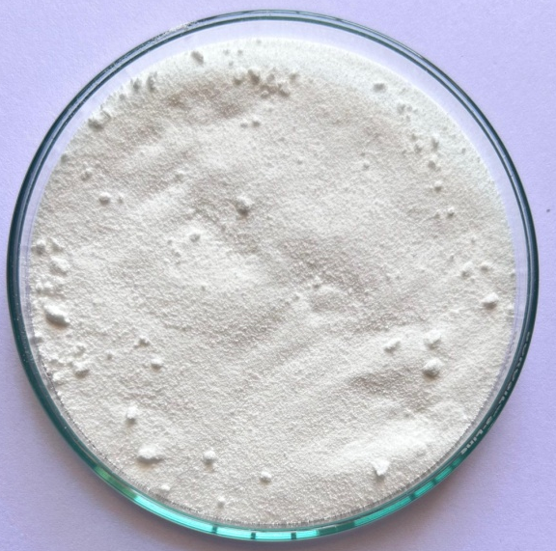
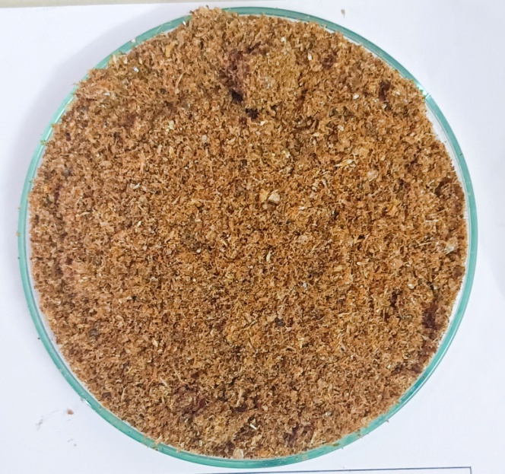
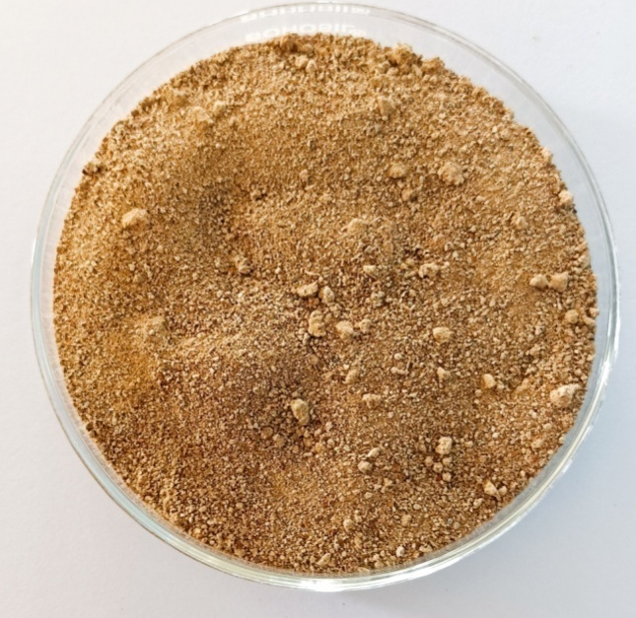
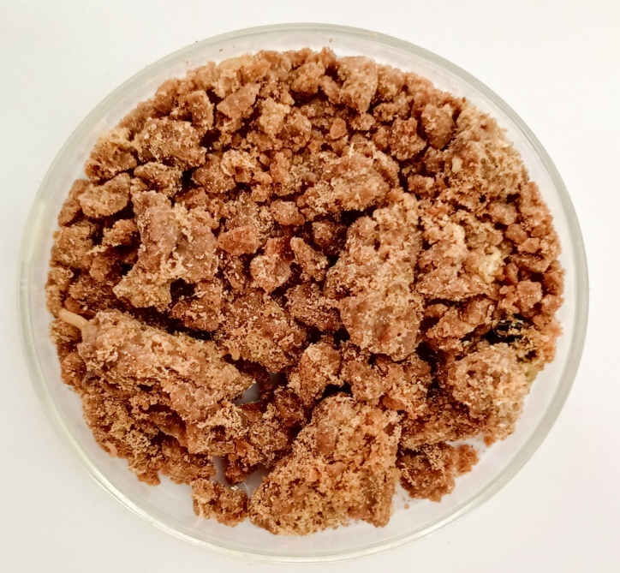
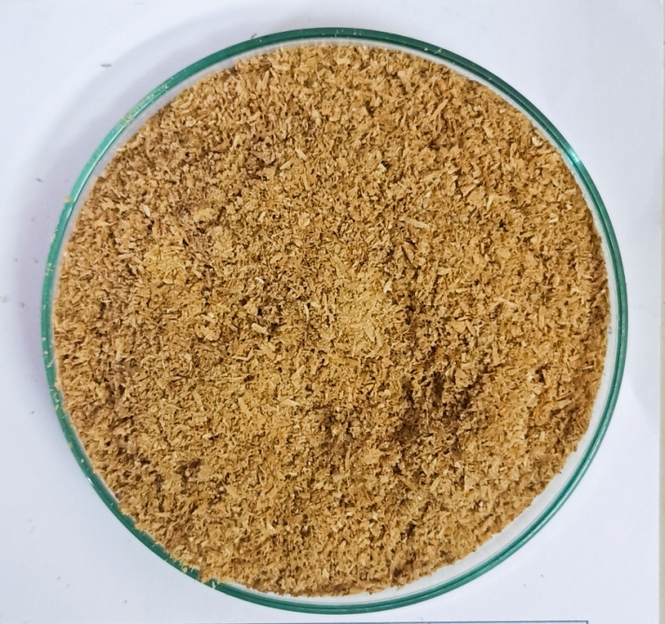
Fig 1: Experimental ingredients
Vitamin Mineral mix
Groundnut oil cake
Rice bran
Fish meal
Fermented silkworm pupal powder
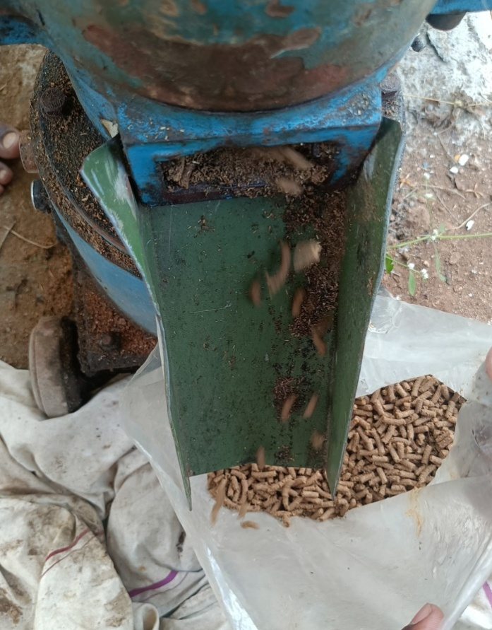
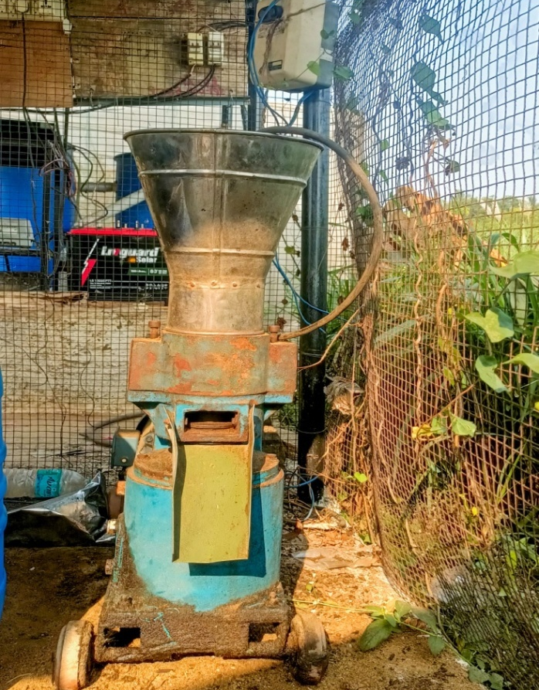

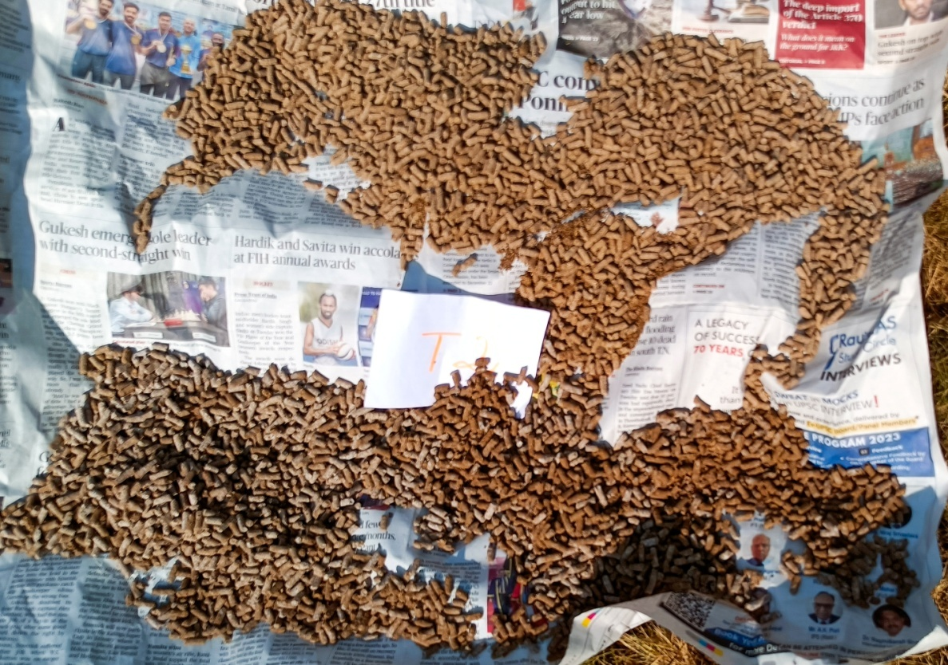
Pellets formed using machine pelletizer
Sun-drying of the prepared pellets
Fig 2: Formation of the fish pellets
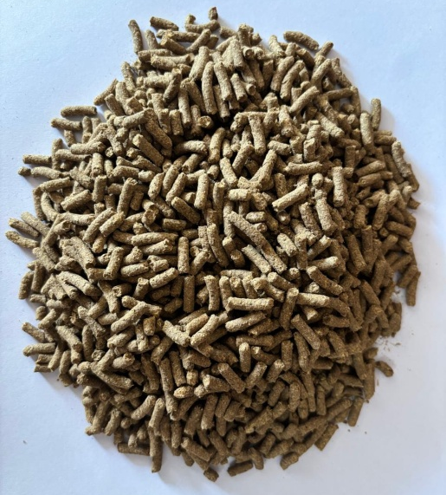
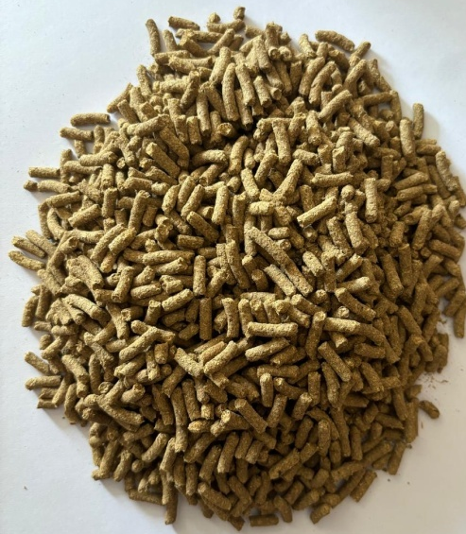
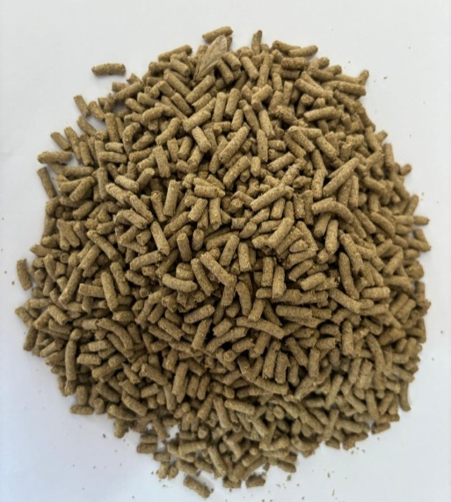
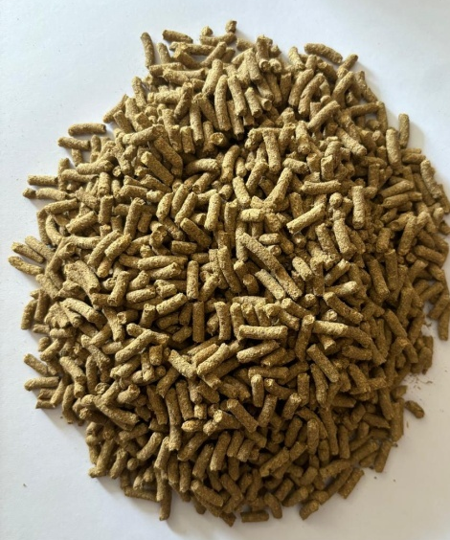
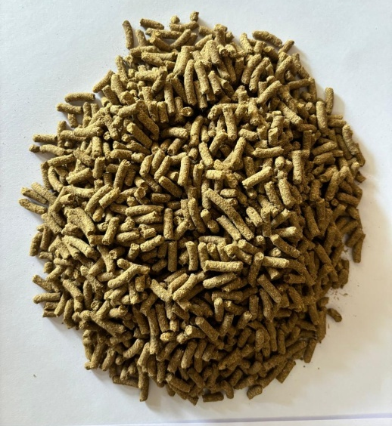
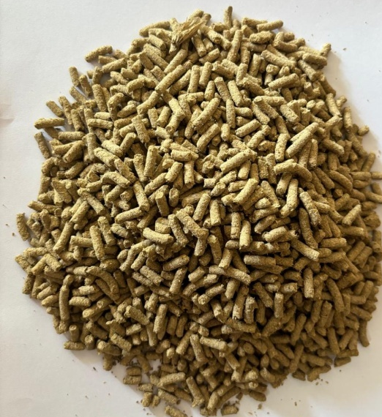
T6
T5
T4
T3
T2
T1
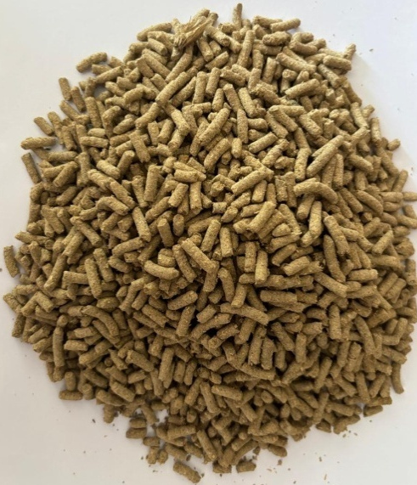
T7

Fig 3: Experimental diets

