Molecular Characterization of Rice Genotype for the Presence of Fertility Restorer Genes and Wide Compatibility Locus using SSR Markers

.
ABSTRACT

The process of screening for the trait of fertility restoration in rice (oryza sativa L.) is difficult and time consuming as it involves test crossing with a set of CMS lines and evaluation of F1 for pollen and spikelet fertility. The use of molecular markers linked to fertility restoring Rf genes can improve the selection efficiency, save time and avoid the complications associated with phenotype-based screening. So this experiment aims To characterize the rice genotypes for the presence of fertility restorer genes and wide compatibility locus. The experiment was conducted during June to October 2021 at Seed Technology Research center, Department of Plant Breeding and Genetics, College of Agriculture, J.N.K.V.V, Jabalpur Madhya Pradesh, India to validate the molecular markers, which had been previously reported to be linked to fertility restorer (Rf) gene(s) for WA-CMS lines of rice. The population of rice consisted of total 32 genotypes in which 15 parents was high restorer, 3 partial restorer, 5 low restorer and 4 are maintainer lines with no setting. 13 SSR markers reported to be linked to Rf genes were analyzed in the mapping populations. Out of Thirteen markers, 7 were polymorphic while six were found to be monomorphic. Our result suggested that the multiplex marker system called S5-MMS targeting the functional nucleotide polymorphisms (FNP) at S5 suitable for deployment in marker-assisted selection (MAS) of wide-compatible genotypes and for identification of allelic status at S5 in rice varieties has been developed through the present study. In the total of ten genotypes WGL-32100, JGL-3828 and RPHR- 612 also comes under maintainers RMS-SF-21 marker clearly distinguishes the fertility restoration and maintainers. Marker s5-inDel is very important for clearly identification of indica, japonica and Wide-compatible derived genotypes. Genotypes CBSN-168 and jagtiyal sanalu found to be partial restoration while, genotypes Kranti, JRSF-21, RYT-3378 and PRR-312 provided dominancy of japonica neutral alleles and all these genotypes are normal fertile and good adoptable to this environment.

Keywords: Rice, fertility restoration (Rf) gene, WA-CMS lines, SSR markers and s5-inDel

- INTRODUCTION

In India, hybrid rice is cultivated in an area of ~3 million hectares, which is about 6.7% of total area of rice cultivation. Hybrid rice accounts for less than 10% of the area under rice cultivation in Bangladesh, Indonesia, and the Philippines and just 10% in Vietnam.Accordingly, large scale adoption of hybrid rice technology by farming community is one of the potential approaches to bridge the productivity gap. Yet, in India so far, a total of 134 hybrids have been developed and released (anonymous).Understanding of the nature of gene action influencing rice yield and its components is required for finding potentially helpful parental line combinations for the production of promising rice hybrids and to improve genetic yield potential.

Hybrid rice technology aims to increase the yield potential of rice by exploiting the phenomenon of hybrid vigour or heterosis. Cytoplasmic male sterility coupled with fertility restoration controlled by nuclear genes is a very useful tool in exploiting heterosis in self pollinated crops. In rice, three CMS systems viz. Wild Abortive (WA), Boro II (BT) and Honglian (HL) are deployed for commercial hybrid rice seed production. Rice fertility restoration is largely controlled by two dominant genes, one of which is more active than the other. The major loci restoring the fertility has designated as Rf3 and Rf4 and have been mapped on chromosome 1 and 10 (Ponnuswamy et al., 2020). Rice is classified into three types namely indica, japonica and javanica based on geographical origin. Limited progress has been acheived because of the semi-sterility of F1s in indica-japonica crosses. Few varieties of tropical japonica having good compatibility, showed normal fertility in F1. Recently hybrid rice breeders made research efforts concentrated on breeding parental lines from indica-tropical japonica crosses to raise heterosis level and increase the genetic diversity among parents (Hari Prasad et al., 2018).

The process of screening for the trait of fertility restoration is difficult and time consuming as it involves test crossing with a set of CMS lines and evaluation of F¹ for pollen and spikelet fertility. The use of molecular markers linked to fertility restoring Rf genes can improve the selection efficiency, save time and avoid the complications associated with phenotype-based screening.

The molecular biology methods, especially polymerase chain reaction (PCR) have contributed to their accuracy, sensitivity and ability to detect genetic differences and to eliminate the disadvantages of conventional methods in diagnosing many organisms (Giantsis et al., 2017), (Stanis et al., 2016). PCR is selecting and amplifying a specific genomic region of the organism based on the differences in the DNA sequence of that region. SSR-PCR marker can work with common lab equipment and is cost-efficient utilized for both low and high throughput genotyping approaches (Vieira et al., 2016).

Currently SSR markers linked to Rf genes are used for screening of major fertility restoration genes as they are co-dominant, highly robust and polymorphic. The use of molecular markers linked to Rf genes that restore fertility can increase decision effectiveness, save time, and avoid issues associated with phenotype-based screening (Prasanna et al., 2022). This technique has been used to diagnose many microorganisms, including plant such as Oryza sativa. Due to the importance of the accurate, Fertility restorer (Rf) genes occur widely in Oryza species with the AA-genome and fertility of a given CMS type is controlled by several Rf alleles in several wild restorer accessions (Li et al., 2005). For supply basic information to improve rice out of breeding programs and estimation of genetic diversity, segregation and finding genetic relationships among for Some selected varied which significant on crop breeding program for selection of suitable diverse parents (Tidke et al., 2014).

In the light of above information, the present investigation had been carried out to attain objective to characterize the rice genotypes for the presence of fertility restorer genes and wide compatibility locus.

- material and methods

The experiment was carried out during June to October 2021 at Seed Technology Research center, Department of Plant Breeding and Genetics, College of Agriculture, J.N.K.V.V, Jabalpur Madhya Pradesh, India. The Geographical co-ordinates of study sites are 23°21’48.4’’N 79°95’88.2’’E.

  - Mapping population development and fertility scoring

The mapping population of rice (oryza sativa L.) was derived from a cross between various CMS –A lines with fertile B lines and consist of resulting total 32 genotypes in which 15 parents was high restorer, 3 partial restorer, 5 low restorer and 4 are maintainer lines shown in Table 1. Pollen fertility was investigated by reporting setting and bagged panicles are evaluated at maturity.

Table 1: Details of genotypes included for molecular analysis
S.NO. | GENOTYPE | CMS-A Line | Fertility restoration | Restorer category
1. | Sugandha 3 | 86A | 85% | High restorer
2. | NPT-29 | 56A | 90% | High restorer
3. | IR 79854-38-2-4 | - | 85% | High restorer
4. | R-712 | 56A | 85% | High restorer
5. | NPT-65 | 56A | 90% | High restorer
6. | NPT-13-01 | 25A | 90% | High restorer
7. | NPT-15 | 3A | 85% | High restorer
8. | NPT-10 | 97A | 90% | High restorer
9. | NPT-70 | 29A | 90% | High restorer
10 | NPT-704 | 25A | 85% | High restorer
11. | NPT-710 | 97A | 85% | High restorer
12. | NPT-86 | 3A | 80% | High restorer
13. | RYT-3378 | 3A | 90% | High restorer
14. | PRR-812 | 25A | 90% | High restorer
15. | PRR-815 | 29A | 90% | High restorer
16. | P 3123 | 99A | 50 % | Partial restorer
17. | CBSN 168 | 56A | 40% | Partial restorer
18. | JR (SF) -21 | 56A | 40% | Partial restorer
19. | WGL 32183 | 88A | 14% | Low restorer
20. | WGL 23985 | 97A | 20% | Low restorer
21. | NPT-82 | 3A | 10% | Low restorer
22. | KRANTI | 86A | 10% | Low restorer
23. | Jagtial sanalu | 86A | 10% | Low restorer
24. | WGL-32100 | 25A | 0% | Maintainer (no setting)
25. | JGL-3828 | 25A | 0% | Maintainer (no setting)
26. | RPHR-612 | 88A | 0% | Maintainer (no setting)
27. | Surekha | 99A | 0% | Maintainer (no setting)

  - Sample collection and seed germination

Seed sample of 32 genotypes was collected from the breeder seed production farm of JNKVV Jabalpur. The Geographical co-ordinates of study site are 23°12'44.4"N 79°56'48.6"E. The healthy seeds were kept in distilled sterilized water and after those seeds were placed in Petri plates and then kept in germinator at 35°C for germination. Watering was done twice a week for proper emergence of radical and plumule. After two weeks, the etiolated leaves were harvested using a sharp sterilized blade. Leaves surface sterilized with 70% ethanol followed by distilled sterilized water.

  - Genomic DNA extraction and DNA quantification

Total genomic DNA extraction by the help of plant DNA extraction kit name Nucleospin plant II kit. Quality of DNA was determined by horizontal submarine gel electrophoresis on 0.8% Agarose gel. Purity of DNA was checked by taking the ratio of optical density (OD) using spectrophotometer at 260 nm to that of 280 nm. The samples with OD ratio (260nm, 280nm) between 1.7, 1.9 were used in subsequent experiments. The quantified DNA was diluted according to the DNA quantity in each sample for PCR amplification in sterile double distilled water.

  - Marker selection

SSRs are co-dominant markers that target single loci in the genome and can easily and economically assay by PCR. In the present study, the genotypes analyzed on the basis of fertility restoration by the use of linked SSR markers. The sequences of a total of thirteen SSR primer pairs (Table 2) were synthesized from IDT (Promega, USA).

Table 2: List of sequences of thirteen SSR markers
Sr. no. | Marker | Chromosome No. | Forward sequence  (5’→3’) | Reverse sequence  (5’→3’) | References
1 | RM 6100 | 10 | TCCTCTACCAGTACCGCACC | GCTGGATCACAGATCATTGC | Singh et al., 2016
2 | RM 10313 | 1 | ACTTACACAAGGCCGGGAAAGG | TGGTAGTGGTAACTCTACCGATGG | Singh et al., 2014
3 | RM1 | 1 | GCGAAAACACAATGCAAAAA | GCGTTGGTTGGACCTGAC | Kumar et al., 2015
4 | RM276 | 6 | CTCAACGTTGACACCTCGTG | TCCTCCATCGAGCAGTATCA | Shamim et al., 2016
5 | RM315 | 1 | GAGGTACTTCCTCCGTTTCAC | AGTCAGCTCACTGTGCAGTG | Singh et al., 2016
6 | RM443 | 1 | GATGGTTTTCATCGGCTACG | AGTCCCAGAATGTCGTTTCG | Singh et al., 2016
7 | RM171 | 10 | AACGCGAGGACACGTACTTAC | ACGAGATACGTACGCCTTTG | Singh et al., 2016
8 | RM216 | 10 | GCATGGCCGATGGTAAAG | TGTATAAAACCACACGGCCA | Kumar et al., 2015
9 | RMS-SF21-5 | 1 | GAGTTGGGGGTCGAGAAATC | CGTACGTGCGGCTAGGATCAA | Pranathi et al., 2016
10 | RMS-PRR9-1 | 10 | GAGTTTTGAATAGATTTACGTGTGGA | AGTGTCCAGATTCGTAGTAATGC | Pranathi et al., 2016
11 | S5-InDel | 6 | CCTACGTTTGACTGCCTGCCTG | CTACACGCGGCTTCGGGAAAGC | Sundaram et al., 2010
12 | RM141 | 6 | CACCACCACCACCACGCCTCTC | TCTTGGAGGAGGAGGAGGCGCGG | Temnykh et al., 2000
13 | RM185 | 4 | AGTTGTTGGGAGGGAGAAAGGCC | AGGAGGCGACGGCGATGTCCTC | Temnykh et al., 2000

  - PCR condition

Standardized considering different parameters viz. initial denaturation, denaturation, annealing, extension and final extension using Boeco Thermal cycler Machine. PCR was performed in 10 µl volumes containing 1 µl of DNA template, 5 µl of 2x PCR master mix, 1 µl of primer and 3 µl of DD H2O. The PCR profile was 940C for 5 min (denaturation), followed by 35 cycles at 94⁰C for 30 sec, 50, 55 or 60⁰C (depend on the melting temperature of the primer pairs) for 30 sec, 72⁰C for 1 min and finally 720C for 7 min in the final extension.

  - Data analysis

The PCR products for SSR were resolved on 2% Agarose gel using electrophoresis to generate microsatellite fingerprints. The products were stained by Ethidium bromide and visualized under UV in Syngene Gel Documentation System.

  - Allele scoring

Clear and distinct bands amplified by SSR marker were scored for presence (1) and absence (0) of the corresponding bands among the genotype. The data were entered into a binary matrix and subsequently analyzed using simqual- sub-program of software NTSYS-pc version 2.1. Thirty-two genotypes of rice for genetic diversity were estimated and a dendrogram was generated by UPGMA method implemented in Darwin 6.0.

3. results and discussion

A total of thirteen primers specific to rf3, rf4 and s5 locus gene linked markers, were used for screening 32 parental lines. Out of Thirteen markers, 7 were polymorphic while six were found to be monomorphic (Table 3). Scoring was done based on the large allele size (1) or small allele size (0) of bands. The polymorphic primers amplified a set of 32 alleles (Figure 1).

Across 17 loci obtained in our study was comparable with the result reported by Kumar et al. (2015) detecting average of 3.1 alleles SSR locus-1, who used a total of 6 SSR markers across 7 elite rice genotypes for their characterization and discrimination. The number of alleles locus ranged from 3 alleles (marker RM216, RMS-SF21-5, and S5-InDel) to 2 alleles (RM 276, RM171 and RMS-PRR-9-1). In another study, Meti et al. (2013) reported an average of 2.08 alleles locus.
Table 3: DNA Polymorphic result by markers utilized in rice
S No. | SSR Primer code | No.of alleles | No. of polymorphic loci | % polymorphism | H(Heterozygosity) gene diversity | PIC (polymorpic information content) | Allele size range (bp)
1 | RM 6100 | 1 | 0 | 0 | 0.0000 | 0.0000 | 150
2 | RM 10313 | 1 | 0 | 0 | 0.0000 | 0.0000 | 180
3 | RM1 | 1 | 0 | 0 | 0.0000 | 0.0000 | 100
4 | RM276 | 2 | 2 | 100.00 | 0.4709 | 0.36 | 104-188
5 | RM315 | 1 | 0 | 0 | 0.0000 | 0.0000 | 136
6 | RM443 | 1 | 0 | 0 | 0.0000 | 0.0000 | 123
7 | RM171 | 2 | 2 | 100.00 | 0.3995 | 0.3197 | 350-385
8 | RM216 | 3 | 3 | 100.00 | 0.2867 | 0.2604 | 142-169
9 | RMS-SF21-5 | 3 | 3 | 100.00 | 0.5861 | 0.5718 | 127-172
10 | RMS-PRR-9-1 | 2 | 2 | 100.00 | 0.3911 | 0.3146 | 160-114
11 | S5-InDel | 3 | 3 | 100.00 | 0.5319 | 0.423 | 280-420
12 | RM141 | 1 | 0 | 0 | 0.0000 | 0.0000 | 145
13 | RM185 | 2 | 2 | 100.00 | 0.2659 | 0.2309 | 200-500
 | Total | 23 | 17 | 700 | 2.9321 | 2.4804
 | Mean | 1.7692 | 1.3077 | 53.8461 | 0.2255 | 0.1908
 | Max. | 3 | 3 | 0 | 0 | 0
 | Min. | 1 | 0 | 100 | 0.5861 | 0.5718

Figure 1: DNA polymorphism by SSR markers in Rice genotypes

3.1 Molecular characterization

Exploitation of strong heterosis noticed in inter-sub-specific hybrids is considered to be an important strategy for developing high-yielding rice (Oryza sativa L.) hybrids. A major difficulty encountered in the development of such inter-sub-specific hybrids is the partial hybrid sterility (HS) frequently observed in most Indica/japonica crosses. A special class of rice germplasm, known as wide-compatible varieties (WCVs), can produce hybrids with normal fertility when crossed with both Indica and japonica. Realizing the importance of WCVs in overcoming HS, studies have been conducted to reveal the genetic basis of wide compatibility in rice. More than 28 genes were reported to control HS and, of them, the S5 locus was considered to be the major locus controlling this trait.

When the primer pair S5-InDel was used for amplification, a 417 bp fragment was amplified in Indica and Japonica alleles, and a 281-bp fragment in genotypes carrying the neutral allele at S5 (Figure 5). Using this primer pair (i.e., marker), it was possible to identify and differentiate genotypes carrying the neutral allele from both the indica and japonica allele-containing genotypes. To conclude, a multiplex marker system called S5- MMS targeting the functional nucleotide polymorphisms (FNP) at S5 suitable for deployment in marker-assisted selection (MAS) of wide-compatible genotypes and for identification of allelic status at S5 in rice varieties has been developed through the present study. We have also identified many rice genotypes possessing the S5-neutral allele (S5n), which could be immediately deployed in hybrid rice breeding for development of superior inter-sub-specific rice hybrids. Importantly, the marker system S5- MMS has the advantages of being simple, robust, less expensive, and amenable for easy assay in a simple Agarose gel without the need for specialized equipment. Therefore, we recommend this functional, co-dominant marker system for large-scale and routine genotyping for the identification of allelic status at the major wide compatibility gene locus S5 in rice germplasm and for the deployment of the S5-neutral allele through MAS for the development of Indica/Japonica hybrids or promising varieties which are free from the semi-sterility problem.

The marker, RMS-SF-21 amplified for 3 loci, contributing fertility restoration in rice. In this study a total of 32 rice genotypes contributed strong restoration; partial restoration and maintainer were applied to the identification of fertility restoration compatible locus to the development of high fertile grain panicle-1. It was noted that in the total of rice genotypes, only ten provided polymorphic alleles. This marker will be utilized to categorize the genotypes as restorer and maintainers.

The marker PRR-9-1 specific for 4 loci categorized the fertile and maintainer genotypes easily. This marker provided 160bp and 114bp banding pattern and easily distinguished genotypes as per the compatible loci for fertility restoration (Figure 4). The allele 160bp is for partial restoration/ maintainer allele while, 114bp for fertility restoration. This marker will be useful for the identification of restorer, partial restorer and maintainers in the breeding population.

RM171 and RM 216 were successfully recognized as hybrid and were discriminated from its parental lines with same alleles. In previous studies, the RM171 primer pair was used successfully to detect genetic variation in some rice genotypes. Al-Kazaz et al. (2014) reported that the RM171 primer pair was efficiently used to reveal the genetic variation in the rice genotypes. In the present study, RM171 showed efficiency in restorer identification whereas non-restorers also identified with higher selection accuracy in comparison with pollen and spikelet fertility it resembles with the result of Al-Musawi et al. (2020).

RM276 and RM185 are also show polymorphism in which RM185 show unique band at 500bp and RM276 are showing stutter banding in gel documentation images. These findings are also in result of Shamim et al. (2016).

Marker RMS-SF-21 classifies Genotypes WGL-32183 possess single allele and this genotype comes under partial restorer (Figure 3). Genotypes R-712, RYT-3378, NPT-82, WGL- 32100, JGL-3828, RPHR-612, NPT- 37, NPT-13-01 and NPT-15 provided 127bp allele. In the total of ten genotypes WGL-32100, JGL-3828 and RPHR- 612 also comes under partial restorers. RMS-PRR-9-1 marker clearly distinguished the strong fertility restoration and partial maintainer specified locus. This marker will be utilized to categorize the genotypes as restorer, partial restores and maintainers. This marker will be of very useful for the identification of restorer, partial restorer and maintainers in the breeding population. These results are found agreement with Pranathi et al. (2016).

Marker s5-inDel is very important for clearly identification of indica, japonica and Wide-compatible derived genotypes. As we know that neutral alleles are important for adoptability and fertility restoration for the obtaining of high fertility panicles in rice. As per the banding pattern identified by this marker, indica and japonica sub species easily he distinguishes by this marker. This marker genotypes possessing neutral alleles at S5 locus (indica neutral allele) or japonica alleles will be highly useful for quick identification of wide-compatible genotypes and for predicating the success of inter-sub-specific cross combination based on allele status at S5. Genotypes NPT-13-01, RYT-3378, JR(SF)-21 and PRR-812 possess three alleles (indica, japonica and wide-compatible). These genotypes will be promising for designing of suitable crossing program to identify the best combinations providing high heterosis with high panicle fertility. Genotypes CBSN-168 and jagtiyal sanalu found to be partial restoration and providing single banding pattern 420bp while, genotypes Kranti, JRSF-21, RYT-3378 and PRR-312 provided dominancy of japonica neutral alleles and all these genotypes are normal fertile and good adoptable to this environment.

The marker system S5- MMS has the advantages of being simple, robust, less expensive, and amenable for easy assay in a simple Agarose gel without the need for specialized equipment. Therefore, we recommend this functional, co-dominant marker system for large-scale and routine genotyping for the identification of allelic status at the major wide compatibility gene locus S5 in rice germplasm and for the deployment of the S5-neutral allele through MAS for the development of Indica/Japonica hybrids or promising varieties which are free from the semi-sterility problem. These results are found similarity with Pranathi et al. (2016).

The marker RM-185 is specific for wide-compatible genes/ alleles and categorized NPT-15, WGL-23985, RPHR-612, Surekha, R-650 and NPT-37 as banding pattern of 500bp (Figure 6). Genotypes R-712 and R-296 were not distinguishing as normal fertility restorer by this marker.

Genotypes possessing neutral alleles at S5 locus (indica neutral allele) or japonica alleles will be highly useful for quick identification of wide-compatible genotypes and for predicating the success of inter-sub-specific cross combination based on allele status at S5. Genotypes NPT-13-01, RYT-3378, JR(SF)-21 and PRR-812 possess three alleles (indica, japonica and wide-compatible). These genotypes will be promising for designing of suitable crossing programme to identify the best combinations providing high heterosis with high panicle fertility. Genotypes CBSN-168 and jagtiyal sanalu found to be partial restoration and providing single banding pattern 420bp while, genotypes Kranti, JRSF-21, RYT-3378 and PRR-312 provided dominancy of japonica neutral alleles and all these genotypes are normal fertile and good adopted to this environment. This finding is also supported by Sundaram et al. (2010). RM-185 Marker study revealed that genotypes R-712 and R-296 were not distinguish as normal fertility restorer by this marker. This finding also reported by Kumar et al. (2015).

Among 80 lines, 13 lines viz., R-650, R-296, R-710, NPT-10, NPT-13-01, NPT-29, NPT-65, NPT-70, Gemini, IR-79854-38-2-4, IR-79854-48-2-1, Johar and UPR2628-9-1-1 found to be highly promising with 90% of fertility restoration in hybrids. Similar results were depicted by Singh et al. (2014).
Lines CR3703-11-1, NP-8421, R-548, R-704, Abhya, R-321, R-304, NPT-37, NP-72, PSP-456, MTU1153, MC-13, CR3424-2-2-5, NP-9165, NPT14-12, mahamaya, R-712, JR -503, Sugandha-3, NPT-15, NPT-35-01, NPT(S) 8-1, IR09N26, AD02207, PAU-3832-79-4-3-1,RP5219-9-6-7-3-2-1-1, MTU11320-41-2-1, P-3123, TRC2013-2, VNR-212, RP5911-52-13-3-2-2-1, CR2829-PLN-32, ANP-553 and JR81 having the fertility restoration between 80-90%, and considered as good restorer lines, similar results was also depicted by Shalini et al. (2015).

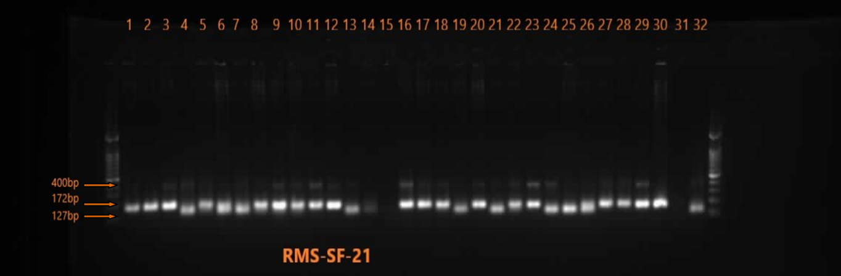
Figure 2: PCR amplification by using SSR marker RMS-SF-21
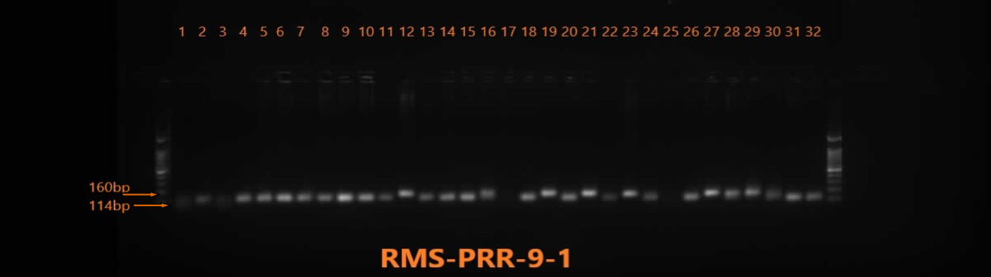
Figure 3: PCR amplification by using SSR marker RMS-PRR-9-1
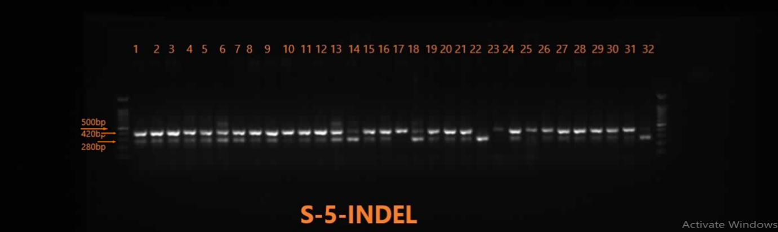
Figure 4: PCR amplification by using SSR marker S-5-INDEL
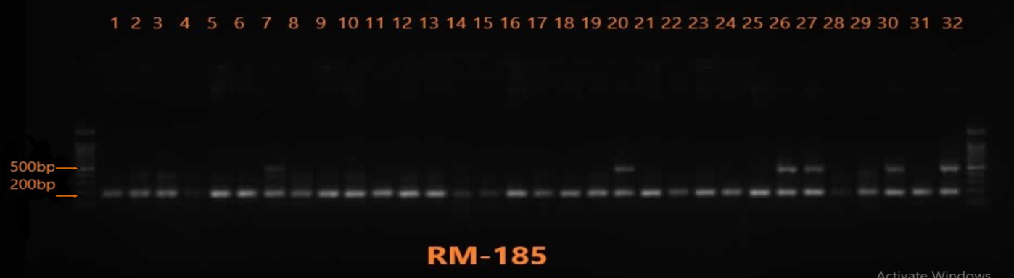
Figure 5: PCR amplification by using SSR marker RM-185

3.2 Cluster analysis of SSR markers

Based on the electrophoretic banding pattern of SSR primers, pair wise genetic similarity amongst thirty-two genotypes of rice for genetic diversity were estimated and a dendrogram was generated by UPGMA method implemented in Darwin 6.0 (Figure 2). The Cluster analysis based on SSR markers across various linkage groups data (Table 4) revealed a relatively broad genetic background of rice genotypes. This approach study was performed to validate the fertility restoration value of such genotypes in said set of accessions under the study.

Table 4: Distribution of genotypes in different clusters based on SSR analysis
Cluster | Sub-cluster | No. of genotypes | Genotypes
I | A | 19 | NPT-13-0, R-712, JR-206, NPT-65, IR-79854-38-2-4, R-650, NPT-15 JR(SF)-21, NPT-70, WGL23985, KRANTI, CBSN-168, PRR-815, NPT-10, NPT-29, PRR-812, RYT-3378, NPT-82 and WGL-32183
I | B | 6 | ABHAYA, R-296, SUREKHA, P 3123, NPT-86 and JAGTIAL SANALU
II | A | 3 | NPT-710, NPT-704 and SUGANDHA-3
II | B | 1 | WGL - 32100
III | A | 1 | RPHR -612
III | B | 1 | JGL - 3828
IV |  | 1 | NPT-37

Figure 6: Dendrogram showing diversity among thirty-two rice genotypes based on SSR markers.

- Conclusion

Study revealed that marker s5-inDel is specific marker to categorize the indica, japonica sub-species and wide-compatible loci. This information will utilize in hybrid breeding program and classification of genotypes with neutral alleles is without neutral alleles as compatible are not compatible for high fertility rice hybrids.

Genotypes NPT-13-01, RYT-3378, JR (SF)-21 and PRR-812 possess 3 alleles (indica, japonica and wide-compatible). These genotypes will be promising for designing of suitable crossing program to identify the best combinations providing high heterosis with high panicle fertility.

DISCLAIMER (ARTIFICIAL INTELLIGENCE)

Author(s) hereby declare that NO generative AI technologies such as Large Language Models (ChatGPT, COPILOT, etc) and text-to-image generators have been used during writing or editing of this manuscript.

.

References

Anonymous.(2023) https://seedres.icar.gov.in/uploads/files/1/AICRP%20NSP%20(Crops)/2022-2023.pdf

Al-kazaz, A.K. (2014). Sequence Variation and Phylogenetic Relationships Among Ten Iraqi Rice Varieties Using RM171 marker. Iraqi Journal of Science 55(1), 145-150.

Al-Musawi, B.H., Al-Abedy, A.N., (2020). Genetic variability analysis of some selected rice (oryza sativa l.) Genotypes in Iraq. International Journal of Agricultural and Statistical Sciences 16(1), 191-197.

Giantsis, I.A., Chaskopoulou, A., Claude Bon, M., (2017). Direct multiplex PCR (dmPCR) for the identification of six phlebotomine sand fly species (Diptera: Psychodidae), including major Leishmania vectors of the Mediterranean. Journal of economic entomology 110(1), 245-249.

Hari Prasad, AS., Senguttuvel, P., Revathi, P., Kemparaju, K.B., Sruthi, K., Sundaram, R.M., Seshu Madhav, M., Prasad, M.S. and Laha, G. S., (2018). Breeding strategies for hybrid rice parental line improvement. Oryza 55, 38-41.

Kumar R., Kumar P., Sharma V.K., Kumari R., and Neha K., (2015). Genetic purity assessment of rice varieties using microsatellite markers. International Journal of Agriculture Sciences ISSN, 0975-3710.

Li, S., Yang, G., Li, S., Li, Y., Chen, Z. and Zhu, Y., (2005). Distribution of fertility-restorer genes for wild-abortive and Honglian CMS lines of rice in the AA genome species of genus Oryza. Annals of Botany, 96(3), 461-466.

Meti, N., Samal, K.C., Bastia, D.N. and Rout, G.R., (2013). Genetic diversity analysis in aromatic rice genotypes using microsatellite based simple sequence repeats (SSR) marker. African Journal of Biotechnology, 12(27), 4238.

Ponnuswamy R, Singh AK, Raman MS Subbarao LV., (2020). Conversion of partial restorer Swarna into restorer by transferring fertility restorer Rf gene(s) through Marker Assisted Backcross Breeding (MABB) in rice. Sci Rep 10, 1101 (2020). https://doi.org/10.1038/s41598-020-58019-1.

Pranathi, K., Viraktamath, B.C., Neeraja, C.N., Balachandran, S.M., Koteswara Rao, P., Revathi, P., Sundaram, R.M., (2016). Development and validation of candidate gene-specific markers for the major fertility restorer genes, Rf4 and Rf3 in rice. Molecular Breeding 36(10), 1-14.

Prasanna, G., Eswari, K.B., Senguttuvel, P., Reddy, S.N., Sundaram, R.M., Beaulah, P. and Veerendra, J., (2022). Studies on genetic divergence and screening of parental lines for Rf3 and Rf4 genes through molecular markers in hybrid rice (Oryza sativa L.) Electronic Journal of Plant Breeding 13(4), 1170-1179.

Shalini P, Manonmani S, Robin S., (2015). Genetic analysis of fertility restoration under CGMS system in rice (Oryza sativa L.) using three-way test-cross method. Journal of Genetics 94(1), 9-16.

Singh, A.K., Revathi, P., Pavani, M., Sundaram, R.M., Senguttuvel, P., Kemparaju, K.B., Viraktamath, B.C., (2014). Molecular screening for fertility restorer genes Rf3 and Rf4 of WA-CMS and evaluation of F1 hybrids in rice (Oryza sativa L.). Journal of Rice Research 7(1), 25-26.

Singh, S.K., Sonkar, S., Vennela, P.R., Singh, D.K., (2016). Identification of restorers and maintainers in rice (Oryza sativa L.) using SSR markers. ORYZA-An International Journal on Rice 53(3), 249-254.

Shamim, M.Z., Manzar, H., Sharma, V.K., Kumar, P., (2016). Microsatellite marker based characterization and divergence analysis among rice varieties. Indian Journal of Biotechnology 15, 182-189.

Stanis, C.S., Song, B.K., Chua, T.H., Lau, Y.L., Jelip, J., (2016). Evaluation of new multiplex PCR primers for the identification of Plasmodium species found in Sabah, Malaysia. Turkish Journal of Medical Sciences 46(1), 207-218.

Sundaram, R.M., Sakthivel, K., Hariprasad, A.S., Ramesha, M.S., Viraktamath, B.C., Neeraja, C.N., Hari,Y., (2010). Development and validation of a PCR based functional marker system for the major wide-compatible gene locus S5 in rice. Molecular Breeding 26(4), 719-727.

Temnykh, S., Park, W.D., Ayres, N., Cartinhour, S., Hauck, N., Lipovich, L., McCOUCH, S.R., (2000). Mapping and genome organization of microsatellite sequences in rice (Oryza sativa L.). Theoretical and applied genetics 100, 697-712.

Tidke, Shashank, Vasist S., Kiran, Harke, Sanjay., (2014). Analysis of Genetic Diversity in 20 Cotton Germplasm Lines Using Random Amplified Polymorphic DNA Marker. Asian Journal of Plant Sciences. 13, 184-189.

Vieira, M.L.C., Santini, L., Diniz, A.L., Munhoz, C.D.F., (2016). Microsatellite markers: what they mean and why they are so useful. Genetics and molecular biology 39, 312-328.

