Original Research Article
Exploring the role of Probiotics and Antioxidants in combination with Citalopram hydrobromide for Depression therapy: A Preclinical study in Swiss Albino Mice model

.
ABSTRACT

Background: Depression is a leading cause of disability worldwide, characterized by mood disturbances and neurobiological alterations. The gut–brain axis and oxidative stress have emerged as critical factors in its pathophysiology. Probiotics, through microbiome modulation, and vitamin C, via antioxidant effects, have shown potential to improve depressive symptoms. Citalopram hydrobromide, a selective serotonin reuptake inhibitor, is widely used but has limitations, including delayed therapeutic onset and partial remission.
Aims: This study aimed to investigate whether adjunctive administration of probiotics and vitamin C could enhance the antidepressant efficacy of citalopram hydrobromide in a stress-induced murine model of depression.
Materials and methods: Adult Swiss albino mice (n=12) were randomized into four groups: vehicle control, stress control, standard (citalopram hydrobromide 10 mg/kg), and test (citalopram hydrobromide + probiotics + vitamin C). Stress was induced using deprivation and cold-water swim protocols over four weeks. Antidepressant activity was evaluated through the forced swim test, tail suspension test, and locomotor activity using an actophotometer. Data were analyzed using analysis of variance (ANOVA) with Tukey’s post hoc test.
Results: The stress protocol significantly increased immobility and reduced locomotor activity compared to controls (p<0.0001). Citalopram hydrobromide reduced immobility in both forced swim test and tail suspension test, confirming antidepressant activity. The test group (citalopram hydrobromide + probiotics + vitamin C) showed significantly greater reductions in immobility (p<0.05–0.001) and enhanced locomotor activity compared to citalopram hydrobromide alone. These findings suggest synergistic effects via modulation of serotonergic pathways, antioxidant mechanisms, and gut–brain interactions.
Conclusion: Adjunctive supplementation with probiotics and vitamin C potentiates the antidepressant efficacy of citalopram hydrobromide in a murine depression model. This multimodal strategy may represent a promising therapeutic approach for major depressive disorder, warranting further mechanistic and clinical investigation.

Keywords: Depression; Citalopram hydrobromide, Probiotics, Vitamin C, Gut–brain axis, Stress-induced murine model

1. INTRODUCTION

Depression is a prevalent and debilitating mental disorder, representing the leading cause of disability among mood disorders worldwide (Murray, 1997). It is often associated with a range of psychiatric complications, including sleep disturbances, anxiety, appetite dysregulation, and, in severe cases, suicidal behavior (Rajashree, 2024). Neurobiologically, depression is linked to structural and functional alterations in key brain regions such as the hippocampus and the dorsal raphe nuclei, the latter being critically involved in the regulation of mood and emotional behavior (Abdalla, 2018). Emerging evidence highlights the pivotal role of the gut-brain axis—a bidirectional communication network between the central nervous system and the gastrointestinal tract—in modulating stress responses and mood (Bienenstock, 2016). Through mechanisms involving the hypothalamic-pituitary-adrenal axis, the vagus nerve, and the endocrine system, the gut microbiota contributes significantly to the regulation of neurotransmitters, including serotonin and dopamine (Neuman, 2015). Animal studies have further underscored this relationship, as germ-free mice, delivered via cesarean section and raised in sterile environments, exhibit altered behaviors reminiscent of neurodevelopmental and mood disorders (Abdalla, 2018).

Within the gut microbiota, certain bacterial genera, particularly Lactobacillus, have demonstrated promising neuroprotective and psychotropic effects. Lactobacillus, a gram-positive bacterium predominantly residing in the human gut, has been shown to modulate stress-induced behavioral deficits. For example, administration of Lactobacillus helveticus NS8 to Sprague-dawley rats ameliorated stress-induced behavioral abnormalities and reduced corticosterone levels (Abdalla, 2018; Foster, 2017). These findings support the potential therapeutic role of probiotics in psychiatric disorders.
Oxidative stress has also been implicated in the pathophysiology of major depressive disorder. Clinical studies report decreased plasma ascorbic acid levels alongside elevated serum markers of oxidative stress, including superoxide dismutase and malondialdehyde, in individuals with major depressive disorder (Sahraian, 2015; Khanzode, 2003). Preclinical investigations demonstrate that vitamin C mitigates stress-induced lipid peroxidation in the cerebral cortex and hippocampus and regulates antioxidant enzymes such as glutathione reductase and glutathione peroxidase (Moretti,. Et al., 2013) Moreover, vitamin C exhibits antidepressant-like effects in animal models, potentially through modulation of the monoaminergic system and antagonism of N-methyl-D-aspartate receptors (Sahraian, 2015). Notably, vitamin C has been shown to enhance the efficacy of conventional antidepressants in preclinical studies (Binfare, 2009).
Based on these findings, the present study aims to evaluate the combined effects of probiotics and the antioxidant vitamin C on depression-like behaviors in a preclinical model. The antidepressant selected for this study is citalopram hydrobromide, a selective serotonin reuptake inhibitor known for its high specificity toward serotonin receptors, favorable tolerability, and minimal drug interactions (Bezchlibnyk-Butler, 2000). This investigation seeks to explore whether the adjunctive use of probiotics and vitamin C can potentiate the therapeutic effects of citalopram hydrobromide, providing a potential novel strategy for depression management.
2. material and methods

2.1 Materials

Citalopram hydrobromide hydrobromide (USP grade) was procured from Swapnaroop Drugs and Pharmaceuticals, India. Vitamin C (ascorbic acid, IP grade) was obtained from CSPC Pharmaceuticals Co. Ltd., India. A probiotic formulation (FLORA®-Zn) was supplied by Swiss Garnier Biotech Pvt. Ltd., India. Normal saline was purchased from a local pharmacy, and purified water was prepared in-house.
2.2 Methods

2.2.1 Animal model
Adult swiss albino mice of either sex, weighing 25–35 g and aged approximately 6 weeks, were obtained from the animal house facility of Sudhakarrao Naik Institute of Pharmacy, Pusad, Maharashtra, India. The animals were maintained in accordance with the guidelines of the Committee for the Purpose of Control and Supervision of Experiments on Animals (CPCSEA), Government of India, before and during the experimental period. They were housed in polypropylene cages under controlled environmental conditions (24 ± 2 °C, 12 hours light/dark cycle) and provided ad libitum access to a standard pellet diet and purified water. The experimental protocol was reviewed and approved by the Institutional Animal Ethics Committee (IAEC) of the institute.
2.2.2 Study design
Swiss albino mice were randomly divided into four groups, each consisting of three animals. All animals were acclimatized to the laboratory environment for 7 days prior to the start of the experiment under controlled conditions (25 ± 2 °C, 12 hours light/dark cycle) with free access to standard chow and water. To minimize stress from handling, cages were cleaned once weekly. Mice were of comparable body weight (25–35 g), and each group was assigned a specific identification code.
Group I (Vehicle control): Received saline solution along with food and water.
Group II (Stress control): Exposed to stress-inducing procedures without drug treatment.
Group III (Standard): Received citalopram hydrobromide (10 mg/kg, p.o.) once daily for 4 weeks in combination with stress induction.
Group IV (Test): Received a combination of citalopram hydrobromide (10 mg/kg, p.o.), vitamin C (1 mg/kg, p.o.), and probiotics (0.2 mL, p.o.) once daily for 4 weeks in combination with stress induction.
Stress was induced using the following procedures: (i) empty water bottles (23 hours water deprivation followed by 1 hour access), (ii) food or water deprivation (23 hours deprivation followed by 1 hour access), and (iii) cold water swimming at 4 °C for 5 minutes. Each stressor was applied individually on different days in a randomized manner over a 4 week period. Behavioral assessments for antidepressant activity were conducted 1 hour after the final drug administration (Abdalla, 2018; Ganesh, 2016).
To evaluate the antidepressant activity of the proposed treatment, immobility time was measured as the primary parameter. Immobility was defined as the absence of all movement except those necessary for respiration. A reduction in immobility time is indicative of antidepressant-like activity. Conversely, mobility was characterized by escape-oriented behaviors exhibited by the animals in response to the induced state of despair. The immobility time of the treatment groups was compared with that of the standard drug, citalopram hydrobromide (Abdalla, 2018).
2.2.3 Assessment for antidepressant activity
2.2.3.1 Forced swimming test
The forced swim test is a well-established behavioral paradigm in rodents that predicts the clinical efficacy of antidepressant treatments. Following the respective treatments, mice were individually placed in an open cylindrical container (10 cm in diameter, 25 cm in height) filled with water to a depth of 19 cm, maintained at 25 ± 1 °C. Each animal underwent a 6 minutes test session, during which the total duration of immobility was recorded in seconds. Immobility was defined as the time the mouse remained floating motionless in the water, making only the minimal movements required to keep its head above the surface. Behavioral observations were recorded on days 1, 15, and 21 of treatment (Abdalla, 2018; Commons, 2017). Data were analyzed using one-way analysis of variance (ANOVA), followed by Tukey’s multiple comparison test. Results were expressed as mean ± standard error of the mean. Statistical significance was considered at *p<0.05, **p<0.01, ***p<0.001.
2.2.3.2 Tail suspension test
The tail suspension test is a widely employed behavioral model in rodents to evaluate depression-like behavior and the potential antidepressant effects of pharmacological interventions. Following the respective treatments, mice were individually suspended by the tail using an adhesive clamp placed 10 mm from the tip of the tail. The animals were suspended inside a sound-attenuated box (250 × 250 × 300 mm), with the head positioned 50 mm above the bottom of the apparatus. The test was conducted in a dark room with minimal background noise to avoid external stressors. Each mouse was suspended for a total duration of 6 minutes, during which the time spent immobile was recorded. Immobility was defined as the absence of active movements, with the mouse hanging passively and motionless. Measurements were taken on days 1, 15, and 21 of treatment (Abdalla, 2018; Ganesh, 2016). Data were analyzed using one-way ANOVA, followed by Tukey’s multiple comparison test. Results were expressed as mean ± standard error of the mean. Statistical significance was set at *p<0.05, **p<0.01, ***p<0.001.
2.2.4 Assessment of locomotor activity
Locomotor activity (horizontal movement) was assessed using an actophotometer, which functions on the principle of photoelectric cells connected in circuit with a counter. When the animal interrupted the light beam, a count was automatically recorded. Following treatment, each animal was individually placed in the actophotometer for a 10 minutes session, and the locomotor activity score was documented. Recordings were taken on days 1, 15, and 21 of treatment (Bhosale, 2011; Gupta, 2014). Data were analyzed using one-way ANOVA, followed by Tukey’s multiple comparison test. Results were expressed as mean ± standard error of the mean. Statistical significance was set at *p<0.05, **p<0.01, ***p<0.001.
3. results and discussion

3.1 Assessment for antidepressant activity
3.1.1 Forced swimming test
The data in table 1 represent the effects of different treatments on immobility time in a stress-induced animal model, likely assessing depressive-like behavior. Group I, the vehicle control, showed stable immobility times around 184–187 seconds across the study period, representing normal baseline behavior. In contrast, Group II, the stress control, exhibited significantly increased immobility (233–239 seconds), indicating that the stress protocol successfully induced depressive-like behavior, as evidenced by the highly significant differences compared to the vehicle control (p < 0.0001). Group III, which received a standard antidepressant treatment, demonstrated a progressive reduction in immobility over time (from 172 seconds to 148 seconds), showing a highly significant improvement compared to the stress control (p < 0.0001), confirming the efficacy of the standard treatment in reversing stress-induced behavioral deficits. Group IV, treated with the test compound, showed a similar trend with reduced immobility (from 153 seconds to 138 seconds), with significance both compared to the stress control (p < 0.0001) and, in some instances, compared to the standard treatment (p < 0.05–0.001). Notably, by Day 28, the test treatment group exhibited lower immobility than the standard treatment group, suggesting a potentially stronger or more sustained antidepressant-like effect. Overall, the results indicate that the stress model effectively induced depressive-like behavior, which was significantly ameliorated by both standard and test treatments, with the test treatment showing particularly promising efficacy over the study period (Fig. 1).
Table 1. Immobility time of mice in the forced swim test
Group | Treatment | Mean immobility time (in seconds)
Group | Treatment | Day 1 | Day 15 | Day 28
I | Vehicle Control | 187 ± 2.64 | 181 ± 1.52 | 184.0 ± 2.30
II | Stress control | 233.3 ± 2.7 *** | 236.7 ± 3.18*** | 239.0 ± 2.30***
III | Standard | 172.3 ± 3.75### | 157.3 ± 2.72### | 148.7 ± 1.85###
IV | Test | 153 ± 2.33###@@ | 181 ± 1.52###@@ | 138.3 ± 1.20###@
Values are mean ± standard error of the mean (n= 3 animals) Data were analyzed by one-way ANOVA followed by the Tukey test.
* Indicate control group compared with stress induced group *** p<0.0001, ns- non-significant.
# Indicate stress induced group compared with standard and test group ### p< 0.0001.
@ Indicate standard group compared with test group @p< 0.05, @@p< 0.001.

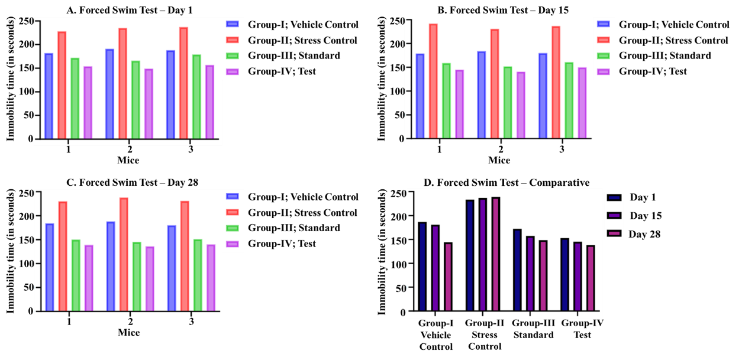
Fig. 1. Immobility time of mice in the forced swim test: A. Day 1; B. Day 15; C. Day 28; and D. Comparative
3.1.2 Tail suspension test
The data in table 2 show the effects of different treatments on immobility time in a stress-induced animal model, which is commonly used to assess depressive-like behavior. The vehicle control group (Group I) displayed relatively stable immobility times around 185–188 seconds across all days, representing normal baseline behavior without stress. In contrast, the stress control group (Group II) showed a marked increase in immobility (214–226 seconds) compared to the vehicle control, with highly significant differences (p < 0.0001), indicating that the stress protocol effectively induced depressive-like behavior. The standard treatment group (Group III) exhibited a substantial reduction in immobility over time (from 157 seconds to 147 seconds), demonstrating a highly significant improvement compared to the stress control (p < 0.0001), confirming the efficacy of the standard antidepressant in mitigating stress-induced behavioral deficits. The test treatment group (Group IV) showed an even greater decrease in immobility (146.7 seconds to 135 seconds), which was significantly lower than both the stress control (p < 0.0001) and the standard treatment (p < 0.05), suggesting that the test compound may provide a stronger antidepressant-like effect than the standard drug. Overall, the findings indicate that the stress model successfully induced depressive-like behavior, which was effectively reversed by both standard and test treatments, with the test treatment showing particularly promising efficacy over the 28-day period (Fig. 2).
Table 2. Immobility time of mice in the tail suspension test
Group | Treatment | Mean immobility time (in seconds)
Group | Treatment | Day 1 | Day 15 | Day 28
I | Vehicle Control | 185.7± 2.18 | 184.0± 2.88 | 187.7 ± 3.38
II | Stress control | 214± 3.21*** | 221.0± 2.08*** | 226.3± 1.45***
III | Standard | 157±1.52### | 154.3±2.60### | 147.0±2.64###
IV | Test | 146.7±0.88###@ | 142.3±2.40###@ | 135.0±2.08###@
Values are mean ± standard error of the mean (n= 3 animals) Data were analyzed by one-way ANOVA followed by the Tukey test.
* Indicate control group compared with stress induced group *** p<0.0001, ns- non-significant.
# Indicate stress induced group compared with standard and test group ### p< 0.0001,
@ Indicate standard group compared with test group @ p<0.05.

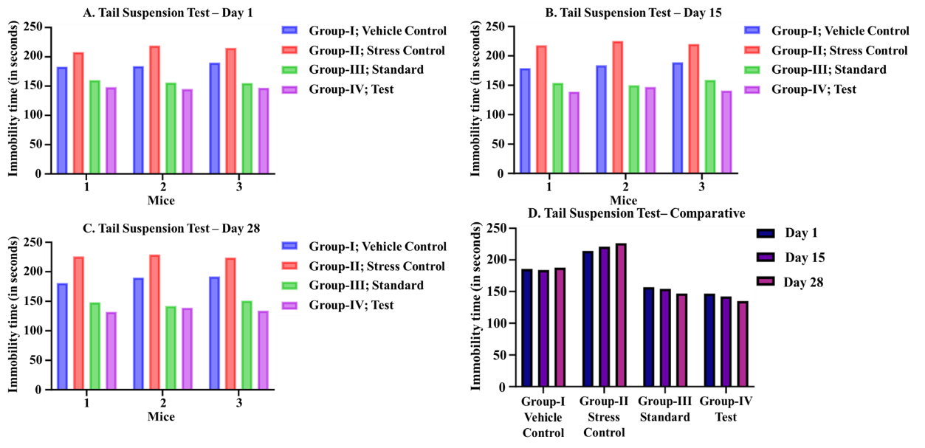
Fig. 2. Immobility time of mice in the tail suspension test: A. Day 1; B. Day 15; C. Day 28; and D. Comparative
3.2 Assessment of locomotor activity
The data in table 3 represent the assessment of locomotor activity in animals over a 28-day period, measured as mean counts in 10 minutes. In the vehicle control group (Group I), locomotor activity remained relatively stable across the study period, with counts ranging from 179 to 225, representing normal baseline activity. The stress control group (Group II) showed a significant reduction in locomotor activity compared to the vehicle control, particularly on Day 15 and Day 28, indicating that stress negatively affected normal activity levels (**p < 0.01 to ***p < 0.001). In contrast, the standard treatment group (Group III) demonstrated a progressive increase in locomotor activity over time (counts from 252.7 to 280.7 counts), with highly significant improvement compared to the stress control (### p < 0.0001), reflecting the efficacy of the standard treatment in restoring normal activity. The test treatment group (Group IV) exhibited an even greater enhancement in locomotor counts (counts from 275 to 304 counts), which was significantly higher than both the stress control (### p < 0.0001) and the standard treatment group (@ p < 0.05 to @@ p < 0.001). These results suggest that while stress impairs locomotor activity, both standard and test treatments effectively restore it, with the test treatment showing superior efficacy in enhancing activity levels over the 28-day period (Fig. 3).
Table 03. Actophotometer counts of mice in the locomotor activity
Group | Treatment | Mean counts in 10 minutes
Group | Treatment | Day 1 | Day 15 | Day 28
I | Vehicle Control | 223.7± 6.64 | 179.0± 2.30 | 224.7± 4.05
II | Stress control | 186.7± 3.75** | 186.7± 1.73*** | 169.7± 1.45***
III | Standard | 252.7±3.75### | 267.3±3.18### | 280.7±3.18###
IV | Test | 275.0±2.88###@ | 285.7±2.96###@@ | 304.0±4.16###@@
Values are mean ± standard error of the mean (n= 3 animals) Data were analyzed by one-way ANOVA followed by the Tukey test.
# Indicate stress induced group compared with standard and test group ### p< 0.0001,
@ Indicate standard group compared with test group @ P<0.05.
@ Indicate standard group compared with test group @@ p< 0.001.

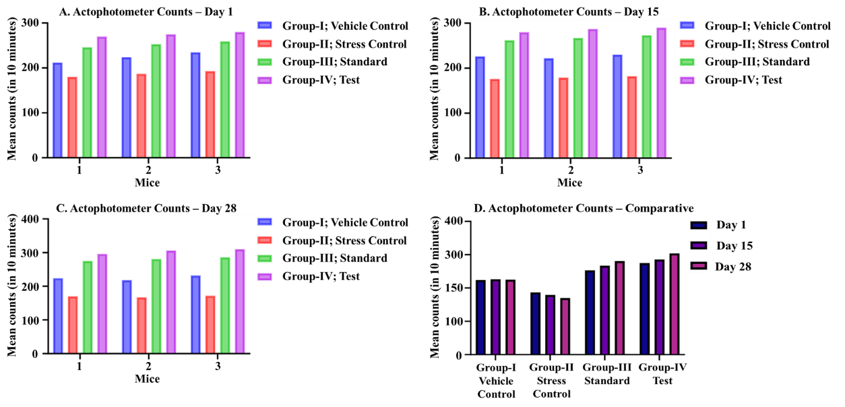
Fig. 3. Actophotometer counts of mice in the locomotor activity: A. Day 1; B. Day 15; C. Day 28; and D. Comparative
The present study evaluated the antidepressant-like effects of combining probiotics and vitamin C with citalopram hydrobromide in a stress-induced murine model of depression. Our findings consistently showed that the adjunctive regimen significantly reduced immobility times in the forced swim test and tail suspension test, while simultaneously enhancing locomotor activity compared to citalopram hydrobromide alone. These results provide preclinical support for a multi-targeted therapeutic approach in depression management.
Probiotics and Modulation of the Gut–Brain Axis: The results from Groups III and IV highlight the contribution of gut microbiota modulation in antidepressant efficacy. Probiotics, particularly Lactobacillus species, are known to influence neurotransmitter pathways, regulate hypothalamic–pituitary–adrenal axis hyperactivity, and attenuate stress-induced behavioral deficits. In our study, the probiotic-containing regimen (Group IV) produced superior reductions in immobility times compared to citalopram hydrobromide alone, suggesting that microbiome modulation may enhance serotonergic signaling and neuroplasticity. This aligns with previous reports where probiotic supplementation reduced corticosterone levels and improved depressive-like behaviors in rodent models (Abdalla, 2018; Gao, et al., 2023).
Vitamin C and Antioxidant Support: Oxidative stress has been strongly implicated in the pathophysiology of depression. Clinical studies consistently report low plasma vitamin C levels in patients with major depressive disorder, alongside elevated oxidative biomarkers. In this study, adjunctive vitamin C likely contributed to improved behavioral outcomes by counteracting lipid peroxidation and supporting antioxidant enzyme activity. Additionally, vitamin C may enhance monoaminergic neurotransmission and act synergistically with SSRIs, thereby accelerating therapeutic effects (Bidaki, 2023; Kohima, 2021). The observed improvement in locomotor activity in Group IV further supports its role in restoring physiological homeostasis beyond mood-related behaviors (Sahraian, 2015).
Synergistic Interaction with Citalopram hydrobromide: Citalopram hydrobromide, as a selective serotonin reuptake inhibitor, is effective but often associated with delayed onset and incomplete remission. The combination of probiotics and vitamin C potentiated its antidepressant-like activity, as evidenced by significantly greater reductions in immobility in both forced swim test and tail suspension test compared to standard treatment. By simultaneously targeting serotonergic signaling, oxidative stress, and gut–brain interactions, this multimodal strategy may offer broader efficacy than monotherapy (Bettina, 2020).
Behavioral Correlates: The validity of these findings is strengthened by the consistent outcomes across independent behavioral paradigms. In both forced swim test and tail suspension test, Group IV displayed significantly shorter immobility times than the stress control and citalopram hydrobromide-only groups. Importantly, the increase in locomotor activity observed in the test group suggests that the reduced immobility was not due to sedation or nonspecific motor impairment, but rather reflects genuine antidepressant-like effects.
Several limitations should be acknowledged. The small sample size (n = 3 per group) reduces statistical power and necessitates caution in interpretation. Moreover, the study relied solely on behavioral endpoints; biochemical analyses of oxidative stress markers, serotonergic activity, or gut microbiota composition were not performed. Incorporating such mechanistic assessments in future studies will clarify the pathways through which probiotics and vitamin C exert their effects. Finally, while the stress-induced murine model provides valuable insights, clinical trials in humans are essential to validate translational potential.
4. Conclusion

In conclusion, this study demonstrates that probiotics and vitamin C significantly enhance the antidepressant efficacy of citalopram hydrobromide in a murine stress model of depression. These findings highlight the therapeutic promise of combining dietary interventions with pharmacological agents to target multiple biological pathways in depression. Future research integrating molecular biomarkers and clinical evaluations is warranted to establish this adjunctive strategy as a viable option for improving outcomes in major depressive disorder.

Ethical approval

All authors hereby declare that experiments have been examined and approved by the Institutional Animal Ethical Committee (IAEC) of Sudhakarrao Naik Institute of Pharmacy, Pusad, Maharashtra, India. (Proposal number: CPCSEA/IAEC/CP-PL/09/2023)

References

Abdalla, M.A., Enass, Y.O., & Osama, A.A. (2018). Comparative therapeutic efficacy study of Lactobacilli probiotics and citalopram hydrobromide in treatment of acute stress-induced depression in lab murine Models. Human Microbiome Journal, 10, 33-36. https://doi.org/10.1016/j.humic.2018.08.001.

Bettina, M., Ariana, E.S., Ana Lúcia, S.R., Alcir, L.D., & Mauricio, P.C. (2020). The role of vitamin C in stress-related disorders. The Journal of Nutritional Biochemistry, 85, 108459. https://doi.org/10.1016/j.jnutbio.2020.108459.

Bidaki, R., Mahdavi, F.M., Motamed, M., Taherzadeh, B.S., & Nadjarzadeh, A. (2023). The Role of Vitamin C in the Treatment of Depression. Journal of Nutrition and Food Security, 8(2), 152-154.

Bienenstock, J., Kunze, W., & Forsythe, P. (2016). The microbiome–gut–brain axis and the con sequences of infection and dysbiosis. American Journal of Gastroenterology, 3, 33-38.

Bezchlibnyk-Butler, K., Aleksic, I., & Kennedy, S.H. (2000). Citalopram hydrobromide–a review of pharmacological and clinical effects. Journal of Psychiatry & Neuroscience, 25(3), 241-254.

Bhosale, U., Yegnanarayan, R., Prachi, P., Zambare, M., & Somani, R.S. (2011). Study of CNS depressant and behavioral activity of an ethanol extract of Achyranthes Aspera (Chirchita) in mouse model. Annals of Neurosciences, 18(2), 44-47. https://doi.org/10.5214/ans.0972.7531.1118204.

Binfare, R.W., Rosa, A.O., Lobato, K.R., Santos, A.R., & Rodrigues, A.L. (2009). Ascorbic acid administration produces an antidepressant-like effect: evidence for the involvement of monoaminergic neurotransmission. Progress in Neuro-Psychopharmacology & Biological Psychiatry, 33(3), 530-540. https://doi.org/10.1016/j.pnpbp.2009.02.003.

Commons, K.G., Cholanians, A.B., Babb, J.A., & Ehlinger, D.G. (2017). The Rodent Forced Swim Test Measures Stress-Coping Strategy, Not Depression-like Behavior. ACS Chemical Neuroscience Journal, 8(5), 955-960. https://doi.org/10.1021/acschemneuro.7b00042.

Foster, J.A., Rinaman, L., & Cryan, J.F. (2017). Stress & the gut-brain axis: Regulation by the microbiome. Neurobiology of Stress, 19(7), 124-136. https://doi.org/10.1016/j.ynstr.2017.03.001.

Ganesh, P., Subrat kumar, B., & Bijay kumar, M. (2016). Effects of Mimosa Pudica L.leaves extract on anxiety, depression and memory. Avicena Journal of Phytomedicine, 6(6), 696-710.

Gao, J., Zhao, L., Cheng, Y., Lei, W., Wang, Y., Liu, X., et al. (2023). Probiotics for the treatment of depression and its comorbidities: A systemic review. Frontiers in Cellular and Infection Microbiology, 13:1167116. https://doi.org/10.3389/fcimb.2023.1167116.

Gupta, S., Kharjul, M., Bhairy, S., Maurya, S., & Upadhyay, A. (2014). Some Evaluated Potential Therapeutic Agents in Herbalism and their Proposed Dosage Forms. International Journal of Innovative Pharmaceutical Sciences and Research, 2(7), 1533-1554.

Khanzode, S.D., Dakhale, G.N., Khanzode, S.S., Saoji, A., & Palasodkar, R. (2003). Oxidative damage and major depression: the potential antioxidant action of selective serotoninre-uptake inhibitors. Redox Report, 8(6), 365-370. https://doi.org/10.1179/135100003225003393.

Kohima, A., Navyug, R.S., Neeru, B., & Manjit, S. (2021). Major depressive disorder: association with vitamin C levels and role of vitamin C supplementation in pharmacotherapy. International Journal of Basic & Clinical Pharmacology, 10(4), 403-408. https://doi.org/10.18203/2319-2003.ijbcp20211023.

Moretti, M., Budni, J., Santos, D.B., Antunes, A., Daufenbach, J.F., Manosso, L.M., et al. (2013). Protective effects of ascorbic acid on behavior and oxidative status of restraint-stressed mice. Journal of Molecular Neuroscience, 49(1), 68-79. https://doi.org/10.1007/s12031-012-9892-4.

Murray, C.J., & Lopez, A.D. (1997). Global mortality, disability, and the contribution of risk factors: Global Burden of Disease Study. Lancet, 349(9063),1436-4142. https://doi.org/10.1016/S0140-6736(96)07495-8.

Neuman, H., Debelius, J.W., Knight, R., & Koren, O. (2015). Microbial endocrinology: the interplay between the microbiota and the endocrine system. FEMS Microbiology Reviews, 39(4), 509-521. https://doi.org/10.1093/femsre/fuu010.

Rajashree, H., Alfiha, Momin., & Srinivas, B. (2024). Formulation development, in-vitro and ex-vivo evaluation of dry adsorbed solid lipid nanoparticles: an approach of overcoming olanzapine drawbacks. European Pharmaceutical Journal, 71(1), 1-15. https://doi.org/10.2478/afpuc-2024-0004.

Sahraian, A., Ghanizadeh, A., & Kazemeini, F. (2015). Vitamin C as an adjuvant for treating major depressive disorder and suicidal behavior, a randomized placebo-controlled clinical trial. Trials, 16, 94-101. https://doi.org/10.1186/s13063-015-0609-1.

