Awareness of chronic migraine diagnosis and management among primary care physicians in PSMMC in Riyadh

Abstract
Background: Chronic migraine (CM) is a disabling neurological disorder frequently underdiagnosed and undertreated in primary care, despite its high prevalence and burden on patients and healthcare systems. Primary care physicians (PCPs) are the frontline providers for headache management, and their knowledge and attitudes directly impact early recognition and evidence-based treatment. Limited regional studies have suggested significant gaps in PCPs’ knowledge of CM in Saudi Arabia.
Objective: This study aimed to assess the level of awareness, diagnostic accuracy, and management knowledge of chronic migraine among PCPs at Prince Sultan Military Medical City (PSMMC), Riyadh, and to identify factors associated with higher knowledge scores.
Methods: A cross-sectional survey was conducted among PCPs in PSMMC from June to July 2025. A validated, self-administered questionnaire comprising 20 knowledge items (scored correct/incorrect) and two attitude questions was distributed electronically. Knowledge scores (0–20) were categorized using modified Bloom’s cut-offs: high (16–20), moderate (12–15), and low (0–11). Data were analyzed with descriptive statistics, score results, chi-square tests, and KR-20 for reliability.
Results: A total of 145 physicians completed the survey. Overall reliability of the knowledge scale was strong (KR-20 = 0.84). The mean total knowledge score was 17.4 ± 3.3, with 77.9% classified as high knowledge, 13.8% as moderate, and 8.3% as low. Diagnostic criteria, red flag recognition, and acute management were well known, but gaps persisted regarding attack duration, follow-up intervals, and non-pharmacological therapies. Significant associations with knowledge levels were observed for age (p = 0.019), nationality (p < 0.001), grade (p = 0.032), years of experience (p = 0.008), and prior course attendance (p = 0.007). Most participants felt very confident in diagnosing CM (64.8%), but fewer expressed confidence in managing it (43.4%).
Conclusion: PCPs at PSMMC demonstrated generally high knowledge and diagnostic confidence in CM, yet important deficiencies remain in preventive strategies and non-pharmacological management. Regular continuing medical education and structured training programs are recommended to address these gaps and optimize migraine care in Saudi primary care settings.
Key words: Awareness; chronic migraine; primary care physicians; PSMMC; Riyadh

Introduction:
Headache is a significant problem in public health care and considered one of the most prevalent disorders among neurological illnesses, and still to be underestimated in terms of its impact on individuals and society and is often underdiagnosed and undertreated worldwide in most of health care institutions all over the globe [1].
The International Classification of Headache Disorders, 3rd edition has issued a classification of headache types in 2013, and they classified Migraine headache into migraine with aura, Migraine without aura and Chronic migraine [2].
In systematic analysis done 2016, measuring the Global Burden of, nearly three billion people were estimated to be affected by headache disorders. Among them, approximately 1.9 billion were diagnosed with tension-type headaches, and one billion were identified as having migraines [3].
Primary health care physicians (PCPs) are the first line of care for migraine patients and the assessment of knowledge in diagnosis and management is vital, A study in france found that 59.7% of patients with headaches presenting to a primary health center were not recognized as having migraine, 11.9% were recognized as having migraine but did not receive migraine management, and 28.4% were recognized as having migraine and received migraine management [4].
And headache consider one of the top 10 patients' reasons for visits in primary health care centers [5].
Study in USA showed the highest occurrence of migraines was observed in individuals in middle age, while it was less common among adolescents and those over 60 years old. Among the migraine sufferers, one third endured attacks three times or more per month, and about half of participants reported significant disability, requiring bed rest. Among all of them, Only 13% were actively using daily medication for migraine prevention [6].
In addition to the pain endured by migraine sufferers, the societal and economic burdens associated with this condition are significant high. According to a study, approximately half of the individuals sought treatment for symptoms related to migraines in an emergency room at least once during the year. Eighty-nine percent of employed survey participants experienced a negative impact on their job performance due to migraines, with more than half of them being absent from work for a minimum of two days per month. Migraine-related hospitalization is not a common occurrence, with only about 7% of patients in the United States experiencing it [7].
The utilization of healthcare resources for migraine management, such as visits to physicians, significantly declined within the three years following the initial diagnosis of migraine. For example, during the initial year (index year), over 70% of migraine patients consulted a primary care physician, whereas this number decreased to about 20% in the subsequent three years [8].
In a Canadian study measuring the impact of migraine on daily life activity, Over half of respondents indicated they have some impact, while about the third of them indicated substantial impact of migraine in their life, and about 13% indicated severe impact.
Participants in the survey indicated that they missed, on average, 20.6% of their total work time because of migraines, half of participants indicated they faced an average impairment while working due to migraine. Additionally, the survey participants reported an average of over 50% activity impairment overall as a result of migraine [9].
Migraine was found to be the second leading cause of disability, following low back pain, and featured in the list of the top ten causes of years of healthy life lost due to disability across all 195 countries [10].
Quality of life was significantly affected in patients, according to a local studies. The least affected quality of life was observed in the younger generation, and the most were observed among age groups, individuals living in rural areas, widows, and those who have lower education level [11,12].
Locally, in Saudi Arabia studies show the prevalence of migraine headaches in the community is significantly high and they found it higher than the worldwide average.
Tension Type Headache was the most common headache type overall about 42.9% while the migraine came second most common and was about 28.7% [13,14].
A study conducted in Jeddah, Saudi Arabia, demonstrated low levels of knowledge and assessment in primary health care providers (PCPs) towards chronic migraine (CM).
This was evident in their inconsistent responses to questions about chronic migraine diagnosis and treatment, with correct answers of items that assess the diagnosis and treatment being less than 70%. primary health care providers with less experience (aged 23-35 years, fresh graduates, and <5 years of experience) had significantly lower knowledge of chronic headache than their more experienced physicians [15].
In cross sectional study done in Saudi Arabia assess the knowledge, attitude, and practice for the general population , Most respondents demonstrated inadequate knowledge of migraine, including gender effects, triggering factors, and prophylactic treatment. They also showed a low level of attitudes towards migraine prevention and treatment, as most did not consider migraine a disorder and needed to seek medical consultation and advice.[AA16] A local study revealed that approximately one-third of the participants do not use medication for their migraine attacks [17].
In study conducted in USA, demonstrate that only less than a third of primary care physicians have adequate knowledge about guidelines on preventive treatment from the American Academy of Neurology, and the study shows, among the participants about 40% and 28% were familiar with American Board of Internal Medicine Foundation (ABIMF) guidelines in treatment and preventive medication [18].
A study in Turkey showed only 10.5 percent of primary care physicians were aware and knew the criteria to diagnose migraine [19].
A study was conducted in Egypt to assess the knowledge and attitudes of non-neurologists towards migraine. The study found that non-neurologists had a significant gap in their knowledge about migraine, 43% of non-neurologists answers were inadequate and low knowledge in diagnose and treatment of chronic migraine, while there were only 20.96% aware of both classic and novel treatments [20].
In study conducted in Greece, measuring the likeability of the primary care health providers in treating the diseases, the participant response very low score regarding the treatment of signs and symptoms of migraine [21].
Study Rational:
There is a need to improve the level of knowledge of the primary care physician regarding the chronic migraine diagnosis and treatment which may require educational programs and courses.
Research Question
What is the Awareness level of primary health care physicians in diagnosis and management of chronic migraine headache?

Hypothesis Null/Alternative
H₀: primary health care physicians are aware about diagnosis and management of chronic migraine headache., as a result of receiving enough health education about diagnosis and management of chronic migraine headache.
H₁: primary health care physicians are not aware about diagnosis and management of chronic migraine headache, and more health education about diagnosis and management of chronic migraine headache is needed.

Study Aim:
This study aimed to analyze the daily clinical practice of primary health care physicians in PSMMC concerning migraine patients.

Study Objectives:
- To assess the knowledge about the diagnosis and management of chronic migraine headache.
- To locate deficiency causes among primary health care physicians.

Methodology
Study design and setting: This was an analytic, observational, cross‑sectional study conducted at Prince Sultan Military Medical City (PSMMC), Riyadh, Saudi Arabia, within the Department of Family Medicine and Primary Care. Primary care is the first point of contact for most patients with headache, and a cross‑sectional design is appropriate to estimate the current level of knowledge and practices regarding chronic migraine at a defined point in time.
Study population and eligibility: The target population comprised all primary care physicians working in PSMMC (general practitioners, family physicians, and family medicine residents; both sexes) during the study period (2024–2025). Inclusion criteria were: physicians currently practicing in PSMMC family medicine clinics. Exclusion criteria were: non‑physician staff and physicians working outside the family medicine department. Based on departmental rosters, the accessible population was 228 clinicians. We aimed for a census by inviting all eligible physicians. Where non‑response occurred, we reported the response rate and compared basic demographics between respondents and non‑respondents to assess non‑response bias.
Sampling and recruitment: A self‑administered, structured electronic questionnaire was distributed via secure institutional communication channels (e.g., email and WhatsApp groups) with two reminders one week apart. Participants provided electronic informed consent before proceeding. Participation was voluntary and anonymous; no financial incentives were provided.
Instrument development: The questionnaire items were adapted from guideline‑concordant clinical knowledge and best practice domains relevant to chronic migraine (diagnosis, red flags, acute treatment, preventive therapy, follow‑up, non‑pharmacological strategies, and safety in special populations). The exact items used in this study are those embedded in the attached Excel file of responses (sheet “Form Responses 1”), covering twenty knowledge items and two attitude items. Content validity was established by review and approval of two PSMMC family medicine consultants. Prior to launch, the instrument was piloted on a convenience sample of 5–10 physicians to ensure clarity and timing; feedback informed minor wording refinements. Internal consistency of the knowledge scale will be assessed post‑hoc using Kuder–Richardson Formula 20 (KR‑20) given dichotomous scoring (correct/incorrect).
Variables and operational definitions: Knowledge items (Q1–Q20) were scored as 1 for a correct response and 0 for an incorrect or missing response, yielding a total knowledge score from 0 to 20. In line with modified Bloom’s cut‑offs commonly used in KAP studies, overall knowledge was categorized as: high (≥80% of the maximum score; 16–20 points), moderate (60–79%; 12–15 points), and low (<60%; 0–11 points). Attitudes were captured by two Likert‑type items addressing confidence in diagnosing and managing chronic migraine (Very confident / Somewhat confident / Not confident); they are summarized descriptively and, where helpful, dichotomized into positive (Very confident) versus non‑positive attitudes for secondary analyses.
Data management: Data were exported directly from the form into a password‑protected Excel file and then imported into statistical software (e.g., SPSS/Stata/R) for analysis. Data cleaning included range and logic checks (e.g., implausible ages), removal of duplicate submissions (by timestamp and overlapping identifiers), and handling of missing values. Missing data in knowledge items were treated as incorrect for scoring, but patterns of missingness were examined and reported.
Statistical analysis: Descriptive statistics summarized demographics and practice characteristics (counts, percentages, means with standard deviations or medians with interquartile ranges as appropriate). Knowledge scores were summarized as mean±SD and as proportions within high/moderate/low categories. Bivariate analyses explored associations between knowledge level and covariates (gender, age, grade, years of experience, prior migraine‑related courses) using χ² tests for categorical variables and t‑tests/ANOVA or non‑parametric equivalents for continuous variables. Where indicated, multivariable ordinal logistic regression modeled predictors of higher knowledge category, reporting adjusted odds ratios (aORs) with 95% confidence intervals. A two‑sided p‑value <0.05 was considered statistically significant.
Bias, validity, and rigor: Selection bias was minimized by inviting all eligible physicians and reporting the response rate. Information bias was reduced by using a pre‑tested, consultant‑validated instrument with standardized response options. The knowledge scale’s reliability (KR‑20) will be reported; sensitivity analyses using alternative cut‑offs (e.g., tertiles) will be undertaken to test robustness of the high/moderate/low classification. Confounding was addressed in multivariable modeling where sample size permitted.
Ethical considerations: The study adhered to institutional ethical standards. Participation was anonymous; no personal identifiers were collected beyond minimal demographics required for analysis. Electronic consent was obtained on the first page of the survey, and participants could exit at any time without penalty. Data were stored on secure, access‑restricted drives and reported in aggregate only.

Knowledge Scoring and Cut-offs
Each knowledge item (Q1–Q20) is scored 1 for a correct response and 0 for incorrect or missing. Total knowledge score ranges 0–20. Knowledge categories use modified Bloom’s thresholds: High (16–20; ≥80%), Moderate (12–15; 60–79%), Low (0–11; <60%).

Results:

Sociodemographic characteristics of participants
A total of 145 primary care physicians in PSMMC completed the survey. Table 1 summarizes their demographic and practice characteristics. Most respondents were male (≈64 %), aged 23–35 years (≈61 %) and Saudi nationals (≈87 %). Residents constituted the largest professional group (≈59 %), followed by specialists/registrars (≈25 %), consultants (≈11 %) and a small number of general practitioners. About two‑thirds had ≤5 years of experience, while roughly one in five had 6–10 years. The majority (≈81 %) reported attending a migraine‑related course in the past five years.
Characteristic | Category | n (%)
Gender | 1- Male | 93 (64.1%)
 | 2- Female | 52 (35.9%)
Age | 1- 23-35 | 89 (61.4%)
 | 2- 36-45 | 44 (30.3%)
 | 3- ≥45 | 12 (8.3%)
Nationality | 1- Saudi | 126 (86.9%)
 | 2- Non- Saudi | 19 (13.1%)
Grade | 2- Resident | 86 (59.3%)
 | 3- Specialist/ Registrar | 36 (24.8%)
 | 4- Consultant | 16 (11.0%)
 | Others | 7 (4.8%)
Years of experience | 1- less than or 5 years | 88 (60.7%)
 | 2- 6-10 years | 35 (24.1%)
 | 3- 11-15 years | 11 (7.6%)
 | 4- more than 15 years | 11 (7.6%)
Participation in migraine-related course in last 5 years | 1- yes | 117 (80.7%)
 | 2- no | 28 (19.3%)

TABLE 1. The table shows the sociodemographic characteristics of participants

Knowledge item performance (Q1–Q20)
Knowledge items were scored as 1 for a correct answer and 0 for an incorrect/missing answer. The internal consistency of the 20‑item scale was excellent (KR‑20 ≈0.84), indicating good reliability. Most questions were answered correctly by the majority of physicians, but there were notable knowledge gaps in some areas. Table 2 shows the proportion of respondents answering each item correctly. Items with the highest incorrect rates were the typical duration of a migraine attack (≈24.8 % incorrect), recognition of common triggers (≈19.3 % incorrect), recommended follow‑up interval (≈17.2 % incorrect) and evidence‑based non‑pharmacological therapies (≈16.6 % incorrect).

Item | Correct (n,%) | Incorrect (n,%)
Q1 Diagnostic criteria | 113 (77.9%) | 32 (22.1%)
Q2 Attack duration | 109 (75.2%) | 36 (24.8%)
Q3 Non typical symptom | 126 (86.9%) | 19 (13.1%)
Q4 Aura duration | 122 (84.1%) | 23 (15.9%)
Q5 Autonomic HA type | 124 (85.5%) | 21 (14.5%)
Q6 Diagnostic modality | 140 (96.6%) | 5 (3.4%)
Q7 Red flag | 134 (92.4%) | 11 (7.6%)
Q8 First-line abortive Tx | 124 (85.5%) | 21 (14.5%)
Q9 Role of abortive meds | 140 (96.6%) | 5 (3.4%)
Q10 Non-drug therapy | 134 (92.4%) | 11 (7.6%)
Q11 Referral time | 125 (86.2%) | 20 (13.8%)
Q12 Initial preventive med | 128 (88.3%) | 17 (11.7%)
Q13 Follow-up frequency | 120 (82.8%) | 25 (17.2%)
Q14 Contraindicated in pregnancy | 137 (94.5%) | 8 (5.5%)
Q15 Role of botox | 135 (93.1%) | 10 (6.9%)
Q16 Trial duration | 129 (89.0%) | 16 (11.0%)
Q17 Non-pharm therapy | 121 (83.4%) | 24 (16.6%)
Q18 Risk of frequent abortive meds | 122 (84.1%) | 23 (15.9%)
Q19 Common trigger | 117 (80.7%) | 28 (19.3%)
Q20 Preferred med in HTN | 123 (84.8%) | 22 (15.2%)

TABLE 2. The table shows the Knowledge item performance

Distribution of total knowledge scores
The mean knowledge score was 17.4±3.29 out of 20 (median = 19.0). According to the modified Bloom’s cut‑offs[1], most physicians achieved a high level of knowledge (≥16 points). Only about 8 % of respondents were classified as having low knowledge. Table 3 presents the distribution of knowledge categories, and Figure 1 illustrates these results.
Knowledge level | n (%)
High | 113 (77.9%)
Moderate | 20 (13.8%)
Low | 12 (8.3%)
TABLE 3. The table shows the distribution of total knowledge scores

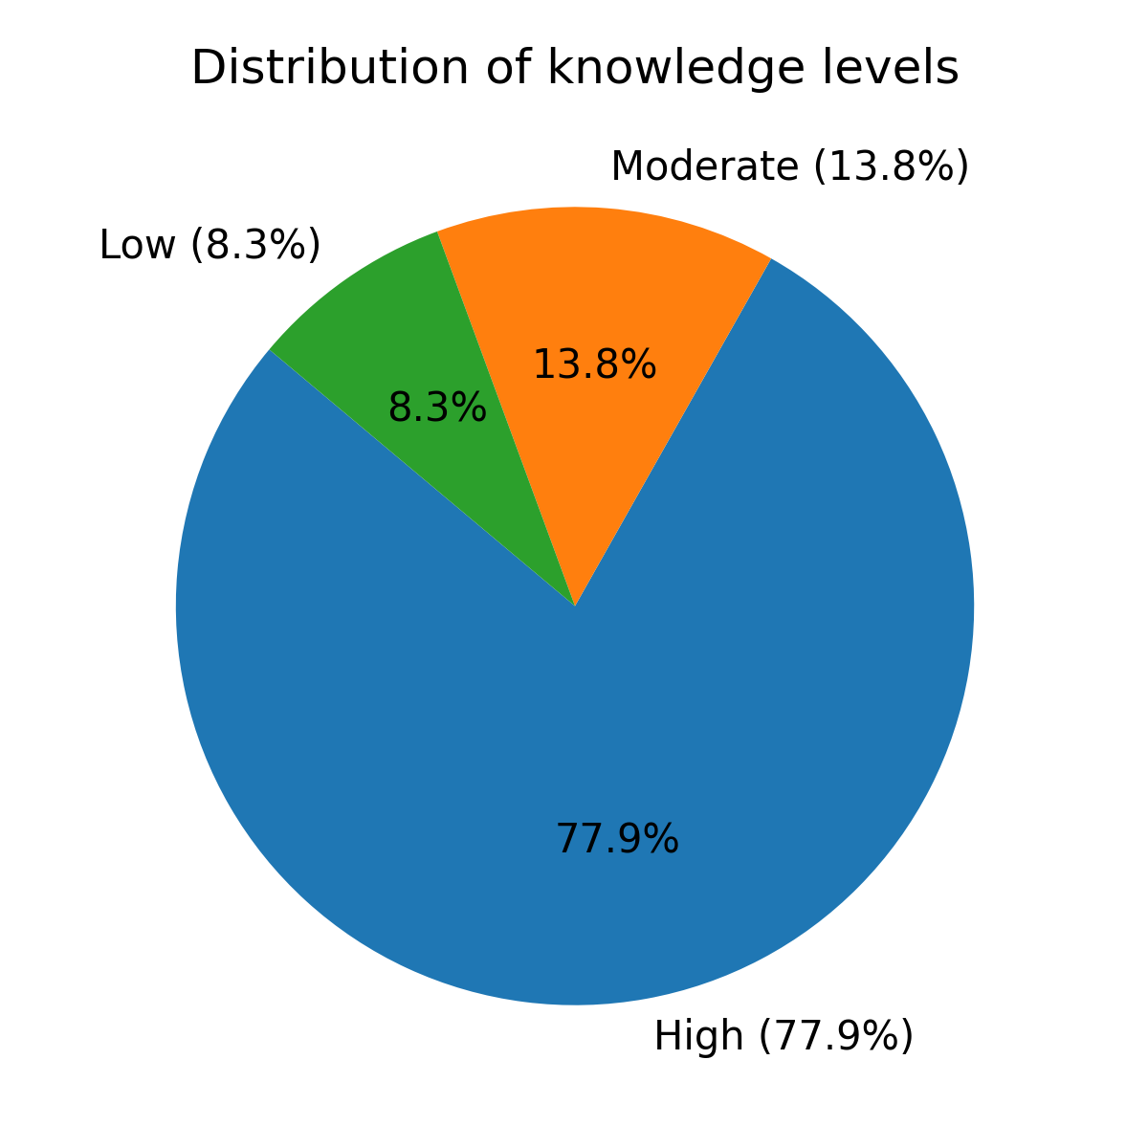
Figure 1. Shows that most of (77.9%) the respondent had high knowledge level about chronic migraine.

Associations between knowledge level and demographic variables
Pearson χ² tests assessed associations between knowledge categories and demographic variables (Table 4). Significant associations were observed for age, nationality, grade, years of experience and participation in migraine‑related courses. Physicians aged ≥45 years and consultants had the highest proportions of high knowledge. Non‑Saudi physicians were more likely to have low or moderate knowledge than Saudis (high‑knowledge proportion 42 % vs. 83 %, p<0.001). Those who had not attended a migraine‑related course were less likely to achieve high knowledge (p≈0.007). Gender was not significantly associated with knowledge level (p≈0.27).
Variable | Category | Low n (%) | Moderate n (%) | High n (%) | p-value
Gender | 1- Male | 7 (7.5%) | 16 (17.2%) | 70 (75.3%)
 | 2- Female | 5 (9.6%) | 4 (7.7%) | 43 (82.7%)
 |  |  |  |  | 0.273
Age | 1- 23-35 | 3 (3.4%) | 12 (13.5%) | 74 (83.1%)
 | 2- 36-45 | 8 (18.2%) | 8 (18.2%) | 28 (63.6%)
 | 3- ≥45 | 1 (8.3%) | 0 (0.0%) | 11 (91.7%)
 |  |  |  |  | 0.019
Nationality | 1- Saudi | 7 (5.6%) | 14 (11.1%) | 105 (83.3%)
 | 2- Non- Saudi | 5 (26.3%) | 6 (31.6%) | 8 (42.1%)
 |  |  |  |  | 0.000
Grade | 2- Resident | 3 (3.5%) | 12 (14.0%) | 71 (82.6%)
 | 3- Specialist/ Registrar | 7 (19.4%) | 6 (16.7%) | 23 (63.9%)
 | 4- Consultant | 1 (6.2%) | 0 (0.0%) | 15 (93.8%)
 | Others | 1 (14.3%) | 2 (28.6%) | 4 (57.1%)
 |  |  |  |  | 0.032
Years of experience | 1- less than or 5 years | 2 (2.3%) | 12 (13.6%) | 74 (84.1%)
 | 2- 6-10 years | 6 (17.1%) | 5 (14.3%) | 24 (68.6%)
 | 3- 11-15 years | 3 (27.3%) | 3 (27.3%) | 5 (45.5%)
 | 4- more than 15 years | 1 (9.1%) | 0 (0.0%) | 10 (90.9%)
 |  |  |  |  | 0.008
Participation in migraine-related course in last 5 years | 1- yes | 10 (8.5%) | 11 (9.4%) | 96 (82.1%)
 | 2- no | 2 (7.1%) | 9 (32.1%) | 17 (60.7%)
 |  |  |  |  | 0.007

TABLE 4. The table represents associations between knowledge level and demographic variables

Attitudes toward diagnosing and managing chronic migraine
Attitudes were assessed by two Likert-type items without scoring. Figure 2 visualizes confidence in diagnosing chronic migraine. About 65 % of respondents felt very confident in diagnosing chronic migraine, while the remainder were somewhat or not confident. For management, roughly 53.8 % were somewhat confident, 43.4 % were very confident and only 2.8 % were not confident. Table 5 presents the full distribution of responses.
TABLE 5. The table shows the attitudes toward diagnosing and managing chronic migraine
Attitude item | Response | n (%)
Diagnosing chronic migraine | Very confident | 94 (64.8%)
 | Somewhat confident | 51 (35.2%)
Managing chronic migraine | Somewhat confident | 78 (53.8%)
 | Very confident | 63 (43.4%)
 | Not confident | 4 (2.8%)
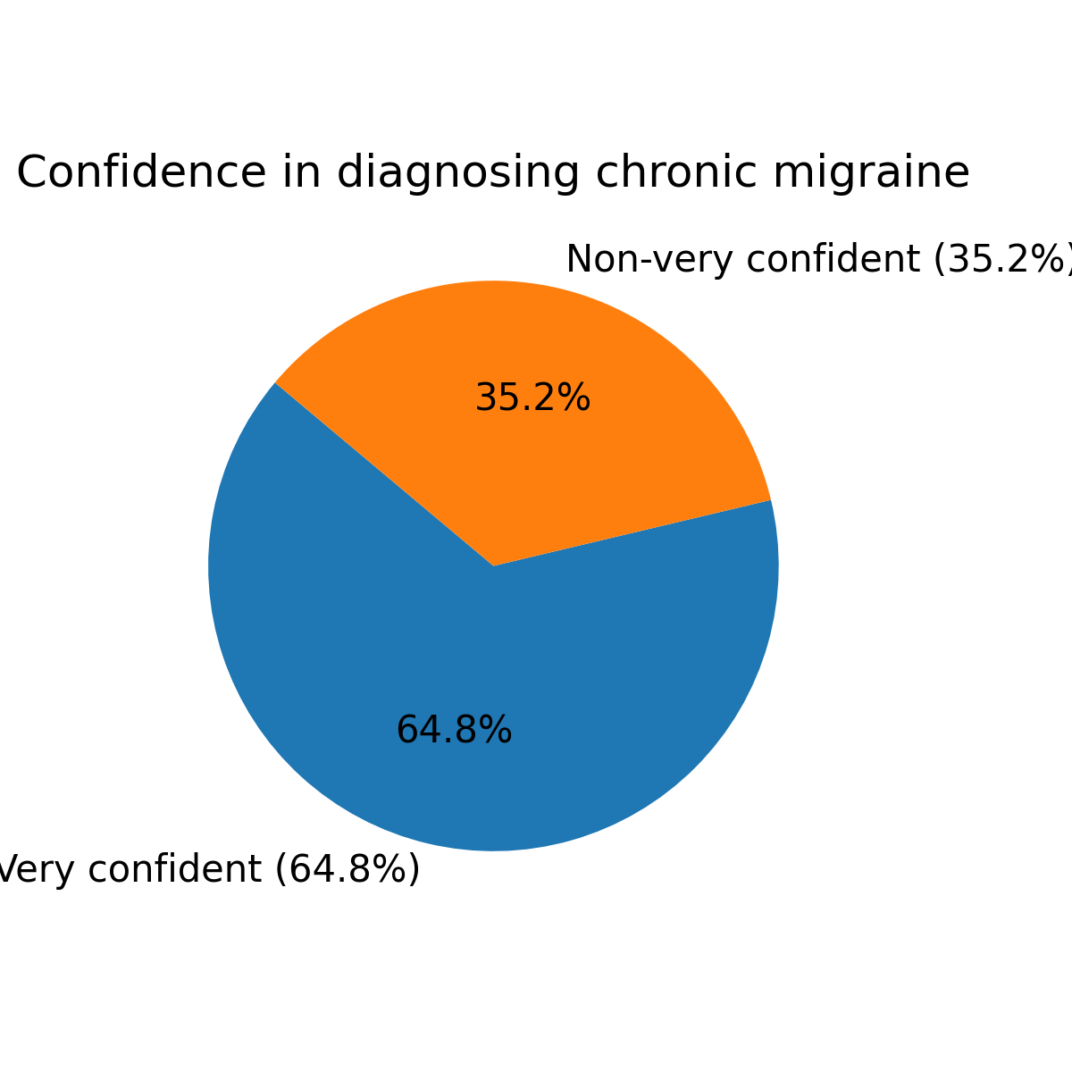
Figure 2. Shows that about two thirds (64.8%) of the respondent showed high confidence in their diagnosing skills of chronic migraine.

Discussion
The present study aimed to assess awareness of chronic migraine (CM) diagnosis and management among primary care physicians (PCPs) at PSMMC, Riyadh, and to explore factors associated with higher knowledge. Overall knowledge was high for most participants, internal consistency of the 20-item knowledge scale was strong, and confidence for diagnosing was greater than confidence for long-term management. These findings are encouraging when contrasted with prior work in Saudi Arabia and elsewhere, yet they also reveal targeted gaps particularly around attack duration, trigger recognition, non-pharmacological therapy, and follow-up intervals that are highly actionable within primary care.
Our sample demonstrated a high knowledge profile (≈78% “high” knowledge; KR-20 ≈0.84). This performance compares favorably with the 2019 Jeddah study of Ministry of Health PCPs, where the median knowledge score was 13/20 and only ~46% scored above the median, with frequent errors on diagnostic thresholds and preventive options [22]. Similarly, a regional survey from Turkey reported very low correct classification of migraine using standard criteria: only ~10% of PCPs knew the necessary diagnostic elements, illustrating an international pattern of underrecognition in frontline care [24]. Our higher scores likely reflect the PSMMC context (a large tertiary system with ready access to neurology), and the significant association we observed between prior course attendance and better knowledge supports the value of targeted education—consistent with large primary-care surveys that identify education needs and limited familiarity with newer therapeutics [34].
Item-level gaps warrant close attention. Many respondents missed the correct attack duration range. Guideline frameworks (ICHD-3, adopted in NICE CG150) define migraine attacks as typically 4–72 hours in adults and detail chronic migraine as ≥15 monthly headache days with ≥8 having migraine features [25]. Underrecognition of duration criteria risks both under-diagnosis and delayed initiation of preventive care. Likewise, some physicians under-identified common triggers. While triggers are not causative, stress is consistently among the most frequently reported precipitants in observational and review literature, and environmental factors (e.g., weather changes, bright light) are often implicated [32]. Improving history-taking with structured headache diaries as recommended by NICE can sharpen diagnostic precision and personalize counseling on modifiable triggers [25].
Non-pharmacological therapies were another area of uncertainty. Contemporary guidelines emphasize multimodal care, including education, sleep and lifestyle regularity, and behavioral interventions (e.g., cognitive-behavioral therapy, relaxation/biofeedback) as adjuncts to, not replacements for, pharmacotherapy [31]. The evidence base for psychological therapies suggests benefit for some outcomes but is heterogeneous and, in Cochrane assessments, often low-to-very-low certainty—underscoring the need for judicious, individualized use alongside guideline-directed drugs [33]. The pattern we observed good familiarity with drug options but hesitation around non-pharmacological tools mirrors gaps reported in international primary-care surveys [34].
In contrast, acute management knowledge in our cohort aligned well with evidence-based recommendations. The American Headache Society’s evidence assessment supports triptans (alone or with NSAIDs) as first-line acute therapy in adults, with antiemetics as needed and avoidance of routine opioids [26]. NICE likewise recommends combination therapy with an oral triptan plus an NSAID or paracetamol for most adults [25]. We also note appropriate caution regarding medication-overuse headache (MOH): NICE specifies overuse thresholds ≥10 days/month for triptans, opioids, ergot or combination analgesics; ≥15 days/month for simple analgesics which primary care can monitor by diary and brief follow-up [25].
Preventive therapy knowledge appeared strong overall but can still be refined. Foundational guidance (AAN/AHS 2012) establishes several effective options (e.g., topiramate, certain β-blockers), and stresses allowing 2–3 months at a therapeutic dose before judging efficacy—convergent with current practice summaries used in primary care [27,36]. Our participants’ uncertainty about the optimal follow-up interval likely reflects the reality that reassessment timelines depend on the agent chosen and on patient goals, adverse effects, and comorbidities; nonetheless, scheduling a structured review by ~8–12 weeks is a defensible default for most preventives. For CM specifically, knowledge of onabotulinumtoxin A was pertinent: phase-3 PREEMPT trials demonstrated efficacy in reducing headache days and improving quality-of-life measures in CM [28]. Awareness of reproductive safety also matters; for example, valproate should not be used for migraine prevention in pregnancy and is contraindicated for prevention in pregnant women due to teratogenicity, per FDA safety communications [30]. These points harmonize with 2021 AHS consensus guidance on integrating newer options (e.g., CGRP-targeting therapies) into individualized care plans [31] and with the 2025 Saudi expert consensus, which contextualizes global evidence to local practice and emphasizes rational sequencing and safety counseling [35].
Observed associations in our data are also consistent with the literature. Higher knowledge among older and more experienced clinicians—and among those with prior migraine-focused education—parallels findings from Jeddah (where ≤5 years’ experience predicted poorer knowledge) and from multi-country primary-care surveys highlighting the need for practical guidance in CM [22,34]. Nationality-related differences in knowledge in our setting should be interpreted cautiously, but they plausibly reflect heterogeneous pre-service training and variable exposure to local guidelines. Orientation that explicitly references regionally endorsed guidance (e.g., Saudi 2025) may help standardize practice across a diverse workforce [35].
Attitudes in our cohort showed high diagnostic confidence but more modest confidence in long-term management—again echoing international surveys in which PCPs report barriers to staying current with rapidly evolving preventive options and mixed comfort with newer agents [34]. Pragmatic steps include structured initial visits with red-flag screening and ICHD-3–based diagnosis; a headache diary and education about MOH; first-line acute therapy with triptan±NSAID; early identification of candidates for prevention; and planned reassessment after 2–3 months to titrate, switch, or refer as appropriate [25–27, 36].
This study has limitations. Its cross-sectional design precludes causal inference; single-center sampling at a tertiary system may overestimate knowledge relative to community clinics; and self-administered questionnaires capture knowledge and self-perceived confidence rather than observed practice. Despite these constraints, the high internal reliability of the knowledge scale and the clear, guideline-concordant targets for improvement support the validity and practical utility of our findings.

Conclusion:
PSMMC PCPs showed strong overall knowledge of CM, with identifiable, fixable gaps in diagnostic thresholds, trigger counseling, non-pharmacological adjuncts, and follow-up planning. Focused micro-learning and periodic refresher training, aligned with current AHS, AAN, NICE, and Saudi guidance, should further enhance primary-care delivery for patients with CM in Riyadh.

References

- Stovner LJ, Hagen K, Jensen R, Katsarava Z, Lipton RB, Scher AI, et al. The global burden of headache: A documentation of headache prevalence and disability worldwide. Cephalalgia [Internet]. 2007 [cited 2023 Nov 2];27(3):193–210. Available from: https://pubmed.ncbi.nlm.nih.gov/17381554/
- Headache Classification Committee of the International Headache Society (IHS). The International Classification of Headache Disorders, 3rd edition (beta version). Cephalalgia [Internet]. 2013 [cited 2023 Nov 2];33(9):629–808. Available from: https://pubmed.ncbi.nlm.nih.gov/23771276/
- GBD 2016 Headache Collaborators. Global, regional, and national burden of migraine and tension-type headache, 1990-2016: a systematic analysis for the Global Burden of Disease Study 2016. Lancet Neurol. 2018 Nov;17(11):954-976. doi: 10.1016/S1474-4422(18)30322-3. Erratum in: Lancet Neurol. 2021 Dec;20(12):e7. PMID: 30353868; PMCID: PMC6191530.
- De Diego EV, Lanteri-Minet M. Recognition and management of migraine in primary care: Influence of functional impact measured by the Headache Impact Test (HIT). Cephalalgia [Internet]. 2005 [cited 2023 Nov 2];25(3):184–90. Available from: https://pubmed.ncbi.nlm.nih.gov/15689193/
- Finley CR, Chan DS, Garrison S, Korownyk C, Kolber MR, Campbell S, et al. What are the most common conditions in primary care? Systematic review. Can Fam Physician [Internet]. 2018 [cited 2023 Nov 2];64(11). Available from: https://pubmed.ncbi.nlm.nih.gov/30429181/
- Migraine prevalence, disease burden, and the need for preventive therapy
- R. B. Lipton, M. E. Bigal, M. Diamond, F. Freitag, M. L. Reed, W. F. Stewart Neurology Jan 2007, 68 (5) 343-349; DOI: 10.1212/01.wnl.0000252808.97649.21
https://n.neurology.org/content/68/5/343.long
- Dr Jane T. Osterhaus,Donna L. Gutterman,John R. Plachetka (1992). Healthcare Resource and Lost Labour Costs of Migraine Headache in the US. PharmacoEconomics, 2(1), 67–76. doi:10.2165/00019053-199202010-00008
- Stang PE, Osterhaus JT, Celentano DD, et al. Migraine: problems of healthcare. Neurology 1994; 44 Suppl. 4: S47-55
- Amoozegar, F., Khan, Z., Oviedo-Ovando, M., Sauriol, S., & Rochdi, D. (2022). The Burden of Illness of Migraine in Canada: New Insights on Humanistic and Economic Cost. Canadian Journal of Neurological Sciences, 49(2), 249-262. doi:10.1017/cjn.2021.75
- GBD 2016 Disease and Injury Incidence and Prevalence Collaborators. Global, regional, and national incidence, prevalence, and years lived with disability for 328 diseases and injuries for 195 countries, 1990-2016: a systematic analysis for the Global Burden of Disease Study 2016. Lancet. 2017 Sep 16;390(10100):1211-1259. doi: 10.1016/S0140-6736(17)32154-2. Erratum in: Lancet. 2017 Oct 28;390(10106):e38. PMID: 28919117; PMCID: PMC5605509.
- Alkahtani RF, Alrumaih SS, Algezlan SS, Almutairi RR, Alturki BA, Alanazi RM, Alateeq FA. The Impact of Migraine Disease on Work Productivity and Quality of Life Among the Adults in Riyadh, Saudi Arabia. Cureus. 2022 Aug 6;14(8):e27733. doi: 10.7759/cureus.27733. PMID: 36106210; PMCID: PMC9444076.
- Alghamdi AA, Aloufi AO. The burden of migraine among the geriatric population in Taif City, Saudi Arabia [Internet]. Longdom Publishing S.L; 2022 [cited 2023 Nov 4]. Available from: https://www.jrmds.in/articles/the-burden-of-migraine-among-the-geriatric-population-in-taif-city-saudi-arabia-92728.html
- Nih.gov. [cited 2023 Nov 2]. Available from: https://www.ncbi.nlm.nih.gov/pmc/articles/PMC7006418/
- Albalawi MF, Alanazi WL, Albalawi HS, Alghannami SS, Albalawi AF. Prevalence of Migraine Headache in Saudi Arabia: A Systematic Review and Meta-Analysis. Cureus. 2023 Apr 14;15(4):e37560. doi: 10.7759/cureus.37560. PMID: 37193445; PMCID: PMC10183147
- Nih.gov. [cited 2023 Nov 2]. Available from: https://www.ncbi.nlm.nih.gov/pmc/articles/PMC7380749/
- Alkhudhairi OS, Alghthy AM, Hindi WSM, Alqassemi SIQ. Assessment of knowledge and attitude and practice towards migraine prevention and treatment among general population in Saudi Arabia. Egypt J Hosp Med [Internet]. 2018 [cited 2023 Nov 2];73(4):6531–4. Available from: https://ejhm.journals.ekb.eg/article_15401.html
- Prevalence and impact of primary headache on quality of life in the general population of Arar, Northern Saudi Arabia. Abukanna AMA, Alenezi NAA, Alenezi AAT, Alenezi MAT. http://discoveryjournals.org/medicalscience/current_issue/v25/n115/A35.htm Med Sci. 2021;25:2431–2439.
- Minen MT, Loder E, Tishler L, Silbersweig D. Migraine diagnosis and treatment: A knowledge and needs assessment among primary care providers. Cephalalgia [Internet]. 2016 [cited 2023 Nov 2];36(4):358–70. Available from: https://pubmed.ncbi.nlm.nih.gov/26122646/
- Gultekin M, Balci E, Ismailogullari S, Yetkin F, Baydemir R, Erdogan F, et al. Awareness of migraine among primary care physicians in turkey: A regional study. Noro Psikiyatr Ars [Internet]. 2016 [cited 2023 Nov 2];55(4). Available from: https://pubmed.ncbi.nlm.nih.gov/30622393/
- Fathy M, ElSadek A, Farag S, Helmy S, AbdElMoneim A. Dilemma of migraine diagnosis and management among non-neurologists. Egypt J Neurol Psychiatr Neurosurg [Internet]. 2021;57(1). Available from: http://dx.doi.org/10.1186/s41983-021-00371-8. Nih.gov. [cited 2023 Nov 2]. Available from: https://www.ncbi.nlm.nih.gov/pmc/articles/PMC10143091/
- Aljunaid, M. A., Jamal, H. H., Mubarak, A. A., & Bardisi, W. (2020). Levels and determinants of knowledge about chronic migraine diagnosis and management among primary health-care physicians in ministry of health, Jeddah 2019. Journal of Family Medicine and Primary Care, 9(5), 2324–2331. https://europepmc.org/articles/PMC7380749/ (Europe PMC)
- Minen, M. T., Loder, E., Tishler, L., & Silbersweig, D. (2016). Migraine diagnosis and treatment: A knowledge and needs assessment among primary care providers. Cephalalgia, 36(4), 358–370. https://journals.sagepub.com/doi/pdf/10.1177/0333102415593086 (SAGE Journals)
- Gültekin, M., Balcı, E., İsmailoğulları, S., et al. (2018). Awareness of migraine among primary care physicians in Turkey: A regional study. Noro Psikiyatr Ars, 55(4), 354–357. https://www.noropsikiyatriarsivi.com/sayilar/c55s4/en/npa_v55n4_354-357.pdf (Noropsikiyatri Arşivi)
- National Institute for Health and Care Excellence (NICE). (2025). Headaches in over 12s: diagnosis and management (CG150). https://www.nice.org.uk/guidance/cg150/resources/headaches-in-over-12s-diagnosis-and-management-pdf-35109624582853 (NICE)
- Marmura, M. J., Silberstein, S. D., & Schwedt, T. J. (2015). The acute treatment of migraine in adults: The American Headache Society evidence assessment of migraine pharmacotherapies. Headache, 55(1), 3–20. https://pubmed.ncbi.nlm.nih.gov/25600718/ (Medscape Reference)
- Silberstein, S. D., Holland, S., Freitag, F., et al. (2012). Evidence-based guideline update: Pharmacologic treatment for episodic migraine prevention in adults. Neurology, 78(17), 1337–1345. https://www.neurology.org/doi/pdfdirect/10.1212/WNL.0b013e3182535d20 (American Academy of Neurology)
- Diener, H.-C., Dodick, D. W., Aurora, S. K., et al. (2010). OnabotulinumtoxinA for treatment of chronic migraine: PREEMPT 2. Cephalalgia, 30(7), 804–814. https://pubmed.ncbi.nlm.nih.gov/20647190/ (SAGE Journals)
- Ailani, J., Burch, R. C., & Robbins, M. S. (2021). The American Headache Society consensus statement: Update on integrating new migraine treatments into clinical practice. Headache, 61(7), 1021–1039. https://headachejournal.onlinelibrary.wiley.com/doi/10.1111/head.14153 (SpringerLink)
- U.S. Food and Drug Administration. (2013). Valproate anti-seizure products contraindicated for migraine prevention in pregnancy. https://www.fda.gov/drugs/drug-safety-and-availability/fda-drug-safety-communication-valproate-anti-seizure-products-contraindicated-pregnancy-prevention (U.S. Food and Drug Administration)
- American Headache Society. Clinical practice resources and guidelines (2021 update). https://americanheadachesociety.org/resources/clinicians/guidelines (American Headache Society)
- Peroutka, S. J. (2014). What turns on a migraine? A systematic review of migraine precipitating factors. Current Pain and Headache Reports, 18(10), 454. https://link.springer.com/article/10.1007/s11916-014-0454-z (Academia)
- Probyn, K., et al. (2019). Psychological therapies for the prevention of migraine in adults. Cochrane Database of Systematic Reviews. https://www.cochranelibrary.com/cdsr/doi/10.1002/14651858.CD012295.pub2/full (UCL Discovery)
- Minen, M. T., et al. (2023). Migraine care practices in primary care: Results from a national US survey. Family Practice, 41(3), 277–282. https://academic.oup.com/fampra/article/41/3/277/7177377 (Oxford Academic)
- Alshareef, A. A., et al. (2025). Saudi clinical practice guidelines for the treatment and prevention of migraine in adults. Neurosciences (Riyadh), 30(2), 77–96. https://nsj.org.sa/content/30/2/77 (NSJ)
- GuidelineCentral. (2025). Prevention of episodic migraine: Pharmacologic treatment—AAN summary. https://www.guidelinecentral.com/guideline/4294243/ (Guideline Central)

