Case Report

ENDODONTIC MANAGEMENT OF RADIX ENTOMOLARIS: A CASE REPORT

.
ABSTRACT

The mandibular first molar typically exhibits two roots and three canals, but anatomical variations, such as the presence of an additional distolingual root known as Radix Entomolaris (RE) which can complicate endodontic treatment. This case report describes the diagnosis and endodontic management of a mandibular first molar with RE in a 24-year-old female patient who presented with symptomatic apical periodontitis. Careful clinical and radiographic examination, including angled radiographs, facilitated the identification of the additional root. A modified access cavity was prepared, and all canals were located, shaped using rotary file system, and obturated successfully. The presence of RE demands precise diagnosis, modification of access design, and meticulous instrumentation to ensure complete debridement and avoid iatrogenic damage

Keywords: Anatomical variations, Endodontic treatment, Mandibular first molars, Radix entomolaris

1. INTRODUCTION
The root canal system exhibits a highly intricate and variable anatomy that poses considerable challenges to successful endodontic treatment. Far from being a simple, single canal in each root, the pulp space can contain multiple canals, accessory canals, lateral canals, isthmuses, fins, loops, and apical deltas, all of which complicate debridement, disinfection, and obturation. These anatomic complexities are influenced by a variety of factors including tooth type, age, ethnicity, and developmental anomalies. It is well documented that mandibular molars frequently exhibit multiple anatomical differences in the number of roots and root canals. This poses as an endodontic dilemma for the clinician with respect to diagnosis and subsequent treatment¹.
Permanent mandibular first molars usually have 2 roots placed mesially and distally and 3 root canals, but variations in the number of roots and in canal morphology are not uncommon. The presence of a third root in the permanent first molar is the major variant in this group. Carabelli was the first one to mention the presence of an additional root in mandibular first molar and called it as radix entomolaris (RE).²This supernumerary root is located distolingually mainly in first molars. When the extra root is present on the mesiobuccal side, it is called as radix paramolaris. This article highlights the clinical approach for the endodontic management of mandibular first molar with radix entomolaris.

2. PRESENTATION OF CASE

A 24-year-old female patient reported to the Department of Conservative Dentistry and Endodontics, Government Dental College, Kottayam, with chief complaint of pain in the left lower back tooth region. She gave a history of intermittent pain for the past one month, which had increased in intensity over the last four days. Clinical examination revealed deep occlusal caries in relation to left mandibular first molar and the tooth was tender on percussion. Thermal and electrical pulp testing elicited a negative response. The diagnostic radiograph showed caries extending to the pulp with widening of the periodontal ligament space, and an angled radiograph taken from the mesial aspect revealed an additional root located distolingual to the mesial root . A diagnosis of Pulpal necrosis with apical periodontitis in relation to left mandibular first molar was made.

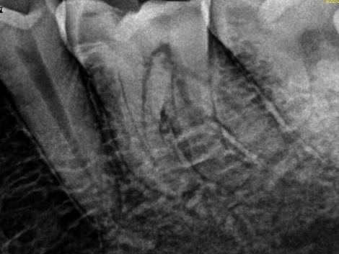
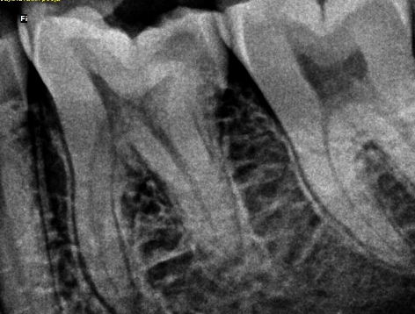

Fig 1. Diagnostic Radiograph

TREATMENT PLAN

Non-surgical endodontic treatment of 36

TREATMENT PROCEDURE

The tooth was anesthetized and isolated using rubber dam. The access cavity was prepared using an endo access bur. Two mesial and two distal canal orifices were located using a DG-16 explorer and 10 # K-file was used to establish patency of the canals. The fourth distolingual canal orifice was negotiated more lingually, away from the rest of the three orifices. The working length was determined using an apex locator and was reconfirmed radiographically. Cleaning and shaping was carried out using the GenEndo rotary file system (Coltene). During instrumentation, 5.25% sodium hypochlorite was used as an irrigant and 17% EDTA followed by sodium hypochlorite was used as final rinse. Single cone Obturation was done using corresponding gutta-percha points. Restoration of access cavity was done with composite resin and a post-obturation radiograph was taken.

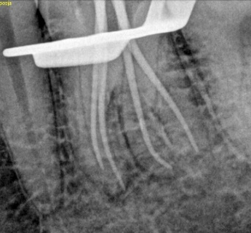
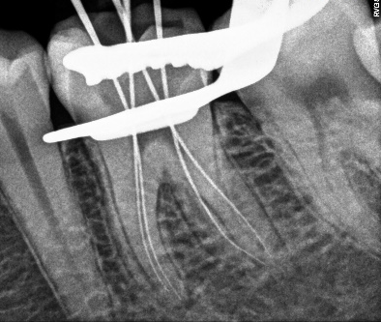

Fig 3. Master Cone X- Ray
Fig 2. Working Length Determination

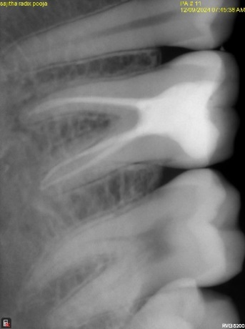
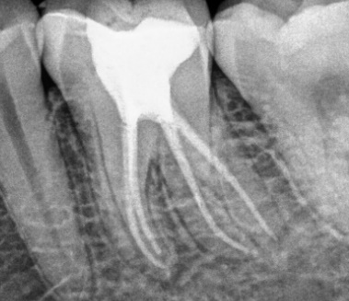

Fig 4. Post Operative Radiograph

3. discussion

The presence of Radix Entomolaris (RE), an additional distolongual root, in the mandibular first molar is known to be associated with specific ethnic groups. In the Indian population, the prevalence of RE is reported to be less than 5%, ³ whereas in Mongoloid population, its occurrence ranges from 5% to more than 30%.⁴ RE can be found in the first, second and third mandibular molars, though it is least commonly observed in the second molar. Several studies have also documented a bilateral occurrence of the RE in approximately 50 to 67% of cases.⁵
RE is typically located distolingually and may be completely or partially fused with the distal root in its coronal third. The morphology of the RE can vary significantly, ranging from a short, conical extension to a fully developed root with normal length and a distinct root canal system. In most cases, the pulpal extension of the RE is visible on radiographic examination. Generally, the RE is smaller in dimension compared to the distobuccal and mesial roots and may exist as a separate structure or exhibit partial fusion with the adjacent roots.⁶
Classification given by Carlsen and Alexanderson describe four types according to the location of the cervical part of the RE.⁷
Type A – Distally located cervical part with two normal distal root components.
Type B – Same as type A but only one normal distal component.
Type C – Mesially located cervical part.
Type AC – Central location between mesial and distal root components
De Moor et al classified RE-based on the curvature in buccolingual orientation into three types.⁸
Type I – Refers to a straight root/root canal.
Type II – Refers to an initially curved entrance which continues as a straight root/root canal.
Type III – Refers to an initial curve in the coronal third of the root canal and a second
buccally oriented curve starting from middle to apical third
The presence of a Radix Entomolaris holds significant clinical relevance in endodontic treatment. Proper identification of these supernumerary roots is crucial to avoid missed canals, which can lead to treatment failure. Since the RE commonly lies in the same buccolingual plane as the distobuccal root, it may be radiographically superimposed, making detection challenging. Therefore, thorough evaluation of preoperative radiographs is essential. To enhance detection, a second radiograph taken at a mesial or distal angulation of approximately 30 degrees is recommended, as it can greatly improve diagnostic accuracy. In the present case diagnostic radiograph showed the contour of an extra root, and a mesial shift radiograph confirmed the presence of an additional root. Beyond radiographic assessment, clinical examination, including evaluation of the crown morphology and probing of the cervical area can also assist in identifying extra roots. Clues such as an accessory cusp, a prominent distal or distolingual lobe, or a cervical convexity may indicate the presence of an additional root. Early recognition of RE prior to initiating endodontic therapy allows the clinician to locate and manage the extra canal effectively.⁶
Concerning the access cavity preparation in the presence of a RE, it is mandatory for the clinician to extend the typical trapezoidal access cavity disto-lingually to more rectangular outline form. The orifice of the RE is located disto- to mesio-lingually from the main root canal/canals in the distal root.⁹ In the present case, the fourth distolingual canal orifice was negotiated more lingually, away from the rest of the three orifices.
The Radix Entomolaris presents a significant challenge from a shaping perspective due to its thin and curved morphology. This anatomical complexity necessitates a careful and precise shaping procedures to avoid iatrogenic complications, such as canal stripping, internal or external transportation, ledge formation, and apical foramen distortion

4. Conclusion

The presence of a radix entomolaris (RE), an additional distolingual root in mandibular molars, presents a significant anatomical variation that poses challenges in endodontic diagnosis and treatment. Successful treatment requires a thorough understanding of root canal anatomy, careful interpretation of radiographs, and appropriate modification of access cavity design. Early identification and proper management of this additional root are critical to avoid missed canals and ensure long-term endodontic success

Consent (where ever applicable)

Written informed consent was obtained from the patient for publication of this case report and accompanying images.

Ethical approval (where ever applicable)

All authors hereby declare that all experiments have been performed in accordance with the ethical standards laid down in the 1964 Declaration of Helsinki.

COMPETING INTERESTS DISCLAIMER:
Authors have declared that they have no known competing financial interests OR non-financial interests OR personal relationships that could have appeared to influence the work reported in this paper.

References

1. Presence-and-clinical-significance-of-radix-entomolaris-and-radix-paramolaris.pdf [Internet]. [cited 2025 May 20]. Available from: https://balkandentaljournal.com/wp-content/uploads/2016/02/Presence-and-clinical-significance-of-radix-entomolaris-and-radix-paramolaris.pdf
2. Calberson FL, De Moor RJ, Deroose CA. The radix entomolaris and paramolaris: clinical approach in endodontics. J Endod. 2007 Jan;33(1):58–63.
3. TRATMAN EK. Three rooted lower molars in man and their racial distribution. Br Dent J. 1938;64:264–74.
4. Walker RT, Quackenbush LE. Three-rooted lower first permanent molars in Hong Kong Chinese. Br Dent J. 1985 Nov 9;159(9):298–9.
5. Steelman R. Incidence of an accessory distal root on mandibular first permanent molars in Hispanic children. ASDC J Dent Child. 1986;53(2):122–3.
6. Calberson FL, De Moor RJ, Deroose CA. The radix entomolaris and paramolaris: clinical approach in endodontics. J Endod. 2007 Jan;33(1):58–63.
7. Carlsen O, Alexandersen V. Radix paramolaris in permanent mandibular molars: identification and morphology. Scand J Dent Res. 1991 Jun;99(3):189–95.
8. De Moor RJG, Deroose C a. JG, Calberson FLG. The radix entomolaris in mandibular first molars: an endodontic challenge. Int Endod J. 2004 Nov;37(11):789–99.
9 . Agarwal M, Trivedi H, Mathur M, Goel D, Mittal S. The radix entomolaris and radix paramolaris: an endodontic challenge. J Contemp Dent Pract. 2014 Jul 1;15(4):496–9.

