Case report
A CASE REPORT ON FOCAL CEMENTO-OSSEOUS DYSPLASIA

Abstract:
Focal cemento-osseous dysplasia (FCOD) is a benign fibro-osseous lesion of the jaw. Most commonly seen in middle-aged women and mandibular first molar is most frequently affected site. Majority of lesions are asymptomatic and incidentally found on radiograph. Rarely, it is symptomatic causing discomfort to patient. We repot a rare symptomatic case of focal cemento-osseous dysplasia in 24-year-old female patient.
Keywords: Focal cemento-osseous dysplasia, fibro-osseous lesion, mandible, CBCT.

1. Introduction
Focal cemento-osseous dysplasia (FCOD) is a benign, non-neoplastic fibro-osseous lesion that involves replacement of normal bone with fibrous connective tissue and mineralized material resembling bone and cementum. It is considered as a localized variant of cemento-osseous dysplasia, distinguished from its periapical and florid counterparts by its solitary presentation.^{[1,2]} FCOD most commonly affects middle-aged women, with a predilection for those of African or Asian descent, although it may occur across all demographic groups.^{[3,6]} Clinically, the lesion is typically asymptomatic and is often detected incidentally during routine radiographic examinations. However, in rare cases, mild expansion, localized pain, or association with secondary infection may be noted.^{[4]}
Radiographically, FCOD evolves through three overlapping stages: an initial radiolucent phase, a mixed radiolucent–radiopaque stage, and a mature radiopaque stage surrounded by a narrow radiolucent rim.^{[7]} Accurate diagnosis requires careful correlation of clinical, radiographic, and histopathological findings to avoid unnecessary surgical intervention, as these lesions are self-limiting and typically requires no treatment unless symptomatic.^{[8]} The present case report describes a rare symptomatic presentation of FCOD.

2. Case Report
A 24-year-old female patient reported to department of Oral Medicine with a chief complaint of swelling in her lower right back region of jaw since one year. Initially the swelling was small and painless, gradually swelling increased in size and became painful since one month. On extraoral examination, diffuse swelling was seen on right side of face without gross facial asymmetry [Fig. 1 (A & B)]. On palpation, the swelling was firm to hard, afebrile and tender. Lymph nodes were not palpable.
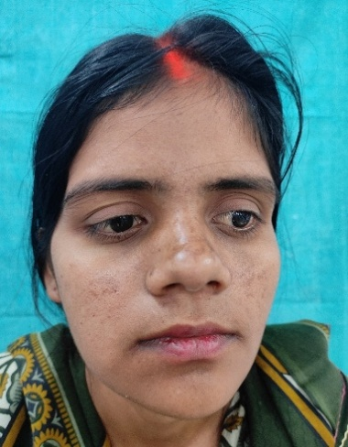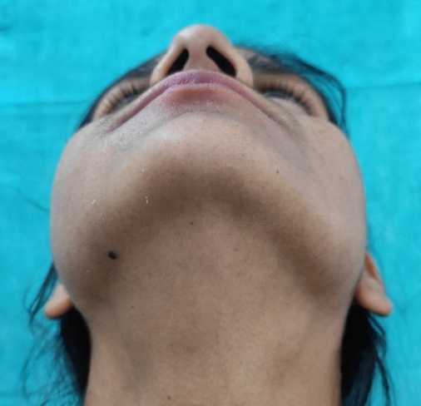
(A) (B)
Fig. 1 (A & B) Extraoral photographs showing diffuse swelling on the right side of face.

An intraoral examination revealed a well-defined swelling extending from the mesial aspect of 45 to mesial aspect of 47 with obliteration of buccal vestibule. On palpation the swelling was bony hard and tender [Fig. 2 (A), (B)]. Based on history and clinical examination, provisional diagnosis of benign odontogenic tumor of right body of mandible was given. While, ossifying fibroma, focal cemento-osseous dysplasia and fibrous dysplasia were given as clinical differential diagnosis.
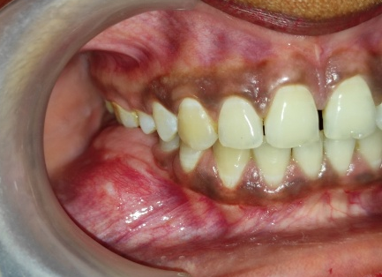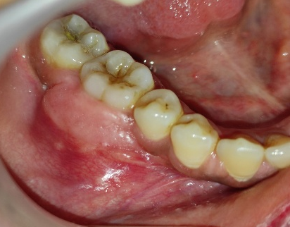
(A) (B)
Fig. 2 Intraoral photographs showing vestibular obliteration in relation to teeth 45–47.

For radiological evaluation, CBCT was done. Curved planar reconstruction showed well-defined, mixed radiolucent-radiopaque lesion with irregular sclerotic borders extending from distal aspect of 45 to mesial aspect of 47. Axial section showed expansion of buccal and lingual cortical plates with loss of cortication. Root anatomy of 46 was not appreciable due to radiopaque lesion in sagittal section. Coronal section showed mixed lesion[Fig. 3 (A), (B), (C), (D), (E)]. Based on this features, cemento-ossifying fibroma was given as radiographic diagnosis. Focal cemento-osseous dysplasia was considered as radiographic differential diagnosis.
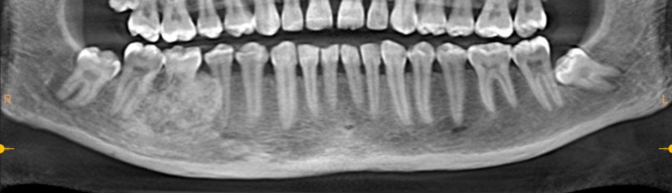
(A)
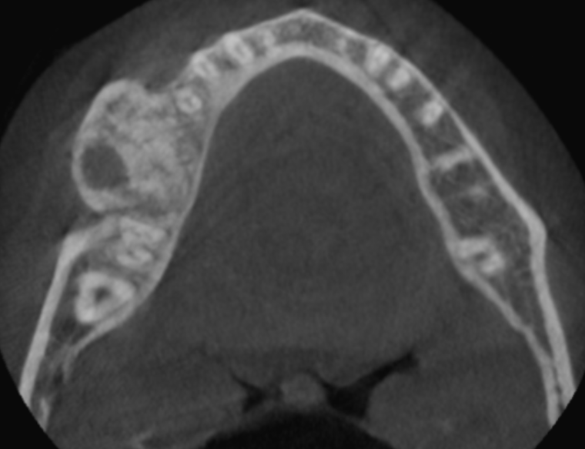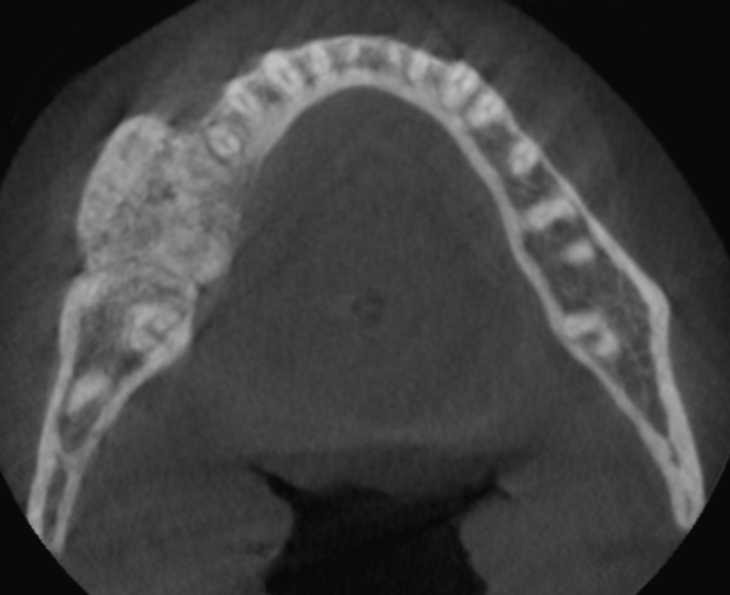
(B) (C)
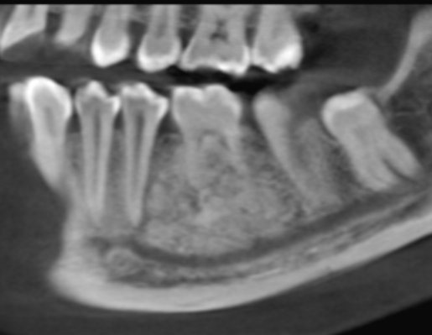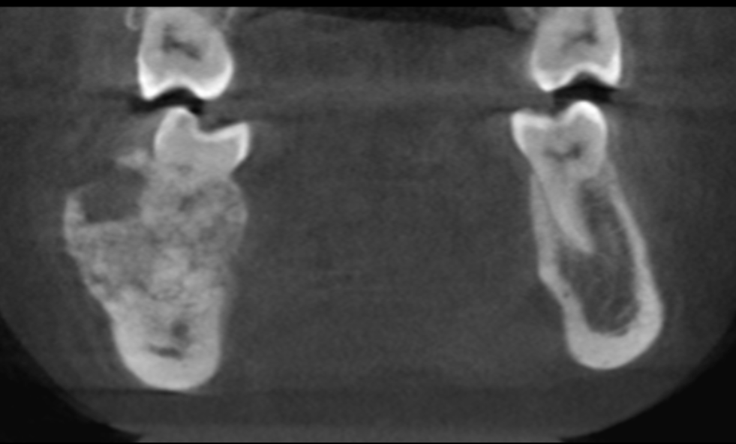
(D) (E)

Fig. 3 CBCT (A) Curved planar reconstruction showing mixed lesion. (B and C) Axial section showing mixed lesion, expansion of buccal and lingual cortical plates with loss of cortication. (D) Sagittal section showing obliteration of roots of 46. (E) Coronal section showing mixed lesion.
Incisional biopsy was done; decalcified H & E-stained section showed osseous trabeculae with fibro-cellular connective tissue stroma. Interconnecting trabeculae contained cemento-osseous material with varying degree of mineralization. Focally basophilic globular calcified masses were seen suggestive of cementum-like material. Connective tissue stroma contained plump spindle shaped fibroblasts, collagen fibers and numerous vascular spaces [Fig. 4]. Based on histopathological findings, focal cemento-osseous dysplasia was given as final diagnosis. Surgical excision of the lesion along with extraction of the involved tooth was performed [Fig. 5]. Postoperative recovery was uneventful, with satisfactory healing at follow-up visits.
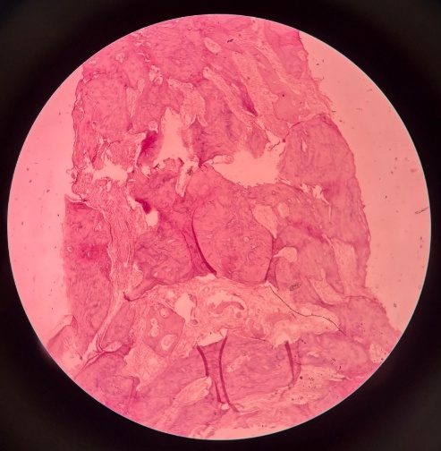
Fig. 4 Decalcified H&E-stained section showing cementum-like calcifications and osseous trabeculae within fibrocellular stroma
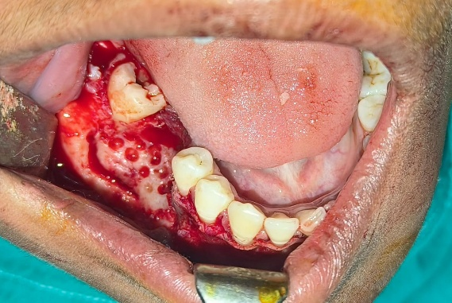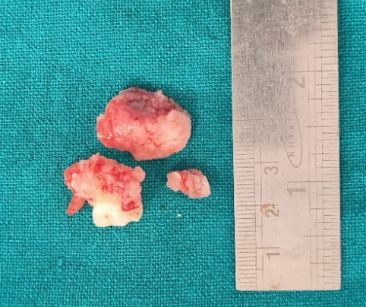
Fig. 5 Intraoperative photograph showing surgical excision of the lesion

3. Discussion
Cemento-osseous dysplasia is the commonest fibro-osseous lesion of tooth bearing areas of jaw, characterized by replacement of normal bone with fibrous tissue and deposition of cementum like mineralized material.^{[2]} It contains three subgroups namely periapical, focal and florid cemento-osseous dysplasia.^{[3]} Periapical type is commonly associated with vital mandibular anteriors while focal type shows single site involvement and commonly seen in mandibular molars.^{[4]} Although the exact etiology remains unknown, the lesion is thought to originate from the periodontal ligament based on its proximity to tooth apices, histologic similarity to cementum, and predilection for tooth-bearing areas.^{[1,3]} Some investigators consider it a reactive or dysplastic process rather than a true neoplasm, possibly triggered by local factors such as mild trauma, inflammation, or abnormal bone remodeling.^{[3,5]} Epidemiologically, FCOD is most often seen in the third to fifth decades of life, with a strong female predilection.^{[3,6]} In our case, right mandibular molar region was involved.
Clinically, FCOD is usually asymptomatic and detected incidentally during routine radiographic examinations or evaluation of unrelated dental problems.^{[3,6]} When symptoms occur, they are typically secondary to complications such as infection or abscess formation - often following extraction, endodontic intervention, or surgical biopsy through the hypo-vascular lesion.^{[5,6]} Teeth associated with FCOD remain vital in the vast majority of cases, making pulp vitality testing a critical diagnostic step.^{[1,6]} In this case, the lesion was painful and symptomatic with bony expansion, which is a rare finding in FCOD.
Radiographically, FCOD progresses through three well-recognized stages ^{[1,3,6]}
- Early (osteolytic) stage: Presents as a well-defined radiolucency near the tooth apex, mimicking a periapical granuloma or cyst. The lamina dura may be intact or lost.
- Mixed stage: Shows both radiolucent and radiopaque components as calcified masses begin to form within the fibrous tissue.
- Mature (osteosclerotic) stage: Appears as a dense radiopaque mass with a thin peripheral radiolucent rim.
Histologically, FCOD demonstrates a fibrocellular connective tissue matrix containing trabeculae and rounded masses of mineralized tissue resembling both bone and cementum.^{[1,3]} Early lesions are vascular and hemorrhagic, while mature lesions are dense, avascular, and brittle.^{[3,5]} The mainstay of FCOD management is conservative.^{[3,5,6]} Asymptomatic lesions with classic radiographic features should be monitored radiographically at intervals of 6–12 months.^{[3]} Surgical intervention is contraindicated unless secondary infection or other complications arise, due to the hypo-vascular nature of the sclerotic bone in mature stages, which predisposes it to poor healing and osteomyelitis.^{[5,7]} In our case, surgical excision was performed as the lesion was painful and symptomatic.

4. Conclusion
FCOD is a benign, non-neoplastic fibro-osseous lesion with distinctive radiologic and histologic features. Accurate diagnosis is essential to avoid unnecessary aggressive surgery. Conservative management with follow-up is effective in most cases, while surgical intervention is indicated for symptomatic or expanding lesions.
Consent
As per international standards or university standards, patient(s) written consent has been collected and preserved by the author(s).

Ethical Approval: Not applicable

References:
- White SC, pharoah MJ. Oral radiology: principles and interpretation. 8th ed. St. Louis, MO: mosby; 2019.
- Sivapathasundharam B, Rajendran R. Cysts of orofacial region. Shafer’s Textbook of Oral Pathology E-book. 9th Edition: Elsevier Health Sciences: 2020
- Ravikumar SS, Vasupradha G, Menaka TR, Sankar SP. Focal cemento-osseous dysplasia. J Oral Maxillofac Pathol. 2020 Feb;24(Suppl 1):S19-S22. doi: 10.4103/jomfp.JOMFP_209_19. Epub 2020 Feb 28. PMID: 32189898; PMCID: PMC7069129.
- Bulut EU, Acikgoz A, Ozan B, Zengin AZ, Gunhan O. Expansive focal cemento-osseous dysplasia. J Contemp Dent Pract. 2012 Jan 1;13(1):115-8. doi: 10.5005/jp-journals-10024-1105. PMID: 22430704.
- Mahajan, Anushi; Grover, Sonal1. A rare case report of focal cement osseous dysplasia associated with recurrent periodontal abscess. CHRISMED Journal of Health and Research 8(3):p 212-215, Jul–Sep 2021. | DOI: 10.4103/cjhr.cjhr_148_20
- Salvi AS, Patankar S, Desai K, Wankhedkar D. Focal cemento-osseous dysplasia: A case report with a review of literature. J Oral Maxillofac Pathol. 2020 Feb;24(Suppl 1):S15-S18. doi: 10.4103/jomfp.JOMFP_349_19. Epub 2020 Feb 28. PMID: 32189897; PMCID: PMC7069140.
- Seifi S, Ghorbani H, Khakbaz O, Bijani F. Focal Cemento Osseous Dysplasia: A Case Report. J Dent (Shiraz). 2022 Jun;23(2):151-154. doi: 10.30476/DENTJODS.2022.88067.1309. PMID: 35783499; PMCID: PMC9206700.
- Decani S, Quatrale M, Costa D, Moneghini L, Varoni EM. Florid cemento-osseous dysplasia: A case report and review of literature. Heliyon. 2024 Jun 27;10(14):e33746. doi: 10.1016/j.heliyon.2024.e33746. PMID: 39114015; PMCID: PMC11305240.

