Case report
Viral Vesicles of the Palate: A Case of Paediatric Herpangina with literature review

Abstract
Herpangina is a common viral illness in children, most often caused by Coxsackievirus and other enteroviruses, and is characterized by fever and vesicular or ulcerative lesions in the posterior oral cavity. We report a case of herpangina in a 6-year-old boy who presented with acute onset of fever, sore throat, and painful oral ulcers on the soft palate and tonsillar pillars. The diagnosis was made clinically, and supportive management with antipyretics, hydration, and dietary modification led to full recovery within a week. This case highlights the importance of clinical recognition and symptomatic care in preventing complications.

Keywords:
Introduction
Herpangina is a common pediatric viral infection caused by enteroviruses, predominantly affecting children under six years of age [1]. It presents as an acute, self-limiting illness characterized by high fever, malaise, and the appearance of small vesicular or ulcerative lesions on the soft palate, uvula, tonsillar pillars, and posterior pharyngeal wall [2]. Among the causative agents, Coxsackievirus A subtypes (CV-A2, CV-A4, CV-A6, CV-A10) are most frequently implicated, along with Enterovirus A71, Echoviruses, and Coxsackievirus B variants [3,4]. The infection demonstrates seasonal variation, with peak incidence during summer and early autumn [5], and is most commonly observed in children aged one to five years [6]. Transmission occurs primarily via the fecal–oral route, but respiratory droplets and contact with contaminated surfaces also play a significant role [7]. Family clustering is frequent, and a slight male predominance has been reported, with an approximate male-to-female ratio of 1.5:1 [8]. Herpangina typically begins with a sudden onset of high-grade fever, often reaching up to 40°C, followed by sore throat, oral discomfort, excessive salivation, and refusal to eat [1,9]. On examination, multiple small vesicular or ulcerative lesions, usually 1–5 mm in size, are observed on the posterior oral cavity, including the soft palate, uvula, and tonsillar pillars, occasionally extending to the buccal mucosa [10]. Despite its acute presentation, the illness is usually self-limiting, with symptoms resolving within 4–6 days and lesions healing without scarring within a week [11]. In this report, we present the case of a 7-year-old male diagnosed with herpangina, managed conservatively with topical and supportive medications, resulting in complete healing of the lesions within two weeks.

Case report
A 7-year-old male patient, reported to the Department of Oral Medicine and Radiology with a chief complaint of pain and burning sensation in the upper jaw region for the past four days. The pain was continuous in nature and aggravated on intake of hot and spicy foods. The patient had a history of fever and throat pain one week prior, for which he consulted a general physician and was prescribed paracetamol. The fever subsided, but throat discomfort persisted. The child’s past medical history was non-contributory. His past dental history revealed pulpectomy with stainless steel crown placement one month earlier and an extraction one year ago.
On general examination, the patient was conscious, alert, and well oriented with no extraoral abnormalities. Intraoral examination revealed multiple coalescing ulcerations covered with pseudomembranous slough in the left palatal region, measuring approximately 3 × 2 cm, along with a single ulcer measuring 0.5 × 0.5 cm in the left buccal mucosa. [ Figure 1] The lesions were tender on palpation. Hard tissue examination showed dental caries in relation to 54, 55, 51, 61, and 83; stainless steel crowns on 65 and 74; and missing teeth 64 and 75. Based on the clinical features, a provisional diagnosis of herpangina was made, with differentials including herpes simplex infection and lichenoid reaction.
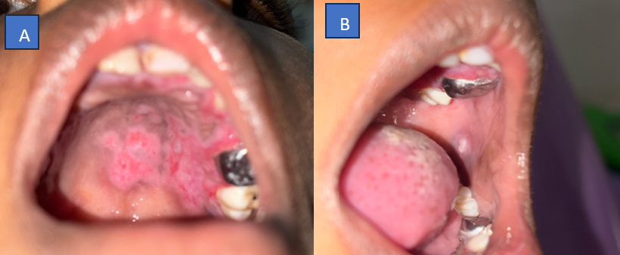
Figure 1 A: Multiple coalescing ulcerations in the left palate region B: Ulcer in the left buccal mucosa
The patient was prescribed chlorhexidine 0.12% mouthwash twice daily, mucopain gel prior to meals, topical acyclovir ointment once daily at night, and paracetamol syrup (Paracip 125) to be taken only if fever recurred. On review after three days, there was a mild reduction in symptoms with persistence of erythema in the palate. The stainless-steel crown on 65 was removed, and syrup erythromycin was added for three days. [figure 2]
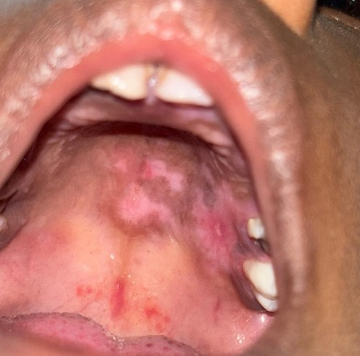
Figure 2 Healing of ulcers in the left palate region
At the subsequent follow-up after 1 week, the patient reported symptomatic relief with reduction of palatal and buccal mucosal lesions, and continuation of the previous regimen was advised. After 4 weeks, the patient was asymptomatic with satisfactory healing [figure 3]

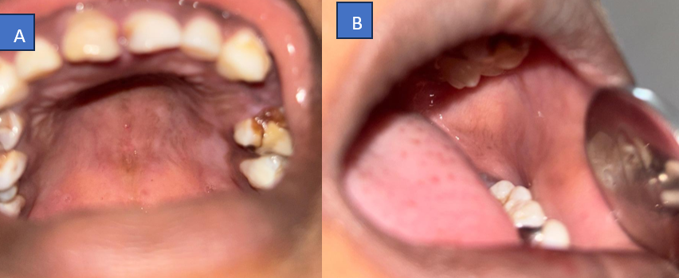
Figure 3 Completely healed site in the left palate and left buccal mucosa region
Discussion
Diagnostic Approaches
Clinical Diagnosis
Diagnosis is primarily clinical, based on the characteristic triad of fever, sore throat, and posterior oropharyngeal vesicles, along with knowledge of seasonal outbreaks [1,12].
Laboratory Diagnosis
Although rarely required, laboratory confirmation is useful in atypical or outbreak scenarios. Real-time RT-PCR remains the gold standard for detecting enteroviral RNA due to its high sensitivity and specificity [13]. Virus isolation through cell culture and VP1 gene sequencing may aid in viral subtyping and epidemiological studies, though these are less commonly performed [14]. Throat or nasopharyngeal swabs collected within five days of symptom onset improve detection rates significantly [13].
Differential Diagnosis
Herpangina must be differentiated from other pediatric oral lesions. Primary herpetic gingivostomatitis presents with anterior oral lesions caused by herpes simplex virus [15]. Hand, Foot, and Mouth Disease (HFMD) shares similar oral findings but includes vesicular lesions on the hands and feet [16]. Aphthous stomatitis presents with recurrent ulcers unrelated to fever, while bacterial pharyngitis requires throat culture or rapid antigen testing for confirmation [17,18].
Treatment and Management
There is currently no specific antiviral therapy for herpangina, and treatment remains primarily supportive, focusing on symptom relief and prevention of complications [1,19]. Antipyretics such as paracetamol are commonly used to control fever and discomfort, while topical oral anesthetics may be applied before meals to reduce pain and improve feeding. Adequate hydration and a soft diet are essential to prevent dehydration and minimize oral trauma. Recent studies have evaluated adjunctive interventions, including hyaluronic acid sprays, which promote mucosal healing [20], interferon α-2b oral sprays, shown to shorten symptom duration [21], and vitamin C supplementation to enhance immune recovery [22]. Family counseling is an integral component, emphasizing proper hygiene, avoidance of contact with infected individuals, and close monitoring for complications.

Complications and Prognosis
Herpangina generally follows a benign and self-limiting course, with spontaneous resolution within 4–6 days and complete recovery within a week [1]. However, in rare cases, serious complications may arise. High fevers can lead to febrile seizures in susceptible children [23], and refusal of oral intake may result in dehydration [24]. Prolonged illness can predispose to secondary bacterial infections [25]. More severe outcomes are typically associated with Enterovirus A71 infections, which have been linked to encephalitis, myocarditis, and multi-organ failure [26]. Although mortality is extremely rare, cases related to EV-A71 have been reported [26].

Prevention Strategies
Preventive measures primarily focus on interrupting transmission and maintaining hygiene. Frequent handwashing with soap and water, covering the mouth and nose when coughing or sneezing, and disinfecting frequently touched objects are strongly recommended [27]. Caregivers should ensure proper food handling, utensil hygiene, and limit close contact with infected individuals. In community and institutional settings, such as schools and daycare centers, outbreak control involves isolating affected children, strengthening surveillance, and enhancing environmental disinfection [28]. Currently, there is no specific vaccine for herpangina; however, vaccines targeting Enterovirus A71 are available in some regions to prevent severe complications, and development of multivalent vaccines against other Coxsackievirus strains is ongoing [29].

Recent Research and Developments
Recent studies reveal significant epidemiological shifts, with non-EV-A71 enteroviruses, particularly CV-A2, CV-A4, CV-A6, and CV-A10, now accounting for more than 75% of cases in many regions [30]. Advancements in diagnostic technologies, such as multiplex RT-PCR and point-of-care rapid diagnostic assays, have improved early detection and outbreak monitoring [31]. Additionally, promising therapeutic research is underway, investigating novel antiviral compounds, immunomodulatory agents, and the development of broad-spectrum multivalent vaccines targeting multiple enterovirus strains, aiming to reduce disease burden and prevent severe outcomes [32].

Conclusion
Herpangina is a self-limiting viral infection commonly seen in children and often presents with painful ulcerations that can mimic other oral ulcerative conditions, making accurate diagnosis crucial. In this case, a 7-year-old male presented with painful palatal and buccal ulcerations along with a recent history of fever. A clinical diagnosis of herpangina was made, and the patient was managed conservatively with topical medications, analgesics, and proper oral hygiene instructions. Regular follow-up visits showed progressive healing, and the lesions resolved completely within two weeks without any complications. This case highlights the importance of early recognition, appropriate differential diagnosis, and timely supportive management to ensure favorable outcomes in pediatric patients presenting with multiple oral ulcerations.

References
- Yu H, Li X, Liu Q, et al. Diagnosis and treatment of herpangina: Chinese expert consensus. World J Pediatr. 2020;16(2):129–134.
- Prathiwi CDR, Bramanti I. Management of herpangina: a viral infection in infants. Majalah Kedokteran Gigi Indonesia. 2023;9(2):87-91.
- Lee MH, Huang LM, Wong WW, et al. Molecular diagnosis and clinical presentations of enteroviral infections in Taipei during the 2008 epidemic. J Microbiol Immunol Infect. 2011;44(3):178-183.
- Li W, Gao H, Zhang Q, et al. Large outbreak of herpangina in children caused by enterovirus in Hangzhou, China. Sci Rep. 2016;6:35388.
- Hosoya M. Enterovirus infection in children. Jpn J Infect Prev Control. 2017;32(6):344–350.
- Chansaenroj J, Auphimai C, Puenpa J, et al. High prevalence of Coxsackievirus A2 in children with herpangina. Virusdisease. 2017;28(1):111-114.
- Chen C. Clinical and epidemiological features of herpangina. Chin J Epidemiol. 2016;37(4):515-518.
- Li W, Li C, Liu L, et al. Molecular epidemiology of enterovirus from children with herpangina. Arch Virol. 2019;164(10):2565-2571.
- Sun Y, Zhou J, Nie W, et al. Epidemiological characteristics of enterovirus among pediatric patients. J Med Virol. 2024;96(2):e29412.
- Liu J, Chen Y, Hu P, et al. Caregivers as potential infection sources in herpangina outbreaks. Arch Public Health. 2021;79(1):1-8.
- Kang H, Yoon J, Lee J, et al. Co-circulation of enterovirus A and B in Korea, 2012-2019. J Pediatric Infect Dis Soc. 2021;10(4):398-406.
- Vallet S, Gagneur A, Legrand MC, et al. Enteroviral infection mimicking primary herpetic stomatitis. Eur J Pediatr. 2005;164(5):289-291.
- Hong C. Pediatric oral medicine. In: Pediatric Dentistry. Wiley; 2023.
- Brzeziński P. Herpangina and erythema multiforme in a three-year-old boy. Przegl Lek. 2013;70(11):953-954.
- Zhang M, Zou Y, Cui Y, et al. Molecular epidemiology of herpangina. Arch Virol. 2024;169(12):1-10.
- Yarush LI, Steele RW. Diagnosis and prospective treatment of enteroviral infections. Clin Pediatr. 2000;39(4):201-211.
- Clinical features of gingivostomatitis due to primary herpes simplex virus infection in children. BMC Infect Dis. 2020;20(1):1-9.
- Barankin B. Hand, foot, and mouth disease: a narrative review. Recent Adv Inflamm Allergy Drug Discov. 2022;16(2):77-95.
- Standard treatment guidelines for herpangina. Medical Guidelines. 2023;15(3):45-52.
- Femilian A, Pramono AA. Hyaluronic acid spray in pediatric oral lesions. Imunity. 2024;1(1):31-36.
- Ye YZ, Dou YL, Hao JH, et al. Efficacy and safety of interferon α-2b spray for herpangina in children. Int J Infect Dis. 2021;107:62-68.
- Liu J, Hu P, Chen X, et al. Nutritional support and vitamin supplementation in pediatric viral infections. Arch Public Health. 2022;80(1):1-6.
- Wu Y. Pathogens and clinical analysis of herpangina during outbreaks. Chin J Contemp Pediatr. 2013;15(5):361-364.
- Onofrei BA, Concita CA, Toader MP. Oral manifestations in common pediatric infections. Rom J Oral Rehabil. 2023;15(2):45-52.
- Botvineva VV, Namazova-Baranova LS, et al. Diagnosis and management of enteroviral infections in children. Pediatr Pharmacol. 2012;9(3):69-74.
- Hsiao KN, Wang YF, Lin CW, et al. Severe EV-A71 pathogenesis in human nucleolin transgenic mice. Med Microbiol Immunol. 2025;214(1):1-15.
- Wanlapakorn N. Coxsackievirus A6 infection and prevention strategies. Pathogens. 2024;13(4):98.
- Chen Y, Sun W, Gu L, et al. Intervention strategies during enterovirus outbreaks. Front Public Health. 2025;13:1559637.
- Jiang M, Zhang R, Rao L, et al. Epidemiological characteristics of enterovirus infection before and after EV-A71 vaccine introduction. Emerg Microbes Infect. 2021;10(1):619-628.
- Zhang H, Cheng J, Li Y, et al. Enterovirus genotype distribution. J Clin Virol. 2020;131:104582.
- Jia X, Yin L, Cheng Y, et al. Multiplex one-step RT-PCR diagnostics. J Virol Methods. 2024;329:114983.
- Lin YW, Kung YA, Shih SR. Antivirals and vaccines for Enterovirus A71. J Biomed Sci. 2019;26(1):1-15.

