Case report
Prosthodontic Rehabilitation With Digitally Designed Mandibular Telescopic Denture Using DMLS Technology– A Case Report

ABSTRACT
This case demonstrates successful prosthodontic rehabilitation combining conventional and digital techniques. A 70-year-old male patient presented with a completely edentulous maxillary arch and partially edentulous mandibular arch retaining teeth. Previous conventional dentures were discontinued due to poor fit and esthetics. A hybrid prosthodontic approach was selected: conventional maxillary complete denture and digitally designed mandibular telescopic denture using DMLS technology. Following endodontic treatment and tooth preparation, primary cobalt-chromium copings were cemented. The mandibular framework was digitally designed using Exocad software and fabricated via DMLS technology with ceramic-layered secondary copings. Telescopic dentures offer superior retention and stability compared to conventional removable partial dentures through precision-fit primary and secondary crowns that distribute occlusal forces uniformly. DMLS technology provides high-strength, biocompatible frameworks with excellent fit and minimal material waste while eliminating casting errors. Digital workflows improve accuracy, reduce clinical time, and enable prosthesis archiving for future duplication. The telescopic mechanism preserves periodontal proprioception, reduces residual ridge resorption, and provides secondary splinting of abutment teeth. This approach is particularly valuable when implant therapy is not feasible due to patient factors or economic considerations. The patient showed excellent functional outcomes with improved chewing ability, speech, and esthetics at follow-up appointments. DMLS-fabricated telescopic dentures provide predictable clinical results with superior mechanical properties and enhanced patient satisfaction. This treatment modality represents a viable alternative to implant-supported prostheses for complex edentulous cases, offering improved quality of life while being more economically accessible.
Keywords: fixed partial dentures, prosthesis, telescopic dentures, maxilla
INTRODUCTION
Partial edentulism can be managed with options like removable partial dentures (RPDs), fixed partial dentures (FPDs), and tooth- or implant-supported overdentures ^{[1,2]}. Dental implants can be expensive and often require additional procedures like bone grafting, especially with inadequate bone volume ^{[3]}. Poor oral hygiene or insufficient remaining teeth may also limit the success of implants or fixed prostheses. In such cases, removable prostheses, particularly telescopic dentures, offer a practical alternative and allowing easier maintenance and long-term reliability ^{[4]}.
Telescopic denture is a prosthesis which consists of a primary coping which is cemented to the abutments in a patient’s mouth and a secondary coping which is attached to the prosthesis which fits on the primary coping. Hence, it increases the retention and stability of the prosthesis. It is also called as overlay denture, overlay prosthesis and superimposed prosthesis.^{[5]}
Integrating digital workflows improves accuracy, reduces manual errors, and enables consistent, reproducible fits with fewer adjustments, reducing clinical time and appointment. Digital design also allows archiving of prosthesis data, so a duplicate denture can be remade quickly if needed, without re-impression.^{[6]} When DMLS is used for the metal infrastructure, you get high-strength, biocompatible, patient-specific frameworks (e.g. titanium or cobalt-chromium) with excellent fit and minimal material waste, and the potential for microporous or lattice structures supporting friction-fit retention.^{[7]}
This case report describes the treatment of a patient with completely edentulous upper arch and partially edentulous lower arch with periodontally compromised teeth. A telescopic prosthesis with chrome-cobalt primary copings, a chrome-cobalt framework as secondary coping for the mandible, and a conventional heat cure complete denture for the maxilla was fabricated.

CASE REPORT
A 70-year-old male patient reported to the Department of Prosthodontics with a chief complaint of missing teeth and inability to chew from the past five years. (Figure 1)
The patient presented a history of generalized deep caries and mobility of teeth, which resulted in the extraction of those teeth. An intraoral examination revealed completely edentulous maxillary arch and 33,34 and 43,44 teeth in the lower arch, according to the Fédération Dentaire Internationale (FDI) notation system. (Figure 2) He had a history of using conventional maxillary complete denture and a mandibular interim removable partial denture one year back which was discontinued to use due to improper fit and poor esthetics.
The patient was informed of the different options available for oral rehabilitation, including implant- or tooth-supported removable and fixed dentures. After considering all the factors, it was decided to go ahead with telescopic overdentures for the mandibular arch and conventional heat cure complete denture for the maxillary arch.
A diagnostic maxillomandibular relationship was recorded to assess the final vertical dimension. The remaining teeth 33,34 and 43,44 were endodontically treated as more teeth preparation was needed for placing telescopic crowns.
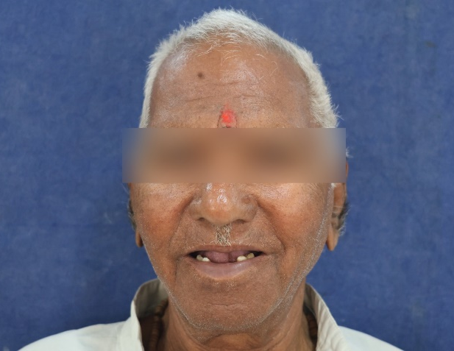

Figure 1: Preoperative extraoral view

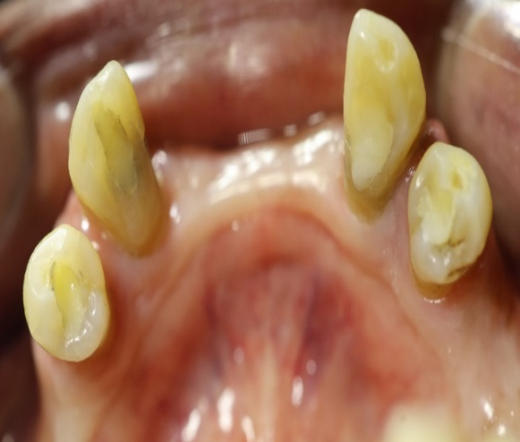
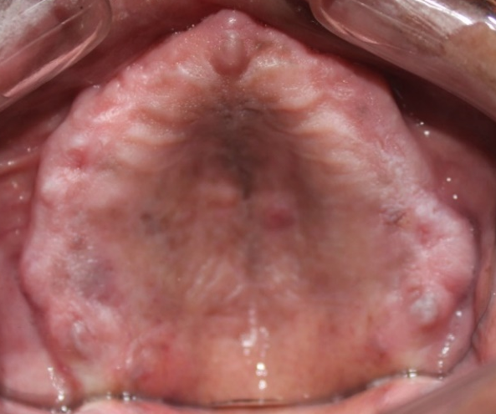

Figure 2: Preoperative intraoral view

CLINICAL STEPS
- Teeth preparation of 33,34 and 43,44 done (Figure 3) and impression of the lower arch was made with addition silicon (Hydrorise, Zhermack S.p.A., Italy)
- Primary copings were fabricated and cemented on the teeth using Resin modified glass ionomer cement (FujiCEM™, GC Corporation , Japan) (Figure 4)
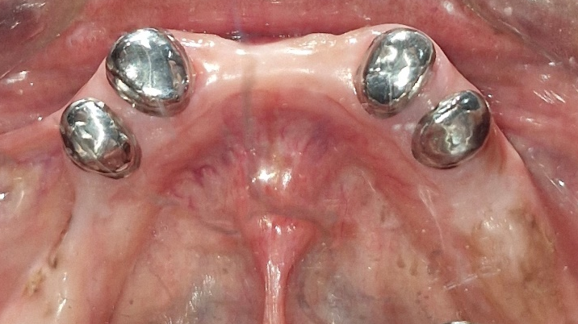
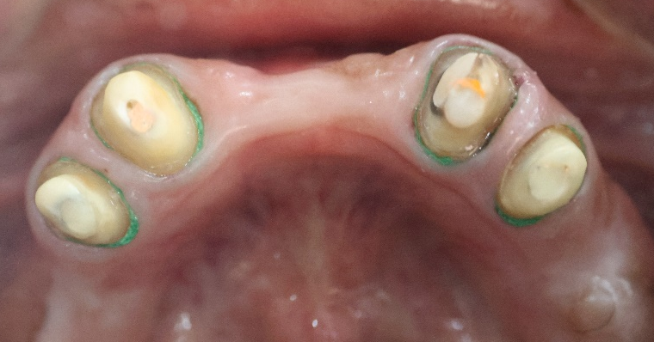
Figure 3: Teeth preparation done on 33,34 and 43,44
Figure 4: Cementation of primary copings

- Primary impression of upper arch made with impression compound (Maarc, Shiva Products,India) and lower arch is made with alginate (Impreceed, GC Corporation, Japan).
- Special trays were fabricated for both upper and lower arches and final impression made by border moulding with low fusing impression compound and wash impression with Condensation silicon light body.
- The lower master cast is scanned and the framework is designed in the exocad software (Figure 5)
- Metal framework with the telescopic crowns was fabricated by DMLS technology. And intraoral trial of metal framework done to check the fit and marginal integrity of secondary copings. (Figure 6)
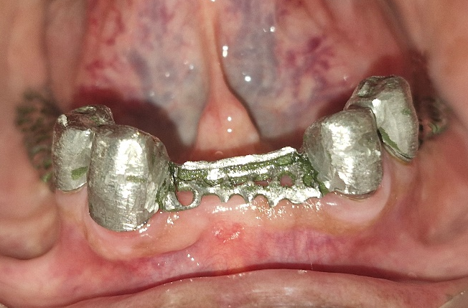
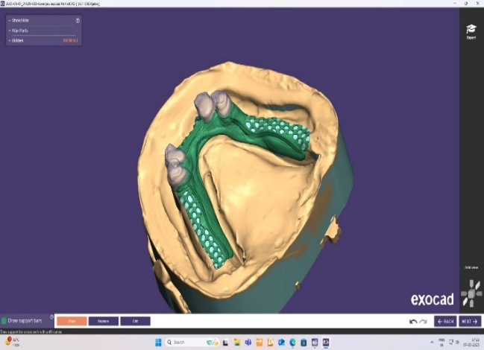
Figure 6: Metal framework trial
Figure 5: Digital design of telescopic denture
- Wax rims were made over the metal framework and jaw relation was recorded.
- After teeth setting, intraoral trial was done and the jaw relation is verified. (Figure 7)
- Ceramic layering of the secondary copings done and the dentures were processed with heat cure acrylic resin. Gingival porcelain is added to the cervical margin of the telescopic crowns to give a more natural appearance.
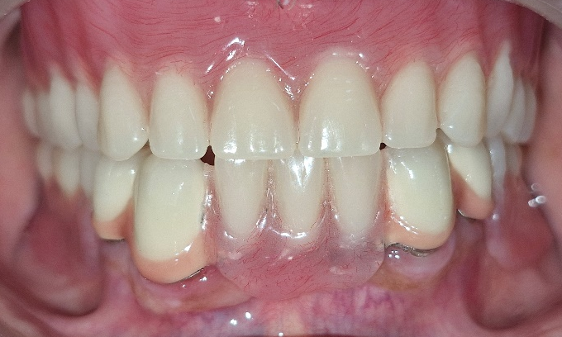
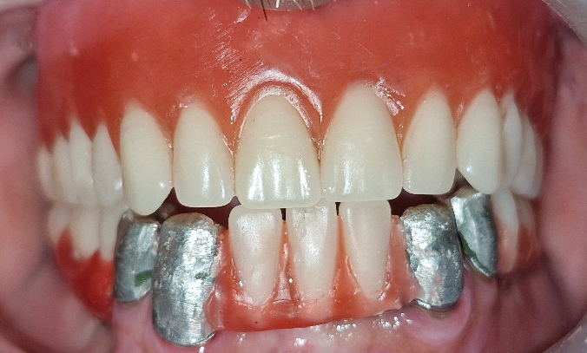
- The prosthesis was polished and placed. Occlusion was assessed. (Figure 8)
Figure 7: Trial denture assessment
Figure 8: Post operative intraoral view
Post denture insertion instructions were given. Post placement recall was done after 24 hours, 1 week and 1 month. The patient was happy with the prosthesis and was able to speak and chew well (Figure 9). The patient was instructed to attend recall visits every 6 months.

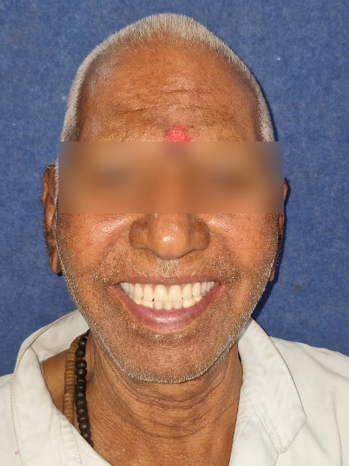

Figure 9: Post operative extraoral view

DISCUSSION
Oral health significantly impacts overall quality of life, with damage to oral structures affecting chewing, taste, and nutrition. Due to the patient’s age and cost considerations, an implant-supported prosthesis was not feasible. A telescopic denture was chosen instead, offering improved retention, stability, proprioception, and chewing efficiency compared to conventional dentures. It also minimizes tissue coverage and ensures better force distribution, helping reduce bone loss. Prosthetic rehabilitation is challenging in patients with multiple edentulous areas and compromised abutment teeth, making the prognosis for fixed prostheses uncertain. As a result, removable partial dentures (RPDs) are often used, though their success depends heavily on the retention and stability provided by the remaining oral structures ^{[8].}
According to Owall et al., 25% of RPDs are abandoned within the first year due to insufficient retention and stability. This is primarily caused by the progressive alveolar bone resorption that naturally follows tooth loss. Since such resorption is inevitable, the only reliable methods to preserve remaining bone are through the use of dental implants or retaining natural tooth roots.^{[9]}Telescopic dentures are particularly suitable when only a few teeth remain in the dental arches, especially when they are bilaterally distributed. These dentures offer enhanced retention and stability, owing to preserved proprioception, better distribution of occlusal forces, and the periodontal ligament’s ability to convert compressive forces into tensile ones. Additionally, they help reduce the rate of residual ridge resorption, thereby positively influencing bone remodeling.^{[10]}
The concept of telescopic crowns was first patented by Dr. J. Beers in 1873 ^{[11]}. Later, Langer (1980) refined the design and categorized them into three types: resilient crowns, conical crowns, and cylindrical-shaped inner crowns ^{[12]}. Among these, cylindrical crowns demonstrated superior retention. However, the increased friction between the copings led to greater wear and fabrication complexity. In contrast, conical and resilient crowns were more biocompatible with supporting tissues and exerted less stress on abutment teeth, but they offered comparatively lower retention ^{[13]}.
By employing digital design and DMLS fabrication for telescopic dentures, you leverage significant clinical and patient-centered benefits. The telescopic mechanism inherently enhances retention, stability, and support, as the precision-fit primary and secondary crowns ensure uniform distribution of occlusal forces along the long axis of abutments and provide secondary splinting action across abutments^{[14]}. The elimination of casting and manual adjustments also means more predictable mechanical properties over time. Clinically, this combined approach yields dentures that are more hygienic, aesthetically pleasing, easier to clean, splint remaining teeth to reduce bone resorption, and deliver increased chewing efficiency and proprioception feedback^{[15]}.

SUMMARY
Telescopic dentures are an excellent treatment option, especially when remaining teeth are not to be extracted. Although the approach involves higher costs and technical demands, it offers significant advantages over conventional dentures. Success depends on careful evaluation and management of abutment teeth, along with the dental technician’s precision during fabrication. These prostheses provide superior retention, stability, occlusion, and proprioceptive feedback, leading to improved chewing efficiency, speech, aesthetics, and reduced harm to gingival tissues. They also help minimize residual ridge resorption through better force distribution.

REFERENCES
- Swatantra SN, Mayya A. Telescopic Denture: A Treatment Option for Occlusal Rehabilitation in Partially Edentulous Patients. Cureus. 2023 Feb 20;15(2):e35202. doi: 10.7759/cureus.35202. PMID: 36968911; PMCID: PMC10032173.
- Ozan O, Orhan K, Aksoy S, Icen M, Bilecenoglu B, Sakul BU. The effect of removable partial dentures on alveolar bone resorption: a retrospective study with cone-beam computed tomography. J Prosthodont. 2013 Jan;22(1):42-8. doi: 10.1111/j.1532-849X.2012.00877.x. Epub 2012 Jun 1. PMID: 22672734.
- Esposito M, Grusovin MG, Felice P, Karatzopoulos G, Worthington HV, Coulthard P. The efficacy of horizontal and vertical bone augmentation procedures for dental implants - a Cochrane systematic review. Eur J Oral Implantol. 2009 Autumn;2(3):167-84. PMID: 20467628.
- Ravikumar, Prasad. S, Kashinath K.R., Naveen B.H. Telescopic com plete denture-with a custom mode stud attachment. Journal of Dental Sciences and Research. 2012; 3: 10-13.
- Shruthi CS, Poojya R, Ram S, Anupama. Telescopic Overdenture: A Case Report. Int J Biomed Sci. 2017 Mar;13(1):43-47. PMID: 28533736; PMCID: PMC5422644.
- Maiti S, Rai N, Appanna P, Jessy P. Digital Telescopic Denture- A Viable Treatment Modality of Preventive Prosthodontics: Clinical Report. Ann Dent Spec. 2022;10(4):1-4. https://doi.org/10.51847/eEgUl0vYgd
- Schweiger J, Güth JF, Erdelt KJ, Edelhoff D, Schubert O. Internal porosities, retentive force, and survival of cobalt-chromium alloy clasps fabricated by selective laser-sintering. J Prosthodont Res. 2020 Apr;64(2):210-216. doi: 10.1016/j.jpor.2019.07.006. Epub 2019 Nov 1. PMID: 31680054.
- Verma, Mahesh; Mutneja, Parul; Gupta, Rekha; Gill, Shubhra. Telescopic Overdenture for Oral Rehabilitation of Partially Edentulous Patient. Indian Journal of Dental Research 30(3):p 468-471, May–Jun 2019. | DOI: 10.4103/ijdr.IJDR_69_17
- Owall G, Bieniek KW, Spiekermann H. Removable partial denture production in western Germany. Quintessence Int. 1995; 26: 621-627.
- Alhammadi SH. Full Mouth Rehabilitation Using Telescopic Removable Prosthesis. Case Rep Dent. 2022 Oct 17;2022:9536443. doi: 10.1155/2022/9536443. PMID: 36299280; PMCID: PMC9592235.
- Improvement in artificial crowns for teeth . (1873). Accessed: February 6, 2023:
http://patents.google.com/patent/US144182A/en#citedBy
- Langer A. Telescope retainers and their clinical application. J Prosthet Dent. 1980 Nov;44(5):516-22. doi: 10.1016/0022-3913(80)90070-0. PMID: 7003109.
- Hakkoum MA, Wazir G. Telescopic Denture. Open Dent J. 2018 Mar 30;12:246-254. doi: 10.2174/1874210601812010246. PMID: 29760817; PMCID: PMC5897958.
- Klotz AL, Hagspiel S, Büsch C, Zenthöfer S, Rammelsberg P, Zenthöfer A. Mid-term survival and complications of double-crown-retained removable dental prostheses placed in the dental practice - a retrospective study. Clin Oral Investig. 2024 Dec 21;29(1):26. doi: 10.1007/s00784-024-06090-7. PMID: 39708169; PMCID: PMC11663171.
- Dusmukhamedov, Shavkat & Lee, Chu-Nui & Jeong, Seung-Mi & Choi, Byung-Ho. (2021). Digital Denture Fabrication: A Technical Note. Applied Sciences. 11. 8093. 10.3390/app11178093.

