Case report

Ischemic Stroke in a Patient with Essential Thrombocythemia (ET) at St. Francis Regional Referral Hospital, Tanzania: A Case Report

ABSTRACT

Introduction: Essential Thrombocythemia (ET) is a slow progressing myeloproliferative neoplasm characterized by persistent thrombocytosis and an increased risk of thrombotic and hemorrhagic complications including ischemic stroke, myocardial infarction, superficial thrombophlebitis, deep vein thrombosis, or pulmonary embolism. While hemorrhagic events can also occur, there is no data in Tanzania of ischemic stroke in patients with essential Thrombocythemia.
Case Presentation: An 85-year-old male presents at our facility with history of sudden onset of left-sided extremity weakness, mouth deviation, numbness on lower extremities, and severe headache for one day. The patient was diagnosed with ET three years ago to the other center, The diagnosis of ET had been confirmed by bone marrow biopsy, and JAK2 VG617F mutation, and was attending the hematology clinic, had been on treatment with hydroxyurea 500mg and low dose aspirin. Also, he reported history of hypertension which was well controlled with antihypertensive and regular follow-up. On arrival, the patient was conscious with a GCS of 11/15 and stable vital signs. Neurological examination revealed left-sided extremity weakness graded 0/5 and mouth deviation. Abdominal examination demonstrated splenomegaly measuring 18 cm below the costal margin.
A non-contrast CT scan of the brain showed a right parietal lobe ischemic infarct and senile atrophy. Laboratory investigations, the complete blood count where abnormal platelet count was 123,500/ μl, total white blood cell count within normal range and hemoglobin level of 10mg/d. He was initiated on hydroxyurea, aspirin, and started physiotherapy. His condition stabilized, and he was discharged home with follow-up plans.

Conclusion: Thrombotic events remain the most serious cause of morbidity in essential thrombocythemia, with ischemic stroke being a major concern in elderly patients. This case demonstrates that, despite cytoreductive and antiplatelet treatment, patients remain vulnerable to thrombotic events, close follow-up, individualized management, and multidisplinary care.

Keywords: Essential thrombocythemia, Myeloproliferative Neoplasm, Ischemic stroke, JAK2 617F, Cytoreductive therapy

INTRODUCTION
Essential Thrombocythemia is one of a chronic myeloproliferative neoplasm (MPNs) characterized by persistent elevation of platelet counts, resulting from abnormal proliferation of megakaryocytes in the bone marrow and excessive platelet production commonly presenting with thrombosis and hemorrhage¹.
It is a relatively rare condition, with an annual incidence of 0.2 to 2.5 new cases per 100,000 population^{1,2}. The incidence increases with age, with a median age at diagnosis of 60 up to 70 years; however, about 20% of patients are younger than 41 years with higher ratio in females comparing to males². The pathogenesis is commonly associated with driver mutations: approximately 60% of patients harbor the JAK2 V617F mutation, while CALR mutations are present in about 75% of JAK2-negative patients, accounting for roughly one-third of all cases. Mutations in the MPL gene are detected in about 4% of patients^{3–5}.
In the early stages, patients with Essential Thrombocythemia (ET) are often asymptomatic, as the disease progresses, they may develop symptoms such as headache, dizziness, visual disturbances, splenomegaly, easy bruising, bleeding, and thrombotic complications^{2,6,7}. Thrombosis may present as ischemic stroke, myocardial infarction, superficial thrombophlebitis, deep vein thrombosis, or pulmonary embolism, while hemorrhagic events can also occur^{1,6,8}. Risk factors for thrombotic complications in ET include advanced age (>60 years), prior history of thrombosis, hypertension, diabetes mellitus, and tobacco use^{9,10}.
The disease is stratified into very low-risk, low-risk, intermediate-risk, and high-risk categories¹¹. Patients with intermediate- and high-risk disease are treated with cytoreductive therapy using hydroxyurea, along with antiplatelet agents, to reduce the risk of vascular complications^{6,11,12}.
Despite appropriate treatment, some patients with Essential Thrombocythemia (ET) may still experience serious thrombotic complication¹². We report the case of an 85-year-old man with ET, maintained on long-term hydroxyurea and aspirin therapy, who presented with clinical features of ischemic stroke. This case highlights the persistent risk of thrombotic events in ET, putting emphasis on the importance of close monitoring and individualized management by underscoring the role of interdisciplinary collaboration in optimizing patient’s outcomes.

CASE PRESENTATION

An 85-year-old male presents at our facility with history of sudden onset of left-sided extremity weakness, mouth deviation, numbness on lower extremities, and severe headache for one day. There was no history of loss of consciousness, convulsions, vomiting, difficulty in breathing, fever, or head trauma. The patient was diagnosed with essential thrombocythemia three years ago to the other center, The diagnosis of essential thrombocythemia had been confirmed by bone marrow biopsy, and JAK2 VG617F mutation, and was attending the hematology clinic, had been on treatment with hydroxyurea 500mg and low dose aspirin. Also, he reported history of hypertension which was well controlled with antihypertensives and regular follow-up in cardiology clinic. On arrival, the patient was conscious with a Glasgow Coma Score (GCS) of 11/15 and stable vital signs. Neurological examination revealed left-sided extremity weakness graded 0/5 and mouth deviation with no other neurological pathological findings observed. Abdominal examination demonstrated splenomegaly measuring 18 cm below the costal margin.
Among other findings, a non-contrasted CT scan of the brain showed a right parietal lobe ischemic infarct and senile atrophy. Echocardiogram (ECHO), and electrocardiogram (ECG) were unremarkable. Laboratory investigations, including the coagulation profile, were within normal limits, except for the complete blood count where abnormal platelet count was 123,500/ μl, which demonstrated marked thrombocytosis, total white blood cell count within normal range and hemoglobin level of 10mg/dl.
The hematology team was consulted, and adjustments were made to the patient’s hydroxyurea up to 1500mg and low dose of aspirin twice a day. Literature recommends to increase the dosage of low dose aspirin twice a day in high-risk patient¹³.He was also commenced on physiotherapy, with significant neurological improvement observed after five days. The patient was discharged home in a stable condition with instructions to continue regular follow-up at the hematology clinic.
Fig.1a. | 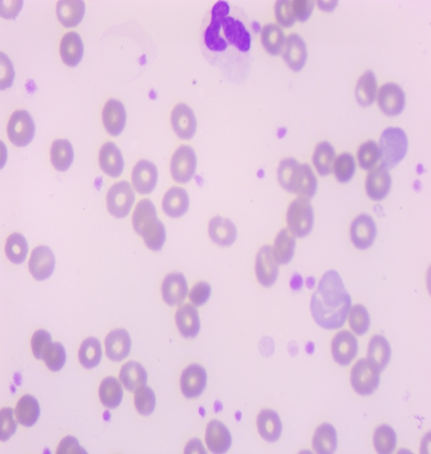  Fig. 1b.
Fig. 1a and 1b. Blood film microscopy findings under 100x magnification were notable for increased platelet count and presence of mature segmented neutrophils during admission and 1b which was showing improvement one month after discharge.

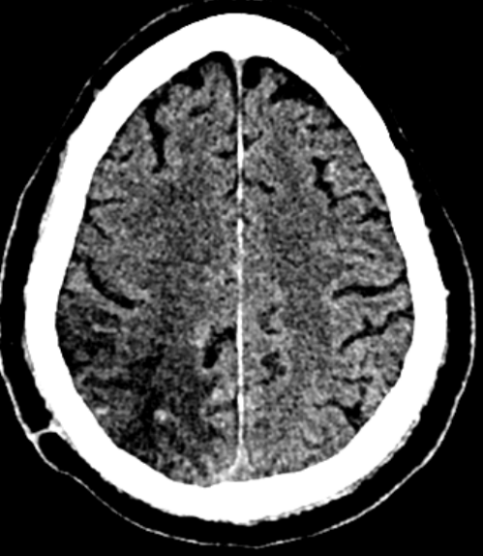  Fig. 2a. | 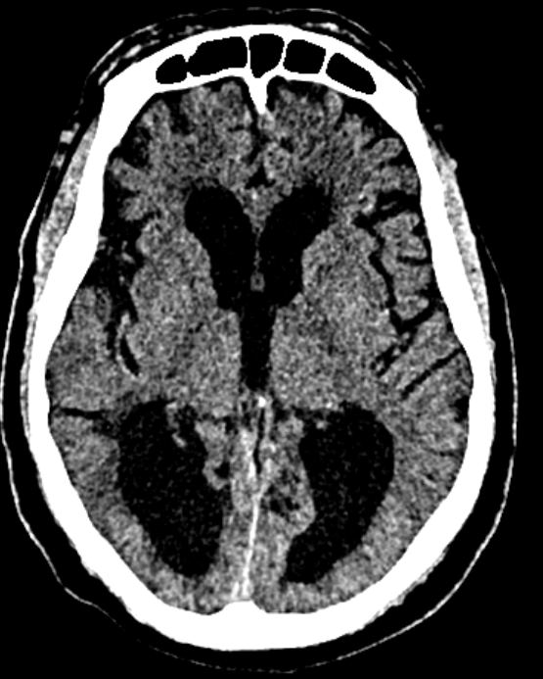  Fig.2b.
Fig.2a and 2b. A non-contrast CT scan of the brain showing hypodensity on the right parietal lobe indicating ischemic infarct and senile atrophy on the posterial lobe.

DISCUSSION
Essential thrombocythemia (ET) is from the group of myeloproliferative neoplasm associated with persistent elevation of platelet and increased risk of thrombotic complications such as ischemic and hemorrhagic events, thrombotic events such as ischemic stroke remain as the leading cause of morbidity and mortality ^{11,14}.Many studies reported patients of advanced age and those with cardiovascular comorbidities, such as hypertension, are at particularly high risk of developing thrombotic complications such as ischemic stroke^{9,10,12,15}. In our case, the patient developed a thrombotic complication despite being on cytoreductive therapy and aspirin, underscoring the challenges in fully controlling thrombotic risk in ET.
In our case report, our patient developed thrombotic event despite receiving cytorective therapy and low dose aspirin for high-risk patient with ET. This indicate the important of close monitoring of of thrombotic events in patient with multiple comorbidities such as advanced age despite being in cytoreductive therapy due to complexity of pathophysiology of essential thrombocythemia⁸.
The pathogenesis of ischemic stroke in ET is associated with many factors, such as endothelial dysfunction, platelet overactivation, and prothrombotic states associated with JAK2 V617F mutation¹⁶. Our patient had additional risk factors including advanced age, elevated platelet, splenomegaly, and long-standing hypertension. Other studies reported the proportional of ET patients with thrombotic events during the disease course, ischemic stroke where the most common presentations.
Cytorecitve therapy with Hydroxyurea lower platelet counts and minimize risk of thrombotic events, and aspirin provides antiplatelet effects¹.In the case hydroxyurea and aspirin does not produce effect, Alternative cytoreductive agents such as anagrelide or interferon-α may be considered in resistant cases^{14,17}.
This case highlights the importance of considering neurological complications in patients with essential thrombocythemia (ET), even in those receiving appropriate treatment. Timely recognition of stroke presentations, prompt diagnosis, and multidisciplinary management are crucial for optimizing patient outcomes.
Furthermore, close collaboration between hematologists, neurologists, and other clinicians crucial for optimizing patient outcomes. Regular follow-up visits allow for reassessment of thrombotic risk, adjustment of therapy, and early detection of complications.

CONCLUSION
Essential thrombocythemia carries a substantial risk of thrombotic complications, particularly ischemic stroke, which can occur despite optimal therapy with hydroxyurea and aspirin. This case emphasizes the importance of adherence to cytoreductive therapy in ET patients and the need for early recognition of neurological symptoms, and timely multidisciplinary care to prevent morbidity and mortality. Generally, treatment planning, and education to patient about the disease, ongoing monitoring continue to be the mainstays of ET patient better outcomes.

ABBREVIATIONS
CT -Computer Tomography
ET -Essential Thrombocythemia
JAK2 -Kinase Kinase 2
CBC -Complete Blood Count
CARL - Calreticulin
MPL -Myeloproliferative Leukemia
SFUCHAS-St Francis University of Health and Allied Sciences
IRB -Institutional Review Board
ECG -Echocardiogram
ECHO -Electrocardiogram
GCS - Glasgow Coma Scale

ETHICAL APPROVAL.

Ethical approval for this case report was obtained from St. Francis University College of Health and Allied Sciences Institutional Review Board (SFUCHAS IRB). Informed consent and assent were obtained from the patient and the next of kin respectively for publication of this case report.

REFERENCES
- Moniruzzaman M, Chandra S, Jakaria Been Sayeed SK. Ischemic Stroke in a patient with Essential Thrombocythemia: Case Report. Journal of Medicine (Bangladesh). 2022;23(2):169-172.
- Godfrey AL, Green AC, Harrison CN. Essential Thrombocythemia; Challenges in Clinical Practice and Future Prospects.; 2022. http://ashpublications.org/blood/article-pdf/141/16/1943/2087877/blood_bld-2022-017625-c-main.pdf
- Beer PA, Green AR. Pathogenesis and Management of Essential Thrombocythemia.; 2009. http://ashpublications.org/hematology/article-pdf/2009/1/621/645646/621_628ash.pdf
- Briére JB. Essential thrombocythemia. Orphanet J Rare Dis. 2007;2(1).
- Tefferi A, Vannucchi AM, Barbui T. Essential thrombocythemia: Am J Hematol. 2024;99(4):697-718.
- Yu Y, Zhang X, Shi Q, Wang M, Jing J, Liu Y. Essential thrombocytosis with recurrent spontaneous abortion in the mid trimester: A case report. Medicine (United States). 2019;98(26).
- Yan R, Mi D, Qiu X, Li Z. A case of ischemic stroke with hemorrhagic transformation associated with essential thrombocythemia and JAK-2 V617F mutation. BMC Neurol. 2022;22(1).
- Patel R, DeRon N. Newly diagnosed essential thrombocythemia leading to cardiogenic shock: a case report. BMC Cardiovasc Disord. 2024;24(1).
- arboix-et-al-ischemic-stroke-as-first-manifestation-of-essential-thrombocythemia.
- Richard S, Perrin J, Baillot PA, Lacour JC, Ducrocq X. Ischaemic stroke and essential thrombocythemia: A series of 14 cases. Eur J Neurol. 2011;18(7):995-998.
- Accurso V, Santoro M, Contrino A, Casimiro P, Raso S. Essential thrombocythemia: Biology, clinical features, thrombotic risk, therapeutic options and outcome. Journal of Hematology and Clinical Research. 2019;3(1):053-059.
- Ergio S, Ortelazzo C, Uido G, et al. HYDROXYUREA FOR PATIENTS WITH ESSENTIAL THROMBOCYTHEMIA AND A HIGH RISK OF THROMBOSIS.; 1995.
- Korucu I, Ciril MF. Essential Thrombocythemia Possible Cause of Ischemic Cerebrovascular Disease: A Case Report. Cureus. Published online October 19, 2024.
- Chen X, Cao L, Feng H, Huang X. Successive development of ischemic stroke and hemorrhagic stroke in a patient with essential thrombocythemia: a case report. Journal of International Medical Research. 2021;49(1).
- Kim BK, Eah KY, Park JM. Essential Thrombocythemia and Ischemic Stroke: A Case Series of Five JAK2-Positive Patients. Preprint posted online June 26, 2023. doi:10.20944/preprints202306. 1743.v1
- Kristiansen MH, Larsen MK, Massarenti L, et al. Thromboinflammation in ischemic cerebrovascular patients with the JAK2V617F mutation. Thromb Res. 2025;245.
- Birgegård G, Besses C, Griesshammer M, et al. Treatment of essential thrombocythemia in Europe: A prospective long-term observational study of 3649 high-risk patients in the evaluation of anagrelide efficacy and long-term safety study. Haematologica. 2018;103(1):51-60.

