Genetic Variability, Diversity and Association Studies in Greengram [Vigna Radiata (L.) Wilczek]

ABSTRACT
Mung bean (Vigna radiata L. Wilczek) is a nutritionally rich pulse crop valued for its protein content and soil fertility enhancing properties, yet its yield improvement remains constrained by complex genetic and environmental interactions. Although previous studies have examined variability or trait associations in mung bean, few have integrated multiple biometrical approaches to simultaneously quantify variability, correlations, path effects, and genetic diversity across a large set of genotypes. This study evaluated 60 genotypes sourced from NBPGR during Kharif 2024 in a randomized block design to quantify genetic variability, trait associations, and diversity for 11 agro-morphological traits. Substantial variation was observed, with seed yield per plant ranging from 3.29 g to 17.35 g and recording the highest coefficient of variation (12.50%). Days to 50% flowering exhibited the lowest variability, underscoring its stability across genotypes. Correlation analysis revealed strong positive associations of seed yield with pod yield per plant (r = 0.749**), test weight (r = 0.395**), and number of seeds per pod (r = 0.295**), while negative associations were noted with plant height and flowering time. Path analysis confirmed pod yield per plant as the most influential determinant of seed yield, exerting the highest direct effect (0.7653). Cluster analysis grouped genotypes into seven distinct clusters, with Cluster IV being the largest, and principal component analysis indicated that the first six components explained 81.5% of total variation. Collectively, these results highlight the potential of exploiting diverse and high-performing genotypes, particularly those combining early flowering with high pod yield, as parents in breeding programs aimed at yield improvement in mung bean.
Key words: Cluster analysis, Correlation, Greengram, Path analysis, Principal component analysis.

INTRODUCTION
Mung bean (Vigna radiata L. Wilczek), commonly known as green gram, is a vital pulse crop of the Fabaceae family cultivated extensively across Asia and other tropical regions. It is valued for its high nutritional quality, containing about 24.6% protein, 57.5% carbohydrates, and significant levels of calcium, iron, and B vitamins (Srivastava and Ali, 2004). Its protein is rich in lysine, complementing cereal-based diets that are deficient in this essential amino acid, while cereals in turn provide sulphur-containing amino acids such as methionine and cysteine. Beyond its dietary importance, mung bean enhances soil fertility through symbiotic nitrogen fixation and serves as a valuable component in crop rotations and green manuring systems (Degefa et al., 2014).
Despite its agronomic and nutritional importance, genetic improvement of mung bean has lagged compared to other pulses. This is partly due to the polygenic nature of seed yield and its strong interaction with environmental factors. For effective selection, understanding genetic variability, heritability, and genetic advance is essential, as these parameters indicate the scope for genetic gain (Majhi et al., 2020; Harsh & Priyal, 2023). Since yield is governed by multiple interrelated traits, correlation analysis provides insights into their associations, while path coefficient analysis further partitions these into direct and indirect effects, helping identify traits with true causal influence (Hemavathy et al., 2015; Ramakrishnan et al., 2018).
Genetic diversity also plays a critical role in broadening the base of breeding programs and enhancing heterosis. Multivariate tools such as cluster analysis and principal component analysis (PCA) have been widely used to classify genotypes and determine the traits contributing most to variability (Shanmugam & Rangasamy, 1982; Mehandi et al., 2015; Sridhar et al., 2022). However, earlier studies often considered these aspects in isolation, with limited integration of variability, trait association, path, and multivariate analyses in a single, comprehensive evaluation.
To address this gap, the present study was undertaken to evaluate 60 diverse mung bean genotypes for yield and related traits under Kharif 2024 conditions. Specifically, the objectives were to (i) quantify genetic variability, heritability, and genetic advance; (ii) determine the relationships among yield and component traits through correlation and path analysis; and (iii) assess genetic divergence and trait contributions using cluster analysis and PCA. The outcomes are expected to provide a robust framework for identifying promising parents and designing effective breeding strategies for yield enhancement in mung bean.
MATERIALS AND METHODS
The experiment was conducted during the Kharif season of 2024 at the research farm located at 17°N latitude, 78°E longitude, and an altitude of 526 m above mean sea level. A total of 60 diverse mung bean (Vigna radiata L. Wilczek) genotypes were obtained from the National Bureau of Plant Genetic Resources (NBPGR), New Delhi, India. The trial was laid out in a randomized block design (RBD) with three replications. Each genotype was sown in a single row of 4 m length, maintaining a spacing of 30 cm between rows and 10 cm between plants. Standard agronomic practices and recommended plant protection measures were followed to ensure a uniform and healthy crop stand.
Data were recorded on five randomly selected plants per replication for eleven agro-morphological traits: days to 50% flowering (DF), height of main stem (HMS, cm), length of primary branches (LPB, cm), number of primary branches (NPB), pods yield per plant (PYPP, g), pod length (PL, cm), number of seeds per pod (NSPP), test weight (TW, g), threshing percentage (TRP, %), number of clusters per plant (NC), and seed yield per plant (SYPP, g). The mean data were subjected to statistical analysis. Descriptive statistics (mean, range, standard deviation, and coefficient of variation) were computed in Microsoft Excel. Correlation coefficients and path analysis were estimated following the biometrical procedures of Singh & Chaudhary, (1979). Principal component analysis (PCA) was performed on the correlation matrix using Windostat v.9.50 to identify major sources of variation. Genetic diversity was assessed using Euclidean distance, and divergence was estimated through Ward’s minimum variance method of clustering in R software v.4.3.2.
RESULTS AND DISCUSSION
Substantial genetic variability was observed among the 60 mung bean genotypes across all eleven traits (Table 1). Seed yield per plant (SYPP) exhibited the widest range (3.29–17.35 g) with the highest coefficient of variation (12.50%), confirming the presence of considerable yield diversity and scope for genetic improvement. Days to 50% flowering (DF) showed the lowest variability (CV = 5.79%), indicating relative stability across genotypes. Variation in plant architecture traits such as plant height (24.93–61.95 cm), length of primary branches (8.28–12.48 cm), and number of primary branches (5.87–10.07) highlights the opportunity for selection of desirable plant types. These findings are consistent with earlier reports on the broad variability in mung bean germplasm (Hemavathy et al., 2015; Harsh & Priyal, 2023).
High-yielding genotypes such as IC-314970 (17.35 g) and IC-8917 (19.60 g pod yield) are promising candidates for direct use and as parents in breeding programs. Conversely, genotypes with extreme values for specific traits (e.g., IC-39414 with highest test weight, IC-76499 with maximum seeds per pod) can be utilized for trait-specific improvement.
Table 1: Genetic variability parameters for eleven quantitative traits in 60 mung bean genotypes
Characters | Mean | Minimum | Genotype | Maximum | Genotype | CV
Days to 50% flowering | 38.04 | 34.33 | IC-76486 | 45.67 | IC-39406 | 5.79
Height of main stem (cm) | 43.46 | 24.93 | IC-242862 | 61.95 | IC-76361 | 7.68
Length of primary branches | 10.30 | 8.28 | IC-252010 | 12.48 | IC-546476 | 8.45
Number of Primary branches per plant | 7.95 | 5.87 | IC-257635 | 10.07 | IC-39407 | 11.99
Pods yield per plant (g) | 11.70 | 5.25 | IC-541830 | 19.60 | IC-8917 | 12.26
Pod length (cm) | 7.68 | 6.15 | IC-325774 | 11.15 | IC-397138 | 6.64
Number of seed per pod | 12.33 | 9.53 | IC-329079 | 14.07 | IC-76499 | 7.38
Test weight (g) | 3.01 | 1.99 | IC-283547 | 4.70 | IC-39414 | 6.87
Threshing percentage (%) | 65.79 | 54.08 | IC-541824 | 79.64 | IC-32006 | 7.20
Number of clusters per plant | 5.57 | 3.67 | IC-283547 | 7.83 | IC-282091 | 7.34
Seed yield per plant (g) | 7.67 | 3.29 | IC-541830 | 17.35 | IC-314970 | 12.50
CORRELATION COEFFICIENT ANALYSIS
Correlation coefficients revealed that seed yield per plant was strongly and positively associated with pods yield per plant (r = 0.749**), followed by test weight (r = 0.395**) and number of seeds per pod (r = 0.295**) (Table 2; Fig. 1). These results demonstrate that selection for higher pod productivity, heavier seeds, and greater seed number per pod would indirectly enhance overall yield. Similar associations were reported by Dhoot et al., 2017, Shakeer et al., 2022 and Yoseph et al., 2023.
Negative correlations of SYPP with days to 50% flowering (r = –0.236**) and plant height (r = –0.363**) indicate that early-flowering and semi-dwarf genotypes tend to produce higher yields. This aligns with the preference for short-duration and medium-height cultivars in intensive cropping systems. Notably, DF also showed a strong negative correlation with number of seeds per pod (r = –0.681**), reinforcing the role of early maturity in yield enhancement. Similar results have also been reported by Khan et al., 2008 and Khatik et al., 2022.
Table 2: Pearson’s correlation coefficients among yield and yield-related traits in mung bean genotypes
Trait | DF | HMS | LPB | NPB | PYPP | PL | NSPP | TW | TRP | NC | SYPP
DF | 1.000 | 0.264** | -0.097 | 0.096 | -0.405** | -0.089 | -0.681** | 0.015 | 0.1 | -0.398** | -0.236**
HMS |  | 1.000 | 0.306** | 0.288** | -0.325** | -0.049 | -0.335** | -0.161* | -0.376** | -0.033 | -0.363**
LPB |  |  | 1.000 | 0.225** | -0.067 | 0.084 | -0.067 | 0.086 | 0.01 | 0.212** | -0.171*
NPB |  |  |  | 1.000 | -0.095 | -0.338** | -0.056 | -0.28** | 0.473** | 0.097 | -0.113
PYPP |  |  |  |  | 1.000 | 0.272** | 0.265** | 0.444** | -0.069 | -0.037 | 0.749**
PL |  |  |  |  |  | 1.000 | 0.05 | 0.755** | -0.128 | 0.048 | 0.172*
NSPP |  |  |  |  |  |  | 1.000 | -0.096 | 0.138 | 0.243** | 0.295**
TW |  |  |  |  |  |  |  | 1.000 | 0.201** | 0.081 | 0.395**
TRP |  |  |  |  |  |  |  |  | 1.000 | -0.057 | 0.08
NC |  |  |  |  |  |  |  |  |  | 1.000 | 0.034
SYPP |  |  |  |  |  |  |  |  |  |  | 1.000
* and ** denotes significant at 5% and 1% level of probability respectively
Traits - Days to 50% flowering (DF), Height of main stem (HMS, cm), Length of primary branches (LPB, cm), Number of primary branches (NPB), Pods yield per plant (PYPP, g), Pod length (PL, cm), Number of seeds per pod (NSPP), Test weight (TW, g), Threshing percentage (TRP, %), Number of clusters per plant (NC), and Seed yield per plant (SYPP, g).
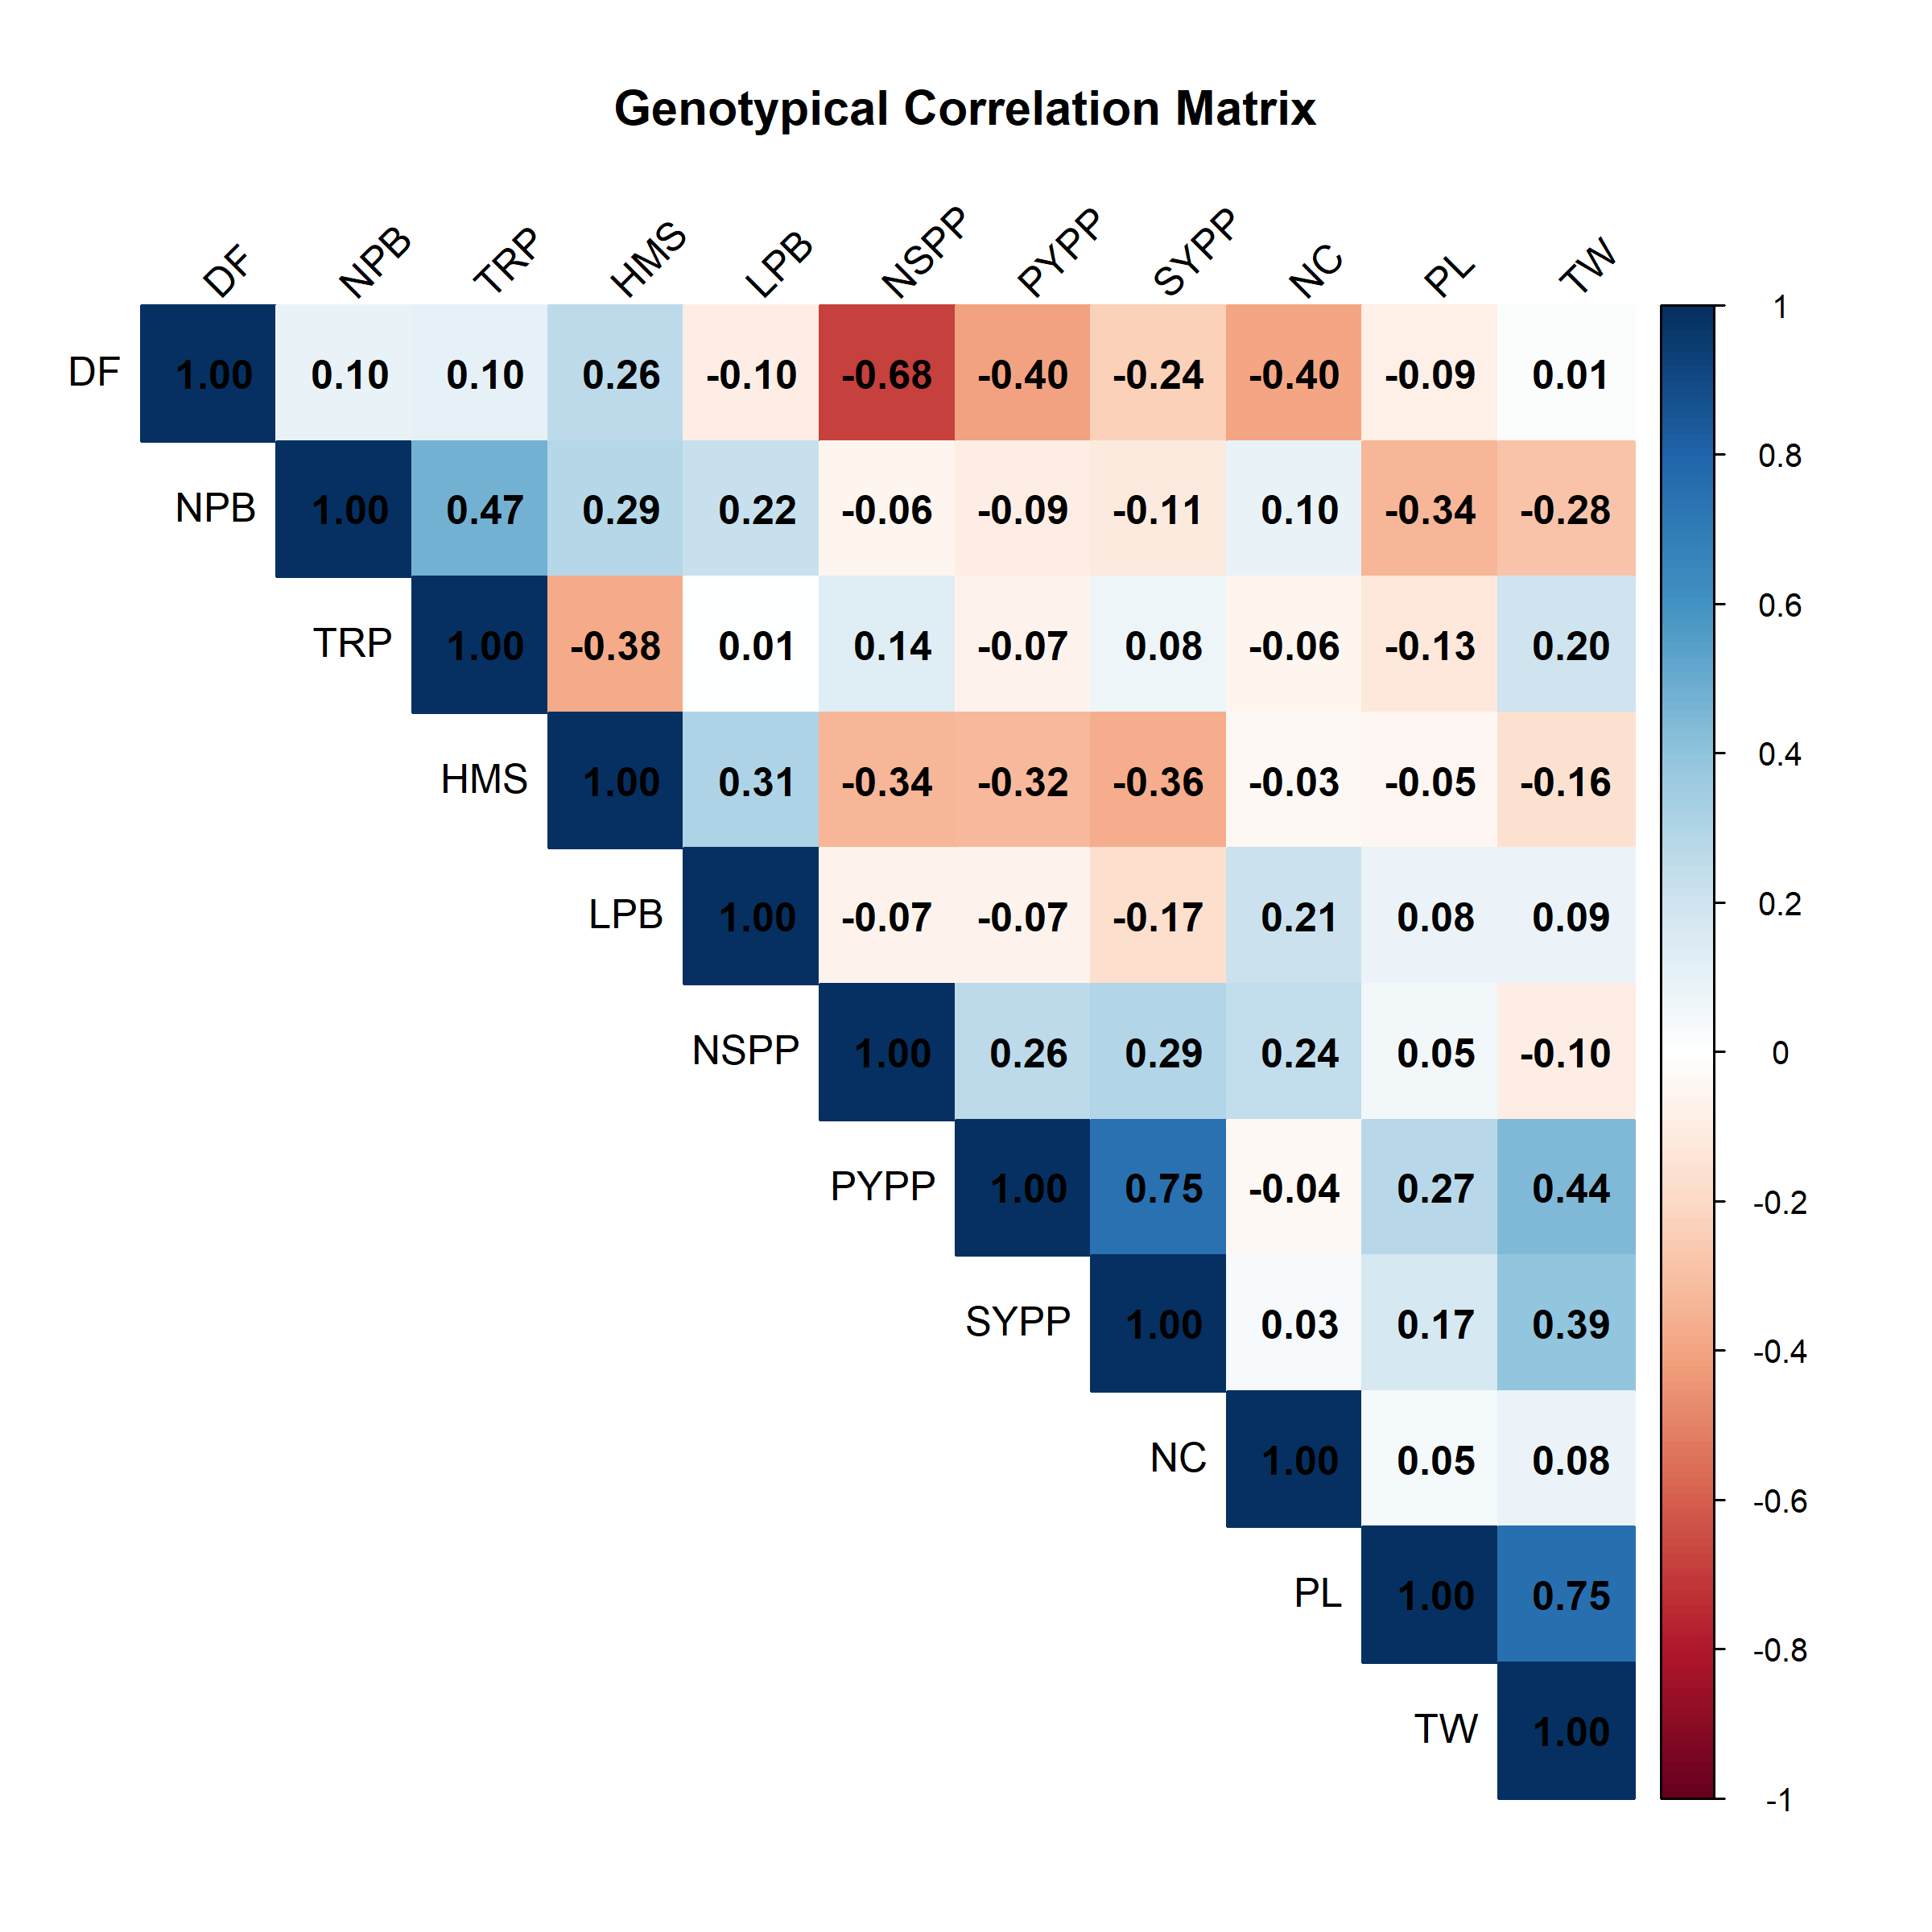
Fig 1: Correlation heatmap showing associations among yield and yield-contributing traits in mung bean
PATH COEFFICIENT ANALYSIS
Path analysis provided insights into the causal contributions of component traits to SYPP (Table 3). Pods yield per plant (PYPP) exerted the largest positive direct effect (0.7653), confirming it as the most reliable selection criterion for yield improvement. Test weight (0.1511) and number of seeds per pod (0.2473) also had positive direct effects, although their correlations with yield were largely mediated through PYPP.
In contrast, days to 50% flowering (–0.236) and plant height (–0.363) had negative direct effects, corroborating their unfavourable correlations with yield. This suggests that breeding strategies should focus on selecting early-flowering, semi-dwarf genotypes with higher pod productivity. Similar observations have been documented in mung bean and related pulses by Ramakrishnan et al., 2018, Nalajala et al., 2022, and Kumar et al., 2024.
Table 3: Direct and indirect effects of component traits on seed yield per plant revealed through path analysis
Trait | DF | HMS | LPB | NPB | PYPP | PL | NSPP | TW | TRP | NC | SYPP
DF | 0.2762 | 0.0731 | -0.0268 | 0.0264 | -0.1118 | -0.0247 | -0.1881 | 0.0041 | 0.0276 | -0.1100 | -0.236**
HMS | -0.0017 | -0.0065 | -0.0020 | -0.0019 | 0.0021 | 0.0003 | 0.0022 | 0.0011 | 0.0025 | 0.0002 | -0.363**
LPB | 0.0081 | -0.0257 | -0.0840 | -0.0189 | 0.0056 | -0.0071 | 0.0056 | -0.0072 | -0.0008 | -0.0178 | -0.171*
NPB | -0.0086 | -0.0258 | -0.0201 | -0.0895 | 0.0085 | 0.0303 | 0.0050 | 0.0251 | -0.0424 | -0.0087 | -0.113
PYPP | -0.3099 | -0.2487 | -0.0511 | -0.0726 | 0.7653 | 0.2078 | 0.2025 | 0.3396 | -0.0531 | -0.0286 | 0.749**
PL | 0.0142 | 0.0078 | -0.0134 | 0.0539 | -0.0432 | -0.1592 | -0.0080 | -0.1201 | 0.0204 | -0.0077 | 0.172*
NSPP | -0.1685 | -0.0829 | -0.0165 | -0.0138 | 0.0654 | 0.0124 | 0.2473 | -0.0236 | 0.0341 | 0.0600 | 0.295**
TW | 0.0022 | -0.0243 | 0.0130 | -0.0423 | 0.0670 | 0.1140 | -0.0144 | 0.1511 | 0.0304 | 0.0123 | 0.395**
TRP | 0.0069 | -0.0258 | 0.0007 | 0.0326 | -0.0048 | -0.0088 | 0.0095 | 0.0138 | 0.0688 | -0.0039 | 0.08
NC | -0.0548 | -0.0046 | 0.0292 | 0.0133 | -0.0051 | 0.0067 | 0.0334 | 0.0112 | -0.0078 | 0.1376 | 0.034
* and ** denotes significant at 5% and 1% level of probability respectively
Traits - Days to 50% flowering (DF), Height of main stem (HMS, cm), Length of primary branches (LPB, cm), Number of primary branches (NPB), Pods yield per plant (PYPP, g), Pod length (PL, cm), Number of seeds per pod (NSPP), Test weight (TW, g), Threshing percentage (TRP, %), Number of clusters per plant (NC), and Seed yield per plant (SYPP, g).
PRINCIPAL COMPONENT ANALYSIS
Principal component analysis (PCA) identified six components with eigenvalues greater than one, cumulatively explaining 81.5% of the total variation among the 60 mung bean genotypes (Table 4; Fig. 2). PC1, which accounted for 24.9% of the variance, was primarily associated with pods yield per plant (PYPP) and seed yield per plant (SYPP), confirming yield as the dominant source of diversity. PC2 explained 15.2% of the variance and was defined by days to 50% flowering (DF), number of seeds per pod (NSPP), and test weight (TW), reflecting maturity and seed quality attributes. PC3 (13.7%) was strongly influenced by length of primary branches (LPB) and number of clusters per plant (NC), indicating the role of plant architecture. These findings align with earlier studies by Mehandi et al., 2015; Kanavi et al., 2020, and Tiwari et al., 2021 demonstrating the utility of PCA for simplifying multivariate variation and identifying the most influential traits in pulses.
The PCA biplot (Fig. 3), anchored by PC1 and PC2 (40.1% variance), clearly separated genotypes based on trait combinations. High-yielding lines such as IC-314970 and IC-8917 were positioned along the vectors of SYPP and PYPP, while IC-39414 aligned with TW, highlighting its value for improving seed weight. In contrast, genotypes placed along the DF vector were characterized by delayed flowering and reduced yield potential, confirming the negative association between flowering duration and productivity. Similar trait associations and genotype groupings have been reported in mung bean and related pulses by Gupta et al., 2021, Sridhar et al., 2022, and Gnanasekaran et al., 2023. Overall, PCA emphasized that yield, maturity, and seed quality traits are the major determinants of genetic diversity in mung bean, and the identification of genotypes associated with favourable vectors offers breeders a strategic basis for selecting parents with complementary strengths.
Table 4: Eigenvalues, proportion of variance, and trait loadings for six principal components in mung bean genotypes
PC | PC1 | PC2 | PC3 | PC4 | PC5 | PC6
Eigen value | 1.656 | 1.294 | 1.228 | 1.127 | 1.009 | 0.865
Variance % | 0.249 | 0.152 | 0.137 | 0.115 | 0.093 | 0.068
Cumulative % | 0.249 | 0.401 | 0.538 | 0.654 | 0.747 | 0.815
Component matrix
Trait | PC1 | PC2 | PC3 | PC4 | PC5 | PC6
DF | 2.56 | 14.83 | 2.09 | 2.28 | 0.00 | 0.02
HMS | 4.04 | 1.43 | 9.49 | 0.34 | 13.48 | 2.07
LPB | 0.31 | 0.20 | 23.59 | 5.35 | 0.64 | 4.88
NPB | 1.47 | 3.99 | 1.49 | 25.50 | 9.35 | 0.09
PYPP | 8.55 | 0.06 | 0.12 | 0.96 | 21.78 | 0.23
PL | 3.79 | 9.26 | 8.56 | 0.69 | 4.02 | 9.15
NSPP | 2.05 | 11.80 | 0.04 | 0.95 | 3.11 | 57.98
TW | 5.44 | 10.92 | 4.55 | 2.55 | 2.16 | 0.67
TRP | 0.03 | 0.01 | 2.88 | 37.58 | 20.22 | 0.91
NC | 0.29 | 7.18 | 11.99 | 0.20 | 10.55 | 53.89
SYPP | 7.95 | 0.05 | 1.52 | 2.30 | 12.88 | 3.80

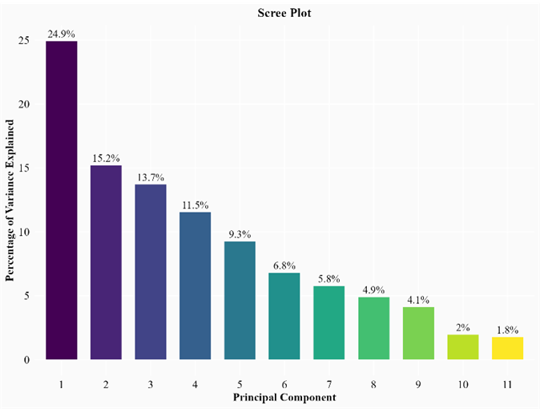
Fig 2: Scree plot depicting eigenvalue distribution of principal components in mung bean genotypes
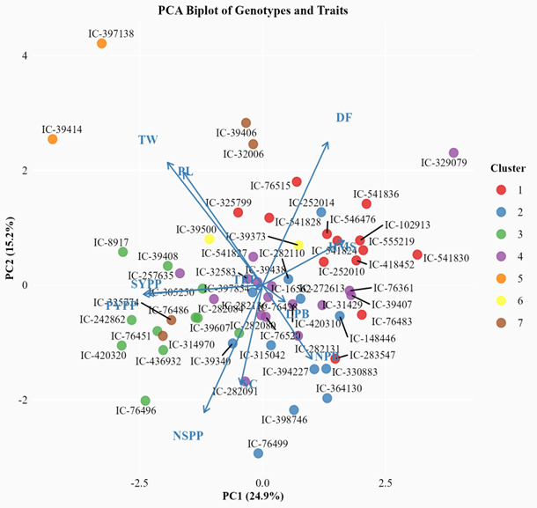
Fig 3: PCA biplot illustrating trait vectors and distribution of 60 mung bean genotypes across the first two components
CLUSTER ANALYSIS
Cluster analysis grouped the 60 mung bean genotypes into seven distinct clusters based on Ward’s minimum variance method, reflecting substantial genetic diversity within the collection (Table 5; Fig. 4). Cluster IV was the largest, containing 16 genotypes, while Clusters V and VI were the smallest with only two genotypes each, indicating their unique genetic makeup. Inter-cluster distances were highest between Cluster V and Cluster VI (225.03), followed by Cluster V with Cluster I (223.65) and Cluster VII (215.88), suggesting that these groups are highly divergent. Such genetic divergence is valuable in breeding, as hybridization between distantly related clusters is likely to maximize heterosis and broaden the genetic base (Shanmugam & Rangasamy, 1982).
The intra-cluster distances revealed varying levels of heterogeneity (Table 6), with Cluster VII showing the highest intra-cluster divergence (54.07), suggesting considerable variability even among its members. Genotypes such as IC-39414 and IC-397138 (Cluster V) and IC-39373 and IC-39500 (Cluster VI) were identified as particularly divergent and therefore represent promising parents for hybridization aimed at yield enhancement and trait introgression. These findings are consistent with earlier studies by Divyaramakrishnan & Savithramma, 2014, and Sarkar et al., 2016 that highlighted the utility of clustering for identifying genetically diverse parental lines in mung bean and related pulses. Overall, the clustering pattern provides a rational framework for selecting parents from distinct and divergent clusters to enhance recombination and develop superior cultivars.
Table 5: Clustering pattern of mung bean genotypes

Cluster | Number of Genotypes | Genotypes
1 | 13 | IC-102913, IC-252010, IC-283547, IC-325799, IC-418452, IC-541824, IC-541828, IC- 541830, IC-541836, IC-546476, IC-555219, IC-76483, IC-76515
2 | 12 | IC-148446, IC-252014, IC-272613, IC-282110, IC-315042, IC-330883, IC-364130, IC- 39340, IC-394227, IC-397854, IC-398746, IC-76499
3 | 11 | IC-242862, IC-282080, IC-305250, IC-39408, IC-39607, IC-420320, IC-436932, IC- 76451, IC-76486, IC-76496, IC-8917
4 | 16 | IC-16562, IC-257635, IC-282084, IC-282091, IC-282131, IC-282136, IC-31429, IC- 32583, IC-329079, IC-39407, IC-39438, IC-420310, IC-541827, IC-76361, IC-76428, IC-76520
5 | 2 | IC-39414, IC-397138
6 | 2 | IC-39373, IC-39500
7 | 4 | IC-314970, IC-32006, IC-325774, IC-39406
Table 6: Inter- and intra-cluster distances among 60 mung bean genotypes based on quantitative traits
 | Cluster-I | Cluster-II | Cluster-III | Cluster-IV | Cluster-V | Cluster-VI | Cluster-VII
Cluster-I | 38.18 | 62.83 | 113.71 | 68.27 | 223.65 | 104.24 | 162.38
Cluster-II | 62.83 | 22.30 | 65.28 | 49.35 | 186.86 | 126.40 | 141.88
Cluster-III | 113.71 | 65.28 | 32.87 | 72.94 | 120.45 | 139.01 | 92.43
Cluster-IV | 68.27 | 49.35 | 72.94 | 33.60 | 161.21 | 113.76 | 133.95
Cluster-V | 223.65 | 186.86 | 120.45 | 161.21 | 37.95 | 197.97 | 215.88
Cluster-VI | 104.24 | 126.40 | 139.01 | 113.76 | 197.97 | 25.65 | 225.03
Cluster-VII | 162.38 | 141.88 | 92.43 | 133.95 | 215.88 | 225.03 | 54.07

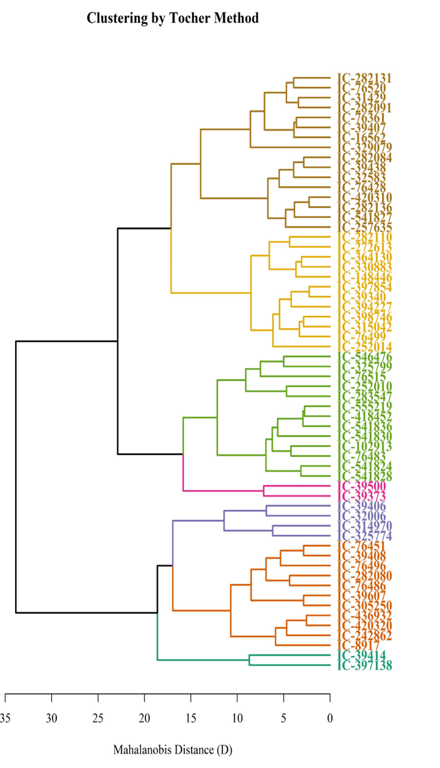
Fig 4: Dendrogram showing genetic relationships and cluster groupings of 60 mung bean genotypes

COMPETING INTERESTS DISCLAIMER:
Authors have declared that they have no known competing financial interests OR non-financial interests OR personal relationships that could have appeared to influence the work reported in this paper.

REFERENCES
Degefa, I., Petros, Y., & Andargie, M. (2014). Genetic variability, heritability and genetic advance in Mung bean (Vigna radiata L. Wilczek) accessions. Horizon 1(2): 94-98. http://dx.doi.org/10.14719/pst.2014.1.2.54.
Dhoot, R., Modha, K., Kumar, D., & Dhoot, M. (2017). Correlations and path analysis studies on yield and its components in Mungbean (Vigna radiata (L.) Wilczek). Int. J. Curr. Microbiol. App. Sci, 6(5), 370-378. https://doi.org/10.20546/ijcmas.2017.605.042
Divyaramakrishnan, C., & Savithramma, D. (2014). Tailoring genetic diversity of mungbean [Vigna radiata (L). Wilczek] germplasm through principal component and cluster analysis for yield and yield related traits. International Journal of Agronomy and Agricultural Research, 5(2), 94-102. https://api.semanticscholar.org/CorpusID:62790282
Gnanasekaran, M., Gunasekaran, M., Thiyagu, K., Muthuramu, S., Ramkumar, J., & Venudevan, B. (2023). Genetic variability, heritability, genetic advance and association studies in blackgram [Vigna mungo (L.) Hepper]. Legume Research-An Int J, 1-5. https://doi.org/10.18805/LR-5203
Gupta, D., Muralia, S., Gupta, N., Gupta, S., Jakhar, M., & Sandhu, J. (2023). Genetic diversity and principal component analysis in mungbean [Vigna radiata (L.) Wilczek] under Rainfed Condition. Legume Research-An International Journal, 46(3), 265-272. https://doi.org/10.18805/lr-4568
Harsh, P., & Priyal, P. (2023). Genetic variability and correlation in green gram [Vigna radiata (L.) R. Wilczek]. Plant Archives (09725210), 23(2). https://doi.org/10.51470/PLANTARCHIVES.2023.v23.no2.024
Hemavathy, A. T., Shunmugavalli, N., & Anand, G. (2015). Genetic variability, correlation and path co-efficient studies on yield and its components in mungbean [Vigna radiata (L.) Wilezek]. Legume Research-An International Journal, 38(4), 442-446. https://doi.org/10.5958/0976-0571.2015.00050.8
Kanavi, P., Koler, P., Somu, G., & Marappa, N. (2020). Genetic diversity study through k-means clustering in germplasm accessions of green gram [Vigna radiata (L.)] under drought condition. International Journal of Bio-resource and Stress Management, 11(2), 138-147. https://doi.org/10.23910/IJBSM/2020.11.2.2078
Khan, H., Mairaj, G., Ali, S., Farhatullah, & Ikramullah (2008). Correlation study on morphological and yield parameters of mungbean (Vigna radiata). Sarhad Journal of Agriculture 24(1), 37−42.
Khatik, C., Dhaka, S., Khan, M., Lal, J., Verma, K., Mahala, S., . . . Meena, R. (2022). Correlation and Path Coefficient Analysis in Rainfed Mung Bean Genotypes [Vigna radiata (L.) Wilczek)]. International Journal of Plant & Soil Science, 34(22), 504-509. https://doi.org/10.9734/ijpss/2022/v34i2231402
Kumar, A., Sharma, N., Kumar, R., Sanadya, S. K., & Sahoo, S. (2024). Correlation and Path Analysis Studies in Mungbean [Vigna radiata (L.) Wilczek] under Arid Environment of Western Rajasthan. Indian Journal of Agricultural Research, 58. https://doi.org/10.18805/ijare.a-6195
Majhi, P. K., Mogali, S. C., & Abhisheka, L. (2020). Genetic variability, heritability, genetic advance and correlation studies for seed yield and yield components in early segregating lines (F3) of greengram [Vigna radiata (L.) Wilczek]. International Journal of Chemical Studies, 8(4), 1283-1288. https://doi.org/10.22271/chemi.2020.v8.i4k.9779
Mehandi, S., Singh, I., Bohra, A., & Singh, C. M. (2015). Multivariate analysis in green gram [Vigna radiata (L.) Wilczek]. Legume Research-An International Journal, 38(6), 758-762. https://doi.org/10.18805/lr.v38i6.6720
Nalajala, S., Singh, N. B., Jeberson, M. S., Sastry, E., Yumnam, S., Sinha, B., & Singh, O. (2022). Genetic Variability, Correlation and Path Analysis in Mung Bean Genotypes (Vigna radiata L. Wilczek): An Experimental Investigation. International Journal of Environment and Climate Change, 12(11), 1846-1854. https://doi.org/10.9734/IJECC/2022/v12i1131170
Ramakrishnan, C. D., Savithramma, D., & Vijayabharathi, A. (2018). Studies on genetic variability, correlation and path analysis for yield and yield related traits in greengram (Vigna radiata (L.) Wilczek). International Journal of Current Microbiology and Applied Sciences, 7(3), 2753-2761. https://doi.org/10.20546/ijcmas.2018.703.318
Sarkar, M., & Kundagrami, S. (2016). Multivariate analysis in some genotypes of mungbean [Vigna radiata (L.) Wilczek] on the basis of agronomic traits of two consecutive growing cycles. Legume Research, 39(4), 523-527. https://doi.org/10.18805/LR.V0IOF.11037
Shakeer, S., Lal, G. M., Varma, V. C., & Saikumar, S. (2022). Correlation and Path Coefficiant Analysis for Quantitative Traits in Greengram [Vigna radiate (L.) Wilczek]. International Journal of Environment and Climate Change, 12(11), 3683-3692. https://doi.org/10.9734/IJECC/2022/v12i111418
Shanmugam, A., & Rangasamy, S. (1982). Genetic diversity for quantitative characters in green gram (Vigna radiata (L.) Wilczek).
Singh, R., & Chaudhary, B. (1979). Biometrical Methods in Quantitative Genetic Analysis. p: 303: Kelyani Publisher, New Delhi, India.
Sridhar, V., Rao, S. S., Sriram, A., & Gopal, G. V. (2022). Studies on genetic divergence among greengram (Vigna radiata L.) germplasm accessions. International Journal of Bio-resource and Stress Management, 13(8), 838-844.
Srivastava, R., & Ali, M. (2004). Nutritional quality of common pulses: Indian Institute of Pulses Research.
Tiwari, P., & Sharma, S. (2021). Principal component analyses in mungbean genotypes under summer season. International Journal of Agricultural Sciences, 17(2), 287-292. https://doi.org/10.15740/has/ijas/17.2/287-292
Yoseph, T., Mekbib, F., Amsalu, B., & Tadele, Z. (2023). Correlation and Path Coefficient Analyses of Mung Bean [Vigna radiata (L.) Wilczek] Genotypes, in South Ethiopia. Journal of Science & Development (JSD), 11(2).

