Original Research Article
Residual Effects of Fly Ash and Farmyard Manure on Soil Quality and Groundnut Productivity in an Acidic Inceptisol

ABSTRACT

Aim
This study investigated the residual effects of fly ash (FA) and farmyard manure (FYM) on soil fertility and groundnut (Arachis hypogaea L.) productivity in loamy sand soils, with a focus on soil health and crop performance.
Methods
Field experiments were conducted with graded doses of FA and in combination with FYM, NPK, or lime. Soil physical, chemical, and biological properties were assessed, along with plant nutrient uptake and yield. Principal component analysis (PCA) was used to evaluate the relationship between soil fertility indicators and crop performance.
Results and Discussion
FA application had little effect on soil texture and bulk density but significantly improved porosity and water-holding capacity while reducing penetration resistance. Soil pH remained slightly acidic, whereas organic carbon increased by up to 160.7% with FA treatments. Macronutrient availability, especially phosphorus and potassium, improved markedly, with FA40+T3 showing the highest increase. Secondary nutrients (S, Ca, Mg) also rose, with sulphur content doubling. Plant-available silicon increased consistently with FA dosage. Among micronutrients, zinc improved most, while copper and manganese remained stable. Soil enzymatic activities (urease, phosphatases, dehydrogenase) were enhanced, indicating greater microbial activity. Groundnut yields increased significantly, with FA40+T3 achieving the highest kernel yield (872.3 kg ha⁻¹) and biomass yield (7164.6 kg ha⁻¹). Improvements in nutrient availability and microbial activity were strongly associated with FA application, as confirmed by PCA, highlighting its role in enhancing soil–plant interactions.
Conclusion
FA, particularly in combination with FYM and fertilizer, offers a sustainable strategy to improve soil fertility, nutrient cycling, and crop productivity in nutrient-deficient sandy soils.

Keywords: Residual effect; Soil amelioration; Farmyard manure; PCA; Plant available-Si; Soil enzymes

1. INTRODUCTION
Fly ash (FA), a fine particulate by-product of coal combustion, poses a significant environmental challenge due to its vast generation from thermal power plants. In India, an estimated 889.66 LMT of FA is produced annually, a figure expected to rise with the country's reliance on low-grade, high-ash coal (NTPC, 2023). Traditionally considered a waste product, FA contains essential plant macro- and micronutrients, and its properties—such as a highly variable pH (4.5–12.0)—are influenced by the source coal and combustion process (Jala and Goyal, 2006; Lal et al., 2012).
Concurrently, agricultural intensification has led to soil degradation, prompting the search for sustainable soil amendments. FA has emerged as a potential candidate to improve soil health by enhancing texture, porosity, and water retention, while supplementing nutrient levels (Ram and Masto, 2014). Its application, particularly in combination with organic amendments like farmyard manure (FYM), can mitigate heavy metal bioavailability and improve nutrient cycling (Kumar et al., 2017; Singh and Pandey, 2013). Despite these benefits and the potential to significantly boost food grain production, FA utilization in Indian agriculture remains below 1% (Down To Earth, 2019).
Most research has focused on the short-term, direct effects of FA on single crops. A critical knowledge gap exists regarding its residual impact within a cropping sequence, where benefits to a first crop may influence a subsequent one. This is particularly relevant for the predominant rice-groundnut system of coastal Odisha, where groundnut is often grown as a residual crop after rice.
To address this, we conducted a three-year field study to evaluate the integrated application of FA and FYM within a rice-groundnut cropping system. Our objectives was to assess the multi-seasonal impact on soil physicochemical properties and microbial activity.

2. material and methods
2.1. Experimental Site and Setup
A field experiment was initiated during the 2021 Kharif season (rice, Oryza sativa cv. Kalinga Dhan 1204) followed by the 2021–22 Rabi season (groundnut, Arachis hypogaea cv. Devi) at the Instruction Farm of Odisha University of Agriculture and Technology (OUAT), Bhubaneswar, India (20.2961° N, 85.8245° E; 45 m above mean sea level). The experimental site has a subtropical humid climate with an average annual rainfall of 1,250 mm. The soil was classified as slightly acidic with a loamy sand texture. Fly ash (FA) was procured from the National Thermal Power Corporation (NTPC) in Talcher, Odisha. Initial physicochemical characteristics of the soil, FA, and farmyard manure (FYM) are presented in Tables 1, 2, and 3 respectively.

Table 1: Physiochemical properties of fly ash
Physical properties | Value
Mechanical analysis (Bouyoucos hydrometer)
Sand (%) | 90.4
Silt (%) | 9.4
Clay (%) | 0.2
Particle density (Mg m⁻³) | 1.71
Bulk density (Mg m⁻³) | 1.04
Porosity (%) | 39.18
Water holding capacity (%) | 92.1
Chemical properties
pH | 6.1
EC (dS m⁻¹) | 0.18
Liming potential (%) | 8.5
By CHNS analyser
C (%) | 0.52
N (%) | 0.05
H (%) | 0.103
S (%) | 0.028
By Di-acid digestion
P (%) | 0.20
K (%) | 0.06

Table 2: Chemical composition and C:N ratio of FYM used
Properties | Value
C (%) | 21.0
N (%) | 0.83
P (%) | 0.26
K (%) | 0.82
C:N ratio | 25.6

Table 3: Physiochemical properties of initial soil (0-15 cm)
Properties | Value
Sand (%) | 83.56
Silt (%) | 8.50
Clay (%) | 7.94
Bulk density (Mg m⁻³) | 1.29
Particle density (Mg m⁻³) | 2.55
Porosity (%) | 50.00
Water holding capacity (%) | 32.22
pH_{w}(1:2.5) | 5.13
EC (dSm⁻¹) | 0.19
CEC (CmolP⁺kg⁻¹) | 3.06
Organic carbon (%) | 0.49
Mineralizable N (kg ha⁻¹) | 111.26
Olsen’s P (kg ha⁻¹) | 8.16
Available K (kg ha⁻¹) | 96.85
Available S (kg ha⁻¹) | 17.45
Exchangeable Ca (meq 100⁻¹) | 8.14
Exchangeable Mg (meq 100⁻¹) | 9.71
DTPA extractable Zn (mg kg⁻¹) | 1.58
DTPA extractable Cu (mg kg⁻¹) | 2.31
DTPA extractable Fe (mg kg⁻¹) | 167.51
DTPA extractable Mn (mg kg⁻¹) | 7.12

2.2. Experimental Design and Treatments
The experiment was laid out in a randomized block design (RBD) with three replications. Individual plot size was 12 m × 5 m. This study evaluates seven treatments: T1: Absolute control (no inputs), T2: 100% recommended NPK (20:40:40 kg ha⁻¹ N:P₂O₅:K₂O for groundnut), T3: T2 + FYM @ 5 t ha⁻¹ (applied each Kharif season), T4: T3 + FA @ 10 t ha⁻¹, T5: T3 + FA @ 20 t ha⁻¹, T6: T3 + FA @ 40 t ha⁻¹ and T7: T3 + Lime @ 0.2 LR (applied for non-rice crops). The full quantity of FYM and FA, as per treatment specifications, was incorporated once during puddling for the Kharif rice crop. Lime (0.2 Lime Requirement) was applied based on soil test values during land preparation for the Rabi groundnut crop.
2.3. Soil Sampling and Analysis
Post-harvest soil samples (0-15 cm depth) were collected from the groundnut plots following a zig-zag pattern to form a composite sample per treatment. Samples were air-dried, ground, and passed through a 2-mm sieve for physicochemical analysis. A subset was stored at 4°C for microbiological and enzymatic assays, which were completed within 15 days of sampling.
Soil analyses were conducted using established standard methods. Texture was determined by the hydrometer method (Bouyoucos, 1962). Bulk density was measured using a core sampler (Blake and Hartge, 1986), while particle density and porosity were determined with a pycnometer (Flint and Flint, 2002). Water holding capacity was assessed using a Keen-Raczkowski box and penetration resistance with a cone penetrometer (Piper, 1950). Soil pH and electrical conductivity (EC) were measured potentiometrically and conductometrically, respectively (Jackson, 1973). Organic carbon (OC) was estimated by the rapid titration method of Walkley and Black (1934). Available nitrogen (N) was determined by the alkaline potassium permanganate method (Subbiah and Asija, 1956). Available phosphorus (P) was extracted with 0.5 M NaHCO₃ (pH 8.5) and measured spectrophotometrically (Olsen et al., 1954). Available potassium (K) was extracted with 1 N ammonium acetate (pH 7.0) and analyzed by flame photometry (Jackson, 1973). Exchangeable calcium (Ca) and magnesium (Mg) were determined by complexometric titration (Baruah and Barthakur, 1997). Available silicon (Si) was extracted with 0.01 M CaCl₂ and estimated spectrophotometrically (Haysom and Chapman, 1975). DTPA-extractable micronutrients (Zn, Fe, Cu, Mn) were quantified using atomic absorption spectrophotometry (Lindsay and Norvell, 1978). Urease activity was measured colorimetrically (Tabatabai, 1994). Acid and alkaline phosphatase activities were assessed by monitoring p-nitrophenol release from p-nitrophenyl phosphate (Tabatabai, 1994). β-glucosidase and arylsulfatase activities were determined by the methods of Tabatabai (1994). Dehydrogenase activity was estimated as described by Casida et al. (1964).
2.4. Statistical Analysis
Data were subjected to Analysis of Variance (ANOVA) appropriate for a randomized block design using R software (version 4.4.1). Treatment means were compared using Fisher’s Least Significant Difference (LSD) test at a 5% level of significance (p < 0.05). Principal Component Analysis (PCA) was performed to visualize multivariate relationships among the treatments and measured parameters.

3. results and discussion

3.1. Soil Physical Properties
Soil texture was consistently sandy across all treatments (81.3–84.7% sand, 8.2–10.7% silt, 5.6–10.4% clay). Fly ash (FA) application improved several physical properties, though not all changes were statistically significant. The lowest bulk density (1.38 Mg m⁻³) and highest porosity (44.74%) were recorded in the FA40+T3 treatment. Surface penetration resistance (SPR) was most reduced in the FA20+T3 and Lime+T3 treatments, showing an 84% decrease compared to the control (Table 4).

Table 4 Effect of FA-amendment on soil physical properties
Treatment | Sand  (%) | Silt  (%) | Clay  (%) | Bulk density (Mg m⁻³) | Particle density  (Mg m⁻³) | Porosity (%) | Water holding capacity (%) | Soil penetration resistance  (kPa)
T1: Absolute control | 81.3±2.07 ª | 8.2±0.98 ^{b} | 10.4±2.16 ª | 1.49±0.22 ª | 2.51±0.11 ª | 39.97±0.10 ª | 32.97±0.80 ª | 184.0±23.02 ª
T2: Recommended NPK | 83.4±1.68 ª | 8.3±0.43^{b} | 8.3±2.06 ^{ab} | 1.47±0.05 ª | 2.53±0.14 ª | 41.78±4.85 ª | 28.83±3.53 ^{b} | 76.3±1.10 ^{c}
T3: FYM at 5t ha⁻¹+recommended  NPK | 81.6±2.31 ª | 10.7±0.72 ª | 7.6±2.19 ^{ab} | 1.44±0.15 ª | 2.52±0.24 ª | 42.94±0.44 ª | 30.40±2.63 ^{ab} | 77.0±2.41 ^{c}
T4: FA10 t ha⁻¹+T3 | 82.7±2.94 ª | 9.3±0.98 ^{ab} | 7.9±1.98 ^{ab} | 1.41±0.02 ª | 2.53±0.20 ª | 43.71±1.88 ª | 31.77±2.33 ^{ab} | 101.3±7.74 ^{b}
T5: FA20 t ha⁻¹+T3 | 82.0±2.25 ª | 9.0±0.28 ^{b} | 8.96±2.47 ª | 1.39±0.06 ª | 2.50±0.12 ª | 44.16±5.93 ª | 33.20±0.17 ª | 29.3±3.25 ^{d}
T6: FA 40 t ha⁻¹+T3 | 84.7±1.10 ª | 9.6±1.37 ^{ab} | 5.6±1.98 ^{b} | 1.38±0.05 ª | 2.49±0.11 ª | 44.74±3.67 ª | 33.38±0.23 ª | 6.3±0.12 ^{e}
T7: Lime 0.2LR+T3 | 82.6±1.74 ª | 8.2±0.46 ^{b} | 9.1±1.71 ª | 1.41±0.02 ª | 2.49±0.16 ª | 43.43±1.88 ª | 30.33±1.40 ^{ab} | 29.7±1.36 ^{d}
MSE | 3.70 | 0.77 | 3.31 | 0.01 | 0.02 | 9.56 | 4.17 | 75.2
LSD (p<0.05) | NS | 1.56 | 3.23 | NS | NS | NS | 3.63 | 15.42
Values - (Mean ± std.dev)
NS – Non Significant

3.2. Soil Chemical Properties
Soil pH remained slightly acidic (5.36–5.98) and electrical conductivity (EC) was low (0.19–0.25 dS m⁻¹), with no significant differences induced by FA treatments. In contrast, soil organic carbon (SOC) increased significantly with higher FA doses, rising by 114.3% and 160.7% in the FA20+T3 and FA40+T3 treatments, respectively, compared to the control (Table 5).

Table 5 Effect of FA-amendment on chemical properties of soil
Treatment | pH | EC  (dS m⁻¹) | OC  (g kg⁻¹) | PASi  (mg kg⁻¹) | N  (kg ha⁻¹) | P  (kg ha⁻¹) | K  (kg ha⁻¹) | Ca  (meq 100 g⁻¹) | Mg  (meq 100 g⁻¹) | S  (kg ha⁻¹) | Zn  (mg kg⁻¹) | Cu  (mg kg⁻¹) | Fe  (mg kg⁻¹) | Mn  (mg kg⁻¹)
T1: absolute control | 5.36±0.83 ª | 0.19±0.013 ^{c} | 0.28±0.01 ^{e} | 25.58±3.83 ^{c} | 197.69±17.89 ^{b} | 9.86±0.22 ^{c} | 63.41±3.41 ^{c} | 16.67±1.85 ^{c} | 16.67±2.35 ^{d} | 12.55±1.45 ^{d} | 0.99±0.03 ^{c} | 8.56±0.98 ^{b} | 66.54±3.57 ^{c} | 4.61±0.68 ^{ab}
T2: recommended NPK | 5.57±0.09 ª | 0.22±0.006 ^{abc} | 0.35±0.02 ^{d} | 23.54±2.40 ^{c} | 203.87±23.24 ^{b} | 11.60±1.33 ^{bc} | 78.46±12.10 ^{b} | 16.67±1.41 ^{c} | 20.00±2.35 ^{c} | 17.04±1.72 ^{c} | 1.29±0.13 ^{ab} | 11.04±0.71 ^{ab} | 152.05±19.11 ^{b} | 5.45±0.45 ª
T3: FYM at 5t ha⁻¹+recommended  NPK | 5.56±0.64 ª | 0.24±0.034 ª | 0.48±0.03 ^{c} | 35.49±3.57 ^{b} | 216.23±10.93 ^{b} | 11.72±0.86 ^{abc} | 79.46±6.11 ^{b} | 20.00±2.07 ^{b} | 23.33±2.35 ^{b} | 17.24±1.70 ^{c} | 1.15±0.13 ^{bc} | 10.21±0.88 ^{ab} | 158.85±1.05 ^{ab} | 5.20±0.22 ^{ab}
T4: FA10 t ha⁻¹+T3 | 5.61±0.31 ª | 0.23±0.020 ^{ab} | 0.51±0.01 ^{c} | 42.05±0.28 ª | 253.29±4.52 | 12.44±1.81 ^{ab} | 85.62±0.84 ^{ab} | 16.67±2.42 ^{c} | 23.33±2.35 ^{b} | 20.35±2.65 ^{bc} | 1.31±0.07 ^{ab} | 9.25±0.76 ^{b} | 143.07±8.61 ^{b} | 5.13±0.81 ^{ab}
T5: FA20 t ha⁻¹+T3 | 5.70±0.07 ª | 0.25±0.020 ª | 0.60±0.04 ^{b} | 45.28±0.08 ª | 265.65±21.79 ª | 13.63±2.15 ^{ab} | 86.58±1.28 ^{ab} | 22.33±2.55 ª | 24.00±2.35 ^{b} | 22.99±2.85 ^{ab} | 1.32±0.11 ^{ab} | 9.65±1.21 ^{ab} | 153.85±22.75 ^{b} | 5.18±0.08 ^{ab}
T6: FA 40 t ha⁻¹+T3 | 5.89±0.06 ª | 0.24±0.020 ª | 0.73±0.04 ª | 46.98±6.88 ª | 278.01±25.13 ª | 13.87±0.52 ª | 94.64±2.62 ª | 20.00±0.32 ^{b} | 26.67±2.35 ª | 25.19±0.77 ª | 1.36±0.06 ª | 9.95±1.40 ^{ab} | 161.02±8.59 ª | 5.22±0.62 ^{ab}
T7: Lime 0.2LR+T3 | 5.98±0.20 ª | 0.20±0.001 ^{bc} | 0.47±0.01 ^{c} | 40.93±3.65 ^{b} | 253.29±30.54 ª | 13.39±0.47 ª | 80.92±7.84 ^{b} | 23.33±0.66 ª | 28.00±2.35 ª | 17.32±2.49 ^{c} | 1.16±0.11 ^{bc} | 10.01±0.62 ^{ab} | 181.04±11.99 ª | 4.36±0.18 ^{b}
MSE | 0.21 | 0.0004 | 0.0008 | 14.55 | 295.04 | 1.61 | 35.31 | 3.59 | 1.87 | 3.93 | 0.01 | 0.95 | 179.7 | 0.24
LSD (p<0.05) | NS | 0.037 | 0.05 | 6.78 | 30.55 | 2.26 | 10.57 | 3.37 | 2.43 | 3.52 | 0.19 | 1.74 | 23.84 | 0.87
Values - (Mean ± std.dev)

3.3. Primary Nutrients
Available nitrogen (N) showed an increasing trend, though not solely attributable to FA dosage. Available phosphorus (P) and potassium (K) increased significantly with FA application. The FA40+T3 treatment resulted in the highest available P (40.6% increase) and K (49.2% increase) over the control (Table 5).
3.4. Secondary Nutrients and Silicon
A significant, dose-dependent increase in available sulphur (S) was observed, with the FA40+T3 treatment achieving a 100.7% increase over the control. Exchangeable calcium (Ca) and magnesium (Mg) were highest in the Lime+T3 treatment, though FA40+T3 recorded comparable Mg levels. Plant-available silicon (Si) content was greatly enhanced by FA, with the highest level (46.98 mg kg⁻¹) found in the FA40+T3 treatment (Table 5).
3.5. Micronutrients
DTPA-extractable zinc (Zn) and iron (Fe) levels were highest in the FA40+T3 treatment. Copper (Cu) and manganese (Mn) concentrations were not significantly influenced by FA application, with the highest values observed in the NPK-only and NPK+FYM treatments (Table 5).
3.6. Soil Enzyme Activities
Soil enzyme activities were significantly enhanced by FA amendments. The highest activities of urease, acid phosphatase (ACP), alkaline phosphatase (ALP), arylsulfatase (ARS), dehydrogenase (DHA), and β-glucosidase (BGU) were consistently recorded in the FA40+T3 treatment, followed by FA20+T3 (Table 6).

Table 6 Effect of FA-amendment biological properties of soil
Treatment | Urease* | Acid phosphatase* | Alkaline phosphatase* | Aryl sulphatase* | β-glucosidase* | Dehydrogenase*
T1: absolute control | 44.2±5.50 ^{d} | 185.8±17.08 ^{d} | 12.2±0.13 ^{d} | 27.9±1.61 ^{d} | 8.5±0.684 ^{f} | 0.5±0.06 ^{e}
T2: recommended NPK | 48.1±6.13 ^{cd} | 187.1±21.11 ^{d} | 15.5±1.53 ^{d} | 42.0±2.29 ^{c} | 10.2±0.001 ^{e} | 3.6±0.26 ^{d}
T3: FYM at 5t ha⁻¹+recommended  NPK | 50.9±0.37 ^{bcd} | 189.5±5.96 ^{d} | 24.1±1.24 ^{c} | 50.6±5.08 ^{b} | 14.2±1.132 ^{d} | 4.2±0.52 ^{d}
T4: FA10 t ha⁻¹+T3 | 59.5±6.59 ^{b} | 229.5±25.01 ^{bc} | 38.5±3.15 ^{b} | 72.8±6.57 ª | 17.8±0.097 ^{c} | 6.9±0.71 ^{c}
T5: FA20 t ha⁻¹+T3 | 69.3±8.27 ª | 256.3±1.10 ^{b} | 52.8±3.92 ª | 74.5±1.36 ª | 19.5±1.924 ^{b} | 13.7±0.43 ^{b}
T6: FA 40 t ha⁻¹+T3 | 77.1±8.13 ª | 293.4±6.55 ª | 57.1±4.60 ª | 76.4±3.42 ª | 27.3±0.118 ª | 16.4±1.71 ª
T7: Lime 0.2LR+T3 | 55.9±1.21 ^{bc} | 211.0±10.72 ^{cd} | 29.2±3.55 ^{c} | 73.1±1.62 ª | 16.8±0.043 ^{c} | 5.9±0.25 ^{c}
MSE | 27.76 | 257.2 | 8.76 | 13.62 | 0.87 | 0.55
LSD (p<0.05) | 9.37 | 28.53 | 5.26 | 6.56 | 1.66 | 1.32
*Unit: Urease (µg NH₄⁺ 5 g soil⁻¹ 5 hr⁻¹), Acid phosphatase (μg pNP g soil⁻¹ hr⁻¹), Alkaline phosphatase (μg pNP g soil⁻¹ hr⁻¹), Aryl sulphatase (μg pNP g soil⁻¹ hr⁻¹), Β-glucosidase (μg pNP g soil⁻¹ hr⁻¹), Dehydrogenase (μg TPF g soil⁻¹ day⁻¹)
Values - (Mean±std.dev)

3.7. Groundnut Yield and Yield Attributes
Kernel and pod yields were maximized in the FA40+T3 treatment (872.3 and 1226.5 kg ha⁻¹, respectively), which outperformed the Lime+T3 and lower FA-dose treatments. Haulm and biomass yields followed a similar trend, with the highest values in the FA40+T3 plot. Shelling percentage was also highest in the FA40+T3 treatment (Table 7).
Table 7 Effect of FA-amendment on Yield and yield attributes of groundnut
Treatment | Kernel yield  (kg ha⁻¹) | Pod yield  (kg ha⁻¹) | Haulm yield  (kg ha⁻¹) | Biomass yield  (kg ha⁻¹) | Shelling  (%)
T1: absolute control | 424.1±58.45 ^{e} | 641.7±8.50 ^{c} | 3797.8±310.8 ^{b} | 4439.5±462.1 ^{c} | 66.1±9.95 ª
T2: recommended NPK | 603.1±40.71 ^{d} | 900.5±96.8 ^{b} | 3976.4±576.7 ^{b} | 4876.9±645.3 ^{bc} | 67.0±8.85 ª
T3: FYM at 5t ha⁻¹+recommended  NPK | 617.5±64.56 ^{cd} | 917.1±138.3 ^{b} | 4246.1±305.8 ^{b} | 5163.2±57.24 ^{bc} | 67.2±0.25 ª
T4: FA10 t ha⁻¹+T3 | 729.1±78.92 ^{bc} | 1080.2±67.1 ^{ab} | 4363.7±116.0 ^{b} | 5443.9±306.6 ^{b} | 67.5±0.49 ª
T5: FA20 t ha⁻¹+T3 | 769.3±77.52 ^{ab} | 1113.4±169.2 ª | 5247.8±198.1 ª | 6361.2±397.9 ª | 69.1±8.15 ª
T6: FA 40 t ha⁻¹+T3 | 872.3±96.16 ª | 1226.5±0.77 ª | 5938.1±752.0 ª | 7164.6±650.3 ª | 70.9±8.85 ª
T7: Lime 0.2LR+T3 | 814.0±34.77 ^{ab} | 1185.7±136.2 ª | 3987.2±109.2 ^{b} | 5172.9±549.7 ^{bc} | 68.6±7.18 ª
MSE | 4323 | 13092 | 171017 | 213981
LSD (p<0.05) | 116.96 | 203.55 | 735.68 | 822.92 | NS
Values - (Mean±std.dev)
NS – Non Significant

3.8. Multivariate Analysis of Soil and Yield Parameters
Principal Component Analysis (PCA) and correlation analysis revealed strong relationships between soil properties, enzyme activities, and yield (Fig. 1, Fig. 2). PC1 (68.02% of variance) was strongly associated with soil fertility and yield attributes. Yield parameters (KY, PY), soil fertility indicators (OC, AvP, Ca, Mg, Fe), and enzyme activities (DHA, ALP, ARS) were positively correlated with each other and clustered together. Sand content, bulk density (BD), and soil penetration resistance (SPR) were negatively correlated with fertility and yield, indicating the detrimental effect of compaction. The PCA biplot clearly separated the absolute control and NPK-only treatments (associated with poorer soil properties) from the FA-amended treatments (FA40+T3, FA20+T3), which were strongly associated with improved soil fertility, microbial activity, and higher groundnut productivity.
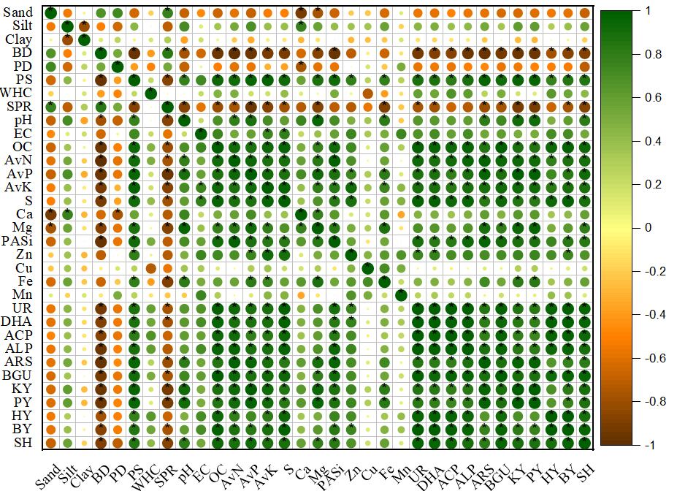
Fig. 1 Correlation matrix among soil parameters (*p≤0.05). The colour and size of each circle indicate the strength and direction of the correlation. Dark green and large circle represent strong positive correlation (closer to +1) while dark brown/orange and large represent strong negative correlation (closer to -1). Similarly, small or no circle represent weak or no correlation (close to 0). Abbreviation (BD: bulk density, PD: particle density, PS: Porosity, WHC: Water holding capacity, SPR: Soil penetration resistance, EC: Electrical conductivity, OC: Organic carbon, AvN: Available N, AvP: Available P, AvK: Available K, S: Available S, Ca: Exchangeable Ca, Mg: Exchangeable Mg, PASi, Plant available Si, Zn: DTPA extractable Zn, Cu: DTPA extractable Cu, Fe: DTPA extractable Fe, Mn: DTPA extractable Mn, UR: Urease, DHA: Dehydrogenase, ACP: Acid phosphatase, ALP: alkaline phosphatase, ARS: Arylsulphatase, BGU: β-Glucosidase, KY: Kernel yield, PY: Pod yield, HY: Haulm yield, BY: Biomass yield, SH: Shelling percentage)
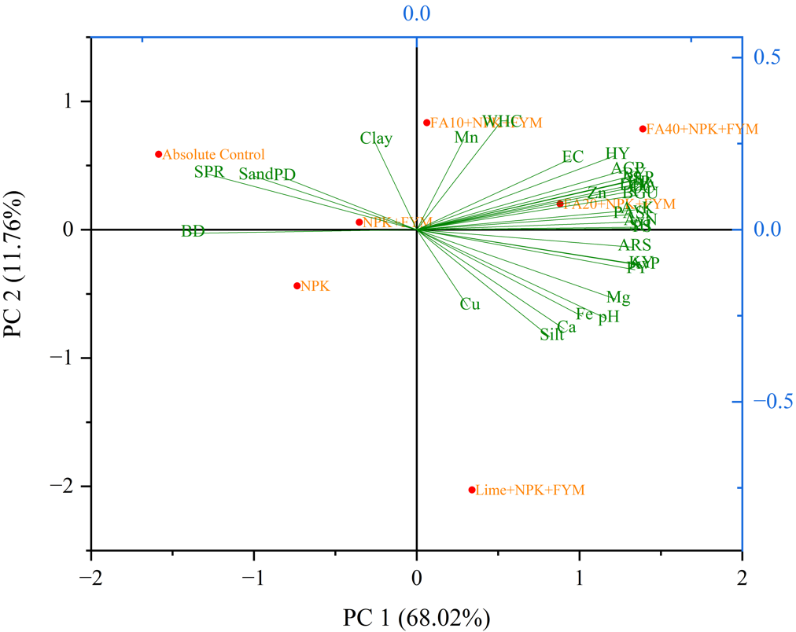
Fig. 2 Biplot of principle component analysis (PCA) showing the effect on soil properties and yield and yield attributes of groundnut due to different FA treatments.

4. DISCUSSION
4.1. Amendment-Induced Modifications to Soil Properties
The integration of fly ash (FA) with farmyard manure (FYM) presents a sustainable strategy for soil amelioration and waste management. Our findings demonstrate that FA application, particularly at higher doses (e.g., FA40+T3), positively influenced soil physical properties, consistent with previous studies (Ahmad et al., 2021). We observed reduced bulk density and soil penetration resistance, alongside increased porosity, suggesting improved soil structure and aeration conducive to root growth.

Notably, FA application did not significantly alter soil pH, likely due to the acidic nature of both the native soil and the FA used. This contrasts with studies utilizing more alkaline FA sources (Tejasvi & Kumar, 2012; Gond et al., 2013). We recorded a dose-dependent increase in soil organic carbon (OC) and major nutrients (N, P, K). The rise in available phosphorus may be attributed to reduced P fixation, a phenomenon also noted with other silicate amendments (Hong et al., 2018; Rautaray et al., 2003). Secondary nutrients (S, Ca, Mg) and plant-available silicon (PASi) were also enhanced, confirming FA's role as a nutrient source (Pandey & Singh, 2010; Lee et al., 2006). Among micronutrients, zinc showed the most pronounced response to FA addition.

Soil enzyme activities (urease, acid and alkaline phosphatase, dehydrogenase, β-glucosidase) were significantly enhanced, serving as robust biomarkers of improved microbial function and biochemical cycling (Nayak et al., 2014; Ramteke et al., 2017). This indicates that FA+FYM integration stimulates microbial processes vital for nitrogen mineralization (urease), phosphorus solubilization (phosphatases), and organic matter decomposition (dehydrogenase, β-glucosidase), thereby enhancing nutrient bioavailability.

4.2. Enhancement of Crop Productivity
Groundnut yield and yield attributes (kernel yield, pod yield, haulm yield, biomass, shelling percentage) exhibited a positive, dose-dependent response to FA application. The highest yields in the FA40+T3 treatment underscore the agronomic benefits of combined nutrient supplementation and soil physical improvement. The critical role of calcium in pod development was further highlighted by the strong performance of the lime-treated plots (Yang et al., 2020). These results align with previous work demonstrating the yield-enhancing potential of FA in groundnut cultivation (Swain et al., 2007; Sireesha & Rani, 2014).

4.3. Integrative Analysis of Soil-Plant Interactions
Multivariate analysis (correlation matrix, PCA) provided a synthesized understanding of treatment effects. The strong positive correlations between soil fertility indicators (OC, AvP, Ca, Mg), enzyme activities, and yield parameters confirm that FA amendments enhance productivity by improving the soil's physico-chemical-biological environment. Conversely, negative associations of yield with compaction indicators (BD, SPR) emphasize the importance of soil physical health.

The PCA clearly differentiated treatments, with high-dose FA amendments (FA40+T3, FA20+T3) clustering with improved soil properties and higher yields, while control treatments were associated with poorer soil conditions. This reinforces the conclusion that the integrated use of FA with organic and inorganic amendments is an effective strategy for enhancing soil quality and crop productivity within a sustainable framework.
5. Conclusion
This study establishes FA as an effective soil amendment that significantly enhanced soil nutrient availability, physicochemical properties, and microbial activity, leading to increased groundnut productivity. The synergistic application of FA with recommended fertilizers and farmyard manure (FYM) was particularly effective in improving soil health and crop performance.
To translate these findings into widespread practice, future research must address the long-term sustainability of fa use. Key priorities include multi-location trials to determine optimal, crop-specific application rates, and rigorous assessment of heavy metal accumulation risks across diverse soil and climatic conditions. Such research is essential to develop safe, evidence-based guidelines for integrating this industrial by-product into sustainable agricultural systems, thereby transforming a waste burden into a valuable resource for enhancing food security and environmental sustainability.

COMPETING INTERESTS DISCLAIMER:
Authors have declared that they have no known competing financial interests OR non-financial interests OR personal relationships that could have appeared to influence the work reported in this paper.

References

Ahmad, G., Khan, A. A., & Mohamed, H. I. (2021). Impact of the low and high concentrations of fly ash amended soil on growth, physiological response, and yield of pumpkin (Cucurbita moschata Duch. Ex Poiret L.). Environmental Science and Pollution Research, 28(14), 17068-17083.
Baruah, T.C. & Barthakur, H.P. 1997. A textbook on Soil Analysis. Vikas Publishing House PVT LTD, 576 Masjid Road, Jangpura, New Delhi 110 014.
Blake, G. R., & Hartge, K. H. (1986). Bulk density. Methods of soil analysis: Part 1 Physical and mineralogical methods, 5, 363-375.
Bouyoucos, G. J. (1962). Hydrometer method improved for making particle size analyses of soils 1. Agronomy journal, 54(5), 464-465.
Casida Jr, L. E., Klein, D. A., & Santoro, T. (1964). Soil dehydrogenase activity. Soil science, 98(6), 371-376.
Down To Earth. (2019, July 12). As told to Parliament (July 12, 2019): India doubled usage of fly ash in nine years. https://www.downtoearth.org.in/mining/as-told-to-parliament-july-12-2019-india-doubled-usage-of-fly-ash-in-nine-years-65614
Flint, Alan L., & Lorraine E. Flint. "2.2 Particle Density." Methods of soil analysis: Part 4 physical methods 5 (2002): 229-240.
Gond, D. P., Singh, S., Pal, A., & Tewary, B. K. (2013). Growth, yield and metal residues in Solanum melongena grown in fly ash amended soils. Journal of Environmental Biology, 34(3), 539.
Haysom, M. B. C., & Chapman, L. S. (1975). Some aspects of the calcium silicate trials at Mackay. 117-122.
Hong, C., Su, Y., & Lu, S. (2018). Phosphorus availability changes in acidic soils amended with biochar, fly ash, and lime determined by diffusive gradients in thin films (DGT) technique. Environmental Science and Pollution Research, 25(30), 30547-30556.
Jackson, M. L. (1973). Soil chemical analysis-advanced course: A manual of methods useful for instruction and research in soil chemistry, physical chemistry of soils, soil fertility, and soil genesis. author.
Jala, S., & Goyal, D. (2006). Fly ash as a soil ameliorant for improving crop production—a review. Bioresource technology, 97(9), 1136-1147.
Kumar, A., Usmani, Z., & Kumar, V. (2017). Biochar and flyash inoculated with plant growth promoting rhizobacteria act as potential biofertilizer for luxuriant growth and yield of tomato plant. Journal of environmental management, 190, 20-27.
Lal, K., Chhabra, R., Mongia, A. D., Meena, R. L., & Yadav, R. K. (2012). Release and uptake of potassium and sodium with fly ash application in rice on reclaimed alkali soil. Journal of the Indian Society of Soil Science, 60(3), 181-186.
Lee, H., Ha, H. S., Lee, C. H., Lee, Y. B., & Kim, P. J. (2006). Fly ash effect on improving soil properties and rice productivity in Korean paddy soils. Bioresource technology, 97(13), 1490-1497.
Lindsay, W. L., & Norvell, W. (1978). Development of a DTPA soil test for zinc, iron, manganese, and copper. Soil science society of America journal, 42(3), 421-428.
Nayak, A. K., Kumar, A., Raja, R., Rao, K. S., Mohanty, S., Shahid, M., ... & Bhattacharyya, P. (2014). Fly ash addition affects microbial biomass and carbon mineralization in agricultural soils. Bulletin of environmental contamination and toxicology, 92, 160-164.
NTPC (2023). Ash Utilization. https://ntpc.co.in/about-us/corporate-functions/ash-utilisation
Olsen, S. R. (1954). Estimation of available phosphorus in soils by extraction with sodium bicarbonate (No. 939). US Department of Agriculture.
Pandey, V. C., & Singh, N. (2010). Impact of fly ash incorporation in soil systems. Agriculture, ecosystems & environment, 136(1-2), 16-27.
Piper, S. C. S. 1950. Soil and plant analysis. Univ. Inter Sci. publishers. Inc. New york. Adelaide, 258-275.
Ram, L. C., & Masto, R. E. (2014). Fly ash for soil amelioration: a review on the influence of ash blending with inorganic and organic amendments. Earth-Science Reviews, 128, 52-74.
Ramteke, L. K., Sengar, S. S. & Porte, S. S., 2017, Effect of fly ash, organic manure and fertilizers on soil microbial activity in rice-wheat cropping system in Alfisols and Vertisols. Int. J. Curr. Microbiol. App,6(7): 1948-1952.
Rautaray, S. K., Ghosh, B. C., & Mittra, B. N. (2003). Effect of fly ash, organic wastes and chemical fertilizers on yield, nutrient uptake, heavy metal content and residual fertility in a rice–mustard cropping sequence under acid lateritic soils. Bioresource Technology, 90(3), 275-283.
Singh, J. S., & Pandey, V. C. (2013). Fly ash application in nutrient poor agriculture soils: impact on methanotrophs population dynamics and paddy yields. Ecotoxicology and Environmental Safety, 89, 43-51.
Sireesha, A., & Rani, P. P. (2014). Effect of flyash and fertilizers on yield, nutrient uptake and soil nutrient status of groundnut (Arachis hypogea).
Subbiah, B. V., & Asija, G. L. (1956). A rapid procedure for the estimation of available nitrogen in soils.
Swain, D. K., Rautaray, S. K., & Ghosh, B. C. (2007). Alkaline coal fly ash amendments are recommended for improving rice-peanut crops. Acta Agriculturae Scandinavica Section B-Soil and Plant Science, 57(3), 201-211.
Tabatabai, M. A. (1994). Soil enzymes. Methods of soil analysis: Part 2 Microbiological and biochemical properties, 5, 775-833.
Tejasvi, A., & Kumar, S. (2012). Impact of fly ash on soil properties. National Academy Science Letters, 35, 13-16.
Walkley, A., & Black, I. A. (1934). An examination of the Degtjareff method for determining soil organic matter, and a proposed modification of the chromic acid titration method. Soil science, 37(1), 29-38.
Yang, S., Wang, J., Tang, Z., Guo, F., Zhang, Y., Zhang, J., ... & Li, X. (2020). Transcriptome of peanut kernel and shell reveals the mechanism of calcium on peanut pod development. Scientific reports, 10(1), 15723.

