Agronomic Assessment of Artificial Termite Mound waste product in Rainfed Rice, Central-Western Côte d’Ivoire

.
ABSTRACT
Aims: To contribute to improving the productivity of rainfed rice by amending the soil with a waste product.
Study design: The experiment was conducted using a randomized complete block design (RCBD) with three replicates, each comprising ten treatments.
Place and Duration of Study: The field trial was conducted in 2018–2019 in Daloa, Côte d'Ivoire.
Methodology: A sandy soil was amended with the waste product “Termisol.” Six doses of Termisol (29.1 t ha⁻¹ to 175 t ha⁻¹) and four controls (zero fertilizer, NPK fertilizer (0.15 t ha⁻¹), manure (7 t ha⁻¹), and natural termite mound soil (116.5 t ha⁻¹) were tested. Observations focused on leaf area, plant height, biomass production, and yield.
Results: The results showed that in the first cycle, the dose of 116.5 t ha⁻¹ produced the largest leaves (56.11±10.48 cm²), the highest plant biomass (21.32±7.75 g), while the dose of 175 t ha⁻¹ produced the tallest plants (67.43±1.95 cm) and the dose of 87.30 t ha⁻¹ produced the highest fresh yield (5.71±1.26 t ha⁻¹). The 175 t ha⁻¹ dose produced the widest leaves (48.24±1.95 cm²), the tallest plants (47.60 ±4.04 cm), the largest biomass (11.50 ± 1.60 g), and the highest yield (4.43 ± 0.15 t ha⁻¹) in the second cycle.
Conclusion: The use of the waste product “Termisol” as a soil amendment to improve soil fertility could be a viable method for reducing production costs and increasing rice yields. However, this study needs to be expanded to refine the economically viable application rates for widespread use.
Keywords: Amendment, waste product, “Termisol,” rice, Daloa, Côte d'Ivoire

1. INTRODUCTION

Food crop farming in Africa is characterized by low productivity due to rapid soil nutrient depletion and the combined effects of poor agricultural land management, varying climatic conditions, and population growth (Sanchez et al., 1997; Bationo et al., 2004). In sub-Saharan Africa, agricultural residues are generally collected after harvest by farmers for domestic use or burned in bush fires to create new pastureland. These actions promote the irreversible export of soil nutrients, leading to a disruption in the renewal of soil organic matter. Furthermore, fallow land is becoming less and less common due to strong pressure on arable land caused by growing needs resulting from population growth (N’Goran et al., 1997). Thus, the dominant role played by agriculture in the economy of Côte d'Ivoire forces farmers to resort to modern agricultural techniques such as varietal selection and the rational use of pesticides and chemical fertilizers to improve yields (N'Goran, 1995). While chemical fertilizers have a rapid beneficial effect on crop productivity, justifying their use, their misuse leads to soil degradation through loss of organic matter and acidification. Furthermore, the cost of fertilizers makes them almost inaccessible to small farmers (Gala et al., 2007; Useni et al., 2012), while the risks of environmental pollution and water eutrophication pose a threat to biodiversity and endanger the lives of populations. As a result, alternative methods of soil fertility management are being sought.
In addition, various studies report on certain soil macroinvertebrates such as termites and earthworms and the use of agricultural residues to improve soil properties (Guei et al., 2020). Thus, the work of Dosso et al. (2017) highlighted the contribution of termites to restoring the fertility of degraded soils by examining their contribution of nutrients through the on-site decomposition of residues from a few plant species, while the work of Soro et al. (2021) demonstrated the fertilizing capacity of waste products from artificial termite mounds and their potential use in rainfed rice cultivation. These results open up an opportunity to initiate the formation by termites of a waste product that retains the characteristics of the natural termite mound in a semi-controlled environment. The overall objective of this study is to contribute to improving rainfed rice productivity by amending the soil with the waste product “Termisol” from the digestion of agricultural residues by termites in an artificial termite mound. The specific objective is to evaluate the fertilizing capacity of the waste product in rainfed rice cultivation.

2. material and methods

2.1 Location of the study site
The work was carried out in Daloa and Campement Zongo. The first site was used for the production of the termite waste product “Termisol” and the second for agronomic testing (Figure 1).

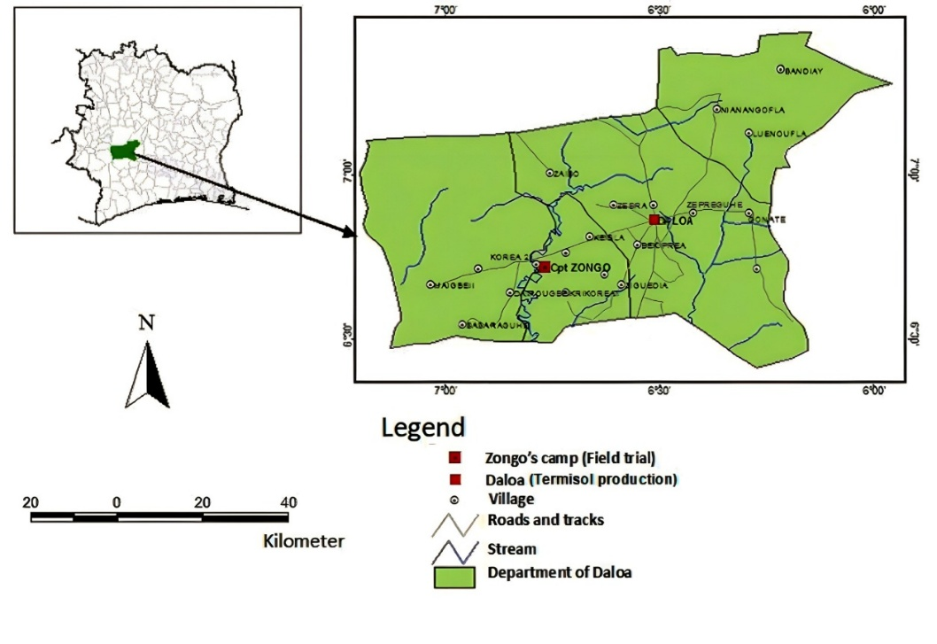
Fig. 1. Location of the production site and the evaluation test of the termite waste product ʽʽTermisolʼʼ

2.2 Material

2.2.1 Biological material
The biological material used in this study consists of rice plants grown from seeds of the IDSA 10 variety. This is a rainfed rice variety with a 105-day cycle and an average yield of 2.5 t ha⁻¹. It also has good drought tolerance (CNRA, 2016).

2.2.2 Technical equipment
The technical equipment used includes an electronic scale for weighing, a carpenter's folding ruler for measuring the height of rice plants, a pair of scissors used for sampling plants, tracing paper for evaluating leaf area, an oven, and aluminum foil for drying samples.

2.2.3 Soil, fertilizers, and soil amendments
The termite waste product “Termisol” is evaluated for its fertilizing capacity in rainfed rice cultivation in the presence of three controls:
­ Poultry manure (organic fertilizer) is characterized by nitrogen (N), phosphorus (P), potassium (K), calcium (Ca), and magnesium (Mg) contents of 1.40%, 0.45%, 1.72%, 2.44%, and 0.32%, respectively. As for trace elements, the copper (Cu), iron (Fe), manganese (Mn), and zinc (Zn) contents were 5.03 mg kg⁻¹, 10.11 mg kg⁻¹, 5.09 mg kg⁻¹, and 7.19 mg kg⁻¹, respectively.
­ NPK (15-15-15) and urea (46% N);
Termite mound soil characterized by a silty sandy texture, low in organic matter (1.16%), slightly acidic with a CEC of 7.2 cmol kg⁻¹. It is a desaturated soil with a saturation rate (V) of 34.44% and a base sum equal to 2.48 cmol kg⁻¹.
Termisol was obtained through the degradation of corn residues and the rise of mineral constituents by termites in an artificial termite mound. It is characterized by a sandy loam texture, rich in organic matter (5.86%), slightly acidic with a CEC of 9.92 cmol kg⁻¹. It is a moderately desaturated soil with a saturation rate (V) of 74.14% and a base sum of 7.4 cmol kg⁻¹ (Soro et al., 2021).

2.3 Methods

2.3.1 Agronomic evaluation of the termite waste product “Termisol”

2.3.1.1 Experimental design
The experimental design is completely randomized blocks (CRB) with three replicates of ten (10) treatments each (Figure 2). The treatments consist of six (6) doses of “Termisol” and four controls.
The doses of “Termisol” applied are calculated based on the mass of soil contained in one square meter at a working depth of 22 cm of the plot to be treated (Soro et al., 2021).
The doses of Termisol used were therefore:
- 29.1 t ha⁻¹, or 1% Termisol (T1);
- 58.30 t ha⁻¹, or 2% Termisol (T2);
- 87.30 t ha⁻¹, or 3% Termisol (T3);
- 116.50 t ha⁻¹, or 4% Termisol (T4);
- 145.50 t ha⁻¹, or 5% Termisol (T5);
- 175 t ha⁻¹, or 6% Termisol (T6).
The control treatments are:
- ZeroF: absolute control without fertilizer (T0);
- NPK: application of 0.15 t ha⁻¹ of NPK (15-15-15): mineral control (T7);
- TermNat: application of 116.50 t ha⁻¹ of natural termite mound soil (T8) taken from the trial site (Boga, 2007);
- Manure: application of chicken manure at a rate of 7 t ha⁻¹: organic control (T9).
The treatments were applied once as basal dressing in cycle 1. During the vegetative phase, top dressing with urea (46% N) at a rate of 0.07 t ha⁻¹ was applied 40 days after sowing (das) on all plots during both cycles.
The basic plot is rectangular, measuring 1.25 m long and 1 m wide.
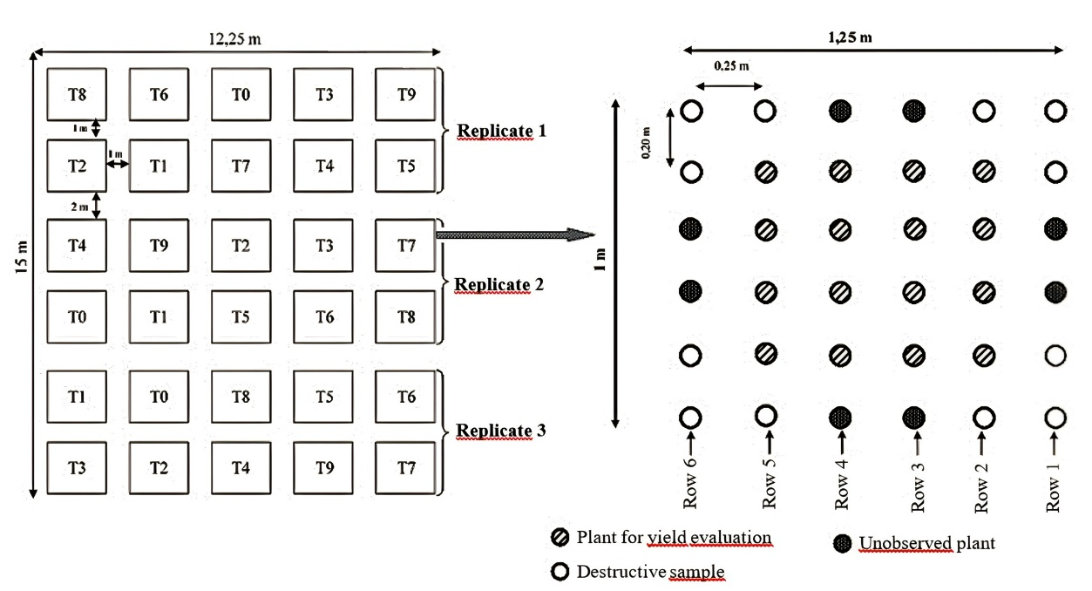
Fig. 2. Experimental design applied in the field

2.3.1.2 Evaluation of leaf area
Leaf area was evaluated at 64 days after sowing (das) by reproducing 4 leaves per treatment on tracing paper. The traced image of the leaf was then cut out and its mass evaluated. This mass was used to estimate the leaf area, knowing the mass per unit area of the tracing paper. The leaf areas were then deduced by correspondence from the calculated masses (Lepengue et al., 2012). Leaf area is expressed in square centimeters (cm²).

2.3.1.3 Evaluation of plant height
Plant height was measured using a carpenter's folding ruler at 75 days after sowing (das). This measurement was taken from the base of the plant at the point where the panicle was attached to the panicle leaf of the most vigorous plant in the plot. Height was expressed in cm.

2.3.1.4 Determination of biomass and root size
Destructive sampling was carried out on two plants per treatment at 75 das. The selected plants were carefully pulled up, the roots were rinsed with water, dried with blotting paper, and their lengths measured with a folding carpenter's ruler. Each fresh plant was then weighed and its root cut at the collar. The fresh roots and fresh aerial parts were weighed separately and placed in an oven to dry at 70°C for 48 hours before dry weighing. Lengths were expressed in cm and masses in g.

2.3.1.5 Evaluation of paddy yield
The rice is harvested by bunch at 105 das. The panicles from the same bunch are then weighed together. Three panicles per plot are sent to the laboratory to be dried in an oven at 65°C for 24 hours.
The dry paddy yield is calculated at 12% moisture content, using a conversion table to convert fresh yield to dry yield:

Yield = (harvested mass (kg))/(area (m²)) x k, where k = (100-H)/(100-h)

Yield = yield in kg m⁻²;
H = moisture content at harvest (%);
h = moisture content of dry grains (12%);
k = conversion factor from wet grain to dry grain.

2.3.2 Data processing
The data were processed using XLSTAT software. The normality of the sample distributions was verified using the Shapiro-Wilk test and the homogeneity of variances was verified using Levene's test. If the variable from which the sample originates follows a normal distribution and the variances are homogeneous, an ANOVA is performed; otherwise, the nonparametric Kruskal-Wallis test is applied. The analysis of variance was supplemented by the Newman-Keuls test, which allowed the means to be ranked using the smallest significant difference (Pvalues) at a 5% probability threshold. A principal component analysis (PCA) was then performed using R software.

3. results and discussion

3.1 Effect of “Termisol” on the growth and yield of rainfed rice depending on treatment

3.1.1 Effect of “Termisol” dose on rice plant height
No significant differences were observed between treatments in terms of rice plant height (Haut), regardless of the crop cycle (Table 1). However, the average plant height varied overall between 31.33±2.47 cm (1% Termisol, cycle 2) and 67.43±1.95 cm (6% Termisol, cycle 1). Between these two extreme values, plants in the 3% and 5% Termisol treatments reached heights of 63.80±1.50 cm and 64.56±0.62 cm, respectively, in cycle 1. The plants in the ZeroF and TermNat treatments were slightly taller than those in the 1% Termisol treatment, reaching heights of 32.53±3.62 cm and 34.07±8.52 cm, respectively, in cycle 2. Overall, the plants were taller in cycle 1.

3.1.2 Effect of the dose of “Termisol” on leaf area
The leaf surface area (Surfol) of rice plants varied significantly in cycle 2 (P = .001) between treatments (Table 1). It ranged from 24.81±0.32 cm² in the TermNat treatment in cycle 2 to 56.11±10.48 cm² in the 4% Termisol treatment (cycle 1). The 5%Termisol and 6%Termisol treatments had leaf areas of 53.61±14.07 cm² and 54.16±9.05 cm² respectively in cycle 1, below that of the 4%Termisol treatment in the same cycle. The ZeroF and 3% Termisol treatments had leaf areas slightly larger than that of the TermNat treatment, which was the smallest in cycle 2.

Table 1. Variation in the number of leaves, leaf area, and height of rice during the two cycles

Treatments | Growth parameters
Treatments | Surfol (cm²) |  |  | Haut (cm)
Treatments | Cycle 1 | Cycle 2 |  | Cycle 1 | Cycle 2
ZeroF (without fertilizer) | 43.05±1.94ª | 25±0.96^{c} |  | 58.46±5.50ª | 32.53±3.62ª
1%Termisol (29.1 t ha⁻¹) | 43.14±3.22ª | 29.35±3.49^{bc} |  | 61.03±1.57ª | 31.33±2.47ª
2%Termisol (58.30 t ha⁻¹) | 50.74±17.76ª | 35.09±3.07^{abc} |  | 61.11±1.46ª | 35.08±5.42ª
3%Termisol (87.30 t ha⁻¹) | 53.24±9.36ª | 29.16±4.88^{bc} |  | 63.80±1.50ª | 39.57±10.39ª
4%Termisol (116.50 t ha⁻¹) | 56.11±10.48ª | 33.98±11.62^{abc} |  | 63.62±1.62ª | 37.73±4.98ª
5%Termisol (145.50 t ha⁻¹) | 53.61±14.07ª | 43.61±3.63^{ab} |  | 64.56±0.62ª | 38.49±4.77ª
6%Termisol (175 t ha⁻¹) | 54.16±9.05ª | 48.24±4.78ª |  | 67.43±1.95ª | 47.60±4.04ª
NPK (0.15 t ha⁻¹) | 44.35±2.85ª | 33.88±2.37^{abc} |  | 62.70±5.20ª | 38.57±4.48ª
TermNat (116.50 t ha⁻¹) | 46.85±10.35ª | 24.81±0.32^{c} |  | 59.05±6.77ª | 34.07±8.52ª
Manure (7 t ha⁻¹) | 43.98±8.95ª | 30.46±11.60^{bc} |  | 62.44±5.99ª | 43.53±2.80ª
CV | 0.1949 | 0.2603 |  | 0.0652 | 0.1749
P | .6217 | .0017 |  | .2566 | .0559
Effect | ns | ** |  | ns | ns
Averages followed by the same letter in the same column are not significantly different at the 5% threshold for the Newman-Keuls test; **highly significant difference P = .001; ns: Non-significant difference P > .05; CV: Coefficient of variation; TermNat: Natural termite mound; ZeroF: Control without fertilizer; Surfol: Leaf area; Height: Height 75 days after sowing (das).

3.1.2 Effect of dose on dry biomass production in rice

The fertilizer dose had a highly significant effect (P = .001) on dry matter production in cycle 2 (Table 2).
Above-ground biomass (MsTF) was higher in the 6% Termisol (18.06±5.34 g), 2% Termisol (19.45±10.78 g), and 4% Termisol (19.84±7.26 g) treatments in cycle 1. The lowest amounts of dry matter were recorded in the ZeroF, 1% Termisol, and TermNat treatments, with values of 2.17±0.43 g, 4.19±0.96 g, and 5.15±0.98 g, respectively, in cycle 2. Above-ground dry matter was more abundant in cycle 1.
Root biomass (MsRac) varied between 0.44±0.03 g (ZeroF, cycle 2) and 1.43±0.46 g (4% Termisol, cycle 1). Between these two values, the 6% Termisol (cycle 2) and 2% Termisol (cycle 1) treatments achieved dry matter quantities of 1.37±0.24 g and 1.41±0.59 g. The TermNat and 1% Termisol treatments showed low biomass values of 0.65±0.15 g and 0.68±0.13 g, respectively, in cycle 2, which were higher than those of the ZeroF treatment in the same cycle, but with a highly significant difference between these three treatments. The total biomass of the plants (MsPE) evolved similarly to the biomass of the aerial part (MsTF). With the exception of the 6% Termisol and NPK treatments, the proportion of root dry matter (MsRac) was higher in cycle 1.

Table 2. Variation in rice biomass during two crop cycles according to fertilizer dose

 |  |  |  | Growth parameters
Treatments | MsPE (g) |  |  |  | MsTF (g) |  |  | MsRac (g)
 | Cycle 1 | Cycle 2 |  |  | Cycle 1 | Cycle 2 |  | Cycle 1 | Cycle 2
ZeroF | 14.69±2.25ª | 2.63±0.41^{b} |  |  | 13.45±2.17ª | 2.17±0.43e |  | 1.18±0.08ª | 0.44±0.03^{b}
1%Termisol | 14.7±2.90ª | 4.89±1.08^{ab} |  |  | 13.39±2.83ª | 4.19±0.96de |  | 1.24±0.07ª | 0.68±0.13^{b}
2%Termisol | 20.94±11.40ª | 6.18±1.64^{ab} |  |  | 19.45±10.78ª | 5.44±1.52^{bcde} |  | 1.41±0.59ª | 0.75±0.12^{b}
3%Termisol | 16.02±0.83ª | 9.01±2.52^{ab} |  |  | 14.72±0.78ª | 8.06±2.33^{abc} |  | 1.25±0.08ª | 0.94±0.19^{ab}
4%Termisol | 21.32±7.75ª | 8.97±3.12^{ab} |  |  | 19.84±7.26ª | 7.99±2.95^{abc} |  | 1.43±0.46ª | 0.99±0.19^{ab}
5%Termisol | 15.55±2.98ª | 9.89±3.21ª |  |  | 14.33±2.80ª | 8.91±3.07^{ab} |  | 1.18±0.22ª | 0.98±0.15^{ab}
6%Termisol | 19.34±5.45ª | 11.50±1.60ª |  |  | 18.06±5.34ª | 10.15±1.47ª |  | 1.26±0.18ª | 1.37±0.24ª
NPK | 14.52±0.87ª | 7.86±2.41^{ab} |  |  | 13.62±0.66ª | 6.92±2.21^{abcd} |  | 0.88±0.22ª | 0.92±0.26^{ab}
TermNat | 14.07±1.39ª | 5.81±1.16^{ab} |  |  | 13.14±1.33ª | 5.15±0.98^{cde} |  | 0.95±0.20ª | 0.65±0.15^{b}
Manure | 14.89±2.14ª | 7.39±3.84^{ab} |  |  | 13.80±2.03ª | 6.55±3.51^{abcd} |  | 1.05±0.21ª | 0.84±0.32^{b}
CV | 0.2937 | 0.4224 |  |  | 0.3004 | 0.4385 |  | 0.2430 | 0.3336
P | .5098 | .0069 |  |  | .5144 | .0084 |  | .3553 | .0017
Effect | ns | ** |  |  | ns | ** |  | ns | **

Averages followed by the same letter in the same column are not significantly different at the 5% threshold for the Newman-Keuls test; * significant difference P =.05; **: highly significant difference P =.001; ns: non-significant difference P > .05; CV: Coefficient of variation;

3.1.3 Effect of the dose of Termisol on 1000-grain weight, grain moisture, and yield
The addition of Termisol had a significant effect (P < .001) on 1000-grain weight (PMG), relative grain moisture at harvest (HR(%)), and fresh yield at harvest (Rendfrais) in the second cycle (Table 3). The PMG varied overall between 17.84±1.58 g (ZeroF, cycle 2) and 26.88±3.19 g (4% Termisol, cycle 2). Thus, the highest PMGs were obtained with the 4%, 5%, and 2% Termisol treatments, with 26.88±3.19 g (cycle 2); 26.22±5.31 g (cycle 2) and 25.74±0.76 g (cycle 1), respectively. The moisture content of the grain at harvest varied significantly (P ˂ .001) between treatments in cycle 2 only. The ZeroF treatment (cycle 2) had the highest grain moisture content at harvest, 23.45±0.92%, and the 4% Termisol treatment had the lowest moisture content in cycle 1, 15.31±1.04%.
The fresh yield at harvest of rice was strongly influenced (P ˂ .001) by treatment during cycle 2 only. The highest fresh yields were obtained with the 3%, 2%, and 1% Termisol treatments, with 5.71±1.26 t ha⁻¹; 5.64±1.42 t ha⁻¹; and 5.16±0.14 t ha⁻¹ respectively in cycle 1. The ZeroF, TermNat and 2% Termisol treatments had the lowest fresh yields, with values of 2.29±0.45 t ha⁻¹, 2.53±0.70 t ha⁻¹ and 2.95±0.54 t ha⁻¹, respectively, in cycle 2.

Table 3. Average change in production parameters during the two cycles

 | Production parameters
Treatments | PMG (g) |  |  | HR(%) |  |  | Rendfrais (t ha⁻¹)
 | Cycle 1 | Cycle 2 |  | Cycle 1 | Cycle 2 |  | Cycle 1 | Cycle 2
ZéroF | 24.29±2.92ª | 17.84±1.58^{c} |  | 16.39±0.41ª | 23.45±0.92ª |  | 3.77±0.41ª | 2.29±0.45^{f}
1%Termisol | 24.76±0.72ª | 21.05±3.10^{c} |  | 16.05±0.68ª | 22.05±1.28ª |  | 5.16±0.14ª | 2.96±0.41^{def}
2%Termisol | 25.74±0.76ª | 19.08±1.39^{c} |  | 15.92±0.59ª | 21.8±1.37ª |  | 5.64±1.42ª | 2.95±0.54^{def}
3%Termisol | 25.57±2.64ª | 21.48±0.51b^{c} |  | 16.18±1.01ª | 22.33±0.49ª |  | 5.71±1.26ª | 3.15±0.63^{cde}
4%Termisol | 24.60±2.08ª | 26.88±3.19ª |  | 15.31±1.04ª | 18.11±1.84^{b} |  | 4.76±0.38ª | 4.08±0.54^{ab}
5%Termisol | 24.28±3.54ª | 26.22±5.31ª |  | 15.66±1.31ª | 19.28±1.80^{b} |  | 4.67±0.29ª | 3.96±0.45^{abc}
6%Termisol | 22.94±2.45ª | 25.56±2.09^{ab} |  | 16.48±0.53ª | 19.28±1.08^{b} |  | 4.86±0.93ª | 4.43±0.15ª
NPK | 25.85±0.73ª | 19.71±1.16^{c} |  | 16.87±1.30ª | 23.28±1.27ª |  | 4.07±0.63ª | 3.48±0.29^{bcd}
TermNat | 24.32±1.07ª | 18.33±2.27^{c} |  | 16.98±0.24ª | 22.98±1.56ª |  | 5.08±0.62ª | 2.53±0.70^{ef}
Manure | 25.24±2.22ª | 20.70±0.95^{c} |  | 15.33±0.77ª | 22.18±0.88ª |  | 3.90±0.45ª | 3.97±0.38^{abc}
CV | 0.0785 | 0.1748 |  | 0.0555 | 0.0971 |  | 0.1917 | 23.21
P | .8542 | .0006 |  | .2744 | .0004 |  | .0696 | .0008
Effect | ns | *** |  | ns | *** |  | ns | ***
Averages followed by the same letter in the same column are not significantly different at the 5% threshold for the Newman-Keuls test; ** P < 0.0001

Paddy yields varied according to the dose of Termisol in cycle 1 and cycle 2 (Figure 3). In cycle 1, fresh yields increased gradually with the doses of Termisol, from 3.77±0.36 t ha⁻¹ (ZeroF) to 5.71±1.26 t ha⁻¹ (3% Termisol), while dry yields increased from 3.58±0.32 t ha⁻¹ (ZeroF) to 5.44±1.18 t ha⁻¹ (3% Termisol). Beyond these values, the yield decreased despite the increase in the Termisol dose. For the second cycle carried out in 2019, yields were lower than those obtained in 2018. For this first cycle, the best yield was obtained on the plot treated with 3% Termisol.
Fresh and dry yields in cycle 2 fluctuated, with the best yields obtained on plots treated with 4% Termisol or more for both fresh and dry yields.

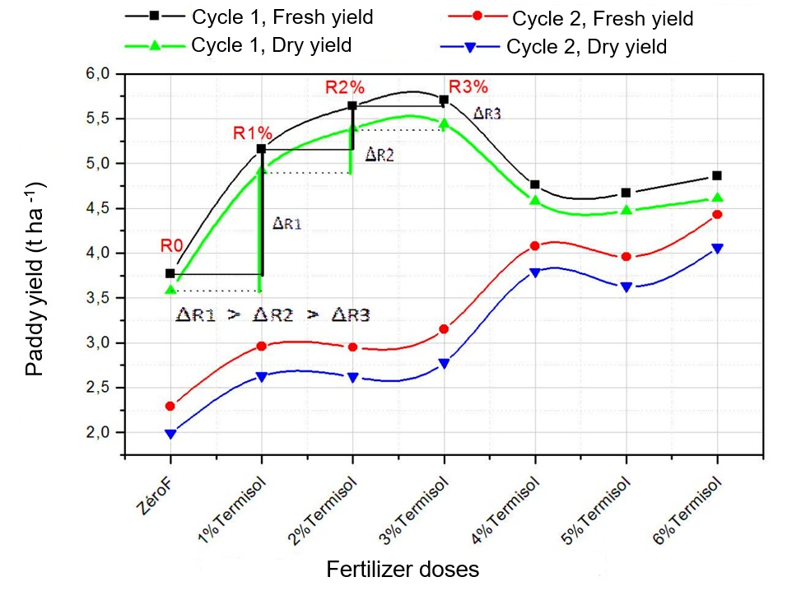
Fig. 3. Yield curves for paddy rice in t ha⁻¹ as a function of the dose in cycles 1 and 2

3.2 Relationship between growth and production parameters in rice
The projection in factorial plane 1-2 associates all growth and production parameters with axis 1 (Figure 4 A).
The factorial map allows two productivity groups to be defined that are opposed on axis 1 (Figure 4 B). Group 1, characterized by low production levels, includes the treatments Termitière naturelle (TermNat), ZéroF, 1%Termisol, NPK, and Fiente, forming the Fiente - NPK group. Group 2, comprising treatments based on Termisol at doses of 2 to 6%, constitutes the Termisol group, characterized by better vegetative growth and higher rice productivity.

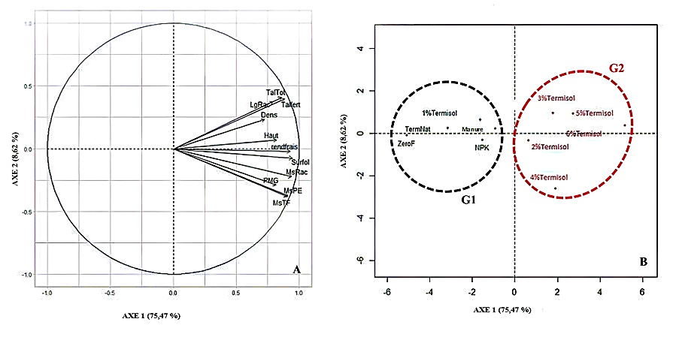
Fig. 4. PCA combining growth and yield parameters for the IDSA10 rice variety
Dens: plant density; LgRac: root length; TalTot: total number of tillers per plant; Talfert: number of fertile tillers per plant.

3.3 Discussion
The results of the study showed that soil amendment with Termisol improved rice growth and production parameters. Termisol promoted good height growth, larger leaf areas, and greater plant biomass. It also promoted good yields with reduced grain moisture at harvest. Thus, despite a slightly lower thousand-grain weight compared to NPK fertilization, the waste products from artificial termite mounds achieved the best yields (Kpangba et al., 2020).
The effect of Termisol on the agronomic parameters of rice demonstrates its good fertility potential. Plots treated with Termisol have a structural advantage in that they remain within the same pH range favorable to rice (Zingore et al., 2014). In addition, the organic matter in Termisol and the presence of clay + silt contributed to the development of physical and chemical conditions favorable to good soil growth and productivity (Drouet, 2010). Organic matter both nourishes plants by releasing adsorbed mineral elements and stores these elements. It forms the basis of soil fertility and plays a role in soil structure (Some et al., 2015). These results confirm those of Boga (2007) and Soro et al. (2021), who observed improved growth parameters for maize and rice in the former case and for rainfed rice in the latter. Mokossesse et al. (2009) showed that termite mound soil significantly influenced the growth of Sorghum sp and Crotalaria ochroleuca in pots, while Kpangba et al. (2020) observed that termite mound soil significantly influenced the growth parameters of black nightshade. Lepage & Duponois (2006) also showed that Cubitermes termite powder used in gardening improves tomato fruit production by 150 to 300%. However, according to these authors, this influence of Cubitermes termite mound soil is due to the high nitrogen-rich fulvic acid content of the nest.
The results of this study show that Macrotermes termite mound soil, a natural termite mound at the test site, has little influence on the agronomic parameters of rice. The results obtained are similar to the observations made by Boga (2007) on corn plants. This low influence is thought to be due to the low colloidal content in natural termite mound soil. Indeed, termite mound soil is highly sandy and lacks chemical fertility potential. However, according to Kang (1978), in addition to this low mineral content, the phosphorus contained in Macrotermes termite mound material is difficult to mineralize and therefore unavailable to plants. The results obtained contradict those of Beugré et al. (2020), who showed that Macrotermes bellicocus termite mound soil was rich in minerals and organic matter, but linked its low influence on the agronomic parameters of cowpea to its high acidity.
The addition of 4% and 6% Termisol had the most significant effects on biomass and rice plant height. The large amount of biomass and large plant size obtained with these treatments compared to the other treatments could be explained by the good organomineral level of these doses of Termisol. Indeed, these doses improved the nitrogen and phosphorus content of the soil. These results corroborate those of Kpangba et al. (2020), who obtained significant effects on the vegetative growth and biomass yield of black nightshade (Solanum nigrum L.) plants with the addition of 2 kg, 4 kg, and 6 kg of termite mound soil. Rice plants require significant amounts of nutrients, particularly nitrogen, potassium, and phosphorus, as well as calcium and magnesium (Cérighelli, 1955; Jacquot & Courtois, 1983). The content of these elements in the soil determines the growth and productivity of rice, which explains why rice grows well with these treatments. Lafon et al. (1985) and Mrhari (1997) reported that the mineral nitrogen absorbed by the plant was used for amino acid synthesis and played an important role in the growth and development of the vegetative system. Termisol probably improved the effectiveness of the urea applied due to its contribution to the texture, organic matter, and consequently the structure of the initially sandy soil. In fact, the 0.07 t ha⁻¹ dose applied to the soil during production would have constituted the mineral supplement to Termisol for sustainable rice production on this type of sandy soil.
From cycle 1 to cycle 2, a gradual decrease in rice plant height and yield was observed in almost all treatments. This decrease could be explained by a gradual depletion of minerals in the soil, due to uptake by the rice plants and leaching by rainwater during each growing season. Termisol therefore acts as a slow-release fertilizer, as most of the nitrogen it contains is supplied in organic form, and the mineral forms that can be used by plants are released gradually (Mokossesse et al., 2012).
The rice was harvested at 105 das with moisture levels ranging from 15.31% to 16.98% in cycle 1 and from 18.11% to 23.45% in cycle 2. In all cases, rice harvested from plots treated with Termisol had the lowest moisture content and higher yields. The application of Termisol therefore provided conditions for earlier harvesting compared to other treatments.
The paddy yield in cycle 2 is lower than that in cycle 1. Furthermore, only the yield in cycle 1 varied according to the law of less-than-proportional yield supplements, in line with the work of Soro et al. (2021). This response of rice to increasing doses of Termisol confirms its fertility potential. Termite activity in the traps over a period of three to six days therefore produced a substance with fertility potential that can be used in food crop agriculture. Furthermore, the variation in paddy yield in cycle 2 is not related to the yield in cycle 1. The differentiated effect between the yields of cycles 1 and 2 for all treatments therefore reflects a different and more significant after-effect of Termisol.

4. Conclusion

The results of the effect of ʽʽTermisolʼʼ on the agronomic parameters of rice show that different doses of ʽʽTermisolʼʼ had a positive influence on the growth and productivity parameters of rice. Amendments of 4% and 6% Termisol resulted in better growth of rice plants and good yields.
All these results show that Termisol could be a sustainable solution for improving soil fertility.
DISCLAIMER (ARTIFICIAL INTELLIGENCE)
Author(s) hereby declare that NO generative AI technologies such as Large Language Models (ChatGPT, COPILOT, etc) and text-to-image generators have been used during writing or editing of this manuscript.

COMPETING INTERESTS DISCLAIMER:
Authors have declared that they have no known competing financial interests OR non-financial interests OR personal relationships that could have appeared to influence the work reported in this paper.

References

Bationo, A., Nandwa, S. M., Kimetu, J. M., Kinyangi, J. M., Bado, B. V., Lompo, F., et al., (2004). Sustainable intensification of crop-livestock systems through manure management in eastern and western Africa: Lessons learned and emerging research opportunities. Sustainable Crop-Livestock Production in West Africa, 173-198.
Beugré, M. M., Ayolié, K., Yapo, S. E-S., Silué, T. A & Kouadio, Y. J., (2020). Soil fertilization effect of Macrotermes bellicocus on the vegetative growth of two cowpea (Vigna unguiculata (L) Walp) accessions in Daloa, Côte d’Ivoire, Afrique Science 16 (6), 38-50
Boga, P. J., (2007). Experimental study of the impact of termite mound materials on growth, maize and rice yield, and soil fertility in South Sudanese savannahs, Boro-Borotou, Ivory Coast. Doctoral thesis, University of Cocody, Ivory Coast.
Cérighelli, R., (1955). Tropical Crops: Food Plants. Volume I. New Agricultural Encyclopedia, J-B. BAILLIERE & FILS, Paris, 454 p.
National Center for Agronomic Research, (2016). Directory of Improved Varieties of Food Crops, 2016 Edition, 53 p.
Dosso, K., Koné, F., Kra, K. D. & Konaté, S., (2017). Decomposition of Plant Residue by Termites and Contribution of Organic Matter to the Soil in the Lamto Region, Ivory Coast. J. of Anim. & Plant Sci., 33 (3), 5320-5331.
Drouet, T. (2010). Pedology BING-F-302,137.
Gala, J. T. B., Camara, M., Assa, A. & Keli, J. Z., (2007). Problems of mineral fertilizer use in rice production areas: the case of central-western Côte d'Ivoire. Agron. Afr. 19 (2), 173-185.
Guei, M. A., Zro Bi, G. F., Bakayoko, S. & Ta Bi, D. F., (2020). Effects of vermicompost based on household waste combined with rice husks on the agronomic parameters of maize (Zea mays L.). J. Appl. Biosci., 154, 15862-15870
Jacquot, M. & Courtois, B. (1983). Rainfed rice. The tropical agriculture technician. Editions Maisonneuve et Larose and A.C.C.T. Paris, 134 p.
Kang, B. T. (1978). Effect of some biological factors on soil variability in the tropics. Effect of macrotermes mounds. Plant and Soil, 50, 241-251.
Kpangba, K. M. P. T, Mpika, J., Makoundou, A., Bita A. M. & Attibayéba (2020). Effect of termite mound soil on the growth of three cultivars of black nightshade (Solanum nigrum L.: Solanaceae) cultivated in Brazzaville (Congo). Int. J. Biol. Chem. Sci., 14 (1), 192-203
Lafon, J. P., Prayer, C. T. & Levy, G. (1985). Biology of Cultivated Plants. Volume I. Organization of the Physiology of Nutrition, Edition of A.R.P.E.P.S Anger, 166-180.
Lepage, M. & Duponois, R. (2006). Termite Mound Powder for Gardens. Cahiers Agricultures, 15 (5), 432-443.
Lepengue, A. N., Ebang, E. G., Ikabanga, U. D., Mouaragadja, I., Bourobou H., Séverin Ake, S., et al. (2012). Influence of Capsicum frutescsens L. (Solanaceae) on the germination and growth of spinach (Spicia oleracea, Chenopodiaceae) in Gabon. Int. Journal of Biological Chemistry Sciences, 6 (1), 298 - 306.
Mokossesse, J. A., Josens, G. and Lepage, M., (2009). Growth in pots of four plant species on substrates enriched with Cubitermes termite mound soil. Tropicultura, 27 (3), 168-173.
Mokossesse A. J., Josens G., Mboukoulida J. & Ledent, F. J., (2012). Effect of field application of Cubitermes (Isoptera termitidae) mound soil on growth and yield of maize in Central Africa Republic, Agron. Afr., 24 (3), 241-252.
Mrhari, A. H., (1997). Diagnostic de la fertility des sols plantees au sucre dans le perimeter du Gharb. DESA thesis, Université ibn Tofail, Faculté des sciences, Kénitra (Morocco), 60p.
N’Goran, A., (1995). Integration of legumes into maize cultivation as a means of maintaining soil fertility and controlling weed growth. Report of the second meeting of the WECAMAN Research Committee, USAID, IITA, 163-171.
N’Goran, A., Gnahoua, G. M., Oualou, K. & Pity, B., (1997). Evolution of soil fertility over four years of cultivation following a six-year tree fallow. Case of a humid forest zone in Côte d’Ivoire. In: Improvement and management of fallow in West Africa. ORSTOM, Paris (France), 101 - 106.
Sanchez, P.A., Shepherd, K.D., Soule, M.J., Place, F.M., Buresh, R.J. & Izac, A.M.N., (1997). Soil fertility replenishment in Africa: an investment in natural resource capital. In: Replenishing soil fertility in Africa. SSSA Special Publication number 51, 1 - 46.
Soro, D., Yeo, L., Konate, Z., Guei, A. M. & Zro-Bi, F. G., (2021). When Termites’ Waste Products Highlight a Fundamental Law of Fertilization under Rainfed Rice Cultivation in West Cote d’Ivoire. Eur. J. Agric. Food Sci., 3 (1), 53-60.
Some, D., Hien, E., Assigbetse, K., Drevon, J. J. & Masse, D., (2015). Dynamics of carbon and nitrogen compartments in the soil of cowpea and sorghum under the zai system in the North Sudanian zone of Burkina Faso, Int. J. Biol. Chim. Sci., 9 (2), 954-969.
Useni, S., Baboy, L., Nyembo, K. & Mpundu, M., (2012). Effects of combined biowaste and inorganic fertilizer inputs on the yield of three Zea mays L. varieties grown in the Lubumbashi region. J. Appl. Biosci., 54, 3935-3943.
Zingore, S., Wairegi, L. & Ndiaye, K. M., (2014). Guide for the management of rice cropping systems. African Soil Health Consortium, Nairobi, 60 p.

