Original Research Article
Performance of Maize (Zea mays L.) Intercropped with Leafy, Leguminous, and Cruciferous Vegetables: Implications for Yield and Disease Management during Rabi Season

ABSTRACT
Aims: Maize (Zea mays L.) is an important cereal crop that is grown extensively for industrial, food, and fodder purposes. However, in monocropping systems, improper use of resources, degraded soil, and increased susceptibility to pests and diseases can limit its output. Intercropping maize with compatible vegetable crops is a potential strategy for increasing system productivity, improving soil health, and lowering disease pressure.
Study design: A field experiment was carried out to assess the performance of maize intercropping with leafy vegetables (fenugreek, spinach, coriander), legumes (pea, french bean), and crucifers (cabbage, cauliflower, broccoli and radish) and sole maize as control.
Place and Duration of Study: Uttar Banga Krishi Viswavidyalaya, Pundibari, Cooch Behar, West Bengal, Rabi season of 2022–2023
Methodology: A total of 10 treatments with three replications were evaluated to determine the most promising intercropping system and the criteria used were: morphological (plant height), physiological (chlorophyll content), yield attributes (biomass, cob weight, and grain yield), and disease assessment parameters (incidence, severity, and AUDPC).
Results: Treatments showed significant differences (p < 0.05) across all parameters. Maize-Cauliflower had the highest chlorophyll content (56.67), Maize-Coriander had the highest plant height (276.13). Sole maize had the maximum Plant biomass (429.60g), cob weight (423.80g), and yield per plot (27.83kg). In intercropped systems, Maize-Coriander (22.68 kg), Maize-Cabbage (21.52 kg), and Maize-Pea (20.65 kg) were the most productive vegetable categories. Disease assessments showed that some intercropping combinations, specifically maize-coriander and Maize-Broccoli, were linked to reduced disease severity and development, however Maize-Radish and Maize-Fenugreek systems were found to be more susceptible.
Conclusion: According to the findings, strategic intercropping of maize with specific vegetable crops could be a useful technique for increasing crop yield, supporting sustainable land use, and managing diseases during the Rabi season.
Key words: Maize, Intercropping, Vegetable crops, AUDPC, Yield
- INTRODUCTION:
Maize (Zea mays L.), also known as Corn, is one of the most significant cereal crops in the world and is frequently referred to as the "Queen of Cereals" because of its high productivity and broad range of uses. Over 200 million hectares are used for its cultivation, and it produces more than 1.2 billion tonnes annually, making it an essential part of food, feed, and industrial systems worldwide (FAO, 2022). India grows maize on about 9.9 million hectares, producing 33.7 million tonnes with an average productivity of 3.4 t/ha throughout the Kharif and Rabi seasons (DAC&FW, 2022–2023). Its economic importance is further increased by its use in the dairy, poultry, and food processing industries. Despite these advantages, monoculture maize frequently faces a number of problems, such as decreased soil fertility, inefficient land and resource use, an increase in weed infestation, and increased susceptibility to pests and diseases, particularly in intensive cultivation systems (Reddy & Reddy, 2017). To overcome these constraints and maintain soil health and production over the long term, diversified and sustainable agricultural systems must be implemented.
Intercropping, the simultaneous cultivation of two or more crops in the same field, has been recognized as a sustainable practice to maximize land productivity and ecosystem services. It promotes efficient use of light, water, and nutrients while also enhancing soil microbial diversity and suppressing pests and diseases naturally (Willey, 1979; Vandermeer, 1989). Maize, with its wide growth habit and comparatively longer duration, provides a suitable foundation for intercropping with short-duration, fast-growing vegetable crops that can successfully occupy inter-row gaps without much competition. Vegetables are high-value crops that offer economic and environmental benefits in intercropping systems. Cruciferous crops such as cabbage, cauliflower, broccoli, and radish promote early ground cover and have biofumigant qualities due to glucosinolates, which can reduce soil-borne diseases and pests (Fahey et al., 2001). Legumes like pea and French bean increase soil nitrogen through symbiotic nitrogen fixation, improve soil structure, and supplement maize's nutrient requirements (Agegnehu et al., 2006; Dhima et al., 2007). Leafy vegetables like as spinach, fenugreek, and coriander are fast-growing crops that work well in intercropping windows, bring diversity to the cropping system, and help with income and nutrition security.
Given the growing need for sustainable intensification and the numerous benefits of diverse agricultural systems, the present study was undertaken during the Rabi season of 2022–2023 at Pundibari Farm,Department of plant Pathology,UBKV. The goal was to compare the performance of maize intercropped with vegetables from three different categories—crucifers, legumes, and leafy greens—based on morpho-physiological characteristics, yield qualities, and disease resistance. The findings are expected to provide important insights for optimising maize-based intercropping systems for increased productivity and long-term crop health management.
- MATERIALS AND METHOD:
A field experiment was conducted during the Rabi season of 2022–2023 at Pundibari Farm,Department of plant Pathology,UBKV. The soil was with neutral pH and moderate fertility. Each plot measured 3.6 × 5m and crops were sown as per recommended spacing. Standard agronomic practices were followed uniformly for all treatments.The study was laid out in a Randomized Complete Block Design (RCBD) with 3 replications, comprising 10 treatments:
- Maize + Cabbage
- Maize + Cauliflower
- Maize + Broccoli
- Maize + Radish
- Maize + Pea
- Maize + French bean
- Maize + Fenugreek
- Maize + Spinach
- Maize + Coriander
- Sole maize
Five plants were selected randomly and tagged in each treatment per replication to record the data. The data were recorded on following parameters:
- Plant height (cm): The Plant height was taken from the base of the plant to the tip of the upper most leaf in cms.
- Chlorophyll content (SPAD value): Chlorophyll content was measured by using a SPAD meter at the mid-vegetative stage.
- Total plant biomass (g/plant): The biomass of each plant was recorded after harvesting of the crop.
- Cob weight (g/cob): The weight of each cob from randomly selected plants was recorded.
- Grain yield (g/plant): The cobs were dehusked and air-dried for four days and were shelled separately. The shelled grains were weighed in grams.
- Yield (kg/plot): The yield was recorded for each plot in kg
- Disease severity (%): Disease severity of northern corn leaf blight on whole plant basis was rated using a visual scale of 0-5; where, 0 = all leaves free from infection, 1= a few restricted lesions on the lower leaves (1-10%), 2= several small and large lesions on many leaves (10.1-25%), 3= numerous small and large lesions on many leaves (25.1-50%), 4= many enlarged and coalesced lesions on many leaves above the cob (50.1-75%), 5= several coalesced lesions, leaf showing wilting, tearing and blotching typical blight symptoms (75.1-100%) (Mayee and Datar, 1986). It was done by using the formula given by Wheeler (1969).
Sum of all disease rating
PDI (%) = ×100
Total no of plants observed × Maximum rating scale

- Disease incidence (%): Disease incidence was assessed as proportion of plants showing symptoms in the field. The total number of plants among all plants (20 plants) of each plot showing NCLB symptoms were counted and expressed as disease incidence using the following formula (Rafique,2016).
No. of diseased plants
DI (%) = × 100
Total no. of plants observed

- AUDPC: Shanner-Finney (1977)
n
∑ (Yi + Yi+1) /2 x dti
i=1
Where, Yi =disease severity at the ith observation n
dti = total number of observations is the interval between each two observations of Yi and Yi+1
Statistical Analysis:The recorded data were subjected to statistical analysis using Analysis of Variance (ANOVA) as per RCBD design. The treatment means were compared using Least Significant Difference (LSD) at 5% level of significance. Statistical analysis was carried out using SPSS 24.0 statistical software package.
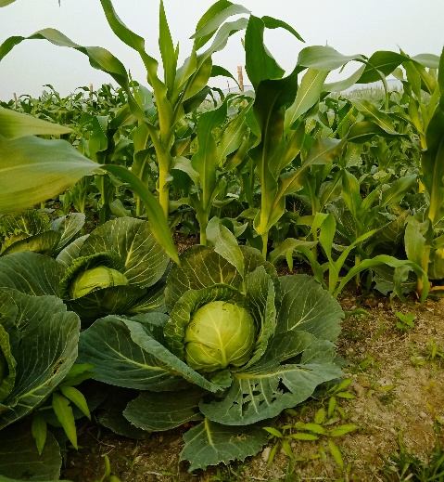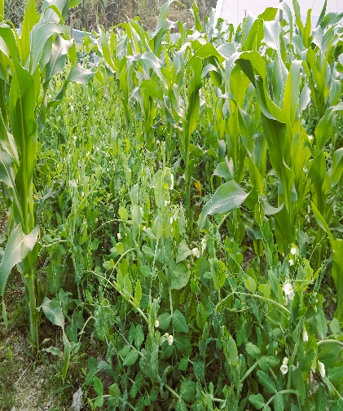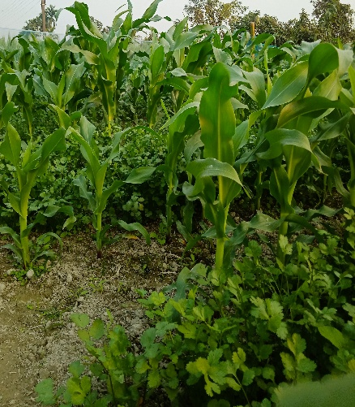
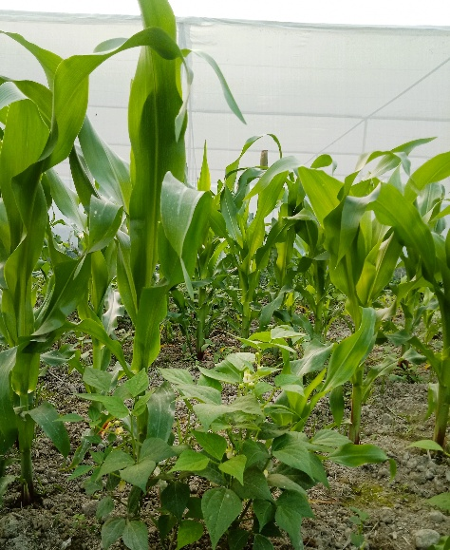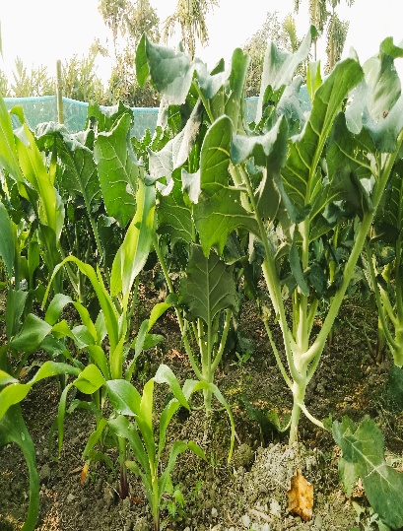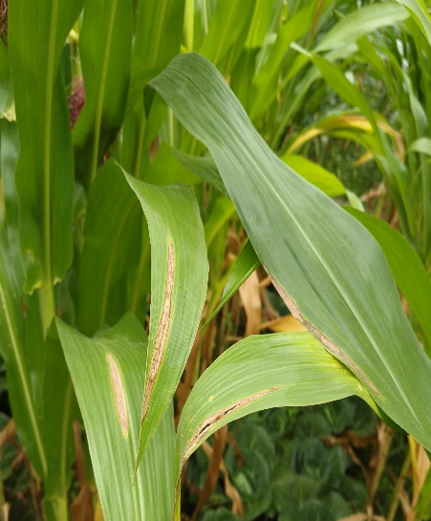
Fig.1. Maize intercrop with Cabbage,Pea,Coriander,French Bean,Broccoli and Infected leaves
3.RESULTS AND DISCUSSION
Selection of best maize- vegetable intercropping each from crucifers, legumes and leafy vegetables was done by considering the results mentioned in table 1. Significant differences were observed across all treatments for chlorophyll content, plant height, biomass, cob weight, and yield, indicating that Maize-Vegetable intercropping notably influenced plant growth and productivity. Likewise, variations in disease severity, incidence, and AUDPC of northern corn leaf blight highlight the intercropping system's role in affecting disease dynamics. From the Table 1 it is clearly evident that mean of yield from intercropping was highest in Maize-Cabbage (21.52), Maize-Pea (20.65), Maize-Coriander (22.68) among crucifers, legumes and leafy vegetables respectively however the highest yield was seen in Sole Maize (27.83) among all the treatments. Maize-Coriander recorded the highest chlorophyll content(55.87), plant height(276.13), plant biomass(358.53), cob weight(371.60), grain yield(229.32) among leafy vegetables, however Cob weight, grain yield was highest in Maize-Cabbage among crucifers. Among the legume’s chlorophyll content, plant height was highest in Maize-Pea, whereas plant biomass, cob weight, grain yield was highest in Maize-Frenchbean intercropping. From all the treatments sole maize stands highest plant height, plant biomass, cob weight, yield per plot.
Table:1 Morphological,Physiological and Yield parameters of Maize under different maize-vegetable based intercropping
Treatments | Chlorophyll | Plant Height (cms) | Plant Biomass (gms) | Cobb Weight (gms) | Grain yield (gms) | Yield per plot (KG)
 | 53.19^{abc} | 275.17ª | 429.60ª | 423.80ª | 218.10^{ab} | 27.83ª
  Sole Maize
Maize-cabbage | 55.32^{ab} | 259.60^{ab} | 342.65^{b} | 391.75^{ab} | 212.81^{ab} | 21.52^{bc}
Maize-Cauliflower | 56.67^{ab} | 256.93^{ab} | 345.40^{b} | 358.93^{bc} | 209.03^{ab} | 17.93^{cd}
Maize-Broccoli | 50.67^{bcd} | 247.80^{ab} | 293.07^{bc} | 379.60^{b} | 194.13^{bc} | 19.84^{bc}
Maize-Radish | 46.60^{cd} | 222.77^{b} | 170.73^{d} | 321.47^{cd} | 192.34^{bc} | 15.99^{d}
Maize-Pea | 50.40^{bcd} | 261.40^{ab} | 279.73^{c} | 318.50^{d} | 176.45^{c} | 20.65^{bc}
Maize-Frenchbean | 42.49^{d} | 249.53^{ab} | 301.40^{bc} | 341.47^{c} | 202.56^{b} | 19.17^{c}
Maize-Fenugreek | 47.30^{cd} | 255.80^{ab} | 293.73^{bc} | 370.73^{b} | 213.99^{ab} | 19.87^{bc}
Maize-Spinach | 50.13^{bcd} | 273.67ª | 307.20^{bc} | 335.73^{c} | 203.41^{b} | 21.44^{bc}
Maize-Coriander | 55.87^{ab} | 276.13ª | 358.53^{ab} | 371.60^{b} | 229.32ª | 22.68^{b}
C.D. | 6.19 | 29.28 | 51.04 | 42.94 | 27.27 | 5.67
SE(m) | 2.14 | 9.78 | 17.05 | 14.34 | 9.11 | 1.89
SE(d) | 2.98 | 13.83 | 24.12 | 20.28 | 12.88 | 2.68
C.V. | 6.91 | 6.58 | 9.46 | 6.87 | 7.69 | 15.84

Disease severity, Disease incidence of E. turcicum leaf blight recorded at two intervals and AUDPC was also taken into account for selection of best maize-vegetable intercropping each from crucifers, legumes and leafy vegetables and results related to this are presented in Table 2. From this table it is clearly evident that the highest disease severity among all the treatments was seen in maize-spinach intercropping and maize-cauliflower along with Maize-Radish intercropping at first interval and second interval respectively. The same was seen lowest at both first and second interval in Maize- Broccoli, Maize-Pea and Maize-Coriander intercropping among crucifers, legumes and leafy vegetables respectively. Among crucifers the disease incidence was seen lowest in Maize-Cauliflower and highest in maize-Broccoli at both intervals whereas in leafy vegetables and legumes the highest disease incidence was recorded in Maize-Fenugreek and Maize-Pea respectively at both intervals. The same was seen lowest in Maize-French Bean at both intervals among legumes and Maize-Coriander at First interval, Maize-Spinach at second interval among leafy vegetables. The highest AUDPC was recorded in Maize-Cauliflower, Maize-French bean, Maize-Fenugreek whereas lowest AUDPC was seen in Maize-Broccoli, Maize-Pea, Maize-Coriander among crucifers, legumes and leafy vegetables respectively.
Combining the data of growth, Physiological, yield attributes and disease assessment parameters among all these treatments of various Maize-Vegetable intercropping in crucifers, legumes, leafy vegetables, we have selected the best one from each. Along with the Sole Maize, Maize-Cabbage (crucifers), Maize-Pea (legumes), Maize-Coriander (Leafy vegetables) was selected by considering the highest yield and lowest disease occurrence from all the treatments.
Table:2 Disease assessment parameters-Disease severity, Disease incidence and AUDPC Maize under different maize-vegetable based intercropping
Treatments | Disease severity-1 | Disease incidence-1 | Disease Severity-2 | Disease incidence-2 | AUDPC
 | 20.22^{cd} | 24.28^{bc} | 35.20^{bc} | 25.91^{ab} | 158.66^{cd}
  Sole Maize
Maize-cabbage | 21.38^{cd} | 23.47^{bc} | 33.60^{bc} | 24.38^{b} | 154.00^{d}
Maize-Cauliflower | 25.57^{b} | 22.22^{d} | 42.30ª | 20.85^{c} | 224.00^{ab}
Maize-Broccoli | 19.94^{d} | 24.16^{bc} | 31.90^{c} | 29.51ª | 138.83e
Maize-Radish | 26.51^{ab} | 22.51^{cd} | 42.30ª | 27.10ab | 228.66ª
Maize-Pea | 22.51^{bc} | 26.87^{ab} | 33.60^{bc} | 27.76^{ab} | 158.67^{cd}
Maize-Frenchbean | 23.46^{bc} | 26.36^{ab} | 41.53^{ab} | 26.32^{ab} | 210.00^{bc}
Maize-Fenugreek | 26.54^{ab} | 28.15ª | 39.97^{ab} | 27.82^{ab} | 214.67^{b}
Maize-Spinach | 28.4ª | 24.49^{b} | 37.56^{b} | 23.50^{b} | 210.00^{bc}
Maize-Coriander | 20.22^{cd} | 23.03^{c} | 33.60^{bc} | 26.77^{ab} | 151.67^{d}
C.D. | 3.10 | 2.67 | 4.99 | 4.63 | 39.47
SE(m) | 1.04 | 0.89 | 1.67 | 1.55 | 13.17
SE(d) | 1.46 | 1.26 | 2.36 | 2.19 | 18.627
C.V. | 7.64 | 6.28 | 7.77 | 10.30 | 12.337

The findings clearly show the effect of intercropping on maize growth, yield, and disease resistance. The increased plant growth characteristics found in Sole Maize are expected due to the lack of interspecific competition. However, certain intercrops, such as coriander, cabbage, and pea, performed competitively or even better in some criteria. In the leafy vegetable category, Maize-Coriander dramatically increased maize biomass and grain output. This could be attributable to less shade and less competition for soil nutrients, resulting in more efficient resource utilisation. Similar findings have been reported in Bangladesh, where Maize-Coriander intercropping increased maize equivalent yields (Hossain et al., 2015). Maize-cabbage and Maize-Cauliflower outperformed other crucifers. Cabbage helped to increase maize cob and grain weights, possibly because to its broader spacing and slower canopy closure, which may have decreased competition (Khanum et al.,2020). Although cauliflower did not yield as much as cabbage, it performed better in terms of plant height and biomass, presumably because of increased nitrogen availability from its deeper roots system. Maize-French bean stood out among legumes in terms of biomass and grain yield. Legumes' nitrogen-fixing capabilities most likely promoted maize growth; intercropping legumes with cereals was shown to improve nutrient availability (Kermah et al., 2017). Interestingly, Maize-Pea had the highest plant height and production per plot, implying that it also maintained good physiological growth, possibly because to balanced competition and facilitative interactions.
The findings from the current study clearly demonstrate that intercropping significantly influenced the progression and severity of Exserohilum turcicum in maize, as reflected by the reduced disease severity, disease incidence, and AUDPC values in several intercropping systems compared to sole maize cropping. Among the treatments, the maize-broccoli intercropping recorded the lowest AUDPC value (138.83), closely followed by Maize-Coriander (151.67), Maize-Cabbage (154.00), and Maize-Pea (158.67), indicating their superior efficacy in suppressing the disease over time. The reduction in disease parameters in these treatments could be attributed to several ecological and physiological mechanisms inherent in intercropping systems. For instance, brassicaceous crops such as cabbage and broccoli are known to release glucosinolates and sulfur-containing volatiles, which have antifungal activity against foliar pathogens (Olivier et al., 2006). This allelopathic interaction might have contributed to the significant decline in E. turcicum severity and incidence in the Maize-Broccoli and Maize-Cabbage treatments.
Moreover, maize intercropped with coriander and pea also exhibited considerable reduction in disease burden, suggesting that non-host crops with different canopy structures and root exudates can interfere with the microclimatic conditions and pathogen life cycle. Coriander, for example, produces essential oils and secondary metabolites with antimicrobial properties, which might suppress conidial germination and pathogen penetration (Talebi et al., 2024). The Maize-Fenugreek and Maize-Spinach combinations, however, reported higher disease severity and AUDPC values (210.00 and 214.67, respectively), potentially due to their canopy characteristics promoting humidity or limited allelopathic interaction, thereby creating a more favourable environment for pathogen proliferation. This observation aligns with earlier reports that intercropping is not universally beneficial, and the choice of companion crop is critical in disease management (Navarro et al., 2021a, Navarro et al., 2021b).
The AUDPC, a cumulative measure of disease development over time, further substantiates the effectiveness of certain intercrops in retarding disease progression. Notably, maize intercropped with radish, although showing moderately high disease severity at the second interval (27.10), recorded a relatively lower AUDPC (228.66) compared to Sole Maize (158.66), indicating some degree of temporal disease suppression. Whereas, disease incidence, the lowest values were also associated with Maize-Broccoli and Maize-Coriander in the second observation, suggesting that these systems not only reduced disease severity but also limited the spatial spread of the pathogen. The role of intercropping in improving air circulation and reducing leaf wetness duration, critical for the sporulation and infection of E. turcicum, might explain these trends (Bankole et al., 2023).
Taken together, these results reinforce the potential of diversified cropping systems as a sustainable approach to disease suppression in maize. Strategic intercropping with crops that exhibit antifungal properties or improve canopy microclimate can serve as an eco-friendly alternative to chemical control. Future research should focus on elucidating the biochemical interactions and soil microbiome shifts underlying these disease reductions to better optimize intercropping strategies for integrated disease management.
4.CONCLUSION
The current study shows that strategically intercropping maize with selected vegetable crops can have a considerable impact on growth, yield, and disease incidence in winter maize. Among all treatments, sole maize produced the most; however, intercropping systems, particularly Maize-Coriander, Maize-Cabbage and Maize-Pea, shown promising performance in terms of yield enhancement and resource efficiency. Notably, Maize-Coriander was linked to higher biomass and grain output, most likely due to its compact growth and reduced interspecific competition. Furthermore, certain intercropping combinations lowered disease severity and AUDPC, implying that pathogen development can be suppressed naturally. These studies demonstrate the agronomic and ecological benefits of incorporating vegetable intercrops into maize-based systems. Appropriate crop combinations can not only maintain yield levels, but also reduce biotic stress, assisting in the creation of resilient and sustainable cropping methods. Future research including soil microbial investigation and economic returns could confirm the long-term benefits of such intercropping systems under a variety of agro-ecological settings.

References:
Agegnehu, G., Ghizaw, A., & Sinebo, W. (2006). Yield performance and land-use efficiency of barley and faba bean mixed cropping in Ethiopian highlands. European Journal of Agronomy, 25(3), 202–207.
Bankole, F.A., Badu-Apraku, B., Salami, A.O. et al. (2023). Variation in the morphology and effector profiles of Exserohilum turcicum isolates associated with the Northern Corn Leaf Blight of maize in Nigeria. BMC Plant Biol 23, 386. https://doi.org/10.1186/s12870-023-04385-7
Dhima, K. V., Lithourgidis, A. S., Vasilakoglou, I. B., & Dordas, C. A. (2007). Competition indices of common vetch and cereal intercrops in two seeding ratios. Field Crops Research, 100(2-3), 249–256.
Fahey, J. W., Zalcmann, A. T., & Talalay, P. (2001). The chemical diversity and distribution of glucosinolates and isothiocyanates among plants. Phytochemistry, 56(1), 5–51.
Hossain, M. H., Bhowal, S. K., & Khan, A. S. M. M. R. (2015). Intercropping system of maize with different winter vegetables: Productivity, profitability, and maize equivalent yield. Malaysian Journal of Medical and Biological Research, 3(2), 49–52. https://doi.org/10.18034/mjmbr.v3i2.412
Kermah, M., Franke,A.C., Adjei-Nsiah, S., Ahiabor, B.D.K., Abaidoo, R.C.,Giller, K.E. (2017). Maize-grain legume intercropping for enhanced resource use efficiency and crop productivity in the Guinea savanna of northern Ghana. Field Crops Research,Volume 213,2017, Pages 38-50, ISSN 0378-4290, https://doi.org/10.1016/j.fcr.2017.07.008.
Khanum, M., Bazzaz, M., Ahmed, B., Huda, M., & Hossain, M. (2020). Intercropping of Cabbage with Maize. Bangladesh Agronomy Journal, 22(1), 115–120. https://doi.org/10.3329/baj.v22i1.44943
Mayee, C.D. and Datar, V.V., (1986). Phytopathometry, Technical Bulletin-I (Special Bulletin-3). Marathwada Agricultural University, Parabhani, p. 950.
Navarro, B.L., Campos, R.A., Gasparoto, M.C.G., Tiedemann, V. A. (2021b). In Vitro and In Planta Studies on Temperature Adaptation of Exserohilum turcicum Isolates from Maize in Europe and South America. Pathogens. 2;10(2):154. doi: 10.3390/pathogens10020154
Navarro, B.L., Ramos Romero, L., Kistner, M.B. et al. (2021a). Assessment of physiological races of Exserohilum turcicum isolates from maize in Argentina and Brazil. Trop. plant pathol. 46, 371–380. https://doi.org/10.1007/s40858-020-00417-x
Olivier, A. R., Uda, Y., Bang, S. W., Honjo, H., Fukami, M., & Fukui, R. (2006). Dried residues of specific cruciferous plants incorporated into soil can suppress the growth of Ralstonia solanacearum, independently of glucosinolate content of the residues. Microbes and Environments, 21(4), 216–226.
Rafique, K., Chaudhuri, A. R., Naz, F. and Sabbir, G. (2016). Management of vascular wilt of lentil through host plant resistance, biological control agents and chemicals. Pakistan Journal of Botany. 48(5): 2085-2092.
Reddy, S. R., & Reddy, R. (2017). Principles of Agronomy (5th ed.). Kalyani Publishers.
Shaner, G. and Finney, R.E. (1977). The effect of nitrogen fertilization in the expression of slow-mildewing resistance in Knox wheat. Phytopathology, 67, 1051-1056.
http://dx.doi.org/10.1094/Phyto-67-1051
Talebi, S.M., Naser, A., Ghorbanpour, M. (2024). Chemical composition and antimicrobial activity of the essential oils in different populations of Coriandrum sativum L. (coriander) from Iran and Iraq. Food Sci Nutr. 20;12(6):3872-3882. doi: 10.1002/fsn3.4047. PMID: 38873442; PMCID: PMC11167142.
Vandermeer, J. (1989). The Ecology of Intercropping. Cambridge University Press.
Wheeler, B. E. (1969). An Introduction to Plant Diseases. John Wiley and Sons, London.
Willey, R. W. (1979). Intercropping—Its importance and research needs. Part 1. Competition and yield advantages. Field Crop Abstracts, 32(1), 1–10.

