In vitro Effect of Physicochemical properties on the Growth of Sclerotium rolfsii Sacc. Causing Collar Rot in Chickpea (Cicer arietinum L.) in Satna M.P.

ABSTRACT
Collar rot of chickpea caused by Sclerotium rolfsii Sacc. is an emerging threat to chickpea production particularly under stress conditions such as high temperature and low soil moisture. This study aimed to investigate the physicochemical behaviour of the pathogen by evaluating its growth response under different temperature and pH levels. Sclerotium rolfsii was isolated from different locations of Satna, M.P. and was purified for further studies through tip and single sclerotium. Pure culture was with white cottony mycelium and brown macrosclerotia. Potato dextrose agar was found best medium for culturing in laboratory. Optimum mycelial growth was achieved at temperature 32°C and pH 5.5-7.0 in laboratory conditions. The results showed that the fungus causing collar rot (Sclerotium rolfsii) favours thermophilic conditions in slightly acidic to neutral pH.
Keywords:
Chickpea, Sclerotium rolfsii, collar rot, temperature, pH
INTRODUCTION
Chickpea often referred to as the "King of Pulses" is one of the most important pulse crops in India. Chickpea (Cicer arietinum L.) is significant pulse crop, contributing about 27% of global production (ICAR - Indian Institute of Pulses Research) it provides 23% protein, 64% carbohydrates and essential minerals [1]. In India, chickpea is extensively grown in Madhya Pradesh under rainfed conditions. However, the crop is increasingly threatened by many fungal diseases including: Ascochyta blight (Ascochyta rabiei), Botrytis gray mold (Botrytis cinerea), Alternaria blight (Alternaria alternata), Colletotrichum blight (Colletotrichum dematium), Phoma blight (Phoma medicaginis), Rust (Uromyces ciceris-arietini), Powdery mildew (Leveillula Taurica), Sclerotinia stem rot (Sclerotinia sclerotiorum), Fusarium wilt (Fusarium oxysporum f. sp. Ciceri, Verticillium wilt (Verticillium albo-atrum), dry root rot (Rhizoctonia bataticola), Phytophthora root rot (Phytophthora medicaginis), Foot rot (Operculella padwickii) [2].
Sclerotium rolfsii Sacc. is a well-known plant pathogen having a wide host range (500 plant species) mostly comprised of dicotyledonous and few monocotyledonous plants and is one of the most destructive soil inhabiting plant pathogens which cause collar rot in different crops all over the world as well as in India [3, 4, 5]. It induces different types of symptoms like crown and root rot, collar rot, foot rot, stem rot, stem canker, damping off, southern wilt or blight or southern stem rot. The fungus was first detected by Rolfs [6] as one of the reasons for tomato blight in Florida. Later, Saccardo [7] named the fungus as Sclerotium rolfsii.
Collar rot is an important disease of chickpea causing quantitative and qualitative losses and farmers often misidentify it as Fusarium wilt, Verticillium wilt and Collar rot due to similar symptoms. The pathogen survives as macrosclerotia in soil and infects collar and roots when plants are under high soil moisture. Collar rot is prevalent in many sub-agroclimatic zones of M. P. viz., Central Narmada valley (8.08-17.20%), Kymore Plateau and Satpura hills (9.30-14.80%), Northern Hill region (8.10-11.76%), Satpura plateau (9.30-11.88%) and Vindhyan plateau (12.00-18.20%) of Madhya Pradesh [8]. The objective of the present study was to characterize the pathogen of collar rot of chickpea (Sclerotium rolfsii) through physicochemical aspects (temperature and pH).
MATERIALS AND METHODS
Survey of the Disease
A robing survey was conducted in the Sohawal block of Satna district during the Rabi season 2024–25 to assess collar rot of chickpea. Ten fields (including field of AKS University) spaced 5–7 km apart were surveyed and disease incidence was calculated using:
Percent Disease Incidence = $\frac{Number of infected plants }{Total number of plants}$x100
Isolation, Identification and Purification of Fungus
Infected chickpea plants from different surveyed fields were collected and brought to the laboratory. The white fungal mycelium showing on the infected collar and roots of chickpea was inoculated separately on PDA medium in petri plate and the petri plates were incubated at 27 ± 2°C in BOD incubator for 5 days. Pure cultures were obtained by using the hyphal tip as well as single sclerotium methods on the same medium. The fungus was identified morphologically on the basis of following characters- a) color of hyphae, b) color and morphology of colony, c) septation and location of septa d) Type and structure of sclerotia and e) color of sclerotia.
Selection of Suitable Culture Medium
Three culture media, viz., corn meal agar, Sabouraud dextrose agar (SDA) and potato dextrose agar (PDA) were used to select one for fast growth of the fungus. These culture media were prepared and sterilized as per the standard protocol and poured in 90mm polyethylene petri plates in laminar air flow. Three petri plates (R₁, R₂ and R₃) with culture medium were inoculated with a single sclerotium each while two petri plates (R₄ and R₅) with culture medium were inoculated with discs of 5mm dia. cut from fresh culture of Sclerotium rolfsii. Total five replicates of each culture media were maintained. All inoculated petri plates were incubated in a BOD incubator at 27 ± 2°C for 7 days. Radial growth of the test fungus and sclerotial formation were observed at 3, 5 and 7 Days After Inoculation (DAI). The data were tabulated to determine the best medium for fungal growth.
Effect of Temperatures on Mycelial Growth
Three replicates (R₁, R₂ and R₃) with PDA culture medium were inoculated with a single sclerotium each from more than 7 days old culture while two replicates (R₄ and R₅) were inoculated with discs of 5mm dia. cut from 3-5 days old culture of Sclerotium rolfsii. Total five replicates of each temperature level were maintained. Inoculated petri plates (each five replicates) were incubated at six different temperatures: 10°C, 15°C, 20°C, 25°C, 30°C, and 35°C up to 7 DAI. Two-dimensional average radial growth was measured at 3, 5, and 7 days after inoculation (DAI) and tabulated for statistical analysis. When maximum radial fungal growth was found from any tested temperatures, two lower and two upper ranges of temperatures of maximum growth temp. were also tried to find out the optimum temperature. The experiment was arranged in a Completely Randomized Design (CRD) with five replications.
Effect of pH levels on Mycelial Growth
Suitable culture medium (Potato dextrose agar) was prepared and divided into eight separate parts (according to pH levels) in conical flasks. Each amount of PDA was adjusted to pH level of 5.0 to 8.5 using 0.1N NaOH or HCl before autoclaving. Cultures medium adjusted to different pH (5-8.5) was poured in petri plates (5 petri plates/pH level having 20 ml/petri plate). Single sclerotium/petri plates (replicates R₁, R₂ and R₃) were placed (inoculated) at the centre of petri plates (culture medium) and two petri plates (R₄ and R₅) were inoculated with discs of 0.5mm dia. cut from fresh culture. Inoculated petri plates were incubated at optimum temp. ± 2°C for 7 days and radial growth was measured at 3, 5, and 7 DAI. Fungal growth data were tabulated for statistical analysis.
RESULTS AND DISCUSSION
Survey of the Disease
Dried foliage of young seedlings with rotting of collar region and roots (Plate 1A) of chickpea plants were found during survey. Young seedlings collapsed (Plate 1B) due to weak stem but older seedlings dried up without collapsing. The whole plant appeared chlorotic (Plate 1C) in early stage of infection A white mycelium was also seen on the tap root of completely dried seedlings. When infected plants were uprooted during robing survey in Rabi season of 2024–25 in AKS University fields and surrounding villages of Satna M.P., the entire taproots found with ruptured and dried epidermis (Plate 1A).
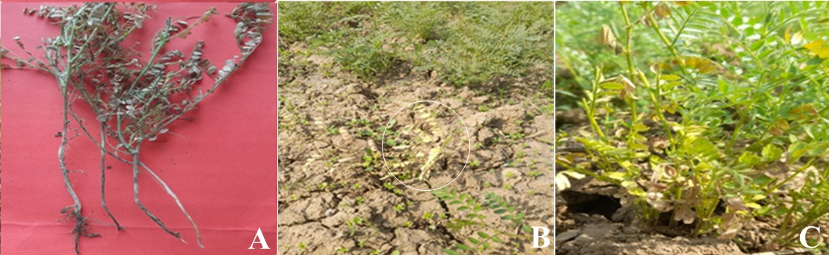
Plate 1. Symptoms of the disease; collar & roots of infected plants (A), dried and collapsed seedling (B), infected young plant (C).
Isolation and Identification of the Fungus (Sclerotium rolfsii)
Collar rot causing fungus (Sclerotium rolfsii) isolated from infected plants on PDA. The isolates grown on PDA medium exhibited the highest colony growth achieving a diameter of 90 mm, within 5 days. The colony colour of Sclerotium rolfsii appeared cottony white with dense radiating mycelial growth (Plate 2A) and it developed numerous brown to dark brown macro-sclerotia dispersed throughout the mycelial mat (Plate 2B). They were initially white turning brown to dark black upon maturity (Plate 2C). The sclerotia of Sclerotium rolfsii were hard, round to oval in shaped and compact in texture. They were typically dry and brittle when matured and the surface of mature sclerotia was rough to slightly wrinkled. The hyphal cells of Sclerotium rolfsii were septate and hyaline. Further study for identification up to the group of the isolated fungus (Sclerotium rolfsii) is going on.
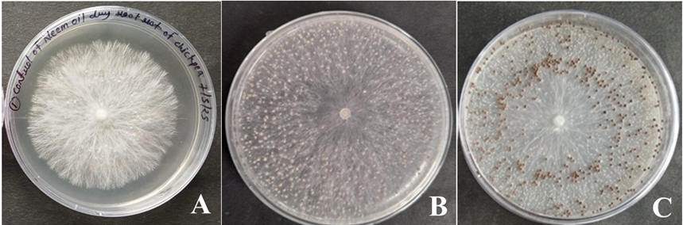
Plate 2: Sclerotium rolfsii fungus; growth of mycelium (A), early stage of sclerotia (B), types of sclerotia (C)
Selection of Suitable Culture Medium

The results presented in Table 1 and Plate 3 clearly indicated that PDA and CMA both supported significantly higher radial growth of the fungus as compared to SDA. The radial growth of fungus (Sclerotium rolfsii) was found very sparce on SDA and sclerotia were also sparkly scattered while on CMA radial growth was less sparce and sclerotia were more in number as compared to SDA (Plate 3). Since, fungus growth and sclerotia were very dense on PDA therefore, it was significantly (Table 1) more suitable than other two (SDA & CMA) culture media.
Table 1: Growth of Sclerotium rolfsii on different culture media
Treatment | Mean Radial growth
Treatment | 3 DAI | 5 DAI | 7 DAI
PDA | 0.210 | 4.370 | 8.500
SDA | 0.000 | 1.070 | 3.480
Corn meal agar | 0.230 | 5.230 | 8.500
SEm+ | 0.03 | 0.22 | 0.12
C.D. (P =.01) | 0.12 | 0.95 | 0.51
C.V. (%) | 46.15 | 14.10 | 4.17
F- Tab | 6.92 | 6.92 | 6.92

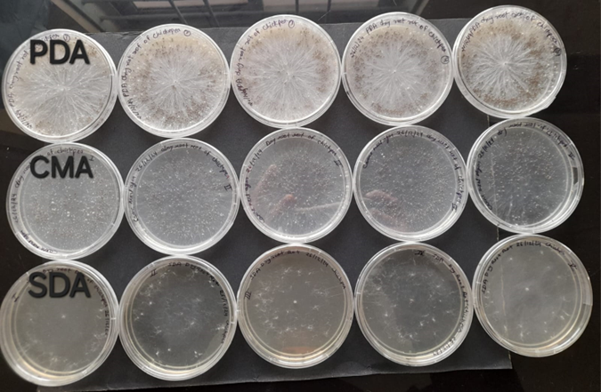
Plate 3. Growth of Sclerotium rolfsii on different culture media at 7 DAI
Effect of Temperature on Growth
There was no fungal (Sclerotium rolfsii) growth at 10°C (Plate 4A). Maximum fungal growth (9.00 cm at 7 DAI) was recorded at 30°C (Plate 4E). Significant differences in growth were observed across all tested temperatures (P = .01) (Table 2 & Fig. 1). When two lower temperatures (28 & 29°C) and two upper temperatures (31 & 32°C) of 30°C were tested, optimum temperature for collar rot causing fungus (Sclerotium rolfsii) in chickpea was found to be 32°C where the highest radial growth (8.62 cm at 7 DAI) was observed (Table 3, Plate 5D). The temperature effect on the growth of Sclerotium rolfsii was found significant as P = .01, C.V. and F values indicated in tables (Table 2 & 3).
Table 2: Effect of Different Temperatures on the radial growth of Sclerotium rolfsii
Treatment (Temperatures in °C) | Mean radial growth (in cm)
Treatment (Temperatures in °C) | 3 DAI | 5 DAI | 7 DAI
10°C | 0.00 | 0.00 | 0.00
15°C | 0.00 | 1.47 | 4.31
20°C | 1.00 | 4.47 | 8.32
25°C | 1.28 | 6.82 | 8.53
30°C | 5.18 | 8.52 | 9.00
35°C | 0.23 | 0.80 | 3.63
SEm+ | 0.45 | 0.30 | 0.20
C.D (P =.01) | 1.77 | 1.18 | 0.79
C.V. (%) | 79.90 | 18.16 | 7.94
F- Tab | 3.89 | 3.89 | 3.89

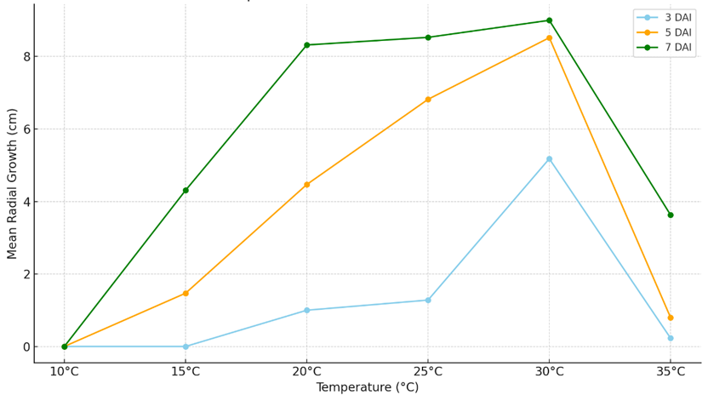
Fig. 1: Effect of Different Temperatures on Radial Growth of Sclerotium rolfsii
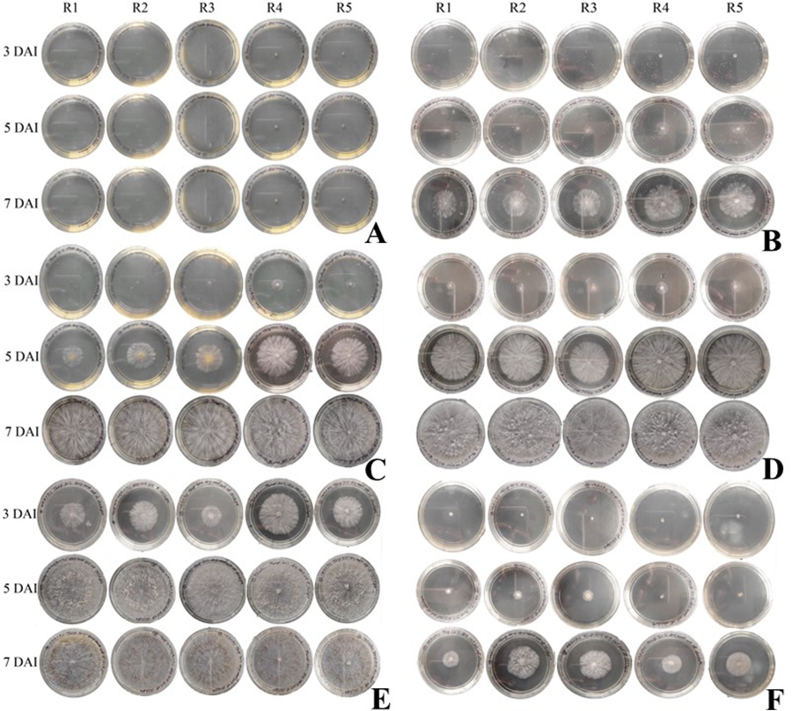
Plate 4: Effect of temp.; effect of 10⁰C (A), effect of 15⁰C (B), effect of 20⁰C (C), effect of 25⁰C (D), effect of 30⁰C (E) and effect of 35⁰C (F) on radial growth of Sclerotium rolfsii
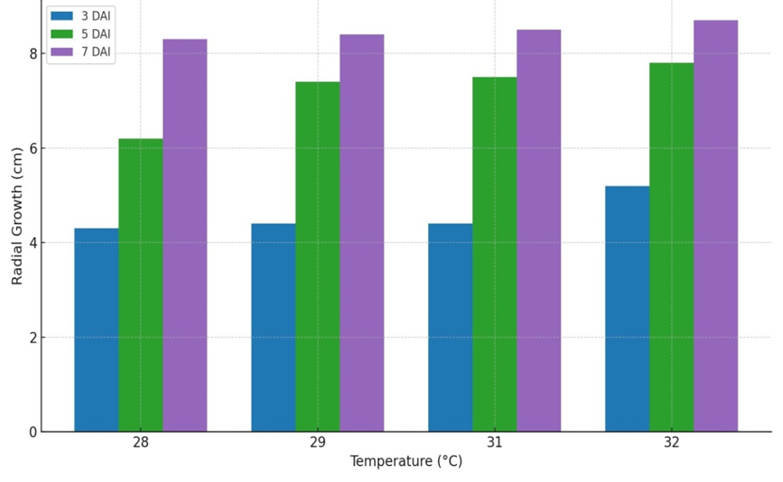
Fig. 2: Optimum Temperature for the growth of Sclerotium rolfsii
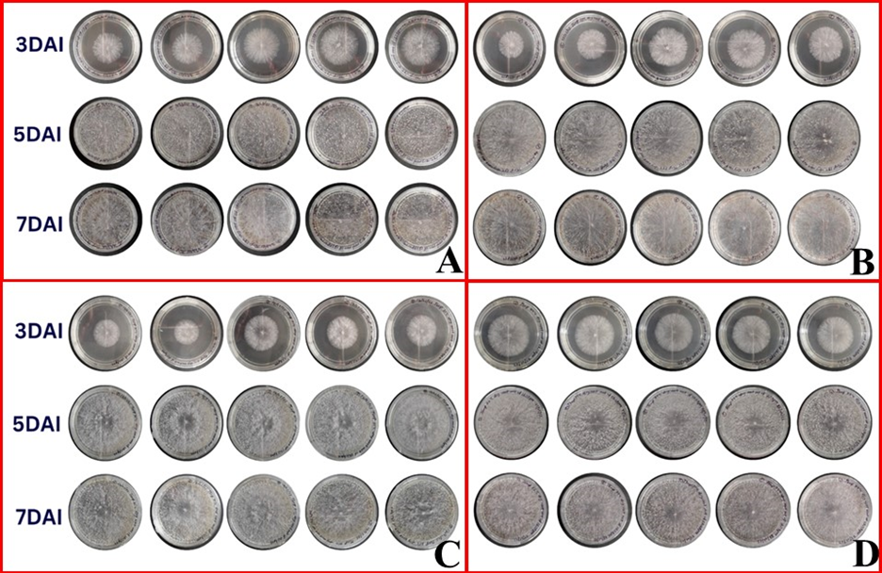
Plate 5: Optimum temperature for the growth of Sclerotium rolfsii; at 28⁰C (A), at 29⁰C (B), at 31⁰C and at 32⁰C (D)

Table 3: Optimum temperature for growth of Sclerotium rolfsii
Treatment (Temperature) | Mean radial growth (in cm)
Treatment (Temperature) | 3 DAI | 5 DAI | 7 DAI
28°C | 4.19 | 6.16 | 8.26
29°C | 4.29 | 7.42 | 8.36
31°C | 4.33 | 7.48 | 8.42
32°C | 5.20 | 7.84 | 8.62
SEm+ | 0.06 | 0.30 | 0.04
C.D. (P =.01) | 0.24 | 1.23 | 0.16
C.V. (%) | 3.40 | 9.36 | 1.26
F-Tab. | 5.29 | 5.29 | 5.29
Effect of pH on Growth of Sclerotium rolfsii
The optimal pH for fungal (Sclerotium rolfsii) growth was found 6.0-7.0 with a minor difference in all tested pH levels except pH 7.5 (Table 4 & Plate 6). Growth was significantly reduced at alkaline pH levels especially at pH 8.5 (Fig. 3). Statistical analysis confirmed the significant effect of pH as P = .01, C.V.% and F values in table 4.
Table 4: Effect of Different pH levels on the radial growth of Sclerotium rolfsii
Treatment (pH levels) | Mean radial growth (in cm)
Treatment (pH levels) | 3DAI | 5DAI | 7DAI
5.0 | 3.83 | 8.32 | 8.90
5.5 | 4.19 | 8.34 | 8.99
6.0 | 4.46 | 8.43 | 8.97
6.5 | 3.91 | 8.48 | 8.98
7.0 | 3.99 | 8.47 | 8.99
7.5 | 2.05 | 5.84 | 7.17
8.0 | 3.50 | 8.48 | 8.91
8.5 | 1.35 | 3.43 | 4.76
SEm+ | 0.56 | 0.66 | 0.78
C.D. (P =.01) | 2.16 | 2.55 | 3.02
C.V. (%) | 36.90 | 19.79 | 21.23
F-Tab | 3.25 | 3.25 | 3.25

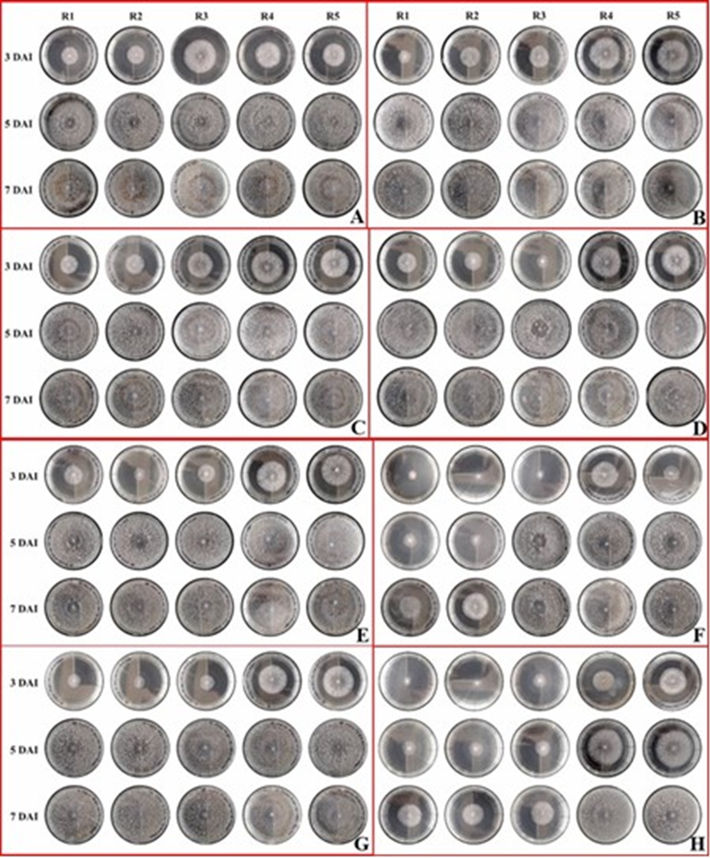
Plate 6: Effect of pH levels on the radial growth of Sclerotium rolfsii; growth on pH 5.0 (A), growth on pH 5.5 (B), growth on pH 6.0 (C), growth on pH 6.5 (D), growth on pH 7.0 (E), growth on pH 7.5 (F), growth on pH 8.0 (G), and growth on pH 8.5 (H)

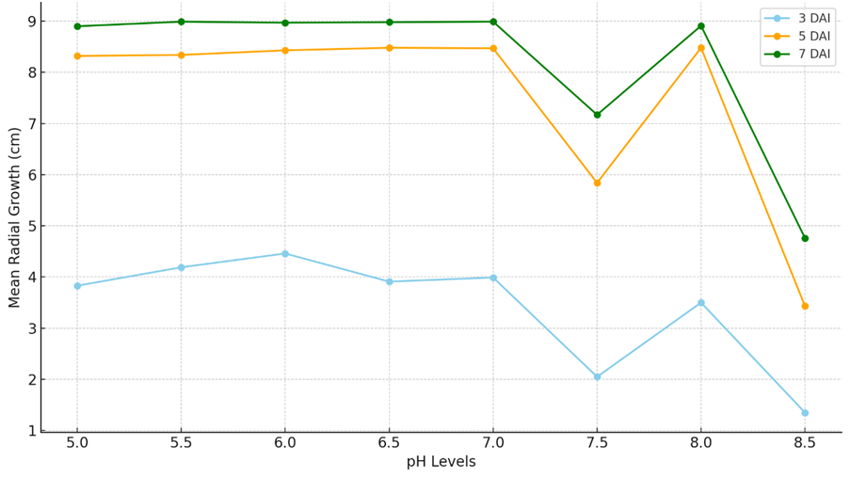
Fig. 3: Effect of Different pH levels on the radial growth of Sclerotium rolfsii

The robing survey conducted in some villages including AKS University field of Sohawal block, Satna, Madhya Pradesh during the Rabi season 2024–25 revealed the widespread occurrence of collar rot disease caused by Sclerotium rolfsii. During the survey, infected seedlings and young plants of chickpea exhibited dried leaves with rotten collar region and root epidermis (Plate 1A, 1B & 1C). Lateral roots were also absent in most infected plants of chickpea. Such types of symptoms were also observed by Nene et al. [9]. Potato dextrose agar (PDA) and corn meal agar (CMA) media supported vigorous mycelial growth of Sclerotium rolfsii but PDA was found to be more suitable for routine growth and morphological studies during isolation and purification of the test fungus (Plate 4). The rapid growth on PDA with a colony diameter of 90 mm (Table 1) within 5 days aligns with findings by Divyashree et.al. [10] and Srividya et.al. [11, 12]. Vigorous mycelial growth on PDA with colonies reaching full diameter (90mm) within 5 days and production of abundant sclerotia were also found in the study of Singh and Mehrotra [13]. The high sclerotial density observed particularly in isolates from Sohawal block indicates a higher sporulation capacity and pathogenic potential. Srividya et.al. [12] also reported a positive correlation between sclerotial density and growth.

Temperature plays a critical role in influencing the mycelial growth of Sclerotium rolfsii, the causal agent of collar rot in chickpea. The results clearly showed that among tested temperatures (10°C to 35°C with 5°C difference) 30°C was the most favorable (Plate 5E) temperature for mycelial development yielding the maximum radial growth (9.00 cm at 7 DAI, Table 2 & Plate 5). These findings emphasize the thermophilic nature of Sclerotium rolfsii and its preference for warm conditions. Again, when experiment was laid down to find out optimum temperature the fungus exhibited maximum mycelial growth at 32°C (Table 3). These findings strongly suggested that 32°C is the optimum temperature for in vitro growth of Sclerotium rolfsii under the conditions of the present study (Fig. 2). The present findings are supported by those of Nene [14] who reported that Sclerotium rolfsii exhibits rapid mycelial growth and prolific sclerotia production at temperatures ranging from 30–32°C, with growth declining sharply at temperatures below 25°C or above 35°C. Maximum radial growth of S. rolfsii also observed at 32°C under in vitro conditions [15].

The present study revealed that pH has a significant effect on the radial growth of Sclerotium rolfsii, the collar rot pathogen of chickpea. Among the tested treatments the fungus exhibited maximum growth at pH 6.0 followed closely by pH 5.5 and pH 7.0 (Table 4, Plate 7). These results suggested that moderately acidic to neutral pH conditions (pH 5.5–7.0) are most favorable for the mycelial proliferation of Sclerotium rolfsii under in vitro conditions. This is suggested that Sclerotium rolfsii prefers a slightly acidic to neutral soil reaction and extreme alkaline conditions may suppress its metabolic activities.
Maximum mycelial growth of S. rolfsii was also found at pH 6.0 followed by pH 5.5 and pH 7.0 with a significant decline under alkaline conditions above pH 7.5 [15]. S. rolfsii is highly sensitive to extreme pH levels with alkaline conditions (pH ≥ 8.0) leading to reduced hyphal extension and lower sclerotial production [16].
CONCLUSION
Sclerotium rolfsii thrives best at 32°C and pH 5.5-7.0 under in vitro conditions. These findings suggested that warm and moderately acidic environments are conducive to the development of collar rot in chickpea. The virulence of collar rot of chickpea is correlated with soil pH and temperature (soil & atmospheric temp.) Because most of farmers know that wilt is the common disease of chickpea which has more or less same symptoms. Though collar rot and wilt of chickpea both produce identical symptoms which can be diagnosed by a experienced person/farmer but most of farmers are not able to diagnose both diseases exactly on the basis of symptoms. Therefore, the present study may be helpful for diagnosis and management of collar rot of chickpea. These findings can also assist in developing targeted management strategies against collar rot in chickpea.

COMPETING INTERESTS DISCLAIMER:
Authors have declared that they have no known competing financial interests OR non-financial interests OR personal relationships that could have appeared to influence the work reported in this paper.

REFERENCES
- Miao M, Zhang T & Jiang B. Characterisation of chickpea starches from different varieties. Food Chemistry. 2009;113(2): 306–312.
- ICRISAT. Field Diagnosis of Chickpea Diseases and their Control. International Crops Research Institute for the Semi-Arid Tropics. Information Bulletin No. 28 (Revised 2012).
- Aycock R. Stem rot and other diseases caused by Sclerotium rolfsii. NC. Agric. Exp. Sta. Tech. Bull., No. 174. 1966; 202pp.
- Punja ZK. Sclerotium (Athelia) rolfsii, a pathogen of many plant species. Vol. 6. In: Advances in Plant Pathology. (Ed.): G.S. Sidhu. Academic Press, London. 1988; pp. 523-534.
- Ciancio A and Mukerji KG. General concepts in integrated pest and disease management. Springer. 2007; 359 pp.
- Rolfs PH. Tomato blight, some hints. Bulletin of Florida Agricultural Experimental Station. 1892; p.18.
- Saccardo PA. Notae mycologicae. Series XIII. Annales Mycologici. 1911; 9(3): 249-257.
- Singh AK, Singh R and Sharma M. Prevalence and distribution of collar rot of chickpea in Madhya Pradesh. Journal of Food Legumes. 2022; 35(1): 18–23.
- Nene YL, Hall SD and Sheila VK. The chickpea: Botany, production and uses. CAB International, Wallingford, UK. 2012.
- Divyashree M, Raghavendra BT and Patil R. Morphological and cultural diversity of Sclerotium rolfsii isolates from chickpea and their in vitro management using combi-fungicides. Journal of Mycology and Plant Pathology. 2024; 54(1), 65–74.
- Srividya P, Reddy BN and Naresh B. Cultural and morphological variability among isolates of Sclerotium rolfsii from chickpea. International Journal of Chemical Studies. 2018; 6(6), 1813–1818.
- Srividya P, Reddy BN and Naresh B. Molecular characterization and genetic diversity analysis of Sclerotium rolfsii isolates from chickpea. Legume Research. 2022;45(6),741–748.https://doi.org/10.18805/LR-4573.
- Singh RS and Mehrotra RS. Effect of culture media on growth and sclerotia production of Sclerotium rolfsii. Indian Phytopathology. 1980;33(2), 300–302.
- Nene YL. A review of research on the diseases of chickpea. ICRISAT, Patancheru, India. 1982.
- Mandhare VK, Khilare VC and Gaikwad SJ. Effect of temperature and pH on the growth and sclerotia formation of Sclerotium rolfsii. Journal of Plant Disease Sciences. 2011; 6(2), 168–170.
- Meena PD, Rathi AS and Mehta N. Effect of temperature and pH on growth and sclerotia formation of Sclerotium rolfsii. Annals of Plant Protection Sciences. 2014; 22(1), 144–147.

