Review Article

Carbon–Nitrogen Coupling in Agroecosystems under Elevated CO₂ Scenarios: A Review

Abstract
Carbon–nitrogen (C–N) coupling is a key element controlling agroecosystem productivity, soil fertility, and the earth's climate. Elevated atmospheric CO₂ levels (eCO₂) promote photosynthesis and biomass production, while augmenting nitrogen (N) requirement in a way that tends to trigger nutrient dilution effects and decreased nutritional quality of crops. This review compiles conceptual foundations, empirical reactions, management practices, and issues underpinning C–N coupling under eCO₂. It emphasizes the dual function of eCO₂ to stimulate plant growth while amplifying N limitation, modifying belowground processes, and impacting greenhouse gas (GHG) processes. Management practices like integrated nutrient management, conservation tillage, legume integration, and microbial interventions hold potential for augmenting C–N balance. Yet, there are uncertainties arising from soil heterogeneity, climate interactions, and limitations of existing models. Future work should focus on long-term multifactor experiments, advanced modeling structures, and innovations in breeding to balance productivity, nutritional value, and environmental stability. Enhancing C–N coupling in eCO₂ is critical for sustainable agriculture, mitigation of climate change, and food security at the global level.
1. Introduction
The highly interdependent carbon (C) and nitrogen (N) cycles tightly coupled together provide the basis for agroecosystems that underpin world food production (Shah, et al., 2019). Carbon supplies the framework as well as source of energy for plant development, whereas nitrogen is a central component in the synthesis of amino acids, proteins, nucleic acids, chlorophyll, and enzymes necessary in plant productivity and metabolism (Nunes-Nesi,. et al., 2010). The equilibrium between these two cycles guarantees not only maximum crop production but also soil health, microbial metabolism, and ecosystem stability in the long run.
Plants assimilate carbon mostly by the process of photosynthesis, fixing atmospheric CO₂ into organic materials like carbohydrates (Raines, 2011). These materials not only form the structural components of plant biomass but also substrates that energize soil microbial populations. Concurrently, nitrogen is obtained primarily from the soil in mineral forms like ammonium (NH₄⁺) and nitrate (NO₃⁻), which become part of organic molecules to fuel plant physiological processes (Shukla et al., 2021). Soil microbes via processes like mineralization, nitrification, and denitrification also control nitrogen availability, thus connecting soil nutrient cycling with plant development.
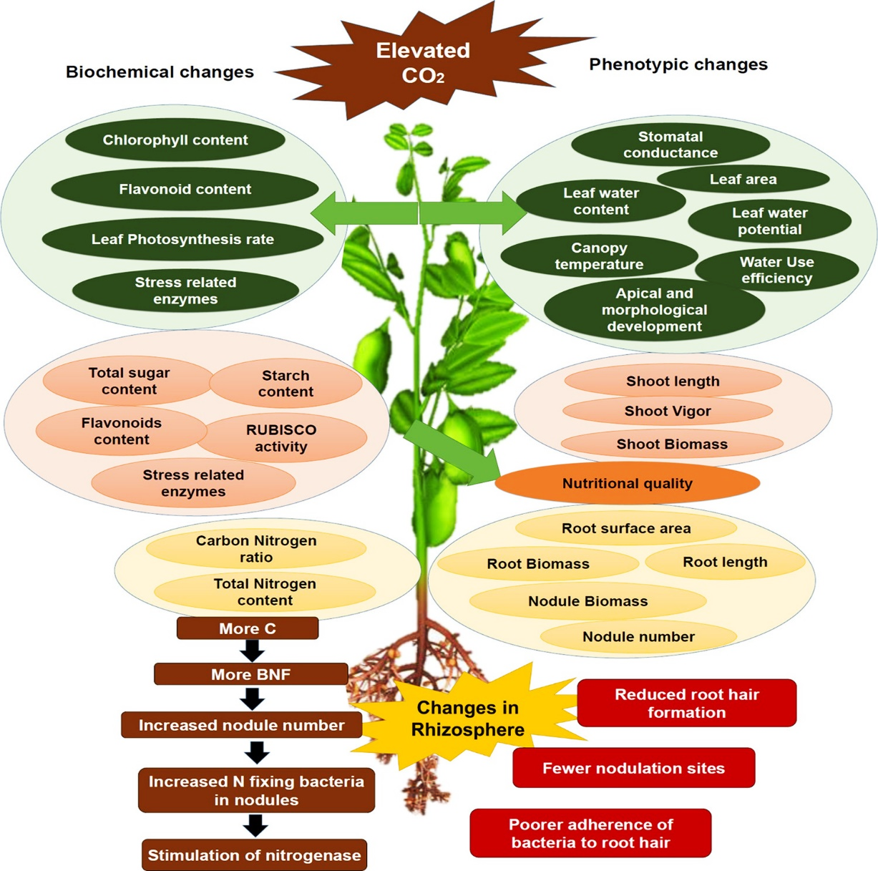

(Source, Palit, et al., 2020)
Fig. 1. Key physiological characteristics affected by increased CO₂ and temperature.
Biochemical and phenotypic changes in legumes exposed to high CO₂ (left) and to the combined effect of high CO₂ and temperature (right). The major biochemical and phenotypic parameters are discussed in Section 1 of this review (Adireddy, et al., 2024). The lower panel shows sequential changes occurring in the rhizosphere, where high CO₂ increases carbon availability, thus impacting biological nitrogen fixation (BNF) and subsequently affecting root nodulation (Schaedel, et al., 2023).
The continued increase in atmospheric concentrations of CO₂ (eCO₂), which is largely anthropogenically driven, has significant ramifications for both carbon and nitrogen cycling within agroecosystems (Shah, et al., 2019). Increased CO₂ generally increases plant photosynthesis (the so-called "CO₂ fertilization effect"), with increased assimilation of carbon and biomass production. Yet, this additional carbon input comes at the price of increased nitrogen demand, as additional proteins, enzymes, and metabolic compounds are necessary to maintain elevated growth rates (Erickson, 1993). This discrepancy can lead to an effect referred to as the dilution effect, where elevated plant biomass under eCO₂ can have comparatively lower nitrogen content, lowering crop nutritional value in general.
Additionally, eCO₂ modifies soil-microbe-plant interactions, affecting root exudation, microbial decomposition, and processes of nitrogen mineralization. Carbon addition to the soil can drive microbial activity, but it may hasten or retard nitrogen availability depending on soil status, quality of organic matter, and microbial community structure (Wang, et al., 2019). Nitrogen limitation in eCO₂ could limit the beneficial effects of increased photosynthesis, resulting in a disconnection of the carbon and nitrogen cycles in some instances.
FIGURE 2.
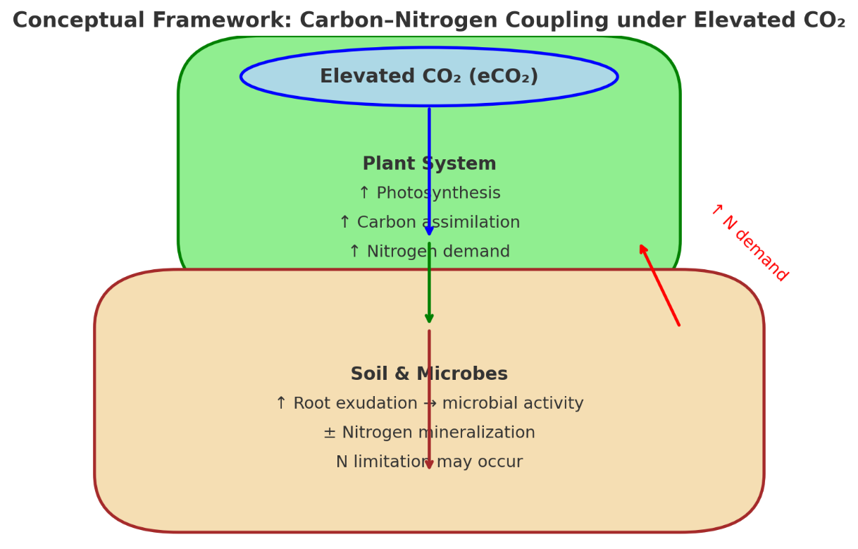

Characterizing these intricate interactions under eCO₂ conditions is of profound significance in the framework of global food security, climate change mitigation, and sustainable agriculture (Thakur, et al., 2024). With a growing world population posed to face uncertain climatic conditions, information on carbon–nitrogen coupling gives useful direction to devise adaptive measures like integrated nutrient management, crop breeding to enhance nitrogen-use efficiency, and managed soil microbial engineering. It will be critical to this knowledge to provide resilient and productive agroecosystems in the future (Walker, et al., 2021).
Nutrient cycling is an important factor in controlling the terrestrial biosphere's carbon uptake and considerably affects how the carbon cycle reacts to temperature and precipitation changes (Luo, 2007). Yet, global coupled carbon–climate models mostly ignore nutrient dynamics. Our research indicates that including nutrient cycling specifically, the tight coupling between carbon and nitrogen within the terrestrial biogeochemistry module of a coupled climate system model radically alters the behavior of a number of important feedback mechanisms connecting terrestrial ecosystems to the global climate (Zaehle and Dalmonech, 2011). When interactions between carbon and nitrogen are accounted for, the globally averaged terrestrial carbon uptake response to increasing atmospheric CO₂ is decreased by 74% relative to a carbon-only model. Furthermore, net land carbon exchange sensitivity to temperature and precipitation changes is greatly reduced by carbon–nitrogen coupling (Jain, et al., 2019). At increasing atmospheric CO₂, carbon cycle responses to temperature and precipitation are weaker in the coupled model, but stronger in the carbon-only model. These results imply that previous carbon-only models most probably exaggerated the terrestrial ecosystems' ability to reduce atmospheric CO₂ increase through direct fertilization effects. So, the next generations of coupled climate–biogeochemistry models ought to represent explicitly and dynamically terrestrial carbon–nitrogen interactions in order to enhance projections of atmospheric CO₂ concentration and climate change (Ciais, et al., 2014).
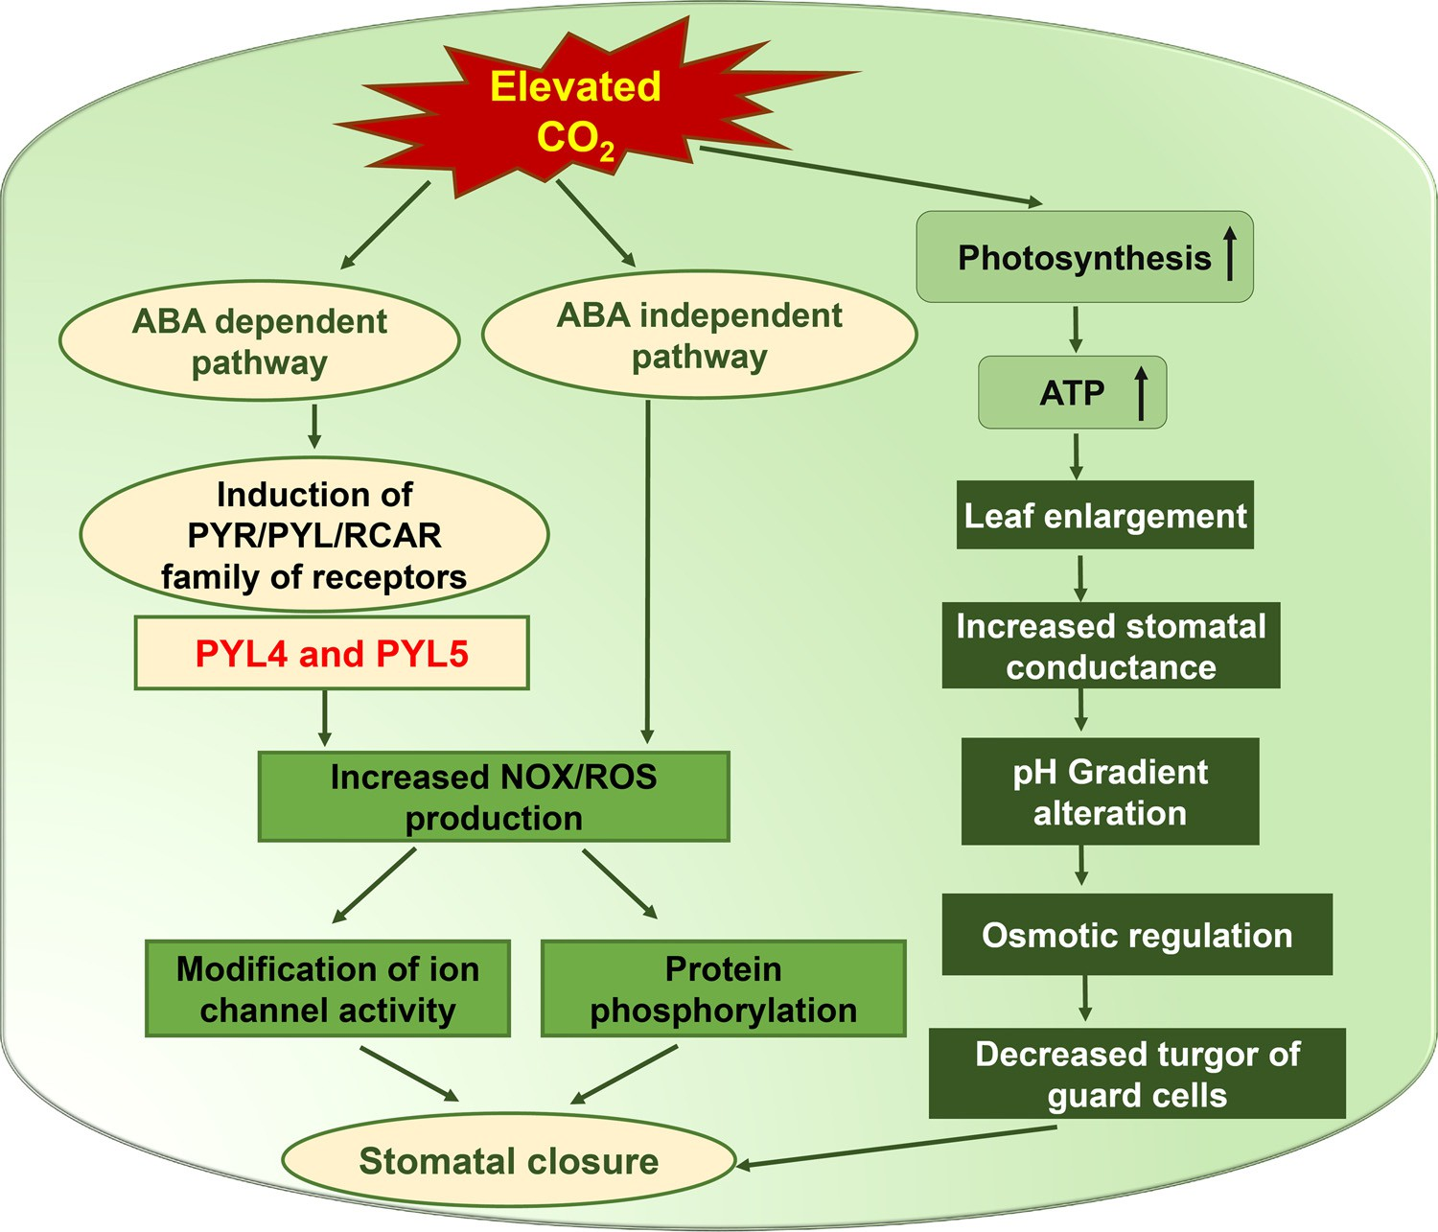

(Source, Palit, et al., 2020)
Fig. 3. Cumulative effects of elevated CO₂ and drought on stomatal behavior.
Increased CO₂ controls OPEN STOMATA1 (OST1) by both ABA-dependent and ABA-independent mechanisms with increased NOX activity, production of reactive oxygen species (ROS), and regulation of the activities of ion channels. These modulate osmotic balance, pH, protein phosphorylation, and turgor pressure in guard cells. Besides, increased photosynthetic rate and ATP production additively affect leaf growth and canopy temperature control.
At the molecular level, high CO₂ causes stomatal closure and diminishes stomatal density mainly through the generation of ROS. The signala pathway branches through ABA and the PYR/RCAR family of ABA receptors in the guard cell ABA signal network. The mechanism is mediated by the loop involving CO₂-induced ABA accretion, which in turn increases sensitivity to CO₂ by the system. The ABA–OST1/SnRK2.6 signaling cascade illustrating basal ABA signaling and OST1/SnRK2.6 activity is required for CO₂ responsiveness in stomata clearly shows that the CO₂-specific response, in particular, requires PYL4 and PYL5, despite ABA and high CO₂ stimulating PYR/PYL/RCAR receptors independently.
2. Conceptual Underpinnings of C–N Coupling under eCO₂
Carbon (C) and nitrogen (N) cycle coupling is the backbone of ecosystem functioning, especially in agroecosystems where plant productivity and soil fertility are strongly interconnected. Increased atmospheric CO₂ (eCO₂) alters the carbon and nitrogen pathways, reorganizing plant–soil–microbe interactions and regulating nutrient processes. A mechanistic understanding of these conceptual underpinnings offers a basis to anticipate ecosystem responses and develop adaptive management approaches (Peng, et al., 2023).

Table 1. Comparative responses of cropping systems to elevated CO₂ (eCO₂)
Level / Process | Positive Outcomes | Negative Outcomes | Conditional / Context-dependent Outcomes
Plant Growth, Yield & Quality | ↑ Biomass accumulation and photosynthesis in C₃ crops; yield gains under adequate N supply | ↓ Grain protein, Fe, Zn → nutritional dilution in cereals | Yield response highly dependent on N availability; C₄ crops less responsive to eCO₂
Belowground C Inputs & SOC | ↑ Root growth, rhizodeposition, and soil C inputs under eCO₂ | In low-N soils, microbial immobilization & priming dominate → SOC gains limited | In high-N soils, greater SOC stabilization through organo-mineral associations
Nitrogen Cycling | In legumes with N supply: ↑ BNF and nifH gene abundance (up to 2×) | eCO₂ alone does not consistently enhance BNF across systems | N fertilization boosts plant growth but can also ↑ N₂O emissions, offsetting C benefits

2.1 CO₂ Fertilization and Nitrogen Constraints
The CO₂ fertilization effect is a highly documented fact in which eCO₂ promotes photosynthetic carbon fixation through enhanced carboxylation efficiency and diminished photorespiration losses in C₃ plants. It usually results in increased biomass accumulation and yield potential. Yet, the magnitude of yield improvement is highly modulated by nitrogen availability. When nitrogen is in short supply, stimulation of photosynthesis under eCO₂ cannot be maximized, resulting in decreasing returns in crop yields (Kant, et al., 2012). Additionally, promoted growth is often accompanied by a nutrient dilution effect, such that plant tissues have more carbon per unit nitrogen, lowering protein content and, by extension, nutritional value of the crops. This disparity highlights the key function of nitrogen to modulate the size of the CO₂ fertilization response (Reich, and Hobbie, 2013).
2.2 Shifts in Allocation and Rhizosphere Processes
In eCO₂ conditions, plants tend to have changed patterns of carbon allocation, with a higher fraction of assimilated carbon directed below ground. This is reflected in elevated root growth, rhizodeposition, and exudation of organic compounds like phenolics, amino acids, and organic acids. These additions serve as energy substrates for soil microbial populations, thus activating microbial activity and altering nutrient turnover (Goswami, and Deka, 2022). Notably, the impact of boosted root exudation on nitrogen cycling is situation-specific: whereas it can increase nitrogen mineralization and make nutrients more accessible, it can also enhance microbial nitrogen immobilization, resulting in temporary conflict between microbes and plants. The overall result is thus largely contingent on both the quality of root-derived carbon inputs and the initial nitrogen status of the soil (Deb, et al., 2023).
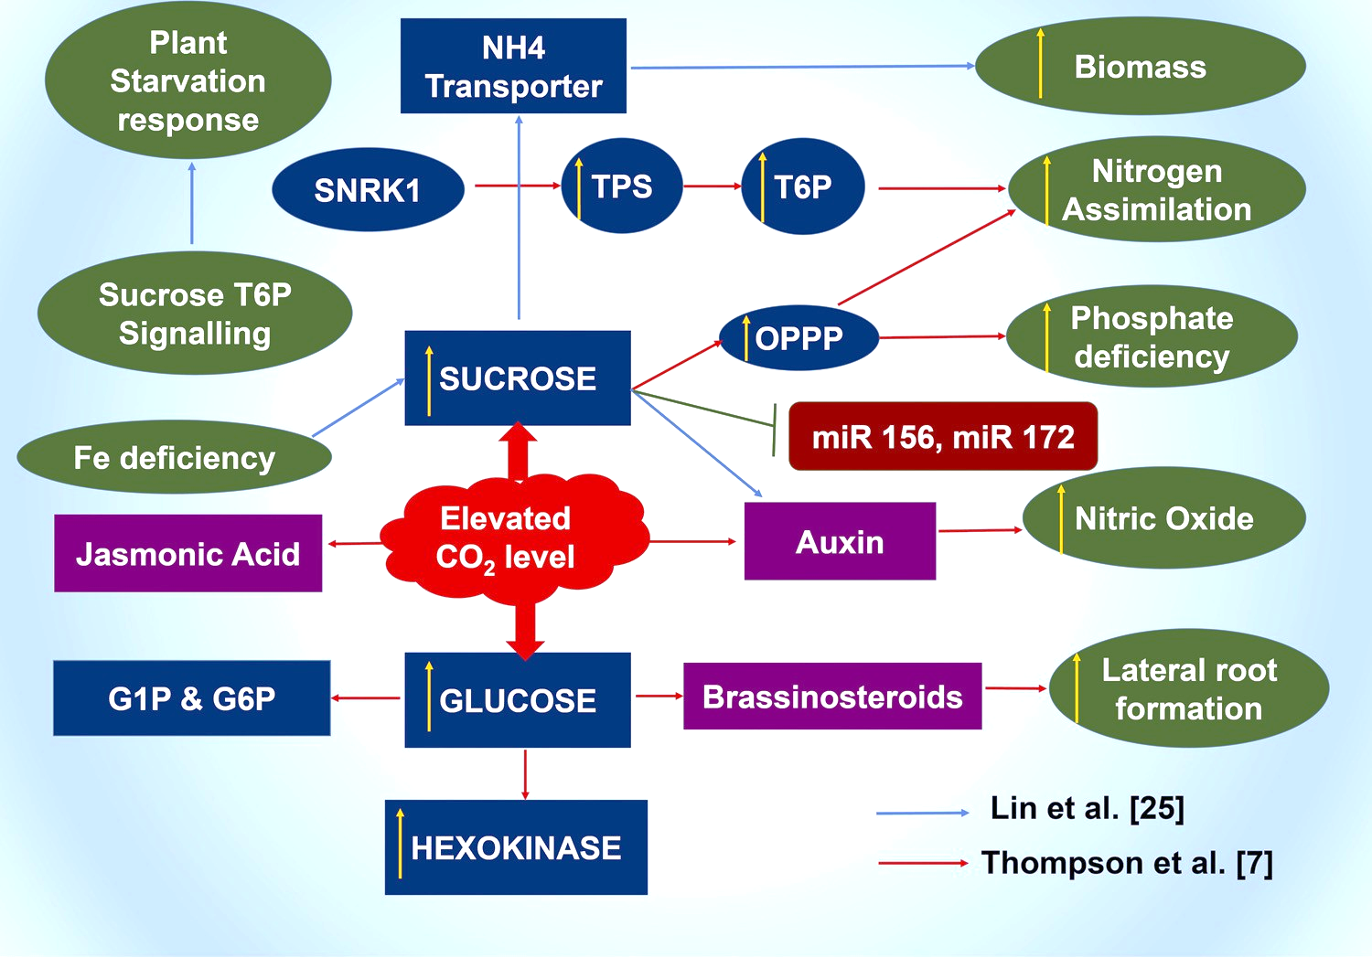

(Source, Palit, et al., 2020)
Fig. 4. Probable model on elevated CO2-mediated response in sugar signaling crosstalk.
The graph illustrates how high CO₂ raises sucrose and glucose, which are energy sources and also signaling molecules. These sugars interact with nutrient assimilation, stress signaling, phytohormones, and microRNAs in controlling biomass buildup, root development, and responses to nutritional deficiencies in plants.
2.3 Soil Moderators
The reaction of the carbon–nitrogen coupling under eCO₂ is not consistent but strongly moderated by soil characteristics and climatic conditions. Soil texture, organic matter content, and mineral composition determine SOC stabilization, whereas moisture and temperature regimes influence microbial process activity and nutrient conversion (Harrison-Kirk, et al., 2014). For example, finer-textured soils with elevated clay contents have a tendency to favor SOC stabilization by organo-mineral associations, while sandy soils tend to have reduced stabilization capacity. Furthermore, eCO₂-induced alterations in aeration of the soil and microbial activity can affect nitrous oxide (N₂O) emissions, an important greenhouse gas. Even though studies on these moderators are still less extensive, available evidence suggests that the interactions among eCO₂, soil properties, and climate actually decide whether or not carbon gains are maintained or balanced out by nitrogen limitation and loss of greenhouse gases (Reich et al., 2014).
3. Empirical Responses in Cropping Systems
Experiments conducted in the field and in controlled environments offer key information on the response of agroecosystems to rising CO₂ (eCO₂). Although a general stimulation of plant growth is noted, the responses of yield, soil organic carbon (SOC), and nitrogen cycling are more complex and vary with crop type, nitrogen management, and soil properties (Kahiluoto et al., 2014).
3.1 Growth, Yield, and Quality
In various cropping systems, eCO₂ increases vegetative growth and biomass production, especially in C₃ cereals like rice, wheat, and soybean. Yield responses depend on nitrogen status. In conditions of high nitrogen, crops exhibit substantial increases in grain yield, whereas under conditions of nitrogen stress, improvements in yield are usually small or non-existent even when biomass is increased (Ekele, et al., 2025). Of major concern is the quality of the harvestable product. Many studies report a reduction in protein, iron, and zinc content in grains produced under eCO₂. Nutrient dilution through this effect threatens human nutrition, especially in areas that rely on cereals as staples. Therefore, although eCO₂ will promote plant growth, it also presents food-quality and nutritional-security issues.
3.2 Belowground Carbon Inputs and SOC
eCO₂ tends to enhance root biomass and rhizodeposition, adding more carbon to the ground. But these additions don't always equate to increased SOC stocks. The impact is heavily influenced by nitrogen status:
Low-N systems: More root-derived carbon tends to increase microbial activity, resulting in increased nitrogen immobilization and priming of soil organic matter decomposition. This can counteract SOC gains and even enhance carbon loss (Cheng, and Kuzyakov, 2005).
In high-N systems, microbial nitrogen demand is satisfied, enabling root-derived carbon to more effectively stabilize SOC, thus increasing soil carbon sequestration (Fitch, et al., 2024).
These divergent effects emphasize the necessity of integrated nutrient management to achieve the potential of eCO₂-driven belowground carbon inputs in long-term soil fertility and climate mitigation.
3.3 Nitrogen Cycling
The influence of eCO₂ on nitrogen cycling is various. The range of CO₂ by itself does not always promote biological nitrogen fixation (BNF) in all cropping systems. In legumes with adequate soil nitrogen, however, eCO₂ stimulates BNF, doubling nifH gene abundance a molecular marker for nitrogen-fixing microorganisms (Nag, et al., 2020). This demonstrates synergistic action of eCO₂ and added nitrogen in enhancing plant nitrogen uptake.
At the system level, nitrogen addition increases plant productivity under eCO₂ but has mixed effects on soil carbon capture and greenhouse gas (GHG) emissions (Yang, et al., 2022). For instance, nitrogen fertilization can increase crop yields while also promoting N₂O emission, a powerful greenhouse gas, thus making eCO₂ climate benefits more complicated. These discrepancies reflect the intricacy of C–N coupling in managed systems, where the interaction between management regime, crop species, and microbial reaction is context-dependent.
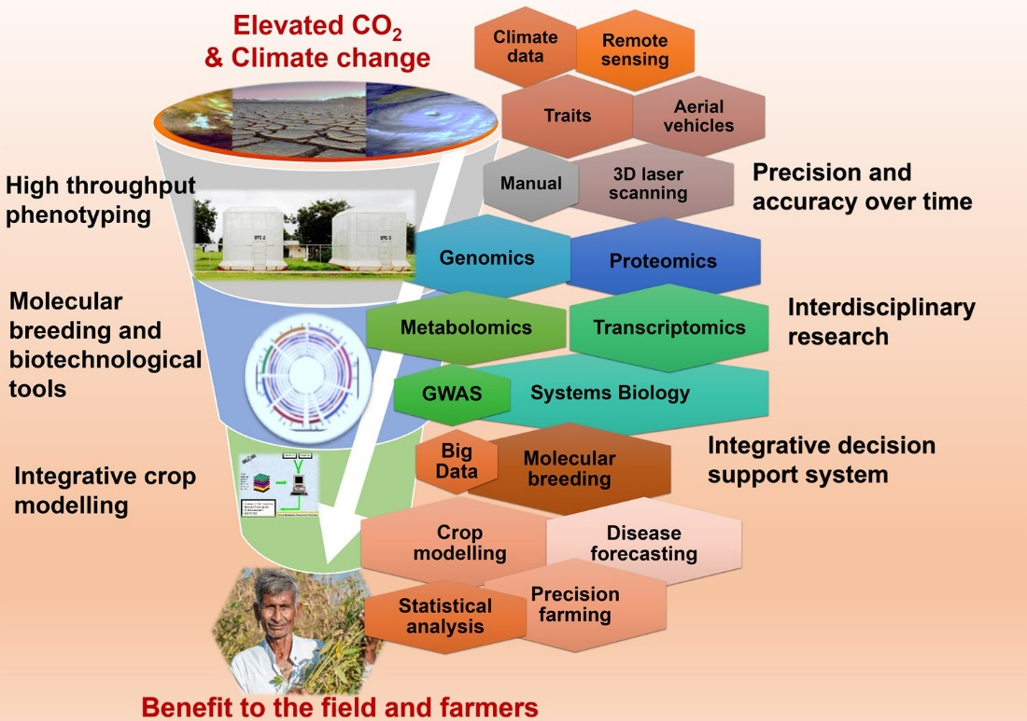

(Source, Palit, et al., 2020)
Fig. 5. Prospective strategy for climate change research in legumes.
The diagram shows a funnel framework where climate stress challenges like higher CO₂ and climate change constitute the initiating point at the top. These challenges are tackled in the middle using multi-scale tools like high-throughput phenotyping, molecular breeding, omics technologies, big data, and crop modeling. At the bottom, these combined methods find expression as usable outputs for farmers, which result in precision farming, improvement of better crop varieties, and increased resilience to climate change (Lobell, and Gourdji, 2012).
The figure illustrates a funnel approach in which climate stress challenges, such as elevated CO₂ and climate change, form the starting point at the top. These challenges are addressed in the middle through multi-scale tools including high-throughput phenotyping, molecular breeding, omics technologies, big data, and crop modeling. At the bottom, these integrated approaches translate into actionable outputs for farmers, leading to precision farming, development of improved crop varieties, and enhanced resilience to climate change.
4. Management Strategies
The challenges of maintaining carbon–nitrogen (C–N) balance under elevated CO₂ (eCO₂) necessitate adaptive management practices that optimize productivity while minimizing environmental trade-offs (Shi, et al., 2025). Several evidence-based strategies are promising:
4.1 4R Nutrient Stewardship
The system of "4R Nutrient Stewardship" situating the right nutrient source, at the right rate, at the right time, and in the right location continues to be at the forefront of enhancing nitrogen use efficiency (NUE). Such a method reduces losses of nitrogen by leaching and denitrification and consequently lowers nitrous oxide (N₂O) emissions, a key climate issue under amplified CO₂–N interactions (Hassan, et al., 2022).
4.2 Legume and Cover Crop Integration
Integration of legumes in crop rotations and cover crops in farming systems augments BNF, hence the use of synthetic fertilizers is minimized. This not only protects cropping systems against nitrogen deficit under eCO₂ but also improves soil fertility, biodiversity, and system resilience (Cui, et al., 2023).
4.3 Residue Retention and Conservation Tillage
Practices like keeping crop residues, reduced tillage, or conservation tillage maintain soil organic carbon (SOC) pools and stabilize nitrogen cycling. Residue cover supplies substrates for microbial activity, minimizes soil erosion, and maximizes soil moisture storage (Li, et al., 2020). These practices complement eCO₂-induced increases in root-derived carbon to enhance long-term soil fertility and carbon sequestration.
4.4 Integrated Nutrient–Water–Carbon Management
With the interconnected nature of water availability and nutrient dynamics, management strategies integrated across fertilization with a balance, optimized irrigation, and enhancement of organic matter in the soil are imperative. These reduce crop dilution risk from nutrients, stabilize yields, and enhance adaptability to climate variability.
5. Research Gaps and Next Steps
A great deal of progress has been made notwithstanding, there are still key knowledge gaps in understanding and managing C–N coupling under eCO₂. A research focus for the future should include the following directions:
5.1 Long-Term Field Experiments
There are requirements for additional long-term Free-Air CO₂ Enrichment (FACE) experiments on various soil types, climatic regions, and crop systems. These would give sound evidence concerning the persistence and variation of C–N response in field conditions (Ainsworth and Long 2021.
5.2 Multifactorial Experiments
In addition to CO₂ enrichment per se, all future experiments should include CO₂ × N × P × water × microbial manipulations to constrain the range of possibilities regarding agroecosystem response complexity. This integrated treatment is necessary since nutrient interactions and water supply frequently co-limit eCO₂ plant productivity.
5.3 Advanced C–N Modeling Frameworks
Current models need to be refined for improved representation of processes like priming effects, microbial nitrogen immobilization, stoichiometric flexibility of microbes and plants, and mycorrhizal pathways of nutrient exchange. These processes would add predictive ability and guide sustainable management strategies.
5.4 Productivity–Quality Trade-offs
An important research area is the balance between greater productivity and reduced nutritional value of crops under eCO₂. Experiments that bridge crop physiology, nutrient biochemistry, and human nutrition consequences are essential to evaluate long-term effects on food security and public health.
5.5 Socioeconomic and Policy Dimensions
In addition to biophysical studies, there must be consideration of the socioeconomic effects and policy structures that guide nutrient management across shifting CO₂ regimes. These involve farmer adoption options, costs of interventions, and coordination with climate-smart agriculture policy.
Challenges under eCO₂ Scenarios
Even though the potential of higher CO₂ (eCO₂) to enhance plant growth and sequester carbon exists, several challenges limit the long-term feasibility of such advantages. Carbon–nitrogen (C–N) coupling interactions add uncertainties that need to be overcome for efficient management.
Nitrogen Limitation
The CO₂ fertilization effect is also highly sensitive to sufficient nitrogen supply. Nitrogen supply in most cropping systems is already a limiting factor, and eCO₂ increases plant nitrogen requirement. Without added inputs or biological nitrogen fixation, the long-term sustainability of yield increases is doubtful. This poses a major challenge in resource-poor farming systems in which fertilizer availability is restricted.
Soil Organic Matter Dynamics
Whereas eCO₂ boosts belowground carbon inputs, it also initiates microbial breakdown of SOM. This tends to speed up nitrogen mineralization but at the same time enhance nitrogen losses by leaching and denitrification. Consequently, short-term gains in productivity may be at the expense of long-term soil fertility and ecosystem stability.
Greenhouse Gas Trade-offs
One of the most important issues at hand is the risk of enhanced nitrous oxide (N₂O) emissions, which is a greenhouse gas with approximately 300 times the global warming potential of CO₂. High nitrogen cycling in eCO₂ may inadvertently increase N₂O fluxes, which could counteract the climate change mitigation potential of increased carbon sequestration. This trade-off makes it more challenging for agroecosystems to play a positive role in climate change mitigation efforts.
Management Gaps
Traditional fertilizer application regimes do not completely resonate with the changed nutrient dynamics under eCO₂. Over-reliance on blanket nitrogen recommendations can cause either deficiency or excess, both of which disempower productivity and environmental benefits. Improved nutrient strategies, such as site-specific and adaptive management, are yet to be properly developed in most areas.
Model Uncertainty
Existing crop and ecosystem models have a tendency to oversimplify C–N coupling, tending to omit processes like microbial nitrogen immobilization, priming effects, and plant–microbe competition. These omissions decrease the validity of long-term predictions, making it challenging to accurately determine the resilience of agroecosystems to future CO₂ scenarios.
These problems demand a multifaceted approach:
Integrated Nutrient Management (INM): The integration of organic and inorganic sources of nutrients can improve nitrogen use efficiency while preserving soil health.
Breeding and Biotechnology: breeding crop plants for enhanced nitrogen-use efficiency, root structure, and symbiotic relationships with beneficial microbes can optimize C–N coupling under eCO₂.
Microbial Interventions: applications of plant growth-promoting rhizobacteria (PGPR), mycorrhizal fungi, and constructed microbial consortia can enhance soil–plant interactions and SOM stabilization.
Advanced Modeling and Monitoring: Coupled carbon–nitrogen models, integrated with remote sensing and big data analytics, are essential to forecast system-level responses under future climate conditions and inform adaptive management practices.
In the long term, enhancing C–N coupling at high CO₂ is not only a technical but also a policy and governance problem. Interdisciplinary collaboration between soil scientists, plant breeders, ecologists, and climate scientists, as well as farmer-focused researchers extension approaches, is necessary to overcome knowledge-to-practice gaps.
Finally, stabilizing carbon–nitrogen bonds is central to maintaining sustainable intensification of agriculture, reducing the impact of climate change, preserving ecosystem services, and promoting global food and nutritional security. In the direction where the world is heading toward net-zero emission commitments, C–N coupling science and its real-world application will be instrumental in reconciling agricultural productivity and environmental sustainability.

Table 1. Effects of elevated CO₂ on carbon and nitrogen processes in agroecosystems
Level | Positive Outcomes | Negative Outcomes | Conditional Outcomes
Plant | ↑ Biomass, ↑ photosynthesis, ↑ water-use efficiency | ↓ Grain protein, ↓ micronutrients | Yield response depends on N availability
Soil | ↑ Root exudates and rhizodeposition, potential SOC storage | Enhanced SOM decomposition, ↑ N losses via leaching/denitrification | SOC stabilization occurs mainly under high-N systems
Microbial | ↑ Rhizosphere activity, stimulation of nifH genes in legumes under eCO₂ + N supply | Potential priming effect, N immobilization reduces plant uptake | N fixation response depends on legume presence and soil fertility

Table 2. Challenges and opportunities for managing C–N coupling under eCO₂ scenarios
Aspect | Challenges | Opportunities
Nitrogen availability | N limitation constrains CO₂ fertilization effect | Integrated Nutrient Management (INM), balanced organic–inorganic fertilization
Soil Organic Matter (SOM) | Enhanced decomposition, N loss through leaching/denitrification | Residue retention, conservation tillage, SOC stabilization
Greenhouse gases (GHG) | ↑ N₂O emissions may offset C gains | Climate-smart practices (agroforestry, cover crops) reduce net GHG footprint
Genetic & microbial innovations | Lack of varieties adapted to eCO₂ and low-N conditions | Breeding for NUE, microbial inoculants (mycorrhizae, diazotrophs)
Modeling & prediction | Crop models oversimplify C–N coupling | Advanced multi-factor models (CO₂ × N × water × microbes)

6. Conclusion
Carbon–nitrogen (C–N) coupling is the keystone of functioning agroecosystems, having direct effects on plant productivity, soil fertility, and environmental sustainability. At elevated CO₂ (eCO₂) levels, crops tend to show increased photosynthetic performance and biomass production, implying potential for enhanced yields. Yet, these advantages are not assured, as nitrogen (N) availability, SOM dynamics, and greenhouse gas (GHG) emissions represent critical limiting and regulatory factors. Weak coupling of carbon and nitrogen cycles can contribute to nutrient dilution in crops, loss of soil fertility, and enhanced nitrous oxide (N₂O) emissions, which could reduce otherwise expected climate change mitigation.

COMPETING INTERESTS DISCLAIMER:
Authors have declared that they have no known competing financial interests OR non-financial interests OR personal relationships that could have appeared to influence the work reported in this paper.
Reference
Adireddy, R. G., Anapalli, S. S., Reddy, K. N., Mubvumba, P., & George, J. (2024). Possible impacts of elevated CO2 and temperature on growth and development of grain legumes. Environments, 11(12), 273.
Ainsworth, E. A., & Long, S. P. (2021). 30 years of free‐air carbon dioxide enrichment (FACE): what have we learned about future crop productivity and its potential for adaptation?. Global change biology, 27(1), 27-49.
Cheng, W., & Kuzyakov, Y. (2005). Root effects on soil organic matter decomposition. Roots and soil management: Interactions between roots and the soil, 48, 119-143.
Ciais, P., Sabine, C., Bala, G., Bopp, L., Brovkin, V., & House, J. I. (2014). Carbon and other biogeochemical cycles. In Climate Change 2013: The Physical Science Basis. Contribution of Working Group I to the Fifth Assessment Report of the Intergovernmental Panel on Climate Change Change (pp. 465-570). Cambridge University Press.
Cui, J., Zhang, X., Reis, S., Wang, C., Wang, S., He, P., ... & Gu, B. (2023). Nitrogen cycles in global croplands altered by elevated CO2. Nature Sustainability, 6(10), 1166-1176.
Deb, P., Mandal, A., Harendra, Choudhury, S. R., Das, A., Hazra, S., ... & Moulick, D. (2023). Improving plant nutrient use efficiency for climate-resilient agriculture. In Climate-resilient agriculture, vol 2: Agro-biotechnological advancement for crop production (pp. 209-243). Cham: Springer International Publishing.
Ekele, J. U., Webster, R., Perez de Heredia, F., Lane, K. E., Fadel, A., & Symonds, R. C. (2025). Current impacts of elevated CO2 on crop nutritional quality: a review using wheat as a case study. Stress Biology, 5(1), 34.
Erickson, J. D. (1993). CARBON DIOXIDE EFFECTS on PLANTS. Agricultural Dimensions of Global Climate Change, 153.
Fitch, A. A., Goldsmith, S. B., Lankau, R. A., Wurzburger, N., Shortt, Z. D., Vrattos, A., ... & Hicks Pries, C. E. (2024). Mycorrhizal associations of temperate forest seedlings mediate rhizodeposition, but not soil carbon storage, under elevated nitrogen availability. Global Change Biology, 30(8), e17446.
Goswami, M., & Deka, S. (2022). Rhizodeposits: an essential component for microbial interactions in rhizosphere. In Re-visiting the rhizosphere eco-system for agricultural sustainability (pp. 129-151). Singapore: Springer Nature Singapore.
Harrison-Kirk, T., Beare, M. H., Meenken, E. D., & Condron, L. M. (2014). Soil organic matter and texture affect responses to dry/wet cycles: Changes in soil organic matter fractions and relationships with C and N mineralisation. Soil Biology and Biochemistry, 74, 50-60.
Hassan, M. U., Aamer, M., Mahmood, A., Awan, M. I., Barbanti, L., Seleiman, M. F., ... & Huang, G. (2022). Management strategies to mitigate N2O emissions in agriculture. Life, 12(3), 439.
Jain, A., Yang, X., Kheshgi, H., McGuire, A. D., Post, W., & Kicklighter, D. (2009). Nitrogen attenuation of terrestrial carbon cycle response to global environmental factors. Global Biogeochemical Cycles, 23(4).
Kahiluoto, H., Kaseva, J., Hakala, K., Himanen, S. J., Jauhiainen, L., Rötter, R. P., ... & Trnka, M. (2014). Cultivating resilience by empirically revealing response diversity. Global Environmental Change, 25, 186-193.
Kant, S., Seneweera, S., Rodin, J., Materne, M., Burch, D., Rothstein, S. J., & Spangenberg, G. (2012). Improving yield potential in crops under elevated CO2: integrating the photosynthetic and nitrogen utilization efficiencies. Frontiers in Plant Science, 3, 162.
Li, Y., Zhang, Q., Cai, Y., Yang, Q., & Chang, S. X. (2020). Minimum tillage and residue retention increase soil microbial population size and diversity: Implications for conservation tillage. Science of the Total Environment, 716, 137164.
Lobell, D. B., & Gourdji, S. M. (2012). The influence of climate change on global crop productivity. Plant physiology, 160(4), 1686-1697.
Luo, Y. (2007). Terrestrial carbon–cycle feedback to climate warming. Annu. Rev. Ecol. Evol. Syst., 38(1), 683-712.
Nag, P., Shriti, S., & Das, S. (2020). Microbiological strategies for enhancing biological nitrogen fixation in nonlegumes. Journal of Applied Microbiology, 129(2), 186-198.
Nunes-Nesi, A., Fernie, A. R., & Stitt, M. (2010). Metabolic and signaling aspects underpinning the regulation of plant carbon nitrogen interactions. Molecular plant, 3(6), 973-996.
Palit, P., Kudapa, H., Zougmore, R., Kholova, J., Whitbread, A., Sharma, M., & Varshney, R. K. (2020). An integrated research framework combining genomics, systems biology, physiology, modelling and breeding for legume improvement in response to elevated CO2 under climate change scenario. Current Plant Biology, 22, 100149.
Peng, X., Zeng, L., Wang, D., Liu, Z., Li, Y., Li, Z., ... & Hou, Y. (2023). Electrochemical C–N coupling of CO 2 and nitrogenous small molecules for the electrosynthesis of organonitrogen compounds. Chemical Society Reviews, 52(6), 2193-2237.
Raines, C. A. (2011). Increasing photosynthetic carbon assimilation in C3 plants to improve crop yield: current and future strategies. Plant physiology, 155(1), 36-42.
Reich, P. B., & Hobbie, S. E. (2013). Decade-long soil nitrogen constraint on the CO2 fertilization of plant biomass. Nature Climate Change, 3(3), 278-282.
Reich, P. B., Hobbie, S. E., & Lee, T. D. (2014). Plant growth enhancement by elevated CO2 eliminated by joint water and nitrogen limitation. Nature Geoscience, 7(12), 920-924.
Schaedel, M., Fudge, R., & Grossman, J. (2023). Biological nitrogen fixation within agroecosystems and plant roots. In Biological Approaches to Regenerative Soil Systems (pp. 129-140). CRC Press.
Shah, T., Lateef, S., & Noor, M. A. (2019). Carbon and nitrogen cycling in agroecosystems: an overview. Carbon and nitrogen cycling in soil, 1-15.
Shah, T., Lateef, S., & Noor, M. A. (2019). Carbon and nitrogen cycling in agroecosystems: an overview. Carbon and nitrogen cycling in soil, 1-15.
Shi, S., Li, H., Wang, X., Wang, Z., Xu, J., He, X., & Yang, Z. A. (2025). Greater biomass production under elevated CO2 is attributed to physiological optimality, trade-offs in nutrient allocation, and oxidative defense in drought-stressed mulberry. Antioxidants, 14(4), 383.
Shukla, S., Shukla, K., Mishra, A., Jindal, T., Sharma, S., Upadhyay, D., & Singh, V. (2021). Ecological perspectives on soil microbial community involved in nitrogen cycling. In Soil nitrogen ecology (pp. 51-91). Cham: Springer International Publishing.
Thakur, A., Kumari, D., & Kumar, P. (2024). Climate Change and Agriculture: Assessing the relationship between agricultural practices, greenhouse gas emissions, and climate change. A Comprehensive Exploration of Soil, Water, and Air Pollution in Agriculture, 155.
Walker, A. P., De Kauwe, M. G., Bastos, A., Belmecheri, S., Georgiou, K., Keeling, R. F., ... & Zuidema, P. A. (2021). Integrating the evidence for a terrestrial carbon sink caused by increasing atmospheric CO2. New phytologist, 229(5), 2413-2445.
Wang, J. J., Bowden, R. D., Lajtha, K., Washko, S. E., Wurzbacher, S. J., & Simpson, M. J. (2019). Long-term nitrogen addition suppresses microbial degradation, enhances soil carbon storage, and alters the molecular composition of soil organic matter. Biogeochemistry, 142(2), 299-313.
Yang, M., Hou, Z., Guo, N., Yang, E., Sun, D., & Fang, Y. (2022). Effects of enhanced-efficiency nitrogen fertilizers on CH4 and CO2 emissions in a global perspective. Field Crops Research, 288, 108694.
Zaehle, S., & Dalmonech, D. (2011). Carbon–nitrogen interactions on land at global scales: current understanding in modelling climate biosphere feedbacks. Current Opinion in Environmental Sustainability, 3(5), 311-320.

