Comparative study of the physicochemical parameters of soils of different litchi (Litchi chinensis Sonn.) cultivars

ABSTRACT
Litchi (Litchi chinensis Sonn.) belongs to the Sapindaceae family and is known as the ‘Queen of Fruits’. It is a subtropical fruit with significant commercial and nutritional value. Its production is governed by a variety of soil and climatic conditions, although scientific data on soil qualities across different litchi cultivars is sparse. The purpose of this study was to evaluate and compare the physicochemical parameters of rhizosphere soils from nine litchi cultivars: ‘Shahi’, ‘Rose Scented’, ‘Dehradun’, ‘Dehra Rose’, ‘Ajhauli’, ‘China’, ‘Mandraji’, ‘Purbi’, and ‘Bombai’, which were collected from the ICAR-National Research Centre on Litchi, Muzaffarpur, Bihar. At a depth of 0–20 cm, soil samples were taken, and their moisture content, water-holding capacity, pH, electrical conductivity, organic carbon, and nitrogen, phosphorus, potassium and sulphur availability were all measured. Litchi cultivars, especially Ajhauli (20.58%) and Dehradun (70%), had a generally higher soil moisture content and water-holding capacity. In comparison to the control, all cultivars had greater soil pH (8.5 to 8.9) and electrical conductivity (0.49 to 0.59 dS/m). However, a significant decrease in organic carbon, nitrogen, phosphorus, and potassium was detected across all rhizosphere soils when compared to the control, with potassium showing the greatest depletion. The available sulphur content was deficit in all the soil samples. These findings suggest that, while litchi cultivation improves some physical properties of the soil, it may eventually lead to nutrient depletion. To preserve soil health and enhance litchi yield, the study emphasizes the importance of cultivar-specific soil monitoring and balanced nutrient management. This study provides valuable information for future efforts to boost litchi orchard production while ensuring long-term soil fertility in crucial farming zones.
Keywords: Litchi, Cultivars, Soil moisture, Electrical conductivity, Nitrogen, Phosphorus, Potassium, Sulphur.
- INTRODUCTION
Litchi (Litchi chinensis Sonn.) is a valuable subtropical evergreen fruit tree of the Sapindaceae family. Litchi is known as the “queen of fruits” due to its outstanding quality, exquisite fruit, well-balanced sugar and acid levels, distinctively pleasant flavor, appealing color, and high nutritional value. India is the world’s second-largest producer of litchi, following China. The area of litchi cultivation increased from 85,000 hectares (2014-2015) to 90,000 hectares (2015-2016). According to Raghavan et al., (2018), the production of litchi is mostly limited to Bihar (40%), West Bengal (16%), Jharkhand (10%), Assam (8.2%), Chhattisgarh (6.4%), Uttarakhand (5.2%), and to a lesser degree, Punjab, Odisha, and Tripura. In terms of land area and litchi production, Bihar is India’s most productive state. Around 40% of India’s total litchi output comes from Bihar, which has an area of roughly 32,000 hectares (2014–15) (Kumar et al., 2018). Litchi farming is a significant source of income for the people of Bihar, as the state produces 73.38 percent of the nation’s litchi. Because it generates work both on and off farms, millions of people depend on it to survive. The majority of litchi is grown in North Bihar districts, including Samastipur, Vaishali, Darbhanga, Sitamarhi, East Champaran, West Champaran, and Muzaffarpur, which is also referred to as India’s Litchi Capital (Kumar et al., 2022). Ajhauli, Gulabi, Bombai, Dehradun, Kasba, Ellaichi, China, Late Bedana, Early Bedana, Rose Scented, and Shahi are some of the well-known cultivars in India. Purbi and Kasba are the most popular cultivars in the eastern regions of Bihar, whereas Shahi, China, and Rose Scented are the most commercial varieties in Muzaffarpur.
Litchi comes in thirty-five different varieties that are produced throughout India. These varieties are mostly derived from Chinese cultivars. Just six cultivars Shahi, China, Rose Scented (Dehradun), Seedless, Muzaffarpur, and Bombai provide the majority of the litchi produced. In fact, each district has its own dominant cultivars. Table 1 displays the classification of litchi cultivars according to their maturity period.
Table 1: Litchi cultivars maturity periods
Period | Cultivars
Early | Shahi, Rose Scented, Dehradun, Dehra Rose, Ajhauli, Deshi, Muzaffarpur, Green, Trikolia
Mid | China, Purbi, Bombai, Culcuttia, Bedana, Swarna Roopa, Kasba, Sabour Bedana, Sabour Madhu
Late | Late Bedana, Longia, Kaselia
(Source: The Litchi, FAO, 2012)
Litchi emerges in the market between May and June, when other fresh fruits are abundant. Fresh litchi is constantly in high demand because of its distinct flavor, color, and taste, even if there are many various kinds of fruits available in the market. The main nutritional advantage of litchi is its acid and sugar content, which varies based on climate and cultivar. There is an urgent need to make Indian litchi globally competitive because it is largely export-oriented and has a significant potential to earn foreign exchange in overseas markets. According to Raghavan et al., (2018), the limited shelf life and short availability of fruits restrict their availability in both domestic and foreign markets.
Litchi fruit is not widely cultivated due to its short post-harvest life and great susceptibility to soil and climate conditions. Litchi plants need cool, dry winters and warm, lush summers to grow. Litchi can be cultivated effectively in various soil types in India, including sandy loams, laterite, calcareous soil, and alluvial sand. However, alluvial sandy loam soils with adequate drainage and access to the water table produce the best litchi orchards (Singh and Babita, 2002). Jharkhand litchi thrives in soils with a pH of 6 to 6.5, while North Bihar's soils range from 7.5 to 8. It grows even in calcareous soil with 30% free lime.
The primary limiting factor for low yield and quality in practically all litchi-growing nations has been determined to be inadequate and unbalanced nutrition combined with a water deficit. The litchi yield in some places of China is low and unstable (Xu et al., 2010), mainly due to inappropriate fertilization (Yao, 2009). Litchi trees with poor K nutrition (Yao et al., 2009), low N and K in the soil (Li et al., 2011), and dynamic variations in nutrition in litchi foliar and the effects of potassium-nitrogen fertilization ratio are some of the most important causes of low yield.
One of the most crucial inputs for raising litchi orchard productivity and production is fertilizer. According to Menzel and Simpson (1987), inadequate nutrition is often associated with low litchi yields and low-quality litchi fruit. All aspects of litchi growth, including floral initiation, appear to be stunted by the severe lack of N, P, and K (Goldweber, 1959). Waseem et al., (2002) reported that undesirable yield losses or a decline in fruit quality can be caused by irrigation (Li et al., 2001), nutrients (Qui et al., 1999), and both high and low temperatures (Menzel and Simpson, 1988). In order to maintain the soil’s available nutrient status at the appropriate level and guarantee good economic output, accurate fertilizer and manure dosages must be applied using reliable diagnostic instruments intended to prevent nutrient imbalance (Mathura et al., 2002).
A short shelf life, inadequate fertilizer management, and sensitivity to soil and climate are some of the issues that affect litchi cultivation despite its great demand and economic significance. Reduced productivity and fruit quality are frequently the result of inadequate knowledge of the requirements for nitrogen, phosphorus, and potassium. There is a lack of region-specific research, particularly in critical areas such as Bihar. To raise Indian litchi’s competitiveness internationally and boost production, fruit quality, and soil health, a concentrated study on balanced nutrient management is necessary. Thus, the present study was carried out to investigate the physicochemical properties of soils of different litchi cultivars in the Muzaffarpur region.
- MATERIALS AND METHODS

  - Site Description
The rhizosphere soil samples of nine different litchi cultivars i.e. ‘Shahi’, ‘Rose Scented’, ‘Dehradun’, ‘Dehra Rose’, ‘Ajhauli’, ‘China’, ‘Mandraji’, ‘Purbi’, and ‘Bombai’, were collected from the litchi orchards of ICAR-National Research Centre on Litchi, Mushahari, Muzaffarpur, Bihar (Figure 1). The centre is located in Muzaffarpur, Bihar, between 26⁰5′87″N latitude and 85⁰26′64″E longitude, with an elevation of 210 meters. The area has a subtropical climate, with an average annual rainfall of 1100-1300 mm. The soil at the location is alluvial, sandy loam in texture, calcareous in nature, and has a pH of 7.5-8.0.
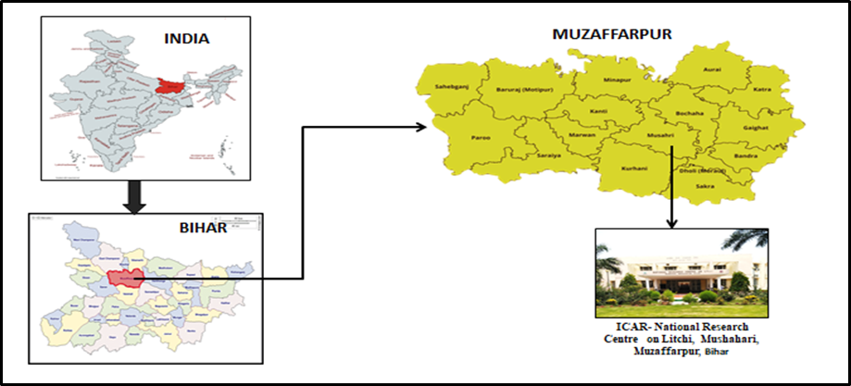Figure 1. Location of the study area

  - Collection of Soil Samples
Samples of soil were collected from the rhizospheres of early and mid-season litchi cultivars to examine differences in the soil’s physicochemical properties. Early-maturing litchi cultivars included ‘Shahi’, ‘Rose Scented’, ‘Dehradun’, ‘Dehra Rose’, and ‘Ajhauli’, whilst mid-season-maturing litchi cultivars included ‘China’, ‘Mandraji’, ‘Purbi’, and ‘Bombai’. For each cultivar, rhizosphere soil samples were randomly collected from the root zone at a depth of 0–20 cm after removing surface debris, grasses, and the topsoil layer. From each tree, three replicates were gathered, combined, and thoroughly mixed. For the control, surface soil (0–20 cm) was collected from an adjacent uncultivated area. Approximately 500 g of soil sample was collected and stored in sterile sample bags. In the laboratory, the collected samples were air-dried, ground using a mortar and pestle, passed through a 2 mm sieve, and stored in plastic bags for soil analysis. Soil samples were sent to the Central Soil Testing Laboratory (CSTL), located in Mithapur, Patna, for the purpose of estimating the physicochemical characteristics and nutrient content of the soil.

  - Analysis of Soil Parameters
Soil moisture was evaluated using the gravimetric method, which involves placing the soil sample in an oven at 105°C and drying it to a consistent weight. The weight difference is assumed to be water present in the soil sample. Water-holding capacity was determined using the method given by Muratore and Knorr (2025) and was calculated based on the volume of water retained by the soil. Soil pH was measured by a pH meter, and electrical conductivity (EC) was measured by an electrical conductivity meter in 1:2 soil water suspensions. Organic carbon was estimated using 1 N potassium dichromate and back titrated with 0.5 N ferrous ammonium sulphate solutions (Walkley and Black, 1934). Available nitrogen was determined by using alkaline potassium permanganate (Subbaiah and Asija, 1956). Available phosphorus in soil was determined by Olsen’s method (Olsen et al., 1954). Available potassium was determined by the neutral ammonium acetate method using a flame photometer (Toth and Prince, 1949). Available sulphur was determined by barium sulphate precipitation method. The methodology described in the methods manual Soil Testing in India (Anonymous, 2011) was followed for laboratory analysis.

  - Statistical Analysis
For all soil parameters, the data was statistically examined using analysis of variance (ANOVA). Several litchi cultivars were compared using a one-way ANOVA in Excel. The experiment was carried out in triplicate, and the mean ± standard deviation (SD) was used to express the data.

- RESULTS

  - Soil moisture
The soil moisture content in the rhizosphere soil of early and mid-season maturing litchi cultivars was measured and compared to the control (Figure 2). The soil moisture content in the rhizosphere soil ranged from 10.78% to 20.58%, while the control (6.84%) showed the lowest soil moisture content. Ajhauli had the highest soil moisture content among the early litchi cultivars (20.58%), while Dehra Rose had the lowest (10.78%). China had the highest percentage of soil moisture content among the mid-season litchi cultivar (15.83%), while Mandarji had the lowest (12.19%). When compared to the control, these differences were statistically significant at p < 0.001.
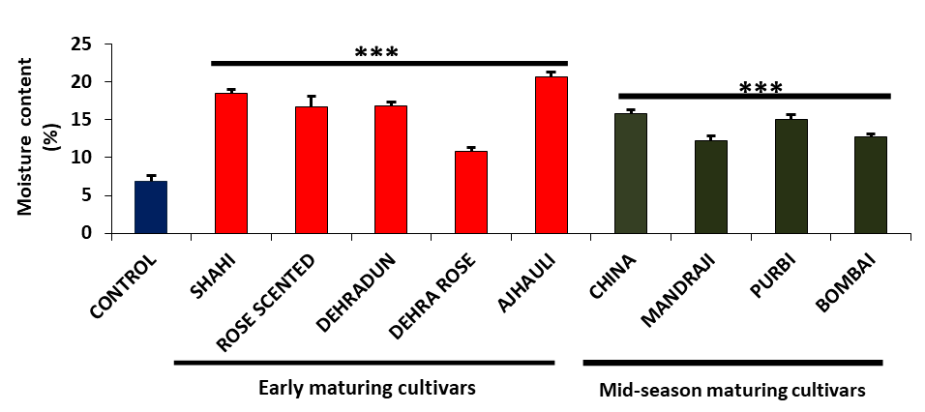
Figure 2. Soil moisture content in the rhizosphere soil of early and mid-season-maturing litchi cultivars was measured and compared to the control. Experiments were performed in triplicate, and data is represented as mean ± SD. The asterisks indicate a significant difference (p < 0.001).

  - Soil water-holding capacity
The water-holding capacity of the rhizosphere soil of litchi cultivars that mature early and mid-season is depicted in Figure 3 in comparison to the control. The findings showed that the control had a water-holding capacity of 46.67%, but the rhizosphere soil’s ranged from 43.33% to 70%. Of the early litchi cultivars, Rose Scented had the lowest water-holding capacity (43.33%), while Dehradun had the highest (70%). Among the mid-season maturing litchi cultivars, Purbi had the maximum water-holding capacity (66.67%), whereas Mandarji had the lowest (48.33%). Litchi cultivars that mature in the early and mid-seasons both have substantially greater water-holding capacities than the control.
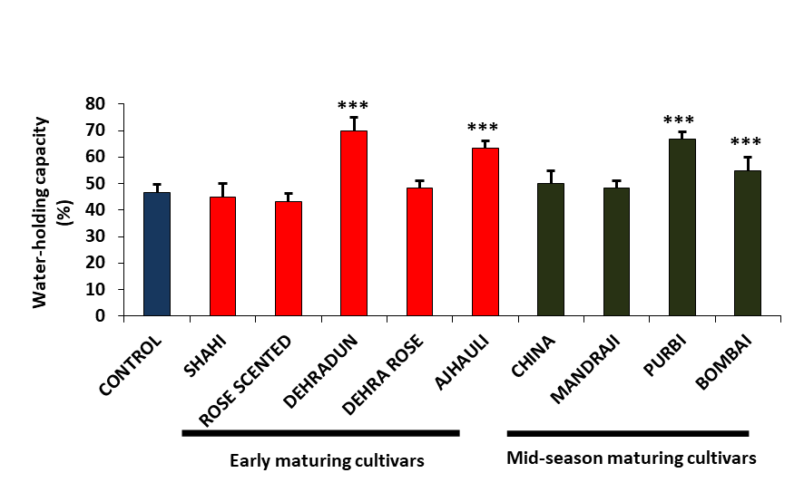
Figure 3. Water-holding capacity in the rhizosphere soil of early and mid-season maturing litchi cultivars was compared to the control. Experiments were performed in triplicate, and data is represented as mean ± SD. The asterisks indicate a significant difference (p < 0.001).

  - Soil pH
The pH level in the rhizosphere soil of early and mid-season maturing litchi cultivars was measured and compared to the control (Figure 4). The control (7.96) has the lowest pH value and is moderately alkaline, but the rhizosphere's soil pH ranged from 8.5 to 8.9, which is moderately to strongly alkaline. Rose Scented had the highest soil pH of any early litchi cultivar (8.9), whereas Dehra Rose had the lowest (8.5). China, Mandraji, and Purbi all had the highest soil pH among the mid-season mature litchi cultivars (8.8), whereas Bombai had the lowest (8.7). Compared to the control, these differences were statistically significant (p < 0.001). According to these findings, the pH values of early- and mid-season litchi cultivars are both noticeably higher than those of the control, with even more variation observed in early-maturing cultivars.
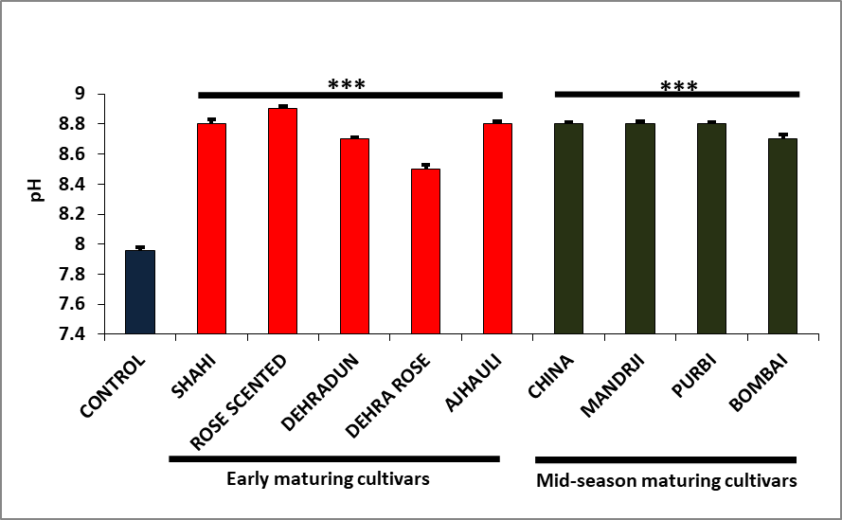Figure 4. Soil pH in the rhizosphere soil of early and mid-season maturing litchi cultivars was compared to the control. Experiments were performed in triplicate, and data is represented as mean ± SD. The asterisks indicate a significant difference (p < 0.001).

  - Soil electrical conductivity (EC)
Litchi cultivars that matured early and mid-season were compared to the control in terms of their rhizosphere soil electrical conductivity (Figure 5). The control had the lowest EC value (0.40 dS/m), while the rhizosphere's soil electrical conductivity ranged from 0.49 to 0.59 dS/m. Dehra Rose had the lowest soil EC value (0.49 dS/m), whereas Rose Scented had the highest (0.59 dS/m) of any early litchi cultivar. China and Bombai were the two cultivars of mid-season mature litchi with the lowest soil EC values (0.51 dS/m), while Purbi had the highest (0.59 dS/m). Additionally, these differences were statistically significant (p < 0.001) when compared to the control. According to our results, all soil samples showed lower EC values (less than 4 dS/m).
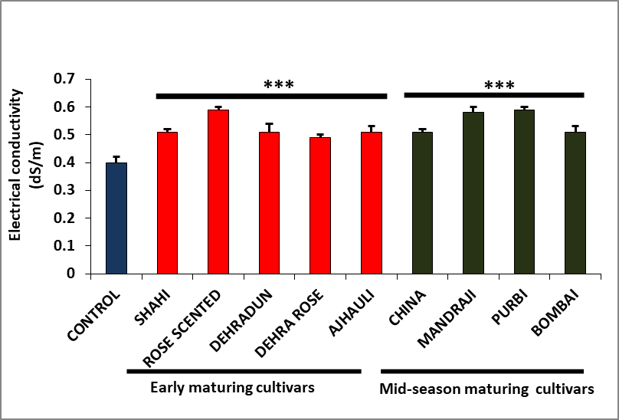
Figure 5. Electrical conductivity in the rhizosphere soil of early and mid-season maturing litchi cultivars was compared to the control. Experiments were performed in triplicate, and data is represented as mean ± SD. The asterisks indicate a significant difference (p < 0.001).

  - Soil organic carbon
The concentration of soil organic carbon in the rhizosphere soil of litchi cultivars that mature early and mid-season is contrasted with the control in Figure 6. The control contained the highest amount of soil organic carbon (0.75%), but the rhizosphere soil's level ranged from 0.49% to 0.60%. Of the early litchi cultivars, Dehra Rose and Shahi had the highest organic carbon content (0.58%), while cultivar Rose Scented had the lowest (0.49%). Among mid-season maturing litchi cultivars, Mandraji and Bombai showed the highest and lowest soil organic carbon concentrations, respectively (0.60% and 0.50%). In comparison to the other samples, which had medium soil organic carbon (0.5–0.75%), the cultivar Rose Scented had low soil organic carbon (less than 0.5%).
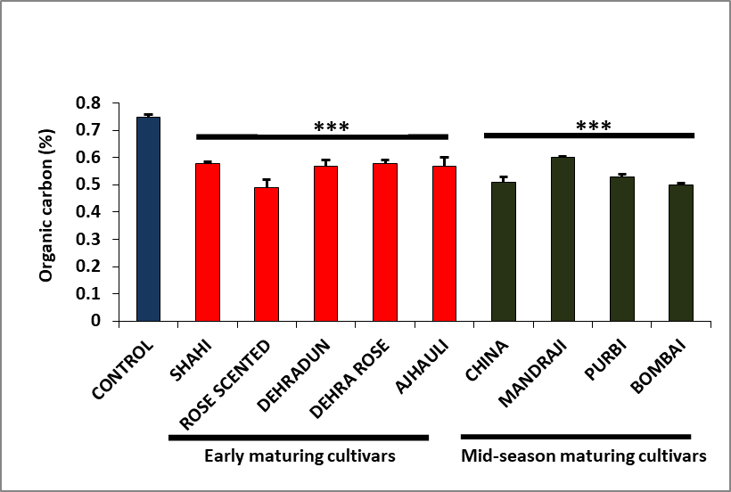
Figure 6. The soil organic carbon content in the rhizosphere soil of early and mid-season maturing litchi cultivars was compared to the control. Experiments were performed in triplicate, and data is represented as mean ± SD. The asterisks indicate a significant difference (p < 0.001).

  - Macronutrients availability
Macronutrients are nutrients that are abundantly absorbed by plants. Primary and most important macronutrients are nitrogen, phosphorus, and potassium, while secondary macronutrient includes sulphur (Daramola, D.A., & Hatzell, M.C., 2023). The macronutrient availability in the rhizosphere soil of early and mid-season maturing litchi cultivars showed significant difference when compared to control.

Available nitrogen content in the soil:
Figure 7 depicts the available nitrogen content in the rhizosphere soil of early and mid-season maturing litchi cultivars as compared to the control. The available nitrogen content in the rhizosphere soil ranged from 335-401 kg/ha, whereas control had the highest nitrogen content (461 kg/ha). Among the early maturing cultivars, Dehra Rose and Shahi recorded the maximum available nitrogen content (389 kg/ha), while Rose Scented recorded the minimum (335 kg/ha). In the mid-season maturing litchi cultivar, Bombai exhibited the lowest available nitrogen content (341 kg/ha), whereas Mandarji had the highest (401 kg/ha). According to our results, in all soil samples available nitrogen was found in medium range.
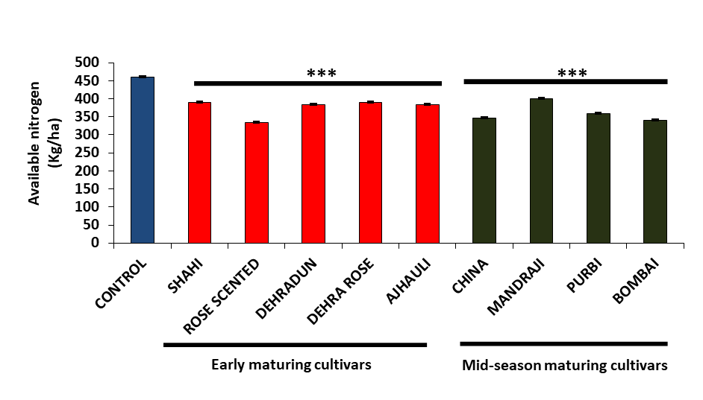
Figure 7. Available nitrogen content in the rhizosphere soil of early and mid-season maturing litchi cultivars was compared to the control. Experiments were performed in triplicate, and data is represented as mean ± SD. The asterisks indicate a significant difference (p < 0.001).

Available phosphorus content in the soil:
The accessible phosphorus concentration in the rhizosphere soil of litchi cultivars that mature early and mid-season is displayed in Figure 8 in contrast to the control. The available phosphorus content in the rhizosphere soil ranged from 33 to 57 kg/ha, whereas control had the highest available phosphorus (137 kg/ha). Among the early maturing cultivars, Dehra Rose recorded the minimum available phosphorus content (36 kg/ha), while Rose Scented recorded the maximum (57 kg/ha). In the mid-season maturing litchi cultivar, Mandraji exhibited the lowest available phosphorus content (33 kg/ha), whereas Purbi had the highest (53 kg/ha). According to our findings, the available phosphorus was high in all soil samples.
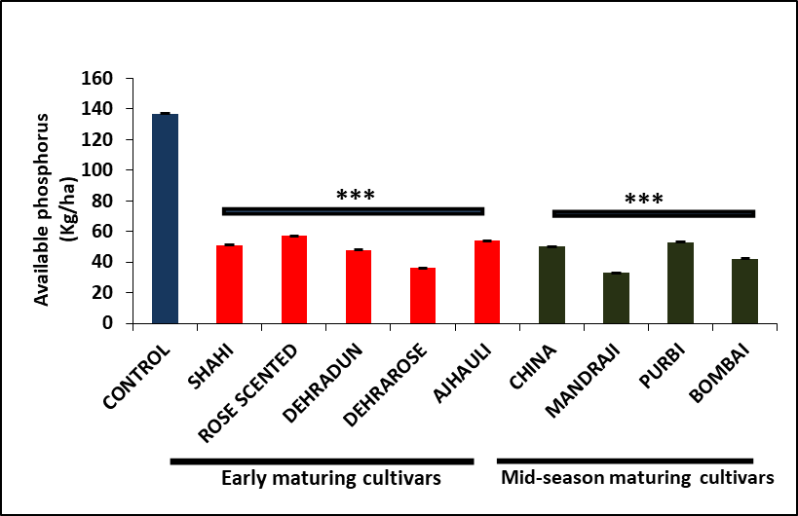
Figure 8. Available phosphorus content in the rhizosphere soil of early and mid-season maturing litchi cultivars was compared to the control. Experiments were performed in triplicate, and data is represented as mean ± SD. The asterisks indicate a significant difference (p < 0.001).
Available potassium content in the soil:
Figure 9 shows the available potassium content in the rhizosphere soil of early- and mid-season-maturing litchi cultivars in comparison to the control. It was observed that the available potassium content in the rhizosphere soil ranged from 47 to 102 kg/ha, whereas the control had the highest available potassium (301 kg/ha). Dehra Rose recorded the minimum available potassium content (62 kg/ha) among the early-maturing cultivars, whereas Rose Scented recorded the maximum (94 kg/ha). Among the mid-season maturing litchi cultivars, Bombai recorded the lowest available potassium content (47 kg/ha), whereas Purbi had the highest (102 kg/ha). The rhizosphere soil had a low amount of available potassium, but the control had a high amount, according to our data.
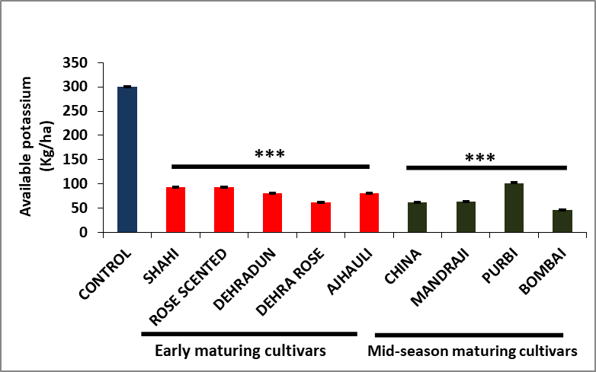
Figure 9. Available potassium content in the rhizosphere soil of early and mid-season maturing litchi cultivars was compared to the control. Experiments were performed in triplicate, and data is represented as mean ± SD. The asterisks indicate a significant difference (p < 0.001).

Available sulphur content in the soil:
The available sulphur content in the rhizosphere soil of early- and mid-season-maturing litchi cultivars was measured and compared to the control (Figure 10). It was observed that the available sulphur content in the rhizosphere soil ranged from 3 to 9 ppm, whereas the control had 6 ppm. Shahi recorded the minimum available sulphur content (3 ppm) among the early-maturing litchi cultivars, whereas Dehradun recorded the maximum (8 ppm), followed by Rose Scented (7 ppm), both of which were significantly higher than the control. Among the mid-season maturing litchi cultivars, Bombai recorded the lowest available sulphur content (4 ppm), whereas Purbi had the highest (9 ppm), significantly higher than the control (p < 0.001). According to our results, in all soil samples available sulphur content was below the critical limit.
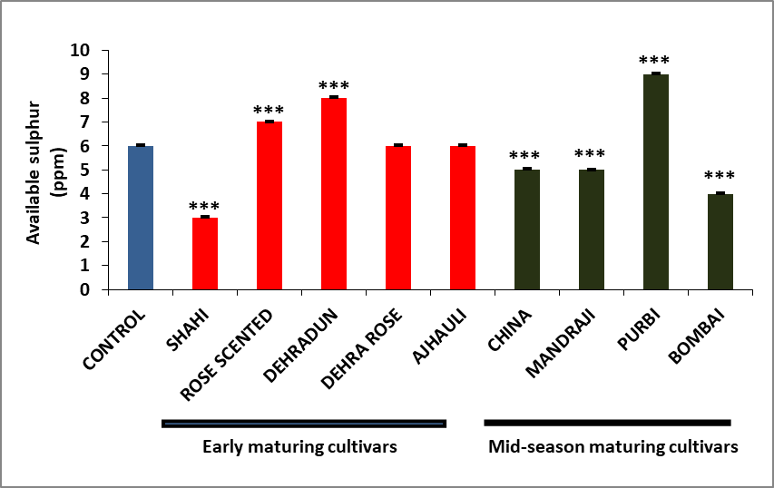
Figure 10. Available sulphur content in the rhizosphere soil of early and mid-season maturing litchi cultivars was measured and compared to the control. Experiments were performed in triplicate, and data is represented as mean ± SD. The asterisks indicate a significant difference (p < 0.001).

- DISCUSSION
Since soil provides vital nutrients for plants, its chemical and physical characteristics are crucial. Litchi tree growth and fruiting are therefore strongly correlated with the fertility status of the soil, which is frequently the capacity of the soil to sustain plant growth. The quantity and availability of the types of nutrients that plants can use are the most crucial aspects of soil fertility. Such levels are determined by a variety of parameters, including nutrient solubility, soil pH, soil texture, soil cation exchange capacity and organic matter content (Singh et al., 2012).

  - Soil moisture
Soil moisture refers to the amount of water present in the soil. According to Cronje and Mosturt (2010), soil moisture is crucial for growing litchi with a high yield and quality. Variations in soil moisture during fruit development result in significant drops in the weight of each individual fruit and, in extreme situations, can cause fruit cracking. Fruit quality, crop productivity, and marketing are all negatively impacted by this. The most important interventions for litchi-bearing behavior and high-quality production are soil moisture conservation (Kaur and Kaundal, 2009). For fruit to set and develop to maturity, litchi needs a lot of moisture in the soil. Skin cracking is lessened by the high soil moisture content throughout maturity (Lal et al., 2022). In our study, we measured and compared the rhizosphere soil moisture content of each early- and mid-season-maturing litchi cultivar with that of the control. We found that the soil moisture content in the rhizosphere soil ranged from 10.78% to 20.58%, while the control (6.84%) showed the lowest soil moisture content (Figure 2). Our results revealed that the rhizosphere soil samples from Ajhauli (20.58%) and China (15.83%) had the highest soil moisture content, while Dehra Rose (10.78%) and Mandarji (12.19%) had the lowest.
  - Soil water-holding capacity
The water-holding capacity or field capacity refers to the volume of water that remains in the soil after excess gravitational water has been removed and the downward water movement has significantly slowed, as defined by Veihmeyer and Hendrickson (1931). This state of field capacity is achieved between 48 to 72 hours of being saturated. It represents the highest level of soil moisture that is accessible to plants. Each early- and mid-season-maturing litchi cultivar’s rhizosphere soil water-holding capacity was compared to the control in our study. We found that the control had a water-holding capacity of 46.67%, but the rhizosphere soil’s ranged from 43.33% to 70% (Figure 3). Comparing the rhizosphere soil samples from Purbi (66.67%) and Dehradun (70%) to the control group, we discovered that they had the greatest capacity to hold water whereas the lowest was observed in Mandarji (48.33%) and Rose Scented (43.33%).

  - Soil pH
The pH of soil is defined as the negative logarithm of the concentration of hydrogen ions. Soil pH, also known as soil reaction, indicates the acidity or alkalinity of soil and is measured in pH units. It is a simple but critical assessment for soils, as soil pH has a significant impact on crop nutrient availability. The soil's acidity (pH) classification is given in Table 2.
Table 2: Classification of soils according to pH
Extremely acid | Strongly acid | Moderately acid | Slightly acid | Neutral | Moderately alkaline | Strongly alkaline
<4.6 | 4.6-5.5 | 5.6-6.5 | 6.6-6.9 | 7.0 | 7.1-8.5 | >8.5
(Source: Anonymous, 2011).
In our study, we compared the rhizosphere soil pH level of each early- and mid-season litchi cultivar to the control. We found that the pH value in the rhizosphere soil ranged from 8.5 to 8.9, while the control showed the lowest pH value, i.e., 7.96 (Figure 4). According to our findings, the rhizosphere soil samples from Purbi (8.8), Mandraji (8.8), China (8.8), and Rose Scented (8.9) had the greatest soil pH in comparison to the control (7.96), while Dehra Rose (8.5) and Bombai (8.7) had the lowest. It clearly showed that all the soil samples are moderately alkaline to strongly alkaline. Kumar et al., (2018) found that in the first year of observation, the soil pH varied between 7.8 and 8.9, aligning closely with our findings. Kumar et al., (2016) found that litchi orchard soil pH ranged from 7.42 to 9.53. The pH values observed in our study were within this interval. Our results are consistent with those of Singh et al., (2012), who reported pH values ranging 5.06 to 8.9, supporting the notion that litchi trees may flourish in a variety of soil pH conditions (Arnon and Johnson, 1942). According to Rai et al., (2001), litchi flourishes on Bihar's calcareous soils at pH levels ranging from 7.5 to 8.5. The soil pH has a direct or indirect effect on the availability of various nutrients, which ultimately impacts the yield and quality.

  - Soil electrical conductivity
Electrical conductivity (EC) is used to determine soluble salt concentrations in soil and is widely used to measure salinity. Saline soils have an EC higher than 4 dS/m, while non-saline soils have an EC below 4 dS/m. In our study, we compared the rhizosphere soil electrical conductivity of early- and mid-season litchi cultivars to the control. We found that the EC value in the rhizosphere soil ranged from 0.49 to 0.59 dS/m, while the control showed the lowest EC value, i.e., 0.40 dS/m (Figure 5). Our results also revealed that the rhizosphere soil samples from Rose Scented (0.59 dS/m) and Purbi (0.59 dS/m) had the highest soil EC when compared to the control. The lowest soil electrical conductivity was observed in Dehra Rose (0.49 dS/m), China (0.51 dS/m), and Bombai (0.51 dS/m). It clearly showed that all the soil samples have lower EC values. Kumar et al., (2018) reported that electrical conductivity was less than 0.2 dS/m. Kumar et al., (2016) also found that electrical conductivity of soil in litchi orchards ranged from 0.07 to 0.39 dS/m. Our data reveal that the EC range found in this investigation was greater than that reported in the majority of the previous literature.

  - Soil organic carbon
Soil Organic Carbon (SOC) refers to the amount of carbon found in the organic matter of soil. It plays a vital role in many ecological processes and is essential to healthy soil. Decomposition of plant and animal waste, such as leaves, roots, and dead organisms, is the main sources of SOC. It’s an important measure of soil fertility and health. SOC affects the soil’s ability to retain and release vital nutrients. It promotes microbial activity and controls water-holding capacity. In our study, we measured and compared the rhizosphere soil organic carbon content of early- and mid-season maturing litchi cultivars to the control. We found that the SOC content in the rhizosphere soil ranged from 0.49% to 0.60%, while the control (0.75%) showed the highest SOC content (Figure 6). Our results also revealed that the rhizosphere soil samples from Dehra Rose (0.58%), Shahi (0.58%), and Mandraji (0.60%) had the highest SOC, while cultivars Rose Scented (0.49%) and Bombai (0.50%) had the lowest. According to Kumar et al., (2016) organic carbon content ranged from 0.02% to 1.05%. The SOC observed in our study falls within this range. Considering the critical range mentioned by Kumar et al., (2016) our data reveal that soil organic carbon was low (<0.5%) in the Rose Scented sample, while in all other samples, it was in the medium range (0.5–0.75%).

  - Macronutrients availability
The nutrients that plants receive in large quantities are known as macronutrients. Nitrogen, phosphorus, and potassium are the primary and most significant macronutrients, but sulphur is a secondary macronutrient.

Available nitrogen content in the soil:
The nutrient that has the greatest impact on litchi plant growth and productivity is nitrogen. Like other plants, litchi orchards depend heavily on nitrogen for vegetative growth, which has a significant impact on the tree’s ability to bear fruit. There have also been reports of increased fruit set, retention, and yield when nitrogen is added. Branches develop poorly, blooming and fruit set are inhibited, and plant growth is slowed in N-deficient plants. Since no reliable correlation has been found between blooming time and nitrogen application or soil nitrogen concentrations, nitrogen has no direct effect on floral initiation (The Litchi, FAO, 2012). We examined the available nitrogen content in the rhizosphere soil of each litchi cultivar that matures early and mid-season and compared it to the control. We found that the available nitrogen content in the rhizosphere soil ranged from 335 to 401 kg/ha, whereas the control had the highest nitrogen level, at 461 kg/ha (Figure 7). Our results showed that the maximum accessible nitrogen concentration was found in the rhizosphere soil samples of Dehra Rose (389 kg/ha), Shahi (389 kg/ha), and Mandraji (401 kg/ha), while the lowest was found in Rose Scented (335 kg/ha) and Bombai (341 kg/ha). According to Ray, P.K. (2004), the critical limit of nitrogen for orchard soil and healthy, high-yielding litchi trees in North Bihar is 250 kg/ha. A deficit may result from a quantity below this limit. According to Kumar et al., (2016) majority of the samples showed high nitrogen while according to our findings all samples exhibited available nitrogen in the medium range (280–560 kg/ha).

Available phosphorus content in the soil:
In addition to nitrogen and potassium, phosphorus is essential for litchi productivity and fruit quality. It has been determined that phosphorus is one of the most crucial minerals for litchi yield, quality, and growth. In regions where mixed fertilizers are frequently applied, litchi phosphorus shortage is uncommon. A high concentration of phosphorus in the soil does not last for many years because it is fixed in calcareous soil as calcium phosphate and in acidic soil as iron and aluminium phosphate. Regular application of phosphorus has also been observed to cause deficiencies in other nutrients, including zinc and iron (Kumar et al., 2017). We compared the available phosphorus concentration in the rhizosphere soil of early and mid-season maturing litchi cultivars to the control. The rhizosphere soil’s accessible phosphorus concentration varied between 33 and 57 kg/ha, whereas the control had the largest amount (137 kg/ha) (Figure 8). According to our findings, the rhizosphere soil samples of Purbi (53 kg/ha) and Rose Scented (57 kg/ha) had the highest accessible phosphorus concentration, whereas Mandraji (33 kg/ha) and Dehra Rose (36 kg/ha) had the lowest. The necessary limit of accessible phosphorus for healthy, high-yielding litchi trees and orchard soil in North Bihar is 25 kg/ha, according to Ray, P.K. (2004). According to our findings, all samples had high amounts of accessible phosphorus (>25 kg/ha).

Available potassium content in the soil:
One of the most important nutrients for fruit quality and fullness (size and weight) is potassium. Potassium also promotes ripening and enhances skin color. Due to its great plant mobility, the peak need for potassium occurs right before harvest. Even in soils that are high in potassium, shortages frequently arise due to inadequate soil uptake, particularly when calcium, magnesium, and nitrogen levels are also high. In our study, we compared the available potassium content in the rhizosphere soil of early and mid-season maturing litchi cultivars to the control. The rhizosphere soil’s available potassium content varied between 47 and 102 kg/ha, whereas the control (301 kg/ha) had the largest amount (Figure 9). According to our findings, the rhizosphere soil samples of Purbi (102 kg/ha) and Rose Scented (94 kg/ha) had the highest accessible potassium concentration, whereas Bombai (47 kg/ha) and Dehra Rose (62 kg/ha) had the lowest. In North Bihar, the critical limit of available potassium for orchard soil and high-yielding litchi trees is 125 kg/ha (Ray, P.K., 2004). According to our data, the control had a significant amount of potassium (>280 kg/ha), whereas the rhizospheric soil of different litchi cultivars had low accessible potassium levels (<112 kg/ha).

Available sulphur content in the soil:
The amount of sulphur in the soil has a direct correlation with its organic matter concentration. The impact of sulphur nutritional status on quality and production is well-established for most crops, with the exception of litchi (Kumar et al., 2017). In our study, we compared the available sulphur content in the rhizosphere soil of early and mid-season maturing litchi cultivars to the control. We found that the available sulphur content in the rhizosphere soil ranged from 3 to 9 ppm, whereas the control had 6 ppm (Figure 10). Our study showed that Dehradun (8 ppm) and Purbi (9 ppm) had the highest sulphur content when compared to the control, while Shahi (3 ppm) and Bombai (4 ppm) recorded the lowest. Considering critical limits of 10 ppm for litchi, all soil samples was found to be below critical limit. These findings are similar to the result of Kumar et al., 2016.

- CONCLUSION
The study found that different litchi cultivars in Muzaffarpur, Bihar, had notable variations in the physical and chemical properties of the soil. In comparison to control soil, we discovered that litchi cultivars’ rhizosphere soils had greater levels of moisture content, water-holding capacity, pH, and electrical conductivity. These enhancements reduce problems like fruit breaking and promote better fruit development. However, compared to the control, litchi rhizosphere soils had lower amounts of organic carbon, accessible nitrogen, phosphorus, potassium, and sulphur. All nutrient levels remained within or above critical limits for optimal litchi growth, despite reduced nutrient availability beneath litchi orchards. The only exceptions were potassium and sulphur, which were below the recommended range in every litchi cultivar. According to these studies, litchi enhances the physical characteristics of soil, but over time, continuous cultivation may deplete vital nutrients. Thus, balanced fertilization and the addition of organic matter are two recommended nutrient management techniques for sustainable litchi production.

REFERENCES

- Anonymous, 2011. Methods Manual, Soil Testing in India. Department of Agriculture and Cooperation, Ministry of Agriculture, Govt. of India, New Delhi.
- Arnon, D.I., and Johnson, C.M., 1942. Influence of hydrogen-ion concentration on the growth of higher plants under controlled conditions. Plant Physiol., 17:525-39.
- Cronje, R.B., and Mostert, P.G., 2010. A Holistic Approach to Improve Litchi Orchard Management in South Africa.
- Daramola, D.A., & Hatzell, M.C., 2023. Energy Demand of Nitrogen and Phosphorus Based Fertilizers and Approaches to Circularity. ACS Energy Letters, 8(3), 1493-1501.
- Goldweber, S., 1959. Observation on lychees grown in pot culture. Proceedings of Florida State Horticultural Society 72:353~6.
- Kaur, K., and Kaundal, G., 2009. Efficacy of herbicides, mulching and sod cover on control of weeds in plum orchards. Indian J. Weed Sci., 104:110-12.
- Kumar, A., Pandey, S.D., Patel, R.K., Kumar, P., Kumar, G., Pongener, A., Ganeshamurthy, A.N., and Nath, V., 2017. Soil Fertility and Nutrition in Litchi: Delineation, Deficiencies and Management of Nutrients. NRCL-TB-12. ICAR-NRCL, Muzaffarpur. Pp: 28.
- Kumar, G., Kumar, R., Nath, V., Pande, S.D., Marboh, E.S., and Kumar, P., 2018. Integrated Soil Management Technique for Young Growing Orchards of Litchi (Lychee chinensis). Int. J. Curr. Microbiol. App. Sci, 7(9), pp.710-722.
- Kumar, G., Tewari, G., Kumar, V., Pandey, S.D., and Nath, V., 2018. Climate resilience in litchi (Litchi chinensis) orchards in Bihar through soil manipulations. Indian Journal of Soil Conservation, 46(2), pp.190-198.
- Kumar, J., Roy, A., Kumar, A., and Singh, S.P., 2022. Economic analysis and marketing efficiency of litchi in Muzaffarpur district of Bihar. The Pharma Innovation Journal, 11(4), pp.690-693.
- Kumar, V., Kumar, R. and Anal, A.K.D., 2016. Spore population, colonization, species diversity and factors influencing the association of arbuscular mycorrhizal fungi with litchi tree in India. Online Copy. Journal of Environmental Biology, 37, pp.91-100.
- Lal, N., Rangare, N.R., Jayswal, D.K., Chandola, J.C., Lakra, J., Chack, S., Kumar, B., Chhigarha, J., Tandon, K. and Sahu, K., 2022. Eco physiology of litchi in relation to variable climatic factors. Agricultural Mechanization in Asia, 53(9), pp.9683-9693.
- Li, G.L., Yao, L.X., Zhang, Z.Q., He, Z.H., Zhou, C.M., Huang, L.X., Guo, B., and Tu, S.H., 2011. Temporal and Spatial Variation of Nutrient Fertility on Guangdong Litchi Plantation. Chinese Journal of Soil Science, 42(5), 1081-1086.
- Li, J.G., Huang, H.B., Gao, F.F., Huang, X.M., and Wang, H.C., 2001. An overview of litchi fruit cracking. Acta Hortic. 558:205-208.
- Mathura, R., Dey, P., Gangopadhyay, K.K., Das, B., Nath, V., Reddy, N.N., and Singh, H.P., 2002. Influence of nitrogen, phosphorus and potassium on growth parameters, leaf nutrient composition and yield of litchi (Litchi chinensis). India J. Agril. Sci, 72(5), pp.267-270.
- Menzel, C.M., and Simpson, D.R., 1987. Lychee nutrition: A review. Scientia Hortic. 31:195-224.
- Menzel, C.M., and Simpson, D.R., 1988. Effect of temperature on growth and flowering in litchi (Litchi chinensis Sonn.) cultivars. J. Hortic. Sci. 63:349-360.
- Muratore, T., and Knorr, M., 2025. Determination of Water Holding Capacity (WHC) of Soil Samples.
- Olsen, S.R. Cole, Watanable, F.S., and Dean, L.A., 1954. Estimation of available phosphorus in soils by extraction with sodium bicarbonate. Circ. U.S. Dep. Agric. 939.
- Qui, Cheng Y.J., Qu, L., Wang, B., and Yuam, P., 1999. Relationship between fruit cracking and endogenous hormones in ‘Nuomoci’ litchi variety. J. Fruit Sci. 16:276-279.
- Raghavan, M., Hazarika, B.N., Das, S., Ramjan, M., and Langstieh, L.B., 2018. Integrated nutrient management in litchi (Litchi chinensis Sonn.) cv. Muzaffarpur for yield and fruit quality at foothills of Arunachal Pradesh. IJCS, 6(3), pp.2809-2812.
- Rai, M., Nath, V. and Dey, P., 2001. Genetic Resources, Production, Protection and Post-Harvest Management and Nutrient Management. Litchi. pp. 45-50.
- Ray, P.K., 2004. Litchi: Production Technology and Post-Harvest Handling for Export. Rajendra Agricultural University, Pusa, Samastipur, Bihar, India, 43.
- Singh, B. and Chadha, K.L., 2012. Evaluation of critical limits and development of leaf nutrient standards in litchi (Litchi chinensis Sonn.). International Journal of Innovative Horticulture, 1(1), pp.24-32.
- Singh, G., Nath, V., Pandey, S.D., Ray P.K., and Singh, H.S., 2012. The Litchi. Food and Agriculture Organization of the United Nations (FAO). New Delhi, India.
- Singh, H.P., and Babita, S., 2002. Lychee production in India. Pub.by: FAO of United Nations, New Delhi, India.
- Subbiah, B.V., and Asija, G.L., 1956. A rapid procedure for the determination of available nitrogen in soils. Curr. Sci. 25: 259-60.
- Toth, S.J., and Prince, A.L., 1949. Estimation of cation exchange capacity and exchangeable Ca, K and Na contents of soils by flame photometric techniques. Soil Sci., 67: 439–445.
- Veihmeyer F.J and Hendrickson A.H. (1931). The moisture equivalent as a measure of field capacity of soils. Soil Sci. 32, 181-194.
- Walkley, A.J. and Black, I.A., 1934. Estimation of soil organic carbon by the chromic acid titration method. Soil Sci. 37: 29-38.
- Waseem, K., Ghafoor, A., and Rahman, S.U., 2002. Effect of fruit orientation on the quality of litchi (Litchi chinenesis Sonn.) under the agroclimatic conditions of Dera Ismail Khan-Pakistan. Int. J. Agric. Biol. 4:503-505.
- Xu, Y.J., Wen, J., Xiao, G.S., Zhang, M.W., Li, S.F., and Wu, J.J., 2010. Comparative studies of processing characteristics of different litchi varieties. Food Science. 31(1), 33-37.
- Yao, L.X., 2009. Investigation report on the application and demand of national litchi nutrient management technology. Litchi Science Technology Communications. 3, 41 54.
- Yao, L.X., Li, G.L., Yang, B.M., He, Z.H., Zhou, C.M., Huang, L.X., and Guo, B., 2009. Nutrient accumulation properties of Guiwei and Feizixiao litchi. Litchi Science Technology Communications, 2, 52-64.

