Original Research Article

Impact of Repeated Tillage Passes on Soil Physical Characteristics

ABSTRACT
Chhattisgarh divided into three main agro-climatic zones: Chhattisgarh Plains, Bastar Plateau, and Northern Hills. Each zone has distinct soil types, rainfall patterns, and topography, leading to variations in paddy farming techniques. Central Zone covers fertile alluvial and clayey soils where paddy is cultivated mostly under irrigated and rainfed conditions. Bastar Plateau Zone practice rainfed upland and midland paddy cultivation. Northern Hills Zone includes terrain and lateritic soils. Paddy is mainly grown under rainfed conditions on terraced fields. The present study was conducted during the Kharif season of 2023–24 at the College of Agriculture and Research Station, Saja (Bemetara) under representative of tillage practices in Direct Seeded Rice (DSR) and Transplanted Rice (TP) systems. The experiment involved a combination of tillage treatments using cultivators and rotavators in varying passes to assess their effects on key parameters such as soil bulk density, moisture content, depth of cut, puddling index, weed population, energy use, and economic performance. Results revealed that both DSR and TP treatments significantly influenced soil physical properties and field conditions. In TP, treatment T5 (Rotavator × 3) recorded the highest puddling index (58.2%), superior moisture retention, reduced bulk density, and lowest weed regermination, indicating its suitability for wet tillage. In DSR, Treatment T8 (Cultivator × 2 + Rotavator × 1) achieved the maximum depth of cut (92 mm) and initial weed suppression, making it effective under dry conditions. All treatments reduced weed population immediately after tillage, though regermination varied with implement type and intensity. The study further stated that intensive use of rotavator enhances puddling effectiveness, while cultivator passes contribute significantly to dry soil penetration. Energy analysis suggested the selection of T5 for TP and T8 for DSR were found to be recommended. Further, findings recommended the farmers to adopt site-specific tillage practices that improve field efficiency, reduce weed pressure, conserve soil moisture, and optimize resource use for sustainable rice production.
Keywords: Tillage, Puddling, Soil physical properties, implements, cultivator, Chhattisgarh

1. Introduction
Chhattisgarh, has diverse agro-climatic zones—Chhattisgarh Plains, Bastar Plateau, and Northern Hills—each influencing distinct paddy cultivation practices. In the Chhattisgarh Plains paddy is grown in irrigated and rainfed fields using short- to medium-duration varieties like Mahamaya and MTU-1010, with widespread use of transplanting, chemical fertilizers, and mechanization. In the Bastar Plateau, tribal farmers grow paddy under rainfed upland and midland conditions using traditional methods, indigenous varieties, and low-input or organic practices. The Northern Hills feature terraced rainfed farming with drought-resistant varieties, mixed cropping, and soil conservation on undulating lateritic terrain. One of the critical aspects of sustainable agriculture is effective management of soil and machinery, which heavily depends on the appropriate use of tillage operations (Verma et.al; 2023). Tillage influences numerous soil physical properties including bulk density, porosity, penetration resistance, moisture retention, and aggregate stability. The type of tillage implement and the frequency of its application (i.e., the number of passes) significantly affect these soil attributes, ultimately determining crop productivity and soil health (Prabhu et.al.; 2025).
However, due to repeated passes of implements such as plough, harrow, rotavator and cultivator leads to adverse outcomes such as soil compaction, structure breakdown, and reduced organic matter content. Hence, effects of multiple passes of selected tillage implements on soil physical properties is essential for optimizing tillage practices, conserving fuel, workers productivity (Kumari et. al; 2025), soil health and crop performance. Soil tillage is traditionally perceived as a necessary activity to prepare the seedbed, manage crop residues, control weeds, and incorporate fertilizers. However, the repeated mechanical disturbance of soil can alter its physical condition, sometimes leading to degradation rather than improvement. Multiple passes of tillage implements may initially improve tilth and create a fine seedbed, but excessive operations can cause compaction in the subsoil layer, decrease macro-porosity, and impair root penetration.
For instance, while a rotavator may provide excellent seedbed preparation in a single pass, its repeated use can lead to the formation of a compacted layer or hardpan just below the tilled zone. Similarly, disc ploughs are effective in inverting and aerating the soil but may cause clod formation when used excessively. Cultivators, on the other hand, are more suited for shallow operations and weed control but have limited capacity to improve deep soil conditions. The number of passes, therefore, becomes a critical parameter in determining the net effect of tillage on soil physical properties.
A thorough field evaluation of tillage implements with varying number of passes offers an empirical basis to establish optimum tillage practices. Such research is particularly relevant in regions where farmers either over-till due to lack of knowledge or under-till due to resource constraints. By understanding the trade-offs involved, extension services and policymakers can promote site-specific tillage recommendations, thereby ensuring sustainable land use and enhanced crop productivity.
Despite the recognition of tillage as a key component of soil management, there remains a gap in our understanding of how multiple passes of different tillage implements affect soil physical properties under varying agro-climatic and soil conditions. Much of the existing research has focused on single-pass operations or comparisons between tillage and no-tillage systems. Limited attention has been given to how increasing the frequency of tillage impacts parameters such as bulk density, penetration resistance, moisture content, and porosity over time (Pandey et.al. 2023).
In the field, multiple passes are often employed to achieve a desired level of soil tilth, especially in heavier or poorly drained soils. However, this practice is frequently adopted without considering the long-term consequences on soil structure and health. In many cases, excessive tillage results in reduced water infiltration, increased runoff and erosion, and deteriorated root zones. Conversely, inadequate tillage may result in poor germination, weak root establishment, and ultimately lower yields. These outcomes highlight the importance of establishing an optimal number of tillage passes for specific implements to balance soil quality and agronomic performance.
Soil degradation, particularly due to mismanagement of tillage operations, is a growing concern in both intensive and extensive farming systems. Compacted soils, reduced infiltration rates, and structural instability are becoming increasingly common problems, particularly in areas where conventional tillage practices dominate. While conservation tillage and zero-tillage have been proposed as alternatives, their adoption is still limited due to various socio-economic and technical barriers. In this context, optimizing conventional tillage practices remains a pragmatic approach for most farmers, especially in developing countries. Rather than eliminating tillage, modifying the number of passes and selecting appropriate implements based on soil response can significantly improve outcomes.
The study evaluates the field performance of selected tillage implements under varying numbers of passes, focusing on their effects on key soil physical properties. Specifically, it aims to assess how disc plough, rotavator, and cultivator influence bulk density, porosity, moisture content, and penetration resistance; quantify changes after one to three passes; determine the optimum number of passes for desirable soil conditions; and compare the efficiency of these implements in modifying soil properties.
2. Review of literature
Dave and Pandey (2000) studied the influence of different tillage combinations using a power tiller on energy consumption, puddling efficiency, and yield in rainfed rice cultivation. They evaluated eight tillage treatment combinations involving various tools like the mouldboard plough, 3-furrow plough, cultivator, and puddler. Their results revealed that mechanized tillage required 1.52 to 2.07 times more energy than manual methods but achieved a 35% higher output-to-input energy ratio. Additionally, energy required for weeding was significantly lower (3.65 to 10.06 times) compared to manually tilled fields. Puddling index ranged between 50–65%, puddling depth between 12–15 cm, and weeding efficiency from 25–50%. Further, Dave (2004) evaluated four tractor-operated puddling tools—rotary puddler, peg-type puddler, shovel-type cultivator, and cage wheel—in vertisol soils. The rotary puddler with two passes showed the most favorable results: highest soil dispersion (48.02%), lowest wet sieving fraction (15.11%), and minimal water percolation rate (0.295 mm/h). It was also found to be the most energy-efficient, with a higher energy output-input ratio and lower specific energy requirement.
Verma and Dewangan (2006) compared puddling treatments using different power sources, from traditional bullock-drawn tools to tractors with cage wheels and rotavators. The tractor-operated rotavator recorded the highest weeding efficiency (98.6%) and puddling index (79.3). The fastest field preparation (9.4 h/ha) was achieved with the tractor and cultivator setup, while the rotavator had the highest energy demand (2390 MJ/ha).
Kumar (2007) examined the puddling performance of animal-drawn implements, specifically the mouldboard and desi ploughs. The mouldboard plough was more efficient, outperforming the desi plough in terms of area coverage (by 22.09%) and weeding efficiency (by 5.6%) under submerged conditions. The combination of the mouldboard plough followed by three passes of a rotary blade puddler was both cost-effective and energy efficient, with improved puddling index.
Ali (2009) explored the energy efficiency of conservation tillage tools in a rice-wheat cropping system. Zero tillage (T5) and strip tillage (T6) treatments required the least time, fuel, and energy inputs, with zero tillage being the most efficient (3.28 h/ha, 11.56 l/ha fuel use, 698.50 MJ/ha energy). In contrast, the rotavator-based system (T7) resulted in higher yields but was less energy-efficient. Zero tillage also proved to be the most cost-effective, with the lowest operational cost (Rs. 1233.77/ha). Saimbhi (2016) evaluated puddling equipment during paddy cultivation and found that the rotavator and pulverizing roller attachment produced the best puddle bed characteristics. The deepest puddle bed was achieved using the pulverizing roller, while the lowest development cost was also associated with this attachment. However, conventional methods using a cultivator-planker showed higher field capacity.
Kalita et al. (2020) highlighted both the advantages and drawbacks of mechanical puddling in wetland rice farming. Although mechanical puddling improves transplanting and weed control by increasing the puddling index and soil bulk density, it also negatively impacts the soil structure, reducing water infiltration and root growth potential for post-rice crops. The study emphasized that while increased puddling intensity enhances rice yield, it also deepens compacted layers and causes cracking. Interestingly, no-till mechanical transplanting yielded better than traditional puddled rice cultivation due to improved soil conditions for subsequent crops.
Rangapara et al. (2017) assessed the performance of different tractor-implement combinations for seedbed preparation. The mini tractor (15 hp) proved to be more efficient and economical than higher-powered tractors or power tillers. The operational cost for the mini tractor was the lowest (Rs. 1396.44/ha), outperforming other systems in terms of draft, fuel use, field efficiency, and soil disturbance volume.
3. Materials and Methods
The study was carried out during the kharif season of 2023–2024 jointly at the Instructional cum seed production farm, KDC College of Agriculture and Research Station, Saja, Bemetara and SV College of Agricultural Engineering and Technology and Research Station, IGKV Raipur. Raipur and Bemetara district fall in CG plain region where annual average rainfall 1400mm plain topography IGKV Raipur is situated 85 km from KDC CARS Bemetara. The field soil was medium black vertisol which contains high nutrients, expanding and shrinkage clay. The cropping pattern was paddy - wheat. Before the experiment, previous crop was wheat and harvested by combine harvester and then straw was burned.
3.1 Selected implements and machinery
For the study, a 11 tine-type cultivator (8–15 cm depth) and rotary tiller (10–15 cm depth, L-blades) were selected to compare linear and intensive soil disturbance. A 8-row rice transplanter was used to assess transplanting quality under varied tillage passes and altered soil conditions. The details of implements and machinery has been given in Table 1.
. Table 1. Details of selected implements for the study
Particulars | Name of implements and machinery
 | Cultivator | Rotavator | Paddy transplanter
Specification | 11 tyne | L-type blade | 8-row
Nominal width | 2.2m | 2.1m | 1.6m
Weight | 230 kg | 430 kg | 360kg
Power source used | 47kW | 47kW | 3.7kW

3.2 Experimental design
The experiment was undertaken to evaluate the effect of multiple passes of selected tillage implements on soil physical properties, machinery performance, and yield characteristics of rice under the agro-climatic conditions of Chhattisgarh. The study was conducted using the Rajeshwari variety of rice, a commonly cultivated variety in the region. The experimental layout as presented in table 2 followed a Randomized Block Design (RBD) to ensure uniformity and control over experimental error.
Table 2. Design of experiments
Design | Randomized block design |  | Parameters to be recorded
Level | 2 | Paddy Transplanting (manual/Mechanical) , Direct seeded Rice (DSR) | - Soil Parameters: Soil bulk density, Moisture content, Puddling Index, Depth of puddling, Soil inversion.  - Machine Parameter: Field capacity, Fuel consumption,  - Crop parameter: Grain yield, straw yield, regermination.
Treatments | 05 each | PT- T1, T2, T3, T4, T5,  DSR- T6, T7, T8, T9, T10

A total of 10 treatments were included, each replicated three times, to study the impact of different tillage intensities and methods under two main cultivation practices: transplanted rice and direct seeded rice (DSR). The treatments involved various combinations of tillage operations using a cultivator and rotavator. For transplanted rice, five treatments were applied; i.e. T1: Cultivator (1 pass) + Rotavator (1 pass), T2: Cultivator (1 pass) + Rotavator (2 passes), T3: Cultivator (2 passes) + Rotavator (1 pass), T4: Rotavator (2 passes) and T5: Rotavator (3 passes). Similarly, under direct seeded rice, five treatments were applied i.e. T6: Cultivator (1 pass) + Rotavator (1 pass), T7: Cultivator (1 pass) + Rotavator (2 passes), T8: Cultivator (2 passes) + Rotavator (1 pass), T9: Rotavator (2 passes) and T10: Rotavator (3 passes).
The study focused on both independent and dependent variables. The independent variable in this experiment was the type and intensity of tillage treatment applied, while the dependent variables included several parameters categorized under soil, machine, and yield aspects. Under soil parameters, the following were measured: Bulk density (g/cm³) to determine soil compaction. Moisture content (%): to evaluate the soil’s water retention capacity post-tillage. Puddling index (%): to assess the degree of soil pulverization and water retention for transplanted conditions. Depth of puddling (cm): indicating how deep the tillage has affected the soil layer. Soil inversion (m²): to estimate the thoroughness of soil mixing and turning.
Under machine performance parameters, the following were recorded: Effective field capacity (ha/h): the actual area covered by the machine per unit time. Field efficiency (%): reflecting the ratio of productive field work time to the total time spent. Fuel consumption (L/h): energy usage for each treatment. Time requirement (h/ha): total operational time needed per hectare. Under yield parameters, the study included: Spike length (cm): a key indicator of potential grain production. Grain yield (q/ha): total grain output per hectare. Straw yield (q/ha): total straw biomass collected per hectare.
4. Results and Discussions
This study aims to examine how different tillage passes of selected implements, namely a tine-type cultivator and a rotary tiller operated with tractor power, along with a self-propelled rice transplanter, affect several factors, including soil bulk density, soil moisture content, time requirements, fuel usage, yield, energy metrics, and economic aspects of various tillage practices in kharif rice farming. The cultivator represents conventional linear soil disturbance, while the rotavator provides intensive pulverization and residue mixing, enabling comparison of their impacts under repeated passes. The self-propelled rice transplanter was included to evaluate how altered soil conditions influence planting efficiency and field performance (Fig.1). Additionally, the option of direct-seeded rice (Fig.2) was considered to compare transplanting with reduced-tillage establishment methods. The observations and outcomes from the experimental work of this study have been detailed in this chapter.

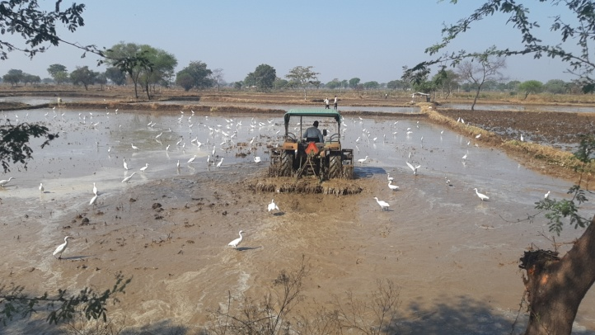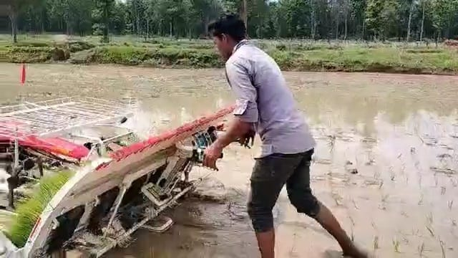
Fig.1. Puddling operation followed by mechanical transplanting of paddy.

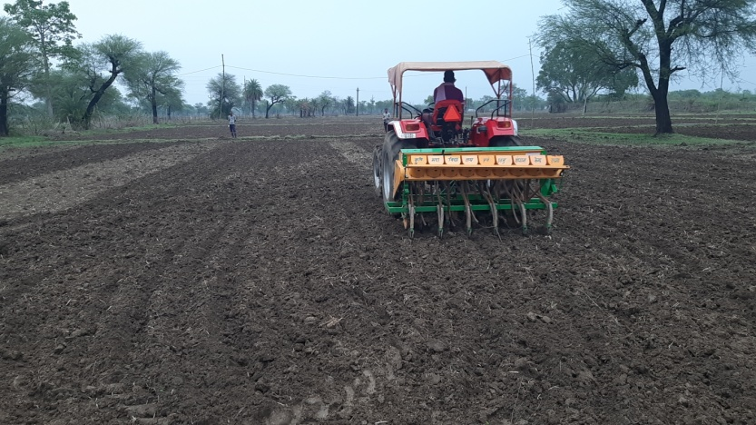
Fig.2. Direct seeding of rice using seed cum fertilizer drill.
4.1 Effect of tillage treatment on bulk density
Two distinct rice cultivation practices— paddy transplanted (TP) and direct seeded rice (DSR) were evaluated. For TP cultivation, puddling was carried out while DSR plots underwent dry tillage operation. For both cultivation methods, soil bulk density was measured twice: once immediately (BDi) after the tillage operation and again 15 days after sowing (BD15) or transplanting. The initial average bulk density of the experimental field across all treatments was recorded as 1.42 g/cm³.
For the TP treatments, the average bulk density immediately after puddling was found to be 1.352 g/cm³. The lowest value was recorded in T5 (Rotavator × 3) at 1.317 g/cm³, indicating better soil loosening. Further, it was followed by T4 (Rotavator × 2) at 1.347 g/cm³, T1 (Cultivator × 1 + Rotavator × 1) at 1.357 g/cm³, T3 (Cultivator × 2 + Rotavator × 1) at 1.363 g/cm³, and T2 (Cultivator × 1 + Rotavator × 2) at 1.377 g/cm³. After 15 days of transplanting, bulk density was highest in T2 (1.387 g/cm³), followed by T1 (1.377 g/cm³), T3 (1.370 g/cm³), T4 (1.367 g/cm³), and T5 (1.333 g/cm³) as indicated in fig.3. The lower bulk density in T5 across both observation points indicates improved soil structure that may enhance root development and water infiltration. These results demonstrate that tillage intensity and method significantly affect soil bulk density, which in turn influences soil health and crop performance.

Fig.3. The change in bulk density immediate and after 15 days of puddling operation.
In the case of DSR, the average bulk density immediately after the first tillage operation was observed to be 1.374 g/cm³. The treatment T9 (Rotavator × 2) reflect the highest bulk density at 1.403 g/cm³, indicating a higher level of soil compaction as shown in fig.4. This was followed by T6 (Cultivator × 1 + Rotavator × 1) at 1.373 g/cm³, T10 (Rotavator × 3) at 1.370 g/cm³, T7 (Cultivator × 1 + Rotavator × 2) at 1.363 g/cm³, and T8 (Cultivator × 2 + Rotavator × 1) at 1.360 g/cm³. After 15 days of seeding, the bulk density remained highest in T9 (1.413 g/cm³), followed by T10 and T6 (both at 1.387 g/cm³), T8 (1.380 g/cm³), and T7 (1.370 g/cm³). The persistently higher bulk density in T9 suggests greater soil compaction, which may adversely affect root penetration and water movement.

Fig.4. The change in bulk density immediate and after 15 days of tillage operation (DSR).
Among all treatments, T9 (Rotavator × 2) consistently exhibited the highest bulk density 15 days after seeding or planting, significantly exceeding all other treatments. Following T9, treatments T2 (Cultivator × 1 + Rotavator × 2), T6 (Cultivator × 1 + Rotavator × 1), and T10 (Rotavator × 3) also showed significantly higher bulk densities, although they were statistically similar to each other. Treatments T8 (Cultivator × 2 + Rotavator × 1) and T1 (Cultivator × 1 + Rotavator × 1) were statistically at par but had higher bulk densities compared to T7, T3, T4, and T5, which indicated comparatively looser soil structures (Pandey and Dave, 2014).
4.2 Effect of Tillage Treatment on Moisture Content
Soil moisture content is a critical factor influencing seed germination, root development, and overall crop performance, and it is directly affected by the type and intensity of tillage practices. The experiment revealed significant variations in soil moisture content among different tillage treatments, both immediately after field operations and 15 days later. In transplanted rice plots, immediately after puddling, the highest soil moisture was found in T5 (Rotavator × 3) at 28.95%, likely due to thorough mixing and surface sealing. It was followed by T1 (28.22%), T3 (27.70%), T4 (25.13%), and T2 (24.94%) as shown in fig.5. After 15 days of puddling, moisture content remained highest in T5 (26.62%), followed by T1 (25.58%), T3 (23.82%), T2 (22.65%), and T4 (22.54%). These results indicate that increased tillage intensity and rotavator use in TP can enhance short-term moisture retention due to the formation of a compact plow pan and reduced percolation losses (Sharma et al., 2018).

Fig.5. Soil moisture condition immediate and 15 days after transplanting.
In DSR plots, the highest moisture content immediately after field operation was observed in treatment T9, with a value of 38.38%, indicating better moisture retention due to higher compaction. It was followed by T8 (37.27%), T7 (34.92%), T6 (28.03%), and T10 (25.94%). Fifteen days after the tillage operation, a similar trend in moisture content was recorded. Treatment T9 again maintained the highest moisture level at 36.45%, followed by T8 (35.39%), T7 (30.79%), T6 (25.23%), and T10 (24.26%). This pattern (Fig.6) suggests that heavier or multiple tillage passes (as in T9 and T8) may reduce infiltration and increase moisture retention in the upper soil layers.

Fig.6. Soil moisture condition immediate and 15 days after direct seed sowing.
The observation highlights that different tillage treatments significantly influence the soil's capacity to retain moisture, with more intensive tillage generally enhancing immediate moisture levels (Patel et al., 2017). However, prolonged moisture retention also depends on the structural integrity and porosity of the soil, which vary between DSR and TP systems. Selecting appropriate tillage combinations based on soil type and cultivation method can thus optimize soil moisture management for improved crop performance.
4.3 Comparison of bulk density and moisture content
Using the critical difference (CD) values, statistically significant differences in soil bulk density and moisture content were identified among the various treatments. For bulk density measured immediately after operation (CD = 0.003), Treatment T5 showed significant differences when compared to all other treatments (T1 to T10), indicating its consistently lower bulk density. Additionally, T4 also differed significantly from treatments such as T2, T6, and T9. After 15 days (CD = 0.005), T5 maintained its significantly lower bulk density compared to almost all other treatments, with some minor significant differences also observed, such as between T4 and T9. Regarding moisture content immediately after operation (CD = 0.65%), Treatments T2 and T4 exhibited significantly lower values compared to T5, T6, T7, T8, and T9. Treatments T8 and T9 recorded the highest and significantly different moisture content levels from the others (Fig.7). After 15 days (CD = 0.91%), T2 and T4 continued to show significantly lower moisture content, while T8 and T9 again remained the highest, with their differences statistically significant. These results highlight the distinct influence of each treatment on soil compaction and moisture retention capacity.
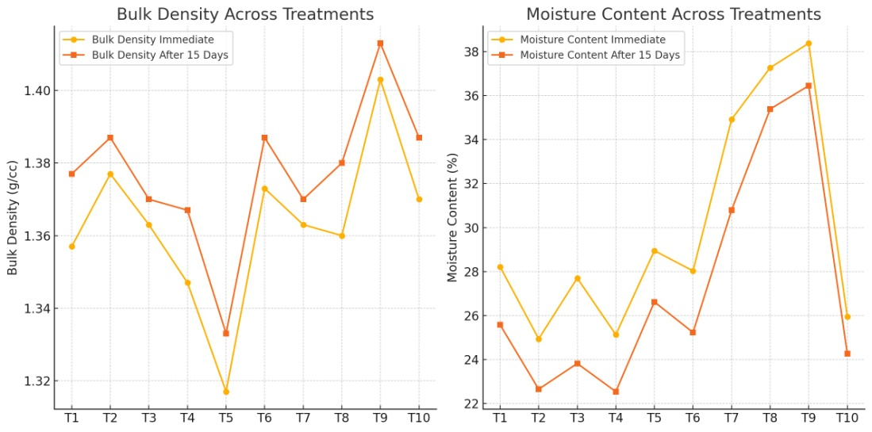
Fig.7. Varying trend of bulk density and moisture content among selected treatments

4.4 Effect of Puddling on Puddling Index
Puddling is a crucial operation in transplanted rice cultivation, primarily aimed at reducing percolation losses, improving water retention, and facilitating transplanting by creating a soft and muddy soil environment. The puddling index serves as a quantitative indicator of the degree of soil pulverization and the effectiveness of puddling, with higher values indicating better puddling quality. In the present study, the puddling index varied significantly across treatments involving different combinations and passes of cultivator and rotavator. According to the observations, the highest puddling index (58.2%) was recorded in Treatment T5 whereas 3 passes of rotavator indicated the most effective puddling among all treatments as shown in fig.8. The lowest puddling index (44.2%) was observed in treatment T1 where single pass of cultivator followed by rotavator were performed, suggesting relatively poor soil pulverization and mixing.
Similarly, the pudlling index of the other treatments was recorded 53.7%, 51.8%, and 48.8% for T2, T3 and T4 respectively. This progression illustrates that increasing the number of rotavator passes has a more pronounced effect on the puddling index than increasing cultivator passes alone. For instance, when the cultivator pass was held constant at one (T1 vs. T2), an increase in rotavator passes from one to two significantly improved the puddling index. Similarly, when the rotavator pass was held at one (T1 vs. T3), increasing the cultivator pass from one to two also improved the puddling index, but not to the same extent as increasing rotavator passes.
These results clearly demonstrate that the level of puddling improves with the increasing intensity of tillage, regardless of the specific combination of implements used. However, rotavator passes contribute more significantly to puddling effectiveness compared to cultivator passes, likely due to the rotavator's ability to achieve finer soil tilth and better water-soil mixing. The similar findings were obtained by Dave and Pandey (2000), Dave (2004), Verma and Dewangan (2006), Kumar (2007), and Saimbhi (2016). They reported that increased rotavator use enhances the puddling index and improves puddling quality in transplanted rice systems. For optimal puddling performance in rice cultivation, increasing the number of rotavator passes, either alone or in combination with cultivator operations is an effective strategy to achieve higher puddling index values and better field conditions for transplanting.

Fig.8. Effect of passes on puddling index

4.5 Effect of Dry and Wet Tillage on Depth of Cut and Depth of Puddling
The depth of tillage—whether in the form of a cut during dry tillage or puddling in wet conditions—is an important parameter that reflects the effectiveness of soil penetration and loosening. It directly influences root development, water infiltration, and field preparation quality. In this study, both depth of cut (dry tillage) and depth of puddling (wet tillage) were evaluated under various tillage treatment combinations involving cultivators and rotavators.

4.5.1 Depth of Puddling
The depth of puddling among the different puddling treatments ranged from 120 mm to 149 mm. The lowest puddling depth (120 mm) was recorded in Treatment T3 (Cultivator × 2 + Rotavator × 1), despite the use of three tillage passes. In contrast, treatments with more rotavator passes, such as T5 (Rotavator × 3) and T2 (Cultivator × 1 + Rotavator × 2), recorded higher puddling depths, confirming that the number of rotavator passes significantly influences the puddling depth. For instance, T2 showed a higher depth than T1, where both had one pass of cultivator but differed in the number of rotavator passes (two in T2 vs. one in T1). Fig.9 suggests that rotavator is more effective than cultivator in achieving greater puddling depth due to its higher soil-cutting and mixing efficiency in saturated conditions. Interestingly, T3, despite having three total passes (two cultivator + one rotavator), resulted in the lowest depth of puddling, possibly due to the limited mixing capacity of the cultivator in wet conditions. These findings are consistent with those reported by Dave and Pandey (2000), Dave (2004), Verma and Dewangan (2006), Kumar (2007), and Saimbhi (2016), who also observed that more rotavator passes improve puddling performance.

Fig.9. Effect of puddling on depth of puddling in different treatment
4.5.2 Depth of Cut
For dry tillage, the depth of cut varied between 64 mm and 92 mm across treatments. The lowest depth of cut (64 mm) was recorded in Treatment T9 (Rotavator × 2), indicating that using only the rotavator, even with multiple passes, may not be as effective in achieving deeper soil penetration in dry conditions. In contrast, Treatment T8 (Cultivator × 2 + Rotavator × 1) recorded the highest depth of cut (92 mm). Fig.10 suggests that the use of the cultivator contributes significantly to increasing the depth of soil penetration during dry tillage. Cultivators, with their tines, can loosen compacted soil more effectively than rotavators, especially in dry conditions. Interestingly, T7 (Cultivator × 2 + Rotavator × 1), which also involved three passes like T8, recorded a lower depth of cut, possibly due to variability in field conditions or operator efficiency. However, the general trend indicates that the inclusion of cultivator passes results in deeper cuts, enhancing soil preparation for seeding or transplanting. The results clearly illustrate that rotavator is more effective in increasing the depth of puddling under wet conditions (Verma et al., 2023), while cultivator use contributes more to the depth of cut under dry conditions. The number and combination of tillage passes play a critical role in determining soil penetration depth. For optimal field preparation, the choice and sequence of tillage implements should be tailored according to soil moisture conditions and desired tillage outcomes.

Fig.10: Effect of rotavator on depth of cut in different treatment

4.6 Effect of Different Treatments on Weed Population
Tillage plays a significant role in managing weed populations by disrupting weed root systems, burying weed seeds, and exposing them to desiccation. In this study, the impact of different dry and wet tillage treatments on weed population density (weeds/m²) was assessed before and after operations, as well as the extent of weed re-germination over time. Across all treatments, a reduction in weed population was observed immediately after tillage—both in dry and wet conditions—when compared to the initial pre-tillage state (Powar et al., 2020). This confirms the general effectiveness of tillage in providing immediate weed suppression.
Under wetland treatments, the highest weed control efficiency was observed in Treatment T5, followed by T2, T4, T3 and T1. The effectiveness of T5 can be attributed to the intensive soil churning by the rotavator, which buries and damages weed propagules and inhibits their regrowth. Among the dry tillage treatments, the highest weeding efficiency was recorded in Treatment T8 (Cultivator × 2 + Rotavator × 1), followed by T7 (Cultivator × 1 + Rotavator × 2), T10 (Rotavator × 3), T9 (Rotavator × 2), and T6 (Cultivator × 1 + Rotavator × 1). The superior performance of T8 can be attributed to the effective mechanical action of multiple cultivator passes combined with rotavator use, which disturbed the soil deeply and uprooted more weed biomass.
4.6.3 Weed Re-germination
Weed re-germination was monitored after the initial reduction, and notable differences were observed among treatments. Treatment T5 showed the lowest weed re-germination, indicating sustained suppression over time due to thorough puddling. On the contrary, T8 exhibited the highest re-germination, suggesting that despite high initial weeding efficiency, conditions in this treatment favored weed re-emergence—possibly due to a finer tilth and surface moisture that facilitated new seedling growth (Victor et al., 2020, Prabhu et al., 2025).
The overall trend of weed re-germination across treatments was follows: T5 < T4 < T2 < T3 < T10 < T1 < T9 < T7 < T6 < T8 as seen in fig.11. These results align with earlier research by Dave and Saxena (2000), Kumar (2007), and Ali (2009), who also found that more intense puddling and multiple rotavator passes are effective in reducing both immediate and delayed weed growth. The study revealed that both dry and wet tillage treatments significantly reduce weed populations initially. However, the long-term effectiveness depends on the intensity and type of tillage equipment used. Treatments involving multiple rotavator passes (like T5) were most effective in minimizing weed re-germination, making them suitable for long-term weed control in transplanted rice systems (Yadav, 2013). Conversely, dry tillage treatments with less aggressive soil disturbance showed higher weed re-growth, emphasizing the need to balance initial control with follow-up weed management strategies.

Fig.11: Effect of soil inversion in different treatment

5. Conclusions
The study demonstrated that various dry and wet tillage treatments had a significant impact on soil physical properties, field performance indicators, weed dynamics, and economic viability in both Direct Seeded Rice (DSR) and Transplanted Rice (TP) systems. For transplanted rice, Treatment T5 is the most effective option, as it provided the highest puddling index, improved soil moisture retention, reduced bulk density, and achieved excellent weed control. For direct seeded rice, Treatment T8 is recommended, offering an optimal depth of cut and effective initial weed suppression, making it well-suited for dry tillage operations. The outcomes of the study underscore the importance of selecting appropriate tillage practices and implement combinations to improve productivity, suppress weed growth, and enhance energy efficiency in rice cultivation. Farmers are encouraged to choose tillage treatments based on their available resources, method of crop establishment, and specific soil conditions to ensure higher returns and maintain long-term soil health.
6. Reference
Ahmed, Nafees., Kumar, Nimit, Singh, S.P., Kachroo, Jyoti, Singh, Harminder and Kumar, Chandan (2013). Economic analysis of cost and return for basmati rice cultivation in Jammu district of J&K state. Internat. J. agric. Sci., 9(2): 674-677.
Alipour A., Veisi H., Darijani F., Mirbagheri B., Behbahani A.G., 2012. Study and determination of energy consumption to produce conventional rice of the Guilan province. Res. Agr. Eng., 58: 99–106.
Alipour, A., Veisi, H., Darijani, P., Mirbagheri, B., and Behbahani, A.G. 2012. Study and determination of energy consumption to produce conventional rice of the Guilan province. J. Res. Agr. Eng.58 (3): 99-106
Chaichana, T., Phethuayluk, S., Tepnual, T. and Yaibok, T., 2014. Energy consumption analysis for Sangyog rice production in Thailand. Energy Procedia V (52): 126-130.
Churpal, D., Kostha, A.K. and Choudhary, V.K., 2015. An economic analysis of rice cultivation and constraint in Dhamtari district of Chhattisgarh, India, Plant Archives. 15(2): 651 – 656.
Dave, A.K. and Saxena, R.R. 2000. Effects of tillage on energy input, puddling quality and yield of rainfed rice under power tiller farming. 9(3&4). 171-176.
Dave, A.K. and Pandey, T.D., 2000. Effect of tillage on energy parameters, puddling quality and yield of rainfed rice under power tiller farming. 37(2): 73-74.
IS 9164:1979. Indian standard guide estimating cost of farm machinery operation.
IS: 11531-1985. Indian standard for testing of Puddler.
Kalita, J., Ahmed, P., and Baruah, N., 2020. Puddling and its effect on soil physical properties and growth of rice and post rice crops: A review. Journal Pharmacognosy and Phytochemistry. 9(4): 503-510.
Nirmala, B. and Muthuraman, P., 2009. Economics and constraint analysis of rice cultivation in Katihar district of Haryana, Indian Research General of Extension Education, 9(1): 43-50.
Verma N, Dave AK, Pandey NK, Shrivastava AK. 2023. Investigates the impact of level of passes of puddling implements on summer rice yield and energy efficiency. Int J Stat Appl Math. 2023;SP-8(5):985-989.
Pandey, H. S and Dave, A.K. 2014. Energetic and Economics analysis of rice based cropping system a case study. Vol. 38. 8-12.
Patel SP, Guru PK, Borkar NT, Debnath M, Lal B, Gautam P, Kumar A, Bhaduri D, Shahid M, Tripathi R, Nayak AK and Pathak H (2017) Energy Footprints of Rice Production. NRRI Research Bulletin No.14, ICAR-National Rice Research Institute, Cuttack, Odisha 753006, India. pp 1-26.
Pawar, V., Khosla, K., Sahu, S. and Madhariya, P., 2020. Estimate the cost of cultivation of paddy in Dhamatari district of Chhattisgarh. International Journal of Chemical Studies. 8(4): 324-327.
Rangapara, D.K., Dabhi, K.L., and Makwana, A.D., 2017. Comparative performance of tractor drawn implements tillage system with rotavator tillage system. International Journal of Agriculture Sciences. 9(5): 3743- 3748.
Rathi, D., Patre, J., Patel, M. and Pandey, S., 2019. Economics of paddy cultivation under different sowing techniques in Raipur district of Chhattisgarh. International Journal of Current Microbiology and Applied Sciences. 8(12): 693-699.
Saimbhi, V., 2016. Effect on puddling equipment on puddling characteristics under Paddy Cultivation in Punjab. International General of Agriculture and Environmental Research. 2(3): 332-338.
Sharma, S., Gurjar, B. and Sahu R.M., 2018. Economic analysis of rice production in Bilaspur district of Chhattisgarh. Journal of Pharmacognosy and Phytochemistry. 2873-2876.
Verma, A.K. and Dewangan, M.L., 2006. Efficiency and energy use in puddling of lowland rice grown on Vertisols in Central India. Soil & Tillage Research 90: 100-107.
Victor, V.M., Dave, A.K. and Lawrence, A.K.A. linear tools 2020. Puddling Effects on Energy Parameters under Animal Farming for Mechanized Cultivation of Rice. IJAEB, 13(4): 447-451.
Yadav, S.N., Chauhan, N.S., Chandra, R. and Khura, T.K., 2013. Energy input-output analysis and mechanization status for cultivation of rice and maize crops in Sikkim. Agric Eng Int: CIGR Journal. 15(3): 108-116.
Prabhu Neelagar, AK Shrivastava and AK Dave. 2025. Energy use and economic viability in rice forming. Int. J. Agric. Food Sci. 2025;7(5):276-278. DOI : https://doi.org/ 10.33545/ 2664844X. 2025.v7.i5d.409
Kumari, M., Shrivastava, A. K., Dave, A. K., & Tiwari, P. (2025). A Comprehensive Analysis of Control Frequency in Self-Propelled Combine Harvesters Operating in Chhattisgarh. Journal of Ecophysiology and Occupational Health, 25(2), 301–306. https://doi.org/10.18311/jeoh/2025/44390
Tiwari P, Shrivastava AK, Dave AK. Anthropometry of tribal farm women to improvise hand tool designs for Bastar district of Chhattisgarh. J Agric Eng. 2021; 58(3):205-221. https://doi.org/10.52151/jae2021581.1746
Shrivastava AK, Mehta CR, Pandey MM, Shrivastava AK. Accessibility index of Indian tractors- A case study. AMA Agric Mech Asia Afr Lat Am. 2010; 41(3):17-20.

