Original Research Article
Assessment of Genetic Variability and Trait Associations for Quantitative Characters in Chilli (Capsicum annuum L.)

ABSTRACT
A field experiment was conducted during 2023-2024 at the School of Agricultural Sciences (SOAS), Malla Reddy University, Hyderabad, using 51 genotypes of chilli (Capsicum annuum L.) in a Randomized Complete Block Design with two replications. The study aimed to estimate genetic variability, heritability, and genetic advance for 15 quantitative traits. The analysis of variance and mean performance revealed significant differences among the genotypes for all yield-contributing traits. Both the genotypic coefficient of variation (GCV) and phenotypic coefficient of variation (PCV) showed substantial variation across all traits, with PCV consistently higher than GCV. High GCV and PCV values were recorded for traits such as the number of secondary branches, ascorbic acid content, and fruit girth, whereas days to harvest exhibited low variability. High heritability coupled with high genetic advance as was observed for single-plant yield, ascorbic acid content, fruit girth, and the number of secondary branches, indicating the predominance of additive gene action. Correlation analysis revealed that key traits influencing fruit yield include the number of green fruits per plant, fruit weight, branching, ascorbic acid, flowering time, and plant height. Path analysis indicated that the number of green fruits per plant and plant height are crucial traits for selection in yield improvement programs. A low residual effect of 0.11 suggests that the traits analyzed sufficiently accounted for yield variation. Enhancing these traits collectively can significantly boost overall yield. These findings suggest strong potential for improving these traits through an effective selection program.

- INTRODUCTION
Chilli (Capsicum annuum L.), belonging to the family Solanaceae and genus Capsicum, has a chromosome number of 2n = 24. It is herbaceous annual crop propagated by seeds, originating from Central and South America, including Mexico, Guatemala, and possibly Bulgaria. The Capsicum genus contains 30 species, with five widely cultivated for their use as vegetables and spices: C. annuum, C. frutescens, C. chinense, C. pubescens, and C. baccatum. Introduced to India by the Portuguese in the 16th century, C. annuum is the most commonly grown species, although C. frutescens and C. chinense are cultivated in regions like northeastern India, Andhra Pradesh, Karnataka, and Kerala. India is the largest producer and exporter of chillies, contributing 43% of global production, followed by China and others. Andhra Pradesh is the top chilli producer, with Telangana ranking second in area and production and first in productivity. Indian chillies, known for their vibrant colour and spiciness, dominate spice exports to countries like China, Vietnam, and Thailand, making up 42% of India's spice export volume.
Genetic and environmental factors influence chilli variability, crucial for breeding programs. Heritability is essential for understanding trait expression and improving selection efficiency. Yield is a complex trait shaped by multiple contributing factors and it requires a systematic breeding approach to effectively optimize selection indices. This study emphasizes assessing genetic variability, heritable diversity, and trait associations to develop high-yielding and adaptable chilli varieties. Assessing the variability in germplasm is essential for designing effective breeding strategies (Krishna et al., 2007). Greater genetic variability within a population increases the potential for selecting desirable traits (Vavilov, 1951). Heritability represents the proportion of phenotypic variation passed from parent to progeny, which is critical for determining whether a trait is influenced by genetics or the environment. High heritable variation improves the likelihood of fixing traits through selection. However, Heritability alone may not effectively predict breeding value; integrating it with genetic advance offers deeper insights into the outcomes of selection (Johnson et al., 1955). Wright (1921) was the first to propose correlation and path analysis as methods to understand the relationship between predictor and response variables. Correlation gives the association between yield and other traits, while path coefficient analysis allows for the separation of correlation into direct effects (path coefficient) and indirect effects (effects exerted through other variables). Path coefficient analysis simplifies the partitioning of correlation coefficients into the direct and indirect impacts of different characteristics on yield. This approach can provide valuable insights for enhancing yield-related traits (Sharma 2019). The success of any breeding program hinges on genetic diversity and the association between traits. This study aims to evaluate genetic variability, heritability and association studies for yield and related traits in 51 chilli genotypes.
- MATERIALS AND METHODS
This study aimed to assess the variability in growth and yield-related traits of chilli. The research was conducted at the School of Agricultural Sciences (SOAS), Malla Reddy University, Hyderabad, during the 2023-2024 growing season. A total of 51 chilli genotypes were assessed under field conditions to identify superior candidates for hybridization programs. Seeds for these genotypes were sourced from SOAS, Malla Reddy University, Hyderabad. The experiment was laid out in a Randomized Block Design (RBD) with two replications during the Rabi season of 2023-2024. Each genotype was grown in single rows with 10 plants per row at a spacing of 45×45 cm. Standard management practices were applied to ensure optimal crop growth. Data were recorded for several traits, including plant height (cm), Number of primary and secondary branches, Days to first flowering and 50% flowering, Stem girth (mm), Fruit girth (mm) and length (cm), Number of green fruits per plant, Average green fruit weight (g), Days to first harvest, Number of seeds per fruit, 1000-seed weight (g), Ascorbic acid content (mg/100g).This comprehensive evaluation aims to facilitate the selection of high-performing genotypes for future breeding initiatives. The genotypic and phenotypic coefficients of variation were calculated according to Burton and Devane (1953). Heritability in the broad sense was estimated as per Falconer (1981), and expected genetic advance was determined using the method of Johnson et al. (1955). The scale for correlation coefficients was suggested by Searle (1965), while Lenka and Misra (1973) categorized the direct and indirect effects.
- RESULT AND DISCUSSION
The analysis of variance showed significant differences among 51 chilli genotypes for all yield-related traits, indicating genetic diversity. Table 1 represents the ANOVA results, while Table 2 and Fig 1and 2 provide values for GCV, PCV, heritability, genetic advance, and GAM. There was considerable variability within the experimental material, offering opportunities for selection and improvement of yield and related traits. It highlights the potential for improving yield and associated traits through targeted selection. Previous studies by Janaki et al. (2016) and Meena et al. (2016) also reported variability in different traits based on their respective chilli genetic materials.
The GCV and PCV showed notable variation across all traits, with PCV generally exceeding GCV. However, the differences were relatively small, indicating that the observed variation was mainly due to genetic factors with limited environmental influence. Previous studies by Ullah et al. (2011), Kumar et al. (2012), and Pandit and Adhikary (2014) also reported higher PCV than GCV, indicating that environmental factors have a lesser impact on trait expression.
Among the traits, the number of secondary branches, ascorbic acid content, and fruit girth showed high values for both PCV and GCV, indicating significant genetic variability for these traits among the chilli genotypes. Single plant yield and fruit length exhibited high PCV and moderate GCV, highlighting the potential for improvement. Similar observations were made by Singh et al. (2017), Murmu et al. (2017), and Nahak et al. (2018). Additionally, Arup Chattopadhyay et al. (2011) and Mishra et al. (2015) also reported high PCV and GCV for ascorbic acid content. Low PCV and GCV values for days to harvest were observed by Amit et al. (2014).
High broad-sense heritability estimates were observed for all the studied traits. The high heritability values indicated that these traits are strongly controlled by genetics, with minimal environmental influence, making phenotypic selection effective for future breeding programs. The results suggests that a major portion of the observed phenotypic variance is due to genotypic variance, reinforcing the reliability of phenotypic selection for these traits. High heritability for various traits such as days to 50% flowering, plant height, fruit girth, average fruit weight, and number of fruits per plant has also been reported by Maurya et al. (2015), Pandiyaraj et al. (2017), and Nahak et al. (2018). Singh et al. (2017) found high heritability for number of fruits per plant, fruit length, average fruit weight, and yield, while Murmu et al. (2017) observed high heritability for plant height, number of fruits per plant, and yield. Patel et al. (2015) and Mishra et al. (2015) reported high heritability for ascorbic acid content.
Traits such as plant height, number of primary and secondary branches, days to first flowering, days to 50% flowering, stem girth, fruit girth, number of green fruits per plant, average green fruit weight, number of seeds per fruit, 1000-seed weight, ascorbic acid content, and single plant yield showed high genetic advance as a percentage of the mean. Pandit and Adhikary (2014), Janaki et al. (2015), Pujar et al. (2017), Pandiyaraj et al. (2017), Singh et al. (2017), and Nahak et al. (2018) also reported high genetic advance for traits like plant height, average fruit weight, ascorbic acid content, and number of fruits per plant while Maurya et al. (2015) and Nahak et al. (2018) observed significant genetic gain for days to 50% flowering. These traits offer promising potential for selection in breeding programs. This study highlighted high heritability combined with high genetic advance for traits like plant height, number of primary and secondary branches, days to first flowering, days to 50% flowering, stem girth, fruit girth, number of green fruits per plant, average green fruit weight, number of seeds per fruit, 1000-seed weight, ascorbic acid content, and single plant yield. This suggests that these traits are primarily governed by additive gene action and are minimally influenced by environmental factors, making them ideal candidates for selection in breeding programs. Similar findings were reported by Ahmed et al. (2022) for average fruit weight, Pandiyaraj et al. (2017) for ascorbic acid content and plant height, and Janaki et al. (2015) for fruit diameter, plant height, and average fruit weight.
The findings of the association analysis, conducted on 51 genotypes across multiple traits, were presented in Table 3 and Fig. 3. Single plant yield exhibited a significant positive correlation with key traits, including the number of green fruits per plant, average green fruit weight, number of primary and secondary branches, ascorbic acid content, days to 50% flowering, and plant height. These results align with earlier studies, viz., Jogi et al. (2015), Patel et al. (2015), and Vikram et al. (2014), who also reported a strong positive association between fruit yield per plant and ascorbic acid content. Likewise, positive and significant correlations of fruit yield with average fruit weight and number of fruits per plant were previously documented by Amit et al. (2014), Patel et al. (2015), Rohini (2015), Hasan et al. (2016), and Pujar et al. (2017). Furthermore, Vidya et al. (2018) observed significant positive correlations of fruit yield with both fruit length and fruit girth. Additionally, the number of green fruits per plant showed a strong positive correlation with average green fruit weight, single plant yield, number of primary and secondary branches, ascorbic acid content, and days to 50% flowering, supporting the findings of Gupta et al. (2009).
Correlation studies revealed that the key traits influencing fruit yield include the number of green fruits per plant, average green fruit weight, number of primary and secondary branches, ascorbic acid content, days to 50% flowering, and plant height. These traits should be given priority in selection strategies aimed at enhancing green fruit yield per plant.
The path analysis results were presented in Table 4 and Fig. 4. The analysis of direct effects on single plant yield demonstrated that the number of green fruits per plant exerted the highest positive direct effect, corroborating the findings of Patel et al. (2015), Sunnia Gorka et al. (2016), Pujar et al. (2017), Murmu et al. (2017), and Vidya et al. (2018). In comparison, plant height showed a low but positive direct effect on yield, consistent with the reports of Pujar et al. (2017), Murmu et al. (2017), and Vidya et al. (2018).
Traits such as days to 50% flowering, number of seeds per fruit, 1000-seed weight, fruit length, stem girth, fruit girth, and ascorbic acid content exhibited only minimal positive direct effects on single plant yield. Similarly, Bijalwan and Mishra (2016) reported a low positive direct effect for ascorbic acid. On the contrary, average green fruit weight had a pronounced negative direct effect on single plant yield. Additionally, traits like days to first flowering, number of primary branches, and number of secondary branches showed negligible negative direct effects. A similar negative direct effect of days to 50% flowering on fruit yield was also reported by Jogi et al. (2015) and Mishra et al. (2015).
Based on association and path analysis, it was revealed that the number of green fruits per plant and plant height should be considered key components for selection in breeding programs aimed at improving yield per plant. Enhancing these traits together would lead to an increase in overall yield. The residual effect for the eleven traits studied was 0.11, indicating that a sufficient number of traits were evaluated for their association with yield.
- CONCLUSION
In chilli breeding programs, selecting genotypes based on key economic traits is essential for improving yield and quality. This study revealed high estimates of genetic variability, heritability, and genetic advance for important traits such as single plant yield, ascorbic acid content, fruit girth, and number of secondary branches. These findings indicate strong genetic control and the potential for effective phenotypic selection.
Correlation and path analysis further highlighted that traits like the number of green fruits per plant, average green fruit weight, number of branches, ascorbic acid content, and plant height are closely associated with yield. Among these, the number of green fruits per plant and ascorbic acid content emerged as particularly influential. These traits can serve as reliable selection indices in breeding programs aiming to develop high-yielding, nutritionally superior chilli genotypes.
Therefore, integrating these traits into selection strategies can significantly enhance the efficiency of chilli improvement programs.

COMPETING INTERESTS DISCLAIMER:
Authors have declared that they have no known competing financial interests OR non-financial interests OR personal relationships that could have appeared to influence the work reported in this paper.

REFERENCES
Amit, K, I Ahad, V Kumar, and S Thakur. 2014. Genetic variability and correlation studies for growth and yield characters in chilli (Capsicum annuum L.). Journal of Spices and Aromatic Crops 23 (2) 170-177.
Arup Chattopadhyay, Arup Chattopadhyay, AB Sharangi, Nuka Dai Nuka Dai, and Subrata Dutta Subrata Dutta. 2011. Diversity of genetic resources and genetic association analyses of green and dry chillies of Eastern India. Chilean Journal Of Agricultural Research. 71(3).
Bijalwan, Priyanka, and AC Mishra. 2016. Correlation and path coefficient analysis in chilli (Capsicum annuum L.) for yield and yield attributing traits. International Journal of Science and Research 5 (3) 1589-1592.
Burton, G. W., and Devane, E. H. 1953. Estimating the heritability in tall fescue (Festuca arundinancea) from replicated clonal material. Agronomy Journal. 45: 478-481.
Falconer, D.S., Quantitative Introduction Genetics, 2nd to edition, Longman Group Ltd., Longman House, Harrow, England, Page no. 350 (1981).
Gupta, Anand Mohan, Daljeet Singh, and Ajay Kumar. 2009. Genetic variability, genetic advance and correlation in chilli (Capsicum annuum). The Indian Journal of Agricultural Sciences, Page no. 79 (3).
Hasan, Rokib, Matin Akand, Nazmul Alam, Abul Bashar, and AKM Mahmudul Huque. 2016. Genetic association analysis and selection indices for yield attributing traits in available chilli (Capsicum annuum L.) genotypes. Molecular Plant Breeding, Page no. 7 (19).
Janaki, M, CV Ramana, LN Naidu, and MP Rao. 2016. Assessment of genetic variability for biochemical traits in chilli (Capsicum annuum L.) genotypes. Environment and Ecology. Vol. 34 (2). 668-672.
Johnson, H. W., Robinson, H. F. and Comstock, R. E. 1955. Estimates of genetic and environmental variability in soyabean. Agronomy Journal 47: 314-318.
Jogi, Mahantesh Y, MB Madalageri, Ravi J Pujari, and Maddeppa S Mallimar. 2015. Genetic variability studies in chilli (Capsicum annuum L.) for yield and quality attributes. Indian journal of ecology 42 (2): 536-539.
Krishna, U. C., Madalageri, M. B., Patil, M. P., Ravindra, M. and Kotlkal, Y. K. 2007. Variability Studies in Green Chilli (Capsicum annuum L.). Karnataka Journal of Agricultural Sciences. 20: 102-104.
Kumar, Diwaker, SB Rangare, and D Singh. 2012. Genetic variability, heritability and correlation studies in chilli (Capsicum annuum L.). HortFlora Research Spectrum.
Lenka, D. & Mishra, B. (1973). Path coefficient analysis of yield in rice varieties. Indian Journal of Agricultural Science. 43(4) : 376.
Maurya, Ashish Kumar, ML Kushwaha, and BK Singh. 2015. Genetic studies in chilli (Capsicum annuum L.). The International Journal of Science and Technoledge 3 (8):289.
Meena, ML, N Kumar, JK Meena, and T Rai. 2016. Genetic variability, heritability and genetic advance in chilli (Capsicum annuum L.). HortFlora Research Spectrum. Vol. 5(2): 153-156.
Mishra, TS, A Chaturvedi, and AN Tripathi. 2015. Genetic analysis of agro-economic traits in chillies (Capsicum annuum). Progressive Horticulture 47 (2):322-332.
Murmu, Dipak Kumar, Bimal Das, Rakesh Yanzone, and Ratul Barman. 2017. Assessment of genetic variability, character association and path coefficient of some quantitative traits of chilli. International Journal of Current Microbiology and Applied Sciences 6 (3):2002-2012.
Nahak, SC, A Nandi, GS Sahu, P Tripathy, S Das, A Mohanty, and SR Pradhan. 2018. Assessment of genetic diversity in different chilli (Capsicum annuum L.) genotypes. International Journal of Current Microbiology and Applied Sciences 7 (9):634-639.
Pandit, MK, and S Adhikary. 2014. "Variability and heritability estimates in some reproductive characters and yield in chilli (Capsicum annuum L.)." International Journal of Plant & Soil Science 3 (7):845-853.
Pandiyaraj, P, V Lakshmanan, Rajeev K Yadav, S Vijay Kumar, and Prasanth K Nimbolkar. 2017. Genetic correlation and path coefficient analysis in chilli (Capsicum annuum L.) germplasm. Research in environment and life sciences. 10(5): 425-428
Patel, Dixita K, BR Patel, JR Patel, and Gopal V Kuchhadiya. 2015. Genetic variability and character association studies for green fruit yield and quality component traits in chilli (Capsicum annuum var. longum (dc.) sendt.). Electronic Journal of Plant Breeding 6 (2):472-478.
Pujar, Udachappa U, Shantappa Tirakannanavar, RC Jagadeesha, VD Gasti, and N Sandhyarani. 2017. Genetic variability, heritability, correlation and path analysis in chilli (Capsicum annuum L.). International Journal of Pure & Applied Bioscience 5 (5):579-586.
Rohini, N. 2015. Genetic anlaysis in F1 and F2 generations of chilli (Capsicum annuum L.). Ph. D (Hort.) Thesis. Tamil Nadu Agricultural University, Coimbatore, India.
Searle, SR. 1965. The value of indirect selection: I. Mass selection. Biometrics: 682-707.
Singh, Pragya, PK Jain, and Anvita Sharma. 2017. Genetic variability, heritability and genetic advance in chilli (Capsicum annuum L.) genotypes. International Journal of Current Microbiology and Applied Sciences. 6 (9): 2704-2709.
Sunnia Gorka, Sunnia Gorka, Sanjeev Kumar Sanjeev Kumar, RK Samnotra, Puja Rattan Puja Rattan, and Rinchan Dolkar Rinchan Dolkar. 2016. Genetic divergence studies in chilli (Capsicum annuum L.). Indian Journal of Ecology. 43(2): 907-909.
Ullah, MZ, Hasan MJ, Saki AI, Rahman A, and Biswas PL. 2011. Association of correlation and cause-effect analysis among morphological traits in chili (Capsicum frutescens L.). International Journal of Biological Research. 10 (6):19-24.
Vavilov, N. I. 1951. Origin, variation, immunity and breeding of cultivated plants. Chronol. Bot. 13: 4-364.
Vikram, Amit, IK Warshamana, and Meenu Gupta. 2014. "Genetic correlation and path coefficient studies on yield and biochemical traits in chilli (Capsicum annuum L)." International Journal of Farm Sciences 4 (2):70-75.
Vidya, C, VS Jagtap, and N Santhosh. 2018. Correlation and path coefficient analysis for yield and yield attributing characters in chilli (Capsicum annum L.) genotypes. International Journal of Current Microbiology and Applied Sciences. 7 (1): 3265-3268.
Wright, Sewall. 1921. Correlation and causation. Journal of agricultural research. 20 (7): 557.

Table 1. Analysis of Variance (ANOVA) for Yield and Associated Traits in Chilli (Capsicum annuum L.)

S.No | Characters | Degrees of freedom |  |  | Sum of square
S.No | Characters | Genotype | Replication | Error | Genotypes | Replication | Error Sum
1 | PH | 50 | 1 | 50 | 515.47** | 1.58 | 1.4
2 | DFF | 50 | 1 | 50 | 31.72* | 0.04 | 0.13
3 | D50% | 50 | 1 | 50 | 176.29* | 0.19 | 0.54
4 | NPB | 50 | 1 | 50 | 3.72* | 0.01 | 0.08
5 | NSB | 50 | 1 | 50 | 31.01** | 0.11 | 0.09
6 | FG | 50 | 1 | 50 | 3.77* | 0.01 | 0.01
7 | FL | 50 | 1 | 50 | 0.78** | 0.01 | 0.01
8 | NGFP | 50 | 1 | 50 | 563.30** | 0.29 | 2.5
9 | AGFW | 50 | 1 | 50 | 558.27** | 0.17 | 0.78
10 | DH | 50 | 1 | 50 | 72.12* | 0.21 | 1.22
11 | NOS | 50 | 1 | 50 | 933.76** | 0.6 | 2.58
12 | TSW | 50 | 1 | 50 | 1.82* | 0.01 | 0.01
13 | SG | 50 | 1 | 50 | 0.20* | 0.02 | 0.05
14 | AA | 50 | 1 | 50 | 948.72** | 0.09 | 0.27
15 | SPY | 50 | 1 | 50 | 433945.91** | 10286 | 10158

PH-Plant height, NPB-Number of primary branches, NSB-Number of secondary branches, DFF-Days to first flowering, D50%-Days to 50 % flowering, SG-Stem girth, FG-Fruit girth, FL- Fruit length, NGFP-Number of green fruits per plant, AGFW-Average green fruit weight, DH-Days to 1st Harvest, NOS- Number of seeds per fruit, TSW-1000 seed weight, AA-Ascorbic acid content, SPY-Single plant yield.
*- significance at 5% level, ** - significance at 1% level

Table 2. Estimates of genetic parameters of variations for various characters in chilli
Characters | Genotypic Variance | Phenotypic Variance | Genotypic Coefficient of Variance | Phenotypic Coefficient of Variance | Heritability (Broad Sense) | Genetic Advance | Genetic Advance as percentage of mean
PH | 75.05 | 94.75 | 13.02 | 14.63 | 79.21 | 15.88 | 23.87
DFF | 14.86 | 16.06 | 13.08 | 13.60 | 92.55 | 7.64 | 25.93
D50% | 86.77 | 91.99 | 15.69 | 16.15 | 94.34 | 18.64 | 31.39
NPB | 0.64 | 0.68 | 17.23 | 17.83 | 93.45 | 1.59 | 34.32
NSB | 7.67 | 8.04 | 25.88 | 26.50 | 95.32 | 5.57 | 52.04
FG | 0.94 | 0.98 | 23.02 | 23.56 | 95.44 | 1.95 | 46.33
FL | 0.26 | 0.80 | 14.46 | 25.18 | 32.96 | 0.61 | 17.10
NGFP | 121.66 | 138.07 | 15.49 | 16.50 | 88.11 | 21.33 | 29.95
AGFW | 129.05 | 140.81 | 15.98 | 16.69 | 91.65 | 22.40 | 31.51
DH | 45.99 | 102.57 | 7.44 | 11.11 | 44.84 | 9.35 | 10.26
NOS | 217.93 | 233.70 | 17.21 | 17.82 | 93.25 | 29.37 | 34.24
TSW | 0.85 | 0.97 | 16.99 | 18.14 | 87.64 | 1.78 | 32.76
SG | 0.04 | 0.04 | 16.16 | 16.87 | 91.75 | 0.39 | 31.88
AA | 231.58 | 239.03 | 24.03 | 24.41 | 96.88 | 30.86 | 48.72
SPY | 28981.10 | 29745.51 | 19.49 | 23.88 | 97.43 | 210.30 | 33.80

PH-Plant height, NPB-Number of primary branches, NSB-Number of secondary branches, DFF-Days to first flowering, D50%-Days to 50 % flowering, SG-Stem girth, FG-Fruit girth, FL- Fruit length, NGFP-Number of green fruits per plant, AGFW-Average green fruit weight, DH-Days to 1st Harvest, NOS- Number of seeds per fruit, TSW-1000 seed weight, AA-Ascorbic acid content, SPY-Single plant yield.

Table 3. Correlation of yield and yield attributing traits of Chilli
 | SPY | NPB | NSB | DFF | D50. | FG | FL | NGFP | AGFW | DH | NOS | TSW | SG | PH
NPB | 0.81**
NSB | 0.78** | 0.74**
DFF | -0.22 | -0.14 | -0.13
D50. | 0.47** | 0.45** | 0.35* | 0.24
FG | 0.01 | 0.00 | 0.07 | -0.13 | 0.08
FL | 0.23 | 0.12 | 0.29* | 0.04 | 0.00 | 0.11
NGFP | 0.93** | 0.84** | 0.81** | -0.14 | 0.49** | -0.01 | 0.19
AGFW | 0.93** | 0.83** | 0.80** | -0.13 | 0.48** | -0.01 | 0.17 | 1.00**
DH | 0.08 | -0.05 | 0.08 | 0.01 | -0.09 | -0.18 | 0.15 | 0.11 | 0.12
NOS | 0.13 | 0.16 | 0.09 | 0.05 | -0.10 | 0.06 | -0.08 | 0.06 | 0.05 | -0.12
TSW | 0.03 | 0.11 | 0.06 | 0.19 | 0.17 | -0.09 | -0.07 | 0.10 | 0.12 | 0.01 | -0.27
SG | 0.21 | 0.18 | 0.14 | -0.07 | 0.09 | 0.04 | -0.09 | 0.20 | 0.22 | 0.07 | 0.00 | 0.11
PH | 0.31* | 0.23 | 0.23 | -0.18 | -0.13 | 0.01 | 0.16 | 0.20 | 0.20 | 0.03 | 0.25 | -0.04 | 0.27
AA | 0.63** | 0.64** | 0.53** | -0.21 | 0.35* | -0.05 | 0.00 | 0.60** | 0.58** | 0.00 | 0.06 | 0.10 | 0.20 | 0.19

PH-Plant height, NPB-Number of primary branches, NSB-Number of secondary branches, DFF-Days to first flowering, D50%-Days to 50 % flowering, SG-Stem girth, FG-Fruit girth, FL- Fruit length, NGFP-Number of green fruits per plant, AGFW-Average green fruit weight, DH-Days to 1st Harvest, NOS- Number of seeds per fruit, TSW-1000 seed weight, AA-Ascorbic acid content, SPY-Single plant yield.
*- significance at 5% level, ** - significance at 1% level

Table 4. Path analysis of yield and yield attributing traits of Chilli
 | NPB | NSB | DFF | D50. | FG | FL | NGFP | AGFW | DH | NOS | TSW | SG | PH | AA
NPB | -0.039 | -0.011 | 0.010 | 0.025 | 0.000 | 0.001 | 2.959 | -2.178 | 0.000 | 0.007 | 0.001 | 0.009 | 0.026 | 0.002
NSB | -0.029 | -0.015 | 0.009 | 0.019 | 0.000 | 0.002 | 2.853 | -2.100 | 0.001 | 0.004 | 0.001 | 0.007 | 0.026 | 0.002
DFF | 0.005 | 0.002 | -0.069 | 0.013 | 0.000 | 0.000 | -0.493 | 0.341 | 0.000 | 0.002 | 0.002 | -0.004 | -0.020 | -0.001
D50. | -0.018 | -0.005 | -0.017 | 0.055 | 0.000 | 0.000 | 1.726 | -1.260 | -0.001 | -0.004 | 0.002 | 0.005 | -0.015 | 0.001
FG | 0.000 | -0.001 | 0.009 | 0.004 | 0.003 | 0.001 | -0.035 | 0.026 | -0.002 | 0.003 | -0.001 | 0.002 | 0.001 | 0.000
FL | -0.005 | -0.004 | -0.003 | 0.000 | 0.000 | 0.008 | 0.669 | -0.446 | 0.001 | -0.003 | -0.001 | -0.005 | 0.018 | 0.000
NGFP | -0.033 | -0.012 | 0.010 | 0.027 | 0.000 | 0.002 | 3.522 | -2.624 | 0.001 | 0.003 | 0.001 | 0.010 | 0.022 | 0.002
AGFW | -0.033 | -0.012 | 0.009 | 0.026 | 0.000 | 0.001 | 3.522 | -2.624 | 0.001 | 0.002 | 0.002 | 0.011 | 0.022 | 0.002
DH | 0.002 | -0.001 | -0.001 | -0.005 | -0.001 | 0.001 | 0.387 | -0.315 | 0.010 | -0.005 | 0.000 | 0.004 | 0.003 | 0.000
NOS | -0.006 | -0.001 | -0.003 | -0.006 | 0.000 | -0.001 | 0.211 | -0.131 | -0.001 | 0.044 | -0.003 | 0.000 | 0.028 | 0.000
TSW | -0.004 | -0.001 | -0.013 | 0.009 | 0.000 | -0.001 | 0.352 | -0.315 | 0.000 | -0.012 | 0.013 | 0.006 | -0.004 | 0.000
SG | -0.007 | -0.002 | 0.005 | 0.005 | 0.000 | -0.001 | 0.704 | -0.577 | 0.001 | 0.000 | 0.001 | 0.050 | 0.030 | 0.001
PH | -0.009 | -0.003 | 0.012 | -0.007 | 0.000 | 0.001 | 0.704 | -0.525 | 0.000 | 0.011 | -0.001 | 0.014 | 0.112 | 0.001
AA | -0.025 | -0.008 | 0.015 | 0.019 | 0.000 | 0.000 | 2.113 | -1.522 | 0.000 | 0.003 | 0.001 | 0.010 | 0.021 | 0.003
Residual | 0.11

PH-Plant height, NPB-Number of primary branches, NSB-Number of secondary branches, DFF-Days to first flowering, D50%-Days to 50 % flowering, SG-Stem girth, FG-Fruit girth, FL- Fruit length, NGFP-Number of green fruits per plant, AGFW-Average green fruit weight, DH-Days to 1st Harvest, NOS- Number of seeds per fruit, TSW-1000 seed weight, AA-Ascorbic acid content, SPY-Single plant yield.

Fig 1. Phenotypic and genotypic coefficients of variations for quantitative characters in 51 lines of chilli

Fig 2. Heritability and GAM for quantitative characters in 51 lines of chilli

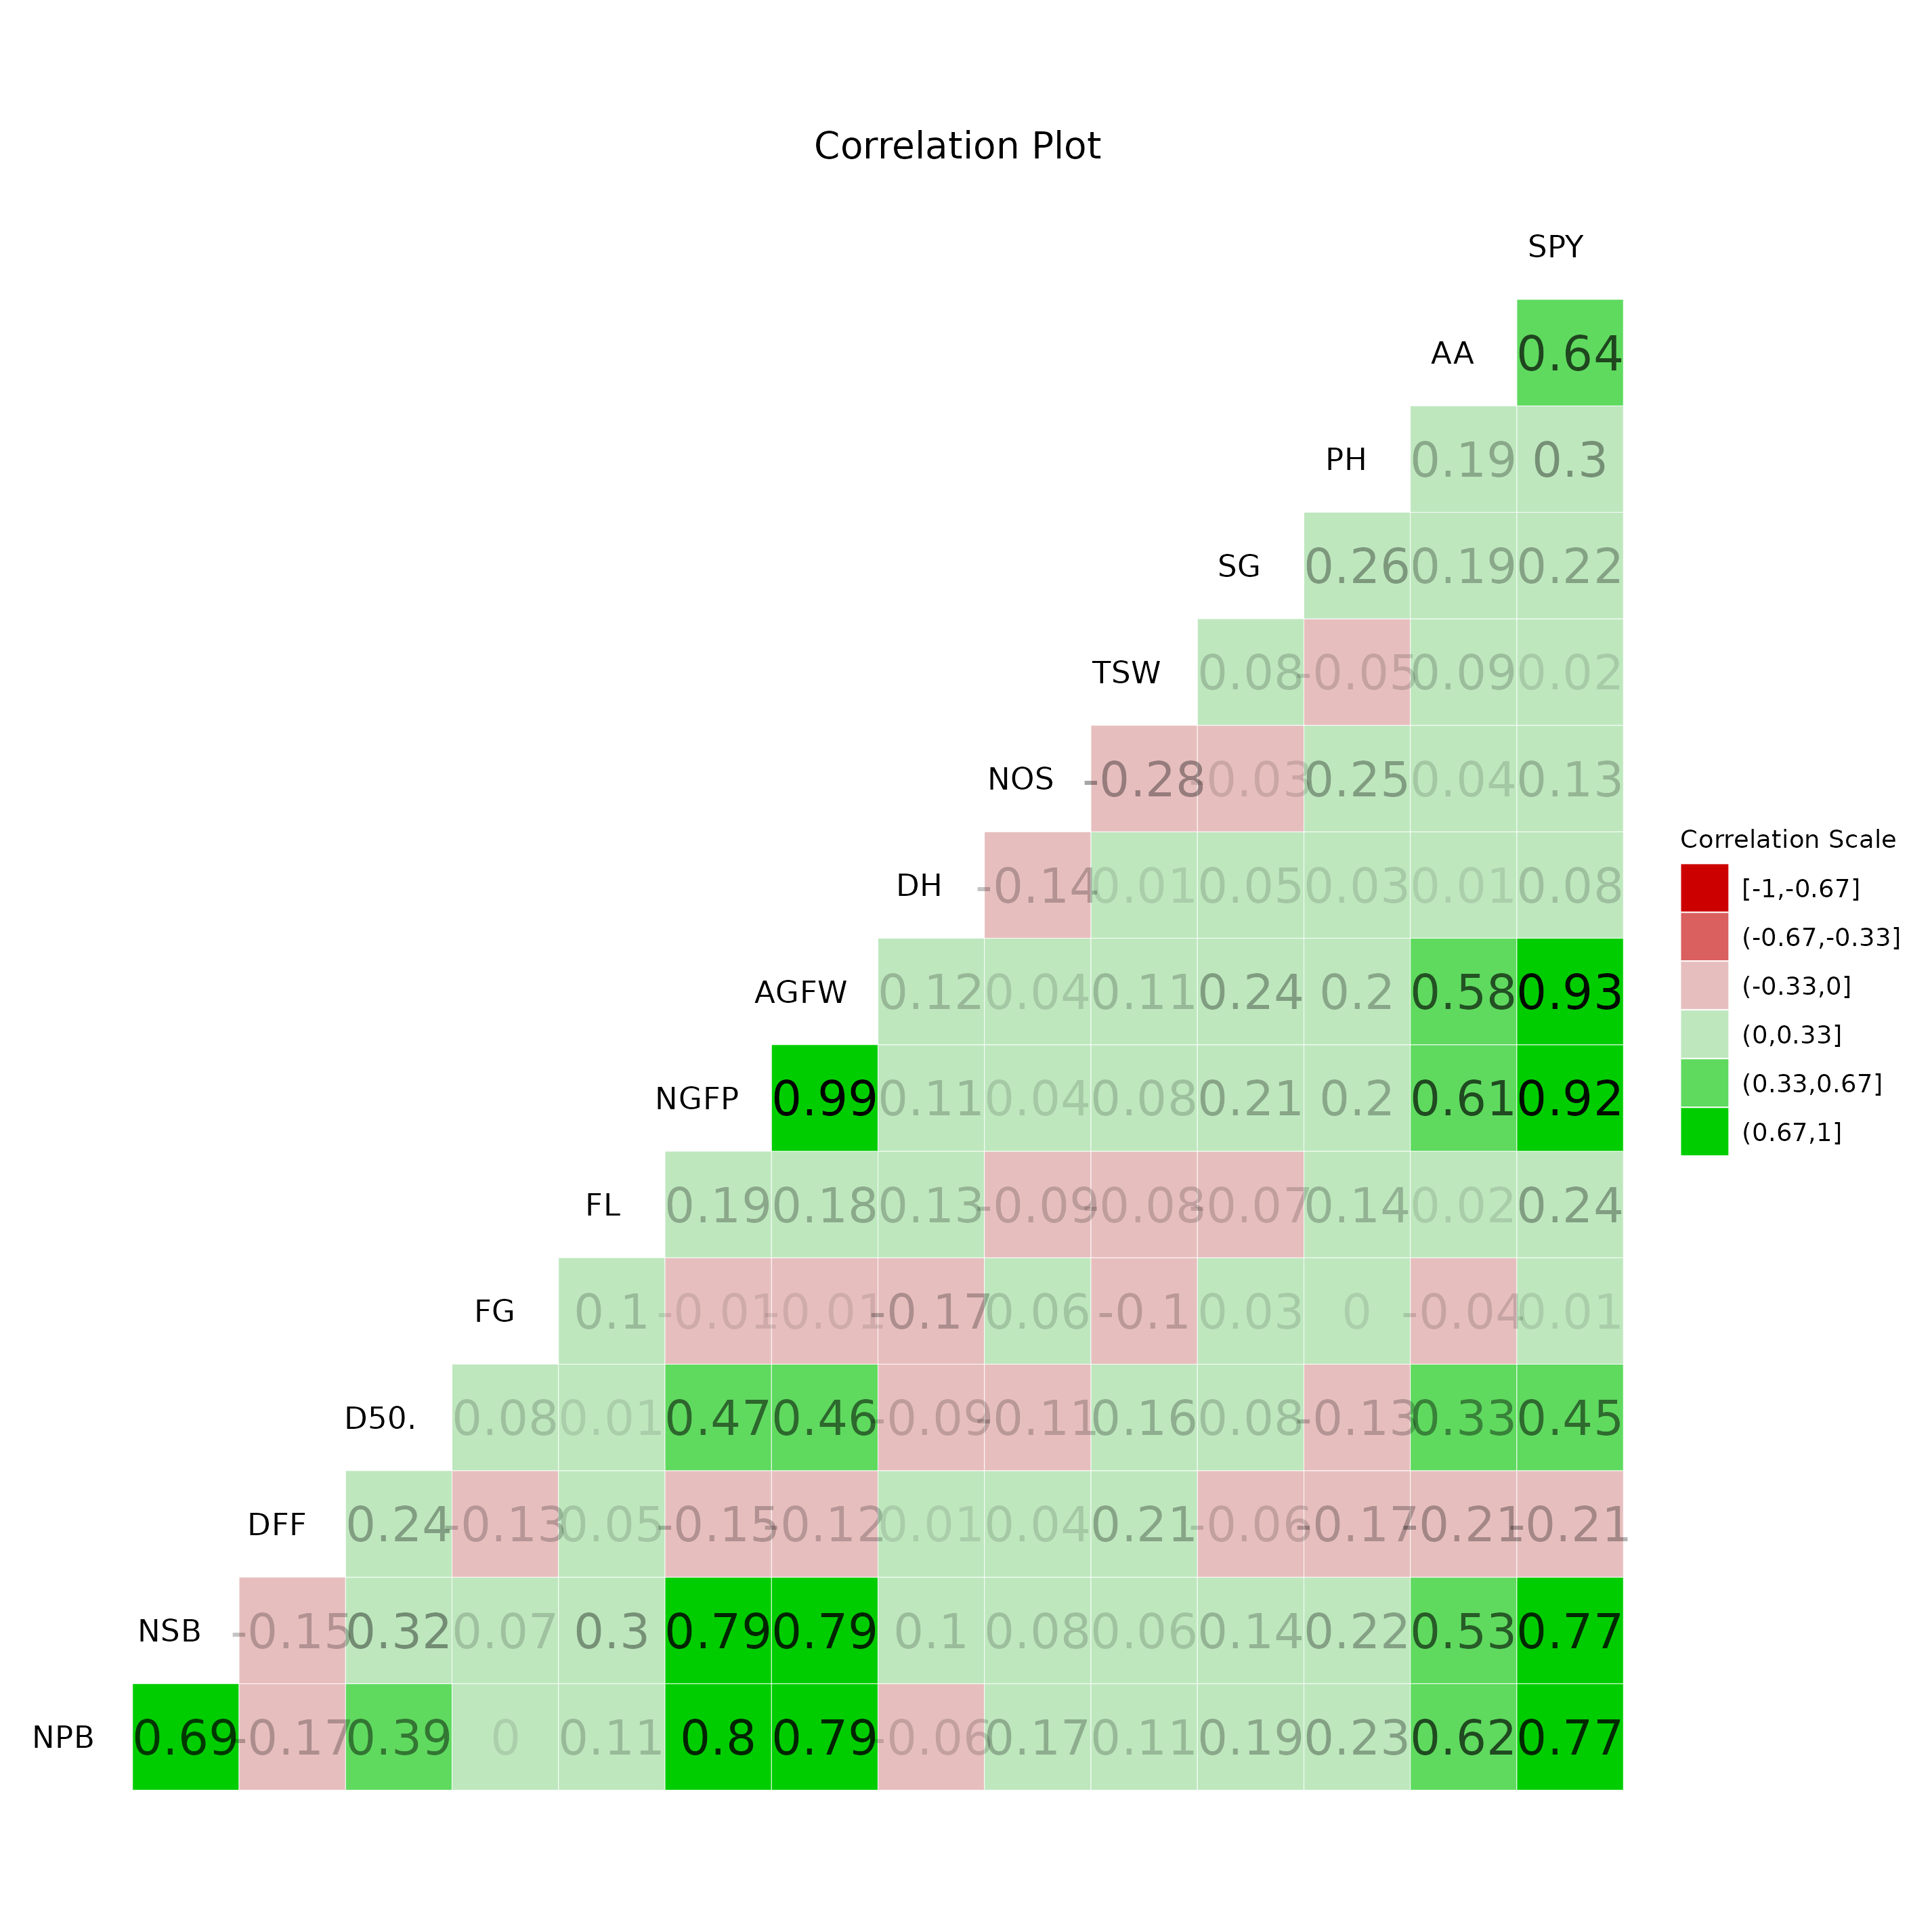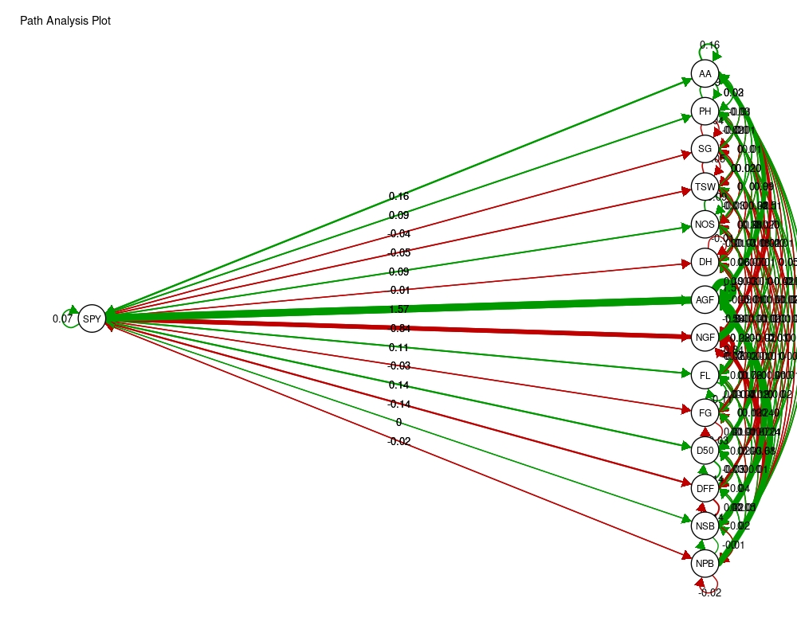
Fig 3. Correlation Coefficients among Yield and Yield-Contributing Traits in Chilli (Capsicum annuum L.) Fig 4. Path Coefficient Analysis of Yield-Contributing Traits in Chilli (Capsicum annuum L.)

