Spatio-Temporal Controls on the Hydrochemistry of Drass River Water in the semi-arid region of Ladakh (India)

Abstract
The progressive decline in river water quality has emerged as a critical environmental challenge, particularly in semi-arid and ecologically sensitive regions such as Ladakh. Periodic assessment of riverine water quality is therefore essential, both for safeguarding potability and sustainable water resource management. This study investigates the temporal variations in the water quality of the Drass River (DR) during 2024, evaluating the water quality and the influence of geochemical processes operating within the basin. A total of fifty-four water samples were collected from six locations along the river during three hydrological phases: Early Melting Period (EMP; April), Peak Melting Period (PMP; July), and Late Melting Period (LMP; November). The ionic composition of the Drass River followed the general order: Ca²⁺ Mg²⁺ >Na⁺ > K⁺ and HCO₃⁻ > SO₄²⁻ > Cl⁻ > CO₃²⁻ in EMP, HCO₃⁻ > SO₄²⁻ > Cl⁻ > F⁻ in PMP, and HCO₃⁻ > SO₄²⁻ > Cl⁻ in LMP, characterised by of Ca²⁺-Mg²⁺-HCO₃⁻ type facies. Increase in sulphate concentration from EMP to LMP reflects glacier retreat, which exposes larger sulphide-bearing rocks to oxidation and water interaction. Elevated levels of F⁻ were noticed during PMP, indicating the possible impact of developmental activities during the period. This research thus provides a comprehensive hydrochemical appraisal of the Drass River in Ladakh, offering methodological guidance for future hydrogeochemical investigations.

Keywords: Kargil; Indus River; Hydrochemical facies; Semiarid; Zojila; Rock Weathering

1. Introduction
River systems are vital for long-term sustainable growth, maintaining ecological and environmental sustainability, economic growth, food security, and public health (Bănăduc et al., 2022). However, this vital resource is under heavy stress due to uncontrolled and unplanned anthropogenic activities. The United Nations World Water Development Report 2023 revealed that over 80% of global wastewater and more than 95% in a few developed countries are discharged directly into the environment without adequate treatment, resulting in widespread ecological degradation and health risks. According to the report, "The Global Water Quality Challenge & SDGs," water pollution poses a serious threat to human health, reduces ecosystem services, and hampers socioeconomic development (UNESCO, 2021). Globally, nearly two million tons of industrial effluents, sewage, and agricultural waste are discharged into water bodies every day. This widespread contamination contributes to the spread of waterborne diseases such as dysentery, diarrhoea, cholera, and typhoid, which together cause more deaths annually than wars and other forms of violence combined (du Plessis, 2022; UNESCO, 2021). The United Nations World Water Development Report (2024) also predicts that if the existing water quality monitoring systems are not upgraded, by 2030, the livelihoods and health of about 4.8 billion people may be at risk. In India, 80% of the water resources are classified under the polluted category, with the Ganges (Ganga) River listed as one of the most polluted rivers in the world (du Plessis, 2022). About 351 rivers in India have been recognised as polluted rivers by the Central Pollution Control Board (CPCB, 2022), characterised by high nitrate loading, microbial contamination, heavy metals and biochemical oxygen demand (BOD)(CPCB, 2018; Dey and Majumdar, 2024). In semi-arid regions, a unique combination of lower water discharge volume and high pollution susceptibility, particularly during the low temperature periods, the conditions of water bodies are further worsened (Graham et al., 2024). Urbanisation, mainly driven by tourism, is also evolving as the prime contributor to water quality deterioration, particularly in ecologically sensitive regions like Ladakh, with the development of urban infrastructure and increasing municipal waste, all of which contribute to river pollution (Ali et al., 2024b; Dame et al., 2019; Pásková et al., 2024). Based on these circumstances, the Drass River, a significant tributary of the Suru and ultimately the Indus River, provides a unique opportunity for baseline water quality assessment in a semi-arid, high-altitude environment of Ladakh.

1.1. About the study area
The Drass sub-division, located in the Kargil district of the Union Territory of Ladakh (India), is one of the most prominent landscapes in the region. It is situated amidst rugged mountainous terrain and is famously known as the “Gateway to Ladakh” as it connects the Kashmir Valley with Ladakh through the strategic Zojila Pass. Drass holds a special place in modern Indian history due to the 1999 Kargil War between India and Pakistan. Several key battle sites, including Tololing, Mushko Valley, and Tiger Hill, are located here and continue to stand as symbols of bravery and sacrifice. A huge number of tourists visit the place, not only due to its breathtaking natural beauty, snow-clad peaks, pristine valleys, and serene landscapes, but also because of the opportunity to witness historic war sites and memorials associated with the Kargil conflict. The region is also home to several important religious and mythological sites that hold great cultural and spiritual significance: Drupati Kund (a sacred pond) and a rock sculpture (believed to be the solidified body of Bhim), which are sacred sites for Hindus. The area is also renowned for its ancient stone carvings, which depict prominent images of Maitreya (the future Buddha) and Avalokiteshvara, reflecting the historical spread of Buddhism in the region (LAHDC Kargil, 2025). Drass is also known for its extreme weather conditions, making it the second coldest inhabited place on Earth, after the Siberian town of Oymyakon. According to records, on January 9, 1995, the temperature in Drass dropped to an unforgiving –60°C (Sharma, 2018). Together, these sites make Drass a unique confluence of religious, cultural, and historical significance. Glacial meltwater and the Drass River are the main sources for irrigation and drinking water in the area. Drass River mainly originates from the Machoi glaciers near Zojila Pass. Hydrologically, the valley is of immense importance as it forms a fifth-order sub-basin of the Indus system, housing nearly 150 glaciers with a combined area of 152.6775 km² and an ice volume of about 62.02 km³. These glaciers, along with seasonal snow cover, act as critical freshwater reservoirs, feeding the Drass River. The meltwater from these glaciers sustains river discharge during the dry summer months, ensuring a perennial water supply for downstream ecosystems, agriculture, and human settlements (Hāṇḍā, 2001; Koul et al., 2016). Since Ladakh was designated as a separate Union Territory after the Jammu & Kashmir Reorganisation Act, 2019 (Act No. 34 of 2019), the region has witnessed accelerated developmental initiatives. Further, in 2024, the Indian government announced the formation of five new districts in Ladakh, one of which is Drass, a significant administrative milestone for the region (DDNEWS, 2024). Major infrastructure projects, including road broadening, tunnel construction (Zojila Tunnel), and tourism facilitation, are underway, positioning Drass as one of the emerging urban areas in Ladakh after Leh and Kargil. However, the current conditions remain relatively pristine, providing a unique opportunity to evaluate the natural hydrochemical signature of river water in the absence of major anthropogenic influences. To the best of our knowledge, no prior study has investigated the hydrogeochemistry of the Drass River across different snow- and glacier-melt periods. Hence, the outcomes of this research will offer valuable scientific insights to support future river management, environmental regulation, and sustainable development in this emerging mountainous region.

2. Materials and Methods
54 water samples collected from 6 sites (3 samples from each site) during three distinct periods in 2024: (i) Early Melting Period (EMP, April); (ii) Peak Melting Period (PMP, July); and (iii) Late Melting Period (LMP, November). The map of sampling sites is shown in Fig. 1, and a brief overview of the sampling sites is discussed in Table 1
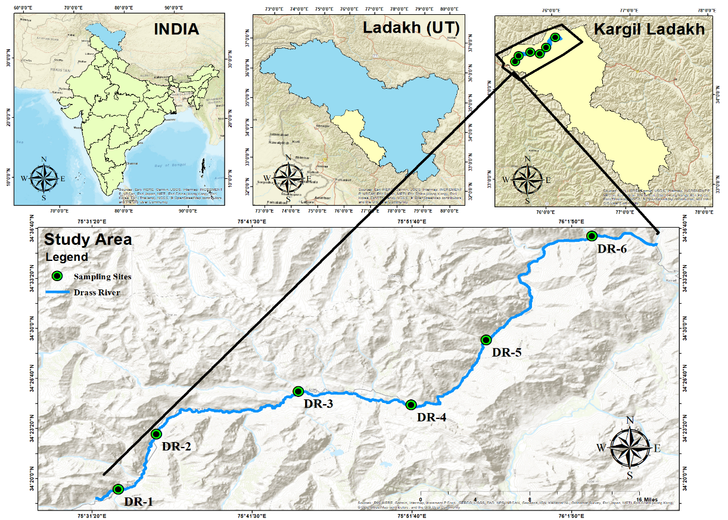
Figure 1 Map of the study area showing different sampling sites across the Drass River.
Table 1
Brief description of the study area across the Drass River Basin (DRB).
Sampling Station  (Station ID) | Coordinates and Altitude (msl) |  | Brief description of Sampling Station
Near Zojila (Zoji La) Pass  (DR-1) | Latitude | 34.32136 | Located near the Machoi Glacier and Zojila Pass, the source of the Drass River, which constitutes a major headwater tributary of the Drass River, offers a unique opportunity to capture critical data on pristine glacial meltwater.
Near Zojila (Zoji La) Pass  (DR-1) | Longitude | 75.55001
Near Zojila (Zoji La) Pass  (DR-1) | Altitude | 3313 m
Matayan Village  (DR-2) | Latitude | 34.38262 | Marks the beginning of human habitation in the vicinity of the river, characterised by highly dispersed settlements and sparse vegetation. Small tributaries further feed the river.
Matayan Village  (DR-2) | Longitude | 75.59007
Matayan Village  (DR-2) | Altitude | 3238 m
Drass Town  (DR-3) | Latitude | 34.43025 | The most populated area in the region serves as the sub-divisional headquarters of the Drass Subdivision. Infrastructural facilities like offices, war memorial, hotels, guest houses, and tourism facilitations are prominent in this region.
Drass Town  (DR-3) | Longitude | 75.74066
Drass Town  (DR-3) | Altitude | 3094 m
Dandal Village  (DR-4) | Latitude | 34.41506 | Located next to Drass town and is characterised by highly dispersed settlements and sparse vegetation.
Dandal Village  (DR-4) | Longitude | 75.86024
Dandal Village  (DR-4) | Altitude | 3026 m
Kharboo Village  (DR-5) | Latitude | 34.48761 | Just before the confluence of Shingo River, the river flows through deep gorges between towering mountains, exhibiting high velocity and discharge rates. Human settlement and agricultural activity are minimum due to the rugged and inaccessible terrain.
Kharboo Village  (DR-5) | Longitude | 75.93951
Kharboo Village  (DR-5) | Altitude | 2907 m
Chanigond Village  (ZR-6) | Latitude | 34.60231 | Characterised by the confluence of the Drass River with the Shingo River before its diversion toward Pakistan.
Chanigond Village  (ZR-6) | Longitude | 76.05156
Chanigond Village  (ZR-6) | Altitude | 2681 m
The samples were properly collected in polypropylene bottles following the standard protocols set by APHA (2012) and stored at 0–4 °C for further chemical analysis. Analytical techniques for estimation of water quality parameters following APHA (2012) are summarised in Table 2 (Rice et al., 2012). The software tools used in this study include ArcGIS 10.8 for spatial mapping, IBM SPSS Statistics 29.0.2.0 (20) and Microsoft Excel 365 for statistical analyses, and AquaChem-10 for hydrochemical plotting.
Table 2
Analytical techniques for estimation of water quality parameters following APHA (2012) (Rice et al., 2012)
S. No. | Parameters and its Unit | Method (Equipment Used) | References
The readings of the following parameters were recorded in the field
 | Temperature (T) °C | Instrumental Method: LABTICAL PPH10 | APHA 2550 B, 23rd Ed
 | pH | Instrumental Method: LABTICAL PPH10 | APHA 4500-H⁺ B, 23rd Ed
 | Electrical Conductivity (EC) µS/cm | Instrumental Method: LABTICAL PPH10 | APHA 2510 B, 23rd Ed
 | Total Dissolved Solids (TDS) mg/L | Instrumental Method: LABTICAL PPH10 | APHA 2550 B, 23rd Ed
 | Dissolved Oxygen (DO) mg/L | Instrumental Method (Thermo Scientific Eutech, DO 6⁺) | APHA 4500-O G, 23rd Ed
 | Turbidity (TU) NTU | Instrumental Method (Thermo Scientific TN-100) | APHA 2130 B, 23rd Ed
The following parameters were analysed in the laboratory
 | Total Hardness (TH) mg/L | Titrimetric Method (Titration with EDTA) | APHA 2340 C, 23rd Ed
 | Ca²⁺ mg/L | Titrimetric Method (Titration with EDTA) | APHA 3500-Ca B, 23 Ed
 | Mg²⁺ mg/L | Titrimetric Method (Titration with EDTA) | APHA 3500-Mg B, 23rd Ed
 | Na⁺ and K⁺ mg/L | Instrumental Method (Systronic Flame Photometer 128) | APHA 3500-Na-K B, 23rd Ed
 | Total Alkalinity (TA) mg/L | Titrimetric Method (Titration with acid) | APHA 2320 B, 23rd Ed
 | CO₃²⁻, & HCO₃⁻ mg/L | Titrimetric Method (Titration with acid) | APHA 2340 B, 23 Ed
 | Cl– mg/L | Argentometric Method | APHA 4500-Cl– B, 23rd Ed
 | NO₃⁻ mg/L | Spectrophotometric Screening Method  (UV-1900i Shimadzu UV-VIS Spectrophotometer) | APHA 4500-NO₃– B, 23rd Ed
 | F⁻ mg/L | SPADNS Method  (UV-1900i Shimadzu UV-VIS Spectrophotometer) | APHA 4500-F– D, 23rd Ed
 | SO₄²⁻ mg/L | Turbidimetric Method  (UV-1900i Shimadzu UV-VIS Spectrophotometer) | APHA 4500-SO₄^{2–} E, 23rd Ed
 | PO₄²⁻ mg/L | Ascorbic Acid Method  (UV-1900i Shimadzu UV-VIS Spectrophotometer) | APHA 4500-P E, 23rd Ed
2.1 Quality Assurance
To ascertain the accuracy of the analytical results, standard quality assurance checks were applied according to the Standard Methods for the Examination of Water and Wastewater, 23rd edition, APHA (2012):
2.1.1 Charge Balance Error (CBE)
The anion–cation balance or Charge Balance Error (CBE) was calculated by using Eq. (1); concentration of all the ions is expressed in milliequivalent per litre [meq/L]:
$CBE=\frac{\sum{Cation-∑Anion}}{\sum{Cation+∑Anion}}×100$ (1)
The percentage differences of all the analysed samples were within the acceptable range (±10%), confirming the electrical neutrality of the samples (Rana et al., 2022; Tiwari and Singh, 2014).
2.1.2. Comparison of the measured TDS and the calculated TDS:
The ratio of [measured TDS / calculated TDS] in water quality analysis is acceptable in the range of 1.0–1.2. Calculated TDS (TDS_{cal}) is obtained by Eq. (2). The concentrations of all the ions are expressed in mg/L.
TDS_{Cal} ​=0.6×Alkalinity∗+[Ca²⁺]+[Mg²⁺] +[Cl⁻]+[SO₄²⁻​]+[Na⁺]+[K⁺]+[SiO₃²⁻​]+[NO₃⁻​]+[F⁻] (2)
Alkalinity* is expressed as mg/L of CaCO₃ to account for carbonate and bicarbonate species; the factor 0.6 for the adjustment of equivalent contribution of alkalinity to TDS. The calculated ratio was within the permissible range of 1.0–1.2 for all the samples.
2.1.3. Comparison of Measured EC and Ion Sums
The total cation and anion sums in the analysed parameters must approximately be equal to 1/100 of the measured EC (µS/cm) as shown in Eq. (3):
[100 × Anion or Cation Sum in meq/L] = [0.9–1.1×EC] (3)
All the results in the study were within the range of 0.9 to 1.1.
2.1.4. Comparison of Calculated TDS and EC ratio
The ratio of [TDS_{Cal} /EC] must fall within the range of 0.55–0.7. The analytical results obtained within the acceptable range of 0.55 to 0.7, ascertaining no substantial presence of unanalysed ions or weakly dissociated species. Based on these multiple layers of internal consistency checks, the analytical correctness of the data and its suitability for hydrochemical understandings and water quality assessments were ensured.

3. Results and discussion
3.1 Periodical Variation in Hydrochemistry of Drass River Water
The physicochemical characteristics and major dissolved constituents of Drass River Basin (DRB) exhibit distinct spatial and temporal variability Table 3; Fig. 2.

Figure 2 Variation in Major ion concentration in the Drass River Basin (DRB)
Table 3
Statistical summary of water quality parameters in the Drass River Basin during the study periods. (SD = Standard Deviation); (Selvam et al., 2021)
Parameters | Study Periods |  |  |  |  |  | BIS (2012) Limit |  | WHO (2017) Limit
Parameters | Early Melting Period |  | Peak Melting Period |  | Late Melting Period |  | Min. | Max. | Desirable | Not Acceptable
Parameters | Mean ± SD | Range | Mean ± SD | Range | Mean ± SD | Range
DO (mg/L) | 12.34±0.73 | 11.75-13.77 | 11.95±1.36 | 9.27-13.17 | 13.5±0.17 | 13.23-13.7
pH | 8.33±0.11 | 8.16-8.5 | 8.13±0.08 | 8.03-8.27 | 8.15±0.04 | 8.06-8.17 | 6.5-8.5 | No Relax. | 6.5-8.5 | No Relax.
EC (µS/cm) | 185.09±13.46 | 169.02-204.8 | 187.39±27.67 | 133.33-205 | 207.44±49.24 | 138-242.67 |  |  | <1000 | <1500
TDS (mg/L) | 122.16±8.88 | 111.55-135.17 | 123.67±18.4 | 88-135.96 | 136.72±32.81 | 92-160.33 | 500 | 2000 | <500 | <1500
Turbidity (NTU) | 77.89±30 | 21.77-99.6 | 79.27±0.42 | 78.8-79.6 | 5.41±1.55 | 4.24-8.43 | 1 | 5
T (⁰C) | 7.67±2.78 | 2.67-10.33 | 9.98±1.55 | 8.3-12.5 | 3.17±0.41 | 3-4
TA as CaCO₃ (mg /L) | 79.14±10.25 | 61.45-89.39 | 67.94±13.48 | 45.17-84.68 | 78.52±15.36 | 54.85-93.57 | 200 | 600
TH as CaCO₃ (mg/L) | 87.19±6.12 | 78.47-95.47 | 83.19±9.44 | 73.4-95.12 | 106.57±27.01 | 72.66-130.79 | 200 | 600 | 100 | 500
Ca Hardness as CaCO₃ (mg/L) | 68.82±3.85 | 65.33-75.79 | 59.85±7.67 | 50.88-71.28 | 69.52±12.32 | 54.12-81.84
Mg Hardness as CaCO₃ (mg/L) | 18.37±8.43 | 2.68-26.22 | 23.33±11.25 | 2.7-33.08 | 37.05±16.45 | 18.54-55.55
Mg²⁺ (mg/L) | 4.48±2.06 | 0.65-6.4 | 5.67±2.73 | 0.66-8.04 | 9.01±4 | 4.51-13.5 | 30 | 100 | <50 | <150
Ca²⁺ (mg/L) | 27.58±1.54 | 26.18-30.37 | 23.38±3.67 | 19.24-28.57 | 27.86±4.94 | 21.69-32.8 | 75 | 200 | <75 | <200
Na⁺ (mg/L) | 1.08±0.32 | 0.7-1.58 | 2.91±2.28 | 0.79-5.04 | 1.02±0.1 | 0.93-1.16 |  |  | <200 | <200
K⁺ (mg/L) | 1.12±0.33 | 0.76-1.72 | 2.56±2.05 | 0.64-4.66 | 0.61±0.05 | 0.53-0.65 |  |  | <10 | <10
HCO₃–(mg/L) | 75.98±13.31 | 53.63-89.39 | 67.94±13.48 | 45.17-84.68 | 78.52±15.36 | 54.85-93.57 |  |  | <300 | <600
CO₃^{2—} | 3.17±3.56 | 0-7.82 | Not detected
SO₄^{2—} (mg/L) | 21.05±2.44 | 16.46-23.34 | 26.14±3.8 | 20.06-29.23 | 31.81±8.48 | 20.85-38.74 | 200 | 400 | <400 | <400
Cl—(mg/L) | 4.85±1.16 | 3.78-6.43 | 6.2±3.62 | 2.98-12.12 | 1.57±0.44 | 1.04-2.08 | 250 | 1000 | <250 | <250
F— (mg/L) | Not detected |  | 0.74±0.91 | 0.08-2.45 | Not detected |  |  |  | 1 | 1.5
(Ca²⁺+Mg²⁺) vs. TZ⁺ | 0.96±0.01 | 0.94-0.97 | 0.90±0.08 | 0.81-0.97 | 0.97±0.01 | 0.96-0.98
(Ca²⁺+Mg²⁺) vs. (Na⁺+K⁺) | 24.41±6.27 | 15.32-32.7 | 18.53±15.57 | 4.15-36.36 | 36.08±10.52 | 22.43-45.48
(Na⁺+K⁺) vs. TZ⁺ | 0.04±0.01 | 0.03-0.06 | 0.1±0.08 | 0.03-0.19 | 0.03±0.01 | 0.02-0.04
[HCO₃⁻/Ca²⁺] | 1.14±0.21 | 0.89-1.49 | 1.12±0.44 | 0.75-1.93 | 1.09±0.11 | 0.96-1.2
[HCO₃⁻/(Ca²⁺+Mg²⁺)] | 0.71±0.13 | 0.52-0.86 | 0.69±0.15 | 0.5-0.87 | 0.61±0.07 | 0.53-0.73
C-Ratio | 0.74±0.05 | 0.66-0.81 | 0.67±0.04 | 0.62-0.74 | 0.66±0.03 | 0.63-0.71
TD/EC | 0.66±0 | 0.66-0.66 | 0.66±0.01 | 0.65-0.67 | 0.66±0.01 | 0.65-0.67
S-Ratio | 0.26±0.05 | 0.19-0.34 | 0.33±0.04 | 0.26-0.38 | 0.34±0.03 | 0.29-0.37
Ca²⁺/Na⁺ | 31.56±8.82 | 20.11-42.91 | 20.55±17.46 | 4.41-38.25 | 32.08±8.28 | 21.45-40.32
Mg²⁺/Na⁺ | 8.9±5.31 | 1.04-14.93 | 7.26±8.04 | 1.42-18.33 | 17.36±8.62 | 7.35-27.28
HCO₃⁻/Na⁺ | 27.96±6.49 | 17.28-35.54 | 16.56±12.75 | 5.19-33.69 | 29.7±7.99 | 17.82-37.64
Na⁺/Cl⁻ | 0.34±0.08 | 0.29-0.49 | 0.64±0.3 | 0.38-1.02 | 1.08±0.37 | 0.7-1.67

The analytical results show temporal variations; most parameters, except Ca²⁺, Cl⁻, CO₃²⁻ and HCO₃⁻, attain comparatively lower values during the Early Melting Period (EMP), primarily due to enhanced dilution from intense snow and glaciers melting with higher contribution from carbonate weathering (Calcite Rocks). In contrast, the concentration of most parameters rises in water, except Na⁺, Cl⁻, K⁺, and F⁻, during the Late Melting Period (LMP). The intensity of snow and glacier melting decreases during winter (LMP), discharge volume declines, and the river flow is sustained primarily by baseflow from groundwater, which may be responsible for the highest values of these parameters recorded during the LMP (Ali et al., 2024a). However, the concentrations of Na⁺, Cl⁻, K⁺, and F⁻ were highest during the PMP (summer), indicating anthropogenic and atmospheric contributions to water quality (Wieczorek et al., 2023). pH values indicate that the river water is generally alkaline during the study periods Table 3. This slight alkalinity is likely attributable to the presence of bicarbonate ions, which are formed when carbon dioxide dissolves in water to produce carbonic acid. The subsequent dissociation of carbonic acid increases bicarbonate concentrations, thereby influencing the pH of the water (Azeez et al., 2000; Magesh and Chandrasekar, 2013). For natural, unpolluted river systems, pH typically falls between 6.50 and 8.50, with waters draining carbonate-rich basins being largely governed by carbonate equilibria (Hren et al., 2007; Thomas et al., 2014). Electrical conductivity (EC) reflects mineralisation and ionic strength, recorded highest during LMP, but markedly lowest in EMP and in PMP. A similar pattern is observed for total dissolved solids (TDS), recorded highest in LMP, lowest during EMP, and PMP Table 3. The lowest TDS and EC values observed during the EMP may be attributed to altered ionic ratios resulting from elevated flow rates under intense snow and glacier melting conditions, which minimise rock–water interaction and enhance dilution of dissolved ions (Zhang et al., 2019). As the river moves downstream towards Drass town (DR-3 & DR-4), a slight increase in TDS and EC is observed, indicating enhanced weathering rates and possible influence of effluents from Drass town and the nearby agricultural area on water quality. At the confluence with the Shingo River (DR-6), EC and TDS values decline sharply, reflecting the dilution effect exerted by the Shingo River on the Drass River. This effect is particularly pronounced during the LMP, when river discharges in the DRB are significantly reduced due to the extreme cold conditions in the area. Turbidity (NTU) measures the optical clarity of water, affected by the presence of dissolved organic and inorganic matter, suspended particulates, and temperature (Kitchener et al., 2017). Temporal variability was most pronounced in the PMP and EMP, following the trend PMP ⁓EMP >> LMP. The turbidity value slightly degraded after DR-3, indicating that urban effluents and agricultural runoff transport suspended sediment load to the Drass River. During the Snow Melting Period (PMP and EMP), snow cover inhibits supra-glacial, subglacial, and englacial drainage from the glacierized zone. As the winter-accumulated snow in the basin melts, suspended solid load in the basin originates from well-routed glacier melt, producing a distinct Q–SSC hysteresis pattern. Further, during the EMP, the alternating action of freeze-thaw cycles accelerates soil erosion, thereby increasing turbidity in the basin (Sun et al., 2022). By September, the declining temperatures lead to partial refreezing of the source and surrounding areas, resulting in a reduction in the river discharge (Łepkowska and Stachnik, 2018; Singh et al., 2020). Therefore, in the LMP, low temperatures freeze the source areas, leading to consistently low turbidity with minimal variability. Total alkalinity (TA) refers to the overall concentration of bases present in water expressed as calcium carbonate (CaCO₃). In most natural waters, bicarbonate is the dominant contributor to alkalinity at pH ≤ 8.3, while carbonate and hydroxide (occasionally) become more significant at higher pH values (Boyd et al., 2016). The mean value of TA as CaCO₃ recorded the lowest during PMP, and comparatively higher in EMP and PMP.
Total Hardness of water is a function of the total concentration of dissolved Ca²⁺ and Mg²⁺ ions in water and is expressed in terms of the concentration of CaCO₃. Bicarbonates and carbonates of Ca²⁺ and Mg²⁺ are responsible for temporary hardness, while their SO₄²⁻ and Cl⁻ contribute to permanent hardness in water (Boyd, 2015). The mean value of TH as CaCO₃ was recorded as the highest in LMP and comparatively lowest during EMP and PMP. Based on the classification of water hardness proposed by Sawyer (1967), hardness values of 0–75 mg/L (as CaCO₃) are considered soft, 75–150 mg/L as moderately hard, 150–300 mg/L as hard, and values exceeding 300 mg/L as very hard (Magesh and Chandrasekar, 2013; Sawyer, 1967). A total of three samples, DR-6 (PMP), and DR-5 and DR-6 (LMP) were classified as ‘soft water’, and the rest are in the ‘moderately hard water category’. Ca²⁺ dominates the cationic composition across all seasons. Its primary sources in natural water systems are weathering of igneous and metamorphic minerals (e.g., pyroxenes, amphiboles, plagioclase feldspars) and carbonate rocks. Mg²⁺ largely sourced from weathering of ferromagnesian minerals such as biotite and amphiboles (Magaritz et al., 1989; Thomas et al., 2014). Temporal variations in Na⁺ and K⁺ concentrations were observed during the study period. The major sources of Na⁺ are atmospheric deposition and mineral weathering (particularly plagioclase), whereas K⁺ predominantly originates from the chemical weathering of K-feldspar minerals such as orthoclase and microcline (Welti et al., 2019). The enhanced concentrations of Na⁺ and K⁺ during the PMP can be attributed to intensified silicate rock weathering under elevated ambient temperatures and increased glacier meltwater discharge, which collectively enhance the mobilisation of these ions into the river system. HCO₃⁻ dominates the anion chemistry throughout the year. CO₃²⁻ remains negligible in all seasons. SO₄²⁻ concentrations were recorded as lowest in EMP and highest during LMP. Increase in sulphate from EMP to LMP reflects glacier retreat, which exposes larger sulphide-bearing rocks to oxidation and water interaction. A study by Salerno et al. (2016) reported a fourfold rise in sulphate in high-elevation Himalayan lakes over two decades, confirming that glacier melting and associated sulphide oxidation are the dominant drivers, while atmospheric deposition and snow cover changes are negligible (Salerno et al., 2016). The Cl⁻ level showed seasonal variation, with the lowest value recorded in the LMP and the highest in the PMP. F⁻ was detected during PMP only; an elevated F⁻ level was observed at site DR-2, higher than the acceptable limit recommended by BIS (2012) and WHO (2017)(BIS, 2012; Selvam et al., 2021; WHO, 2017). However, the concentration consistently decreased downstream, consistent with a localised anthropogenic input that becomes diluted by tributary mixing. Ongoing works on the Zojila Tunnel are situated near the DR-2, and several materials commonly used in tunnel construction, especially shotcrete with alkali-free accelerators that contain fluoride/fluorosilicate species, may be responsible for leachable fluoride. Runoff or wastewater from such works can therefore plausibly contribute F⁻ to nearby surface waters (Wang et al., 2025, 2022). By contrast, natural F⁻ in Himalayan settings typically derives from weathering of F-bearing minerals (e.g., fluorite/apatite) (Natarajan and Subramanian, 2001); however, the sharp spatial rise at DR-2 during PMP and subsequent downstream dilution are more consistent with a point-proximate construction source than with diffuse lithologic weathering alone. Overall, all measured parameters, except turbidity, remain within the permissible limits for drinking water as per Bureau of Indian Standards (BIS, 2012) and World Health Organisation (WHO, 2011) guidelines, indicating the suitability of DRB waters for potable use after proper treatment for turbidity.
3.2 Major Ion Chemistry
The abundance of cations in the DRB shows a consistent pattern following the order Ca²⁺ > Mg²⁺ > Na⁺ > K⁺ in all the study periods. In contrast, anions show a distinct periodic pattern: in the EMP, the order of anion abundance was HCO₃⁻ > SO₄²⁻ > Cl⁻ > CO₃²⁻, HCO₃⁻ > SO₄²⁻ > Cl⁻ > F⁻ in PMP, and HCO₃⁻ > SO₄²⁻ > Cl⁻ in LMP. The relative abundance of major cations and anions is illustrated in the bar diagram in Fig. 2.
To understand the mechanism that controls the hydrogeochemistry and ionic sources in the DRB, the ionic relationships and their ratios were examined (Bisht et al., 2022; Kumar et al., 2019; Sharma et al., 2013). The scatter plot (Ca²⁺ + Mg²⁺) vs. TZ⁺ (TZ⁺=Na⁺+K⁺+Ca²⁺+Mg²⁺), shows all the points above the 1:1 equiline Fig. 3, reflecting the dominance of divalent cations with a mean ratio of 0.96±0.01 in EMP, 0.90±0.08 in PMP, and 0.97±0.01 in LMP Table 3. Similarly, the ratios of [(Ca²⁺+Mg²⁺)/(Na⁺+K⁺)] were 24.41±6.27 in EMP, 18.53±15.57 in PMP, and 36.08±10.52 in LMP, higher than the global average of 2.2, showing that carbonate weathering is primarily responsible for dissolved ions (Ahmad et al., 1998). The scatter plot of TZ⁺ versus (Na⁺+K⁺) shows that all the points deviate markedly from the 1:1 equiline, with mean ratios of 0.04 ± 0.01 in EMP, 0.10 ± 0.08 in PMP, and 0.03 ± 0.01 in LMP Fig. 4.
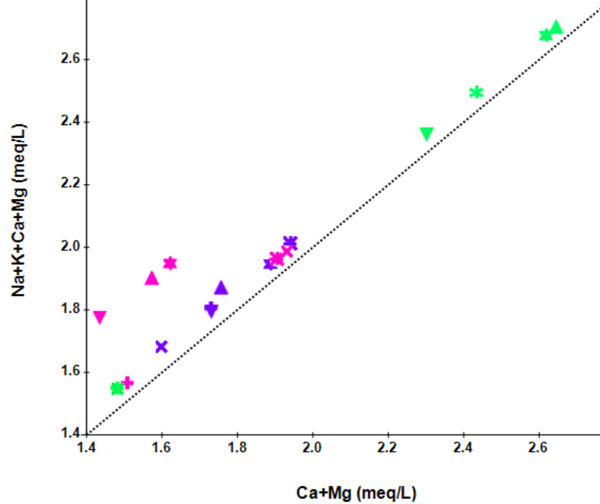
Figure 3 Scatter plot of (Ca²⁺ + Mg²⁺) vs. TZ⁺ (TZ⁺=Na⁺+K⁺+Ca²⁺+Mg²⁺)

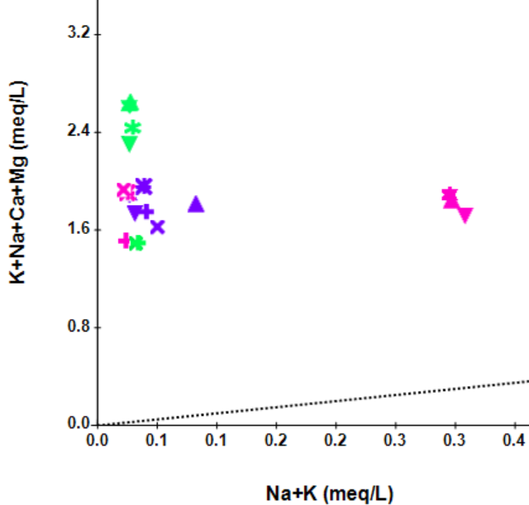
Figure 4 Scatter plot of (Na⁺+K⁺) vs. TZ⁺
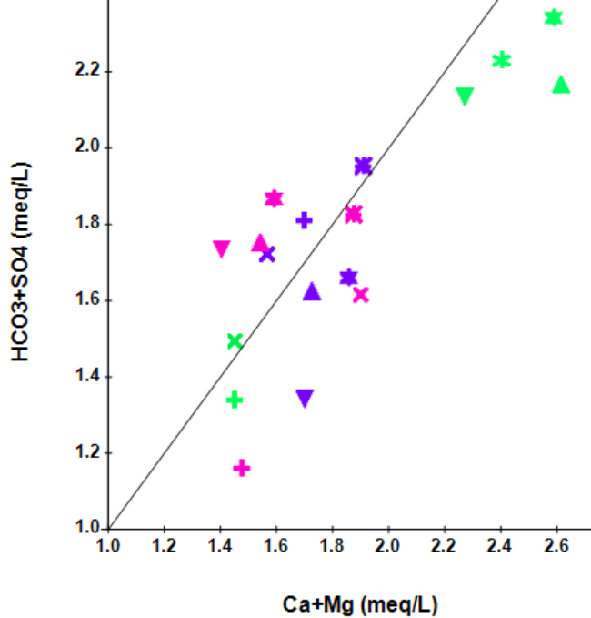
Figure 5 Scatter plot of (Ca²⁺+Mg²⁺) vs (HCO₃⁻ + SO₄²⁻)
The consistently low [(Na⁺+K⁺)/TZ⁺] ratios, coupled with high [(Ca²⁺+Mg²⁺)/(Na⁺+K⁺)] ratios, indicate that carbonate weathering is the dominant process governing the hydrogeochemistry of Drass River water across all periods, with only a minor contribution from silicate weathering (Bisht et al., 2022). Generally, carbonate minerals weather 12–40 times faster than silicates; thus, even minor carbonate outcrops can exert major control on regional water chemistry (Meybeck, 1987). The [HCO₃⁻/Ca²⁺] ratio generally ranges between 1.0 and 2.0, reflecting the combined effects of carbonic acid and strong acids such as HNO₃ and H₂SO₄, whereas a ratio of 1.0 to 0.5 indicates dolomite dissolution. Similarly, [HCO₃⁻/(Ca²⁺+Mg²⁺)] ratios in the range of 1.0 to 2.0 confirm that carbonate weathering is the main source of Ca²⁺, Mg²⁺, and HCO₃⁻. Samples with a ratio equal to 1.0 specifically signify the dissolution of dolomite (Benmerabet et al., 2025). In this study, the [HCO₃⁻/Ca²⁺] ratio was observed: 1.14±0.21 in EMP, 1.12±0.44 in PMP, and 1.09±0.11 in LMP, collectively highlighting the influence of both carbonic acid and strong acids on carbonate weathering Table 3. Similarly, [HCO₃⁻/(Ca²⁺+Mg²⁺)] ratios were comparatively lower, with values of 0.71 ± 0.13 in EMP, 0.69 ± 0.15 in PMP, and 0.61 ± 0.07 in LMP, falling below the typical carbonate weathering range Table 3. These lower ratios suggest that, alongside carbonate dissolution, other geochemical processes contribute to the release of Ca²⁺ and Mg²⁺, possibly due to sulphate mineral dissolution (e.g., gypsum, anhydrite), sulphide oxidation (pyrite oxidation producing sulfuric acid, which releases Ca²⁺ and Mg²⁺), and strong acid weathering (H₂SO₄ or HNO₃) (Benmerabet et al., 2025). To evaluate the relative importance of proton-generating reactions, namely carbonate dissolution and sulphide oxidation, the C-ratio, defined as [HCO₃⁻/(HCO₃⁻+SO₄²⁻)], was calculated. A C-ratio of 1.0 signifies dominant weathering by carbonation reactions, whereas values close to 0.5 reflect coupled processes, where carbonate dissolution is driven by protons released during pyrite oxidation (Brown et al., 1996). Similarly, the S-ratio, expressed as [SO₄²⁻/(SO₄²⁻+HCO₃⁻)], provides complementary insights. Values near 0.5 denote the combined influence of sulphide oxidation and carbonate dissolution, while ratios approaching zero highlight carbonation as the principal weathering mechanism (Bisht et al., 2022; Tranter et al., 1997). In the present study, the C-ratio of the Drass River was calculated as: 0.74±0.05 during the EMP, 0.67±0.04 during the PMP, and 0.66±0.03 during the LMP. Based on the C-Ratio, the overall composition of the river water is largely governed by coupled reactions where carbonate dissolution is driven mainly, though not solely, by protons released during sulphide oxidation (Brown et al., 1996). Carbonate dissolution is further promoted by CO₂-rich water, which enhances the solubility of calcite and dolomite along the flow path, thereby raising Ca²⁺, Mg²⁺, and HCO₃⁻ concentrations. Furthermore, the average S-ratios of 0.26±0.05 in EMP, 0.33±0.04 in PMP, and 0.34±0.03 in LMP further substantiate that coupled reaction is the dominant chemical weathering process operating in the basin. The sources of major ions like Ca²⁺, Mg²⁺, HCO₃⁻ and SO₄²⁻ in water can be further understood by the scatter plot of (Ca²⁺+Mg²⁺) vs (HCO₃⁻ + SO₄²⁻). If the water samples fall below the 1:1 equiline, it signifies that (Ca²⁺ + Mg²⁺) exceeds that of the corresponding anions (HCO₃⁻ + SO₄²⁻), indicating predominance of carbonate weathering. In contrast, when the sample points are located above the equiline, it reflects a dominant contribution from silicate weathering, since the release of cations is relatively lower compared to the associated anions. Samples that fall along the equiline (where Ca²⁺ + Mg²⁺ = HCO₃⁻ + SO₄²⁻) suggest that the dissolved ions are derived from a combined influence of both carbonate weathering and silicate weathering (Ahmad et al., 1998; Dehnavi et al., 2011; Tay, 2021). As shown in Fig. 5, most of the water samples cluster above and below the line, suggesting that the combined influence of carbonate weathering, silicate weathering, and ion-exchange reactions controls water composition. Natural waters draining from carbonate rocks are enriched in Ca²⁺ and Mg²⁺ and exhibit distinctly higher ion ratios: HCO₃⁻/Na⁓120, Ca²⁺/Na⁓50, and Mg²⁺/Na⁓10 (Meybeck, 1983; Négrel et al., 1993; Singh et al., 2014). Conversely, waters draining silicate rocks exhibit much lower values, with HCO₃⁻/Na⁺ ⁓2 ± 1, Ca²⁺/Na⁺ ⁓0.35 ± 0.15, and Mg²⁺/Na⁺ ⁓0.24 ± 0.12 (Ali et al., 2024a; Gaillardet et al., 1999; Tiwari and Singh, 2014). In the DRB, the HCO₃⁻/Na⁺ ratios are 27.96±6.49 in EMP, 16.56±12.75 in PMP, and 29.7±7.99 in LMP. Similarly, Ca²⁺/Na⁺ ratios are 31.56±8.82 during the EMP, 20.55±17.46 in the PMP, and 32.08±8.28 in the LMP, while Mg²⁺/Na⁺ ratios are 8.9±5.31, 7.26±8.04, and 17.36±8.62, respectively Table 3. These values surpass the standard Ca²⁺ and Mg²⁺ ratio limits, draining silicate terrains, but are comparatively close to carbonate-dominated catchments. These patterns indicate that the weathering of carbonate lithology is the principal contributor, with a minor contribution from silicate lithology for the dissolved ions in the DRB. The results further suggest that the contribution from silicate weathering plays a comparatively greater role in PMP in shaping the chemical composition of the main DRB than in EMP and LMP. Higher ratios during EMP and LMP likely result from increased atmospheric CO₂ dissolution during low temperature and water discharge. The higher Ca²⁺/Na⁺ and Mg²⁺/Na⁺ ratios indicate dominance of Ca²⁺ and Mg²⁺ over Na⁺, reflecting mafic mineral weathering and/or carbonate dissolution, with enrichment especially during LMP. These values are generally higher than the global mean (2.40), underscoring incongruent dissolution or multiple Ca²⁺ sources. Ca²⁺/SO₄²⁻ ratios > 1.0 in all seasons indicate H₂CO₃-driven chemical weathering. Mg²⁺/Ca²⁺ > 0.50 suggests carbonate precipitation tendencies, although actual precipitation is limited under near-neutral pH (Tay, 2021). In snow-dominated basins, atmospheric inputs such as alkaline dust and sea-salt aerosols can add dissolved ions to meltwater in addition to rock weathering. The Na⁺/Cl⁻ ratio is widely used to identify chloride sources: values near 0.86 indicate marine aerosol contributions; however, the continental rain records higher values (1.1–1.8) due to salt fractionation during transport, while ratios close to 1 suggest halite dissolution (Möller, 2002; Pande et al., 1994; Sarin et al., 1989; Tiwari and Singh, 2014). Since no halite deposits are reported in the region and chloride concentrations are low compared with SO₄²⁻, evaporite weathering is unlikely to be a major source (Pande et al., 1994). Therefore, atmospheric deposition appears to be a probable source of chloride in water.

3.3 Mechanisms controlling hydrochemical composition
The Gibbs plot is a useful tool to evaluate the dominant mechanisms controlling water quality in a catchment. It also helps to relate water chemistry to the underlying lithology (Gibbs, 1970; Tay, 2021). In the present study, Gibbs plots [Cl⁻/ (Cl⁻ + HCO₃⁻) vs. TDS and Na⁺/ (Na⁺ + Ca²⁺) vs. TDS] reveal that all samples from the DRB fall within the rock–water interaction dominance zone Fig. 6. This suggests that rock weathering is the primary process governing solute concentrations in the DRB.
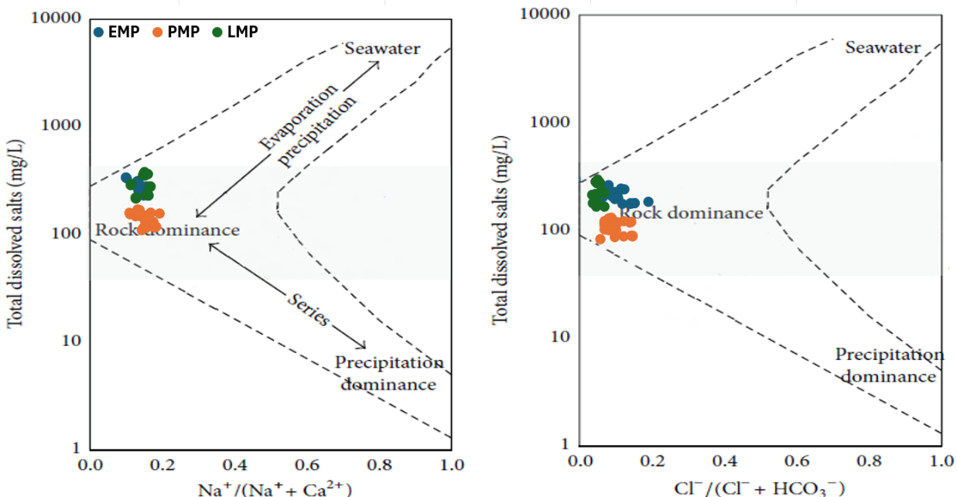
Figure 6 Gibbs plot for Drass River during the study period

The relative influence of silicate and carbonate weathering on water chemistry can be interpreted using a Ca–Mg– (Na + K) ternary diagram. This triangular plot illustrates the phase behaviour of three end-members—Na + K, Ca, and Mg. Samples clustering near the (Na + K) apex suggest dominance of silicate weathering, whereas those plotting closer to the Ca or Mg apex indicate carbonate weathering. When sample points fall in the central part of the diagram, it reflects a mixed contribution from both silicate and carbonate weathering (Blum et al., 1998; Krishnan et al., 2012; Pattanaik et al., 2013; Vinnarasi et al., 2021). In the present study, the ternary plot in Fig. 7 shows that water samples are predominantly controlled by carbonate weathering.

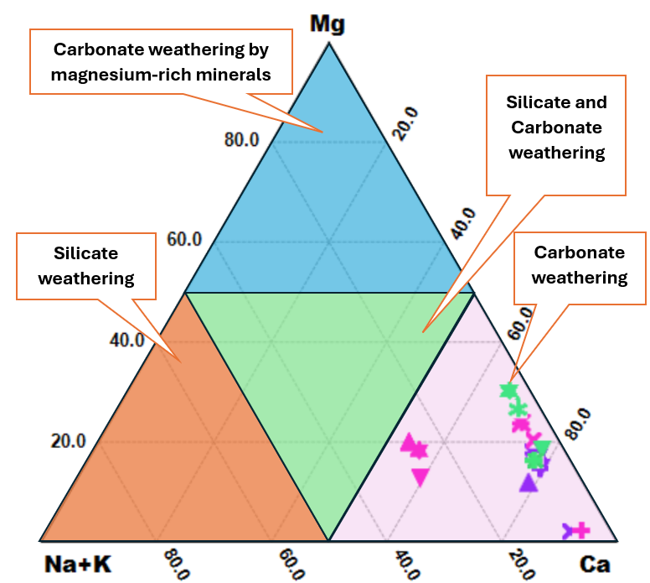
Fig. 7 Calcium–magnesium– (sodium +potassium) ternary diagram for the Drass River.

3.4 Hydrogeochemical evaluation
Piper diagrams are widely used to evaluate the sources of dissolved constituents in water samples (Piper, 1944). This diagram consists of two triangular fields—one for cations (left) and the other for anions (right)—along with a central diamond-shaped field that represents the combined distribution of cations and anions (Sharma et al., 2021). In this study, the ionic concentrations of the three periods were plotted on a Piper diagram to characterise the hydrochemistry of Drass River water Fig. 8.

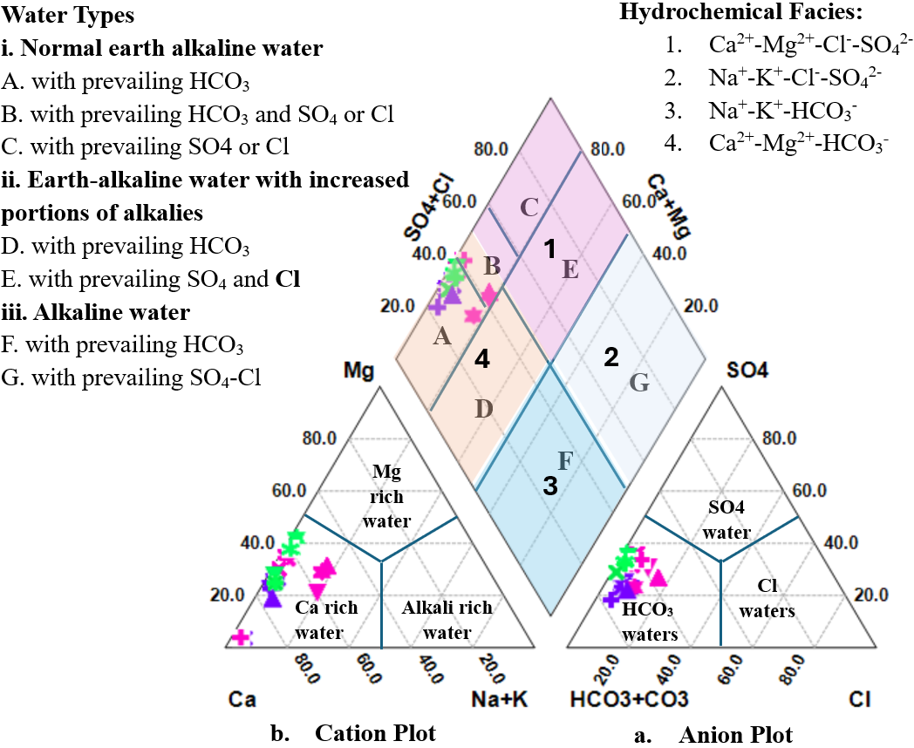
Fig. 8 Piper diagram illustrating the chemical composition of Drass River water.

The results show that all samples fall within the Ca²⁺–Mg²⁺–HCO₃⁻ facies, which corresponds to temporary hardness, where alkaline earth elements (Ca²⁺+Mg²⁺) exceed the alkali elements (Na⁺+K⁺). Moreover, the concentration of weak acids (CO₃²⁻+HCO₃⁻) was found to be higher than that of strong acids (SO₄²⁻ and Cl⁻), indicating HCO₃⁻ as the principal anion in the river water during the EMP and LMP. However, SO₄²⁻becomes significant marginally at DR-1, DR-2 and DR-6 during the PMP. The cation triangle shows that Ca²⁺ is the dominant cation, and the anion triangle shows that HCO₃⁻ dominates in all the study periods Table 3. The low and insignificant concentrations of Na⁺, K⁺, Cl⁻, and SO₄²⁻ across seasons further emphasise the predominance of carbonate weathering.

4. Conclusion
The hydrochemical investigation of the Drass River in Ladakh across early, peak, and late melting periods revealed that water chemistry is predominantly governed by carbonate weathering, with secondary input from silicate weathering, sulphide oxidation, and sulphate mineral dissolution. Ca²⁺ and HCO₃⁻ emerged as the dominant ions, classifying the river water primarily as Ca²⁺-Mg²⁺-HCO₃⁻ facies. The temporal variations observed underscore the sensitivity of the system to seasonal meltwater discharge, dilution, and mixing dynamics with tributaries and the impact of anthropogenic activities. Elevated concentrations of potassium, chloride, and fluoride ions during the PMP suggest significant inputs from anthropogenic sources, whereas the higher sulphate levels observed during the peak and late melting periods reflect the accelerated recession of glacial cover in the basin. This study underscores the urgent need for sustained monitoring of the Drass River Basin to track emerging water quality challenges, particularly the impact of anthropogenic activities, while ensuring the long-term viability of its aquatic ecosystems and dependent livelihoods. Adoption of integrated management practices, including soil erosion control, improved turbidity mitigation techniques, and periodical assessment of water, particularly near the construction sites and city area, will be critical to safeguarding water security and guiding evidence-based policy in this fragile Himalayan environment.

Declaration of Competing Interest
The authors declare that they have no known competing financial interests or personal relationships that could have appeared to influence the work reported in this paper.
Data availability
Data and materials used and generated in this work shall be made available upon request.

DISCLAIMER (ARTIFICIAL INTELLIGENCE)
The author(s) hereby declare that no generative AI technologies (such as Large Language Models, e.g., ChatGPT, Copilot, etc., or text-to-image generation tools) were used in the preparation, writing, or editing of this manuscript.

5. References
Ahmad, T., Khanna, P.P., Chakrapani, G.J., Balakrishnan, S., 1998. Geochemical characteristics of water and sediment of the Indus River, Trans-Himalaya, India: constraints on weathering and erosion. J. Asian Earth Sci. 16, 333–346. https://doi.org/10.1016/S0743-9547(98)00016-6
Ali, Gh., Chaudhari, M.P., Syed, S., Rajpurohit, D., Sanyal, M., Shrivastav, P.S., 2024a. Hydrogeochemical investigation and water quality assessment of the Indus River in the semiarid region of Ladakh, India. Mar. Pollut. Bull. 211, 117413. https://doi.org/10.1016/j.marpolbul.2024.117413
Ali, Gh., Chaudharı, M., Shah, P., Shrivastav, P., 2024b. Temporal changes in water quality in Leh Ladakh region: Impact of urbanization. Environ. Res. Technol. 7, 637–664. https://doi.org/10.35208/ert.1431710
Azeez, P.A., Nadarajan, N., Mittel, D., 2000. The impact of a monsoonal wetland on ground water chemistry. Pollut. Res. 19, 249–255.
Bănăduc, D., Simić, V., Cianfaglione, K., Barinova, S., Afanasyev, S., Öktener, A., McCall, G., Simić, S., Curtean-Bănăduc, A., 2022. Freshwater as a Sustainable Resource and Generator of Secondary Resources in the 21st Century: Stressors, Threats, Risks, Management and Protection Strategies, and Conservation Approaches. Int. J. Environ. Res. Public. Health 19, 16570. https://doi.org/10.3390/ijerph192416570
Benmerabet, N., Sedrati, N., Djabri, L., 2025. Hydrogeochemical processes, water–rock interactions, and the suitability of groundwater in a semi-arid region, Northeastern Algeria. Water Supply 25, 404–423. https://doi.org/10.2166/ws.2025.023
BIS, I.S.D.W.S., 2012. Bureau of Indian Standards. New Delhi 2–3.
Bisht, H., Kotlia, B.S., Kumar, K., Taloor, A.K., Arya, P.C., Sah, S.K., Agnihotri, V., Tewari, M., Upadhyay, R., 2022. Hydrogeochemical analysis and identification of solute sources in the meltwater of Chaturangi glacier, Garhwal Himalaya, India. Appl. Water Sci. 12, 29. https://doi.org/10.1007/s13201-021-01510-5
Blum, J.D., Gazis, C.A., Jacobson, A.D., Page Chamberlain, C., 1998. Carbonate versus silicate weathering in the Raikhot watershed within the High Himalayan Crystalline Series. Geology 26, 411–414.
https://doi.org/10.1130/0091-7613(1998)026%3C0411:CVSWIT%3E2.3.CO;2
Boyd, C.E., 2015. Total Hardness, in: Boyd, C.E. (Ed.), Water Quality: An Introduction. Springer International Publishing, Cham, pp. 179–187. https://doi.org/10.1007/978-3-319-17446-4_9
Boyd, C.E., Tucker, C.S., Somridhivej, B., 2016. Alkalinity and Hardness: Critical but Elusive Concepts in Aquaculture. J. World Aquac. Soc. 47, 6–41. https://doi.org/10.1111/jwas.12241
Brown, G.H., Sharp, M., Tranter, M., 1996. Subglacial chemical erosion: seasonal variations in solute provenance, Haut Glacier d’Arolla, Valais, Switzerland. Ann. Glaciol. 22, 25–31. https://doi.org/10.3189/1996AoG22-1-25-31
CPCB, 2018. River stretches for restoration of water quality [Online Document]. URL https://cpcb.nic.in/wqm/PollutedStretches-2018.pdf
Dame, J., Schmidt, S., Müller, J., Nüsser, M., 2019. Urbanisation and socio-ecological challenges in high mountain towns: Insights from Leh (Ladakh), India. Landsc. Urban Plan. 189, 189–199. https://doi.org/10.1016/j.landurbplan.2019.04.017
DDNEWS, 2024. Centre announces five new districts in Ladakh [Online Document]. ddnews. URL https://ddnews.gov.in/en/centre-announces-five-new-districts-in-ladakh/ (accessed 8.2.25).
Dehnavi, A., Sarikhani, R., Nagaraju, D., 2011. Hydro geochemical and rock water interaction studies in East of Kurdistan, N-W of Iran. Int J Env. Sci Res 1.
Dey, S., Majumdar, A., 2024. Current Status of Pollution in Major Rivers and Tributaries of India and Protection-Restoration Strategies, in: Kanhaiya, S., Singh, S., Dixit, A., Singh, A.K. (Eds.), Rivers of India: Past, Present and Future. Springer International Publishing, Cham, pp. 69–93. https://doi.org/10.1007/978-3-031-49163-4_4
du Plessis, A., 2022. Persistent degradation: Global water quality challenges and required actions. One Earth 5, 129–131. https://doi.org/10.1016/j.oneear.2022.01.005
Gaillardet, J., Dupré, B., Louvat, P., Allègre, C.J., 1999. Global silicate weathering and CO2 consumption rates deduced from the chemistry of large rivers. Chem. Geol. 159, 3–30. https://doi.org/10.1016/S0009-2541(99)00031-5
Gibbs, R.J., 1970. Mechanisms Controlling World Water Chemistry. Sci. New Ser. 170, 1088–1090.
Graham, D.J., Bierkens, M.F.P., van Vliet, M.T.H., 2024. Impacts of droughts and heatwaves on river water quality worldwide. J. Hydrol. 629, 130590. https://doi.org/10.1016/j.jhydrol.2023.130590
Hāṇḍā, O., 2001. Buddhist Western Himalaya: A politico-religious history. Indus Publishing.
Home |Department of Registration| Government of J&K [Online Document], 2025. Govt J K. URL https://igr.jk.gov.in/ (accessed 8.2.25).
Hren, M.T., Chamberlain, C.P., Hilley, G.E., Blisniuk, P.M., Bookhagen, B., 2007. Major ion chemistry of the Yarlung Tsangpo–Brahmaputra River: Chemical weathering, erosion, and CO2 consumption in the southern Tibetan plateau and eastern syntaxis of the Himalaya. Geochim. Cosmochim. Acta 71, 2907–2935. https://doi.org/10.1016/j.gca.2007.03.021
Kitchener, B.G., Wainwright, J., Parsons, A.J., 2017. A review of the principles of turbidity measurement. Prog. Phys. Geogr. https://doi.org/10.1177/0309133317726540
Koul, M.N., Bahuguna, I.M., Ajai, Rajawat, A.S., Ali, S., Koul, S., 2016. Glacier Area Change over Past 50 Years to Stable Phase in Drass Valley, Ladakh Himalaya (India). Am. J. Clim. Change 05, 88. https://doi.org/10.4236/ajcc.2016.51010
Krishnan, A.S., Smith, S.D., Spontak, R.J., 2012. Ternary Phase Behavior of a Triblock Copolymer in the Presence of an Endblock-Selective Homopolymer and a Midblock-Selective Oil [Online Document]. ACS Publ. https://doi.org/10.1021/ma300417u
Kumar, Ramesh, Kumar, Rajesh, Singh, A., Singh, S., Bhardwaj, A., Kumari, A., Sinha, R.K., Gupta, A., 2019. Hydro-geochemical analysis of meltwater draining from Bilare Banga glacier, Western Himalaya. Acta Geophys. 67, 651–660. https://doi.org/10.1007/s11600-019-00262-w
LAHDC Kargil, 2025. Drass | District Kargil, Union Territory of Ladakh | India. Kargil Ladakh. URL https://kargil.nic.in/tourist-place/drass/ (accessed 8.23.25).
Łepkowska, E., Stachnik, Ł., 2018. Which Drivers Control the Suspended Sediment Flux in a High Arctic Glacierized Basin (Werenskioldbreen, Spitsbergen)? Water 10, 1408. https://doi.org/10.3390/w10101408
Magaritz, M., Aravena, R., Peña, H., Suzuki, O., Grilli, A., 1989. Water chemistry and isotope study of streams and springs in northern Chile. J. Hydrol. 108, 323–341. https://doi.org/10.1016/0022-1694(89)90292-8
Magesh, N.S., Chandrasekar, N., 2013. Evaluation of spatial variations in groundwater quality by WQI and GIS technique: a case study of Virudunagar District, Tamil Nadu, India. Arab. J. Geosci. 6, 1883–1898. https://doi.org/10.1007/s12517-011-0496-z
Meybeck, M., 1987. Global chemical weathering of surficial rocks estimated from river dissolved loads. Am. J. Sci. 287, 401–428. https://doi.org/10.2475/ajs.287.5.401
Meybeck, M., 1983. Atmospheric inputs and river transport of dissolved substances. Dissolved Loads Rivers Surf. Water Quant. Relatsh. 141, 173–192.
Möller, D., 2002. The Na/CL ratio in rainwater and the sea salt chloride cycle. Tellus B 42, 254–262. https://doi.org/10.1034/j.1600-0889.1990.t01-1-00004.x
Natarajan, M., Subramanian, V., 2001. Fluoride concentration in river waters of South Asia. Curr. Sci. 80, 1312–1319.
Négrel, P., Allègre, C.J., Dupré, B., Lewin, E., 1993. Erosion sources determined by inversion of major and trace element ratios and strontium isotopic ratios in river water: the Congo Basin case. Earth Planet. Sci. Lett. 120, 59–76.
Pande, K., Sarin, M.M., Trivedi, J.R., Krishnaswami, S., Sharma, K.K., 1994. The Indus River system (India-Pakistan): Major-ion chemistry, uranium and strontium isotopes. Chem. Geol. 116, 245–259. https://doi.org/10.1016/0009-2541(94)90017-5
Pásková, M., Štekerová, K., Zanker, M., Lasisi, T.T., Zelenka, J., 2024. Water pollution generated by tourism: Review of system dynamics models. Heliyon 10, e23824. https://doi.org/10.1016/j.heliyon.2023.e23824
Pattanaik, J.K., Balakrishnan, S., Bhutani, R., Singh, P., 2013. Estimation of weathering rates and CO2 drawdown based on solute load: Significance of granulites and gneisses dominated weathering in the Kaveri River basin, Southern India. Geochim. Cosmochim. Acta 121, 611–636. https://doi.org/10.1016/j.gca.2013.08.002
Piper, A.M., 1944. A graphic procedure in the geochemical interpretation of water‐analyses. Eos Trans. Am. Geophys. Union 25, 914–928. https://doi.org/10.1029/TR025i006p00914
Rana, B., Jha, S., Molla, S., Kulkarni, M., 2022. Hydrogeochemical characterization and evaluation of subsurface water quality in the Proterozoic Cuddapah Basin, Andhra Pradesh, India. Environ. Monit. Assess. 194. https://doi.org/10.1007/s10661-022-10501-1
Rice, E.W., Bridgewater, L., APHA, 2012. Standard methods for the examination of water and wastewater, 23rd ed. American Public Health Association, American Water Works Association, Water Environment Federation.
Salerno, F., Rogora, M., Balestrini, R., Lami, A., Tartari, G.A., Thakuri, S., Godone, D., Freppaz, M., Tartari, G., 2016. Glacier Melting Increases the Solute Concentrations of Himalayan Glacial Lakes. Environ. Sci. Technol. 50, 9150–9160. https://doi.org/10.1021/acs.est.6b02735
Sarin, M.M., Krishnaswami, S., Dilli, K., Somayajulu, B.L.K., Moore, W.S., 1989. Major ion chemistry of the Ganga-Brahmaputra river system: weathering processes and fluxes to the Bay of Bengal. Geochim. Cosmochim. Acta 53, 997–1009.
Sawyer, C.N., 1967. Chemistry for Sanitary Engineers. McGraw-Hill.
Selvam, S., Jesuraja, K., Roy, P.D., Venkatramanan, S., Chung, S.Y., Elzain, H.E., Muthukumar, P., Nath, A.V., Karthik, R., 2021. Assessment of groundwater from an industrial coastal area of south India for human health risk from consumption and irrigation suitability. Environ. Res. 200, 111461.
Sharma, G., Lata, R., Thakur, N., Bajala, V., Kuniyal, J.C., Kumar, K., 2021. Application of multivariate statistical analysis and water quality index for quality characterization of Parbati River, Northwestern Himalaya, India. Discov. Water 1, 5. https://doi.org/10.1007/s43832-021-00005-3
Sharma, P., Ramanathan, A.L., Pottakkal, J., 2013. Study of solute sources and evolution of hydrogeochemical processes of the Chhota Shigri Glacier meltwaters, Himachal Himalaya, India. Hydrol. Sci. J. 58, 1128–1143. https://doi.org/10.1080/02626667.2013.802092
Sharma, S.N., 2018. Drass: Summer in Drass, India’s coldest inhabited place - The Economic Times [Online Document]. Summer Drass India’s Coldest Inhabited Place. URL https://economictimes.indiatimes.com/magazines/panache/summer-in-drass-indias-coldest-inhabited-place/articleshow/64141398.cms?from=mdr (accessed 8.23.25).
Singh, A.T., Sharma, P., Sharma, C., Laluraj, C.M., Patel, L., Pratap, B., Oulkar, S., Thamban, M., 2020. Water discharge and suspended sediment dynamics in the Chandra River, Western Himalaya. J. Earth Syst. Sci. 129, 206. https://doi.org/10.1007/s12040-020-01455-4
Singh, V.B., Ramanathan, AL., Pottakkal, J.G., Kumar, M., 2014. Seasonal variation of the solute and suspended sediment load in Gangotri glacier meltwater, central Himalaya, India. J. Asian Earth Sci. 79, 224–234. https://doi.org/10.1016/j.jseaes.2013.09.010
Sun, B., Liu, J., Ren, F., Li, H., Zhang, G., Ma, J., Ma, B., Li, Z., 2022. Effects of seasonal freeze–thaw and wind erosion on runoff and sediment yields of three loamy slopes of Loess Plateau, China. CATENA 215, 106309. https://doi.org/10.1016/j.catena.2022.106309
Tay, C.K., 2021. Hydrogeochemical framework of groundwater within the Asutifi-North District of the Brong-Ahafo Region, Ghana. Appl. Water Sci. 11, 72. https://doi.org/10.1007/s13201-021-01398-1
Thomas, J., Joseph, S., Thrivikramji, K.P., Manjusree, T.M., Arunkumar, K.S., 2014. Seasonal variation in major ion chemistry of a tropical mountain river, the southern Western Ghats, Kerala, India. Environ. Earth Sci. 71, 2333–2351. https://doi.org/10.1007/s12665-013-2634-2
Tiwari, A.K., Singh, A.K., 2014. Hydrogeochemical investigation and groundwater quality assessment of Pratapgarh district, Uttar Pradesh. J. Geol. Soc. India 83, 329–343. https://doi.org/10.1007/s12594-014-0045-y
Tranter, M., Sharp, M.J., Brown, G.H., Willis, I.C., Hubbard, B.P., Nielsen, M.K., Smart, C.C., Gordon, S., Tulley, M., Lamb, H.R., 1997. Variability in the Chemical Composition of in Situ Subglacial Meltwaters. Hydrol. Process. 11, 59–77. https://doi.org/10.1002/(SICI)1099-1085(199701)11:1<59: AID-HYP403>3.0.CO;2-S
UN World Water Development Report 2024 [Online Document], 2024. UN World Water Dev. Rep. URL https://Online.unwater.org/publications/un-world-water-development-report-2024 (accessed 6.15.24).
UNESCO, 2021. The Global Water Quality Challenge & SDGs [Online Document]. Intergov. Hydrol. Programme. URL https://en.unesco.org/ waterquality-iiwq/wq-challenge. (accessed 8.3.25).
UN-Water, 2023. UN World Water Development Report 2023 [Online Document]. UN World Water Dev. Rep. 2023. URL https://Online.unwater.org/publications/un-world-water-development-report-2023 (accessed 8.4.25).
Vinnarasi, F., Srinivasamoorthy, K., Saravanan, K., Gopinath, S., Prakash, R., Ponnumani, G., Babu, C., 2021. Chemical weathering and atmospheric carbon dioxide (CO2) consumption in Shanmuganadhi, South India: evidences from groundwater geochemistry. Environ. Geochem. Health 43, 771–790. https://doi.org/10.1007/s10653-020-00540-3
Wang, Jiawei, Wu, Z., Li, C., Pan, Y., Wang, Jin, Qiu, J., Ren, S., Xu, H., 2025. Synergistic effect of sodium metasilicate and sodium fluorosilicate in an accelerator on cement hydration. Adv. Cem. Res. 1–12. https://doi.org/10.1680/jadcr.24.00144
Wang, W., Zeng, L., Du, S., Qiao, M., Chen, J., Zhu, B., 2022. The Influence of Alkali-Free Shotcrete Accelerators on Early Age Hydration and Property Development within Cement Systems. Materials 15, 6907. https://doi.org/10.3390/ma15196907
Welti, A., Lohmann, U., Kanji, Z., 2019. Ice nucleation properties of K-feldspar polymorphs and plagioclase feldspars. Atmospheric Chem. Phys. Discuss. 1–25. https://doi.org/10.5194/acp-2018-1271
WHO, 2017. Guidelines for drinking-water quality, 4th edition, incorporating the 1st addendum [Online Document]. Guidel. Drink. Water Qual. Fourth Ed. Inc. First Add. World Health Organ. Geneva. URL https://Online.who.int/publications/i/item/9789241549950 (accessed 7.12.25).
Wieczorek, K., Turek, A., Wolf, W.M., 2023. Combined Effect of Climate and Anthropopressure on River Water Quality. Int. J. Environ. Res. Public. Health 20, 3032. https://doi.org/10.3390/ijerph20043032
Zhang, F., Qaiser, F.-R., Zeng, C., Pant, R.R., Wang, G., Zhang, H., Chen, D., 2019. Meltwater hydrochemistry at four glacial catchments in the headwater of Indus River. Environ. Sci. Pollut. Res. 26, 23645–23660. https://doi.org/10.1007/s11356-019-05422-5

