GEOSPATIAL ANALYSIS OF THE EFFECT OF URBANIZATION ON LAND SURFACE TEMPERATURE OF AKURE METROPOLITAN AREA IN ONDO STATE

Abstract

This study employed geospatial techniques to analyze the spatiotemporal impact of urbanization on Land Surface Temperature (LST) in the Akure Metropolitan Area, Nigeria, from 1994 to 2024. Multi-temporal satellite imagery from Landsat (4TM, 7ETM+, 8OLI) and Sentinel-2 were processed to derive land use/land cover (LULC) maps and LST distributions for four epochs (1994, 2004, 2014, 2024). A supervised classification algorithm was used to categorize LULC into built-up, vegetation, forest, cropland, bare surface, and water bodies. LST was retrieved from thermal infrared bands using a standardized radiative transfer equation. The results revealed a dramatic transformation of the landscape, characterized by a rapid expansion of built-up areas from 6.97% (69.12 km²) in 1994 to 24.39% (241.77 km²) in 2024, alongside a severe decline in vegetation cover from over 86% to less than 58%. Concurrently, the maximum LST exhibited a significant increasing trend, rising from 24°C in 1994 to 34°C in 2024. Statistical analysis confirmed a strong positive correlation between the increase in impervious surfaces (built-up and bare land) and the rise in LST, while a strong negative correlation was observed between vegetation loss and temperature increase. The study conclusively establishes the intensification of the Urban Heat Island (UHI) effect in Akure, directly driven by unplanned urbanization and loss of natural land cover. The findings underscore the critical need for integrated urban planning, the promotion of green infrastructure, and strict land use policies to mitigate thermal discomfort and enhance climate resilience in the metropolitan area

Introduction
Urbanization is a dominant global demographic trend, with over half of the world's population now residing in urban areas. This rapid transformation of natural landscapes into built environments significantly alters the physical, chemical and biological properties of the land surface. One of the most pronounced environmental consequences of this change is the modification of the local and regional climate, leading to the phenomenon known as the Urban Heat Island (UHI) effect. The Urban Heat Island effect describes the observable temperature difference between an urban area and its surrounding rural countryside, where urban regions are significantly warmer (Voogt & Oke, 2003). This study focuses on Akure, the capital city of Ondo State, Nigeria, which has experienced considerable spatial expansion and population growth in recent decades. This research employs geospatial technologies—Remote Sensing (RS) and Geographic Information Systems (GIS)—to quantitatively analyze the spatiotemporal patterns of urbanization in Akure and its environs and to investigate its correlative effect on the Land Surface Temperature (LST). Providing empirical evidence, this study aims to contribute to sustainable urban planning and climate change mitigation strategies for the region.

Background of the Study
Akure, situated in the southwestern part of Nigeria, serves as the administrative, commercial and educational hub of Ondo State. Historically a modest town, Akure has undergone rapid urbanization driven by rural-urban migration, economic opportunities, and its status as a state capital. This growth has led to the expansion of impervious surfaces such as buildings, roads, and parking lots, while reducing vegetative cover through deforestation and land clearing.
The Land Surface Temperature (LST) is a key indicator of the Earth's surface energy balance and is a primary parameter in urban climate studies. Unlike air temperature measured by weather stations, LST represents the radiative skin temperature of the land surface, which can be accurately derived from satellite thermal infrared sensors. The conversion of pervious, vegetated land to impervious, non-vegetated surfaces changes the surface albedo (reflectivity), reduces evapotranspiration and increases heat storage and anthropogenic heat release. These changes are the fundamental drivers of the Urban Heat Island effect.
Geospatial technology provides a powerful, efficient, and cost-effective tool for monitoring such environmental changes over large areas and time periods. Satellite imagery, particularly from the Landsat series (Landsat 5, 7, 8, and 9), offers a long-term, consistent archive of multi-spectral data, including visible, near-infrared and thermal infrared bands. This allows researchers to extract land use/land cover (LULC) classes and derive LST maps, enabling a robust analysis of the relationship between urbanization and surface temperature dynamics.

Problem Statement
The rapid and often unplanned urbanization of Akure has raised concerns about its environmental sustainability and impact on the local microclimate. Anecdotal evidence and local observations suggest an increase in thermal discomfort within the city core compared to outlying rural areas. However, there is a scarcity of empirical, data-driven studies that quantitatively assess the extent and intensity of the Urban Heat Island effect in Akure and its direct linkage to the city's expansion.
Key questions remain unanswered: What is the precise rate and pattern of urban growth in Akure over the past 20 to 30 years? How has this spatial expansion translated into changes in Land Surface Temperature? Is there a statistically significant correlation between the loss of vegetation/increase in built-up areas and the rise in surface temperature? Without this critical information, urban planners and policymakers lack the evidence base needed to implement effective land use policies, green infrastructure initiatives, and mitigation strategies to combat urban heating. This study, therefore, seeks to fill this gap by providing a geospatial analysis of the effect of urbanization on the LST of Akure metropolitan area.
Scope of the Study
Spatial scope: The study was confined to Akure metropolitan area in Ondo State, Nigeria. The geographical extent was defined by the Local government boundary of Akure North and South that capture the city's core and its surrounding peri-urban and rural areas for effective comparison. Temporal Scope: The analysis covered a period of approximately 30 years (1994 to 2024). This timeframe will be divided into four epochs (1994, 2004, 2014 and 2024) to effectively capture the dynamics of urban growth and LST change. The specific years will be chosen based on the availability of cloud-free satellite imagery. Methodological Scope: Image processing, classification and analysis was done to determine the LULC of the study area. Derivation of Land Surface Temperature (LST) from thermal bands was also carried out. Quantification of urban sprawl using change detection techniques. Statistical analysis of the correlation between LULC changes and LST patterns. Limitations: The study relied on satellite-derived LST, which is a measure of surface temperature, not ambient air temperature. Challenges such as cloud cover, sensor errors, and the accuracy of classification algorithms were acknowledged and properly mitigated.
Aim and Objectives
The study assessed the impact of urbanization on the Land Surface Temperature of Akure metropolitan area using geospatial techniques.
The specific objectives are to:
- To classify and map the land use/land cover (LULC) of the study area from 1994 to 2024.
- To estimate and map the spatial distribution of Land Surface Temperature (LST) for the same epochs.
- To quantify the rate and pattern of urban sprawl and the changes in vegetation cover between 1994 and 2024.
- To analyze the relationship between the changes in the land use/land cover (particularly the increase in built-up areas and decrease in vegetation) and the variations in Land Surface Temperature.
- To propose recommendations for sustainable urban planning and Urban Heat Island mitigation based on the findings.
Justification of the Study
This study will contribute to the body of knowledge on urban climatology in medium-sized cities in the developing world, particularly within the tropical Nigerian context. It will demonstrate the application of RS and GIS as indispensable tools for environmental monitoring. The findings will provide crucial data for urban planners, environmentalists, and policymakers in Ondo State. The generated land use/land cover change maps and LST zones can serve as a decision-support tool for future land use zoning, guiding development away from sensitive areas and promoting green infrastructure. Understanding the Urban Heat Island effect is vital for addressing issues related to thermal discomfort, increased energy demand for cooling, and the exacerbation of heat-related illnesses among the urban population. The study highlights the critical role of vegetation in moderating urban microclimates, strengthening the case for urban forestry, park creation, and the protection of green spaces as a strategy for climate change adaptation and sustainable development in Akure metropolitan area.
Literature Review
The pervasive phenomenon of Urban Heat Islands (UHI) stands as a significant environmental consequence of an increasingly urbanized world. First observed and meticulously documented by Luke Howard in the 19th century through his detailed meteorological observations in London (Howard, 1833), the UHI effect describes the consistent temperature differential where urban centers are significantly warmer than their surrounding rural or natural landscapes. This temperature disparity is not merely an incidental outcome of development but a direct result of profound alterations to the Earth's surface energy balance within urbanized zones (Oke, 1982). The primary driver behind the UHI effect is the extensive replacement of natural, pervious surfaces (such as vegetation and soil) with artificial, impervious materials like concrete, asphalt, and building structures. These urban materials possess distinct thermophysical properties, including high heat capacity and thermal conductivity, which enable them to absorb and retain a greater amount of solar radiation throughout the day compared to natural covers. Consequently, they re-emit this stored heat slowly into the atmosphere, particularly during the evening and night, leading to elevated temperatures (Oke, 1995).
Beyond material properties, several synergistic factors contribute to UHI intensification. The significant reduction in vegetation cover curtails natural cooling processes such as evapotranspiration, where plants release water vapor into the atmosphere, dissipating heat. The complex geometry of urban canyons (streets flanked by tall buildings) traps outgoing longwave radiation and reduces wind speed, inhibiting effective heat dispersal. Furthermore, anthropogenic heat release from human activities—including vehicle emissions, industrial processes, and the waste heat generated by air conditioning systems—acts as a direct source of warming within the urban fabric. The combined effect of these factors means that UHI intensity is typically highest during nocturnal hours, particularly under clear skies and calm wind conditions, as these meteorological conditions prevent the mixing and dispersion of trapped heat (Oke, 1982). Understanding these intricate spatial and temporal dynamics of Land Surface Temperature (LST) is paramount for effective urban climate studies, as LST serves as a direct proxy for the radiative skin temperature of the land surface, providing a comprehensive view of the thermal environment (Voogt & Oke, 2003).
The advent of remote sensing technology has unequivocally revolutionized the study of UHIs, offering an unparalleled capability for synoptic and repetitive measurement of LST across vast geographical areas. This technological leap addresses the inherent limitations of traditional, ground-based weather stations, which often provide sparse spatial coverage and cannot capture the intricate variability of urban thermal landscapes. Satellite platforms, particularly the Landsat series (e.g., Landsat 4TM, 7ETM+, 8OLI) and more recently Sentinel-2, provide an invaluable long-term archive of multi-spectral data (United States Geological Survey, 2023; Copernicus Open Access Hub, 2024). These satellites are equipped with specialized sensors that capture data across various electromagnetic spectrum bands, crucially including thermal infrared (TIR) bands, which are essential for deriving LST maps. Additionally, Near-Infrared (NIR) and Red bands are utilized for calculating vegetation indices.
Researchers have extensively leveraged this data to extract not only LST but also key environmental indicators like the Normalized Difference Vegetation Index (NDVI). The NDVI, first developed by Rouse et al. (1974), is a widely recognized spectral index that quantifies vegetation greenness and density based on the differential reflection of solar radiation in the red and near-infrared bands. Numerous studies have consistently demonstrated a strong negative correlation between vegetation abundance (as indicated by high NDVI values) and surface temperature (LST) (Yuan & Bauer, 2007; Mallick et al., 2013). This relationship underscores the critical role of green spaces in moderating urban temperatures through biophysical processes such as evapotranspiration and the shading effect of tree canopies. Weng (2009) provides a comprehensive review of the methods, applications, and trends in thermal infrared remote sensing for urban climate and environmental studies, emphasizing its indispensable role in current UHI research. The ability of remote sensing to provide detailed, spatially continuous, and temporally consistent data makes it an indispensable tool for monitoring environmental changes in urban areas over extended periods.
In the context of Nigerian cities, a growing body of literature robustly corroborates the direct and intensifying relationship between rapid, often unplanned, urbanization and escalating LST. Nigeria, experiencing significant population growth and rural-urban migration, presents a critical case study for understanding these dynamics within a tropical developing context. Research conducted in major urban centers across the country consistently reveals patterns that mirror global UHI trends. For instance, in Lagos, a mega-city characterized by high population density and extensive impervious surfaces, studies have confirmed a notable UHI effect, with satellite remote sensing techniques being instrumental in its assessment (Adegunleye & Balogun, 2018). Similarly, analyses in the capital city of Abuja have demonstrated a clear spatio-temporal link between changes in land use/land cover (specifically, increased built-up areas) and corresponding increases in LST (Eze & Eze, 2019). The findings from Port Harcourt further reinforce this regional trend, showing that areas with high built-up density invariably correspond with LST hotspots, while the few remaining vegetated areas effectively function as "cool islands," providing thermal relief (Ede & Edokpa, 2017).
These studies collectively highlight several recurring themes unique to the Nigerian urban landscape. The rapid pace of urban sprawl, often driven by a quest for economic opportunities and administrative functions, frequently outstrips the capacity for planned development. This leads to the unchecked conversion of natural and agricultural lands into built environments, exacerbating the loss of crucial cooling surfaces. The environmental ramifications extend beyond increased thermal discomfort to encompass elevated energy demand for cooling, potential impacts on public health due to heat-related illnesses, and compromised air quality. The consistent evidence from these regional studies underscores the urgent need for integrating UHI mitigation strategies into urban planning policies across Nigeria, particularly given the vulnerability of its rapidly expanding urban populations to climate change impacts. The issue of urban sprawl and its multifaceted environmental consequences remains a pervasive and critical theme in the discourse on sustainable urban development within Nigeria. Population data from sources like the National Population Commission (NPC, 2006) and the National Bureau of Statistics (NBS, 2021) further underscore the scale of urban demographic shifts driving these land cover changes.
The methodological backbone of UHI and LULC studies fundamentally relies on advanced geospatial and remote sensing techniques. The process typically begins with the meticulous acquisition and pre-processing of satellite imagery. Raw satellite data often requires geometric correction to remove spatial distortions and atmospheric correction to minimize the effects of atmospheric interference (haze, aerosols) on spectral reflectance values (Jensen, 2005; Lillesand et al., 2015). Radiometric calibration coefficients, such as those provided for Landsat sensors (Chander et al., 2009), are crucial for converting raw digital numbers (DN) into physically meaningful units like spectral radiance or reflectance.
Following pre-processing, image classification is performed to categorize pixels into distinct land cover classes. Supervised classification algorithms, such as the Maximum Likelihood Classifier (MLC), are widely employed due to their robust statistical foundation. This involves selecting representative "training sites" for each desired land cover class (e.g., built-up, vegetation, forest, water bodies, bare surface), from which the algorithm learns the spectral signatures. The MLC then uses these signatures to assign every pixel in the image to the class it most closely resembles based on statistical probability. Once LULC maps for different epochs are generated, change detection techniques are applied to quantify the magnitude, rate, and spatial pattern of urban growth and land cover transformation over time (Singh, 1989; Lu, D et al., 2004). These techniques can involve post-classification comparison, where classified maps from different dates are compared pixel-by-pixel, or image differencing, where changes are detected directly from multi-temporal images.
The derivation of LST from thermal infrared bands is a multi-step process. First, the DN values from the thermal band are converted into spectral radiance (L) using sensor-specific calibration parameters. This radiance is then converted into brightness temperature (BT), which represents the temperature a blackbody would have to emit the same amount of radiation, typically in Kelvin (Sobrino et al., 2004; Jiménez-Muñoz et al., 2014). This conversion often utilizes Planck's radiation law, simplified into sensor-specific constants (K1​ and K2​). Finally, to obtain the true LST, the brightness temperature must be corrected for land surface emissivity (ϵ), as natural surfaces are not perfect blackbodies. Emissivity, which represents a surface's efficiency in emitting thermal radiation, is typically estimated based on the proportion of vegetation (PV) derived from NDVI values. Algorithms like the mono-window algorithm (Wang et al., 2015) incorporate BT, emissivity, and the wavelength of emitted radiance to calculate the final LST, often presented in Celsius. The precise and meticulous application of these steps, often facilitated by Geographical Information System (GIS) software, ensures the accuracy and reliability of the geospatial analysis. The administrative boundaries of the study area, for example, are obtained from official sources like the Office of the Surveyor General of the Federation (OSGOF, 2023).
Despite the burgeoning body of literature on urbanization and LST dynamics within Nigeria, there remain specific research gaps concerning the Akure metropolitan area. While some studies have addressed the general patterns of urban spatial expansion in Akure (Olayiwola et al., 2018), there is a notable scarcity of empirical, quantitative research that directly and explicitly links this urban growth to concomitant changes in the thermal environment. Most existing works often provide either a purely LULC-focused analysis or offer LST assessments without a detailed, statistically robust correlational analysis between specific LULC types (e.g., the expansion of built-up areas, the reduction of vegetation, or the increase in bare surfaces) and the observed variations in LST patterns.
This current study is critically positioned to address this significant lacuna in the regional urban environmental research. By providing an integrated, multi-temporal, and quantitative analysis specifically targeting the UHI effect in Akure, this research will fill a crucial gap. It aims to offer empirical evidence that directly establishes the precise linkages between urbanization drivers and thermal responses over a substantial period. Such detailed, local-scale insights are indispensable for policymakers and urban planners who require robust data to formulate effective, evidence-based sustainable urban planning strategies and climate change adaptation measures. The findings will not only contribute to the local context of Akure but also enrich the broader narrative of sustainable urban development in tropical regions of Nigeria, serving as a model for similar rapidly urbanizing cities facing comparable environmental challenges.

METHODOLOGY
Study area
Akure is the capital of Ondo State, located in the southwestern part of Nigeria. It is made up of two Local Government Areas: Akure South, which hosts the main urban center, and Akure North, which encompasses surrounding suburban and rural settlements. Together, they form the political, economic and administrative hub of Ondo State.
Akure South LGA covers an estimated land area of 331 km².Akure North LGA spans approximately 660 km², making it more extensive in land area than Akure South. Combined, the Akure metropolitan area covers about 991 km², encompassing urban, peri-urban and rural landscapes. According to the 2006 National Population Census, Akure South had a population of about 353,211, while Akure North had about 131,587. However, recent estimates by the National Bureau of Statistics (2021) place the total population of the Akure Metropolitan area at over 750,000, due to rapid urbanization and in-migration. The metropolitan area hosts a growing middle class, civil servants, students and migrants from other parts of Nigeria, contributing to its increasing population density.

The Akure Metropolitan area lies between latitudes 7°15'N and 7°30'N, and longitudes 5°00'E and 5°15'E. It is situated on a gently undulating terrain, with a mix of lowlands and isolated hills and ridges. The city is located in a transitional zone between the rainforest zone and the derived savannah.
Vegetation in Akure South is predominantly tropical rainforest, consisting of thick canopy trees, shrubs and grasses. In Akure North, due to agricultural activities and urban encroachment, the vegetation has been partially degraded into derived savannah, with patches of natural forest remaining. Crops such as cocoa, cassava, maize and yam are widely cultivated, especially in Akure North.

Drainage
The drainage system of Akure Metropolitan area is defined by seasonal streams and rivers, many of which are tributaries of the Owena River, a major water body in Ondo State.
Notable rivers include Ala River, Ogbese River and several smaller streams that flow through valleys and low-lying areas. Poor urban planning and blocked drainage channels in Akure South often result in flash flooding during the rainy season
Climate
Akure Metropolitan area experiences a tropical humid climate, with two distinct seasons: rainy season from March to October while the dry season is from November to February. The average annual rainfall ranges between 1,200 mm and 1,500 mm. Temperatures are generally high throughout the year, with mean daily temperatures between 22°C and 32°C. Humidity levels are higher during the wet season and lower in the dry months, especially when the Harmattan winds from the Sahara are dominant.
Data type and source
Sentinel 2 10m high resolution data of 2014 and 2024, Landsat Thematic Mapper (TM, 1994) and Landsat Enhanced Thematic Mapper plus (ETM, 2004) are among the data used in the study. The base layers were created using the OSGOF Nigeria Administrative map. The USGS EARTH-EXPLORER provided the temporal remote sensing data from the Landsat satellite series, while the COPERNICUS website provided the Sentinel image, which was geometrically rectified. Land use analysis was carried out using supervised pattern classifier - Maximum Likelihood Classifier (MLC) algorithm.
Remote sensing data was classified using signatures from training sites that include predominant land use types. Mean and covariance matrix are computed using estimate of maximum likelihood estimator for the 5 different classes such as Built up, Water body, Vegetation, Crop land and Bare surface. The images were maintained at common resolution of 30m for landsat and 10m for the sentinel2 by down-scaling. Downscaling is the enhancement of the spatial resolution of the original LST data set. The administrative boundary was obtained from department of GIS and Cartography in Office of Surveyor General of the Federation and the Landsat imageries were downloaded from an open source.

Table 1: Data types and source
S/N | Data | Resolution | Year | Source | Relevance
1 | Administrative boundaries shape file |  | 2023 | OSGOF | To define the spatial boundary
2 | Landsat imageries 4TM, 7ETM, 8OLI | 30mx30m | 1994,2004 and 2014 | Earth explorer USGS | For land use land cover and land surface temperature
3 | Thermal Near infrared (7ETM, 8OLI and 9TIRS) | 30mx30m | 1994,2004,2014 and 2024 | Earth explorer USGS | For land surface temperature and Land use
4 | Sentinel 2 | 10m x 10m | 2024 | Sentinel Copernicus Hub | For land use land cover

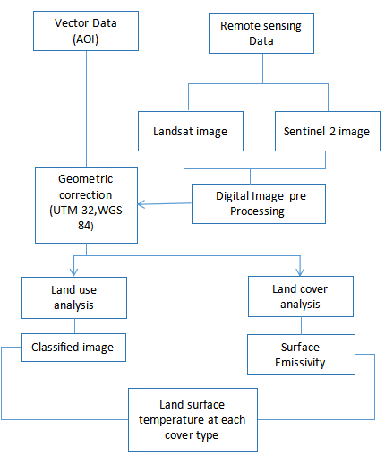 Figure 1: Conceptual frame work

Techniques of Data Analysis
The downloaded images were extracted and layer stacked using Arc GIS software 10.8 to give a false-color composite image using bands 4, 3, 2. The layer stacked images were then sub-mapped to the area of interest (Akure Metropolitan area) for visualization and proper analysis.
In this study, a supervised classification approach was adopted using an interactive maximum likelihood algorithm for the classification of the images. The overall objective of image classification is to automatically categorize all pixels in an image into land cover classes or themes. It is the process of grouping or categorizing different image classes into their pixel characteristics. The categorized data are then used to produce the thematic map present in the scene
Considering the visual and digital interpretation of satellite images, about six (6) different land use/land cover types or classes were examined in the study area and due to the emphasis laid on urban expansion and its impact on agricultural land. The land cover and land use classes were categorized and classified using supervised classification approach into crop land, bare soil, built-up area, vegetation and water bodies, then vectorization was done to convert raster to polygon for calculation of geometry different land use (LU) changes over the period under assessment. There are three (3) levels embarked on in computing the change detection for each LU by area statistics which involves;
i.The first stage involved the calculation of the magnitude of change and this is done by subtracting observed change of each period of the year from earlier periods of the years.
ii. The next step was the calculation of the percentage change of each of the land use (trend), this was achieved by subtracting the percentage change of the previous land use from the recent land-use, divided by the previous land-use and multiplied by 100. Consequently, this will help assess at a glance, the spatial extent of LU gained or lost.
iii. Finally, the last step involved the calculation of the annual rate of change by dividing the percentage change by 100 and multiplied by the number of the study years, which is 10 years.

Table 2: Various land use types in the study area.
Land use type | Description
Build up area | These include Residential, commercial and service, transportation, communication and utilities, industrial and commercial complexes
Bare surface | These also includes dry salt flats, beaches, sandy areas other than beaches, bare exposed rocks, strip mines, queries and gravel pits.
Crop land | These are crop land, pasture, orchard, nurseries, and ornamental
 | agricultural area
Vegetation | This includes areas of natural vegetation of any plant species, trees, deciduous and ever greened forest lands.
Water bodies | These involves areas persistently lodge with waters such as streams, canals, lakes, reservoirs, bays and estuaries.
Forest area | Involves area with Tick Vegetation covers

Assessing the land surface temperature and decadal changes in Akure Metropolitan area from 1994 to 2024
Imported the multispectral thermal image (Band 6, 10) through Add data and catalog Landsat 4TM, 7ETM spectral radiance data has also been converted to planetary TOA reflectance. Using coefficients of reflectance rescaling provided in metadata associated with the Landsat 7ETM.
For converting DN values into TOA reflection in the ETM image use the following equation:
L1 = (Lmax – Lmin / QCALmax – QCAL min) * (QCAL – QCAL min) + Lmin………. Equation 1.
Whereas;
L = Spectral radiance.
QCAL = Quantized Calibrated Pixel Value in Digital Number.
Lmax = Spectral radiance scaled to QCALmax in watts
Lmin = Spectral radiance scaled to QCALmin in watts
QCALmax = Maximum quantized calibrated pixel value
QCAL min= Minimum quantized calibrated pixel value
Conversion radiance into Bright Temperature (In kelvin)
……………………………………………………...Equation 2
Whereas
K1 and K2 = specific thermal conversion constant from the Metadata
(From obtaining the result in Celsius the radiant temperature is revised by adding the absolute zero (approx.-273.15).
Secondly, we also calculated the reflectance value from the satellite data Landsat 8 OLI. Landsat 8 OLI spectral radiance data has also been converted to planetary TOA reflectance using coefficients of reflectance rescaling provided in the Landsat 8 OLI file. For converting DN values into TOA reflection in the OLI image use the following equation:
Formulae; L^ = ML * QCAL + AL – Oi………………. Equation 3
Whereas
L^ = Atmosphere Sensor Temperature (AST)
ML = Radiance Multiplicative Band 10
AL = Add band
QCAL = Quantized and calibrated standard produce pixel value band 10
0i = Correction value for band 10 = 0.29
Note: you can only get your radiance multiplicative value for band 10 and radiance adds a band of band 10 in your metadata in the band sequence of your downloaded Landsat 8 imagery.
Conversion AST to Bright Sensor Temperature
Formulae; Kelvin to Celsius
BT = K2/Ln (K1/L^+1) – 273.15 ………………. Equation 4

Whereas
K1 and K2 = Specific thermal conversion constant from the Metadata
(From obtaining the result in Celsius the radiant temperature is revised by adding the absolute zero (approx.-273.15).
Normalized Difference Vegetation Index
NDVI is a standard vegetation index calculated using near-infrared and red
Formulae;
Float (NIR – RED) / Float (NIR + RED) ………………. Equation 5
Whereas
NIR = Band 5
RED = Band 4
Land surface emissivity
Land surface emissivity is the average emissivity of an element on the surface of the earth calculated from NDVI
Formulae;
PV = square ((NDVI - NDVI min)/ (NDVI max – NDVI min)) ………………. Equation 6
E = 0.004 * PV + O.986 ………………. Equation 7
Whereas
NDVI max = High value
NDVI min = Low value
PV = Proportion of vegetation
0.986 corresponds to a correctional value of the equation
Land surface temperature
The land surface temperature is the radioactive temperature which calculated using an atmosphere sensor of temperature, brightness, wavelength of emitted radiance, and land surface emissivity.
Formulae;
LST = BT / (1+ (^*BT/C2) * Ln (E)) ………………. Equation 8
Here, C2 = 14388µmk
The value of the ^ for Landsat 8 for band 10 is 10.8 and band 11 is 12.0
For which the peak response and the average of the limiting wavelength
(^ = 10.895), Source: (Wang et al, 2009)
Whereas
BT = Bright Temperature
^ = Wavelength of the emitted radiance
E = Land surface emissivity
H = Planck‘s constant = 6.626 * 10-34
S = Boltzman constant = 1.38 * 10 -23
C = Velocity of light = 2.998 * 103
C2 = H * C/S

RESULT AND DISCUSSION
Land Use and Land Cover Change Detection Analysis in Akure Metropolitan area (1994 - 2024)
Total Area Estimation
The total estimated land area for Akure Metropolitan area based on the dataset is approximately 991.26 km². This value was used as the baseline for calculating percentage changes over the years.
The Land Use Land Cover Result For 1994
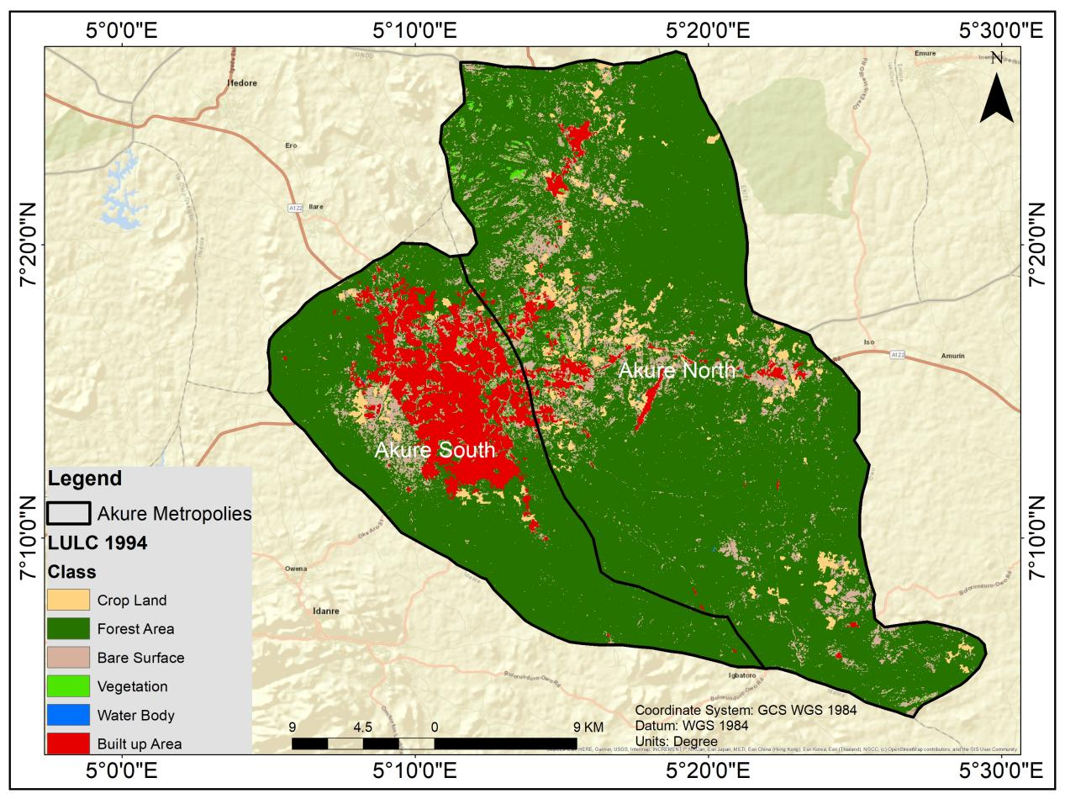
Fig2-: Land use Land cover Map of Akure Metropolitan area 1994

Table 3-LULC Table for 1994
Class | Area (km²) | Percentage (%)
Crop Land | 55.107 | 5.56%
Forest Area | 715.7629 | 72.21%
Vegetation | 141.7779 | 14.30%
Bare Surface | 8.3758 | 0.85%
Water Body | 1.1143 | 0.11%
Built-up Area | 69.1236 | 6.97%
Total | 991.2615 | 100%

It was observed from the 1994 analysis above that its forest cover has the highest coverage and urban area was minimal. Forest area and vegetation covered approximately 86%. There was minimal human interference as shown in low built-up area (6.97%). Landscape largely untouched, supporting biodiversity and agriculture

Fig 3-The Land Use Land Cover Result For 2004
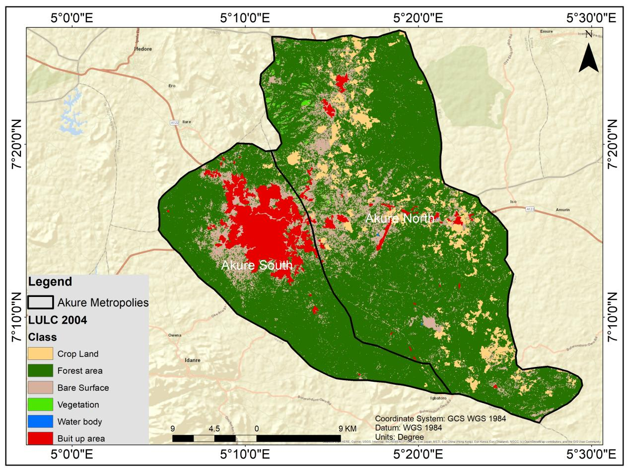

Table 4-LULC Table For 2004
Class | Area (km²) | Percentage (%)
Crop Land | 26.5627 | 2.68%
Forest Area | 776.4048 | 78.34%
Vegetation | 93.9033 | 9.47%
Bare Surface | 9.9454 | 1.00%
Water Body | 1.0873 | 0.11%
Built-up Area | 83.358 | 8.41%
Total | 991.2615 | 100%

Interpretation: - Slight increase in forest area. - Crop land and vegetation declined. - Urban area continued to expand slowly.
Fig 4-The Land Use Land Cover Result For 2014
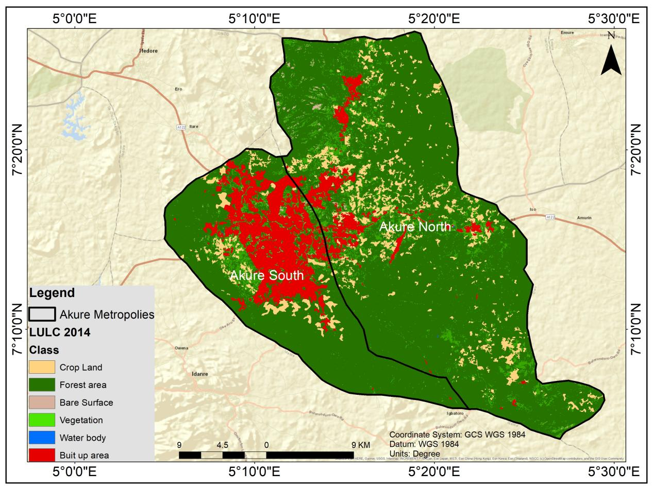

Table 5-LULC Table For 2014
Class | Area (km²) | Percentage (%)
Crop Land | 67.3353 | 6.79%
Forest Area | 726.4575 | 73.30%
Vegetation | 77.1086 | 7.78%
Bare Surface | 10.522 | 1.06%
Water Body | 0.828 | 0.08%
Built-up Area | 108.9549 | 11.0%
Total | 991.2063 | 100%
Interpretation: - Urban area grow significantly. - Crop land rebounded. - Forest area decline.
Fig 5-The Land Use Land Cover Result For 2024
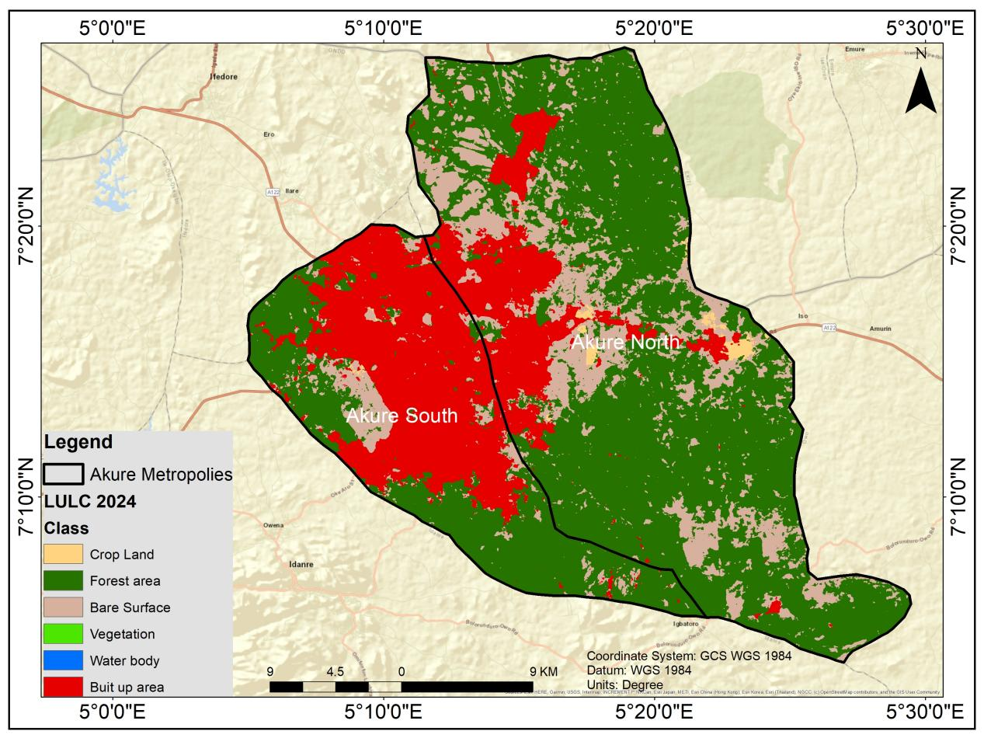
Table 6-LULC Table For 2024
Class | Area (km²) | Percentage (%)
Crop Land | 6.592 | 0.66%
Forest Area | 568.247 | 57.32%
Vegetation | 6.0341 | 0.61%
Bare Surface | 168.6034 | 17.01%
Water Body | 0.015 | 0.002%
Built-up Area | 241.77 | 24.39%
Total | 991.2615 | 100%
Interpretation: - Urban/built-up areas tripled compared to 2014. - Forest and vegetation suffered major losses. - Bare surfaces expanded drastically.
Table 7-Change Detection Summary (1994 - 2024)
Class | Change (km²) | Trend Description
Crop Land | -48.515 | Declined drastically due to urban encroachment.
Forest Area | -147.5159 | Significant deforestation and degradation.
Vegetation | -135.7438 | Nearly disappeared due to urban growth.
Bare Surface | +160.2276 | Expanded over 20 times its original size.
Water Body | -1.0993 | Almost dried up or replaced by development.
Built-up Area | +172.6464 | Rapid urban expansion across 30 years.

Table 8-Land surface temperature and decadal changes in Akure Metropolitan area from 1994 to 2024
Year | LST Low (°C) | LST High (°C) | Temperature Range (°C)
1994 | 16 | 24 | 8
2004 | 18 | 27 | 9
2014 | 20 | 30 | 10
2024 | 22 | 34 | 12

1994 to 2024
The result of LST reveal that the maximum temperature ranges from 24ºC in 1994 to 34ºC in 2024 through 27ºC and 30ºC respectively in 2004 and 2014. The minimum temperature increased from 16ºC in 1994 through 18ºC and 20ºC in 2004 and 2014 respectively to 22ºC in 2024. It is obvious that as the maximum temperature and the minimum temperature is on constant increase. Also, higher temperatures appeared more in the north west areas for the three epochs. These areas are more of the city center and are characterized by urban development. Moreover, the spatial extent of higher LST was larger in 2024 as compared to those of 1994, 2004 and 2014.

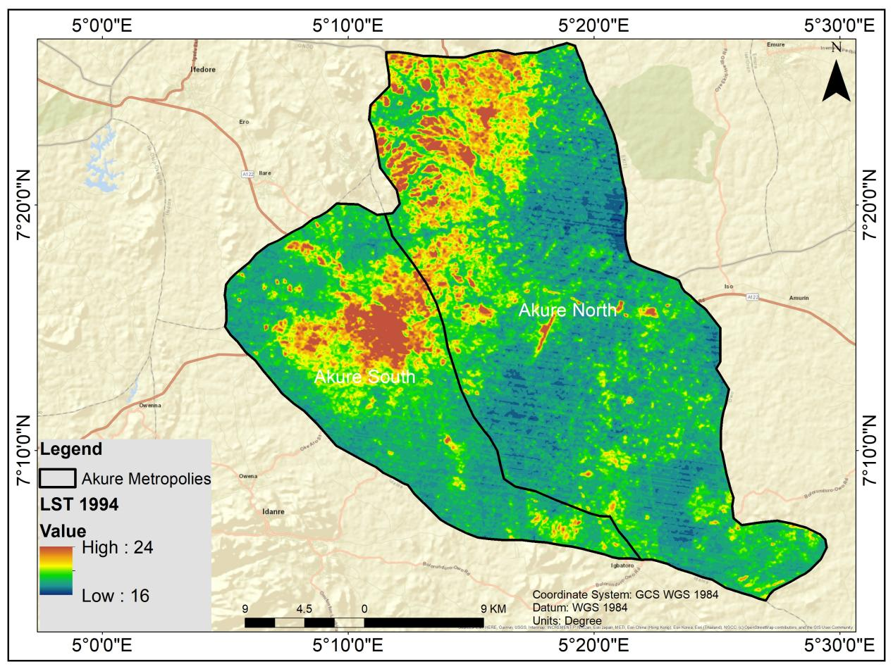
Fig 6- The Land Use Land Cover Result For 1994
1994 – Low Surface Temperature
LST Range: 16°C to 24°C.
Cooler environment due to extensive vegetation and forest cover (over 86%).
Minimal urban surfaces (built-up and bare lands), which absorb and retain heat.
Indicates healthy natural landscape with good evapotranspiration rates and canopy cover

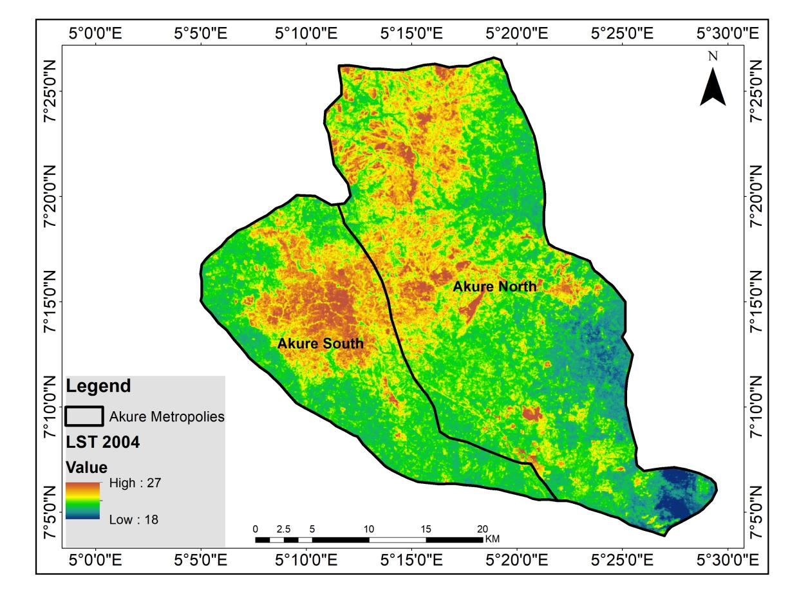
Fig 7-The Land Use Land Cover Result For 2004
2004 – Slight Increase in Temperature
LST Range: 18°C to 27°C.
Increase of 2–3°C from 1994.
Urban expansion begins; built-up areas increase from 6.97% to 8.41%.
Reduction in cropland and vegetation reduces surface cooling.
Heat retention starts becoming evident, though forest area was still dominant.

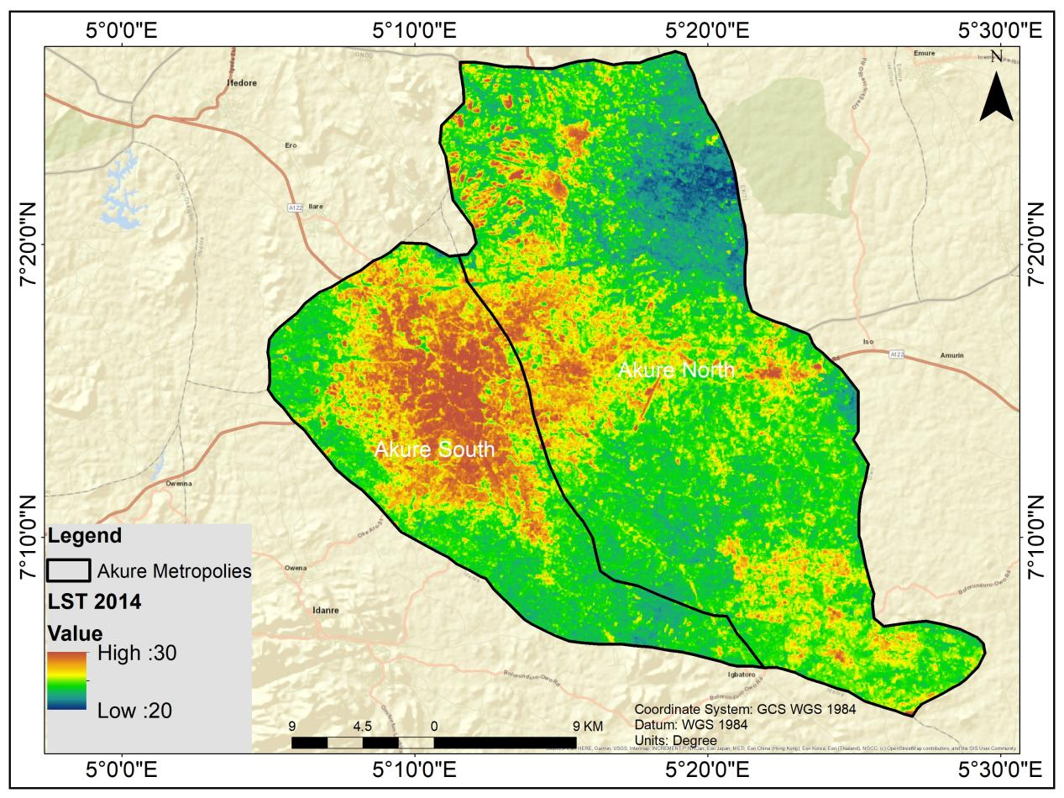
Fig 8- The Land Use Land Cover Result For 2014
2014 – Noticeable Warming
LST Range: 20°C to 30°C.
Urban/built-up area reaches 11%.
Vegetation and forest cover continue to decline.
Urban heat island (UHI) effect intensifies with more impervious surfaces (roofs, roads).
Reduction in moisture content and canopy shade leads to higher LST values

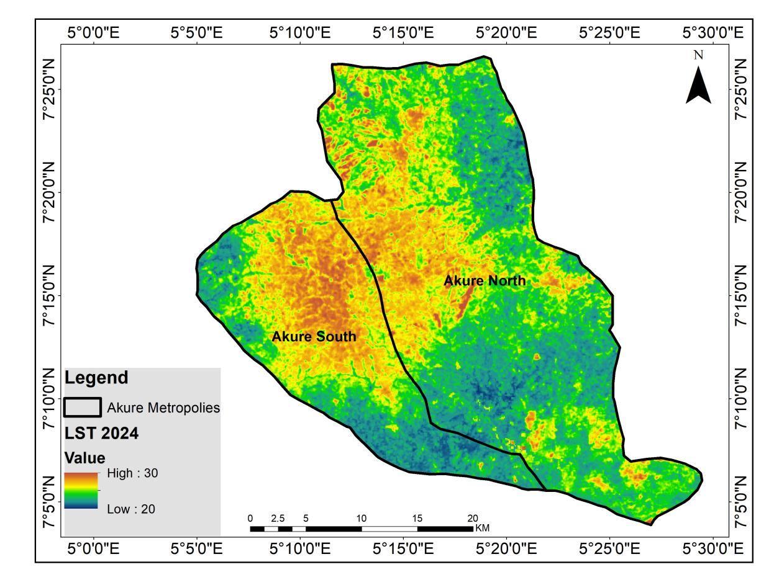
Fig 9- The Land Use Land Cover Result For 2024
2024 LST
2024 – High Surface Temperature
LST Range: 22°C to 34°C — Highest in the 30-year record.
Built-up area surged to 24.39%, while vegetation and cropland almost disappear.
Bare surface also rises significantly (17%).
Less transpiration, more solar radiation absorption.
Shows the direct correlation between LULC changes and rising temperature

Key Observations
Consistent Temperature Rise: LST increased from 6–10°C across 30 years.
LST and Urbanization Link: The trend corresponds closely with the increase in built-up and bare land and the decline in natural vegetation.
Urban Heat Island Effect: Rising temperatures are likely a result of urban expansion, where concrete and asphalt surfaces trap more heat
Environmental Implication: Higher surface temperatures contribute to thermal discomfort, energy demand, reduced air quality and health risks in urban settings.

Relationship Between Land Use and Land Surface Temperature (LST)

Natural Covers (Forest, Vegetation, Cropland) → Lower LST; areas covered by forest and vegetation have lower LST due to:
Evapotranspiration cools the environment through the shading effect from trees and canopy cover. In 1994, Akure had extensive vegetation (over 86%), and LST was low (16–24°C). As natural covers declined over time (to less than 10% in 2024), their cooling influence diminished.

Built-up Areas and Bare Surfaces → Higher LST
Built-up areas (concrete, asphalt, rooftops) and bare surfaces (cleared land, roads) absorb and retain heat, causing higher surface temperatures and urban heat island effect (city areas hotter than rural surroundings). In Akure, built-up area grew from 6.97% in 1994 to 24.39% in 2024. Bare surface also increased massively (from 0.85% to 17.01%). Correspondingly, LST rose from 24°C (max) in 1994 to 36°C in 2024.

Temporal and Spatial Correlation
As vegetation and forest cover decrease, and built-up/bare surfaces increase, LST consistently rises.
Hotspots (areas of high temperature) in Akure appear more in northwest zones (urban core), confirming the spatial link between urban development and warming.
CONCLUSION AND RECOMMENDATION
Akure Metropolitan area is undergoing rapid urbanization, especially in the past decade.
Natural vegetation and croplands are being replaced by built-up areas and bare land. Sustainability concerns may arise if this trend continues, especially regarding food security, climate resilience and water resource management.
The steady rise in Land Surface Temperature in Akure Metropolitan area from 1994 to 2024 reflects a significant transformation from a naturally vegetated environment to an urban-dominated landscape. This environmental change underscores the urgent need for:
Urban green planning, Sustainable land use policies, Climate-smart infrastructure and reforestation efforts to mitigate heat stress.
The conversion of vegetated land to built-up areas is the main driver of increased LST in Akure Metropolitan area. LST acts as a thermal indicator of how land is being used or modified.

COMPETING INTERESTS DISCLAIMER:
Authors have declared that they have no known competing financial interests OR non-financial interests OR personal relationships that could have appeared to influence the work reported in this paper.

References
1. Adegunleye, B., & Balogun, I. A. (2018). Assessment of urban heat island over Lagos, Nigeria using satellite remote sensing. Indonesian Journal of Geography, 50(2), 150-159.
2. Ede, P. N., & Edokpa, D. O. (2017). Satellite-based assessment of the urban heat island phenomena in Port Harcourt, Nigeria. American Journal of Climate Change, 6(2), 293-304.
3. Eze, C. J., & Eze, E. C. (2019). Spatio-temporal analysis of land use/land cover change and its impact on land surface temperature in Abuja, Nigeria. Journal of Geography, Environment and Earth Science International, 22(3), 1-15.
4. Howard, L. (1833). The Climate of London, Deduced from Meteorological Observations. Harvey and Darton.
5. Mallick, J., Kant, Y., & Bharath, B. D. (2013). Estimation of land surface temperature over Delhi using Landsat-7 ETM+. Journal of Indian Geophysical Union, 17(3), 283-293.
6. National Bureau of Statistics (NBS). (2021). Estimated Population Figures for Nigerian States and Local Government Areas.
7. Oke, T. R. (1982). The energetic basis of the urban heat island. Quarterly Journal of the Royal Meteorological Society, 108(455), 1-24.
8. Olayiwola, A. M., Adeleye, B. M., & Ogunseye, N. O. (2018). Spatial expansion of Akure, Nigeria: A geospatial analysis. Journal of Settlements and Spatial Planning, 9(1), 1-10.
9. Wang, F., Qin, Z., Song, C., Tu, L., Karnieli, A., & Zhao, S. (2015). An improved mono-window algorithm for land surface temperature retrieval from Landsat 8 thermal infrared sensor data. Remote Sensing, 7(4), 4268-4289.
10. Weng, Q. (2009). Thermal infrared remote sensing for urban climate and environmental studies: Methods, applications, and trends. ISPRS Journal of Photogrammetry and Remote Sensing, 64(4), 335-344.
11. Yuan, F., & Bauer, M. E. (2007). Comparison of impervious surface area and normalized difference vegetation index as indicators of surface urban heat island effects in Landsat imagery. Remote Sensing of Environment, 106(3), 375-386.
12. United States Geological Survey (USGS). (2023). Landsat 8-9 Collection 2 Level 2 Science Product Guide.
13. Copernicus Open Access Hub. (2024). Sentinel-2 User Handbook.
14. Office of the Surveyor General of the Federation (OSGOF). (2023). Administrative Boundaries of Nigeria.
15. Jensen, J. R. (2005). Introductory Digital Image Processing: A Remote Sensing Perspective (3rd ed.). Prentice Hall.
16. Lillesand, T., Kiefer, R. W., & Chipman, J. (2015). Remote Sensing and Image Interpretation (7th ed.). John Wiley & Sons.
17. Chander, G., Markham, B. L., & Helder, D. L. (2009). Summary of current radiometric calibration coefficients for Landsat MSS, TM, ETM+, and EO-1 ALI sensors. Remote Sensing of Environment, 113(5), 893-903.
18. Sobrino, J. A., Jiménez-Muñoz, J. C., & Paolini, L. (2004). Land surface temperature retrieval from LANDSAT TM 5. Remote Sensing of Environment, 90(4), 434-440.
19. Jiménez-Muñoz, J. C., Sobrino, J. A., Skoković, D., Mattar, C., & Cristóbal, J. (2014). Land surface temperature retrieval methods from Landsat-8 thermal infrared sensor data. IEEE Geoscience and Remote Sensing Letters, 11(10), 1840-1843.
20. Rouse, J. W., Haas, R. H., Schell, J. A., & Deering, D. W. (1974). Monitoring vegetation systems in the Great Plains with ERTS. NASA SP-351, 1, 309-317.
21. Singh, A. (1989). Digital change detection techniques using remotely-sensed data. International Journal of Remote Sensing, 10(6), 989-1003.
22. Lu, D., Mausel, P., Brondízio, E., & Moran, E. (2004). Change detection techniques. International Journal of Remote Sensing, 25(12), 2365-2401.
23. Oke, T. R. (1995). The heat island of the urban boundary layer: characteristics, causes and effects. In Wind Climate in Cities (pp. 81-107). Springer, Dordrecht.
24. Voogt, J. A., & Oke, T. R. (2003). Thermal remote sensing of urban climates. Remote Sensing of Environment, 86(3), 370-384.
25. National Population Commission (NPC, 2006). 2006 Population and Housing Census of the Federal Republic of Nigeria.
26. Congedo, L. (2021). Semi-Automatic Classification Plugin: A Python tool for the download and processing of remote sensing images in QGIS. Journal of Open Source Software, 6(64), 3172.
27. Akure North Local Government. (2023). Geospatial and Demographic Data.
28. Akure South Local Government. (2023). Geospatial and Demographic Data.
39. Ondo State Ministry of Physical Planning and Urban Development. (2022). Akure Master Plan Report.

