Original Research Article

Impact of climate variability on Hydroelectric Power Generation in Côte d’Ivoire: The Case of the Buyo Dam (Western Côte d’Ivoire)

ABSTRACT

|  |
| --- |
| This study aims to analyze the historical trends and futures projections of water availability for hydroelectric production at the Buyo dam in Côte d’Ivoire. It relies on the combined use of climatic data (precipitation, temperature), hydrological data (streamflow), and operational data (useful water depth, turbine flows), collected from SODEXAM, the Directorate of Hydrology, and the dam management team. The useful water depth was calculated to assess the actual volume of water available for power generation, and a hydrological vigilance index (Leff) was developed to monitor temporal trends in water scarcity risk. Results show notable interannual variability in water availability, particularly influenced by El Niño events, which have historically led to severe rainfall deficits. Using Leff index quintiles, the study identified specific periods of hydric alert and crisis that pose potential risks to energy production. A significant vulnerability is observed from March to August during dry years. Climate projections for 2040 and 2060, based on multi-model averages (NCC, ICHEC and IPSL) under RCP4.5 and RCP8.5 scenarios, suggest that droughts will become more frequent and intense, which could reduce the availability of water suitable for use in turbines. These findings emphasise the importance of proactive and adaptive water management strategies to ensure the continued reliability of hydroelectric production in the face of increasing climate uncertainty. The vigilance index (Leff) is a valuable tool for providing early warnings and supporting decision-making. Strengthening monitoring systems and integrating climate scenarios into reservoir operation plans is essential for ensuring national energy security. |

*Keywords: Hydroelectricity, Useful Water Level, Drought, Sassandra Watershed, Côte d’Ivoire*

1. INTRODUCTION

Electricity production in Côte d'Ivoire remains highly dependent on hydropower, a key pillar of the national energy mix, with the Buyo dam serving as a major strategic actor [1]. However, the sustainability of this source is contingent upon the availability of water, a factor that is susceptible to the effects of increasing climate variability. As highlighted by [2], Ivorian water resources are increasingly subject to unpredictable seasonal fluctuations, affecting the performance of hydropower facilities. This instability poses a significant challenge to national energy security in the context of accelerated climate change. Recent studies have confirmed that the Republic of Côte d'Ivoire is experiencing increasingly pronounced fluctuations in rainfall and temperature. The national average temperature has increased by approximately 1 °C between the 1960s and the present day. As demonstrated in Figure 1, nine of the ten hottest years since 1960 have been recorded since the year 2000. Concurrently, the 2023 World Bank Group report cautions that pivotal sectors, including energy, are already imperilled, with a projected loss risk of 13% of GDP by 2050 if no adaptation measures are implemented**.** This hydrometeorological irregularity exerts direct pressure on water levels in reservoirs, thereby compromising turbine capacity and, consequently, electricity production. A study conducted in the N'Zi basin corroborates this trend, indicating a significant decrease in rainfall since the 1970s, leading to a marked reduction in water resources [3]. These fluctuations are attributable to climate disruption affecting West Africa, and particularly Côte d'Ivoire [4]. Furthermore, recent studies combining hydrological modelling and artificial intelligence applied to several reservoirs in Côte d'Ivoire have produced future flow projections ranging from -10% to +37%. This variation has been shown to directly impact energy potential, with ranges from -10% to +40% documented [5]. Concurrently, the gradual rise in average temperatures has been shown to intensify evapotranspiration, thereby significantly reducing water availability [6]. As asserted by the Intergovernmental Panel on Climate Change, hydraulic infrastructures within tropical regions are deemed to be particularly vulnerable to the impacts of climate change. This necessitates the implementation of robust adaptation strategies. These observations underscore the strategic importance of Ivorian hydropower production, which is nevertheless facing growing challenges due to climate variability and the decline in water resources. The sustainability and resilience of the national hydropower system, particularly that of the Buyo dam, are therefore directly threatened by these increasingly unpredictable climatic hazards. It is therefore imperative to enhance our comprehension of the extent to which climate change impacts water availability and production capacity, in order to facilitate anticipation of medium- and long-term energy crises. The present study aligns with this approach by proposing an analysis of historical trends and future projections to support adaptive and secure management of water resources dedicated to electricity production in Côte d'Ivoire.

**2. Presentation of the study area**

The Sassandra River originates in the Beyla region of Guinea (Fig. 1) under the name Feroudougouba. The area covered by its watershed is approximately 75,000 km² up to the sea level, as reported by [7]. The Guinean portion of the basin covers an area of approximately 8,000 km². The Ivorian portion of the watershed, characterised by the presence of the Buyo hydropower dam as its outlet, encompasses an area of 39,980 km². Its geographical location is characterised by a range of western longitudes spanning from 6°50' to 8°20', and northern latitudes extending from 6°15' to 9°50'.

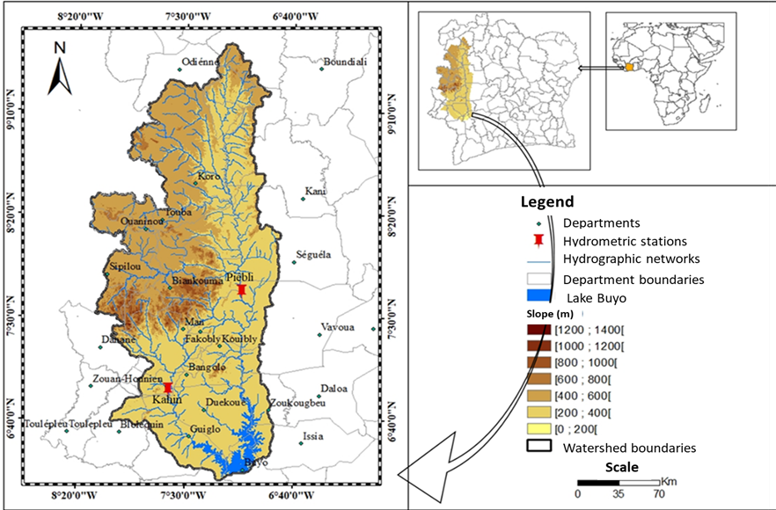

**Fig. 1:** **Watershed of the Sassandra River at Buyo**

The watershed of the Sassandra River at Buyo is influenced by three climatic regimes, as illustrated in Figure 2: the attenuated tropical transition climate (I), the mountain climate (II), and the attenuated equatorial transition climate (III). The mean annual temperature in the southern part of the Sassandra basin is 25°C, while in the north it is 26°C. The soils of the basin are predominantly linked to a series of podzolic soils, which are associated with the lower Côte d'Ivoire region [8]. The entire basin is located on the ancient basement, comprising the Lower and Middle Precambrian formations, with sporadic outcrops of dolerites and basalts dating back to the Paleozoic era [9]. The topography of the basin is characterised by a uniform relief, a consequence primarily of the erosion of the surrounding mountain ranges, which have gradually transformed into a peneplain. As [10] demonstrate in their study, altitudes gradually decrease from a height of 500 metres in the northernmost point of the area to less than 50 metres in the southernmost point. The vegetation of the basin can be divided into two distinct domains, characterised by specific plant formations that respond to divergent ecological conditions. These domains are referred to as the Sudanian domain and the Guinean domain. The Sudanian domain is characterised by the presence of forest and savanna formations, which are juxtaposed in the northern region of Côte d'Ivoire. The Guinean domain, extending from south to north, is characterised by a diverse array of ecological regions, including coastal savannas, rainforests, mesophilic forests, and montane forests [11]. Across the basin, a total of twelve dams with various uses have been constructed. Prior to the construction of the Buyo hydroelectric dam in 1981, 74% of the Buyo area was covered with dense forests, of which less than 25% were barely affected by human activities. In the aftermath of the construction of the Buyo hydroelectric dam, the forest in the Buyo region has been subjected to a significant decline in biodiversity, with an estimated loss of 90% of plant and animal species.

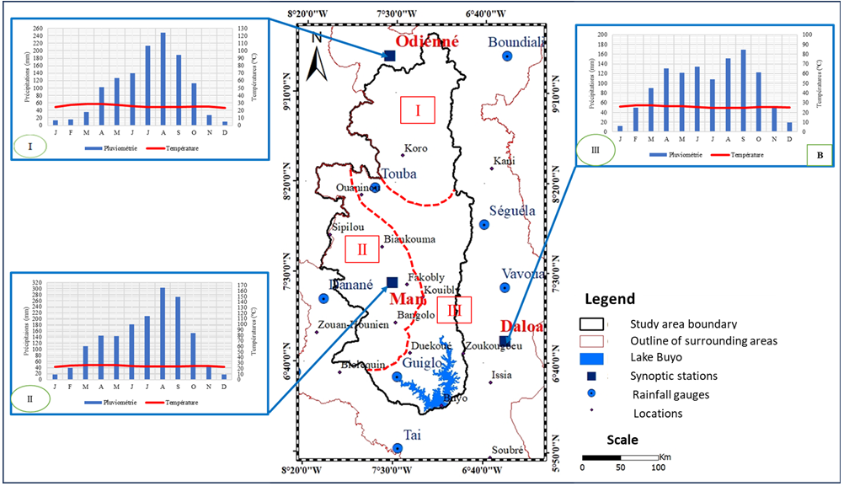

**Fig.2: Climatic regimes of the sassandra river watershed at buyo**

3. matEriAl AND mEthods

**3.1. Material**

In this study, a number of datasets were utilised for the purpose of analysing water availability at the Buyo dam. The data set encompasses climatic variables (precipitation and temperature), hydrological data (streamflow), and dam operation data, which were obtained from SODEXAM, the Directorate of Hydrology, the CORDEX-Africa program, and the Directorate of the Buyo dam, respectively. Precipitation and temperature data are collected on a daily basis at three synoptic stations located within the confines of the Sassandra River watershed at Buyo. The data set under consideration herein covers the period from 1971 to 2020. Daily climate model outputs are extracted from the NCC, ICHEC, and IPSL models (CORDEX-Africa) under the RCP4.5 and RCP8.5 scenarios. The data on streamflow were obtained from the hydrometric stations of Piébli (Sassandra River) and Kahin (N'Zo River), and span the period from 1981 to 2001. With regard to operational data, including water levels in the reservoir, turbine discharges, and spilled volumes, these span the period from 2005 to 2023.

**3.2. METHODS**

The study employs a multi-methodological approach to assess the availability of turbine water at the Buyo dam, integrating climatic, hydrological, and operational data (production data).

### **3.2.1. Determination of ISP Indices**

The Standardized Precipitation Index [10,11] and [12,13]was developed to quantify rainfall deficits at multiple time scales. The term was adopted in 2009 by the World Meteorological Organization (WMO) as a global tool for characterising meteorological droughts, under the terms of the "Lincoln Declaration on Drought Indices" [14]. As asserted by [15,16] respectively, this index is employed to ascertain the severity of drought within a classification. Negative values are indicative of drought, whereas positive values are indicative of wet conditions.

The mathematical expression is as follows:

|  |  |
| --- | --- |
| $$ISP=\frac{P_{i}-P_{m}}{δ}$$ | (1) |

With Pi: rainfall of month or year *i* ;

Pm: mean rainfall of the 1981–2010 normal ;

S: standard deviation of the 1981–2010 normal.

Consequently, a drought is characterised by a consecutive negative SPI. The process is terminated when the SPI becomes positive. A classification of drought according to SPI values is established in Table I.

**Table 1:** Classification of Drought Sequences According to ISP

|  |  |
| --- | --- |
| **ISP Value Range** | **Drought/Wet Category** |
| ≥ +2.0 | Extremely Wet |
| +1.5 to +1.99 | Very Wet |
| +1.0 to +1.49 | Moderately Wet |
| 0 to +0.99 | Near Normal / Wet Condition |
| 0 to -0.99 | Mild Drought |
| -1.0 to -1.49 | Moderate Drought |
| -1.5 to -1.99 | Severe Drought |
| ≤ -2.0 | Extreme Drought |

### **3.2.2. Multi-model climate projections and water depth evolution scenarios**

In order to anticipate future climate changes, this study utilises projected daily climate data from three regional models: RCA4-NCC, RCA4-ICHEC, and RCA4-IPSL. These models were selected from the CORDEX-Africa database. These models provide simulations of the regional climate under several emission scenarios. Nevertheless, two scenarios were retained for the purposes of this analysis: RCP4.5 is an intermediate scenario, while RCP8.5 reflects a high-emission pessimistic trajectory.

In order to reduce the uncertainties associated with individual projections, the outputs of the three models were combined to produce a multi-model average. This approach is commonly recommended in the literature as a means of obtaining more robust climate estimates [17]**.** Two-time horizons were considered: 2021-2040 (horizon 2030) and 2041-2060 (horizon 2050), in comparison to the historical reference period 1981-2005. The Standardized Precipitation Index (SPI) is a statistical metric used to identify years with rainfall deficits, particularly those marked by El Niño events. Finally, for the deficit years in question, annual rainfall profiles will be established from daily data in order to analyse the most critical periods of the year. It is proposed that inferences regarding the impact on available water depth shall be made using historical trends as a point of reference. This shall be achieved by means of analysis of the behaviour of seasonal rainfall.

### **3.2.3. Determination of the useful water layer**

The useful water depth (Leu) is defined as the difference between the daily water level (Hj) and the minimum production water level (Min Level). This water depth facilitates analysis of the availability of water for turbine operation. It has been demonstrated that this index is a reliable metric for evaluating the water height in meters (m) available for turbine flow and, consequently, the hydroelectric production capacity [18].

$Leu=Hj-\min{cost}$ (2)

When:

$Leu>0$

The dam contains excess water that can be utilised to meet electricity production needs.

The time at which this will take place is as follows:

$$Leu<0$$

The dam's water level has been reduced to align with the current production requirements. This has the potential to result in power outages.

### **3.2.4. Classification of alert levels**

The effective water depth index (Leff) has been defined as a means of monitoring the alert level of the water depth in the reservoir.

|  |  |  |
| --- | --- | --- |
| $$Leff=\frac{Leu}{\max{coast}-\min{coast}}$$ | (3) |  |

The term "max coast" is used to denote the maximum level, whilst "min coast" is used to denote the minimum level. The difference between these two values is said to represent the optimal water depth.

The index ranges from 0, indicative of a water crisis, to 1, reflecting optimal comfort, as presented in Table 2. Systematic monitoring of this index enables not only the evaluation of alert levels but also facilitates the identification of critical periods throughout the year.

**Table 2:** Classification of alert levels

|  |  |
| --- | --- |
| **Index value** | **Alert Level** |
| 0 - 0,20 | Crisis |
| 0,20 - 0,40 | Alert |
| 0,40 - 0,60 | Pre-alert |
| 0,60 - 0,80 | Watch |
| 0,80 - 1 | Comfort |

**4. Results et discussion**

**4.1 Results**

**4.1.1 Rainfall variation**

During the 42-year period under consideration (1981–2022), 24 years were associated with El Niño, representing approximately 57%, or two years out of three. Years with moderate to extreme droughts were defined as those with an SPI ≤ -0.5. Consequently, the severity of drought is more pronounced in Daloa, followed by Odienné, and then Man. An average rainfall deficit of 12% (10/42) is observed in Daloa, with 23.8% of years experiencing severe to extreme droughts (Table 3). In Odienné, the average rainfall deficit is 4% (8/42), with 19.5% of years exhibiting severe to extreme droughts. In Man, an average rainfall surplus of 5% is observed, although 11% of years recorded periods of moderate to extreme drought.

According to the same table, El Niño years have been demonstrated to be associated with drought periods, particularly the severe droughts observed in Odienné and Man. Over the 42-year period (1981–2022) of the study, marked droughts occurred in 1983, 1986–1987, 1991–1992, 2002–2003, 2004–2005, and 2006–2007. The El Niño phenomenon was observed from 2002 to 2010, with the exception of 2008. It is a well-established fact that El Niño years are characterised by deficits in rainfall across all three regions. However, in certain El Niño years, wet conditions were observed, particularly during the periods 2009–2010 and 2018–2019.

**Table 3: Standardized precipitation index (spi) and drought intensity in daloa, odienne, and man (1981–2022)**

|  |  |  |  |  |  |  |  |  |
| --- | --- | --- | --- | --- | --- | --- | --- | --- |
|  | |  | **Stations** | | | |  | **Observed Phenomena** |
|  | **Daloa** | |  | **Odienne** |  | **Man** |  |
|  | |  | **SPI** | | | |  |
| **Years** |  | | **Intensity** |  | **Intensity** |  | **Intensity** |
| 1981 | -1.2 | | SS | 0.5 |  | 1.0 |  |  |
| 1982 | -0.2 | |  | 1.1 | SS | 0.9 |  | EL-Nino |
| 1983 | -1.2 | | SS | -1.1 | SS | -0.8 |  | EL-Nino |
| 1984 | -0.8 | | SM | -0.3 |  | 0.4 |  |  |
| 1985 | 0.4 | |  | -0.9 | SM | 0.7 |  |  |
| 1986 | -0.3 | |  | -1.2 | SS | -0.5 | SM | EL-Nino |
| 1987 | 1.9 | |  | -1.3 | SS | 0.1 |  | EL-Nino |
| 1988 | -0.4 | |  | -0.3 |  | 0.5 |  | EL-Nino |
| 1989 | 0.0 | |  | 0.1 |  | 0.1 |  |  |
| 1990 | -1.2 | | SS | -0.6 | SM | -0.3 |  |  |
| 1991 | -1.5 | | SS | -0.1 |  | 0.2 |  | EL-Nino |
| 1992 | -1.1 | | SS | -1.1 | SS | 0.2 |  | EL-Nino |
| 1993 | -1.1 | | SS | -0.5 | SM | -0.7 | SM |  |
| 1994 | -0.5 | |  | 0.7 |  | 1.3 |  | EL-Nino |
| 1995 | 0.6 | |  | 0.8 |  | 1.6 |  | EL-Nino |
| 1996 | 0.0 | |  | 0.0 |  | 1.0 |  |  |
| 1997 | -0.7 | | SM | 0.2 |  | 0.1 |  | EL-Nino |
| 1998 | -0.6 | | SM | 1.1 |  | 0.9 |  | EL-Nino |
| 1999 | 1.0 | |  | -0.2 |  | 1.8 |  |  |
| 2000 | 0.6 | |  | 0.3 |  | 0.3 |  |  |
| 2001 | -1.9 | | SS | 0.0 |  | 0.4 |  |  |
| 2002 | **-0.1** | |  | **-0.6** | SM | 0.7 |  | EL-Nino |
| 2003 | 1.0 | |  | **-1.2** | SS | **-0.8** |  | EL-Nino |
| 2004 | 0.1 | |  | **-1.6** | SE | **-2.0** | SE | EL-Nino |
| 2005 | **-0.5** | | SM | **-0.9** | SM | **-1.4** |  | EL-Nino |
| 2006 | **-0.1** | |  | **-1.6** | SE | **-1.8** | SE | EL-Nino |
| 2007 | **-0.4** | |  | **-1.6** | SE | **-1.8** | SE | EL-Nino |
| 2008 | 1.2 | |  | 0.1 |  | **-0.5** | SM |  |
| 2009 | 0.2 | |  | 0.3 |  | -0.9 | SM | EL-Nino |
| 2010 | 1.1 | |  | 1.5 |  | 0.8 |  | EL-Nino |
| 2011 | **-1.1** | | SS | **-0.6** | SM | **-1.1** | SS |  |
| 2012 | 1.3 | |  | 0.2 |  | **-0.7** | SM |  |
| 2013 | 1.9 | |  | 0.6 |  | 0.2 |  |  |
| 2014 | 1.6 | |  | -0.5 | SM | 0.4 |  | EL-Nino |
| 2015 | **-0.7** | | SM | **-0.1** |  | **-0.2** |  | EL-Nino |
| 2016 | 0.0 | |  | 1.4 |  | 1.0 |  | EL-Nino |
| 2017 | -2.0 | | SE | -1.2 | SS | 0.7 |  |  |
| 2018 | 0.6 | |  | 1.4 |  | 0.5 |  | EL-Nino |
| 2019 | 0.8 | |  | 2.0 |  | **-0.3** |  | EL-Nino |
| 2020 | 0.1 | |  | 1.3 |  | 0.2 |  |  |
| 2021 | **-0.6** | |  | 1.3 |  | 0.1 |  |  |
| 2022 | **-1.1** | | SS | 1.0 |  | **-0.2** |  |  |

**4.1.2 Temperature Variation**

In relation to the measurement of temperature, it has been observed that the Sassandra basin has experienced an average increase of 0.3°C since the 1990s (Table 4). Notably, the year 2010 was the hottest on record, with a deviation of +1.2°C compared to the 1961–1990 normal average. The years 2008 and 2005 are the next most significant, with deviations of 0.9°C. Furthermore, significant temperature deviations have been observed, which have the potential to affect the evaporation of water bodies in the Buyo dam, thereby influencing hydroelectric power production. Indeed, at elevated temperatures, significant evaporation from water bodies and the watershed is observed. Since the 1990s, temperature deviations have remained above 0.5°C, indicating a significant increase in temperatures.

These increases have the potential to result in elevated levels of evaporation from reservoirs and rivers supplying the Buyo dam, consequently diminishing the volume of water available for hydroelectric power generation. The mean increase in temperature across the watershed from 1981 to 2022 was 0.2°C, 0.6°C, and 0.7°C in Daloa, Odienné, and Man, respectively. For the periods 1991–2022 and 2001–2022, these increases rose from 0.2°C to 0.4°C in Daloa, 0.6°C to 0.8°C in Odienné, and 0.7°C to 1°C in Man, corresponding to an average increase of 0.1°C per decade.

**Table 4 :** Temperature deviations in Daloa, Odienne, and Man compared to the 1961–1990 and 1991–2020 normals

|  |  |  |  |  |  |  |
| --- | --- | --- | --- | --- | --- | --- |
|  | **Deviation 1961-1990** | | | **Deviation 1991-2020** | | |
|  | **Stations** | | | **Stations** | | |
| **Years** | **Daloa** | **Odienne** | **Man** | **Daloa** | **Odienne** | **Man** |
| **1981** | -0,2 | 0,1 | 0,2 | -0,6 | -0,6 | -0,6 |
| **1982** | -0,4 | -0,2 | -0,1 | -0,8 | -0,9 | -0,9 |
| **1983** | 0,5 | 0,5 | 0,4 | 0,1 | -0,3 | -0,4 |
| **1984** | 0,2 | 0,2 | 0,2 | -0,2 | -0,5 | -0,7 |
| **1985** | -0,2 | 0,4 | -0,2 | -0,6 | -0,4 | -1,0 |
| **1986** | -0,4 | 0,0 | -0,1 | -0,8 | -0,8 | -0,9 |
| **1987** | 0,2 | **1,0** | 0,9 | -0,2 | 0,3 | 0,1 |
| **1988** | -0,1 | 0,5 | 0,2 | -0,4 | -0,2 | -0,6 |
| **1989** | -0,3 | 0,1 | 0,2 | -0,6 | -0,6 | -0,7 |
| **1990** | 0,0 | 0,5 | 0,5 | -0,4 | -0,2 | -0,4 |
| **1991** | -0,2 | 0,5 | 0,3 | -0,6 | -0,3 | -0,5 |
| **1992** | -0,2 | 0,1 | 0,4 | -0,6 | -0,6 | -0,4 |
| **1993** | -0,3 | 0,3 | 0,5 | -0,7 | -0,5 | -0,3 |
| **1994** | 0,5 | 0,2 | 0,3 | 0,1 | -0,5 | -0,6 |
| **1995** | 0,4 | 0,4 | 0,4 | 0,1 | -0,3 | -0,5 |
| **1996** | -0,1 | 0,6 | 0,6 | -0,4 | -0,1 | -0,3 |
| **1997** | 0,1 | 0,5 | 0,6 | -0,2 | -0,2 | -0,3 |
| **1998** | 0,6 | **1,2** | **1,2** | 0,2 | 0,5 | 0,3 |
| **1999** | 0,0 | 0,3 | 0,2 | -0,4 | -0,4 | -0,6 |
| **2000** | -0,1 | 0,4 | 0,3 | -0,5 | -0,3 | -0,5 |
| **2001** | 0,3 | 0,5 | 0,5 | -0,1 | -0,3 | -0,3 |
| **2002** | -0,6 | 0,7 | 0,5 | -1,0 | -0,1 | -0,3 |
| **2003** | 0,4 | 0,6 | 0,7 | 0,1 | -0,1 | -0,1 |
| **2004** | 0,8 | 0,8 | **1,0** | 0,4 | 0,1 | 0,2 |
| **2005** | **0,5** | **1,0** | 0,7 | 0,2 | 0,3 | -0,1 |
| **2006** | **0,6** | 0,8 | **1,1** | 0,2 | 0,1 | 0,2 |
| **2007** | **0,5** | **0,9** | **1,3** | **0,2** | **0,1** | 0,5 |
| **2008** | 0,4 | **0,6** | 0,9 | **0,0** | **-0,1** | **0,1** |
| **2009** | 0,4 | **1,5** | **1,4** | 0,0 | 0,7 | 0,6 |
| **2010** | **1,1** | **1,5** | **1,6** | 0,7 | 0,8 | 0,8 |
| **2011** | 0,3 | **0,8** | **1,0** | **-0,1** | **0,1** | **0,2** |
| **2012** | 0,3 | **0,9** | **1,1** | **-0,1** | **0,1** | **0,3** |
| **2013** | 0,3 | **1,2** | **1,0** | **0,0** | 0,5 | **0,2** |
| **2014** | 0,4 | 0,6 | 0,9 | 0,0 | -0,1 | 0,1 |
| **2015** | **0,7** | 0,8 | 0,6 | **0,3** | **0,1** | **-0,2** |
| **2016** | **1,1** | **1,0** | **1,3** | 0,7 | **0,3** | 0,5 |
| **2017** | 0,8 | 0,7 | 0,8 | 0,5 | 0,0 | 0,0 |
| **2018** | **1,3** | 0,9 | **1,3** | **1,0** | 0,2 | 0,5 |
| **2019** | **1,1** | **1,0** | **1,2** | 0,7 | **0,3** | **0,4** |
| **2020** | -0,4 | 0,5 | 0,9 | **-0,8** | **-0,2** | **0,1** |
| **2021** | -0,4 | 0,9 | **1,3** | **-0,7** | **0,2** | **0,4** |
| **2022** | -0,7 | 0,4 | 0,9 | **-1,0** | **-0,3** | **0,1** |

**4.1.3 Analysis of the temporal evolution of water depth**

The graph in Fig. 3 reveals several crucial aspects of the effective water depth index over the period 2005–2022. The index, ranging from 0 to 1, corresponds to the coloured curves. The horizontal dashed lines delineate the different alert levels of the effective water depth index, which are classified from "Comfort" to "Crisis". These markers are imperative for evaluating the condition of the resource to ensure energy production. The identification of a "crisis" situation is determined by the occurrence of effective water depth index values that fall below the crisis level (red dashed line).

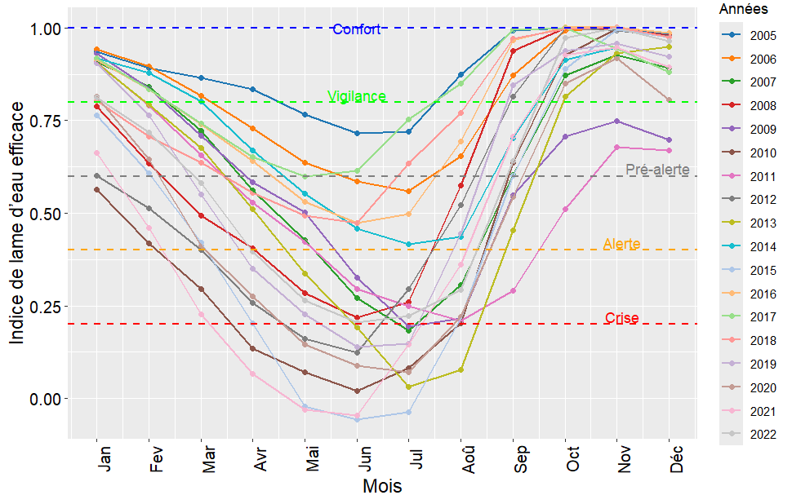

**Fig. 3**: Interannual evolution of the effective Water depth Indices

The years 2007, 2008, 2010, 2011, 2012, 2013, 2015, 2019, 2020, 2021 and 2022 were identified as having reached the 'crisis' threshold, with specific months during which the effective water depth index fell below the critical threshold of 0.22 (Fig. 4).

Of particular pertinence is the period from March to August, which appears to be especially susceptible to crisis conditions. This observation suggests a potential correlation with climatic fluctuations or specific meteorological phenomena, such as the El Niño event.

**Fig. 4**: Interannual Trends in Effective Water Depth Indices During Critical Years

*4.1.3.1. Current climate impacts on hydroelectric energy production*

With reference to the geographical area under consideration, it is the Man and Odienne stations that exert the most significant influence on the water depths that enter the reservoir. It is evident that during the years 2007, 2008, 2010, 2011, 2012, 2013, 2015, 2019, 2020, 2021 and 2022, when the effective water depth index fell below the critical threshold of 0.22 (see Table 5), the rainfall situation was as follows:

* the years 2007, 2011, 2015, 2021, and 2022 show periods of moderate to severe drought.
* the years 2008, 2010, 2012, 2013, 2019, 2020, and 2021 did not show significant drought, even though the water depth fell below the crisis threshold, suggesting that other local factors may influence water conditions.
* specific years when the effective water depth fell below the crisis threshold, combined with high temperatures, can exacerbate the reduction of river flows.

The years 2010, 2015, 2019, 2020, 2021 and 2022 exhibited elevated temperature variations, suggesting the possibility of hydric stress scenarios that could impact hydroelectric production. Consequently, the combined effects of elevated temperatures and diminished precipitation have the capacity to diminish the reservoir's capacity to sustain adequate water levels for the purpose of energy production.

**Table 5** : Drought intensity of the years identified as critical years

|  |  |  |  |  |
| --- | --- | --- | --- | --- |
| **Years** | **Man** | **Drought intensity** | **Odienne** | **Drought intensity** |
| 2007 | **-1.8** | Severe drought | **-1,6** | Severe drought |
| 2008 | -0,5 | Mild drought | 0,1 | No drought |
| 2010 | 0,8 | No drought | 1,5 | No drought |
| 2011 | **-1,1** | Severe drought | -0,6 | Mild drought |
| 2012 | -0,7 | Mild drought | 0,2 | No drought |
| 2013 | 0,2 | No drought | 0,6 | No drought |
| 2015 | -0,2 | Mild drought | -0,1 | Mild drought |
| 2019 | -0,3 | Mild drought | 2 | No drought |
| 2020 | 0,2 | No drought | 1,3 | No drought |
| 2021 | 0,1 | No drought | 1,3 | No drought |
| 2022 | -0,2 | Mild drought | 1 | No drought |

*4.1.3.2. Analysis of the influence of rainfall on streamflows*

The analysis of Fig. 5 and 6 demonstrates that, irrespective of the hydrological year (wet or dry), periods of water flow in the catchment areas tend to coincide with episodes of heavy rainfall or the succession of relatively close rainfall events. Conversely, any absence of rainfall leads to low or even zero flows.

However, even in cases of intense rainfall during the early season, this does not necessarily result in runoff. In the N'ZO basin at Kahin and the Sassandra basin at Piébli, hydrological peaks are observed to occur after those of rainfall. The maximum monthly rainfall is recorded in August at Man and Odienne, while the peak in streamflow is observed in September. This is indicative of the concentration time required for raindrops from the most distant areas (hydrograph peaks) to reach the main outlets.

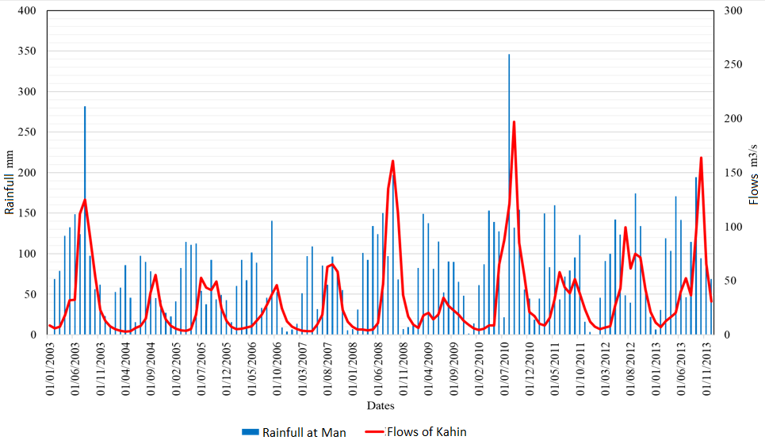

**Fig. 5:** Rainfall and Streamflow Profiles in the N’ZO Watershed at Kahin

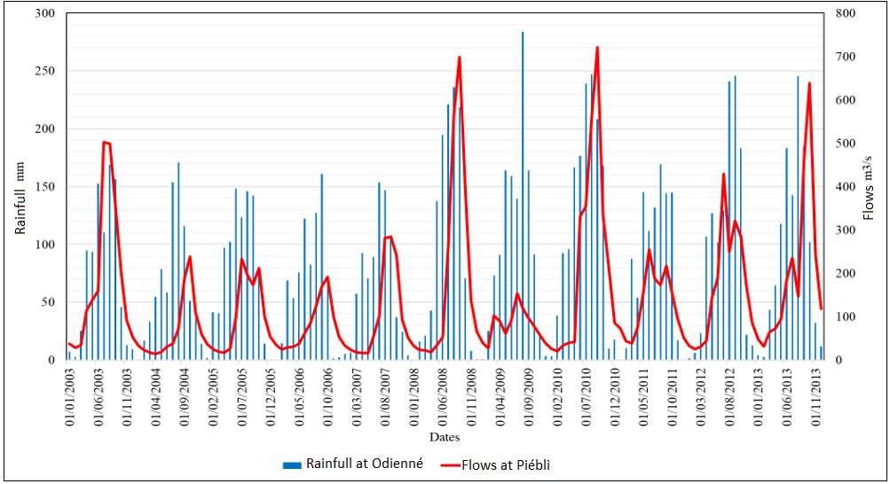

**Fig. 6:** Rainfall and Streamflow Profiles in the N’ZO Watershed at Piebli

*4.1.3.3. Projected Climate Impacts on Hydroelectric Power Production*

* **Precipitations**

Over the period 2023–2060, years with significant drought are characterized by a Standardized Precipitation Index (SPI) below -1.0 (Fig. 7).

* Under the RCP 4.5 scenario, the years 2023 (SPI = -1.9), 2029 (SPI = -1.6), 2033 (SPI = -2.3), and 2041 (SPI = -1.7) could experience severe to extreme droughts.
* Under the RCP 8.5 scenario, the years 2021 (SPI = -1.7), 2028 (SPI = -1.0), 2040 (SPI = -1.0), 2041 (SPI = -1.3), 2058 (SPI = -1.5), and 2059 (SPI = -1.2) could also face severe to extreme droughts.

These years are likely to see a significant reduction in precipitation, leading to a substantial drop in river and reservoir water levels. This would result in a decrease in hydroelectric power potential. Specifically:

* Under RCP 4.5, 2033 (SPI = -2.3) could experience a drastic reduction in precipitation, severely affecting water availability.
* Under RCP 8.5, years like 2021 and 2058, with SPI values of -1.7 and -1.5, indicate periods of significant water stress, which would negatively impact hydroelectric potential due to reduced water inflow.

Precipitation, therefore, is a pivotal factor in determining the availability of water for hydroelectric production. In years projected to experience moderate to extreme droughts, the effective water level is expected to fall below normal, potentially resulting in a reduction in hydroelectric output.

However, other factors must be considered when analysing the relationship between hydroelectric production and water management strategies, including reservoir storage capacity.

It is imperative that, in the context of long-term planning and management of water resources and hydroelectric power production, consideration is given to drought forecasts and their potential impacts.

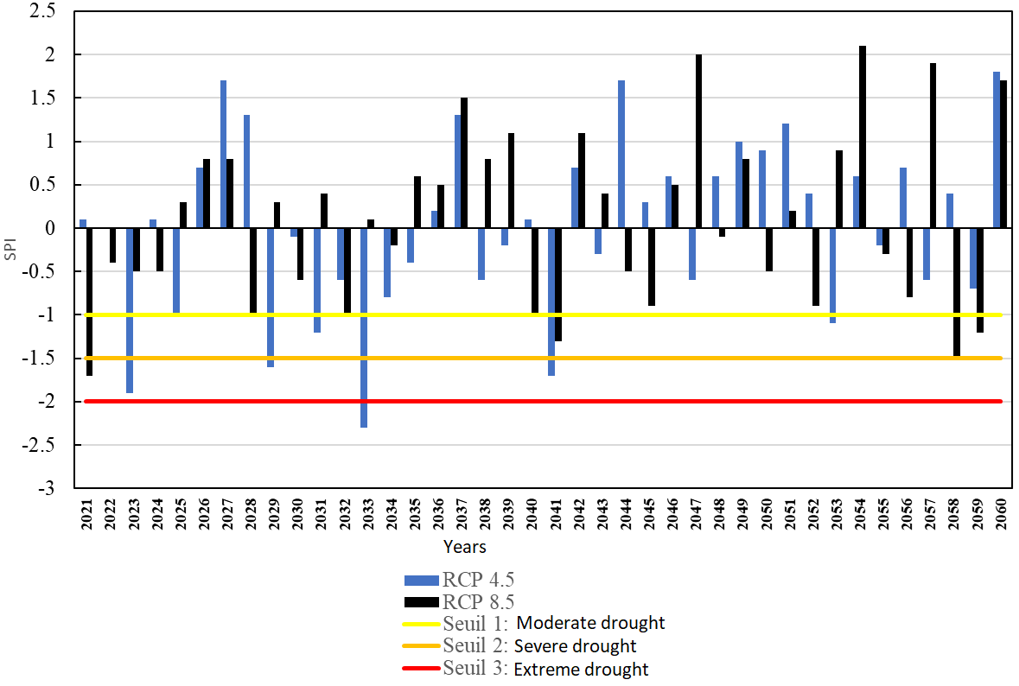

**Fig. 7**: Characteristics of Projected Precipitation Indices (2021–2060)

* **Temperatures**

Fig. 8 presents the projected temperature anomalies under the RCP4.5 and RCP8.5 scenarios from 2021 to 2060. The projections indicate a general upward trend in temperatures for both scenarios. The RCP4.5 scenario anticipates a gradual rise in global temperatures, with an anticipated increase of 0.03°C per year. In contrast, the RCP8.5 scenario projects a more rapid escalation, with a steeper increase of 0.05°C per year. This rise in temperatures is accompanied by significant annual variability. Consequently, the projected increase in global temperatures, particularly under the RCP8.5 scenario, is likely to result in increased reservoir evaporation, more frequent and intense drought periods, and thermal stress on hydropower infrastructure, potentially reducing their efficiency and lifespan. This situation has the potential to reduce the water levels available for energy production, which may in turn compromise the operational capacity of the Buyo hydropower dam.

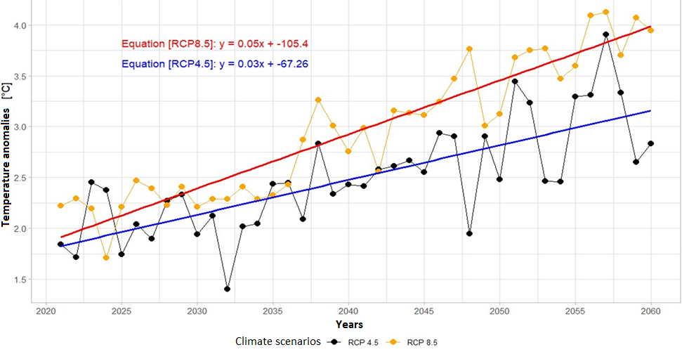

**Figure 8:** Evolution of projected temperature anomalies

**4.2 Discussion**

The analysis of precipitation data from 1981 to 2022 indicates a notable prevalence of the El Niño phenomenon, with its occurrence in more than half of the observed period. This frequency underscores the significance of El Niño in modulating regional climate, thereby corroborating the findings of [19]. A recurrence of moderate to severe rainfall deficits has been observed in Daloa and Odienné, whilst Man experiences rainfall surpluses despite occasional droughts. These regional discrepancies in rainfall underscore the heterogeneity of the El Niño phenomenon, as also observed by [20,21]. It is further noted that the most intense droughts often coincide with El Niño years, particularly between 1983 and 2007, a pattern supported by the results of [22]**.** However, it should be noted that this relationship is not systematic, as some El Niño years exhibit above-average rainfall, thus demonstrating the complexity of interactions with other regional climatic forces. The El Niño phenomenon, which is defined as a warming of the Pacific Ocean's surface temperatures, is characterised by several episodes of severe drought [23]**.** The active El Niño period (2002-2010), with the exception of 2008, is a notable example of this phenomenon.

Furthermore, the thermal analysis of the Sassandra River watershed demonstrates a general warming trend, which is consistent with the findings of several regional studies [24] and [25]**.** Despite the observed increases in temperature of +0.2°C in Daloa, +0.6°C in Odienné, and +0.7°C in Man over the 1981-2022 period, an intensification is evident during 2001-2022. These dynamics are also reported by [26] in Côte d'Ivoire. It is noteworthy that thermal anomalies of up to +1.2°C were recorded in 2010, with El Niño being partially attributed as a contributing factor, as stated in [27]**.**

Increases in temperature above water bodies have been shown to lead to increased evaporation and reduced storage volumes, with the result that seasonal water resource management and hydroelectric production are compromised, as described by [28]. It is emphasised that lower water levels have a detrimental effect on turbine flows. In addition, [29]observe that evaporation is a significant factor in water losses in tropical reservoirs.

Interannual analysis of the effective water layer index in the Sassandra watershed demonstrates marked variability, with several episodes evident. The index has fallen below the crisis threshold, indicating the recurrence of water crises between 2007 and 2022. This observation is consistent with the findings of [30], who reported a seasonal lag between precipitation and reservoir recharge, exacerbated by high evapotranspiration during the dry season. [31] also corroborate the finding that available flows are reduced during these critical periods.

Furthermore, the recurrence of seasonal water crises appears to be associated with extreme weather events, such as El Niño, which have been shown to disrupt West African rainfall patterns [32]. Consequently, it is imperative to enhance the efficacy of hydrological monitoring instruments and assimilate these indices into adaptive methodologies [33].

The rainfall stations at Man and Odienné directly influence the water layers that feed the Buyo reservoir. [34]report that prolonged rainfall deficits in these areas result in significant flow reductions, which in turn have a detrimental effect on hydroelectric production. From 2007 to 2022, there were several years in which effective water layers were recorded to be below the critical threshold, without the occurrence of marked droughts. This was notably the case in 2008, 2010 and 2013. This finding indicates the necessity for further consideration of additional factors, including increased evapotranspiration and changes in land use [27].

In 2007, 2011, 2015, and 2021, moderate to severe droughts coincided with critical water layers, illustrating the overlap between extreme climatic conditions and water crises [35]. Furthermore, the seasonal lag between peak rainfall (August) and peak flow (September) is a key factor in the predictive management of turbine volumes at the Buyo dam, as confirmed by [36].

With regard to climate projections, SPI indices for 2023–2060 under RCP4.5 and RCP8.5 indicate a greater frequency and severity of droughts. Under RCP4.5, the years 2023, 2029, 2033, and 2041 are projected to experience extreme episodes (SPI < -1.5), while RCP8.5 anticipates such episodes in 2021, 2028, 2040, 2058, and 2059. These conditions are likely to significantly reduce reservoir inflows, thereby rendering energy production more uncertain [37].

Concurrently, the progressive rise in temperatures – more pronounced under RCP8.5 (+0.05°C/year versus +0.03°C/year under RCP4.5) – increases evaporation losses and thermal stress on infrastructure. [38] emphasise that this combination compromises the sustainability of hydroelectric production, especially in contexts of high energy dependence.

**5. Conclusion**

This study underscores the mounting repercussions of climate variability on water resources and hydroelectric production within the Buyo watershed. A thorough examination of climatic and hydrological data indicates a general upward trend in temperatures since the 1990s, concomitant with increasingly pronounced periods of water deficit. The findings indicate a recurrence of critical years during which the effective water depth index falls below the crisis threshold, particularly between March and August, coinciding with phases of the El Niño phenomenon.

Thermal monitoring of the basin has revealed an average temperature increase of up to +1.2°C. This may have implications for reservoir evaporation and, consequently, the volume of water available for energy production. Concurrently, precipitation anomalies and intra-annual variability further compromise water availability. Should these trends persist, there is a risk of compromised performance of hydroelectric infrastructure and the country's energy security.

In this context, the integration of observed climate data, projection models, and hydrological monitoring tools emerges as a critical approach for the sustainable management of water resources. The enhancement of local capacities, basin-scale planning, and the anticipation of climate-related hazards, particularly those associated with El Niño, are pivotal mechanisms for bolstering the resilience of hydroelectric systems in the face of climatic disruptions.

**COMPETING INTERESTS**

Authors have declared that no competing interests exist

COMPETING INTERESTS DISCLAIMER:

Authors have declared that they have no known competing financial interests OR non-financial interests OR personal relationships that could have appeared to influence the work reported in this paper.

**6. References**

1. [1] Kouadio A.M., N’Guessan P. & Adou K. (2019). Role of hydropower in the energy development of Côte d’Ivoire. Ivorian Journal of Renewable Energy, 10(2), 45–58.
2. [2] Kouassi K.D., Bamba I. & Yao A.K. (2021). Climate change and sustainable water resources management in Côte d’Ivoire: Implications for hydropower production. African Journal of Environmental Sciences, 12(2), 45–62.
3. [3] Koné S.A., Yao K.M., Dembélé A., Diomandé M. & Soro N.A. (2020). Evolution of precipitation and water availability in the N’Zi basin (Côte d’Ivoire). West African Journal of Environmental Sciences, 15(1), 75–89.
4. [4] Diallo M., Traoré A. & Cissé I. (2019). Climate variability and impacts on water resources in West Africa. Journal of West African Climate Studies, 7(2), 110–125.
5. [5] Touré M.B., Coulibaly Z.M., Koffi C.E., N’Guessan K.J. & Bamba F.T. (2023). Simulation of hydroelectric production in the context of climate change: An artificial intelligence approach applied to Ivorian dams. African Journal of Climate and Energy Studies, 8(3), 121–137.
6. [6] Sangaré A., Fofana D. & Koulibaly Y. (2021). Effects of rising temperatures on evapotranspiration and watershed management in Côte d’Ivoire. Hydrology and Environmental Research, 12(4), 235–249.
7. [7] Girard G., Sircoulon J. & Touchebeuf P. (1971). Overview of hydrological regimes. Natural environment of Côte d’Ivoire, ORSTOM Memoir, 50: 109–155.
8. [8] Perraud A. (1971). Soils. The natural environment of Côte d’Ivoire. ORSTOM Memoir, 50: 157–263.
9. [9] Camus H. (1969). Hydrology of the Sassandra Basin (preliminary note). (5: 69): 79.
10. [10] Ardoin-Bardin S., Dezetter A., ​​Servat E. & Mahé G. (2005). Assessment of the impacts of climate change. In: Regional hydrological impacts of climatic change: proceedings of the International Symposium on Regional Hydrological Impacts of Climatic Variability and Change with an Emphasis on Less Developed Countries (S6): held during the Seventh Scientific Assembly of the International Association of Hydrological Sciences (IAHS) at Foz do Iguaço [sic], Brazil, 3-9 April, 2005, IAHS, p. 194.
11. [11] Konan B. (2002). Modeling and integrated management of water resources in the Sassandra watershed (Ivory Coast). Doctoral thesis, University of Abobo-Adjamé, Ivory Coast, 145p.
12. [12] McKee T.B., Doesken N.J. & Kleist J. (1993). The relationship of drought frequency and duration to time scales. In: Proceedings of the 8th Conference on Applied Climatology, Boston, pp. 179–183.
13. [13] Hayes S.C., Wilson K.G., Gifford E.V., Follette V.M. & Strosahl K. (1996). Experiential avoidance and behavioral disorders: A functional dimensional approach to diagnosis and treatment. Journal of consulting and clinical psychology, 64(6): 1152.
14. [14] Jouilil I., Bitar K., Salama H., Amraoui A., Mokssit A. & Tahiri M. (2013). Meteorological Drought in the OUM ER RBIA Hydraulic Basin Over Recent Decades. LARHYSS Journal, P-ISSN 1112-3680 / E-ISSN 2521-9782, Issue 12, p. 12.
15. [15] Bergaoui M. & Alouini A.W.S. (2002). Characterization of meteorological and hydrological drought: the case of the Siliana watershed in Tunisia. Science and Planetary Change/Drought, 12(4): 205–13.
16. [16] Ali A. & Lebel T. (2009). The Sahelian standardized rainfall index revisited. International Journal of Climatology: A Journal of the Royal Meteorological Society, 29(12): 1705–1714.
17. [17] Kouakou B.C., Douhou S., & Kouamé F.K. (2022). Climate scenarios and water vulnerability in the Sassandra watershed: an integrated approach. Ivorian Journal of Water and Environment, 7(1), 55–70.
18. [18] Yao B., Kouadio K.Y., & Koffi Y.M. (2017). Correlation between meteorological drought and water fluxes in the Sassandra basin. Ivorian Journal of Water Sciences, 2(1), 95–110.
19. [19] Trenberth K.E. (1997). The definition of El Niño. Bulletin of the American Meteorological Society, 78(12), 2771–2777.
20. [20] Ropelewski C.F. & Halpert M.S. (1987). Global and regional scale precipitation patterns associated with the El Niño/Southern Oscillation. Monthly Weather Review, 115(8), 1606–1626.
21. [21] Nicholson S.E. & Kim J. (1997). The relationship of the El Niño–Southern Oscillation to African rainfall. International Journal of Climatology, 17(2), 117–135.
22. [22] McPhaden M.J., Zebiak S.E. & Glantz M.H. (2006). ENSO as an integrating concept in earth science. Science, 314(5806), 1740–1745.
23. [23] NOAA. (2023). Historical El Niño/La Niña episodes (1950-present). National Oceanic and Atmospheric Administration. https://www.noaa.gov
24. [24] Kouassi A.M., Soro G.E., & Yao, K.M. (2010). Temperature Changes in Côte d'Ivoire from 1950 to 2000. Climatology, 7, 25–40.
25. [25] Koné M., Soro G.E. & Yao K.M. (2018). Analysis of Climate Variability and Peasant Perception in Western Côte d'Ivoire. European Scientific Journal, 14(2), 207–224.
26. [26] Soro G.E., Kouamé K.F. & Kouadio E.K. (2021). Global Warming and Temperature Variability in Côte d'Ivoire: A Statistical Approach and Implications. West African Geographic Review, 9(2), 43–60.
27. [27] Konan A.K., Kouassi A.M. & Koffi K.J. (2021). Changes in Land Use and Impacts on Water Resources in Haut-Sassandra (Côte d'Ivoire). Environmental Change Observatory Notebooks, 9(1), 59–74.
28. [28] Traoré M., Kouassi A.M. & Yao K.M. (2017). Impact of climate change on the management of hydroelectric dams in West Africa: the case of the Buyo Dam in Côte d’Ivoire. European Scientific Journal, 13(15), 221–234.
29. [29] Touré S., Bamba I., & Koné M. (2012). Hydrological balance and modeling of evaporation losses in water reservoirs in humid tropical zones. Afrique Science, 8(1), 123–135.
30. [30] Yao K.M., Kouassi A.M. & Koné B. (2015). Relationships between precipitation, runoff and filling dynamics of the Buyo Dam (Côte d’Ivoire). Journal of Scientific Research of the University of Lomé, 17(2), 233–248.

[31] Soro G.E., Yao K.M. & Kouassi A.M. (2019). Analysis of interannual variability of flows in the watersheds of Côte d’Ivoire. Journal of Water Sciences, 32(1), 67–82.

[32] Kouassi A.M., Kouakou A.K. & Koffi Y.B. (2012). Effects of El Niño on rainfall and droughts in Côte d’Ivoire. Ivorian Journal of Science and Technology, 19, 45–61.

[33] Touré B., Fofana N. & Kouadio L. (2020). Management of water reservoirs and climate change in tropical areas: the case of the Buyo dam. Ivorian Journal of Science and Technology, 35, 99–115.

[34] Kouassi A.M., Soro G.E. & Konan K.C. (2019). Rainfall trends in watersheds in Côte d’Ivoire and implications for water resources. Africa Science, 15(3), 1–18.

[35] Yao K.M., Traoré M. & Kouadio L. (2018). Water crises and droughts in West Africa: trends and implications for dams. Ivorian Journal of Environmental Sciences, 6(2), 71–88.

[36] Touré A.M., Koffi Y.M., & Kouadio K.Y. (2021). Dam management during drought: the case of the Buyo dam. Journal of the Houphouët-Boigny National Polytechnic Institute, 11(1), 109–121.

[37] Bamba I., Kouassi A.M., Kouamé K.F. & Fofana N. (2017). Effects of climate change on water resources in the Sassandra basin (Côte d’Ivoire). Tropical Geography Review, 12(1), 87–101.

[38] Zohouri B., Kouadio E.K. & Koné M. (2022). Climate change and energy sustainability: the case of the Buyo hydroelectric power plant in Côte d’Ivoire. Sustainable Development Papers, 18(1), 52–69.