Landslide Susceptibility Mapping Using Weighted Overlay Analysis

.
ABSTRACT
The Bhilangana Basin, located in the Upper Himalayas of Uttarakhand, India, is a geologically sensitive and topographically intricate area subject to frequent landslides. The goal of this research is to map landslide susceptibility zones in the basin employing the Analytical Hierarchy Process (AHP) coupled with the Weighted Overlay technique in a GIS platform. Ten causative factors—Slope, Digital Elevation Model (DEM), Rainfall, Curvature, Land Use/Land Cover (LULC), Normalized Difference Vegetation Index (NDVI), Aspect, Relative Relief, Distance from Roads, and Distance from Rivers—were chosen on the basis of geomorphological, climatic, and anthropogenic importance. Thematic maps were derived from satellite data, field data, and secondary sources, and categorized into susceptibility classes and risk values. AHP-based weights ranked slope (20%), distance from roads (18%), rainfall (14%), and distance from rivers (13%) as the most critical factors. The combined susceptibility map classified the basin into Low (40.6%), Moderate (46.0%), and High (11.97%) risk zones. High-risk zones, although in a narrow degree of coverage, are nearly all concentrated within mid-elevation zones with high slopes, barren land, concave topography, and proximity to road and river networks. These areas present significant risks to infrastructure, transportation, and habitation, which require site-specific mitigation measures like slope stabilization, enhanced drainage, and vegetation rehabilitation. The strategy proves the utility of multi-criteria decision analysis for regional landslide hazard assessment and can inform disaster readiness and land-use planning in other mountainous areas. Patients. These predictors, however, need further work to validate reliability.

Keywords: GIS, Landslide susceptibility mapping, weighted overlay,LULC,NDVI

- INTRODUCTION
Landslides are a major natural hazard, especially prevalent in mountainous areas. They involve the movement of soil, rock, and debris down a slope under the influence of gravity. While natural processes can trigger landslides, human activities such as deforestation, poorly planned construction, slope modification, and inappropriate land use significantly contribute to their frequency and intensity. Globally, landslides result in substantial loss of life, property, and environmental degradation, particularly in geologically fragile and densely populated regions.
Uttarakhand, located in the seismically active Himalayan region of northern India, is highly vulnerable to landslides. Its steep slopes, young and unstable geological structures, intense monsoonal rainfall, and frequent earthquakes make the state a hotspot for landslide occurrences. Districts such as Rudraprayag, Chamoli, Pithoragarh, Bageshwar, Tehri Garhwal, and Uttarkashi have experienced numerous damaging events, including the devastating 2013 Kedarnath flood and the 2021 Chamoli landslide.
Human induced pressures such as rapid urbanization, large hydropower projects, expanding road networks, and unregulated tourism have further destabilized natural slopes. Climate change has added to this risk by altering rainfall patterns and accelerating glacial melt, leading to increased slope failures, especially in high-altitude regions.
To address these challenges, landslide risk analysis is crucial. It involves identifying hazard-prone zones, assessing exposure, and evaluating vulnerability. Tools like remote sensing, GIS, and Multi-Criteria Decision-Making (MCDM) models such as AHP is used to develop landslide susceptibility and risk maps. These maps assist in planning, infrastructure development, and disaster preparedness.
In conclusion, a comprehensive approach combining geospatial analysis, scientific assessment, early warning systems, and community awareness is vital to mitigate landslide risks and enhance resilience in the ecologically sensitive region of Uttarakhand.
2. methodology
2.1 study area
The Bhilangana Basin lies in the Upper Himalayan region, specifically within the Uttarkashi district of Uttarakhand, India. Covering an area of around 1400 square kilometers, the basin features elevation levels that range between 4,000 and 5,800 meters. Geographically, it is positioned between latitudes 31°1’39.31”N and 30°42’8.30”N, and longitudes 78°43’29.61”E to 79°50’45.55”E. The variation in elevation across the basin has been assessed using Shuttle Radar Topography Mission (SRTM) Digital Elevation Model (DEM) data at a spatial resolution of 30 meters, as depicted in Fig. 1.
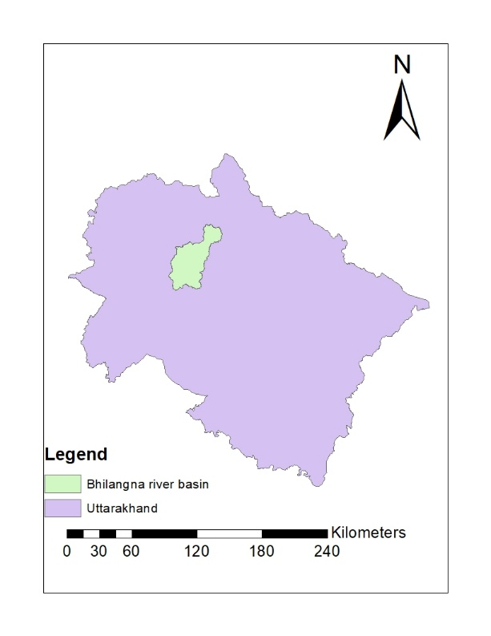
Fig. 1. Study Area, Bhilangna River Basin

This chapter presents the results of the landslide susceptibility mapping using the Analytical Hierarchy Process (AHP) and Weighted Overlay method in GIS environment. The primary objective is to delineate areas prone to landslides based on multiple thematic layers. The parameters considered in this analysis include Slope, Digital Elevation Model (DEM), Rainfall, Curvature, Land Use Land Cover (LULC), Normalized Difference Vegetation Index (NDVI), Distance from Roads, Distance from Rivers, Aspect, and Relative Relief.
2.2 Generation and Classification of Thematic Layers
The Bhilangana River Basin, located in the Upper Himalayas of Uttarkashi district, Uttarakhand, is a geologically fragile and topographically complex region. Understanding landslide causative factors in this basin is critical for accurate risk assessment and mitigation planning. The following parameters were selected based on their geomorphological, climatic, and anthropogenic relevance to landslide occurrences in the region:
• Elevation In the Bhilangana Basin, elevation ranges from approximately 4,000 to 5,800 meters. Elevation influences rainfall intensity, temperature variation, and weathering processes. Higher elevations in the basin are more prone to frost action, glacial melt, and precipitation-induced slope failures, especially in snow-bound and glaciated zones.
• Slope Slope is a key determinant of gravitational force acting on slope materials. In the Bhilangana Basin, steep slopes dominate much of the terrain, particularly in high-relief zones, making them highly vulnerable to mass wasting. Slopes exceeding 30° show a higher landslide frequency, especially during monsoon periods.
• Aspect Aspect determines the direction of slope exposure, which affects solar radiation, snowmelt rates, and moisture retention. In the Bhilangana Basin, landslides are predominantly observed on southeast-facing slopes due to higher sun exposure and accelerated thawing, which weakens slope integrity.
• Curvature Curvature reflects the shape of the land surface and its impact on water flow and accumulation. Concave slopes within the Bhilangana Basin tend to collect water and debris, increasing pore pressure and triggering slope failures, while convex slopes often experience surface erosion.
• Rainfall The basin receives moderate to high monsoonal rainfall, ranging from 550 mm to 1200 mm. Intense precipitation increases infiltration and saturation in loose soil and weathered rock layers, especially on deforested slopes, leading to frequent landslide activity in the middle and lower reaches.
• Normalized Difference Vegetation Index (NDVI) Vegetation helps stabilize slopes by reducing surface runoff and reinforcing soil with root systems. In the Bhilangana Basin, areas with dead or sparse vegetation—often due to deforestation or high-altitude cold conditions—show a higher incidence of landslides.
• Land Use and Land Cover (LULC) LULC in the Bhilangana Basin includes forests, agricultural land, barren areas, built-up zones, and snow cover. Landslides are primarily concentrated in forested and barren areas where human activity (e.g., slope cutting, logging) and natural exposure reduce slope stability. Some events also occur near settlements and roads.
• Relative Relief The basin exhibits a high variation in relative relief, reflecting rugged terrain and steep elevation gradients. Lower relative relief zones, typically in middle elevations, have a higher landslide density due to more human interference and weathering processes compared to higher altitudes with limited accessibility.
• Distance from Roads In the Bhilangana Basin, roads are often carved into steep hillsides without proper engineering control. Slope cutting, poor drainage, and lack of vegetation near road corridors lead to increased landslide occurrences, especially during or after rainfall.
• Distance from Streams Proximity to streams significantly impacts slope stability due to toe erosion, increased saturation, and undercutting. The Bhilangana River and its tributaries erode the base of adjacent slopes, particularly during high-flow periods, making nearby areas more susceptible to landslides.

3. results and discussion
The landslide susceptibility analysis of the Bhilangana River Basin was carried out using Weighted Overlay in a GIS environment, incorporating ten causative factors: Elevation, Slope, Aspect, Curvature, Rainfall, NDVI, Land Use/Land Cover (LULC), Relative Relief, Distance from Roads, and Distance from Streams. Each parameter was classified into sub-categories and assigned risk values based on their contribution to slope instability, derived from both field knowledge and literature review.
3.1 Elevation and Slope
The basin’s elevation varies from 4,000 m to over 5,800 m. Landslide-prone areas were mostly concentrated between 2,700–4,600 m elevation, correlating with the high- and very-high-risk classes. These zones are transitional in nature—often combining steep gradients with active human and glacial interaction. Similarly, the slope factor showed that areas with slopes greater than 30° (classified as high to very high) were particularly susceptible to landslides. These zones experience gravitational stress and material detachment, especially during heavy rainfall and snowmelt.
3.2 Aspect and Curvature
The aspect analysis revealed a higher concentration of landslides on southeast-facing slopes, which receive more solar radiation, accelerating snowmelt and soil dryness during summer, followed by saturation during monsoon. Curvature analysis showed that concave slopes had the highest susceptibility due to water accumulation and increased pore pressure, triggering failure in loose material.
3.3 Rainfall and NDVI
Rainfall distribution across the basin ranged from 550 mm to 1200 mm. High rainfall zones (above 1000 mm) exhibited a direct correlation with increased landslide occurrences. The NDVI analysis supported this observation, indicating that areas with poor or dead vegetation cover (NDVI values closer to bare land or degraded vegetation) corresponded with a higher landslide frequency. Vegetation loss in these areas reduces root cohesion and increases runoff, intensifying slope instability.
3.4 Land use and Land cover
LULC analysis revealed that most landslides occurred in forested and barren land categories. Forests in the mid-altitude zones, though offering some root reinforcement, are often degraded due to anthropogenic activities. Barren lands showed the highest risk due to lack of vegetation and exposure to erosive forces. Although settlements were not the direct location of landslides, proximity to built-up areas, especially roads, often showed slope failures.
3.5 Relative Relief and Proximity Factors
The analysis of relative relief showed that areas with moderate elevation variation (99–180 m) were most susceptible to landslides, as they typically feature moderate to steep slopes with greater accessibility and human activity. Areas of very low relief (0–98 m), especially in valley bottoms, also showed significant landslide activity due to sediment accumulation and toe erosion. Proximity to roads emerged as a critical factor. Landslides were frequently observed within 100–300 m of road corridors, highlighting the destabilizing effects of unplanned slope cutting, poor drainage, and vehicular vibrations. Similarly, areas within 100–200 m of streams exhibited high susceptibility due to toe erosion, undercutting, and slope saturation, especially during monsoons and glacial melt periods.
Table 1. Classification and score of landslide parameters

Parameter | Class Range / Type | Classification | Assigned Risk Value
Elevation (m) | 700–1800 | Very Low | 1
 | 1900–2600 | Low | 2
 | 2700–3500 | Moderate | 5
 | 3600–4600 | High | 7
 | 4700–6600 | Very High | 9
Slope (°) | 0–10 | Very Low | 1
 | 10–20 | Low | 2
 | 20–30 | Moderate | 3
 | 30–40 | High | 4
 | >40 | Very High | 5
Aspect | Flat | Flat | 1
 | North | North | 2
 | Northeast | Northeast | 7
 | East | East | 4
 | Southeast | Southeast | 9
 | South | South | 5
 | Southwest | Southwest | 4
 | West | West | 3
 | Northwest | Northwest | 2
Curvature | Flat | Flat | 1
 | Concave | Concave | 7
 | Convex | Convex | 5
Rainfall (mm) | 550–730 | Very Low | 1
 | 740–880 | Low | 3
 | 890–1000 | Moderate | 5
 | 1001–1100 | High | 8
 | 1101–1200 | Very High | 9
NDVI | Dead Plant | Dead vegetation | 9
 | Unhealthy vegetation | Unhealthy vegetation | 7
 | Moderate vegetation | Moderate vegetation | 4
 | Very healthy vegetation | Very healthy vegetation | 1
LULC | Water | Water | 1
 | Tree | Forest | 2
 | Crops | Agricultural | 3
 | Built-up area | Built-up | 8
 | Bare garland | Barren land | 9
 | Snow | Snow | 1
 | Rangeland | Rangeland | 3
Relative Relief | 0–98 | High | 9
 | 99–180 | Moderate | 5
 | 190–250 | Low | 2
Distance from Road (m) | 100 | Very High (near road) | 1
 | 200 | Low | 9
 | 300 | Moderate | 7
 | 400 | Low | 6
 | 500 | Very Low | 4
 | >500 | Normal | 2
Distance from Stream (m) | 100 | Very High | 9
 | 200 | Low | 6
 | 300 | Moderate | 5
 | 400 | Low | 3
 | 500 | Very Low | 2
 | >500 | Normal | 1
3.6 AHP Weight Calculation
TABLE 2. A pairwise comparison matrix was created for AHP, and consistency was checked (CR < 0.1).
Criteria | Weight (%)
DEM | 8
Slope | 20
Curvature | 10
Rainfall | 14
Aspect | 5
Distance from Rivers | 13
Distance from Roads | 18
LULC | 8
NDVI | 4
Relative Relief | 3
3.7 Landslide Susceptibility Zonation Map
3.7.1 Overall Susceptibility Mapping
The integrated landslide susceptibility map categorized the basin into three susceptibility zones: Low, Moderate, and High risk zones were primarily located in the mid-elevation zones of the basin, often near road networks, concave slopes, barren land, and steep gradients. These zones demand immediate attention for mitigation planning, especially in areas where infrastructure and settlements are expanding.
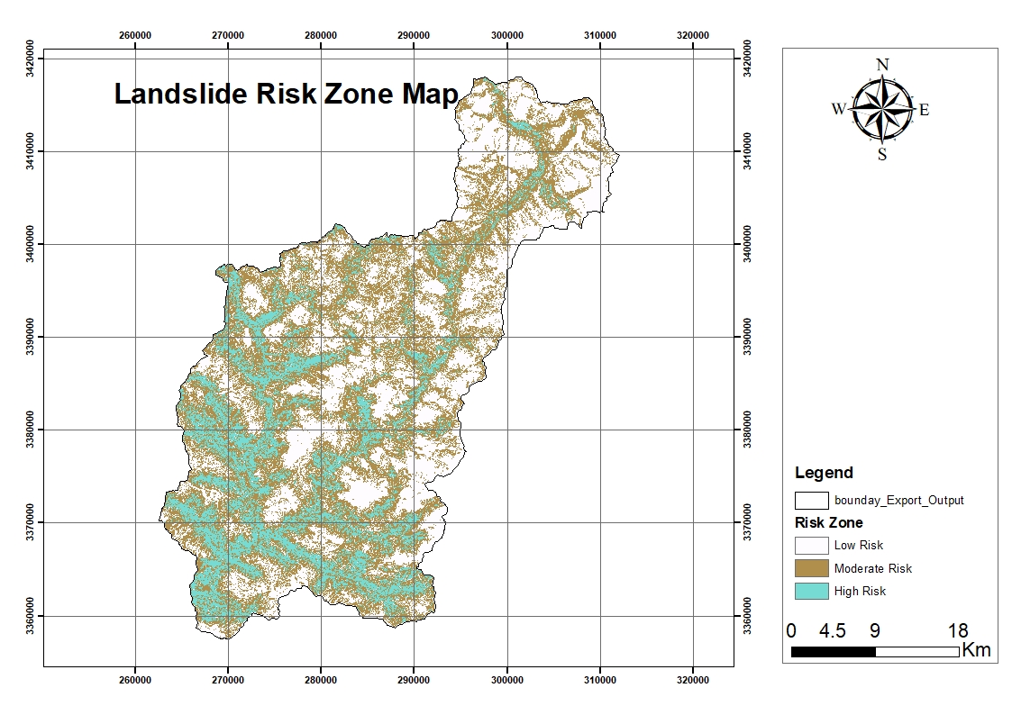
Fig. 2. Landslide Risk Zone Map
Table 3. Area Distribution of Susceptibility Classes
Susceptibility Zone | Area (sq.km) | Percentage (%)
Low | 569 | 40.6
Moderate | 645 | 46.0
High | 168 | 11.97
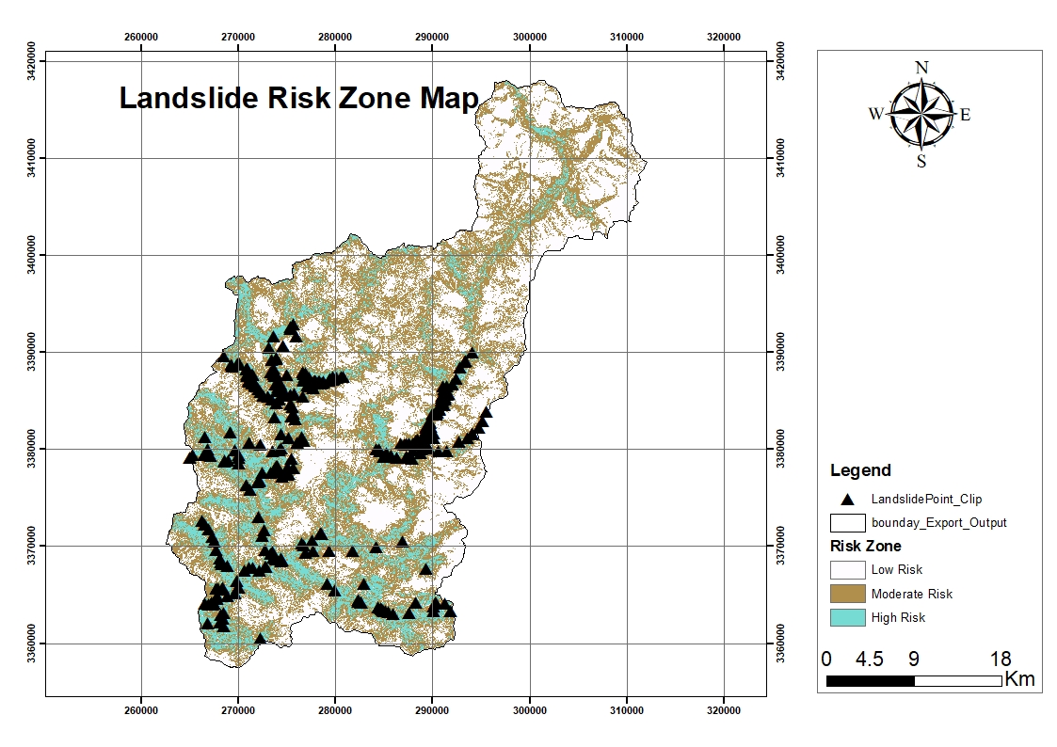
Fig.3.Validation point distribution Map
4. Conclusion

The susceptibility zonation classified the basin into five categories: Low, Moderate and High. While the majority of the basin fell under moderate risk (46%) and low risk (40.6%),and high (11.97%) zones though spatially smaller pose significant threats to infrastructure, transportation networks, and nearby settlements. These areas require priority attention for slope stabilization, drainage improvement, and vegetation restoration.

COMPETING INTERESTS DISCLAIMER:
Authors have declared that they have no known competing financial interests OR non-financial interests OR personal relationships that could have appeared to influence the work reported in this paper.

References
Akbar, T.A. and Ha, S.R. (2011). Landslide hazard zoning along Himalayan Kaghan Valley of Pakistan by integration of GPS, GIS, and remote sensing technology. Landslides, 8(4): 527-540.
Akgun, A. and Türk, N. (2010). Landslide susceptibility mapping for Ayvalik (Western Turkey) and its vicinity by multicriteria decision analysis. Environ. Earth Sci., 61(3): 595-611.
Avtar, R., Singh, C.K., Singh, G., Verma, R.L., Mukherjee, S. and Sawada, H. (2011). Landslide susceptibility zonation study using remote sensing and GIS technology in the Ken-Betwa River Link area, India. Bull. Eng. Geol. Environ., 70(4): 595-606.
Basharat, M., Shah, H. R., and Hameed, N. (2016). Landslide susceptibility mapping using GIS and weighted overlay method: a case study from NW Himalayas, Pakistan. Arabian Journal of Geosciences, 9(4). https://doi.org/10.1007/s12517-016-2308-
Batar, A. K., and Watanabe, T. (2021). Landslide Susceptibility Mapping and Assessment Using Geospatial Platforms and Weights of Evidence (WoE) Method in the Indian Himalayan Region: Recent Developments, Gaps, and Future Directions. ISPRS International Journal of Geo-Information, 10(3), 114. https://doi.org/10.3390/ijgi10030114
Chang, K.-T., Merghadi, A., Yunus, A. P., Pham, B. T., and Dou, J. (2019). Evaluating scale effects of topographic variables in landslide susceptibility models using GIS-based machine learning techniques. Scientific Reports, 9(1). https://doi.org/10.1038/s41598-019-48773-2
Chauhan, S., Sharma, M., Arora, M.K. and Gupta, N.K. (2010). Landslide susceptibility zonation through ratings derived from artificial neural network. Int. J. Appl. Earth Obs. Geoinf., 12(5): 340-350.
Chauhan, V., Gupta, L., and Dixit, J. (2025). Landslide susceptibility assessment for Uttarakhand, a Himalayan state of India, using multi-criteria decision making, bivariate, and machine learning models. Geoenvironmental Disasters, 12(1). https://doi.org/10.1186/s40677-024-00307-3
Daneshvar, M.R. and Bagherzadeh, A. (2011). Landslide hazard zonation assessment using GIS analysis at Golmakan Watershed, Iran. Front. Earth Sci., 5(1): 70-81.
Devara, M., Tiwari, A. and Dwivedi, R. (2021). Landslide susceptibility mapping using MT-InSAR and AHP enabled GIS-based multi-criteria decision analysis. Geomat. Nat. Hazards Risk, 12(1): 675-693.
Dikshit, A., Sarkar, R., Pradhan, B., Segoni, S., and Alamri, A. (2020). Rainfall Induced Landslide Studies in Indian Himalayan Region: A Critical Review [Review of Rainfall Induced Landslide Studies in Indian Himalayan Region: A Critical Review]. Applied Sciences, 10(7), 2466. Multidisciplinary Digital Publishing Institute. https://doi.org/10.3390/app10072466
Du, J., Glade, T., Woldai, T., Chai, B., and Zeng, B. (2020). Landslide susceptibility assessment based on an incomplete landslide inventory in the Jilong Valley, Tibet, Chinese Himalayas. Engineering Geology, 270, 105572. https://doi.org/ 10.1016 j.enggeo.2020.105572
Ghimire, M., and Timalsina, N. (2020). Landslide Distribution and Processes in the Hills of Central Nepal: Geomorphic and Statistical Approach to Susceptibility Assessment. Journal of Geoscience and Environment Protection, 8(12), 276. https://doi.org/ 10.4236/gep.2020.812017
Hussain, S., Sun, H., Ali, M. Z., and Ali, M. Z. (2021). PS-InSAR based validated landslide susceptibility modelling: a case study of Ghizer valley, Northern Pakistan. Geocarto International, 37(13), 3941. https://doi.org/ 10.1080/ 10106049.2020.1870165
Kamp, U., Growley, B.J., Khattak, G.A. and Owen, L.A., (2008). GIS-based landslide susceptibility mapping for the 2005 Kashmir earthquake region. Geomorphology, 101(4): 631-642.
Kayastha, P., Dhital, M.R. and De Smedt, F. 2013. Application of the analytical hierarchy process (AHP) for landslide susceptibility mapping: A case study from the Tinau watershed, west Nepal. Comput. Geosci., 52: 398-408.
Khaidem, S., and Singh, K. (2021). Landslide Susceptibility Mapping along Manipur-Assam NH-37. IOP Conference Series Earth and Environmental Science, 889(1), 12002. https://doi.org/10.1088/1755-1315/889/1/012002
Mandal, K., Saha, S., and Mandal, S. (2021). Applying deep learning and benchmark machine learning algorithms for landslide susceptibility modelling in Rorachu river basin of Sikkim Himalaya, India. Geoscience Frontiers, 12(5), 101203. https://doi.org/10.1016/j.gsf.2021.101203
Melsse, D. W., Tegegne, M. A., Mekonnen, Y. A., and Bihon, Y. T. (2025). Morphometric analysis for understanding river basin hydrology: a case of gelda watershed, Tana Sub-Basin, Ethiopia. Applied Water Science, 15(7), 171. https://doi.org/10.1007/s13201-025-02526-x
Mondal, S. and Maiti, R. (2012). Landslide susceptibility analysis of Shiv-Khola watershed, Darjiling: a remote sensing and GIS based Analytical Hierarchy Process (AHP). J. Indian Soc. Remote Sens., 40(3): 483-496.
Napoli, M. D., Martire, D. D., Bausilio, G., Calcaterra, D., Confuorto, P., Firpo, M., Pepe, G., and Cevasco, A. (2021). Rainfall-Induced Shallow Landslide Detachment, Transit and Runout Susceptibility Mapping by Integrating Machine Learning Techniques and GIS-Based Approaches. Water, 13(4), 488. https://doi.org/10.3390/w13040488
Noorollahi, Y. (2018). Landslide modelling and susceptibility mapping using AHP and fuzzy approaches. International Journal of Hydrology, 2(2). https://doi.org/ 10. 15406/ijh.2018.02.00063
Othman, A.N., Naim, W.M. and Noraini, S. (2012). GIS based multi-criteria decision making for landslide hazard zonation. Procedia Soc. Behav. Sci., 35: 595-602.
Panchal, S., and Shrivastava, A. K. (2020). Application of analytic hierarchy process in landslide susceptibility mapping at regional scale in GIS environment. Journal of Statistics and Management Systems, 23(2), 199. https://doi.org/ 10.1080/ 09720510.2020.1724620

Pandey, A., Dabral, P.P., Chowdary, V.M. and Yadav, N.K. (2008). Landslide hazard zonation using remote sensing and GIS: a case study of Dikrong river basin, Arunachal Pradesh, India. Environ. Geol., 54(7): 1517-1529.
Pathak, L., Baral, B., Joshi, K., Basnet, D. R., and Godone, D. (2025). Landslides in the Himalayas: The Role of Conditioning Factors and Their Resolution in Susceptibility Mapping. Geosciences, 15(4), 131. https://doi.org/10.3390 /geosciences15040131
Pirasteh, S., and Li, J. (2017). Probabilistic frequency ratio (PFR) model for quality improvement of landslide susceptibility mapping from LiDAR-derived DEMs. Geoenvironmental Disasters, 4(1). https://doi.org/10.1186/s40677-017-0083-z
Pradhan, B. (2010). Use of GIS-based fuzzy logic relations and its cross application to produce landslide susceptibility maps in three test areas in Malaysia. Environmental Earth Sciences, 63(2), 329. https://doi.org/10.1007/s12665-010-0705-1
Qi, T., Zhao, Y., Meng, X., Chen, G., and Dijkstra, T. (2021). AI-Based Susceptibility Analysis of Shallow Landslides Induced by Heavy Rainfall in Tianshui, China. Remote Sensing, 13(9), 1819. https://doi.org/10.3390/rs13091819
Rasheed, Y., Agalgaonkar, A. P., and Muttaqi, K. M. (2025). Enhancing Resiliency in Distribution Power Grids with Distributed Generation Through Application of Visualisation Techniques. Energies, 18(7), 1847. https://doi.org/ 10.3390/ en18071847
Roccati, A., Paliaga, G., Luino, F., Faccini, F., and Turconi, L. (2021). GIS-Based Landslide Susceptibility Mapping for Land Use Planning and Risk Assessment. Land, 10(2), 162. https://doi.org/10.3390/land10020162
Saha, A.K., Gupta, R.P., Sarkar, I., Arora, M.K. and Csaplovics, E. (2005). An approach for GIS-based statistical landslide susceptibility zonation—with a case study in the Himalayas. Landslides, 2(1): 61-69.
Selamat, S. N., Majid, N. A., and Taha, M. R. (2025). Multicollinearity and spatial correlation analysis of landslide conditioning factors in Langat River Basin, Selangor. Natural Hazards, 121(3), 2665-2684.
Shano, L., Raghuvanshi, T. K., and Meten, M. (2020). Landslide susceptibility evaluation and hazard zonation techniques – a review [Review of Landslide susceptibility evaluation and hazard zonation techniques – a review]. Geoenvironmental Disasters, 7(1). Springer Nature. https://doi.org/10.1186/ s40677-020-00152-0
Sharma, M. and Kumar, R. (2008). GIS-based landslide hazard zonation: a case study from the Parwanoo area, Lesser and Outer Himalaya, HP, India. Bull. Eng. Geol. Environ., 67(1): 129-137.
Sinčić, M., Gazibara, S. B., Krkač, M., and Arbanas, S. M. (2022). Landslide susceptibility assessment of the city of karlovac using the bivariate statistical analysis. Rudarsko-Geološko-Naftni Zbornik, 37(2), 149. https://doi.org/ 10.17794/ rgn.2022.2.13
Sujatha, E. R., and Sridhar, V. (2021). Landslide Susceptibility Analysis: A Logistic Regression Model Case Study in Coonoor, India. Hydrology, 8(1), 41. https://doi.org/10.3390/hydrology8010041
Sur, U., Singh, P., and Meena, S. R. (2020). Landslide susceptibility assessment in a lesser Himalayan road corridor (India) applying fuzzy AHP technique and earth-observation data. Geomatics Natural Hazards and Risk, 11(1), 2176. https://doi.org/10.1080/19475705.2020.1836038
Sur, U., Singh, P., Meena, S. R., and Singh, T. N. (2022). Predicting Landslides Susceptible Zones in the Lesser Himalayas by Ensemble of Per Pixel and Object-Based Models. Remote Sensing, 14(8), 1953. https://doi.org/ 10.3390/ rs14081953

Veerappan, R., Negi, A. and Siddan, A. (2017). Landslide susceptibility mapping and comparison using frequency ratio and analytical hierarchy process in part of NH-58, Uttarakhand, India. ‘In: Workshop on World Landslide Forum’ at Slovenia, during. May. pp. 1081-1091.
Xie, W., Li, X., Jian, W., Yang, Y., Liu, H., Robledo, L. F., & Nie, W. (2021). A Novel Hybrid Method for Landslide Susceptibility Mapping-Based GeoDetector and Machine Learning Cluster: A Case of Xiaojin County, China. ISPRS International Journal of Geo-Information, 10(2), 93.
Zou, Q., Jiang, H., Cui, P., Zhou, B., Jiang, Y., Qin, M., Liu, Y., & Li, C. (2021). A new approach to assess landslide susceptibility based on slope failure mechanisms. CATENA, 204, 105388. https://doi.org/10.1016/j.catena.2021.10538

