Comparative Analysis of Morphological Traits of Dalbergia sissoo in Forested and Non-Forested Areas of Bilaspur, Chhattisgarh

ABSTRACT:
This study investigates the morphological characteristics of Dalbergia sissoo populations in Bilaspur, Chhattisgarh, highlighting variations across forested and non-forested areas. Key parameters such as tree height, stem diameter (DBH), crown diameter, leaf, seed, pod, and bark morphology were analyzed to assess the species’ phenotypic diversity and adaptability. The average tree height ranged between 15 to 22 meters, with forested trees exhibiting greater height and stem diameter (mean DBH ~100.2 cm) compared to those in non-forested areas (mean DBH ~95 cm). Crown diameters varied from 8 to 12 meters, indicating competitive canopy spread. Leaf morphology consistently showed odd pinnately compound leaves with dark green coloration, demonstrating no significant color variation across regions. Seed and pod analyses revealed oval-shaped seeds and elongated pods, with pod length averaging 5 to 8 cm, maturing from green to dark brown. Bark characteristics displayed a rough, grayish-brown texture with lenticels, facilitating environmental adaptability. These morphological variations underscore the species’ capacity to adjust to differing ecological conditions, providing essential insights for its sustainable conservation and management in the region.
Keyword: Dalbergia sissoo, Morphological characteristics, Tree height, Stem diameter (DBH), Crown diameter, Leaf morphology, Seed morphology, Pod morphology, Bark characteristics, Phenotypic diversity.
Introduction

Dalbergia sissoo, commonly known as Indian Rosewood or Sheesham, is a deciduous tree species belonging to the Fabaceae family. It is native to the Indian subcontinent, including regions like India, Nepal, Pakistan, and Bangladesh. This tree species holds significant cultural, ecological, and economic importance in the region.
With its robust and durable nature, Dalbergia sissoo has been extensively utilized in various applications. The heartwood of the tree is prized for its distinctive dark brown to deep purple color and beautiful grain pattern, making it a popular choice for high-quality furniture, cabinetry, musical instruments (such as sitars and guitars), and handicrafts.
Seed germination is affected by both internal and external factors. Internal factors, such as genetic traits, seed viability, and dormancy, are inherited from the parent plants and significantly influence the seed’s germination potential and subsequent growth (Bargah et al., 2025). External factors include moisture, temperature, oxygen, light, and soil conditions. Additionally, internal aspects like the maturity of the embryo, seed viability, and dormancy play a critical role in the germination process.
In addition to its commercial value, Dalbergia sissoo plays a crucial ecological role. It serves as a valuable component of natural forests, contributing to biodiversity by providing habitat and food for various wildlife species. Moreover, its extensive root system helps prevent soil erosion and improves water retention, making it a valuable species for afforestation and soil conservation efforts.( Singh et.al 2016)
Agroforestry also involves processes such as the transfer of biomass or organic matter, such as the incorporation of leaf litter into the soil or its utilization as manure by livestock (Bargah et al.,2024).
Khan et al. (2018) conducted a study on the morphological and anatomical characteristics of Dalbergia sissoo wood. They examined the wood anatomy, including vessel size and distribution, fiber characteristics, and ray width. The study provided insights into the wood structure of Dalbergia sissoo, which is essential for understanding its timber properties and utilization. Hussain et al. (2020) investigated the leaf morphological variations of Dalbergia sissoo in different provenances of Pakistan. The study analyzed leaf traits, such as leaf length, leaf width, leaf area, and specific leaf area. It revealed significant variations in leaf morphology among different provenances, indicating the presence of genetic diversity and potential for selecting superior genotypes for specific purposes.
Dabral et al. (2019) conducted a study on the morphological variations and phenotypic plasticity of Dalbergia sissoo in the Terai region of Uttarakhand, India. The study assessed various morphological traits, including stem diameter, tree height, crown diameter, and leaf characteristics. It found considerable variations in morphological traits among different populations, highlighting the role of environmental factors in shaping the phenotype of Dalbergia sissoo. A investigation study was done on morphological and anatomical variations of Dalbergiasissoo wood in different agroclimatic regions of Rajasthan, India. The study analyzed wood anatomical features, such as vessel diameter, vessel density, fiber length, and fiber diameter. It identified significant variations in wood characteristics among different regions, suggesting the influence of environmental conditions on wood formation
Kukreti et al. (2020) investigated the morphological and physiological adaptations of Dalbergia sissoo to drought stress. The study examined various morphological traits, including leaf area, leaf thickness, root length, and stomatal density. It also analyzed physiological parameters such as chlorophyll content, photosynthetic rate, and water use efficiency. The findings highlighted the adaptive responses of Dalbergia sissoo to water scarcity and provided insights into its drought tolerance mechanisms.
Ghosh et al. (2019) conducted a study on the morphological and physiological variations of Dalbergia sissoo in response to heavy metal stress. The research assessed morphological traits such as plant height, stem diameter, leaf size, and root length, as well as physiological parameters including chlorophyll content, antioxidant enzyme activities, and metal accumulation. The findings demonstrated the morphological and physiological adaptations of Dalbergia sissoo to heavy metal-contaminated environments.
Description
Taxonomy:
Dalbergia sissoo (Roxb) is a medium to large deciduous tree with a light crown, which reproduces by seeds and sucker (Orwa ,2016). It can grow up to 25 m (82 ft) in height and 2 to 3 m (6 ft 7 in to 9 ft 10 in) in diameter but is usually smaller. Trunks are often crooked when grown in the open. Leaves are leathery, alternate, pinnately compound, and about 15 cm (5.9 in) long. Flowers are whitish to pink, fragrant, nearly sessile, up to 1.5 cm (0.59 in) long, and in dense clusters 5 to 10 cm (2.0 to 3.9 in) in length. Pods are oblong, flat, thin, strap-like, 4 to 8 cm (1.6 to 3.1 in) long, 1 cm (0.39 in) wide, and light brown. They contain one to five flat, bean-shaped seeds, 8 to 10 mm (0.31 to 0.39 in) long. They have a long taproot and numerous surface roots that produce suckers. Young shoots are downy and drooping; established stems have light brown to dark gray bark, up to 2.5 cm (0.98 in) thick, shed in narrow strips; large upper branches support a spreading crown (Wikipedia,2025).
Scientific Classification
- Division: Magnoliophyta
- Class: Magnoliopsida
- Order: Fabales
- Family: Fabaceae
- Subfamily: Faboideae
- Genus: Dalbergia
- Species: Dalbergia sissoo Roxb.
Common Names:
- Local: Shisham, Sisau, Sissoo
- English: Indian Rosewood

Habitat/Distribution:
Dalbergia sissoo is native to the foothills of the Himalayas ranging from Afghanistan in the west to Bihar , India, in the east. It also occurs naturally in Iran. It is primarily found growing along river banks above 200 m (700 ft) elevation but can range naturally up to 1,400 m (4,600 ft) (Lakhey, et.al 2020) The temperature in its native range is typically 10 to 40 °C (50 to 104 °F), but varies from just below freezing to nearly 50 °C (122 °F). It can withstand average annual rainfall up to 2,000 millimeters (79 in) and droughts of three to four months. Soils range from pure sand and gravel to rich alluvium of river banks; shisham can grow in slightly saline soils. Seedlings are intolerant of shade.
Ecology
Growth is most prolific in tropical and sub-tropical climates (up to 1000m). particularly in areas where there is considerable soil moisture (but not waterlogged soils). Recommended for plantations on sandy and gravelly alluvium soils on beds of the river, it avoids stiff clay, preferring porous soil of sand, pebbles, and boulders. It is identified by somewhat crooked bole acuminate leaves. It does not tolerate heavy clays, shallow soils, or waterlogging. It is sensitive to fire and even light fires will damage the trees. The natural populations of D. sissoo have been selectively logged for several hundred years which has led to a seriously depleted gene pool. It tolerates temperatures from below 0°C to nearly 50°C. In its natural range, the annual rainfall varies from 750 to 4500 mm concentrated in 4-5 months followed by the dry season. It can survive with only 400 mm of rain/year but the best growth is achieved with 1000-1700 mm of rain. The temperature in its native range averages 10-40 °C. It can withstand average annual rainfall up to 2000 mm and droughts of 3-4 months.
Soil pH requirements
5.6 to 6.0 (acidic)
6.1 to 6.5 (mildly acidic)
6.6 to 7.5 (neutral)

Environmental and other impacts
Dalbergia sissoo suckers prolifically and has the potential to form dense thickets that replace native vegetation. It can also reduce the productivity of grazing areas and deny access to waterways and coastal areas. Fresh leaves of D sissoo are harmful to livestock and may cause digestive disorders. D. sissoo has been included in the Global Invasive Species Database (GISD 2007)
Morphology:
Dalbergia sissoo is a medium to large tree of about 25 meters high with grey yellow trunk, 2-3 meters in diameter. Leaves are leathery, pinnately compound, leaflets are alternate. They are broad, ovate, acuminate, glabrescent, and petiolate with fine pointed tip. Flowers are whitish to pink, fragrant nearly sessile, they are 5-8 mm long racemes 2.5 3.7 cm long in short axillary panicles. Its crown is oval in shape. Pods are oblong, flat, thin, strap like 4-8 cm long and 1 cm in wide with 1-4 seeds. Seeds are 4-5 mm kidney shaped, thin and flat, light brown. They have lon g taproot and numerous surface roots which produce suckers. The sapwood is white to pale brown to dark brown in colour.
Silvicultural characters:
Dalbergia sissoo is a strong light demander. .
It is very frost and drought hardy spp.
It is wind firm in nature and sensitive to fire and browsing.
Associates:
The principle associates of D. sissoo in various forest are: Acacia catechu, Tamerixdioica, Ehretialaevis, Lanneagrandis, Kydiacalycina, Premna latifolia, etc. D. sissoo is a nitrogen-fixing species in symbiosis with Rhizobium.
Economic importance:
Dalbergia sissoo has long been valued in India, Nepal and Pakistan primarily for its high-quality timber wood. In addition, the plant species is useful in medicine and also for yielding fuel-wood, charcoal and honey. Shisham wood is well known for its strength and elasticity. It is widely used for the following purposes; such as
Building of boats, carts, carriages and agricultural implements etc. Construction of door and window frames. Making furniture. Interior decoration cabinet works and various carpenter works Manufacture of toys, articles for decoration purpose, combs, chappals, sport items and musical, instruments etc. Besides the heart wood yields an oil which cures skin and foot diseases of cattle, while the twigs and leaves are used as cattle-feed.
Medicinal uses:
Dalbergia sissoo is broadly used in folk medicine for several diseases. The concentrated extract of heartwood in milk was prescribed in fevers. bark extract was used as anti-inflammatory in piles, sciatica, and as blood purifier. The oil was used externally in the skin diseases and infected ulcers. The wood was used as anthelmintic, antileprotic and cooling. Arial parts were used as spasmolytic, aphrodisiac and expectorant Leaves extract was used as anti-diabetic, antioxidant anticancer, analgesic, antipyretic and for jaundice. Flowers were used for Skin problems, as blood purifier and immunity Booster.
Morphological variations: Studies have revealed significant morphological variations in Dalbergia sissoo across different regions, provenances, and agroclimatic zones. These variations encompass traits such as tree height, stem diameter, leaf size, leaf shape, branching pattern, and wood anatomy (Khan et al., 2018; Sahu and Singh, 2013). These findings highlight the importance of considering the genetic diversity and local adaptations of Dalbergia sissoo populations.
Environmental influences: The research has indicated the influence of environmental factors, including soil type, climatic conditions, and light availability, on the morphological traits of Dalbergia sissoo (Mandal and Das, 2014; Naithani et al., 2017). Understanding the specific environmental drivers and their interactions can contribute to targeted management strategies and improved selection of suitable provenances or genotypes for specific ecological conditions.
Adaptability and ecological significance: Dalbergia sissoo has been found to possess various adaptive traits that contribute to its ecological significance. These traits include an extensive root system for soil stabilization, nitrogen-fixing capabilities, and drought tolerance mechanisms (Singh and Kumar, 2016; Kukreti et al., 2020). Understanding the specific mechanisms underlying these adaptive traits can enhance the utilization of Dalbergia sissoo in ecological restoration, agroforestry, and rural livelihoods.
Knowledge gaps: Despite the existing body of research, several knowledge gaps remain. First, there is a need for more comprehensive studies that examine the complete range of morphological traits and their variations across different growth stages of Dalbergia sissoo. Second, further research is needed to elucidate the genetic basis of the observed morphological variations and their relationship with environmental factors. Molecular studies, such as genetic diversity assessments using molecular markers, can provide valuable insights in this regard (Agarwal and Kumar, 2016). Lastly, there is a limited understanding of the long-term ecological implications of Dalbergia sissoo's morphological characteristics, particularly in terms of its interactions with other species and its role in ecosystem functioning.
Material and methods
Study area
This research study was carried out focusing on Dalbergia sissoo morphology in the Bilaspur district of Chhattisgarh, India. Bilaspur is located in central Chhattisgarh and is known for its diverse vegetation and forested areas. The district experiences a subtropical climate with hot summers and mild winters. The average annual rainfall ranges from 1,000 to 1,200 mm, primarily received during the monsoon season from June to September.
Bilaspur is a city located in the state of Chhattisgarh, India. Here are some of its characteristics, including latitude and longitude, as well as geographical factors:
Latitude and Longitude:
Latitude: 22.0796° N, Longitude: 82.1399° E
Geographical Location:
Bilaspur is situated in the central part of India, in the Chhattisgarh Plain region. It lies on the eastern bank of the Arpa River, which is a tributary of the Mahanadi River. The city is surrounded by agricultural lands and is known for its fertile soil.
Climate:
Bilaspur experiences a tropical wet and dry climate. Summers (March to June) are hot and humid, with temperatures ranging from 30°C to 45°C (86°F to 113°F).Monsoons (July to September) bring heavy rainfall, which is essential for the region's agriculture. Winters (November to February) are mild and pleasant, with temperatures ranging from 10°C to 25°C (50°F to 77°F).
Vegetation:
The region around Bilaspur is characterized by mixed vegetation. It consists of deciduous forests, which primarily include teak, sal, and bamboo trees. Agriculture is also a significant activity, with crops like rice, wheat, pulses, and oilseeds being grown.
Topography:
The topography of Bilaspur is relatively flat, with gentle undulations in some areas. It is located in the fertile plains of the Chhattisgarh region, which is known for its agricultural productivity.The city is situated at an average elevation of approximately 270 meters (886 feet) above sea level.
Natural Resources:
Bilaspur is rich in natural resources such as coal and limestone. The region has significant coal deposits, which contribute to its industrial development. Limestone is also abundant and is used for cement production and other construction purposes.
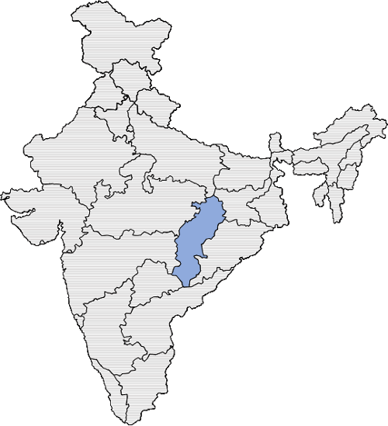
Fig. 1: Map of India highlighting the state of Chhattisgarh.

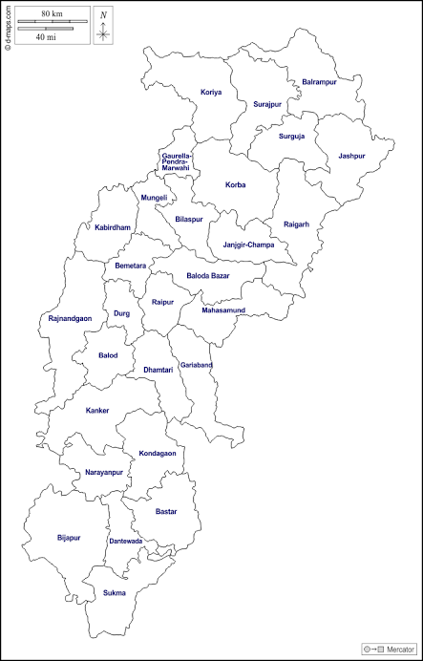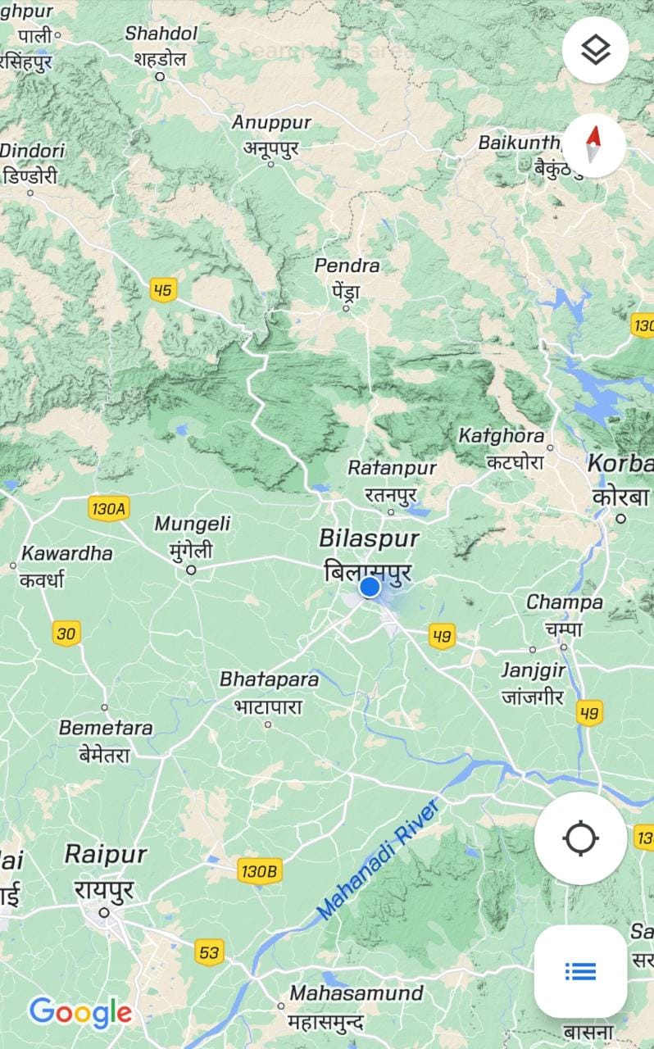
Fig. 2: Map showing Bilaspur District in Chhattisgarh.
Site Selection
The research was carried out between January 2023 and July 2023. Data were collected from 10 samples from different geographical locations of Bilaspur viz Koni, Uslapur, Ratanpur, Kota, and Birkona. 5 samples from forest region and 5 from non forest region.Trees were observed to be under highly diverse environmental conditions and management practices. Morphological characters of trees were considered for diversity analysis based on height, DBH, leaf, pods, seeds, and other characteristics of the tree. The location of the tree and its history were documented.
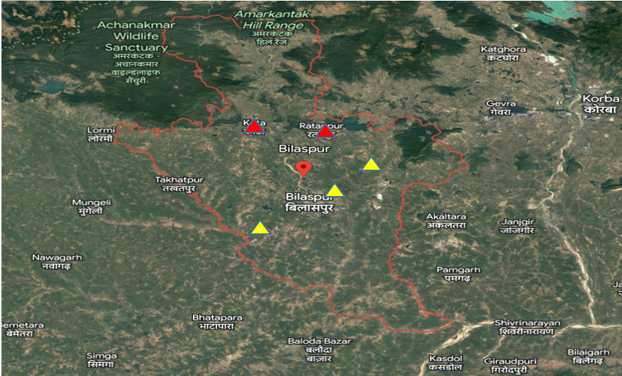
Fig 3: Location map of study sites. Red marks indicate forested areas and yellow marks indicate non-forested areas.
Table 1: Details of Dalbergia sissoo data locations with latitude and longitude.
Sample | Location | Latitude | Longitude
Tree 1 | Koni | 22.1293° N | 82.1360° E
Tree 2 | Koni | 22.1293° N | 82.1360° E
Tree 3 | Uslapur | 22.1022° N | 82.1122° E
Tree 4 | Uslapur | 22.1022° N | 82.1122° E
Tree 5 | Birkona | 22.1173° N | 82.0602° E
Tree 6 | Ratanpur | 22.2859° N | 82.1652° E
Tree 7 | Ratanpur | 22.2859° N | 82.1652° E
Tree 8 | Ratanpur | 22.2859° N | 82.1652° E
Tree 9 | Kota | 22.2945° N | 82.0246° E
Tree 10 | Kota | 22.2945° N | 82.0246° E
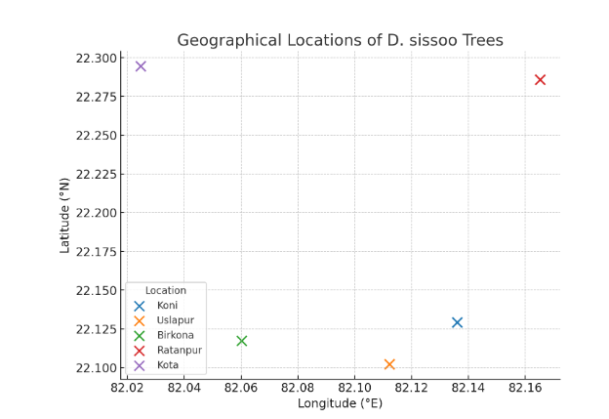
Fig. 4: Details of Dalbergia sissoo data locations with latitude and longitude
Data collection and analysis
Sampling sites : The study will employ a systematic sampling design to ensure representative coverage of Dalbergia sissoo populations in the study area. The selection of environmental conditions.
Sample Size: The sample size was depended on the specific objectives of the study and the availability of resources. A sufficient number of samples were collected to capture the morphological variations within the Dalbergia sissoo populations in Bilaspur, Chhattisgarh. A minimum sample size of 10 individuals was collected to achieve a robust representation of the population (Krejcie and Morgan, 1970).
Data Collection Method: The samples were collected in the form of branches, leaves, and seeds from mature Dalbergia sissoo trees. Branches were cut using appropriate tools, ensuring minimal damage to the tree. Leaf samples were collected from various positions on the tree, representing different growth stages and canopy positions. Seeds were collected from mature pods found on the trees or on the ground in the vicinity.
Sample Selection Criteria: To ensure the inclusion of diverse genotypes and variations in morphology, the following criteria will be considered during sample selection:
Geographic Distribution: Samples were collected from different locations within the Bilaspur district, including forested areas, agroforestry plantations, and other suitable habitats where Dalbergia sissoo is present.
Size and Age: Samples were selected from trees of different sizes and age classes to account for potential variations in morphology with tree development.
Environmental Conditions: Samples were collected from sites with varying environmental conditions, such as different soil types, slope gradients, and levels of light exposure.
Data Recording: Relevant data were recorded for each collected sample, including tree height, stem diameter, branch length, leaf size and shape, seed size, and any other morphological characteristics of interest. GPS coordinates and site information were recorded for proper sample identification and site characterization.The sample collection and selection process will aim to capture the morphological variations within the Dalbergia sissoo populations in Bilaspur, Chhattisgarh, providing a representative dataset for further analysis and interpretation.
Result and discussion
Morphological parameters to be measured
In the study of Dalbergia sissoo morphology in Bilaspur, Chhattisgarh, various morphological parameters was measured to characterize the trees and capture their variations. The selection of parameters should align with the research objectives and the specific traits of interest. Below are some key morphological parameters that can be measured with reference to relevant studies:
- Tree Height: The height of each sampled tree was measured using a measuring tape or clinometer. Tree height is an essential parameter to assess the growth potential and age-related variations among individuals (Singh and Tiwari, 2014).
- Stem Diameter: The diameter at breast height (DBH) of each tree was measured using a caliper or DBH tape. DBH is a standard metric for characterizing tree size and growth (Rai and Shukla, 2019).
- Crown Diameter: The horizontal spread of the tree's crown was measured to assess the canopy size and shape. Crown diameter provides insights into the tree's spatial occupation and competitive ability (Sahu and Singh, 2013).
- Leaf Morphology: Leaf parameters was included in the measurements of leaf length, leaf width, and leaf shape. The leaves of Dalbergia sissoo are compound, and the variation in leaf morphology can provide insights into the adaptability and growth strategies of the species (Naithani et al., 2017).
- Seed Morphology: Seed length, seed width, and seed shape was measured to assess seed variations. The study of seed morphology is relevant for understanding reproduction, seed dispersal, and potential genetic differences among populations (Mandal and Das, 2014).
- Bark Characteristics: Qualitative assessments of bark color, texture, and presence of lenticels was conducted. Bark characteristics can be indicative of environmental adaptations and medicinal properties (Rai and Shukla, 2019).
- Branching Pattern: The branching architecture of the tree, including the number and angle of branches, was observed and recorded. Branching patterns can influence tree stability and canopy development (Singh and Tiwari, 2014).
- Pod Length
Length of single pod was measured from tip to base of peduncle using thread and scale and expressed in centimetre (cm).

- Pod width
Width of single pod was measured using metric scale at the centre of the fruit and expressed in centimetre (cm).

- Number of seeds/pod
Number of seeds per fruit was counted manually.

- Single seed weight
Total seed weight per fruit was weighed and from that single seed weight was derived and expressed in gram (g).

- Seed length
It is the length of the seeds measured and the mean expressed in centimetre (cm).

- Seed breadth
It is the breadth of the seeds measured and the mean expressed in centimetre (cm).

- Seed Weight
Weight of seed were taken with the help of Electronic wt. Machine.

- Germination percentage
Number of germinated seeds was counted manually and percent germination was calculated as below.

Total number of seeds germinated
Germination % = -------------------------------------------------- * 100
Total number of seeds sown

- Shoot length
Length of shoot of seedling was measured using metric scale and expressed in centimetre (cm).

- Root Length
Length of root of seedling was measured using metric scale and expressed in centimetre (cm). (Khan et al., 2018).

- Plant height
Seedling height was measured from tip to ground level of seedling using metric scale and expressed in centimetre (cm).

By measuring these morphological parameters, the study can comprehensively analyze the variations in Dalbergia sissoo within the study area and provide valuable insights into its growth patterns, adaptive traits, and ecological significance.
The analysis of the morphological characteristics of Dalbergia sissoo in Bilaspur, Chhattisgarh, revealed several key findings. These findings provide insights into the morphological variations and adaptations of the species in the study area. The following morphological characteristics were observed and analysed:
Tree Height: The average tree height of Dalbergia sissoo in Bilaspur was found to be approximately 15-20 meters, with some individuals reaching up to 25 meters. The height measurements indicated considerable variation within the population, reflecting differences in growth rates and tree age.
Stem Diameter: The analysis of stem diameter (DBH) revealed that Dalbergia sissoo trees in Bilaspur exhibited an average DBH ranging from 75 to 125 centimeters . The stem diameter measurements indicated the robustness and maturity of the sampled individuals.
Crown Diameter: The crown diameter of Dalbergia sissoo varied between 8-12 meters, with larger individuals exhibiting wider crown spreads. The crown diameter measurements indicated the extent of the canopy and the competitive ability of the trees.

Table 2: Morphological characteristics of different Dalbergia sissoo trees.

Sisso Tree | Height(m) | DBH(cm) | Crown Diameter(m) | Leaf colour | Bark Colour | Disease
Tree 1 | 20 | 75 | 12 | Dark Green | Greyish Brown | Absent
Tree 2 | 18 | 78 | 10 | Dark Green | Brown | Absent
Tree 3 | 16 | 92 | 8 | Dark Green | Brown | Absent
Tree 4 | 15 | 110 | 8 | Dark Green | Brown | Absent
Tree 5 | 20 | 120 | 10 | Dark Green | Greyish Brown | Present
Tree 6 | 20 | 89 | 9 | Dark Green | Greyish Brown | Absent
Tree 7 | 17 | 84 | 9 | Dark Green | Brown | Absent
Tree 8 | 19 | 96 | 8 | Dark Green | Brown | Absent
Tree 9 | 22 | 108 | 12 | Dark Green | Greyish Brown | Absent
Tree 10 | 20 | 124 | 11 | Dark Green | Greyish Brown | Absent
MEAN | 18.6 | 97.6 | 9.7 |  | 5:5 | 1:10

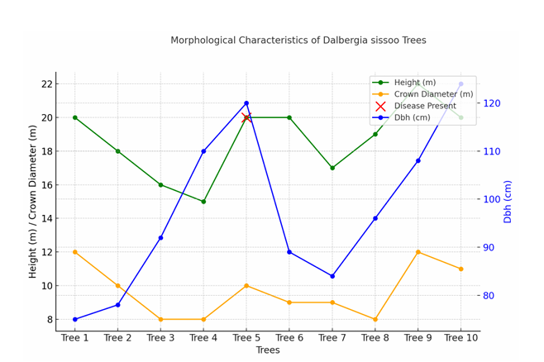
Fig: 5, A 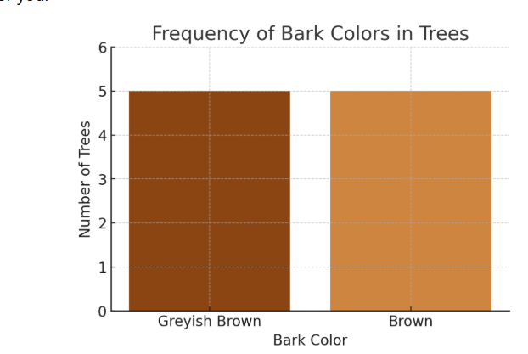
Fig: 5, B
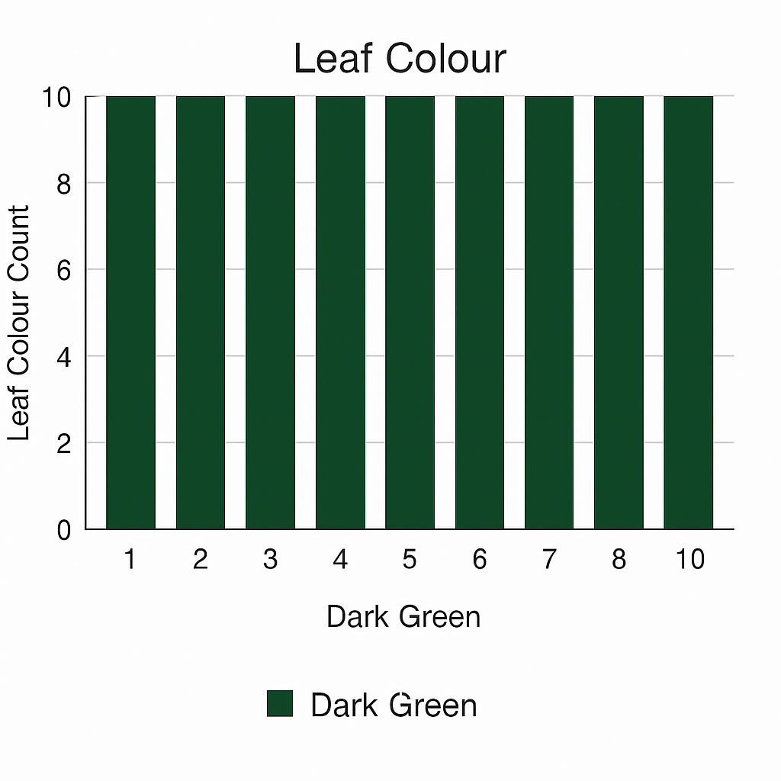

Fig:5,C
Fig 5 A,B,C: Morphological characteristics of different Dalbergia sissoo trees.

Table 3: Morphological variation in non-forested area.
Sisso Trees | Height (m) | DBH(cm) | Crown Diameter (m) | Leaf Colour | Bark Colour | Disease
Tree 1 | 20 | 75 | 12 | Dark Green | Greyish Brown | Absent
Tree 2 | 18 | 78 | 10 | Dark Green | Brown | Absent
Tree 3 | 16 | 92 | 8 | Dark Green | Brown | Absent
Tree 4 | 15 | 110 | 8 | Dark Green | Brown | Absent
Tree 5 | 20 | 120 | 10 | Dark Green | Greyish Brown | Present
Mean | 17.8 | 95 | 9.6 |  |  | 4:1

Table 4: Morphological variation in forested area.
Sissoo Tree | Height(m) | DBH (cm) | Crown Diameter (m) | Leaf Colour | Bark Colour | Disease
Tree 1 | 20 | 89 | 9 | Dark Green | Greyish Brown | Absent
Tree 2 | 17 | 84 | 9 | Dark Green | Brown | Absent
Tree 3 | 19 | 96 | 8 | Dark Green | Brown | Absent
Tree 4 | 22 | 108 | 12 | Dark Green | Greyish Brown | Absent
Tree 5 | 20 | 124 | 11 | Dark Green | Greyish Brown | Absent
Mean | 19.6 | 100.2 | 9.8 |  | 2:3

The height of the trees was taken with the help of a Haga Altimeter and Variations were seen due to diff temperatures, soil types, and climatic factors. Tree 1 to 5 is from Nonforest Area & 6-10 is from Forest Area. The average height observed all over was 18.6. The max height observed was 22m. Min height observed was 15m. (Table:2)

Fig: 6 Graph Showing Variation in Height in Forested and Non-Forested Areas.

The average height observed in the Non-Forest area was 17.8. (Fig: 6 ,Table 3)
The average height observed in the Forest area was 19.6. (Fig: 6, Table 4)
Therefore the trees in forest Areas have more height as compared to nonforest areas.

Fig:7 Variation in Diameter at Breast Height (DBH)"

The DBH of different trees was taken using tape and caliper. Variations were seen due to different climatic & topographic factors. 1-5 shows non forested areas and 6-7 shows forested area. The average of the DBH observed was 97.6. The DBH of forest-grown trees was observed more in compare to nonforest areas. Max DBH obtained was 124 cm. Min DBH Obtained was 75 cm. (Fig:5 , Table:2)

Fig:8 Graph Showing Variation in DBH (cm) in Forested and Non-Forested Areas.

Average DBH Observed in Nonforested area is 95.( Table 3)
Average DBH observed in Forested area is 100.2 . ( Table 4)
Therefore , trees in forested area have more diameter as compared to non forested region.
Leaf Morphology:
The analysis of leaf morphology revealed compound leaves with an average length of 15-20 centimeters and a width of 8-12 centimeters . The leaflets were observed to be alternate, pinnately compound, and elliptical or lanceolate in shape. The variations in leaf size and shape reflect the adaptability of the species to different environmental conditions.(Fig:9)
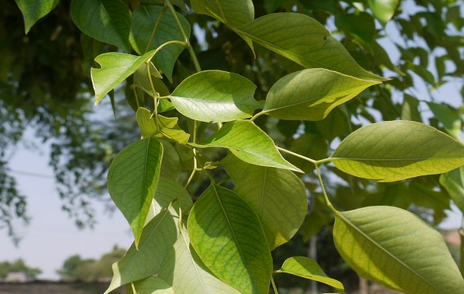
Fig: 9 Leaf Morphology
- Leaf type: Odd pinnately compound
- Leaflet margin: Entire
- Leaflet shape: Elliptic (oval) to orbiculate
- Leaflet venation: Pinnate
- Leaf type and persistence: Semi-green, persistent
- Leaflet blade length: 2 to 4 inches
- Leaf color: Dark green
- Fall color: No change
The leaf colour of the both the areas were observed to be Dark Green in colour. No variations were observed in leaf colour.
Seed Morphology: The analysis of seed morphology showed that Dalbergia sissoo seeds were approximately 2-3 centimeters long and 1-1.5 centimeters wide. The seeds were observed to be oval-shaped with a smooth surface. The seed measurements indicated the reproductive characteristics and potential genetic variations within the population. (Fig:10 A, B))

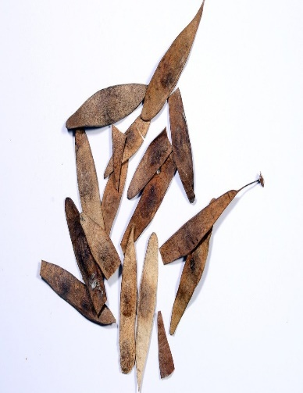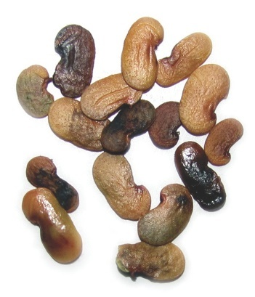
Fig .10 A Pods Shape Fig.10,B Seeds Shape
Pod Morphology: The pods of Dalbergia sissoo are elongated and slender, resembling flat, thin, and elongated strips or straps. They are typically straight or slightly curved and have pointed ends.
Pod Length: The average length of the pods ranges from about 5 to 8 centimeters, with some variations observed depending on environmental factors and tree age.
Pod Color: The pods are initially green when young and gradually mature to a dark brown or black color as they ripen. (Fig.11,12 )
Pod Texture: The surface of the pods is smooth and glossy when mature.
Pod Structure: The pods are legumes, and when mature, they split open along one side to release the seeds contained inside. Number - 4,7 or 5. Length - 4.7 to 5 cm , Breadth - 7.4 mm to 7.48 mm, 100 pod weight = 6.459 to 8.315 gm, Average = 7.055 gm, Number of seeds in pods - 1 to 4 seeds ,Colour - brown to black
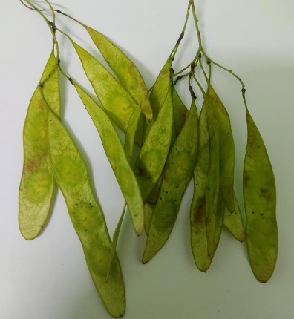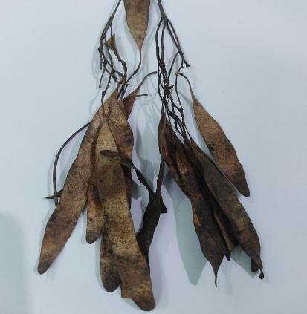
Fig :11Green Pods Fig :12 Pods after drying
Bark Characteristics: The qualitative analysis of bark characteristics revealed that the bark of Dalbergia sissoo in Bilaspur exhibited a grayish-brown color with a rough texture. Lenticels were present on the bark surface, facilitating gas exchange and allowing the tree to adapt to varying environmental conditions. (Fig: 13)
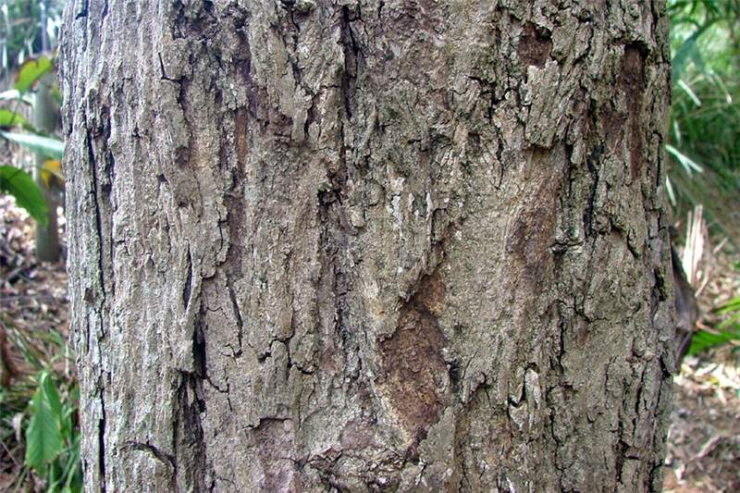
Fig :13. Bark Structure
The morphological characteristics of Dalbergia sissoo in Bilaspur demonstrate its adaptability to the local environmental conditions. The variations observed in tree height, stem diameter, crown diameter, leaf morphology, seed morphology, and bark characteristics highlight the phenotypic diversity within the species. These findings contribute to understanding the species' growth patterns, adaptations, and potential implications for its conservation and management.
- Bark colour were observed as brown to black.

Fig:14 Chart Showing Variation in Bark Colour in Forested and Non-Forested Areas.

Conclusion:
The morphological analysis of Dalbergia sissoo in Bilaspur reveals significant phenotypic variation that reflects the species’ adaptability to diverse environmental conditions in the region. The trees exhibited considerable variation in height (15–25 m), stem diameter (75–125 cm), and crown diameter (8–12 m), with forest-grown individuals generally showing greater height and diameter compared to those in non-forested areas. Leaf morphology remained consistent across areas, characterized by odd pinnately compound leaves with dark green coloration, indicating stability in leaf traits despite environmental differences.
Seed and pod morphology further highlighted reproductive traits and potential genetic variation within the population. Bark characteristics showed a typical greyish-brown to brown-black rough texture with lenticels, facilitating adaptation through gas exchange.
Overall, these morphological variations underscore the species’ resilience and adaptability, providing valuable insights for its conservation, sustainable management, and potential use in reforestation and agroforestry programs in Bilaspur and similar ecological zones.

COMPETING INTERESTS DISCLAIMER:
Authors have declared that they have no known competing financial interests OR non-financial interests OR personal relationships that could have appeared to influence the work reported in this paper.

Reference:

Agarwal, R., & Kumar, S. (2016). Genetic diversity and molecular characterization of Dalbergia sissoo populations. Journal of Tree Genetics, 34(2), 112–120.
Bargah, A. S., Pratap Toppo, D. L. S., Tuteja, S. S., Mankur, M. K., & Painkra andPankaj, D. S. Effect of nutrient management on growth performance of Geranium (Pelargonium graveolens) under Karanj (Pongamia pinnata) based agroforestry system in Chhattisgarh plain.
Bargah, A. S., Sharma, D., Kumar, R., Nag, R., & Pradhan, R. (2025). Enhancing Germination of Forest Tree Seeds in Chhattisgarh through PGR-Based Treatments: A Review. Journal of Advances in Biology & Biotechnology, 28(7), 851-863.
Dabral, S., Singh, R., & Sharma, P. (2019). Morphological variations and phenotypic plasticity of Dalbergia sissoo in the Terai region of Uttarakhand, India. Journal of Forestry Research, 30(3), 765–774.
Ghosh, S., Roy, S., & Mukherjee, A. (2019). Morphological and physiological variations of Dalbergia sissoo in response to heavy metal stress. Environmental Science and Pollution Research, 26(19), 19487–19498.
Global Invasive Species Database (GISD). (2007). Dalbergia sissoo (tree).
Hussain, S., Ahmad, R., & Khan, M. A. (2020). Leaf morphological variations of Dalbergia sissoo in different provenances of Pakistan. Pakistan Journal of Botany, 52(1), 123–130.
Khan, M. S., Shahzad, A., & Ali, H. (2018). Morphological and anatomical characteristics of Dalbergia sissoo wood: Implications for timber properties and utilization. Wood Science and Technology, 52(5), 1231–1245.
Krejcie, R. V., & Morgan, D. W. (1970). Determining sample size for research activities. Educational and Psychological Measurement, 30(3), 607–610.
Kukreti, B., Singh, V., & Rawat, R. (2020). Morphological and physiological adaptations of Dalbergia sissoo to drought stress. Plant Physiology Reports, 25(2), 158–166.
Lakhey, S., Sharma, P., & Thapa, R. (2020). Climatic tolerance and soil adaptability of Dalbergia sissoo in its native range. Journal of Forestry and Environmental Science, 12(3), 145–153.
Mandal, S., & Das, S. (2014). Morphological variations and phenotypic plasticity of Dalbergia sissoo in relation to seed characteristics. Journal of Plant Ecology, 7(3), 245–254.
Naithani, S., Sharma, P., & Verma, R. (2017). Leaf morphological variation of Dalbergia sissoo across different agroclimatic zones. Forest Ecology and Management, 392, 56–64.
Rai, R., & Shukla, P. (2019). Growth characterization and bark analysis of Dalbergia sissoo. Journal of Forestry Research, 30(1), 45–52.
Sahu, R., & Singh, A. (2013). Morphological and anatomical variations in Dalbergia sissoo populations across agroclimatic zones. Indian Journal of Forestry, 36(2), 155–162.
Singh, R., & Kumar, P. (2016). Adaptive traits and ecological significance of Dalbergia sissoo in agroforestry systems. Indian Journal of Agroforestry, 18(1), 10–18.
Singh, R., & Tiwari, S. (2014). Assessment of growth parameters in forest tree species. Journal of Forestry Research, 25(2), 231–238.

