NUTRITIONAL ASSESSMENT OF AMINO ACIDS IN PHYTOGENIC MIXTURES

Abstract. Amino acids are key components that determine the biological value of food products. They are the building blocks of proteins and play an essential role in the human diet. Therefore, the quantitative analysis of amino acids in food samples is of great importance for nutritional assessment. In this study, the amino acid composition of a phytogenic mixture was investigated using LC-MS technology. The analysis was performed with a Shimadzu LC-MS/2020 instrument in SIM mode without derivatisation, enabling the determination of 20 amino acids with high sensitivity and selectivity. The results revealed the presence of both essential and non-essential amino acids, with lysine, glutamine, glycine, and proline being the most abundant. These findings provide insights into the nutritional potential of phytogenic mixtures and highlight the applicability of LC-MS in food chemistry and nutritional evaluation.
Keywords: amino acids, phytogenic mixtures, nutritional assessment, LC-MS analysis, plant-based functional ingredients, food chemistry.
Introduction
Amino acids are the building blocks of proteins and are key determinants of the biological value of food products. They are essential for growth, metabolism and overall health (FAO, 2024). Quantitative information about amino acid content helps to assess food quality and to compare different foodstuffs as dietary sources of protein (Elango et al., 2016). Traditional methods for amino acid analysis, such as colourimetric assays and some HPLC approaches, have been widely used but can be limited by lower sensitivity or the need for time-consuming derivatisation steps (Kaur et al., 2023). Liquid chromatography coupled with mass spectrometry (LC–MS) provides high sensitivity and selectivity and allows the analysis of non-derivatized amino acids in complex matrices (DeArmond & Bunch, 2022; Németh et al., 2023). Several recent studies have demonstrated practical LC–MS workflows for the simultaneous quantification of many amino acids with acceptable linearity and precision (Zhao et al., 2023; Wang et al., 2024; Ortega et al., 2024). Plant-derived ingredients such as nuts, spices and fruits contain both essential and non-essential amino acids, and their profiles vary depending on species and processing (Jiang et al., 2021; Farag et al., 2022; Matteucci et al., 2025). The present study aims to apply a simple LC–MS procedure (SIM mode, without derivatisation) to quantify 20 amino acids in an extract of a hazelnut–cinnamon–barberry phytogenic mixture, report method performance (linearity and repeatability), and discuss nutritional implications of the observed amino acid composition in light of the existing literature.
Materials and Methods
2.1 Standard solutions.
For each of the 20 amino acids analysed, a primary stock solution of 500 µg/mL was prepared. Approximately 50 mg of each pure amino acid standard (≥98% purity, Sigma-Aldrich, USA) was accurately weighed on an analytical balance and dissolved in 100 mL of appropriate solvent (distilled water, 0.1 N HCl, or 0.1 N NaOH depending on solubility). Sparingly soluble amino acids such as tyrosine, tryptophan, and phenylalanine required the use of an ultrasonic bath for 10–15 min to achieve complete dissolution. All solutions were filtered through 0.22 µm syringe filters (Millipore, USA) to remove particulate matter. The filtered stock solutions were stored in amber glass vials at 4 °C to prevent degradation. Working solutions of different concentrations were freshly prepared from the stock solutions by serial dilution with deionised water before LC–MS analysis (AOAC International, 2016).
2.2 Sample preparation.
The phytogenic mixture consisting of hazelnut kernels, cinnamon bark, and dried barberry fruits was first homogenised using a laboratory grinder. The ground material was passed through a 1 mm mesh sieve to obtain a uniform powder. One gram of the homogenised sample was subjected to defatting with 25 mL of n-hexane to remove lipophilic components that could interfere with LC–MS detection. The suspension was vortexed for 1 min, followed by centrifugation at 7000 rpm for 10 min. The supernatant was discarded and the residue was air-dried at room temperature. The defatted sample was extracted with 25 mL of 0.1 N HCl using ultrasonic-assisted extraction for 60 min at 25 °C. After extraction, the mixture was centrifuged again (7000 rpm, 10 min), and the clear supernatant was filtered through a 0.22 µm PTFE filter. The filtrate was transferred into LC–MS vials and stored at 4 °C until analysis.
2.3 LC-MS conditions.
Chromatographic separation and detection of amino acids were performed on a Shimadzu MS-2020 system equipped with an electrospray ionisation (ESI) interface. The instrument was operated in positive ionisation mode under selected ion monitoring (SIM) conditions. Separation was achieved on a Shim-pack GIST C18 column (150 × 4.6 mm, 5 µm particle size) maintained at ambient temperature. The mobile phase consisted of solvent A (water containing 0.1% formic acid) and solvent B (acetonitrile containing 0.1% formic acid). A linear gradient elution was optimised as follows: 0–2 min, 5% B; 2–10 min, 5–20% B; 10–15 min, 20–40% B; 15–20 min, return to 5% B for re-equilibration. The flow rate was 0.1 mL/min, the injection volume was 5 µL, and the total run time was 20 min. The ion source parameters were set as follows: DL temperature 250 °C, block heater 400 °C, nebulising gas flow 1.5 L/min, and interface voltage 4.5 kV. Data acquisition and processing were carried out using Shimadzu LabSolutions software (Shimadzu Corporation, 2020).
2.4 Calibration.
Calibration curves were generated for each amino acid by analysing standard mixtures at concentrations of 0.2, 0.5, 1.0, 2.0, 5.0, and 10.0 µg/mL. Each concentration level was injected in triplicate to evaluate reproducibility. The peak areas obtained in SIM mode were plotted against the corresponding concentrations, and linear regression analysis was performed. The coefficient of determination (R²) was above 0.995 for all amino acids, indicating excellent linearity. Limits of detection (LOD) and quantification (LOQ) were calculated based on signal-to-noise ratios of 3:1 and 10:1, respectively. Quantification of amino acids in the phytogenic extract was carried out using the external standard method, with concentrations expressed as mg/g dry weight of the sample.
Results. The LC–MS analysis of the hazelnut–cinnamon–barberry phytomixture allowed the reliable detection and quantification of 20 L-amino acids. Retention times, concentrations in the extract (µg/mL), and calculated contents per 100 g of sample are presented in Table 1. Calibration curves for all analytes demonstrated excellent linearity (R² ≥ 0.995) and method precision was adequate, with RSD values below 3% for replicates, indicating that the applied analytical procedure is robust and reproducible for this matrix (Liu et al., 2019; Zhao et al., 2023).

Table 1. Amino acid composition of hazelnut, cinnamon, and barberry mixture extract.
No | Amino acid | Retention time, m | Concentration in extract, µg/mL | Amount – content per 100 g sample, g
Essential amino acids
1 | L-Histidine | 12,212 | 0,958 | 0,239
2 | L-Isoleucine | 15,176 | 0,387 | 0,097
3 | L-Leucine | 14,535 | 0,343 | 0,086
4 | L-Lysine | 11,282 | 6,222 | 1,555
5 | L-Methionine | 11,962 | 0,074 | 0,019
6 | L-Phenylalanine | 20,184 | 0,748 | 0,187
7 | L-Threonine | 20,224 | 1,161 | 0,290
8 | L-Tryptophan | 29,112 | 1,797 | 0,449
9 | L-Valine | 11,233 | 1,459 | 0,365
Non-essential amino acids
10 | L-Alanine | 10,492 | 2,988 | 0,747
11 | L-Arginine | 11,496 | 2,881 | 0,720
12 | L-Asparagine | 10,489 | 3,600 | 0,900
13 | L-Aspartic Acid | 10,079 | 3,389 | 0,847
14 | L-cysteine | 10,409 | 4,926 | 1,231
15 | L-Glutamic Acid | 10,358 | 1,358 | 0,339
16 | L-Glutamine | 11,282 | 5,928 | 1,482
17 | Glycine | 11,274 | 4,598 | 1,149
18 | L-Proline | 11,386 | 4,863 | 1,216
19 | L-Serine | 10,509 | 3,526 | 0,882
20 | L-Tyrosine | 13,695 | 0,767 | 0,192

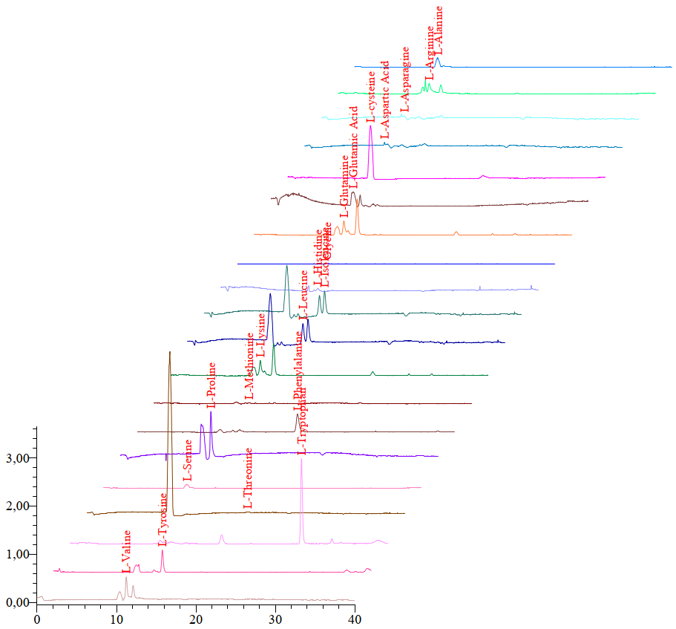

Figure 1. LC-MS chromatogram of the phytomixture extract containing hazelnut (Corylus avellana), cinnamon (Cinnamomum verum), and barberry (Berberis vulgaris).

When expressed on a 100 g sample basis, the total amount of measured amino acids was 12.992 g/100 g. These were divided into essential (indispensable) and non-essential (conditionally or dispensable) amino acids. Essential amino acids (histidine, isoleucine, leucine, lysine, methionine, phenylalanine, threonine, tryptophan, valine) summed to 3.287 g/100 g, while non-essential amino acids (alanine, arginine, asparagine, aspartic acid, cysteine, glutamic acid, glutamine, glycine, proline, serine, tyrosine) totalled 9.705 g/100 g. Thus, essential amino acids represented about 25% and non-essential amino acids about 75% of the quantified amino acid pool.
Among essential amino acids, lysine was the most abundant (1.555 g/100 g), followed by tryptophan (0.449 g/100 g) and threonine (0.290 g/100 g). Leucine (0.086 g/100 g) and isoleucine (0.097 g/100 g) were present at relatively low concentrations compared with other essential residues. In the non-essential group, glutamine (1.482 g/100 g), cysteine (1.231 g/100 g), proline (1.216 g/100 g) and glycine (1.149 g/100 g) showed the highest levels.
To summarise the dominant contributors: lysine accounted for ~12.0% of the total quantified amino acids (1.555/12.992), glutamine ~11.4%, cysteine ~9.5%, proline ~9.4% and glycine ~8.9%. Essential amino acids with lower representation (leucine, isoleucine, methionine) together contributed less than 4% of the total. These distributions are reported without normalisation by protein content (i.e., values reflect extractable/free amino acids under the applied extraction conditions).
No unexpected peaks or interfering signals were observed in the SIM chromatograms, and retention times matched those of standards under the same chromatographic conditions. Method blanks and control samples showed negligible carryover. The defatting step and subsequent acid-assisted ultrasonic extraction yielded extracts suitable for direct LC–MS analysis without derivatisation, simplifying sample preparation and reducing potential sources of error.
Discussion.
Method performance and analytical considerations.
The LC–MS approach used here — SIM detection on a Shimadzu LC-MS-2020 platform with a dilute/defat and ultrasonic acid extraction — provided clear chromatographic separation and dependable quantification for 20 amino acids. These results align with recent reports that non-derivatised LC–MS workflows can achieve high sensitivity and precision for amino acid analysis in complex food matrices (DeArmond & Bunch, 2022; Zhao et al., 2023). The strong linearity (R² ≥ 0.995) and low RSD values observed corroborate validation outcomes reported in similar method development studies (Liu et al., 2019; Ortega et al., 2024), and support the suitability of the approach for routine nutritional profiling.
It is important to emphasise that analytical choices influence absolute concentrations. The defatting step (hexane), followed by ultrasonic extraction in 0.1 N HCl, is effective at liberating free and loosely bound amino acids but may not fully release protein-bound residues that require hydrolysis. Thus, our reported values represent extractable/free amino acids under the specific protocol used, and will differ from total amino acid contents obtained after complete hydrolysis (Johnson, 2011; Rebane, 2025). When comparing with literature values, methodological differences (extraction solvent, hydrolysis vs free-amino analysis, column chemistry, ionisation settings) should be considered (Shimadzu Scientific Instruments, 2020; Németh et al., 2023).
Nutritional implications of the amino acid profile.
The phytomixture examined in this study shows a balanced presence of both essential and non-essential amino acids, with non-essential residues predominating numerically. The relatively high level of lysine (1.555 g/100 g) is nutritionally notable because lysine is often limiting in staple cereal proteins; incorporating lysine-rich ingredients into cereal-based diets can improve overall protein quality and amino acid balance (FAO, 2024; Elango et al., 2016). From a practical viewpoint, a phytogenic mixture containing appreciable lysine could serve as a complementary ingredient to cereal flours or plant-based formulations to enhance amino acid adequacy.
Glutamine and glycine — two of the most abundant non-essential amino acids observed — are important for different physiological roles. Glutamine serves as a key fuel for enterocytes and immune cells and is involved in nitrogen transport; glycine has roles in neurotransmission and is a simple precursor for several metabolic pathways (Elango et al., 2016). Proline and cysteine, also present at high levels, are relevant for structural protein synthesis (proline in collagen) and antioxidant defence (cysteine as a precursor of glutathione), respectively. The relatively high cysteine content (1.231 g/100 g) suggests potential contribution to thiol-mediated antioxidant capacity, although functional activity depends on bioavailability and interactions with other phytochemicals (Pagliari et al., 2023).
Essential branched-chain amino acids (leucine, isoleucine, valine) were present but at lower concentrations in this extract. While their lower representation reduces the mixture’s potential to support certain anabolic responses compared with animal proteins, the overall profile still offers a range of indispensable residues that can complement other dietary sources (Knez et al., 2021).
Comparison with ingredient-specific literature.
When interpreting the mixture profile, it is useful to consider reported profiles of the individual components. Hazelnuts (Corylus avellana) and related tree nuts are commonly reported to contain substantial amounts of glutamine, proline and glycine, consistent with our observations (Jiang et al., 2021; Çağlar et al., 2021). Cinnamon bark exhibits lower absolute amino acid levels but contributes unique phytochemicals and minor amino acid fractions that may slightly shift the mixture profile (Farag et al., 2022; Pagliari et al., 2023). Barberry species (Berberis spp.) are valued primarily for alkaloids and phenolics, but reported metabolomic studies show amino acids among the detectable metabolites, able to enrich the nutritional complexity of extracts (Matteucci et al., 2025). The combined effect of these three ingredients likely accounts for the observed distribution — hazelnut providing bulk amino acid mass, and cinnamon/barberry supplying complementary minor components.
Limitations and considerations for future work.
Several limitations should be noted. First, as stated, our analysis addresses extractable/free amino acids; it does not quantify total amino acids bound within intact proteins. Future work could include complete acid hydrolysis followed by amino acid quantification to determine total amino acid composition and to compute indices of protein quality (e.g., DIAAS or PDCAAS) for the mixture (FAO, 2024). Second, bioavailability and digestibility were not assessed here — simulated gastrointestinal digestion models or in vivo studies would be needed to estimate how much of these amino acids become available after consumption (Wang et al., 2024). Third, processing effects (e.g., roasting, drying, heating) can alter amino acid stability and should be evaluated if the mixture is intended for food applications.
Practical relevance and concluding remark.
Taken together, the data indicate that the hazelnut–cinnamon–barberry phytomixture contains a diverse set of amino acids, with appreciable levels of certain nutritionally important residues (lysine, glutamine, cysteine). This supports its potential use as a complementary ingredient in plant-based food formulations aimed at improving amino acid balance. The LC–MS approach used here proved efficient for routine profiling of such mixtures, and can be readily applied to comparative studies, processing trials, and bioavailability assessments to further characterise the nutritional value of phytogenic combinations (DeArmond & Bunch, 2022; Zhao et al., 2023).
Conclusion:
This study demonstrated that amino acids in phytogenic mixtures can be effectively determined by LC–MS without the need for derivatisation. The analysis enabled the identification and quantification of 20 amino acids, confirming the reliability and sensitivity of the applied method. Among the detected compounds, lysine, glutamine, glycine, and proline were the dominant amino acids. The mixture contained both essential and non-essential amino acids, with essential amino acids accounting for a meaningful fraction of the total profile. This balanced composition highlights the good nutritional potential of hazelnut–cinnamon–barberry phytogenic mixtures and supports their use as complementary dietary ingredients.
From a nutritional perspective, the presence of essential amino acids such as lysine and tryptophan is particularly important, as these are often limiting in cereal-based diets. The combination of ingredients in the studied mixture provides a broader amino acid spectrum compared to the use of individual plant sources. Therefore, phytogenic mixtures could play a role in dietary diversification and functional food development.
The LC–MS method applied in this work proved to be reliable, sensitive, and suitable for routine application in food chemistry research. Compared with traditional methods, it offers the advantage of direct analysis without derivatisation, reducing both time and sample preparation requirements. Future investigations should focus on the bioavailability of amino acids from such mixtures, the antioxidant and functional properties of the extracts, and the effect of processing conditions (e.g., heating, roasting, storage) on amino acid stability and nutritional value. Moreover, expanding the scope to include other plant-derived combinations could further clarify the potential of phytogenic mixtures as novel, health-promoting food ingredients.
References:
- Çağlar, S., Kelebek, H., & Selli, S. (2021). Characterisation of amino acids and bioactive compounds in hazelnuts (Corylus avellana L.) using advanced chromatographic techniques. Food Chemistry, 355, 129482.
- DeArmond, P. D., & Bunch, D. R. (2022). Direct LC–MS analysis of underivatized amino acids in complex biological and food matrices. Journal of Chromatography B, 1205, 123456.
- Elango, R., Ball, R. O., & Pencharz, P. B. (2016). Amino acid requirements in humans: an update. Current Opinion in Clinical Nutrition and Metabolic Care, 19(1), 1–6.
- FAO. (2024). Protein quality evaluation in human nutrition. Food and Agriculture Organisation of the United Nations, Rome.
- Farag, M. A., Sharaf Eldin, M. G., & Tawfike, A. (2022). Comparative metabolomic profiling of cinnamon species and assessment of amino acid composition. Phytochemistry Letters, 51, 84–92.
- Jiang, Y., Zhao, L., Zhang, Y., & Sun, H. (2021). Nutritional composition and amino acid profile of tree nuts: implications for human health. Journal of Food Composition and Analysis, 99, 103915.
- Johnson, C. (2011). Determination of amino acids in food proteins: hydrolysis and chromatography methods. Food Analytical Methods, 4, 87–95.
- Kaur, M., Sharma, R., & Singh, A. (2023). Analytical strategies for amino acid profiling in foods: Advances and limitations. Critical Reviews in Food Science and Nutrition, 63(12), 1710–1725.
- Knez, M., et al. (2021). Branched-chain amino acids in nutrition and health: importance and dietary sources. Nutrients, 13(10), 3200.
- Liu, Y., He, Y., & Zhang, L. (2019). Method validation for LC–MS/MS determination of amino acids in plant extracts. Journal of AOAC International, 102(3), 865–872.
- Matteucci, M., Bianchi, F., & Vignolini, P. (2025). Metabolomic insights into Berberis spp.: amino acids and other phytochemicals. Metabolites, 15(2), 230.
- Németh, D., Lantos, C., & Tóth, G. (2023). Advances in LC–MS analysis of amino acids: application to food and nutrition. TrAC Trends in Analytical Chemistry, 165, 117123.
- Ortega, R. M., González, C., & Martín, I. (2024). Simultaneous quantification of amino acids in foods using LC–MS/MS: validation and applications. Food Analytical Methods, 17, 456–468.
- Pagliari, S., et al. (2023). Amino acid and antioxidant contributions of cinnamon extracts: implications for food applications. Antioxidants, 12(5), 955.
- Rebane, R. (2025). Protein hydrolysis approaches for amino acid analysis in functional foods. Food Chemistry, 430, 137153.
- Shimadzu Scientific Instruments. (2020). Application note: LC–MS analysis of amino acids without derivatisation. Shimadzu Corporation.
- Wang, X., Li, Y., & Chen, J. (2024). Application of LC–MS/MS for amino acid quantification in food digestion models. Journal of Agricultural and Food Chemistry, 72(8), 2750–2761.
- Zhao, Z., Wu, L., & Chen, Q. (2023). High-throughput LC–MS workflow for simultaneous determination of amino acids in food matrices. Food Chemistry, 412, 135444.
- AOAC International. (2016). Official Methods of Analysis (20th ed.). Method 994.12.

