Impact of Dialysis Frequency on Body Mass Index and Bone Mass in Haemodialysis Patients
ABSTRACT
The frequency of haemodialysis sessions is a determining factor in the nutritional status of patients with end-stage chronic renal failure. Among anthropometric indicators, body mass index (BMI) and bone mass (BM) are often used to assess nutritional balance and the risk of morbidity and mortality. Several studies have shown that higher dialysis frequency (≥ 3 sessions per week) contributes to better purification of uraemic toxins, improved protein-energy metabolism and reduced chronic inflammation, thereby helping to maintain a more stable BMI and BM. Conversely, a reduced frequency of dialysis is often associated with hydrosodium overload, increased protein catabolism and altered appetite, leading to a progressive reduction in BMI and an increased risk of protein-energy malnutrition. The results showed that a high proportion of haemodialysis patients have a low body mass index (9.16% for haemodialysis duration < 1 year, 10.69% (1 to 2 years), 8.40% (2 to 3 years), 10.69% (3 to 4 years), 7.63% (4 to 5 years) and 10.69% (> 5 years). Increasing the frequency of dialysis appears to be a favourable strategy for preserving nutritional status and limiting undernutrition in these haemodialysis patients, but its impact needs to be analysed within a multidimensional framework incorporating diet quality and biochemical markers.
Key words: haemodialysis; frequency of dialysis; body mass index ; nutritional status ; chronic renal failure.
1.INTRODUCTION
Chronic renal failure (CRF) is a progressive disease characterised by irreversible impairment of renal function (Bensaha, 2024), progressing to a terminal stage requiring renal replacement therapy, of which haemodialysis is the most accessible option in Togo. Haemodialysis remains the most commonly used renal replacement therapy for patients with chronic end-stage renal disease (Djiguiba, 2023). In addition to its main function of blood purification, dialysis has a significant impact on patients' nutritional and metabolic status (Piedrafita, 2021). The body mass index (BMI) and the bone mass, although imperfect, are a good indicators of a patient's nutritional status. anthropometric measurement widely used to assess nutritional status and predict the risk of morbidity and mortality in this population (Dahel, 2020). Among the factors influencing nutritional status, the frequency of dialysis sessions plays a decisive role. The frequency of dialysis sessions is an essential parameter likely to influence changes in BMI and BM. More frequent dialysis promotes better elimination of uraemic waste, reduces fluid overload and improves metabolic tolerance, all of which contribute to maintaining a more stable nutritional state (Jean et al. 2017). Conversely, insufficient dialysis frequency can accentuate protein catabolism, reducing appetite, promoting protein-energy malnutrition and consequently leading to a progressive decrease in BMI and BM (Moro, 2021). However, interpretation of BMI and BM in haemodialysis patients remains complex due to variability in hydration status and body composition, requiring integrated analysis with other biochemical and nutritional parameters (Laidouni & Semra, 2021). In this context, it is essential to study the impact of dialysis frequency on BMI and on BM in order to better understand the links between therapeutic management, nutritional status and the clinical prognosis of haemodialysis patients.
2. MATERIAL AND METHODS
2.1. Type and scope of the study
This was a descriptive and analytical cross-sectional study of haemodialysis patients in the nephrology departments of a number of hospitals in Togo.
2.2. Study population
Patients suffering from chronic renal failure and receiving haemodialysis in the hospitals concerned.
Inclusion criteria
All haemodialysis patients who gave informed consent were included in this study.
Exclusion criteria
Patients with amputations or persistent massive oedema that could prevent anthropometric parameters from being measured were excluded.
Non-inclusion criteria
This study did not include haemodialysis patients who had not given their consent.

2.3. Sampling
Sampling technique
Sampling was exhaustive and included all patients with chronic kidney disease (CKD) undergoing haemodialysis treatment in the hospitals concerned.
2.4. Data collection technique for body mass index and bone mass
Height was measured using a measuring tape, with patients barefoot, heels together and head slightly extended.
Body mass index was assessed before the dialysis session using a ZOETOUCH impedancemeter scale. The patients, as light as possible, removed their shoes before stepping on the scale, placing their feet on the electrodes (one or two on each side). Data was recorded for each patient's age, height and sex. An electric current was then emitted by the sensors on one side (left or right) and recovered by those on the opposite side, after passing through the whole body. The results were displayed a few moments later on an Android smartphone connected to the scale via Bluetooth, and then recorded.
2.5. Data processing and analysis
Data were entered using Excel spreadsheets. The qualitative variables in proportion, mean and the test of correlation (ANOVA) between the variables were established for a value of p < 0.05 (significance threshold of 5%) using GraphPad Prism 10 software.
3. RESULTS AND DISCUSSION
3.1. Results
Body mass index (BMI)
Among one hundred and thirty-two haemodialysis patients surveyed, the proportion with a low body mass index (BMI) was 9.16% for a haemodialysis duration < 1 year, 10.69% (1 to 2 years), 8.40% (2 to 3 years), 10.69% (3 to 4 years), 7.63% (4 to 5 years) and 10.69% (> 5 years). In contrast, the proportion of patients with a very high BMI was much lower: 1.53% for a duration of less than 1 year, and 0.76% for durations of 1 to 2 years, 2 to 3 years, 3 to 4 years and > 5 years. No cases of very high BMI were observed in patients with a haemodialysis duration of between 4 and 5 years (Table 1).

Table 1. Distribution of haemodialysis patients according to BMI
BMI | <1 year (%) | 1-2 years (%) | 2-3 years (%) | 3-4 years (%) | 4-5 years (%) | > 5 years (%)
Low (< 18,5) | 9,16 | 10,69 | 8,40 | 10,69 | 7,63 | 10,69
Normal (18,5 – 24,9) | 7,63 | 6,87 | 4,58 | 5,34 | 3,82 | 3,82
Low High (25 – 30) | 1,53 | 1,53 | 0,76 | 0,76 | 0,76 | 0,76
Very high (> 30) | 1,53 | 0,76 | 0,76 | 0,76 | 0 | 0,76
Bone mass (BM)
Among the haemodialysis patients surveyed, low bone mass was observed in 4.55% of patients in groups < 1 year and 2-3 years, 6.82% in groups 1-2 years and 3-4 years, 5.30% (4-5 years) and 7.58% (> 5 years). In contrast, high bone mass was found in 3.79% of patients in the < 1 year group, 1.52% (2-3 years), 0.76% (3-4 years), and no cases (0.00%) in the 1-2 years, 4-5 years and > 5 years groups (Table 2).
Table 2. Distribution of haemodialysis patients according to BM
BM (%) | < 1 year (%) | 1-2 ans (%) | 2-3 years (%) | 3-4 years (%) | 4-5 years (%) | > 5 years (%)
Low (<3,5) | 4,55 | 6,82 | 4,55 | 6,82 | 5,30 | 7,58
Normal (3,5- 5) | 12,12 | 12,88 | 8,33 | 9,85 | 6,82 | 8,33
High (>5) | 3,79 | 0,00 | 1,52 | 0,76 | 0,00 | 0,00

Average values for BMI and bone mass in the study population
In the population studied, the mean value of the body mass index (BMI) associated with malnutrition was 15.00 ± 1.00. Of these patients, 12.67 ± 0.71 had a low BMI and 1.00 ± 0.26 a very high BMI. With regard to bone mass, the mean value associated with malnutrition was 9.17 ± 0.60, of which 7.83 ± 0.70 corresponded to low bone mass and 1.33 ± 0.80 to high bone mass (Figures 1 and 2).
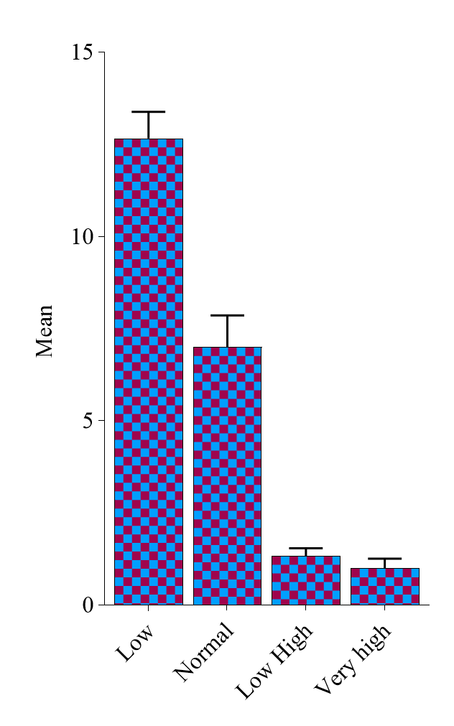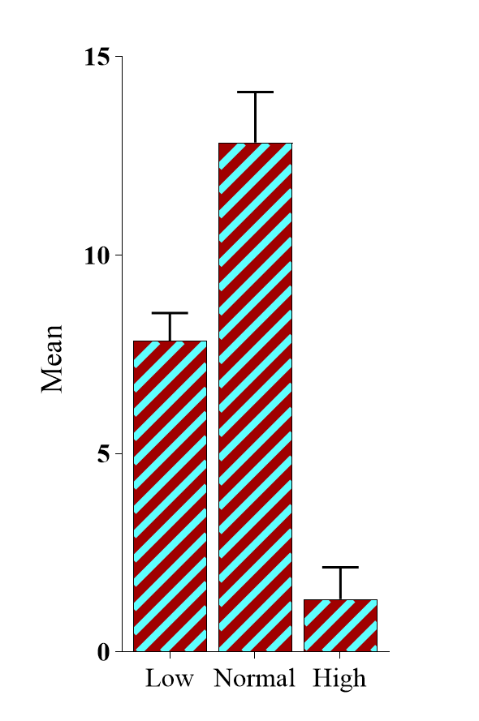
Figure 2: Mean value of malnutrition according to BM

Figure 1: Mean value of malnutrition according to BMI

Comparison between dialysis frequency and body mass index and bone mass
The analysis of variance (ANOVA) performed to assess the effect of frequency of dialysis sessions on body mass index (BMI) and bone mass (BM) showed no statistically significant difference (p > 0.05), as shown in Table 3.
Table3. Comparison between dialysis frequency and body mass index and bone mass
Indices | Test de comparaison (ANOVA)
Body mass index (Kg/m2) | 0,081(p>0,05)
Bone mass (%) | 0,10(p>0,05)

3.2. Discussion
Body mass index (BMI)
A body mass index (BMI) of less than 18.5 kg/m² was observed in more than half of haemodialysis patients (52.38%), indicating a state of undernutrition and highlighting the high prevalence of protein-energy malnutrition in this population (Dehak & Arab, 2024). Similar results were reported by Kalantar-Zadeh et al (2010). This situation is the result of multiple factors, including loss of appetite induced by uraemia, dietary restrictions, chronic inflammation, metabolic acidosis and protein losses during dialysis sessions (Kovesdy & Kopple, 2001 ; Fouque et al., 2008). Furthermore, the distribution of malnourished patients by sex shows a slight male predominance (28.57% versus 23.81%), probably linked to hormonal, behavioural and metabolic differences (Mabiama, 2021). Conversely, 9.52% of patients with were obese (BMI > 30 kg/m²), equally divided between men (4.76%) and women (4.76%). This prevalence could be linked to the presence of co-morbidities such as hypertension, diabetes or cardiovascular disease (Djaouida, 2024). Paradoxically, a high BMI can sometimes be associated with better nutritional reserves and a more moderate inflammatory response (Kalantar-Zadeh et al., 2005).
Average values for BMI and bone mass in the study population
The mean values observed for BMI and bone mass highlight nutritional and metabolic abnormalities in haemodialysis patients (Nora, 2025). A low BMI indicates frequent protein-energy malnutrition (Ousmane, 2023), while very high values indicate obesity, illustrating the double nutritional burden of this population (Mère, 2025). Similarly, low bone mass suggests an increased risk of demineralisation linked to disorders of phosphocalcic metabolism (Philippoteaux et al., 2025), while high values could correspond to bone disorders of the renal osteodystrophy type (Lafage-Proust, 2025). These results highlight the need for individualised nutritional and metabolic management, incorporating dietary monitoring and correction of mineral and bone disorders (Delarue, 2021).
Comparison between dialysis frequency and body mass index and bone mass
The absence of a significant difference between the frequency of dialysis sessions and body mass index (BMI) and bone mass suggests that increasing the number of weekly sessions does not necessarily lead to an improvement in the nutritional status and body composition of haemodialysis patients. In fact, BMI and bone mass depend on multiple factors, such as dietary intake, inflammatory status, age, level of physical activity and length of time on dialysis, which may attenuate or mask any direct effect of dialysis frequency (Saddik, 2021). Previous studies have shown that while more frequent dialysis promotes better uraemic clearance and a more stable fluid and electrolyte balance, its impact on nutritional status remains controversial (Fernane, 2024). Some authors report a stable BMI regardless of the frequency of sessions (Gagné, 2018), while others highlight an improvement in nutritional status in specific contexts, particularly when dietary management is reinforced at the same time (Delestre, 2023). In the context of this study, the absence of a significant difference seems to reflect the multifactorial complexity of undernutrition and bone disorders in haemodialysis patients rather than a direct effect of the frequency of dialysis (Diagne, 2024). These results highlight the need for a multidimensional approach incorporating nutritional monitoring, appropriate supplementation and correction of metabolic disorders, as a complement to the dialysis regimen (Prézelin-Reydit, 2021).
4.CONCLUSION
The analysis carried out in this study did not reveal any statistically significant relationship between the frequency of dialysis sessions and the body mass index and bone mass of haemodialysis patients. These results suggest that BMI and BM remain relatively stable regardless of dialysis frequency, and that these indicators, although often used, do not optimally reflect the nutritional alterations often encountered in this population. Thus, the absence of a significant link does not necessarily mean that dialysis has no impact on nutritional status, but rather highlights the limitations of BMI and MB as the sole assessment tool. It therefore seems essential to supplement BMI and BM with other more specific anthropometric and biochemical markers in order to better assess nutritional status and identify imbalances linked to haemodialysis treatment at an early stage.
REFERENCES
Lanasri, S., Oussama, B., Boukhalfa, S., Chourak, M., Saoud, Z., & Hadjoudj, O. (2024). Prevalence of malnutrition according to HAS criteria in elderly hemodialysis patients over 70 years of age in the Algiers region. NPG Neurologie-Psychiatrie-Gériatrie, 24(141), 155-160.
Fernane, A. (2024). The main biochemical disturbances in a chronic hemodialysis population in the nephrology department of the Tizi-Ouzou University Hospital (Doctoral dissertation, Mouloud Mammeri University).
Djiguiba, Y. S. O. (2023). Quality of Life in Chronic Hemodialysis Patients in the Nephrology and Hemodialysis Department of the Point G University Hospital.
Piedrafita, A. (2021). Acute Kidney Failure: Role of Metabolism, Place of the HNF-1b Transcription Factor, and Identification of New Diagnostic Biomarkers (Doctoral Dissertation, Université Paul Sabatier-Toulouse III).
Prézelin-Reydit, M. (2021). Progression of Chronic Kidney Disease Before and After Initiation of Replacement Therapy: Relationship with Metabolic Abnormalities and Dialysis Duration Before Kidney Transplantation (Doctoral Dissertation, University of Bordeaux).
Delestre, F. E. (2023). Nutritional Treatments: The Value of Innovative Approaches to Optimize Treatment Compliance (Doctoral Dissertation, Université Paris Cité).
Wandji Ngueyep, M. D. (2024). Epidemiology of Chronic Kidney Disease in the Nephrology and Hemodialysis Department of the Point G University Hospital.
Manel, H. A. M. A. N. A. C. H. E., & Chahinez, B. O. U. G. U. E. D. A. D. (2023). Lipid Abnormalities in Three Patient Categories: Hemodialysis, Continuous Ambulatory Peritoneal Dialysis, and Kidney Transplant Patients.
Marinelli, L. (2024). From Perception to Regulation of Bodily Signals in Eating Behaviors: The Role of Interoceptive Awareness and Mindfulness (Doctoral Dissertation, University of Bordeaux).
Djaouida Kerbi, D. K. (2024). Obesity Profile in the Hemodialysis Population: Prevalence Study and Multifactorial Analysis. Algerian Journal of Medical and Health Research, 3(3), 55-66.
Kalantar-Zadeh K, Abbott KC, Salahudeen AK, Kilpatrick RD, Horwich TB. (2005). Survival advantages of obesity in dialysis patients: a possible explanation for the obesity paradox. Am J Clin Nutr. 81(3):543–554.
Dahel, C. C. (2020). Assessment of the nutritional status of adults: Case of undernutrition. Nutrition & Health, 9(2), 52-73.
Ketteler, M., Block, G. A., Evenepoel, P., Fukagawa, M., Herzog, C. A., McCann, L., ... & Leonard, M. B. (2017). Executive summary of the 2017 KDIGO Chronic Kidney Disease–Mineral and Bone Disorder (CKD-MBD) Guideline Update: what’s changed and why it matters. Kidney International, 92(1), 26-36.
Jean, G., Daugas, É., Roth, H., Drueke, T., Bouchet, J. L., Hannedouche, T., ... & Fouque, D. (2017). The management of mineral and bone metabolism disorders before the dialysis stage still remains perfectible. Based on data from the National Observatory of Mineral and Bone Metabolism Photo-Graphe. Nephrology & Therapeutics, 13(6), 470-478.
Moro, J. (2021). Impact of essential amino acid deficiency on protein and energy metabolism, and identification of metabolic signatures (Doctoral dissertation, Université Paris-Saclay).
Laidouni, I., & Semra, K. (2021). Contribution of biological markers in the assessment of bone status in patients with chronic kidney failure (Doctoral dissertation, Constantine 3 Salah Boubnider University, Faculty of Medicine).
Kalantar-Zadeh, K., Streja, E., Kovesdy, C. P., Oreopoulos, A., Noori, N., Jing, J., ... & Anker, S. D. (2010, November). The obesity paradox and mortality associated with surrogates of body size and muscle mass in patients receiving hemodialysis. In Mayo Clinic Proceedings (Vol. 85, No. 11, pp. 991-1001). Elsevier.
Bensaha, H. (2024). CHRONIC KIDNEY FAILURE IN DIABETICS IN THE GHARDAIA REGION.
Mabiama, G. (2021). Assessment of the nutritional status of elderly people in Cameroon and associated factors (Doctoral dissertation, University of Limoges; University of Douala).
Dehak, S., & Arab, F. (2024). Prospective and analytical study of dyslipidemia in subjects with end-stage chronic renal failure (Doctoral dissertation, Mouloud Mammeri University).
Kovesdy CP, Kopple JD. (2001). Effect of nutritional supplementation on mortality in malnourished hemodialysis patients. Am J Kidney Dis. 38(5):988–996.
Fouque, D., Kalantar-Zadeh, K., Kopple, J., Cano, N., Chauveau, P., Cuppari, L., ... & Wanner, C. (2008). A proposed nomenclature and diagnostic criteria for protein–energy wasting in acute and chronic kidney disease. Kidney International, 73(4), 391-398.
Saddik, H. (2021). Bone Mineral Density in Elderly Subjects with Low Skeletal Muscle Mass Index: Relationships with Anthropometric Characteristics and Muscle Strength Indices (Doctoral d dissertation, University of Orléans; University of Balamand (Tripoli, Lebanon).
Gagné, A. (2018). Assessment of reaction time in adolescents: Impact of age, sleep, and BMI (Doctoral dissertation, University of Quebec at Chicoutimi).
Diagne, N. K. (2024). Mineralo-bone disorders in chronic hemodialysis patients at the Ziguinchor Regional Hospital.
Nora, B. E. N. A. I. C. H. E. T. A. (2025). Biological assessment of metabolic risks in hemodialysis patients (Doctoral dissertation, Department of Biological Sciences).
Ousmane Oumarou Djibo, F. (2023). Evaluation of the epidemio-clinical and biological aspects of malnutrition in diabetic patients hospitalized in the Department of Medicine and Endocrinology of the Mali Hospital (Doctoral dissertation, USTTB).
Mère, P. (2025). Clinical assessment of obesity. Practical clinical nutrition: In adults, children, and the elderly, 27(97), 266.
Philippoteaux, C., Paccou, J., Chazard, E., & Cortet, B. (2025). Proton pump inhibitors, bone and phosphocalcic metabolism. Rheumatism Review.
Lafage-Proust, M. H. (2025). Mineral and bone disorders in chronic kidney disease. Revue Francophone des Laboratoires, 2025(569), 20-27.
Delarue, J. (2021). Nutrition: Integrated Teaching - Nutrition EU. Elsevier Health Sciences.

