Original Research Article

NUTRITIONAL AND ANTIOXIDANT POTENTIAL OF THE WASTES FROM THREE VARIETIES OF THE GENUS ALLIUM (PURPLE ONION, YELLOW ONION AND GARLIC) CONSUMED IN CÔTE D’IVOIRE

.
ABSTRACT

Aims: This study aims to evaluate the nutritional and antioxidant potential of the waste products of three varieties of the Allium genus (purple onion, yellow onion and garlic) consumed in Côte d'Ivoire.
Place and Duration of Study: This study was conducted at the Biocatalysis and Bioprocesses Laboratory of the Food Science and Technology Training and Research Unit at Nangui ABROGOUA University, Abidjan, Côte d'Ivoire, between September 2024 and June 2025.
Methodology: The physicochemical composition of onion (purple and yellow) and garlic waste was determined using standard and referenced methods. Similarly, the total polyphenol, flavonoid, and tannin content, as well as the antioxidant activity, of aqueous and hydroethanolic extracts of this waste were determined.
Results: Biochemical analyses reveal that these residues are rich in dietary fiber (27.41–44.03%) and minerals (7.15–8.42%) and have a low energy value (128.96–165.13 kcal/100 g). Hydro-ethanolic extracts show high concentrations of total polyphenols (12.89–45.51 mg Eq AG/g), flavonoids (30.48–106.74 mg Eq Q/g) and tannins (5.23–12.90 mg Eq cat/g). High antioxidant activity was also observed, with antiradical activity indices (IAA) ranging from 0.070 to 26.125 and reducing power values (FRAP) ranging from 28.89 to 37.49 mg Trolox/g.
Conclusion: These results highlight the strong potential for valorizing Allium waste as a source of high value-added bioactive compounds. Their exploitation, through sustainable extraction processes, could contribute to better management of agri-food waste and the development of functional ingredients for the agri-food and pharmaceutical industries.

Keywords: agri-food by-products; antioxidant activity; garlic waste; nutritional composition; onion waste, phytochemical compounds.
1. INTRODUCTION
Garlic (Allium sativum L.) and onion (Allium cepa L.) are major vegetable species of the Amaryllidaceae family, cultivated and consumed worldwide for their organoleptic and therapeutic qualities and high nutritional value (Konate et al., 2017; Gambogou et al., 2019). Global production of these Alliums has increased significantly in recent years, with onion production estimated at over 141 million tons and garlic production at over 52 million tons in 2022 (Tridge, 2025).
In Africa, onion and garlic production was estimated at over 2 million tons and 1 million tons, respectively (Tridge, 2025). Côte d'Ivoire, Africa's leading importer of onions in 2023 with around 270,000 tons, also imported more than 6,500 tons of garlic in 2025 (Tridge, 2025).
However, these commodities inevitably generate by-products during their packaging and use. In the specific case of onions, approximately 38% of their fresh weight is discarded as waste, representing more than 103,000 tons of waste nationally (Tridge, 2025), thus constituting a major environmental problem.
However, these Alliums are particularly rich in nutrients and phytochemicals, including fiber, minerals, flavanols, anthocyanins, and tannins, which offer many possibilities for reuse. Indeed, onion peels contain a wide variety of phenolic compounds, such as flavanols, anthocyanins, and tannins (Gorrepati et al., 2024). Garlic peels, on the other hand, contain significant amounts of alliin, a precursor to allicin (Tresina et al., 2022). Studies have shown that the total phenolic compound content is approximately 8.5 times higher in onion peel than in the bulb, and that the antioxidant activity is approximately 5 times higher in the peel (Ola-Mudathir et al., 2018).
This situation raises the question: how can this plant waste be recycled to reduce its environmental and economic impact?
Recycling this waste in the form of high value-added functional ingredients could be part of a sustainable waste management approach and meet the Ivorian government's sanitation objectives (ANAGED, 2017; Paesa et al., 2022).
Recent studies have highlighted opportunities for recycling onion and garlic waste by extracting their phenolic compounds for use in medicine, the pharmaceutical industry, and the agri-food industry.
With this in mind, the present study aims to evaluate the nutritional and antioxidant potential of onion and garlic wastes available in Côte d'Ivoire.

2. material and methods

2.1 Plant Materials
The plant material used consists of shoots from three varieties of the genus. These are yellow and purple onions (Allium Cepa L) and garlic (Allium sativum L) (Figure 1). These samples were collected from wholesalers at the Gouro market in the municipality of Adjamé (Abidjan, Côte d'Ivoire).

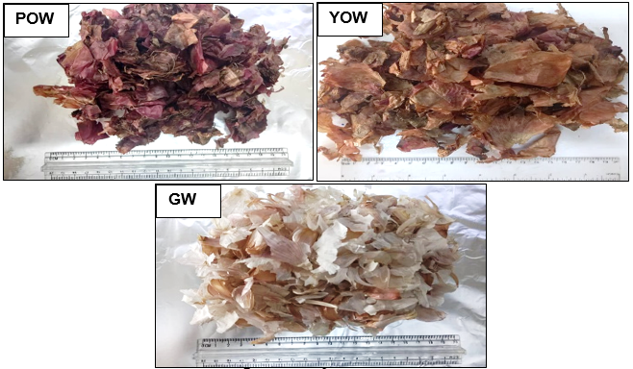
Fig. 1: Allium wastes
POW: pur ple onion waste, YOW: yellow onion waste, GW: garlic waste
2.2 Methods
2.2.1 Sample collection method
Onion samples were collected from three (03) wholesalers and garlic samples from two (02) wholesalers at the Gouro market in Adjamé (Côte d'Ivoire). These samples were placed in jute bags and transported to the Biocatalysis and Bioprocesses Laboratory (LBB) at Nangui ABROGOUA University (UNA). They consisted of various waste products (bulbs, peelings, roots, etc.).
2.2.2 Methods for processing the various samples
Once at the laboratory, the various samples were washed separately with tap water to remove all debris (grains of sand, pieces of wood, insects, etc.). These samples were then drained and dried at the laboratory's ambient temperature (21±2 ºC) for five (5) days.The dry samples were ground using a Multi-purpose Blender, China. The resulting powders were stored in light-proof containers and placed in a dry location.
2.2.3 Biochemical characterization of the different samples
2.2.3.1 Determination of moisture and dry matter content
The moisture and dry matter content of the onion (purple and yellow) and garlic waste powders was determined using the AOAC (1990) method. This method involves evaporating the water contained in the raw material by drying it in an oven at 105°C for three (3) days until a constant mass is achieved. Dry crucibles were used to determine the moisture content and dry matter. Two grams (2g) of sample (Me) were placed in crucibles to obtain a mass (M1). They were then placed in an oven (IBX Instruments, France) at 105°C until the mass was constant. The crucible and dried sample were cooled in a desiccator for one hour (1h), then the mass of the crucible containing the dried sample (M2) was determined. The dry matter and moisture content were determined using the following formulas, respectively:
Moisture (%) =$\frac{M1-M2}{Me}×100$

The dry matter content was calculated using the following expression:
DM (%) = 100 – Moisture (%)

Where:
Me: mass of the sample (g)
M2: mass of the crucible + sample (g)
M2: mass of the crucible + sample dried in an oven (g)
DM: dry matter.

2.2.3.2 Determination of ash content
The ash content of onion (purple and yellow) and garlic (white) waste was determined using the AOAC (1990) method. Mineral matter or ash is the residue obtained after the destruction of organic matter by calcination. Five (5) g of the different dried samples (Me) of onion (purple and yellow) and garlic (white) waste were weighed in a porcelain crucible of known mass (M0). The mixture was then placed in a muffle furnace (CERADEL, Industries) at 550°C for 12 hours. The incinerated sample was placed in a desiccator. The crucible containing the calcined sample was weighed (M1). The ash content was calculated using the following formula:
Ash (%) =$\frac{(M1-M0)}{Me}×100$
Cendres (%) =$\frac{(M1-M0)}{Me}×100$
Cendres (%) =$\frac{(M1-M0)}{Me}×100$
Where:
M0: mass (g) of the empty crucible
Me: mass (g) of the sample
M1: mass (g) of the whole (crucible + ashes) after incineration
2.2.3.3 Determination of total lipids content
The total lipids in onion (purple and yellow) and garlic (white) waste were extracted using the SOXHLET method (AOAC, 1990) with hexane as the organic solvent from the dry matter of each sample. Five (5) g (Me) of dry matter from each sample was placed in a WHATMAN cellulose cartridge. A volume of 200 mL of hexane was placed in a pre-weighed extraction flask (M0). The flask containing the hexane was placed on the heating cap for eight (8) hours for complete lipid extraction. After this extraction time, the flask was removed from the SOXHLET and the hexane was evaporated on a rotary evaporator (HEILDOLPH Laborata 4003 Control, Schwabach, Germany) at 100ºC for 20 min to evaporate any traces of solvent. After cooling for five (5) minutes in the desiccator, the flask was reweighed (M1). The lipid content expressed as a percentage was determined using the following equation:
Total Lipids (%) =$\frac{(M1-M0)}{Me}×100$
Where:
M0: Mass in grams (g) of the empty flask.
Me: Mass in grams (g) of the sample.
M1: Mass in grams (g) of the whole (flask + lipid after incineration).
2.2.3.4 Determination of total protein content
The protein content of the different samples of onion waste (purple and yellow) and garlic waste (white) was estimated using the Kjeldahl method (AOAC, 1990). A sample of 1 g of crushed onion (purple and yellow) and garlic (white) waste was heated to 400°C for 150 min in the presence of a pinch of the catalyst mixture [selenium + potassium sulfate (K2SO4)] and 20 ml of sulfuric acid (H2SO4) 95-97%. The mineralized sample was made up to 60 mL with distilled water. Then, 50 mL of soda (40%, w/v) was added. This mixture was brought to a boil in a LEGALLAIS distiller. The ammonia released was trapped in a measuring vessel containing ten (10) mL of a mixture of boric acid (4%, w/v) with a mixed indicator (methyl red + bromocresol green) at pH 4.4-5.8. The titration was then carried out using a sulfuric acid solution (0.1N). A blank was performed under the same conditions as the test. The protein content of each sample was determined using the following equation:
Total Protein = $\frac{(V1-V0)×14×6.25×N×100}{1000×Me}$
Where:
V0: volume (mL) of sulfuric acid solution poured for the blank test.
V1: volume (mL) of sulfuric acid solution poured for the test (samples)
Me: mass (g) of the sample
N: normality of the sulfuric acid solution: 0.1N
14.007: atomic mass of nitrogen (g/mol)
6.25: Conversion coefficient of nitrogen to protein
2.2.3.5 Determination of crude fiber content
The crude fiber content of onion (purple and yellow) and garlic (white) waste was determined using the AOAC (1990) method. A mass of two (2) g (Me) of each dried and ground sample of onion (purple and yellow) and garlic (white) waste was weighed into a flask containing 50 mL of 0.25 N sulfuric acid. The mixture was homogenized and boiled for 30 min under reflux. Next, 50 mL of 0.31 N sodium hydroxide was added to the contents of the flask, which was brought to a boil again for 30 min under reflux. The extract obtained after boiling was filtered through Whatman No. 4 filter paper, and the residue was washed several times with hot water until the alkali was completely removed. The residue was dried in an oven (IBX Instruments, France) at 105°C for 8 hours. It was then placed in a desiccator, weighed (M1), and incinerated in a muffle furnace (CERADEL, Industries) at 550°C for 3 hours. The ashes obtained were weighed (M2). The crude fiber content of the samples was calculated using the following equation:
Crude Fiber (%) =$\frac{(M1-M2)}{Me}×100$
Fibre brute (%) =$\frac{(M1-M2)}{Me}×100$
Where:
M1: mass (g) of dried residue
M2: mass (g) of ash obtained
Me: mass (g) of sample
2.2.3.6 Determination of total carbohydrates content
Total carbohydrates were determined by estimation using the following relationship described by the FAO (2002).
Carb (%) = 100-[Mois (%)+Prot (%) + Lip (%) + Fib (%) + Ash (%)]
Gluc(%) = 100-[hum(%)+prot (%) + lip (%) + fib (%) + cen (%)]
Where:
Mois: moisture content
Prot: total protein content
Lip: total lipids content
Carb: carbohydrate content
Ash: ash content
Fib: Crude fiber content
2.2.3.7 Determination of energy value
The energy value was calculated according to FAO (2002) using the following equation:
Energy Value (kcal/100g) = 2.44 Prot (%) + 8.37 Lip (%) + 3.57 Carb (%)
Where 2.44, 8.37 and 3.57 are the specific energy factors for protein, lipids, and carbohydrates, respectively.
With:
Prot: total protein content
Lip: total lipids content
Carb: carbohydrate content
2.2.4 Phytochemical characterization and antioxidant activities of the different samples
2.2.4.1 Preparation of aqueous and hydro-ethanolic extracts
The preparation of aqueous and hydro-ethanolic extracts was carried out according to the method of Zihiri et al. (2003). A quantity of 100 g of powder from the different samples was dissolved in either 1.5 L of distilled water or 1.5 L of 80% ethanol, for the aqueous and hydro-ethanolic extracts, respectively. The different mixtures were then homogenized 10 times in a blender (Multi-purpose Blender, China) for two (2) minutes with 20-second stops after each cycle (at the same speed). The homogenates obtained were filtered through a clean white cloth and then pressed to collect the filtrates in clean containers. These filtrates were filtered twice (2) successively with cotton wool placed at the end of the funnels and once with filter paper. The filtrates obtained were evaporated in an oven (IBX Instruments, France) at 50°C for 48 hours. The powders obtained represent the dry aqueous and hydro-ethanolic extracts. They were collected and stored in jars in the refrigerator (4°C).
2.2.4.2 Reconstitution of extracts
To reconstitute the extracts, 500 mg of each dry extract (aqueous or hydro-ethanolic) from the different samples was suspended in 25 mL of extraction solvent (distilled water or 80% hydro-ethanolic solution).
2.2.4.3 Total polyphenol content (TPC)
The total polyphenol content of onion (purple and yellow) and garlic waste was determined using the method described by Singleton et al. (1999). A volume of 0.5 mL of each extract (aqueous or hydro-ethanolic) was added to 0.5 mL of Folin Ciocalteu reagent (10%) in test tubes. The mixtures were vigorously homogenized by manual shaking for two (2) min at room temperature, then left to stand on the bench for three (3) min. A volume of 0.5 mL of an aqueous sodium carbonate solution (20%, w/v) was added and the volume was adjusted to five (5) mL with distilled water. The tube was then placed in the dark for 30 min. The optical density was read on a spectrophotometer (MS-A 5100 Spain) at 725 nm against a blank in which the extract was replaced by distilled water. Finally, a range of gallic acid concentrations from 0 to 0.1 mg/mL was prepared for the calibration curve. The total phenolic compound content was expressed in mg gallic acid equivalent (GAE)/g.
2.2.4.4 Total Flavonoid content (TFC)
The flavonoid content of the different onion (purple and yellow) and garlic waste products was determined using the method described by Meda et al. (2005) using aluminum chloride. To a volume of 0.5 mL of each extract (aqueous or hydro-ethanolic), 0.5 mL of distilled water, 0.5 mL of aluminum chloride (10% w/v), 0.5 mL of sodium acetate (1 M), and two (2) mL of distilled water were added successively. The tubes were then left to stand for 30 min at room temperature. The optical density was read using a spectrophotometer (MS-A 5100, Spain) at 415 nm against a blank consisting of 0.5 mL of extract and 3.5 mL of distilled water. Finally, a range of quercetin concentrations from 0 to 1 mg/mL was prepared for the calibration curve. The results were expressed in mg quercetin equivalent (QE)/g.
2.2.4.5 Total Tannin content (TTC)
The tannin content of the different onion (purple and yellow) and garlic (white) waste products was determined using the method described by Bainbridge et al. (1996). A volume of 0.5 mL of each extract (aqueous or hydro-ethanolic) was taken. To this volume, 2.5 mL of vanillin reagent (0.01 mg/mL vanillin in 70% sulfuric acid (v/v)) was added. Each tube was left to stand for 20 min in the dark and the optical density was read at 500 nm using a spectrophotometer (MS-A 5100, Spain) against the blank in which the extract was replaced by distilled water. Finally, a range of catechin concentrations from 0 to 1 mg/mL was prepared for the calibration curve. The results were expressed in mg catechin equivalent (CE)/g.
2.2.4.6 Evaluation of antioxidant activity using the ferric reducing antioxidant power (FRAP) test.
The FRAP method is based on the reduction of ferric ion (Fe3+) to ferrous ion (Fe2+). This method evaluates the reducing power of compounds (Dieng et al., 2017).
In practice, the reducing power of extracts from onion (yellow and purple) and garlic waste samples was determined using the method described by Ferreira et al. (2007). To a test containing 0.1 mL of prepared sample extract, two (2) mL of phosphate buffer (0.2M, pH 6.6) were added, followed by two (2) mL of 1% (m/v) potassium hexacyanoferrate [K3Fe (CN)6]. The mixture was incubated at 50°C in a water bath for 20 minutes, then cooled. Two (2) mL of 10% (m/v) trichloroacetic acid (TCA) was then added and the mixture was centrifuged at 3000 rpm for ten (10) minutes using a centrifuge (SIGMA 3-16KL, Germany). Finally, two (2) mL of the supernatant were mixed with two (2) mL of distilled water and 0.4 mL of ferric chloride [FeCl3] (1 g/L). The mixture was placed in the dark for 30 min. The absorbance was measured at 700 nm against the blank, for which the extract was replaced by distilled water. Finally, a range of Trolox concentrations from 0 to 100 µg/mL was used for the calibration curve. The results were expressed in mg Trolox/g.
2.2.4.7 Evaluation of antioxidant activity by DPPH (1,1-diphenyl-2-picrylhydrazyl) radical scavenging
Antioxidant assay was carried out using the 2,2-diphenyl-1-pycrilhydrazyl (DPPH) spectrophotometric method outlined by Choi et al. (2002). At different concentrations (0 to 0.5 mg/mL) of extracts (aqueous or hydro-ethanolic) of onion (yellow and purple) and garlic waste, two (2) mL were added to one (1) mL of an ethanolic solution of DPPH (3 mM). The mixture was shaken vigorously and left to stand for 30 minutes in the dark. The reduction of DPPH was determined by measuring the absorbance at 517 nm. A control was performed by also measuring the absorbance of the DPPH solution (3 mM). The antioxidant activity of each sample extract, as indicated by the decolorization of the DPPH solution, was calculated as a percentage of reduction using the following equation:
Percentage reduction (%) =$\frac{Acontrol-Asample}{Acontrol}×100$
Where:
A_{Control}=Absorbance of the DPPH ethanol solution (3mM)
Pourcentage de réduction (%) =$\frac{Acontrôle-Aéchantillon}{Acontrôle}×100$
A_{Sample}=Absorbance of the DPPH solution reduced by the sample extract
The curve showing the evolution of the concentrations of the extracts from each sample as a function of the percentages of DPPH radical inhibition was used to determine the 50% reduction concentration (RC50). This parameter is defined as the concentration of antioxidant required to reduce the initial DPPH concentration by 50%.
2.2.4.8 Measurement of the antioxidant activity index
The antioxidant activity index (AAI) of the extracts from the different onion (yellow and purple) and garlic samples was calculated using the method described by Scherer & Godoy (2009) according to the following equation:
AAI =$\frac{\left[DPPH\right]final}{RC50}$
Where:
[DPPH]_{final} = final concentration of DPPH
RC50 = 50% reduction concentration of the DPPH radical
2.2.4 Statistical analyses
The analyses of the biochemical and phytochemical compounds of the samples of the different onion and garlic waste were carried out in three trials. EXCEL 2013 software was used to plot curves and graphs and to calculate means and standard deviations. A one-way analysis of variance (ANOVA I) followed by Duncan's and Tukey's tests were used to compare the means of the biochemical and antioxidant parameters, respectively. All analyses of the data collected on biochemical and antioxidant parameters were processed using STATISTICA 7.1 software. The comparison of means was made at a significance level of 5%.
In addition, a principal component analysis (PCA) was also performed using STATISTICA (version 7.1) to group the different samples according to their nutritional potential on the one hand and their phytochemical and antioxidant potential on the other.

3. results and discussion

3.1 Result
3.1.1 Biochemical composition of onion and garlic waste
Analysis of the results reveals that the values of all parameters differ significantly (p ≤ 0.05) between the different samples (Table 1). In general, the highest levels of total lipids (1.34%), ash (8.42%), protein (6.97%), total carbohydrates (38.34%), and energy value (165.13 kcal/100g) are observed in purple onion waste. However, garlic waste has the highest dry matter (86.94%) and crude fiber (44.03%) contents.
Table 1. Biochemical properties and energy values of garlic and onion (yellow and purple) peelings
Paramters | POW | YOW | GW
Dry Matter (%) | 82.48 ± 0.07ª | 80.00 ± 0.03^{b} | 86.94 ± 0.05^{c}
Total Lipids (%) | 1.34 ± 0.03ᶜ | 0.95 ± 0.03ᵃ | 1.09 ± 0.03ᵇ
Ash (%) | 8.42 ± 0.06ᶜ | 7.94 ± 0.15ᵇ | 7.15 ± 0.07ᵃ
Crude Fiber (%) | 27.41 ± 0.30ᵃ | 29.01 ± 0.01ᵇ | 44.03 ± 0.64ᶜ
Total Protein (%) | 6.97 ± 0.05ᶜ | 5.32 ± 0.00ᵇ | 2.98 ± 0.00ᵃ
Total Carbohydrates (%) | 38.34 ± 0.26ᶜ | 36.78 ± 0.17ᵇ | 31.52 ± 0.44ᵃ
Energy Value (kcal /100g) | 165.13 ± 1.20ᶜ | 152.28 ± 0.38ᵇ | 128.96 ± 1.45ᵃ
POW: purple onion waste, YOW: yellow onion waste, GW: garlic waste
Tests: n=3; means ± standard deviation marked with different lowercase letters on the same line are significantly different at p ≤ 0.05 according to Duncan's test.

3.1.2 Principal component analysis (PCA) of biochemical compounds in onion and garlic waste
Principal component analysis (PCA) of biochemical compounds shows the reduction of seven (07) measured variables (dry matter, total lipids, ash, crude fiber, protein, total carbohydrates, and energy value) in the different Allium samples into two (02) principal components (F1 and F2) (Figure 2). The F1 axis explains 82.11% of the total variation, while the F2 axis explains 17.89%. In short, F1 and F2 together explain 100% of the measured variables. Furthermore, most variables are negatively correlated with the F1 axis. The graphical representation of the characteristics studied and the samples is produced in the plane formed by the F1 and F2 components. It highlights three (3) major groups of Allium. Group 1, which consists of purple onion shoots, is richer in ash, protein, total carbohydrates, and has a high energy value. On the other hand, garlic shoots, which make up group 2, are richer in dry matter and crude fiber. Unlike the other two groups, group 3, composed of yellow onion shoots, has characteristics that are intermediate between the other two groups.
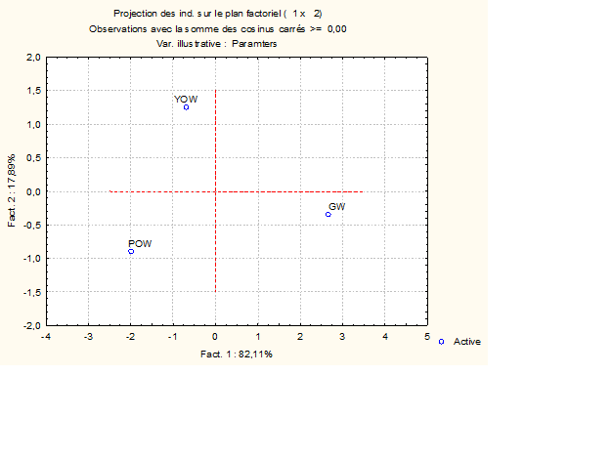
A
B

Fig. 2: Projection of the biochemical parameters and Allium waste studied in the 1-2 factorial plan of the principal component analysis
A= Projection of variables, B= Projection of individuals
YOW: yellow onion waste, POW: purple onion waste, GW: garlic waste, DM: Dry Matter, Pro: total protein content, Lip: total lipids content, Carb: carbohydrate content, Ash: ash content, Fib: Crude fiber content, EV: Energy Value

3.1.3 Phytochemical composition and antioxidant activities of onion and garlic waste
3.1.3.1 Phytochemical composition
The phytochemical composition (total polyphenols, flavonoids, and tannins) of hydro-ethanolic and aqueous extracts of onion and garlic waste shows a significant difference at the 5% threshold (Figure 3). However, the highest values are observed in the hydro-ethanolic extracts. The total polyphenol content of the hydro-ethanolic extracts is 45.51 mg GAE/g for yellow onion waste, 44.42 mg GAE/g for purple onion waste, and 12.89 mg GAE/g for garlic waste. The same is true for flavonoid content, which is 106.74 mg QE/g for yellow onion waste, 84.40 mg QE/g for purple onion waste, and 30.48 mg QE/g for garlic waste. Finally, the same observations can be made for hydro-ethanolic extracts of tannins, which have levels of 12.90 mg EC/g for yellow onion waste, 9.76 mg CE/g for purple onion waste, and 5.23 mg CE/g for garlic waste.

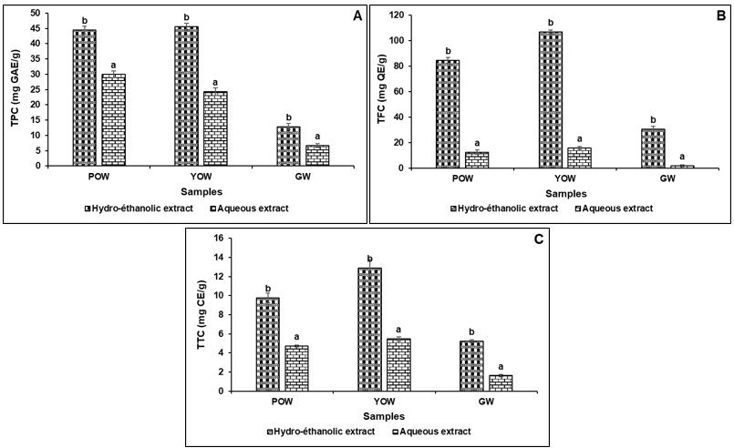
Figure 3: Total polyphenol (A), flavonoid (B), and tannin (C) content of extracts (hydro-ethanolic and aqueous) from onion (purple and yellow) and garlic wastes
POW: purple onion waste, YOW: yellow onion waste, GW: garlic waste, TPC : Total polyphenol content, TFC : Total Flavonoid content, TTC : Total Tannin content
Tests: n = 3; Tukey's test indicates that histograms labeled with distinct lowercase letters differ significantly at p ≤ 0.05.

3.1.3.2 Antioxidant activity through DPPH radical scavenging (1,1-diphenyl-2-picrylhydrazyl)
Analysis of the results shows that, in general, the percentage reduction in the DPPH radical increases proportionally with the concentration of hydro-ethanolic and aqueous extracts from the different onion and garlic samples (Figure 4). However, the increase in this percentage is higher for hydro-ethanolic extracts compared to aqueous extracts.
Furthermore, the DPPH reduction concentrations (CI50) of the various hydro-ethanolic extracts of the purple onion (0.001 mg/mL), yellow onion (0.039 mg/mL), and garlic (0.039 mg/mL) samples are lower than those of the aqueous extracts (Table 2). Conversely, the antioxidant activity indices (AAI) of the hydro-ethanolic extract are higher, with values of 26.125 for the hydro-ethanolic extract of purple onion waste, 0.389 for the hydro-ethanolic extract of yellow onion waste, and 0.070 for the hydro-ethanolic extract of garlic waste.
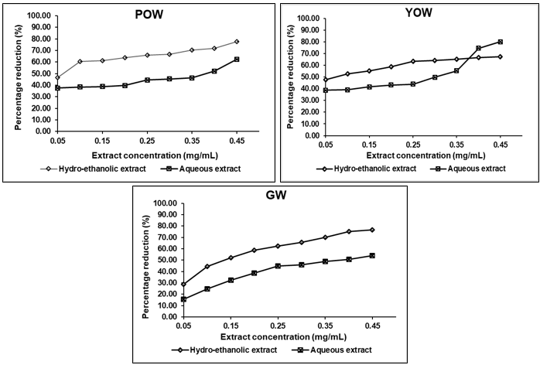
Fig. 4. Change in the percentage reduction of the DPPH radical as a function of the concentration of extracts (hydro-ethanolic and aqueous) from onion (yellow and purple) and garlic wastes
POW: purple onion waste, YOW: yellow onion waste, GW: garlic waste
Table 2. 50% reducing concentration (RC50) of the DPPH radical and antioxidant activity index (AAI) of extracts from onion (purple and yellow) and garlic wastes
Samples | Type of extract | RC50 (mg/mL) | AAI
POW | Hydro-éthanolic extract | 0.001 | 26.125
POW | Aqueous extract | 0.345 | 0.051
YOW | Hydro-éthanolic extract | 0.039 | 0.389
YOW | Aqueous extract | 0.234 | 0.077
GW | Hydro-éthanolic extract | 0.215 | 0.070
GW | Aqueous extract | 0.416 | 0.035
POW: purple onion waste, YOW: yellow onion waste, GW: garlic waste
3.1.3.3 Antioxidant activity using the ferric reducing antioxidant power (FRAP) test
The results of the antioxidant activity using the ferric reducing antioxidant power (FRAP) test reveal higher levels for the hydro-ethanolic extracts of the different samples (Figure 5). These values are 36.65 mg trolox/g for yellow onion waste, 37.49 mg trolox/g for purple onion waste, and 28.89 mg trolox/g for garlic waste.

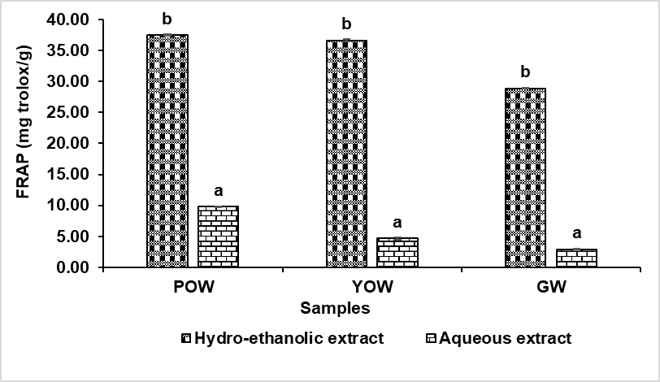
Fig. 5. Antioxidant activity measured by the ferric reducing antioxidant power (FRAP) test of the ethanol and aqueous extracts of the different samples
POW: purple onion waste, YOW: yellow onion waste, GW: garlic waste
Tests: n = 3; Tukey's test indicates that histograms labeled with distinct lowercase letters differ significantly at p ≤ 0.05.

3.1.3.4 Principal component analysis (PCA) of phytochemical compounds in onion and garlic waste
Principal component analysis (PCA) reduces the six (06) measured variables (PR, IAA, FRAP, total polyphenols, flavonoids and tannins) in the different Allium samples to two (02) principal components (F1 and F2) (Figure 6). The F1 axis explains 80.37% of the total variation, while the F2 axis explains 11.76%. In short, F1 and F2 together explain 92.13% of the measured variables. Furthermore, almost all of the variables studied are negatively correlated with the F1 axis. The graphical representation of the characteristics studied and the samples is produced in the plane formed by the F1 and F2 components. It highlights two (2) major groups of Allium. Group 1 is distinguished by a richness of the six (6) variables measured, consisting of ethanol extracts of purple onion (POWeth) and yellow onion (YOWeth). Group 2, which includes the ethanol extract of garlic (GWeth) and the aqueous extracts of purple onion (POWaq), yellow onion (YOWaq), and garlic (GWaq), is characterized by a general paucity of measured variables.
A
B

Fig. 6: Projection of phytochemical parameters and ethanol and aqueous extracts from Allium waste studied in the 1-2 factorial plan of principal component analysis
A= Projection of variables, B= Projection of individuals
RC50 = reduction concentration; AAI = antioxidant activity index; FRAP = iron reduction power; TPC = Total polyphenols content; TFC = Total flavonoid content; TTC = Total tannin Content; POWaq =aqueous extract of purple onion waste; POWeth =ethanolic extract of purple onion waste; YOWaq =aqueous extract of yellow onion waste; YOWeth =ethanolic extract of yellow onion waste, GWaq = aqueous extract of garlic waste; GWeth = ethanolic extract of garlic waste;

3.1 Discussion
The dry matter content of food and agricultural by-products represents the fraction of nutrients present in the matrix. As a result, the high dry matter content (80-86.94%) of onion and garlic waste explains their high nutrient content. Furthermore, the levels recorded are consistent with values ranging from 85 to 88% and 77 to 82% in dried garlic and onion peelings, respectively (Benítez et al., 2011; Sharma et al., 2019).
The ash content of foods represents the proportion of minerals in a food matrix. The ash contents (7.15-8.42%) recorded in this study are higher than the value of 6.70% found by Sharma et al. (2019) in garlic peelings. As a result, these onion and garlic waste products could be important sources of minerals for the formulation of food supplements and organo-mineral fertilizers.
The crude fiber content (27.41–44.03%) of onion and garlic waste is lower than the value of 62.10% found by Azmat et al. (2023) in garlic peelings. However, they are close to the 38.61% found by Sharma et al. (2019). This difference may be due to the variety or the method of analysis used. Nevertheless, these results show that garlic and onion waste are fiber-rich by-products that could therefore open the way to numerous industrial applications. They could be used as ingredients to enrich functional foods such as specialty breads and dietetic biscuits with fiber. In addition, they could be used as thickeners, gelling agents, and texturizers (Yangilar, 2013). Furthermore, the low energy value (128.96-165.13 kcal/100g) of these waste products would be beneficial in the development of low-calorie diet foods suitable for obese, overweight, and diabetic individuals.
Phenolic compounds are attracting growing interest for their applications in many fields such as pharmaceuticals (antimicrobial, anticholesterolemic, anticancer), agri-food (natural preservatives, natural colorants) and pharmacology. However, the extraction of these biomolecules is strongly influenced by the nature of the solvent (Assanvo et al., 2023). This observation is consistent with the results of the present study. Indeed, this study showed that the phenolic compound content (total polyphenols, flavonoids, and tannins) of hydro-ethanolic extracts from onion and garlic waste is higher than that of aqueous extracts. The positive influence of 70% ethanol could be explained by its high polarity, which plays a very important role in the solubilization of polyphenols (Bouterfas et al., 2014). These results corroborate those of Sy et al. (2018) and Assanvo et al. (2023), who found that ethanol concentrations between 60 and 80% are better extractors of phenolic compounds. Furthermore, the high antioxidant activity of hydro-ethanolic extracts could be explained by their strong correlation with phenolic compounds. Indeed, a molecule's ability to trap free radicals is linked to chemical compounds that can easily donate an electron or a proton. It is therefore proportional to the phenolic compound content of plants (Bamba et al., 2021). In addition, the high activity of purple onions is confirmed by the study by Benítez et al. (2011). As a result, onion and garlic waste extracts can be used in the production of natural medicines, bio-preservatives for edible oils, and many foods intended for people suffering from metabolic diseases.
4. Conclusion

At the end of this study, it appears that Allium waste (onions and garlic) has high levels of macronutrients such as fiber and ash with low energy value. However, purple onion waste is the richest in nutrients. -------
Furthermore, analysis of phytochemical compounds showed that hydro-ethanolic extracts of onions and garlic are excellent sources of total polyphenols, flavonoids, tannins, and natural antioxidants.
Thus, the use of agricultural by-products such as onion and garlic waste offers advantages for environmental preservation and the creation of high-nutritional-value foods suitable for people with metabolic diseases.

DISCLAIMER (ARTIFICIAL INTELLIGENCE)
Author(s) hereby declare that no generative AI technologies such as Large Language Models (ChatGPT, COPILOT, etc) and text-to-image generators have been used during writing or editing of this manuscript.

References

ANAGED, (2017). Decree No. 2017-692 of October 25, 2017, establishing the creation, powers, organization, and operation of the public industrial and commercial establishment known as the National Waste Management Agency (ANAGED). https://anaged.net/wp-content/uploads/2022/08/DECRET-ANAGED-FINAL3.pdf. 8P.
AOAC (1990).Official methods of Analysis.WashingtonDC. Association of Official Analytical Chmists (15thEd.).771 p.
Assanvo, B. J-A., Disseka, W. K., Djina, Y., N’gbo, M. L. K., Dayoro, K. S. V., & Faulet-Ahonzo M. B. (2023). Effect of individual factors on the extraction of phenolic compounds from turmeric rhizomes (Curcuma longa) and moringa leaves (Moringa oleifera). World Journal of Advanced Research and Reviews, 20(01), 650–659
Azmat, F., Imran, A., Islam, F., Afzaal, M., Zahoor, T., Akram, R., ... & Asif Shah, M. (2023). Valorization of the phytochemical profile, nutritional composition, and therapeutic potentials of garlic peel: a concurrent review. International Journal of Food Properties, 26(1), 2642-2655.
Bainbridge, Z., Tomlins, K., Wellings, K., & Westby, A. (1996). Methods for assessing quality characteristics ofnon-grain starch staples.Natural Resources Institute: pp.1-32.
Bamba, B., Benie, C. K. D., Ouattara, A., Doukourou, D. N., Kamou, R. K., & Ouattara, K. (2021). Total phenolic contents and antioxidant activities of macerates and decoctions of the leaves of Uvaria chamae P. Beauv. (Annonaceae). International Journal of Biological and Chemical Sciences, 15(1), 54-67.
Benítez, V., Mollá, E., Martín-Cabrejas, M. A., Aguilera, Y., López-Andréu, F. J., Cools, K., & Esteban, R. M. (2011). Characterization of industrial onion wastes (Allium cepa L.): dietary fibre and bioactive compounds. Plant Foods for Human Nutrition, 66(1) : 48–57
Bouterfas K, Mehdadi Z, Benmansour D, Khaled MB, Bouterfas M, Latreche A. Optimization of extraction conditions of some phenolic compounds from white horehound (Marrubium vulgare L) leaves. International Journal of Organic Chemistry; 4(05) : 292-308.
Choi, C. W., Kim, S. C., Hwang, S. S., Choi, B. K., Ahn, H. J., Lee, M. Y., ... & Kim, S. K. (2002). Antioxidant activity and free radical scavenging capacity between Korean medicinal plants and flavonoids by assay-guided comparison. Plant science, 163(6), 1161-1168.
Dieng, S. I. M., Fall, A. D., Diatta-Badji, K., Sarr, A., Sene, M., Sene, M., Mbaye, A., Diatta, W., & Bassene, E. (2017). Evaluation of the antioxidant activity of hydro-ethanolic extracts of the leaves and bark of Piliostigma thonningii Schumach. International Journal of Biological and Chemical Sciences, 11(2), 768-776.
FAO, 2002. Food energy-methods of analysis and conversion factors. FAO Ed, Rome, pp: 97.
Gambogou, B., Ameyapoh, Y. A., Gbekley, H. E., Soncy, K., Anani, K., & Karou, S. D. (2019). Review on Garlic and its Bioactive Compounds. European Scientific Journal February, 15(6), 74-90.
Gorrepati, K., Kumar, A., Ahammed, S. T. P., Khan, Z., Satpute, P., Anandhan, S., Arunachalam, T., Yalamalle, V. R., Mahajan, V., Singh, M (2024) Characterization and evaluation of antioxidant potential of onion peel extract of eight differentially pigmented short-day onion (Allium cepa L.) varieties. Frontiers in Sustainable Food Systems. 8:1469635.
Konate, M., Parkouda, C., Tarpaga, V., Guira, F., Rouamba, A., & Sawadogo–Lingani, H. (2017). Evaluation of the nutritional potential and the conservation capacity of eleven varieties of bulb onion (Allium cepa L.) introduced in Burkina Faso. International Journal of Biological and Chemical Sciences, 11(5), 2005-2015.
Meda, A., Lamien, C. E., Romito, M., Millogo, J., & Nacoulma, O. G. (2005). Determination of the total phenolic, flavonoid and proline contents in Burkina Fasan honey, as well as their radical scavenging activity. Food chemistry, 91(3), 571-577.
Ola-Mudathir, F. K., Wahab, A. A., Moshood, A. I., & Obuotor, E. M. (2018). Comparative Evaluation of Antioxidant Properties of Methanol Extracts of Allium cepa bulb, Allium cepa bulb peels and Allium fistulosum. Kragujevac Journal of Science, 40 (2018) 131-141.
Paesa, M., Nogueira, D. P., Velderrain-Rodríguez, G., Esparza, I., Jiménez-Moreno, N., Mendoza, G., Osada, J., Martin-Belloso, O., Rodríguez-Yoldi M. J., & Ancín-Azpilicueta, C. (2022). Valorization of onion waste by obtaining extracts rich in phenolic compounds and feasibility of its therapeutic use on colon cancer. Antioxidants, 11(4), 733.
Scherer, R.; & Godoy, H.T (2009). Antioxidant activity index (AAI) by the 2,2-diphenyl-1-picrylhydrazyl method. Food Chemistry. 112, 654–658, https://doi.org/10.1016/j.foodchem.2008.06.026.
Sharma, K., Ko, E. Y., Assefa, A. D., Ha, S., & Nile, S. H. (2019). Compositional characterization and bioactive properties of garlic (Allium sativum L.) skin: A potential food waste resource. Food Chemistry, 282, 156–164.
Singleton V. L., Orthofer R. & Lamuela-Raventós R. M. (1999). Analysis of total phenols and other oxidation substrates and antioxidants by means of folin-ciocalteu reagent. In Methods in enzymology, (299), 152-178
Sy, A. N., Dior-Fall, A., Ndiaye, M., Ndiaye, K., Gueye, R. S., Bassene, E., Dieye A. M., & Sy, G. Y. (2018). Evaluation of the antioxidant activity of Moringa oleifera Lam.(Moringaceae) leaves from Senegal. International Journal of Biological and Chemical Sciences, 12(4), 1816-1823.
Tresina, P. S., Selvam, M. S., Doss, A., & Mohan, V. R. (2022). Antidiabetic bioactive natural products from medicinal plants. Studies in Natural Products Chemistry, 75, 75-118.
Tridge (2025) - Global Food Sourcing & Data Hub. https://www.tridge.com/ (accessed on 01-07-2025)
Yangilar, F. (2013). The application of dietary fibre in food industry: structural features, effects on health and definition, obtaining and analysis of dietary fibre: a review. Journal of food and nutrition research, 1(3), 13-23.
Zirihi, G. N., Kra, A. K. M., & Guédé-Guina, F. (2003). Evaluation of the antifungal activity of Microglossa pyrifolia (Lamarck O. KuntzeAsteraceae) “PYMI” on the in vitro growth of Candida albicans. Journal of African Medicine and Pharmacopoeias, 17(3), 11-19.

