Standardization of Levels of Mahua Pulp (Fresh and Dried), Semolina, Guar Gum for Development of Pasta Using Response Surface Methodology (RSM) Technique

Abstract
This review examines recent breakthroughs in utilizing mahua flowers for culinary and medicinal purposes, exploring their potential for future value addition. The present study aimed to develop nutrient-rich pasta from mahua flower pulp, leveraging its nutritional value The research demonstrates that fortified pasta with sun-dried and fresh Mahua flower pulp possesses an excellent nutritional profile, Optimal ingredient ratios for producing high-quality, acceptable pasta were identified. The RSM approach was used to optimize ingredients in the pasta production using four factors as responses, for dried Mahua flower pulp, the ideal ratios are Mahua (15%), Guar gum (8g), oil (16ml), and salt (4g). For fresh Mahua flower pulp, the optimal ratios are Mahua (10%), Guar gum (10g), oil (12ml), and salt (5g). These formulations yield pasta products with superior nutritional value and sensory attributes, making them ideal for consumption. The model also explains the effect of ingredients on pasta characteristics.
Keywords: Mahua flower pulp, pasta, RSM
INTRODUCTION

Pasta is a beloved and versatile ready-to-cook cereal food, cherished globally and liked by the consumers of all age groups, because of its ease of preparation and serving, low cost, flexibility, sensory qualities, and extended shelf life. (Bergman et al.,1994). While pasta plays an integral role in regular diet, but its regular consumption can lead to nutritional deficiencies due to its limited nutritional profile, which lacks essential vitamins, minerals, and fibre. (Saraswathi and Sahul Hameed. 2018) Pasta products have developed into improve the nutritional quality by the addition of other ingredients like pulses, vegetable and fruit extracts which is help to get the nutritional well-being of the consumers (Bresciani et al. 2022). This shift presents an opportunity to utilize the non-traditional raw materials to increase the nutritional quality of pasta. Among these non-traditional raw materials as mahua represent a rich source of fibre, vitamins, and mineral but their limited availability, perishable nature, and short shelf life have restricted their popularity as a food source among local populations (Mishra B. 2024). This review aims to focus on recent advancements in utilizing mahua flowers as food, and explore their future prospects for value addition.

Method and materials

The experiment was conducted in the Department of Food Science and Technology, College of Agriculture, Jawaharlal Nehru Krishi Vishwavidyalaya, Jabalpur. The materials and methodologies are listed under the headings below.

Experimental material

Fresh and dried mahua flowers was obtained from local farmers of JNKVV Jabalpur, Madhya Pradesh, while semolina, guar gum, oil, salt, and other items were obtained from the local market of Jabalpur, Madhya Pradesh. The department's potable water was utilized to prepare various blends of mahua flower pulp, semolina and other ingredients for pasta development. The prepared pasta was packaged in high-density polyethylene bags sourced from M/s Satyam Plastics, Jabalpur. All chemical reagents used in this study were of standard analytical grade, procured from reputable suppliers including BDH (India), E-Merck, and Sarabhai M. Company. The glassware employed in this study was obtained from Qualigens and Borosil Company, ensuring the use of high-quality materials throughout the research.
Equipment and Machineries
Table 1: Following machines and equipment were used in the research work
Name of equipment | Purpose | Source of Supply
Electronic Weighing Balance | To measure the accurate quantity of raw materials, baking ingredients, chemicals and prepared waffles. | M/S Supreti Traders Shop No 6 Methodist Center,Opp. Kartik Hotel Napier Town, Jabalpur (MP)
Hot air oven | For determination of moisture  content of the samples | M/S J.K. Sales & Promoters Gole Bazaar, Write Town, Jabalpur (M.P.)
Continuous band packaging machine | For storing prepared waffles in polythene. | M/S Supreti Traders Shop No 6 Methodist Center, Opp Kartik Hotel Napier Town, Jabalpur

Methodology
Recipe for making of pasta from refined wheat flour and semolina (control sample).The pasta was formulated using the following ingredients, according to the process described in the Table below:
Table 2: The ingredients and their quantities used to prepare the control pasta are as follows:
S. No. | Ingredients | Quantity
1. | Semolina (g) | 100
2. | Oil (ml) | 5
3. | Guar gum(g) | 2
4. | Salt (g) | 1
5. | Water (ml) | 45
(Launay B. and Lisch LM, 1983)
Chart 1 : Process Flow for Mahua Flower Pasta Production:
Mixing: Combine mahua flower pulp, semolina, oil, salt, guar gum, and water. Mix by hand for 10-15 minutes.
↓
Kneading: Transfer the mixture to a pasta machine and knead.
↓
Extrusion: Extrude the dough using a single-screw extruder.
↓
Dicing: Cut the extruded pasta into the desired size.
↓
Drying: Dry the pasta in an oven at 75°C for 3 hours
↓
. Packing and Storage: Pack and store the dried pasta.
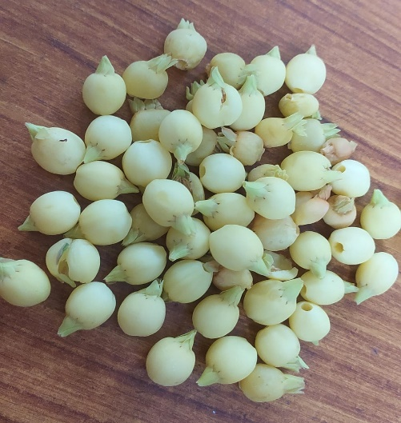 | 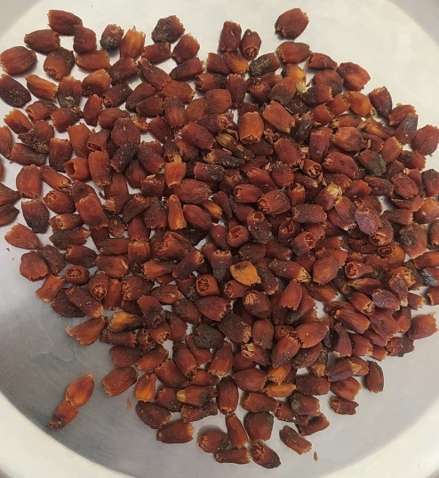
Fresh mahua flower | Dried mahua flower
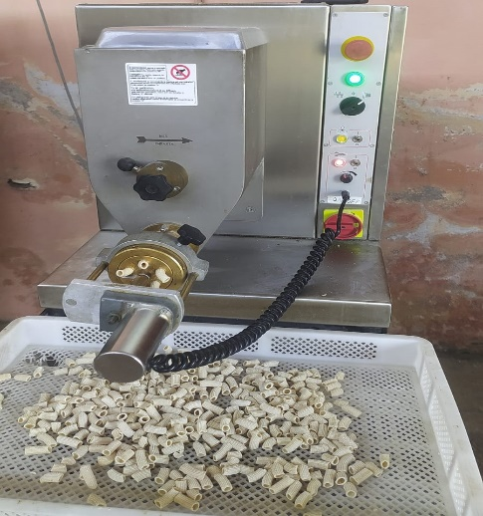 | 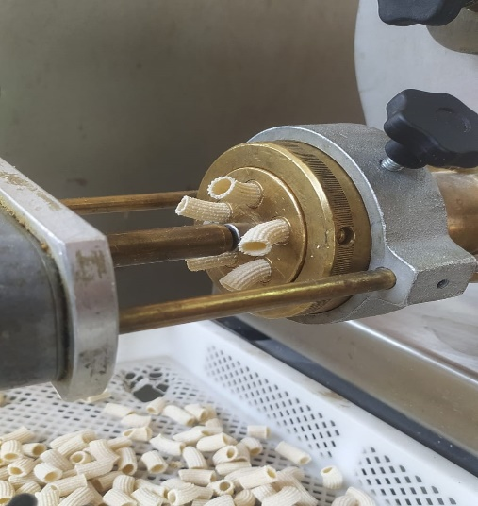
Pasta extruder machine | Extrusion process
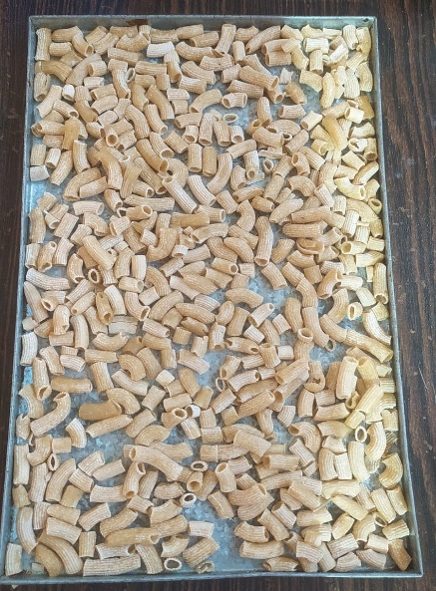 | 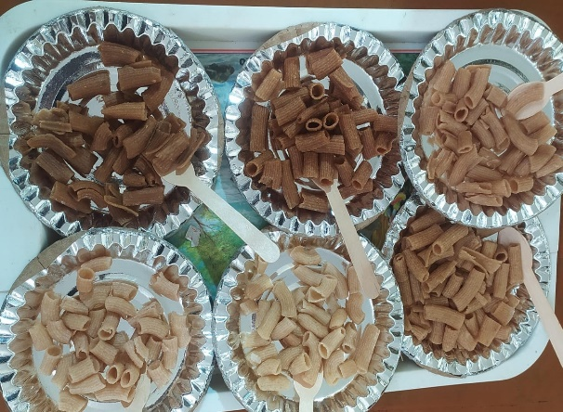
Extrudate pasta | Fresh and Dried pasta after cooking
Fig 1 : Mahua Pasta making process

Experimental Design
For preparation of best-quality mahua flower (fresh and dried) pulp fortified pasta, the levels of mahua flower pulp, semolina, guar gum, oil, and salt will be standardized. The responses surface methodology (Mayer's, 1976) was used to reduce the number of experiments while maintaining the accuracy of the results. The experiment was planned in central composite rotatable the formulation to achieve the best product quality. Thus, four variables were chosen for formulation creation based on information accessible in the literature: Mahua flower (fresh and dried), guar gum, oil, and salt. A half-replicate design with 30 experiments was used. First 16 experiments in first order part, 8 experiments in second order part and next 6 experiments were at central point or replication.

Table:3 Experimental variables their coded and decoded (actual) values for fresh and dried Mahua flower pulp fortified pasta
S. No. | Variables | Unit | Code | Coded Levels
 |  |  |  | -2 | -1 | 0 | +1 | +2
1. | FMF/DMF: Semolina | g | X_{1R} | 10:90 | 15:85 | 20:80 | 25:75 | 30:70
2. | GG | g | X_{2R} | 6 | 8 | 10 | 12 | 14
3. | Oil | ml | X_{3R} | 4 | 8 | 12 | 16 | 20
4. | Salt | g | X_{4R} | 3 | 4 | 5 | 6 | 7
a: ±values, b: center point,FMF: fresh mahua flower, DMF: dried mahua flower, GG: guar gum
Table.4 Experimental design matrix for production of Mahua flower pulp fortified pasta
Coded Form |  |  |  |  | Un-Coded Form
Expt.  No. | X_{1R} | X_{2R} | X_{3R} | X_{4R} | FMF/DMF (g)  X_{1R} | GG  (g)  X_{2R} | Oil  (ml)  X_{3R} | Salt  (g)  X_{4R}
First Order Interaction
1. | -1 | -1 | -1 | -1 | 1 15515 | 88 | 88 | 44
2. | 1 | -1 | -1 | -1 | 25 | 8 | 8 | 4
3. | -1 | 1 | -1 | -1 | 15 | 12 | 8 | 4
4. | 1 | 1 | -1 | -1 | 25 | 12 | 8 | 4
5. | -1 | -1 | 1 | -1 | 15 | 8 | 16 | 4
6. | 1 | -1 | 1 | -1 | 25 | 8 | 16 | 4
7. | -1 | 1 | 1 | -1 | 15 | 12 | 16 | 4
8. | 1 | 1 | 1 | -1 | 25 | 12 | 16 | 4
9. | -1 | -1 | -1 | 1 | 15 | 8 | 8 | 6
10. | 1 | -1 | -1 | 1 | 25 | 8 | 8 | 6
11. | -1 | 1 | -1 | 1 | 15 | 12 | 8 | 6
12. | 1 | 1 | -1 | 1 | 25 | 12 | 8 | 6
13. | -1 | -1 | 1 | 1 | 15 | 8 | 16 | 6
14. | 1 | -1 | 1 | 1 | 25 | 8 | 16 | 6
15. | -1 | 1 | 1 | 1 | 15 | 12 | 16 | 6
16. | 1 | 1 | 1 | 1 | 25 | 12 | 16 | 6
Second Order Interaction
17. | -2 | 0 | 0 | 0 | 1100 | 1010 | 12 | 5
18. | 2 | 0 | 0 | 0 | 30 | 10 | 12 | 5
19. | 0 | -2 | 0 | 0 | 20 | 6 | 12 | 5
20. | 0 | 2 | 0 | 0 | 20 | 14 | 12 | 5
21. | 0 | 0 | -2 | 0 | 20 | 10 | 4 | 5
22. | 0 | 0 | 2 | 0 | 20 | 10 | 20 | 5
23. | 0 | 0 | 0 | -2 | 20 | 10 | 12 | 3
24. | 0 | 0 | 0 | 2 | 20 | 10 | 12 | 7
Centre Point
25. | 0 | 0 | 0 | 0 | 2020 | 10 | 1122 | 5
26. | 0 | 0 | 0 | 0 | 20 | 10 | 12 | 5
27. | 0 | 0 | 0 | 0 | 20 | 10 | 12 | 5
28. | 0 | 0 | 0 | 0 | 20 | 10 | 12 | 5
29. | 0 | 0 | 0 | 0 | 20 | 10 | 12 | 5
30. | 0 | 0 | 0 | 0 | 20 | 10 | 12 | 5

Development of mahua flower fortified pasta
This research aimed to identify the ideal ingredient ratios for producing high-quality pasta fortified with fresh and dried mahua flower pulp, and to explore the impact of these ingredients on the pasta's characteristics. A total of 30 different formulations were created by varying the proportions of dried mahua flower, guar gum, oil, and salt. The dried mahua flower was incorporated at varying levels between 10 to 30 percent (by weight), while guar gum was added at concentrations ranging from 6 to 14 (g/100g), oil from 4 to 20 (ml/100g), and salt from 3 to 7 (g/100g).
Statistical analysis
The data from each trial was analyzed using Design Expert 13 statistical software on HP core i3 processor laptop. Response surface graphs of selected responses were created to investigate the effect of independent factors and optimize ingredient amounts. The results of the experiments are described in the following chapter.
Result and discussion
Response Surface Methodology (RSM) was used to determine the effect of independent variables on certain significant responses, such as physical qualities, proximate composition and sensory characteristics of developed pasta. The central composite design of response surface methodology was used in this work to design a statistical model and to define the optimal level of components for developing pasta. According to the RSM, the best adequate model was a two-factor interaction (2FI) model. The Efficacy of models was tested using F ratio and coefficient of determination (R²).
$$Y= β0+ \sum_{i=1}^{4}{βi Xi+ \sum_{i=1}^{3}{\sum_{j=i+1}^{4}{βij Xi Xj}}}$$
This chapter examines the effects of various ingredients on the product, with focusing on the individual impacts of semolina, mahua flower, guar gum, oil, and salt, respectively.
This research aimed to identify the ideal ingredient ratios for producing high-quality pasta fortified with mahua flower pulp, and to explore the impact of these ingredients on the pasta's characteristics The sensory (colour, appearance, taste, texture) characteristics, proximate (moisture, ash, fat, protein, carbohydrate) analysis and physical properties (diameter, length, thickness, bulk density, optimum cooking time, water absorption capacity, gruel loss) of the developed pasta were Assessed.
In this study, the potential of mahua flower as health food was utilized to improve the nutritional and health benefits of wheat (semolina) based products (pasta). Mahua flowers, rich in natural sugars like glucose, fructose, and sucrose (Mishra & Poonia, 2019), offer a promising opportunity for gluten-free pasta production. Their utilization could provide economic benefits to underprivileged tribal groups (Vishal & Kumar, 2020) and serve as a sustainable alternative to traditional wheat-based pasta (Gomez & Sciarini, 2015). With yields of up to 99 kg per batch and a 1:3 flower-to-water extraction ratio (Patel et al., 1982), mahua flowers are a viable option for large-scale production. Further research is needed to explore the nutritional, sensory, and storage properties of mahua flower-based pasta.
The physical properties of mahua flower pasta were evaluated in terms of bulk density, water absorption capacity (WAC), cooking time, and gruel loss. The bulk density of dried mahua pasta ranged from 0.69-0.89 g/ml, while fresh mahua pasta ranged from 0.7-0.87 g/ml, comparable to findings by (Oduro et al. 2007) in breadfruit flour and wheat flour pasta. The WAC of pasta made from dried mahua pulp ranged from 154.2% to 177.2%, and from 151.2% to 174.2% for fresh mahua pulp, indicating increased water absorption capacity with varying sample compositions. This trend is consistent with (Dayakar Rao Benhur et al.2015), who found increased WAC in sorghum pasta blended with wheat semolina. Cooking times for dried and fresh mahua pasta mixes varied significantly, ranging from 5.45-7.8 minutes and 4.51-6.7 minutes, respectively. Gruel loss in dried mahua fortified pasta ranged from 10.05% to 16.58%, while fresh mahua fortified pasta exhibited losses between 11.5% and 16.96%. Notably, increased oil content significantly reduced gruel loss, consistent with findings by (Espinosa-Solis et al. 2019) in pasta samples prepared with oat bran or apple flour. Further research can optimize formulations and processing conditions to enhance the quality and acceptability of mahua flower pasta.
The sensory characteristics of pasta changed with fresh and dried mahua flower inclusion. Pasta with 10% substitution of semolina achieved the highest score, while 30% substitution received the lowest scores. Similar findings were reported by (Kulkarni et al. 2012) in finger millet noodles and (Jalgaonkar et al.2016) in pearl millet pasta.
Optimized Values
The RSM approach was used to optimize ingredients in the pasta production using four factors as responses. The ideal pasta formulation was achieved by substituting 25% of the ingredients with dried mahua flower, combined with optimal levels of guar gum (12g/100g), oil (8ml/100g), and salt (6g/100g) with 84%desirability. This study demonstrates the viability of using dried mahua flower in pasta production, providing insights into its effects on quality parameters and guiding the optimization of its use in pasta formulations.

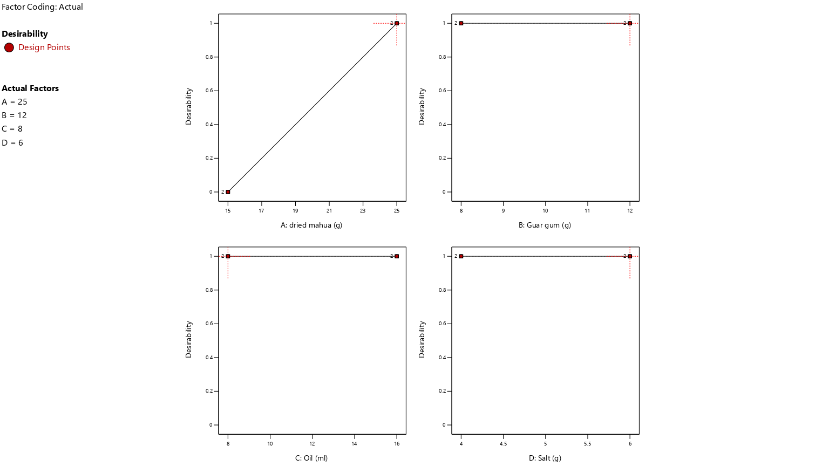
Fig 2 : Desirability of Dried mahua pulp fortified pasta

Conclusion
It was possible to create pasta using Fresh and dried mahua flower. At temperatures between 60°C and 65°C, drying pasta products may be completed in 3.5- 4 hours The incorporation of 15% dried mahua and 10% fresh mahua into pasta has yielded highly acceptable results, balancing nutritional excellence with superior sensory qualities.
The study's findings confirm that the developed models effectively predict the effects of ingredients like Guar gum, oil, salt, and Mahua flower pulp (fresh and dried) on pasta characteristics. The research demonstrates that fortified pasta with sun-dried and fresh Mahua flower pulp possesses an excellent nutritional profile, including high crude protein, crude fat, total ash, carbohydrates, and essential minerals such as zinc and iron. Optimal ingredient ratios for producing high-quality, acceptable pasta were identified. For dried Mahua flower pulp, the ideal ratios are 15% Mahua, 8g Guar gum, 16ml oil, and 4g salt. For fresh Mahua flower pulp, the optimal ratios are 10% Mahua, 10g Guar gum, 12ml oil, and 5g salt. These formulations yield pasta products with superior nutritional value and sensory attributes, making them ideal for consumption

References

- Bergman C. Gualberto D and Weber C. 1994 Development of high temperature dried soft wheat macaroni supplemented with cowpea (Vigna unguiculata (L.) Walp). Cooking quality, colour and sensory evaluation. Cereal Chem 71:523–527.
- Bresciani A, Pagani MA and Marti A. 2022. Pasta-Making Process: A Narrative Review on the Relation between Process Variables and Pasta Quality. Foods, 11: 256.
- Saraswathi R and Sahul Hameed R. 2018. Fortification of Pasta Using Different Plant Sources, Journal of Agricultural Science and Technology, 8: 327-340
- Vishal J and Kumar R. 2020. Mahua: A versatile Indian tree species. Journal of Pharmacognosy and Phytochemistry 9(6): 1926-1931.
- Mishra A and Poonia A. 2019. Mahua (Madhuca longifolia) flowers: review on processing and biological properties. Nutrition & Food Science, doi: 10.1108/NFS-12-2018-0358
- Gomez M, and S Sciarini L. 2015. Gluten-free bakery products and pasta. OmniaScience Monographs, 265.
- Patel JD, Venkataramu K, Subba MS and Rao. 1982. Mahua (Madhuca longifolia Macb) flowers as a raw material for brandy. Journal of Food Science and Technology 19(3): 123-126.
- Launay B. and Lisch LM, 1983. Twin screw extrusion cooking of starches: Flow behavior of starch pastes, expansion and mechanical properties of extrudates. J. Food Eng., 2: 259-280.
- Mishra B. 2024. A Study on Estimation of Phytochemical, Nutrition and the Antioxidant Activity of Dried Madhuca longifolia Flowers. International Journal for Research in Applied Science and Engineering Technology, doi: 10.22214/ijraset.2024.58108
- Jalgaonkar K and Jha SK. 2016. Influence of particle size and blend composition on quality of wheat semolina-pearl millet pasta. Journal of cereal science, 71: 239-245.
- Kulkarni SS, Desai AD, Ranveer RC and Sahoo AK. 2012."Development of Nutrient-Rich Noodles by Supplementation with Malted Ragi Flour." International Food Research Journal, 19(1): 309-313
- Espinosa-Solis V, Zamudio-Flores PB, Tirado-Gallegos J M, Ramírez-Mancinas S, Olivas-Orozco, GI, Espino-Díaz M and Baeza-Jiménez R. 2019. Evaluation of cooking quality, nutritional and texture characteristics of pasta added with oat bran and apple flour. Foods, 8(8): 299.

- Dayakar R, Benhur G, Bhargavi K, Kalpana AD, Vishala KN, Ganapathy JV and Patil. 2015. Development and standardization of sorghum pasta using extrusion technology. Journal of Food Science and Technology-mysore, 52(10): 6828-6833. doi: 10.1007/S13197-015-1801-8
- Oduro I, Ellis WO and Narh ST. 2007. Expanding breadfruit utilization and its potential for pasta production. Discovery and Innovation, 19(special ed. no. (3): 243-247. Panghal A, Kaur R, Janghu S, Sharma P, Sharma P and Chhikara N. 2019. Nutritional, phytochemical, functional and sensorial attributes of Syzygium cumini L. pulp incorporated pasta. Food chemistry, 289: 723-728.

