Original Research Article

Formulation and Physicochemical Characterization of noodles with Foxtail Millet and Sourgham millet noodles

Abstract
The growing demand for functional foods and plant-based dietary options has encouraged the incorporation of underutilized millets and bioactive ingredients in staple food products. In this study, functional noodles were developed by partially replacing refined wheat flour with sorghum and foxtail millet flours, and by incorporating plant-derived hydrocolloids (guar gum and xanthan gum). Six formulations (T0 to T5) were prepared to evaluate the effect of varying millet and functional ingredient proportions on the nutritional, sensory, microbial, and economic attributes of the noodles. Nutritional analysis revealed a significant improvement in protein, dietary fiber, ash, and antioxidant activity across the composite formulations compared to the control (T0). Total carbohydrate content decreased with increasing millet substitution, reflecting the higher dietary fiber and lower glycaemic index of millets. T5 (35% foxtail millet, 15% sorghum) emerged as the most nutritionally superior formulation, showing optimal levels of protein (10.10%), crude fiber (4.5%), ash (4.20%), and antioxidant activity (9.3% DPPH inhibition). The addition of guar and xanthan gum improved dough elasticity and structure. Sensory evaluation revealed that T5 achieved the highest panel scores in taste, flavour, texture, and overall acceptability (9/10), indicating that appropriate millet blending and the use of functional ingredients can enhance both health benefits and consumer appeal. This study confirms the potential of millet-based noodles as a nutritionally enriched, sensory acceptable, and shelf-stable functional food product.

Key Words – Noodles, Foxtail millet, Springe Onion, Gluten-free.

Introduction
Celiac disease (CD) is triggered by the consumption of gluten proteins present in widely consumed grains such as wheat, barley, rye, and oats. When gluten is ingested, it damages the villi in the small intestine due to an inability to tolerate certain cereal prolamins. This damage results in a reduced absorption of essential nutrients, including calcium, folic acid, and iron. Additionally, proteins like secalin and hordein, which are abundant in rye and barley, respectively, have been identified as causative agents of celiac disease (Meyodi et al.,2015). It is recommended to eliminate such proteins from the diets of individuals with Celiac Disease (CD) and those who are allergic to them. Consequently, there is a significant opportunity and market potential for developing gluten-free food products (Cayres et al.,2020).
Noodles are a popular food consumed worldwide and represent a rapidly growing sector due to their convenience, affordability, ease of preparation, and relatively long shelf life. In many Asian countries, noodles have been a staple for thousands of years. Traditionally made from refined wheat flour, which is high in carbohydrates, they tend to lack essential nutrients such as dietary fiber, protein, minerals, and vitamins. With the rising demand for nutrient-dense products to support health and nutrition, there is a growing need to enhance the nutritional profile of noodles to offer greater health benefits to consumers (Hymavathi et al.,2019). They are highly popular among various communities due to their ease of preparation and appealing sensory qualities. The typical ingredients used in noodle preparation include wheat flour, salt, and eggs. The gluten present in wheat flour influences the textural qualities, including elasticity and hardness. Composed of glutenin and gliadin, gluten enhances elasticity and minimizes cooking loss ( Purwandari et al.,2014).
Millet has been a staple food globally for thousands of years, known for its short growing cycle and adaptability to harsh, relatively dry climates. Identifying the nutritional and functional properties of millet is essential for developing millet-based products (Habiyaremye et al.,2016). Beyond their nutritional benefits, millets are gluten-free pseudocereals that have been shown to aid in managing type 2 diabetes and reduce the glycemic index (GI) of foods (McSweeney et al.,2022). Foxtail millet is a gluten-free, nutrient-dense whole grain. Compared to rice and wheat, it offers a variety of vitamins, minerals, and a higher protein content. Additionally, it has a lower glycemic index than foods made from rice or wheat flour. To expand the use of foxtail millet in food products, it is essential to modify it to enhance its processing characteristics. However, this modification may have both positive and negative impacts on its nutritional components, making it crucial to study how different processing methods affect the nutritional quality of foxtail millet (Yang T et al.,2022). The research reported that traditional wheat-based noodles have low protein, mineral, and lysine content. To improve their nutritional value, foxtail millet (Setaria italica) flour was incorporated at different levels (30%, 40%, and 50%) with wheat flour. Additionally, 5% mushroom (Pleurotus ostreatus) and rice bran (Oryza sativa L.) flour were added. The results showed that FTM50 noodles had significantly lower carbohydrate content (p < 0.05) and higher protein, fiber, ash, calcium, and phosphorus. The lysine content, protein efficiency ratio (PER), and essential amino acid index (EAAI) were also improved. FTM50 noodles had no bacterial contamination and met acceptable sensory standards. These findings suggest that foxtail millet flour can enhance the nutritional quality of instant noodles. The study supports the use of millet-based flour for developing value-added food products (Meherunnahar et al.,2023).
Sorghum millet is one of the most significant millets, known for its durability and nutritional content. The nutritional profile of sorghum is normally 73% carbohydrates, 10% protein, and 3.5% fat; however, its composition varies depending on the variety and environmental conditions. Sorghum has a nutritional value similar to other cereal grains, containing necessary macronutrients. A 100-gram portion of sorghum has around 332 calories and at least 73 grams of carbs. It has higher protein, calcium, and vitamin B1 than rice and maize, making it a nutritional choice in gluten-free recipes ( Yulviatun et al., 2024). The researchers revealed that Sorghum starch has potential for use in noodle preparation. The need to optimize the noodle-making procedure for each sorghum genotype resulted from the variation in properties of starch from different sorghum genotypes, which resulted in differences in noodle-making quality (Beta & Corke 2001).
Materials and Methods
Procurement of Raw Materials
Foxtail millet flour, sorghum flour, and wheat flour were procured from the local market of Prayagraj, Uttar Pradesh, India. Guar gum, xanthan gum, salt, and oil (optional) were obtained from reputed suppliers. Potable water was used for formulation.
Noodle Preparation
Ingredients were weighed according to formulations. Hydrocolloids were hydrated in warm water and mixed with flours, chlorella, and spring onion powder. The dough was kneaded, rested, and manually extruded (die size 1.2 mm), cut to uniform lengths, dried at 60 °C, packed, and stored at ambient conditions.

Formulation of Foxtail Millet Noodles by incorporating guar gum. And xanthan gum
Flow chart for the preparation of noodles
Selection of Ingredients

Hydrocolloid preparation (with worm water)

Mixing

Kneading

Resting

Dough Feeding

Extrusion (manually) ( Shape – round, die – 1.2mm)

Cutting

Drying at 60⁰ C

Packaging

Storage
Chart 1- preparation of noodles

Table 1-Treatment Composition
Ingredients | T0 | T1 | T2 | T3 | T4 | T5
Wheat flour | 100 | 46 | 46 | 46 | 46 | 46
Foxtail millet | – | 15 | 20 | 25 | 30 | 55
Sorghum flour | – | 35 | 30 | 25 | 20 | 15
Guar gum | – | 1 | 1 | 1 | 1 | 1
Xanthan gum | – | 1 | 1 | 1 | 1 | 1
Chlorella Powder |  | 1 | 1 | 1 | 1 | 1
Spring onion Powder |  | 1 | 1 | 1 | 1 | 1
*All Values are represented in percentage.
Chemical Analysis
Proximate composition (moisture, ash, protein, fat, carbohydrate) was determined as per AOAC (2005) methods:
- Moisture-
The moisture content of the sample was estimated by drying the sample in a hot air oven at 50˚C to a constant weight.
Calculation:
Moisture (g/100 g) = W1 – W2 × 100
W
Were,
W1 = Initial weight of crucible with sample
W2 = Final weight of crucible with dried sample
W = Weight of sample
- Ash:
Principle: When a food sample is subjected to high temperature (600°C) for 4-5 hours in a muffle furnace, organic matter starts burning and gets converted into gases but the mineral elements remain intact and weighed as mineral ash.
- Protein:
Principle: The protein content of food stuff is obtained by estimating the nitrogen content of the foodstuff and multiplying the nitrogen value by 6.42. It depends on the fact that organic nitrogen when digested with sulphuric acid in the presence of a catalyst is converted into ammonium sulphate. A strong alkali instantly liberates ammonia from ammonium sulphate. The liberated ammonia is made to complex loosely with boric acid after steam distillation and condensation. The final step involves the titrimetric estimation of basic ammonia by a standard acid using bromocresol green as an indicator.
Calculation:

Nitrogen N % = 14.01 × 0.1N × (TV – BV) × 100
W × 1000
Where,
14.01 = Ammonia’s molecular weight
0.1N = Titration solution’s normality
TV = Test value/ volume (ml) of 0.1N HCl used to titrate test sample
BV = Blank value/ volume (ml) of 0.1N HCl used to titrate blank
W = Sample weight
- Fat:
Principle: Fat is soluble in petroleum ether. Heating the sample containing fat with petroleum ether brings the fat into the beaker which is measured by taking the weight of the beaker.
Calculation:
Fat (g/100g) = W2 – W1 × 100
W
Where,
W1 = Initial weight of the beaker, W2 = Final weight of the beaker
W = Weight of the sample
- Carbohydrates: By difference. The carbohydrate content of the sample was calculated using the subtraction method.
Calculation: Carbohydrates (g/100g) = 100 – (Moisture + Ash + Protein + Fat + Fibre)
- Energy value: Calculated as 4 × (Protein + Carbohydrate) + 9 × Fat.
Antioxidant Activity
DPPH radical scavenging activity was determined spectrophotometrically at 517 nm (Joshi et al., 2015). Results were expressed as % inhibition.
Sensory Evaluation
Sensory attributes were evaluated by 10 semi-trained panellists using a 9-point hedonic scale (1 = dislike extremely, 9 = like extremely).
Statistical Analysis
The Experiments were performed in triplicate and mean values were used for statistical analysis. The data were analysed using one-way analysis of variance (ANOVA) by using Mini-tab for identification of significant difference between samples.

Result and Discussion
Proximate Analysis Results
Parameter | T0 | T1 | T2 | T3 | T4 | T5
Total carbohydrates | 78.10 | 77.07 | 76.40 | 74.50 | 72.77 | 70.90
Protein | 5.10 | 6.10 | 7.10 | 8.20 | 9.20 | 10.10
Fat | 2.10 | 3.00 | 4.10 | 5.20 | 6.20 | 7.10
Moisture | 11.17 | 9.30 | 7.10 | 5.50 | 4.03 | 3.20
Ash | 2.10 | 2.50 | 2.80 | 3.40 | 3.90 | 4.20
Crude fibre | 1.50 | 2.03 | 2.50 | 3.20 | 3.90 | 4.50
Antioxidant activity (DPPH) | 23.50 | 31.10 | 34.03 | 44.53 | 53.53 | 62.40
*Each value represents the average of three dimensions
Table 2- The table shows the Proximate Analysis Results
In comparison to the wheat control, the addition of foxtail millet and sorghum flour to noodle compositions produced noticeable enhancements in their nutritional and functional qualities. The naturally lower carbohydrate contents in millets compared to wheat were the reason for the non-significant (P>0.05) decrease in carbohydrate content from 78.10% in the control (T0) to 70.90% in T5, which was consistent with findings by Gull et al. (2015). Consistent with Obadina et al. (2014), who observed greater protein levels in millet-based pasta, the protein content rose considerably (P<0.05) from 5.10% to 10.10% with increased millet inclusion. Additionally, the fat content increased dramatically from 2.10% to 7.10%, indicating that sorghum and foxtail millet have greater lipid fractions, as demonstrated by Hithamani and Srinivasan (2014). Moisture content declined sharply from 11.17% to 3.20%, possibly due to the lower water-holding capacity of millet flours and more efficient drying, corroborating the findings of Singh et al. (2012). Ash content, a marker of mineral richness, increased from 2.10% to 4.20%, highlighting the mineral-dense nature of millets, as noted by Saleh et al. (2013). Crude fibre content rose significantly from 1.50% to 4.50%, indicating the dietary fibre advantage of millet incorporation, in line with Shukla and Srivastava (2014). Furthermore, antioxidant activity, measured by DPPH radical scavenging, improved markedly from 23.50% to 62.40%, likely due to the phenolic compounds, flavonoids, and tannins present in millets, supporting the findings of Chandrasekara and Shahidi (2011). Overall, the results demonstrate that replacing wheat flour with foxtail millet and sorghum significantly enhances the nutritional profile and functional properties of noodles, offering potential health benefits alongside product diversification.

Sensory Analysis Results

Fig no.1 Sensory Analysis Results Graph
Treatments
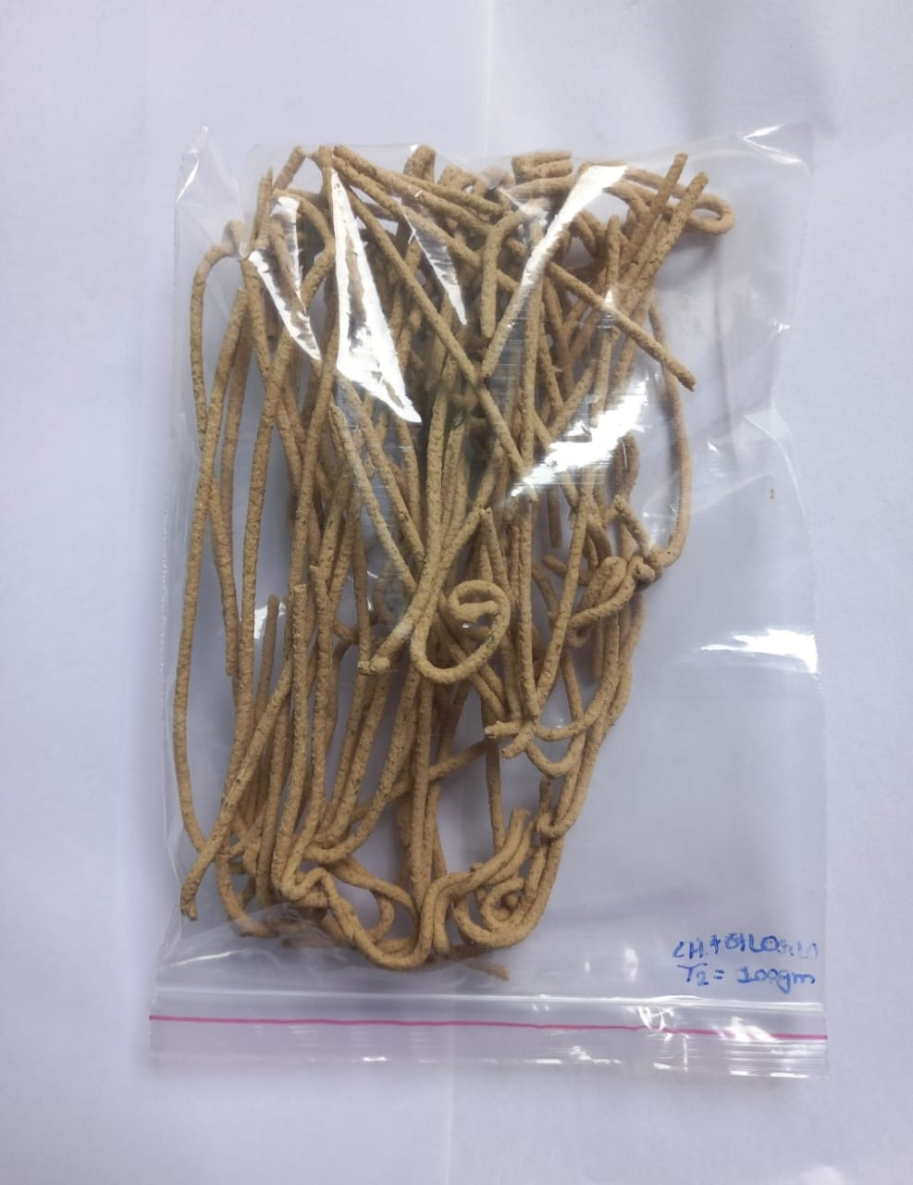
T2
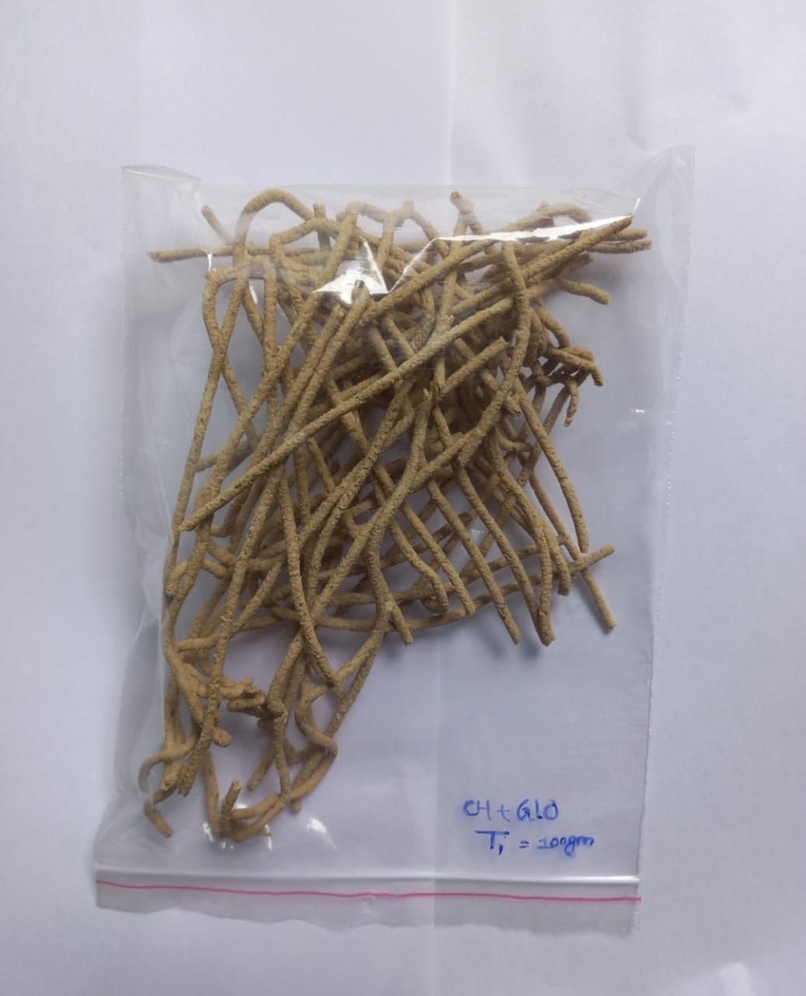
T1

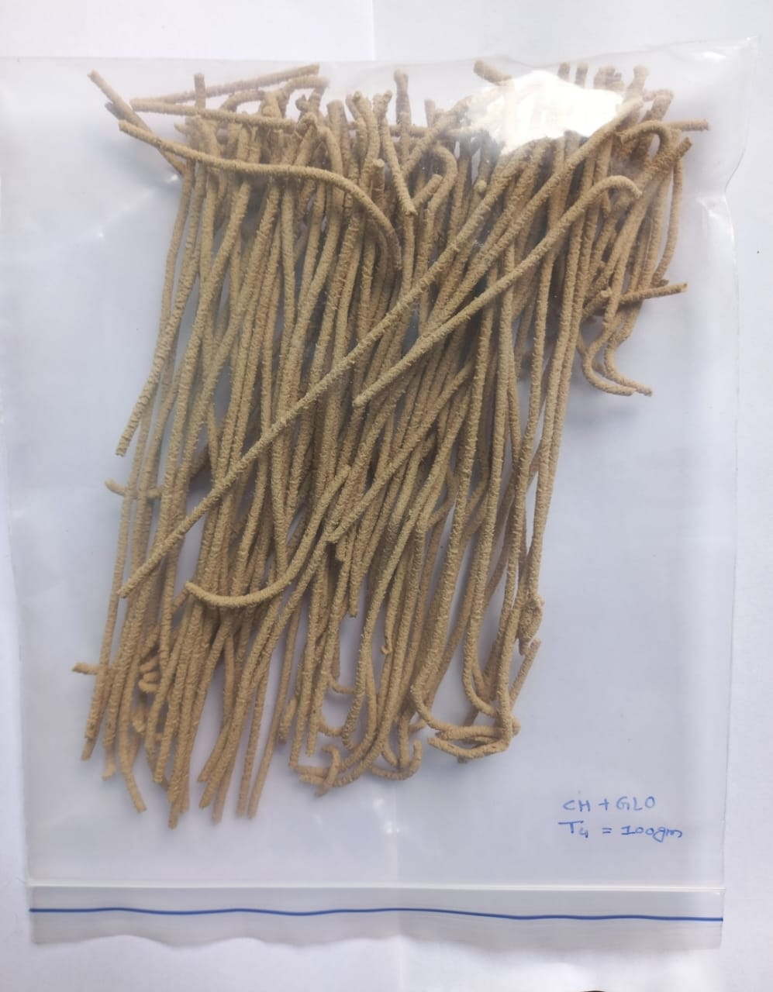

T4
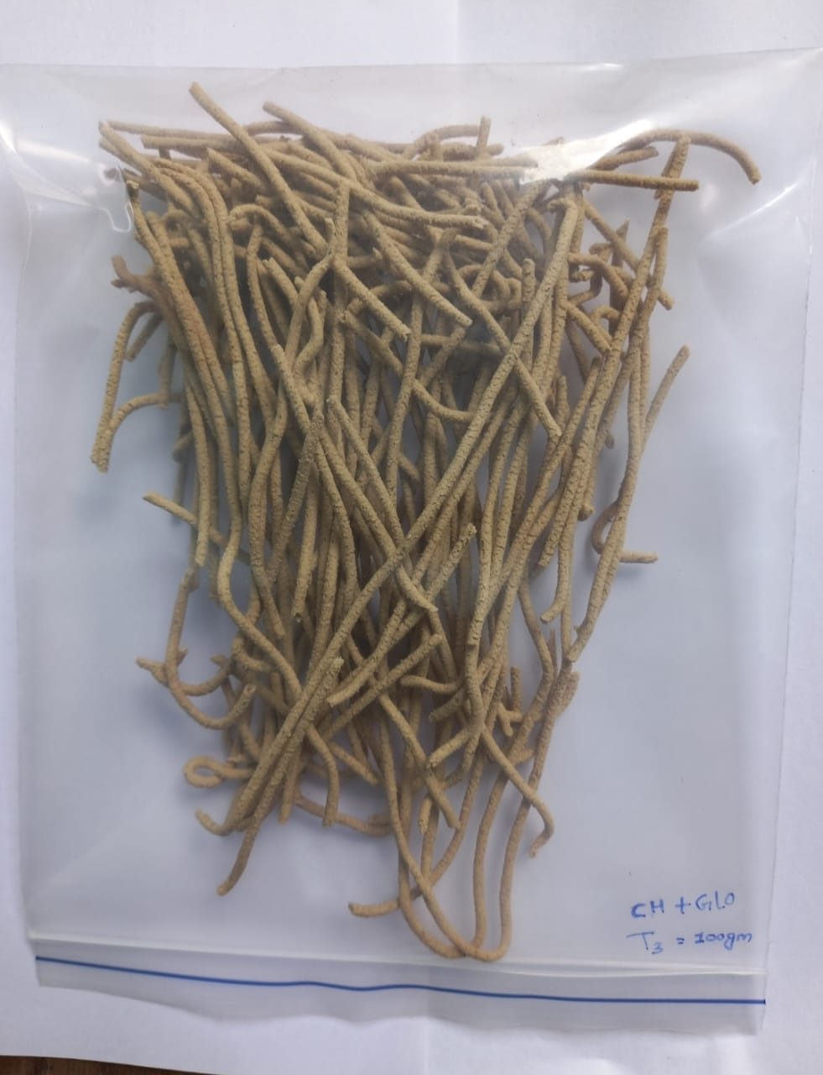

T3

T5

Fig 2- The samples of traditional wheat noodles
Sensory analysis revealed notable variations in appearance, texture, flavour, taste, and overall acceptability across treatments. The control sample, T0 (100% wheat flour), scored highest for appearance (8) and texture (8) due to its well-developed gluten structure, while flavour (7) and taste (8) were moderate; overall acceptability was high (8), indicating a preference for traditional wheat noodles. T1 (15% foxtail millet + 35% sorghum) received the lowest ratings for colour (6) and taste (5), likely due to the dominance of sorghum imparting bitterness and a darker appearance, resulting in the lowest overall acceptability score (5) and panel rejection of excessive sorghum incorporation.T2 (20% foxtail millet + 30% sorghum) yielded moderate scores across all parameters, with texture (6) and taste (7) suggesting acceptable but not exceptional palatability (overall acceptability 6). In contrast, T3 (25% foxtail millet + 25% sorghum) recorded the lowest scores among millet-based samples, particularly in flavour (6) and texture (6), likely due to a grainy mouthfeel and slight bitterness from millet, resulting in a lower overall acceptability (7).T4 (30% foxtail millet + 20% sorghum) showed improvements in colour (7), texture (8), and taste (8), attributed to the higher foxtail millet content which imparted a lighter texture and subtle sweetness, achieving a fair overall acceptability score of 8.T5 (35% foxtail millet + 15% sorghum) emerged as the most preferred millet-based formulation, recording the highest flavour (9) and taste (9) scores, with an overall acceptability of 9, likely due to the balanced millet blend and inclusion of functional ingredients such as chlorella and spring onion, which enhanced aroma and mouthfeel.
Conclusion
The current study aimed to improve nutritional quality without sacrificing sensory qualities by partially replacing wheat flour with sorghum and foxtail millet flours to create functional noodles. The addition of these underused grains improved the product's overall nutritional profile by considerably raising its protein, fiber, ash, and antioxidant content while lowering its carbohydrate load. Out of all the formulations that were examined, Treatment T5 (35% foxtail millet + 15% sorghum) produced the best balance, providing both increased nutritional density and higher sensory acceptance. Based on the findings, noodles with enhanced health advantages, consumer appeal, and potential commercial value may be produced by carefully combining sorghum and foxtail millet.
Reference
Alves Cayres, C., Luis Ramírez Ascheri, J., Antonieta Peixoto Gimenes Couto, M.,& Lopes Almeida, E. (2021). Whole‐grain sorghum, orange pomace, and whey blends as a novel gluten‐free pregelatinized ingredient: Assessment of physicochemical and pasting properties (sorghum‐based pregelatinized flour). Journal of Food Processing and Preservation, 45(1), e15014.
Amaral, T. N., Junqueira, L. A., Prado, M. E. T., Cirillo, M. A., de Abreu, L. R., Costa, F. F., & de Resende, J. V. (2018). Blends of Pereskia aculeata Miller mucilage, guar gum, and gum Arabic added to fermented milk beverages. Food Hydrocolloids, 79, 331-342.
AOAC. Official Methods of Analysis for protein. Association of Official Analytical Chemists.18th Edition. Arlington V VA 2209, USA. AOAC 984.13, 2005
Arora, L., Aggarwal, R., Dhaliwal, I., Gupta, O. P., & Kaushik, P. (2023). Assessment of sensory and nutritional attributes of foxtail millet-based food products. Frontiers in Nutrition, 10, 1146545.
Belton, P. S., & Taylor, J. R. (Eds.). (2002). Pseudocereals and less common cereals: grain properties and utilization potential. Springer Science & Business Media.
Butt MS, Shahzadi N, Sharif MK, Nasir M (2007) Guar gum: a miracle therapy for hypercholesterolemia, hyperglycemia and obesity. Crit Rev Food Sci Nutr 47:389–396
Cawley RW (1964) The role of wheat flour pentosans in baking. II. Effect of added flour pentosans and other gums on gluten starch loaves. J Sci Food Agr 15:834 838
Cayres Morris JB (2010) Morphological and reproductive characterization of guar (cyamopsis tetragonoloba) genetic resources regenerated in Georgia, USA. Genet Resour Crop Ev 57:985–993
Dartois A, Singh J, Kaur L, Singh H (2010) Influence of guar gum on the in vitro starch digestibility-rheological and microstructural characteristics. Food Biophysics 5:149–160
Gupta, S., & Variyar, P. S. (2018). Guar gum: a versatile polymer for the food industry. In Biopolymers for food design (pp. 383-407). Academic Press.
Habiyaremye, C., Matanguihan, J. B., D’Alpoim Guedes, J., Ganjyal, G. M., Whiteman, M. R., Kidwell, K. K., & Murphy, K. M. (2017). Proso millet (Panicum miliaceum L.) and its potential for cultivation in the Pacific Northwest, US: areview. Frontiers in plant science, 7, 1961.
Hymavathi, T. V., Thejasri, V., & Roberts, T. P. (2019). Enhancing cooking, sensory and nutritional quality of finger millet noodles through incorporation of hydrocolloids. International Journal of Chemical Studies, 7(2), 877-881.
Islam, M. F., Islam, S., Miah, M. A. S., Bhuiyan, M. N. I., Abedin, N., Mondol, M.M. H., ... & Linkon, K. M. M. R. (2024). Quality assessment and sensory evaluation of green banana starch-enriched instant noodles. Applied Food Research, 4(1), 100431.
Kaur, A., Shevkani, K., Singh, N., Sharma, P., & Kaur, S. (2015). Effect of guar gum and xanthan gum on pasting and noodle-making properties of potato, corn, and mung bean starches. Journal of food science and technology, 52, 8113-8121.
Lu, H., Zhang, J., Liu, K. B., Wu, N., Li, Y., Zhou, K. & Li, Q. (2009). The earliest domestication of common millet (Panicum miliaceum) in East Asia extended to 10,000 years ago. Proceedings of the National Academy of Sciences, 106(18), 7367-7372.
McSweeney, M. B., Seetharaman, K., Dan Ramdath, D., & Duizer, L. M. (2017). Chemical and physical characteristics of proso millet (Panicum miliaceum) based products. Cereal Chemistry, 94(2), 357-362.
Meherunnahar, M., Ahmed, T., Chowdhury, R. S., Miah, M. A. S., Sridhar, K., Inbaraj, B. S., ... & Sharma, M. (2023). Development of novel foxtail millet-based nutri-rich instant noodles: Chemical and quality characteristics. Foods, 12(4), 819.
Mudgil, D., Barak, S., & Khatkar, B. S. (2014). Guar gum: processing, properties and food applications—a review. Journal of food science and technology, 51, 409-418.
Norton IT, Foster TJ (2002). Hydrocolloids in real food systems. In: Williams PA, Phillips GO (eds) Gums and stabilizers for the food industry, vol 11. The Royal Society of Chemistry, Cambridge, pp 187–200
Özkaya H, Kahveci B. Tahıl ve Ürünleri Analiz Yöntemleri. Gıda Teknol. Dernei Yayınları 1990; 14:146-148.
Pakhare KN, Dagadkhair AC, Udachan IS, Andhale RA. Studies on Preparation and Quality of Nutritious Noodles by Incorporation of Defatted Rice Bran and Soy Flour. J Food Process Technol. 2016; 7:629. Doi: 10.4172/2157 7110.1000629
Purwandari, U., Khoiri, A., Muchlis, M., Noriandita, B., Zeni, N. F., Lisdayana, N., & Fauziyah, E. (2014). Textural, cooking quality, and sensory evaluation of gluten-free noodles made from breadfruit, konjac, or pumpkin flour. International Food Research Journal, 21(4), 1623.
Rai M.(2002). Nutritive cereals Survey of Indian Agriculture, 2002, The Hindu, Chennai, Tamil Nadu, India (2002) pp. 59-62.
Romero, H. M., Santra, D., Rose, D., & Zhang, Y. (2017). Dough rheological, properties and texture of gluten-free pasta based on proso millet flour. Journal of Cereal Science, 74, 238-243.
Sabbatini, S. B., Sanchez, H. D., Torre, M. A., & Osella, C. A. (2014). Design of apremix for making gluten-free noodles. International Journal of Nutrition and Food Sciences, 3(5), 488-492.
Sabbatini, S. B., Sanchez, H. D., Torre, M. A., & Osella, C. A. (2014). Design of a premix for making gluten-free noodles. International Journal of Nutrition and Food Sciences, 3(5), 488-492.
Sadiq, M. B. (2019). Influence of whey protein-xanthan gum stabilized emulsion on stability and in vitro digestibility of encapsulated astaxanthin.
Sema Arora, S. A., & Sarita Srivastava, S. S. (2002). Suitability of millet-based food products for diabetics.
Sharma, N., & Niranjan, K. (2018). Foxtail millet: Properties, processing, health benefits, and uses. Food reviews international, 34(4), 329-363.
Sheahan, C. M. (2014). Plant guide for Foxtail millet (Setaria italica). USDA Natural Resources Conservation Service, Cape May Plant Materials Center.
Singh JP, Kaur A, Shevkani K, Singh N (2015) Influence of jambolan (Syzygium cumini) and xanthan gum incorporation on the physicochemical, antioxidant and sensory properties of gluten-free eggless rice muffins. Int J Food Sci Technol 50:1190–1197
Werbin SJ (1950) Natural Gums in the Baking Industry, Paper presented at the American Association of Cereal Chemists, Dec. 5
Xue, Y. Y., Li, P., & Lin, Q. B. (2008). Research evolution on the chemical component and physical characteristics of foxtail millet. J Chin Cereal Oil Assoc, 22, 51-56.

