Development of Protein Enriched Drynaria quercifolia Biscuits to Enhance Human Health

ABSTRACT
The present study was conducted to develop protein-enriched biscuits using Drynaria quercifolia (Mudavattukal Kilangu in Tamil language (India)) rhizome powder as a functional values. Drynaria quercifolia is traditionally recognized for its medicinal and nutritional properties, particularly its protein and antioxidant content. In this study, the rhizome was cleaned, dried and grind into a fine powder, then incorporated into biscuit formations at different proportions (5, 10, 15 %) replacing a part of wheat flour. The formulated biscuits were evaluated for their nutritional composition, organoleptic characteristics and shelf-life stability. Nutritional analysis revealed an increase in protein, dietary fiber and mineral contents with higher levels of Drynaria supplementation. The evaluation was conducted using a 9-point hedonic scale and results indicated that biscuits containing 10% Drynaria quercifolia powder achieved the highest overall acceptability. Microbial analysis confirmed the safety of the product over a standard storage period. Thus, the study demonstrates the feasibility of incorporating Drynaria quercifolia into baked products, offering a novel approach to enhance the nutritional value of biscuits while utilizing an underexplored traditional plant resource.
Keyword: Protein-enriched biscuits, Drynaria quercifolia, rhizome powder.

INTRODUCTION
Drynaria quercifolia (Mudavattukal Kilangu) Biscuits are traditionally made with a blend of ingredients like wheat flour, sugar, and ghee (clarified butter), giving them a rich flavor and soft yet crispy texture. Mudavattukal Kilangu Biscuits have a distinctive aroma, often enhanced with cardamom or other spices, making them a favorite among tea-time snacks. This research addresses the growing demand for protein-rich and health-conscious food options by developing a novel biscuit incorporating Drynaria quercifolia (Mudavattukaal Kilangu) rhizome flour and millet flour, further enriched with protein-D. quercifolia, an underutilized plant resource with traditional value (Wheeler et. al. 2013), is combined with the nutritional benefits of millets to create a potentially synergistic base. The study investigates the critical impact of baking temperature and time on the resulting biscuits' nutritional composition, physicochemical properties, and sensory attributes, aiming to optimize quality and consumer acceptability. This work contributes to the valorization of D. quercifolia and the promotion of millet-based foods, offering insights into the development of a nutritious and sustainable baked product.
Millet mixer powder, a blend of flours from various nutritious and gluten-free millets like finger, pearl, and foxtail, offers a rich source of dietary fiber, essential minerals, and plant-based protein. Its versatility makes it a valuable ingredient for enhancing the nutritional profile of diverse food products, from traditional staples to modern baked goods and convenience foods. In the context of developing protein-enriched Drynaria quercifolia biscuits, the inclusion of millet mixer powder not only contributes a spectrum of beneficial nutrients and a unique flavor profile but also aligns with the growing demand for gluten-free and sustainable food options, potentially creating a more wholesome and appealing final product.

MATERIALS AND METHODS
  - Raw material
The protein-enriched biscuits in this project will be formulated using a base of millet mixer powder (comprising pearl millet, kodo millet, little millet, foxtail millet, and sorghum) and Drynaria quercifolia (Mudavattukal Kilangu) flour, sweetened with jaggery, enriched with added protein (to be specified), and incorporating butter or ghee along with cashew, almond, and pistachio for flavor enhancement, further complemented by selected flavoring agents.

Table 1 - Formulation of Biscuits Drynaria quercifolia
Ingredient | T1 (190° C) | T2 (210° C) | T3 (21 5°C)
Millet Powder, gm | 50 | 35 | 50
Drynaria Quercifolia, gm | 35 | 45 | 50
Sugar, gm | 20 | 20 | 20
Butter, ml | 20 | 20 | 20
Baking Soda, gm | 0.5 | 0.5 | 0.5
Flavour, drops | 2 | 2 | 2
Baking Temperature, ºC | 190 | 210 | 215

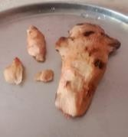
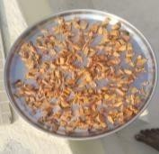
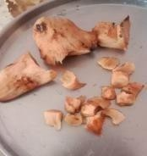
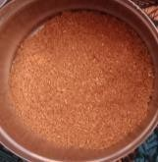
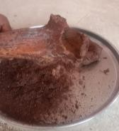
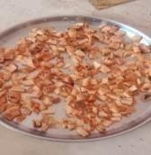

Fig 1. Preparatory procedure of cookies
The processing of the tubers, such as Drynaria quercifolia, into a usable flour involves a series of key steps. Initially, the outer skin is removed through peeling, followed by thorough washing to eliminate dirt and surface starch. To facilitate efficient drying, the peeled tubers are then subjected to size reduction, typically by cutting them into thin slices or small pieces. The crucial step of moisture removal is achieved through sun-drying until the pieces are completely dehydrated ensuring preservation. Subsequently, the dried material is grand into a fine powder using a grinder or flour mill. Finally, sieving is performed to obtain a uniform and fine-textured flour by removing any coarse particles, resulting in a consistent ingredient suitable for incorporation into food products like biscuits.
1.2. Biscuit preparation
The table showcases three distinct formulations (T1, T2, and T3) where the primary difference lies in the ratio of millet powder to Drynaria quercifolia flour. All other ingredients – sugar, butter, baking soda, and flavoring – are held constant across these treatments. This experimental design suggests that the researchers are specifically interested in understanding how varying the proportions of the two main flour components, while keeping other factors consistent, affects the final biscuit product when baked at different temperatures.
Treatment 1 (T1) involved baking the biscuits at a temperature of 190 °C. The ingredient composition for this treatment consisted of 50 grams of millet powder, 35 grams of Drynaria quercifolia, 20 grams of sugar, 20 millilitres of butter, 0.5 grams of baking soda, and 2 drops of flavoring.
Treatment 2 (T2) utilized a higher baking temperature of 210°C. The ingredient quantities were adjusted in this formulation, with 35 grams of millet powder and 45 grams of Drynaria quercifolia, while the amounts of sugar (20g), butter (20ml), baking soda (0.5g), and flavoring (2 drops) remained the same as in T1.
Treatment 3 (T3) employed the highest baking temperature among the three treatments, at 215°C. The ingredient proportions for this formulation were 50 grams of millet powder and 50 grams of Drynaria quercifolia, with the quantities of sugar (20g), butter (20ml), baking soda (0.5g), and flavoring (2 drops) consistent with the other two treatments.
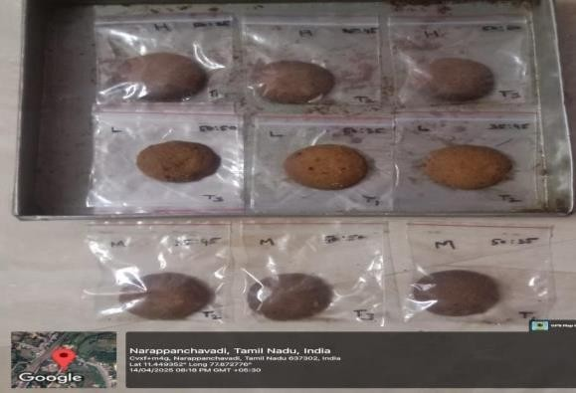

Fig 2. Samples of Biscuits
The table illustrates three distinct biscuit formulations where the ratio of millet powder to Drynaria quercifolia varies across the treatments, while the amounts of sugar, butter, baking soda, and flavoring are kept constant. Each formulation was subjected to a different baking temperature to investigate the impact of this processing parameter on the final biscuit characteristics

Sensory evaluation
Sensory evaluation of the protein-enriched Drynaria quercifolia-millet biscuits was conducted using a panel of [Number] untrained consumers who assessed the overall liking and specific sensory attributes of three different biscuit formulations (T1, T2, T3) baked at varying temperatures. Coded samples were presented under controlled conditions, and panelists used 9-point hedonic scales to rate appearance, aroma, texture (crispness, hardness, friability, mouth feel), and taste (sweetness, overall flavor, specific notes), as well as overall acceptability. Qualitative feedback was also collected through open- ended questions. The resulting data were statistically analyzed using [Statistical method] to determine significant differences between the treatments, providing insights into consumer preferences and the impact of flour ratios and baking temperatures on the biscuits' sensory quality.

Physical properties
The protein-enriched Drynaria quercifolia- millet biscuits exhibited physical properties such as hardness, crispness, color (quantified by L∗, a∗ and b∗ values), moisture content, and dimensions, all of which were influenced by the varying ratios of millet powder to Drynaria quercifolia and the applied baking temperatures. Instrumental analyses were conducted to objectively measure these attributes, providing quantitative data on the biscuits' texture, appearance, and moisture characteristics, which are crucial for understanding their overall quality and consumer acceptance.

Chemical composition
The chemical composition of the protein- enriched Drynaria quercifolia-millet biscuits was determined by quantifying key nutritional components, including protein, fat, ash, crude fiber, and total carbohydrates, using standard analytical methods. These analyses provided a detailed nutritional profile for each biscuit formulation (T1, T2, and T3), allowing for the calculation of their energy value and a comparative assessment of how varying flour ratios and baking temperatures influenced the macronutrient content of the final product. Statistical analysis was performed to identify significant differences in these components across the treatments.

Antioxidant properties
The antioxidant properties of the protein- enriched Drynaria quercifolia-millet biscuits were evaluated using in vitro assays such as DPPH, ABTS, and FRAP to determine their free radical scavenging capacity. Biscuit extracts prepared from each treatment (T1, T2, and T3) were analyzed spectrophotometrically, and the resulting antioxidant activity was quantified and statistically compared to assess the influence of varying flour ratios and baking temperatures on the potential health- promoting properties of the final product.

Statistical analysis
The collected data from nutritional, physicochemical, and antioxidant analyses were statistically evaluated using [Specify software, e.g., ANOVA] to determine significant differences between the biscuit treatments (T1, T2 and T3). Mean values and standard deviations were calculated for each parameter, and post-hoc tests [Specify test, e.g., Tukey's HSD] were applied where significant differences were found, with a significance level set at p≤0.05 to draw evidence-based conclusions.

Results and Discussion
This study investigated the impact of varying the ratio of millet powder to Drynaria Quercifolia (Mudavattukal Kilangu) flour and different baking temperatures on the key physicochemical and sensory characteristics of newly developed protein-enriched biscuits.
Three distinct formulations (T1, T2, and T3) were prepared, each with a unique proportion of the two flours and subjected to different baking temperatures (190 °C, 210 °C and 215 °C, respectively). The resulting biscuits were then evaluated for their color, texture, taste, flavor, hardness at first bite, sweetness, mouth-feel, and overall acceptability. The objective results obtained from these analyses for each formulation will be presented and followed by a comprehensive discussion of the observed differences and potential underlying mechanisms. The influence of ingredient ratios and baking temperatures on the final biscuit quality and consumer acceptability will be critically examined, providing insights into the optimal parameters for producing protein- enriched biscuits incorporating Drynaria Quercifolia and millet (Prasanna et. al. 2014).

Sensory properties of the biscuits
The sensory properties of the biscuits varied across the three tested temperatures (T1, T2, and T3). Biscuits baked at T1 exhibited a generally acceptable colour and appearance, along with a pleasant aroma, but received lower scores for taste and flavour, resulting in moderate overall acceptability. Increasing the baking temperature to T2 led to improvements in most sensory attributes, with higher scores for colour, taste, flavour, and appearance, ultimately yielding the highest overall acceptability among the three temperatures. However, when the baking temperature was further increased to T3, while still generally acceptable, the biscuits showed a slight decline in colour, aroma, taste, and appearance scores compared to T2, indicating that the intermediate temperature of T2 was most favourable for the sensory characteristics of these biscuits (Khan et. Al., 2014). The standard deviations provided in the table also suggest varying levels of consistency in panel list ratings for each attribute across the different temperatures

Physical parameters of biscuits
The sensory evaluation of the biscuit samples revealed distinct profiles across the Control, T1, T2, and T3 formulations. The Control sample exhibited high scores for Color, Texture, Aroma, and Taste, resulting in a good level of Overall Acceptability. Sample T1 showed a slight decrease in Aroma but a marginal increase in Taste and Overall Acceptability compared to the Control. Notably, T2 emerged as the most preferred sample, achieving the highest scores in Taste and Overall Acceptability, along with favorable ratings for Color and Aroma, although its Texture was slightly lower than the Control. In contrast, T3 generally received the lowest scores across most sensory attributes, indicating it was the least favored among the evaluated samples. Overall, the variations in formulation or processing represented by T1, T2, and T3 led to noticeable differences in sensory perception, with T2 demonstrating the most promising characteristics for consumer preference (Irudayaraj et. Al., 2004).
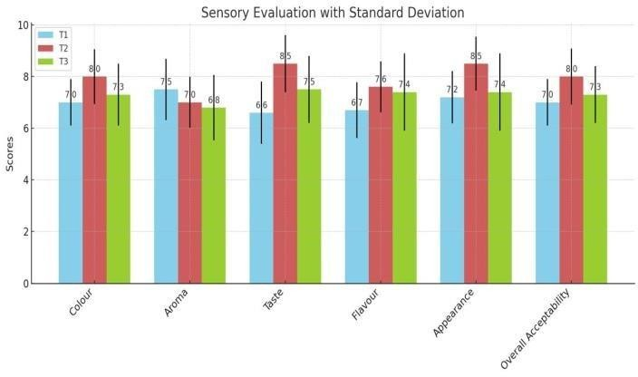
Fig.3a. Physical characteristics of Drynaria Biscuits

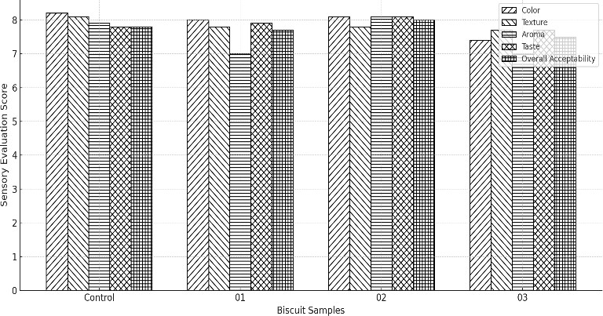
Fig.3b. Physical characteristics of Drynaria Biscuits

Chemical composition of biscuits
T1 (190°C): At a baseline temperature of 190°C, the product presents a relatively low moisture content of 2%, suggesting a fairly dry state. The total fat content, at 25%, indicates a significant lipid component, which likely contributes substantially to the overall texture and flavor profile at this initial processing stage. The protein content of 7.5% suggests a moderate presence of structural and functional proteins within the matrix. With an ash content of 1.3% and crude fiber at 1.5%, the mineral and indigestible carbohydrate fractions are present in relatively small proportions. The carbohydrate content of 52 g/100g forms a substantial portion of the product's composition, serving as a primary source of energy, which is reflected in the initial energy value of 500 Kcal. This initial profile at 190°C establishes a foundation for understanding how subsequent temperature changes impact the product's characteristics (Janarthanan et. al. 2016 and Saha et. al. 2011).
T2 (210°C): Elevating the temperature to 210°C induces notable shifts in the product's composition. The slight increase in moisture content to 2.12% might be attributed to the release of bound water or potentially some Maillard reaction byproducts. A more pronounced change is observed in the total fat content, which jumps to 30.96%, suggesting either a concentration effect due to moisture loss of other components or a potential extraction or mobilization of fats within the product structure (Hegde and Souza, 2000).

Table 2. Different parameters analysis
Parameters | T1 | T2 | T3
Moisture Content, % | 2 | 2.12 | 4.8
Total Fat, % | 2.5 | 30.96 | 26.5
Protein, % | 7.5 | 8.34 | 10.25
Ash Content, % | 1.3 | 1.48 | 1.8
Crude Fiber, % | 1.5 | 1.79 | 2.2
Carbohydrate, g/100 g | 52 | 55.31 | 53
Energy Value, Kcal | 5000 | 533.24 | 505.75

The protein content also sees a moderate increase to 8.34%, possibly due to denaturation or aggregation. The ash and crude fiber contents show minor increases to 1.48% and 1.79%, respectively. The carbohydrate fraction also expands to 55.31 g/100g, potentially due to the breakdown of more complex carbohydrates into simpler forms. Das et. al., 2014, revealed that these changes collectively contribute to a higher energy value of 533.24 Kcal, indicating a more energy- dense product at this intermediate temperature, likely influenced by the increased fat and carbohydrate content.
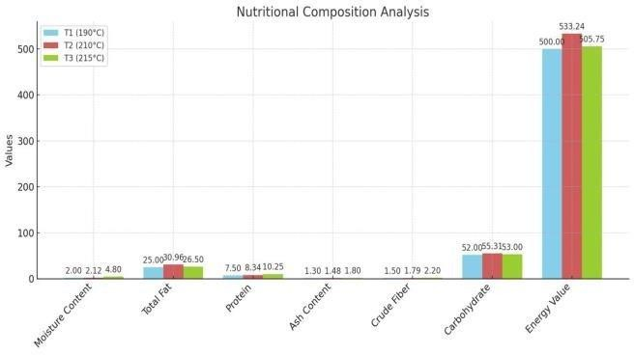
Fig.4 Nutritional composition Analysis of Drynaria Biscuits
T3 (215°C): At the highest temperature of 215°C, the product undergoes further significant transformations. The substantial rise in moisture content to 4.8% is intriguing, possibly indicating the release of more tightly bound water or the formation of water through chemical reactions. Conversely, the total fat content experiences a decrease to 26.5%, which could be due to volatilization, degradation, or interaction with other components at this elevated temperature. The protein content continues its upward trend, reaching 10.25%, potentially reflecting further denaturation and aggregation, or a concentration effect due to the loss of other volatile components. The ash and crude fiber contents also show the highest values at 1.8% and 2.2%, respectively, suggesting a concentration of these non- combustible components. The carbohydrate content settles slightly lower at 53 g/100g compared to T2, possibly due to caramelization or other degradation reactions. The resulting energy value of 505.75 Kcal, while still higher than the initial value at T1, is slightly lower than at T2, likely reflecting the complex interplay of increased moisture and decreased fat content (Amir Gull, et. Al., 2014 & Prasanna et. al., 2019). This final profile at 215°C highlights the dynamic changes occurring within the product as it is subjected to increasing thermal processing.

Conclusions
The development of protein-enriched biscuits using Mudavattukal Kilangu and millet demonstrated the feasibility of enhancing nutritional content. Variations in ingredient ratios and baking temperatures resulted in distinct chemical compositions and significantly influenced sensory characteristics. While specific formulations, such as Trial 2, showed promising sensory acceptability, further optimization is needed to refine texture and potentially enhance other qualities. This study establishes the potential of incorporating Mudavattukal Kilangu for protein enrichment in millet biscuits, warranting further research into formulation, processing, and shelf-life to fully realize its nutritional and functional food potential. Surrey, UK) in penetration mode with a cylinder of 2 mm diameter probe plunged 4 mm at 1 mm s⁻¹. The resistance to penetration was measured by the maximum force (in newtons) from the peak on the texturogram which corresponds to the firmness value. Measurements were done in duplicate, five replicates, after preparation, weekly (during the first month) and after 2 and 3 months, as already mentioned.

References
- Amir Gull., Romee Jan., Gulzar Ahmad Nayik., Kamlesh Prasad and Pradyuman Kumar, (2014) Significance of Finger Millet in Nutrition, Health and Value added Products: A Review: Journal of Food Processing & Technology: Vol.3.No.3, 1601-1608
- Das B, Dey A, Das Talukdar A, Nongalleima KH, Choudhury MD, Deb L. Antifertility efficacy of Drynaria quercifolia (L.) J. Smith on female Wister albino rats. J Ethnopharmacol. 2014;153 (2):424-9. doi: 10.1016/j.jep.2014.02.047, PMID 24607496.
- Hegde S. and D’Souza L (2000). In vitro sporophyte production from rhizome of Drynaria quercifolia. Indian Fern Journal. 17:72-76
- Irudayaraj V, Senthamarai and R. Pharmacognostical studies on a medicinal fern, Drynaria quercifolia (L.) J. Sm. (Polypodiaceae: Pteridophyta). Phytomorphology. 2004;54:193-200
- Janarthanan L, Karthikeyan V, Balakrishnan, BR, Jaykar B, Senthilkumar KL, Anandharaj G. Pharmacognostical standardization and phytochemical profile of rhizomes of Drynaria quercifolia (L.) J. Smith. European. J Biomed Pharm Sci. 2016;3(8):278-87.
- Khan A, Islam MH, Islam ME, Al-Bari MA, Parvin MS, Sayeed MA, et al. Pesticidal and pest repellency activities of rhizomes of Drynaria quercifolia (J. Smith) against Tribolium castaneum (Herbst). Biol Res. 2014; 47 (1):51. doi: 10.1186/0717-6287-47-51 , PMID 25299149.
- Prasanna G, Devi R, Ishwarya G. In vitro evaluation of antidiabetic and cytotoxicity potentials of the rhizome extract of Drynaria quercifolia (L.) J. Smith. Asian J Pharm Clin Res. 2019; 12 (11):72-6.
- Prasanna G, Janaranjani B, Chitra M. Anti- inflammatory and antipyretic activities of Drynaria quercifolia rhizome in rats. Int J Pharm Sci Rev Res. 2014;29 (1):57-61.
- Saha S, Gupta A, Singh SRK, Bharti N, Singh KP, Mahajan V, Gupta HS. Compositional and varietal influence of finger millet flour on rheological properties of dough and quality of biscuit. LWT – Food Science and Technology. 2011;44(3):616-621.
- Wheeler T, Von Braun J. Climate change impacts on global food security. Science 2013;341:508-513.

