Synthesis, Structural characterization of a New Ethylenediammonium Hydrogenophosphate salt

.
ABSTRACT

A new organic–inorganic hybrid salt, ethylenediammonium hydrogenophosphate, [H₃N–CH₂–CH₂–NH₃][HPO₄], was synthesized under aqueous reflux conditions. The compound was characterized by single-crystal X-ray diffraction and FT-IR spectroscopy. It crystallizes in the monoclinic system, space group P2₁/c, with unit cell parameters a = 7.4896(8) Å, b= 11.7702(12) Å, c = 8.0080(8) Å. The asymmetric unit consists of one ethylenediammonium dication and one monohydrogenophosphate anion.
Structural analysis reveals that the crystal packing is governed by an extended three-dimensional network of N–H···O and O–H···O hydrogen bonds, which link the cations and anions into a robust supramolecular framework. FT-IR spectroscopy confirms the presence of protonated amine groups together with hydrogenophosphate units, consistent with the crystallographic findings.
These results demonstrate the ability of ethylenediamine to promote the formation of stable hydrogen-bonded phosphate frameworks. Owing to their structural robustness and hydrogen-bonding features, such hybrids may represent promising candidates for potential applications in proton-conducting systems and functional optical materials.

Keywords: Ethylenediammonium, Hydrogenophosphate, X-ray diffraction, Hydrogen bonds

1. INTRODUCTION

Organic–inorganic hybrid materials combining organic cations with phosphate anions have attracted increasing attention owing to their rich structural chemistry and potential applications in proton-conducting membranes, nonlinear optical crystals, and thermally stable frameworks [1–3]. Among these, organoammonium phosphate-based salts incorporating mono- or di-deprotonated phosphate species (H₂PO₄⁻/HPO₄²⁻) and protonated organic amines have emerged as promising candidates for the design of advanced functional compounds [4–8]. Their structural diversity arises from the ability of both the organic and inorganic components to engage in extended hydrogen-bonding interactions, which generate low-dimensional supramolecular networks and enable specific structure–property relationships [9–15].
Ethylenediamine (H₂N–CH₂–CH₂–NH₂) is a simple aliphatic diamine that, upon protonation, yields the [H₃N–CH₂–CH₂–NH₃]²⁺ dication. Owing to its two ammonium groups, this cation acts as a versatile multidentate hydrogen-bond donor. When combined with hydrogenophosphate anions, it can stabilize extended architectures through cooperative N–H···O and O–H···O interactions, thus favoring the formation of robust supramolecular assemblies. In the present work, we report the synthesis and detailed characterization of ethylenediammonium hydrogenophosphate, obtained by slow evaporation from aqueous solution. The structural features are analyzed to highlight the role of hydrogen bonding in the crystal packing, while vibrational analyze provide complementary insights into the stability of the compound. Particular emphasis is placed on the supramolecular hydrogen-bonding network, which is expected to play a key role in the potential functional properties of this hybrid material.

2. experimental details

2.1 SYNTHESIS

Phosphoric acid (H₃PO₄, 98%) and ethylenediamine (C₂H₈N₂, 98%) were purchased from Sigma-Aldrich and used without further purification. Distilled water was employed as solvent throughout the preparation.
Ethylenediammonium hydrogenophosphate was synthesized by mixing equimolar aqueous solutions of orthophosphoric acid and ethylenediamine (1:1 molar ratio) under reflux condition with continuous stirring at 200ºC temperature. The resulting clear solution was allowed to evaporate slowly at ambient conditions. After several days, colorless single crystals suitable for single-crystal X-ray diffraction were obtained. Yield: 45%.
The formation of the compound can be represented by the following reaction scheme:

H₃PO₄ + H₂N–CH₂–CH₂–NH₂ → [H₃N–CH₂–CH₂–NH₃][HPO₄]

2.1 Characterization Methods
IR spectroscopy measurements were carried out for the compounds. IR measurements were performed using ATR (Attenuated Total Reflectance) method from 4000 to 400cm⁻¹ [16].
A single-crystal X-ray diffraction data for the compound were measured on a Bruker APEX-II CCD
diffractometer (Mo Kα radiation, λ=0.71073Å).The crystal was kept at 150.0 K during data collection. Using Olex2 [17], the structure was solved with the SHELXT [18] structure solution program using Intrinsic Phasing and refined with the SHELXL [19] refinement package using Least Squares minimization.

3. results and discussion

3.1 Crystal Structure

Single-crystal X-ray diffraction analysis shows that the compound crystallizes in the Monoclinic system with space group P2₁/c and unit cell parameters are a = 7.4896(8), b = 11.7702(12), c = 8.0080(8) Å. The asymmetric unit contains one ethylenediammonium cation and one hydrogenophosphate anion (Fig.1). Crystallographic data are summarized in Table 1.

Table 1. Crystallographic data for compound
Empirical formula | C₂H₁₁N₂O₄P
Formula weight | 158.10
Temperature/K | 150.0
Crystal system | monoclinic
Space group | P2₁/c
a/Å | 7.4896(8)
b/Å | 11.7702(12)
c/Å | 8.0080(8)
α/° | 90
β/° | 110.268(3)
γ/° | 90
Volume/Å³ | 662.23(12)
Z | 4
ρ_{calc}g/cm³ | 1.586
μ/mm⁻¹ | 0.368
F(000) | 336.0
Crystal size/mm³ | ? × ? × ?
Radiation | MoKα (λ = 0.71073)
2Θ range for data collection/° | 5.798 to 55.048
Index ranges | -9 ≤ h ≤ 9, -15 ≤ k ≤ 15, -10 ≤ l ≤ 10
Reflections collected | 27310
Independent reflections | 1527 [R_{int} = 0.0310, R_{sigma} = 0.0113]
Data/restraints/parameters | 1527/0/85
Goodness-of-fit on F² | 1.119
Final R indexes [I>=2σ (I)] | R₁ = 0.0250, wR₂ = 0.0739
Final R indexes [all data] | R₁ = 0.0280, wR₂ = 0.0774
Largest diff. peak/hole / e Å⁻³ | 0.33/-0.39

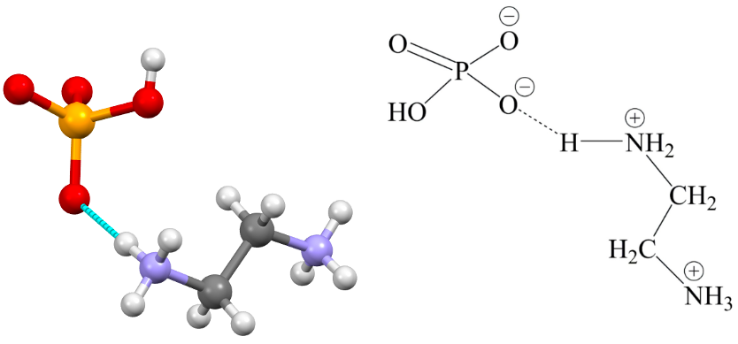
Fig. 1. Asymmetric unit Scheme . 1: Chemical Scheme

The [H₃N–(CH₂)₂–NH₃]²⁺ dication is fully protonated, with both nitrogen atoms bearing three protons. The anion of the title compound consists of hydrogenophosphate groups, each interacting with the ethylenediammonium cation through multiple hydrogen bonds, forming ${(C}_{2}H_{10}N_{2})[{HPO}_{4}]$ units. In the hydrogenophosphate anion, the phosphorus atom is surrounded by three oxygen atoms covalently bonded to phosphorus and one hydroxyl group (–OH), completing the tetrahedral geometry (Fig. 2). The two terminal oxide ligands bonded to phosphorus, i.e., P–Ot (Ot = O001, O002, O005), exhibit bond lengths in the range of 1.5205(2)–1.5353(9) Å, which are shorter than the bond length of 1.588(1) Å for the hydroxyl oxygen atom bonding to phosphorus, i.e., P–Ob (Ob = O004). This difference confirms the stronger bonding of the terminal oxides to phosphorus but also the mesomere effect between the three terminals oxygen atoms (Sch. 2).
The resulting Ot–P–Ot and Ot–P–Ob bond angle values, respectively [110.65(5); 111.67(5); 112.57(5)] and [108.72(5); 108.62(5); 104.32(5)°], are very close to 109.5°, the ideal tetrahedral angle, confirming only a slight distortion from tetrahedral geometry around the phosphorus atom(Fig.2) [20].
Bond valence sums calculations indicate that P site is in the +5-oxidation state. Which means that for the stabilization, the anion is surrounded with one organic diammonium molecules to counterbalance the charge.

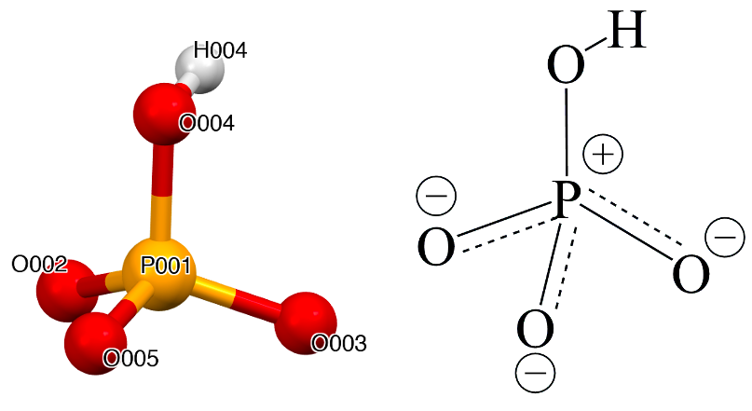
Fig. 2: Tetrahedral geometry of the anion Scheme. 2: Resonance representation of the anion

Each ammonium group participates in multiple hydrogen bonds with surrounding phosphate oxygens.
In the compound, the crystal packing can be rationalized in terms of nonbonding interactions between the anion [(HPO₄]²⁻ and the (C₂H₁₀N₂)²⁺ cations. As shown in Figure 4, it is striking that the structures exhibit extensive multiple hydrogen-bonding interactions among ethylenediammonium cation and hydrogenophosphate anion.
Moreover, for the compound, the two anion monomers are further linked with each other to form
a dimeric, trimeric, and tetrameric structure through hydrogen bonds between the hydroxyl group and terminal oxo ligands of another anion. This hydrogen bonds network led to the formation of an infinite 1D chain in zig-zag (Fig.3). The cation actively participates in the stabilization of the crystal structure through hydrogen bonding interactions N—H…...(O) and N—H…...(O). These interactions occur between the cation and oxygen atoms of neighboring anions and parallel chain, leading to the formation of a three-dimensional supramolecular network (Figure 3). This network enhances the cohesion of the crystal and contributes to its overall structural integrity. Such cation-mediated hydrogen bonding is a common feature in coordination compounds, often playing a key role in directing crystal packing.

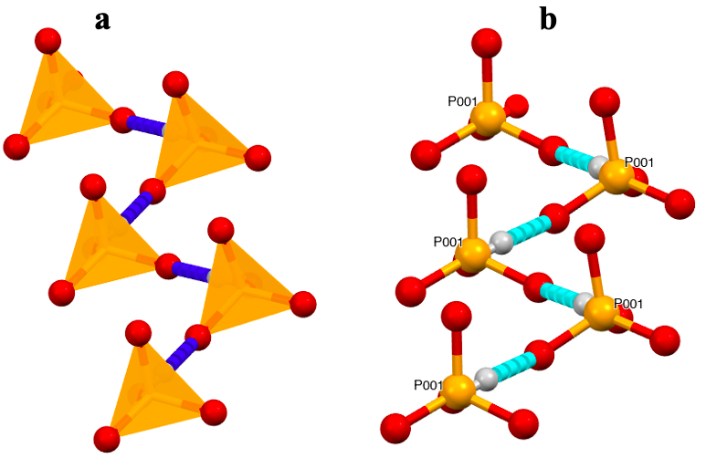
Fig. 3. Infinite 1D chain in zig-zag: (a): tetrahedral form, (b): Ball and Stick

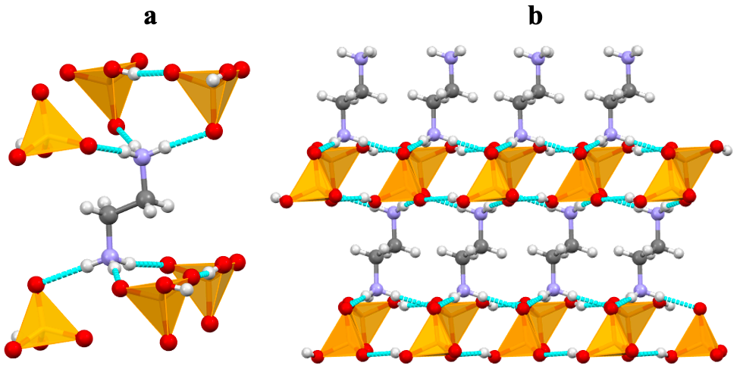
Fig. 4. (a): organo-ammonium cation comportment, (b): three-dimensional supramolecular network

3.2 Vibrational Spectroscopy

The IR spectrum displays broad absorption bands in the 3200–3400 cm⁻¹ region, assigned to N–H stretching vibrations of the organoammonium groups, with contributions from O–H stretching of the hydrogenophosphate unit due to extensive hydrogen bonding. Additional features at 1607 and 1516 cm⁻¹ can be attributed to the N–H bending modes of the –NH₃⁺ cations [21]. The strong absorptions at 1091 and 1021 cm⁻¹ correspond to the asymmetric and symmetric P–O stretching vibrations, respectively, whereas the band near 887 cm⁻¹ is characteristic of the P–O–H bending mode [10, 22]. The low-frequency absorption at 658 cm⁻¹ further supports the presence of phosphate skeletal vibrations.
These spectroscopic features are consistent with the coexistence of protonated ethylenediammonium cations and hydrogenophosphate anions, confirming the salt formulation [H₃N–CH₂–CH₂–NH₃][HPO₄].

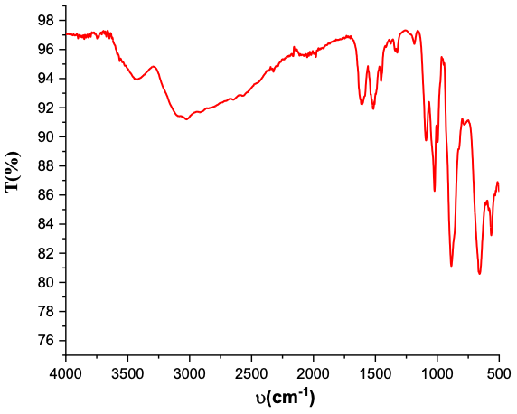
Fig. 5. IR spectra of compound
4. Conclusion

A new organic–inorganic hybrid material, [H₃N–CH₂–CH₂–NH₃][HPO₄], has been successfully synthesized and structurally characterized. Single-crystal X-ray diffraction revealed that the compound crystallizes in the monoclinic system, space group P2₁/c. The structure is governed by strong supramolecular interactions, where cations and anions are interconnected through a robust three-dimensional hydrogen-bonding network involving ethylenediammonium and hydrogenophosphate groups. These interactions play a crucial role in stabilizing the crystal packing.
This study enriches the growing family of organic–inorganic phosphates and provides valuable insights into their structural features. Furthermore, the specific arrangement of hydrogen bonds suggests potential applications of this class of materials in proton-conducting devices, optical systems, drugs, and other functional materials.

References

[1] Mobin, R., Rangreez, T. A., Chisti, H. T. N., & Rezakazemi, M., In Functional polymers. Springer, Cham. (2019), 1-22.
[2] Garc.a-Mart.nez J-M, Collar E.P., Polymers 13 (15), (2021), 2390.
[3] Garc.a-Mart.nez J-M,. Collar E.P., Polymers 13 (1), (2020), 86.
[4] Heck J.G., Napp J., Simonato S., M.llmer J., Lange M., Reichardt H.M., Staudt R., Alves F., Feldmann C., J. Am. Chem. Soc., 137 (23), (2015), 7329.
[5] Alhendawi H.M.H., Brunet E., Rodríguez-Payán E. (2017) Phosphate-based organic-inorganic hybrid materials: design, construction and technological applications. In: Schorr Wiener M, Valdez B (eds) Phosphoric acid industry—problems and solutions. InTechOpen, London.
[6] Rafik A., Abderrahmane E., Dagdag O., Kim H., Zouihri H., Sabbar E., Guedira T., Chem Phys Impact 8 (2024) 100590.
[7] Zeng H., Tang Y., Luan L., Dong X., Zou G., Lin Z., Inorg. Chem. Commun. 151, (2023),110559.
[8] Wang C., Li J.R., Li Y., Tu H.L., Tzou D.L.M., Wang C.M., Inorg.Chem. 60 (15), (2021), 11655-11660.
[9] Ittyachan R., Ahigna M.S., Jagan R., Acta Crystallogr E Crystallogr. Commun., 72, (2016), 530-533.
[10] Guelmami L., Hajji M., Monatshefte für Chemie - Chemical Monthly, 156(7), (2025), 759-770.
[11] Mangstl M., Wied J. K., Weber J., Pritzel C., Trettin R., Günne J. S., RSC Adv., 9, (2019), 1822-1830.
[12] Balamurugan P., Jagan R., Sivakumar K ., Acta Crystallogr. C 66, (2010), 109-113.
[13] Suriya M., Boaz B.M., Chakkaravarthi G., Vinitha G., Murugesan K.S., J. Mol. Struct. 1180, (2019), 330-343.
[14] Budzikur D., Kinzhybalo V., Ślepokura K., CrystEngComm. 24, (2022), 4417-4429.
[15] Macetti G., Loconte L., Rizzato S., Gatti C., Lo Presti L., CrystGrowth Des. 16,(2016), 6043-6054.
[16] FT-IR Spectroscopy-Attenuated Total Reflectance (ATR), Perkin Elmer Life and Analytical Sciences (2005)
[17] Dolomanov, O.V., Bourhis, L.J., Gildea, R.J, Howard, J.A.K., Puschmann, H., J. Appl. Cryst. 42, (2009), 339-341.
[18] Sheldrick, G.M., Acta Cryst. A71, (2015), 3-8.
[19] Sheldrick, G.M., Acta Cryst. C71, (2015), 3-8.
[20] Eder F. and Weil M. Acta Cryst. E80, (2024), 207–212
[21] Soumano A., Gueye P. A., Yaffa L., Seye D., Touré A., Fall B., Duhayon C. , Diop C. A. K., Gyepes R., Sidibe M.,. Int. J. Adv. Res. 12(12), (2024), 122-132.

