Biopolymer composites: Integrating agro waste-Fillers with LDPE for Enhanced Mechanistic and Moisture Properties

Abstract
Availability of sustainable materials has been closely linked to the development of new technologies; by using agricultural wastes in combination with polymer in the development of novel bio-polymer composite materials, a sustainable consumption of resources is possible. In this study, agro-waste materials; Coconut shell (CS) and Saw dust (SD) were employed as filler materials in the production of polymer composites using low density polyethylene (LDPE) as matrix at varying composition ratios ranging from 10/90 to 50/50 of filler/LDPE. A total of fifteen (15) composites materials (Coconut shell (CS) and Saw dust (SD) and Hybrid (HB) bio-polymer composites) were fabricated and studied. SEM micrographs showed that the distribution of particles was largely homogenous with a good interfacial bonding at the filler/matrix interface while, FTIR analysis identified hydrophilic hydroxyl (OH) groups responsible for moisture absorption on the composites. The mechanical properties; hardness, impact energy, impact strength, tensile strength and modulus and % elongation were studied for all fifteen (15) bio-polymer composite samples. The mechanical properties showed that the type and loading of the filler materials greatly influenced the strength of materials and the trend observed in the properties. Increasing filler concentrations enhanced material stiffness and reduced elasticity, HB 50/50, CS 50/50 and SD 40/60 composite samples had the least tolerance for moisture due to their high cellulosic filler concentrations while CS 10/90, SD 30/70 and HB 20/80 had the most tolerance for moisture. It is possible using the approach and waste materials, to obtain sustainable bio-polymer composites having stable and durable properties for a variety of industrial applications.

1.0 Introduction
The growing world population and economic indices suggests that social resources like construction materials are in increasing demand for housing and other economic activities. The availability of suitable materials has been closely linked to the development of technologies that improve the convenience of human existence. (Chamas et al., 2020; Guna et al., 2019). One of the most common problems in developing economies around the world such as Nigeria is proper management of waste materials and sustainable consumption of resources. Research has also shown that using agricultural waste and by products in the development of materials, and in combination with polymer wastes, is a viable sustainable approach that not only addresses environmental pollution but enhance sustainable consumption of resources. In 2024, 220 million tonnes of plastic waste will be created. In 2024, nearly 70 million tons of plastic will end up in nature due to imbalance between the volumes of plastics consumed and the capacity to manage the plastic at the end of its life. Plastic waste has risen by 7.11% since 2021(Pilapitiya & Ratnayake, 2024: UNEPA, 2024). Nigeria produced 5.2 million tons of wood waste and 1.8 million tons of sawdust annually compared to the United States' 64 million tons in 2021 (Owoyemi et al., 2016). Nigeria's coconut production is expected to increase slightly to 230,470 metric tons by 2026. This is a 0.1% year-on-year compound annual growth rate (CAGR). In several fields, including packaging, construction, aerospace, and the automotive industries, where significant load bearing capacities are not necessary, agro-waste reinforced polymer composites have previously been used effectively (Sethuraman et al., 2020). Additionally, there is a great chance to produce superior composites for automotive, aircraft, and recreational uses. The most appealing qualities of agro-waste polymer composites are their comparatively low weight, high specific strength, ease of formability, and significant resistance to corrosion and fatigue. When compared to composites with synthetic fillers, biodegradable materials have some drawbacks, such as a high degree of anisotropy and moisture absorption ((Ezeudu & Ugochukwu, 2024; Rosso, 2006). Also, composites reinforced with agricultural waste have a significant deal of promise to replace synthetic composites, which could result in more affordable, durable, and ecologically friendly products (Yogitha et al., 2020), even though, there are many problems with their manufacture. For a better interface and improved mechanical properties, the compatibility of recycled/virgin adhesive matrices and agro-waste materials with other components in the composite system presents significant hurdles (Owuamanam and Cree, 2020; Salifu et al., 2022). For instance, agricultural wastes contain extraneous material that can prevent the polymer matrix from bonding with them. In most cases, researchers used various pre-treatment techniques to remove the interfering substances from the fiber components. By incorporating lignocellulosic agro-wastes into polymer matrices, it is feasible to produce bio-polymer composite materials with increased durability and moisture tolerance since bio-polymer composite materials require less energy and easily degrade into water-soluble polymers as functional groups like ester and amide bonds in their chemical structure deteriorate (Yogitha et al., 2020).
2.0 Materials and Methods
3.1 Processing of filler materials
The saw dust (SD) and coconut shell (CS) was granulated to reduce their particle size and stored to serve as filler materials, while the polyethylene waste was cut into tiny pieces with a pair of scissors and stored to serve as polymer matrix. The saw dust (SD) and coconut shell (CS) was washed with tap water and dried to remove moisture.
3.2 Composition of Polymer composite Materials
The mixing process involving the introduction of the polymer while the rolls of the two rolls mill machine for a period of 5 minutes at a temperature of 170 °C homogenized the mixture. After which a metal mould of dimensions 120mm x100mm x 3.2 mm was placed on the hydraulic hot press (Compression Moulding Machine) for shaping at temperature of 150ºC and pressure of 2.5 MPa for 5mins. The composition ratios for both coconut shell (CS) and saw dust alone with low density polyethylene (LDPE)and both of them combined as hybrid is shown in Table 1.
Table 1: Composite ratios (LDPE/CS and LDPE/SD)
Sample |  | LDPE/CS  Composites |  | LDPE/SD  Composites
 | LDPE (wt%) | CS (wt%) | SD (wt%) | SD (wt%) | CS (wt%)
A | 100 | 0 | 0 | 0 | 0
B | 90 | 10 | 0 | 10 | 0
C | 80 | 20 | 0 | 20 | 0
D | 70 | 30 | 0 | 30 | 0
E | 60 | 40 | 0 | 40 | 0
F | 50 | 50 | 0 | 50 | 0

Table 2: Composite ratios (LDPE/CS/SD)
Sample | LDPE (wt%) | CS (wt%) | SD (wt%)
A | 90 | 5 | 5
B | 80 | 10 | 10
C | 70 | 15 | 15
D | 60 | 20 | 20
E | 50 | 25 | 25

Characterization of materials
The physical and chemical properties after processing for the coconut shell (CS) will be monitored using scanning electron microscope (SEM), while the functional groups present on the prepared composites will be monitored using Fourier transformed infrared spectroscopy (FTIR).
3.5 Preparation of bio-polymer composites for Testing
For the mechanical test, test samples were cut from the composites in accordance with the suggested standard for each test. According to ASTM D618, each sample underwent conditioning at a temperature of 23 °C and a relative humidity of 65% before the test.
3.6 Mechanical Properties of bio-polymer composites
The following mechanical properties were determined on the prepared bio-polymer composites.

3.6.1 Hardness test
The ASTM D2583 method was used to gauge the composites' hardness. Prior to testing, the test specimens were preconditioned for 40 hours at 23°C and 50% relative humidity. The samples were sliced from the composites, and a micrometer screw gauge was used to measure their thickness. The test was performed using a durometer, which forced the indentor pin to penetrate the sample while displaying the sample's hardness on the display screen. For every sample, the procedure was carried out three times.
Average Hardness = $\frac{1st + 2nd + 3rd }{3}$ (Hv) ……………………………………….. ()
3.6.2 Impact test
The materials were subjected to an impact test in line with ASTM D6110. The specimen samples were cut into 64, 12.7, 6.4 mm dimensions. In a pendulum impact test fixture, a specimen was clamped, and when the pendulum was released, it striked the specimen. The energy that the sample had absorbed was used to determine the impact strength, which was displayed on screen.
3.6.3 Tensile test
A material testing machine was used to conduct the tensile strength measurement experiment at a constant strain rate of 0.5 mm/minute. According to ASTM D638, the composite samples was cut into dumbbell shapes with cross-sectional dimensions 135 by 114 by 14 4.0 mm. Up until it fractures, the load handle was constantly turned. The determinations; ultimate tensile strength, strain, and elastic modulus (E) were done using equations 3.1, 3.2, and 3.3:
δ = F/A …………………………………. (3.1)
ε = e/l ……………. ……………………..(3.2)
E= δ/ε ………………………………. (3.3)
where F is the breaking load, A is the cross-sectional area, e is the extension, and l is the original length.
3.0 Results and Discussion
3.1 Characterization of bio-polymer composites
3.1.1 Surface morphology of bio-polymer composites
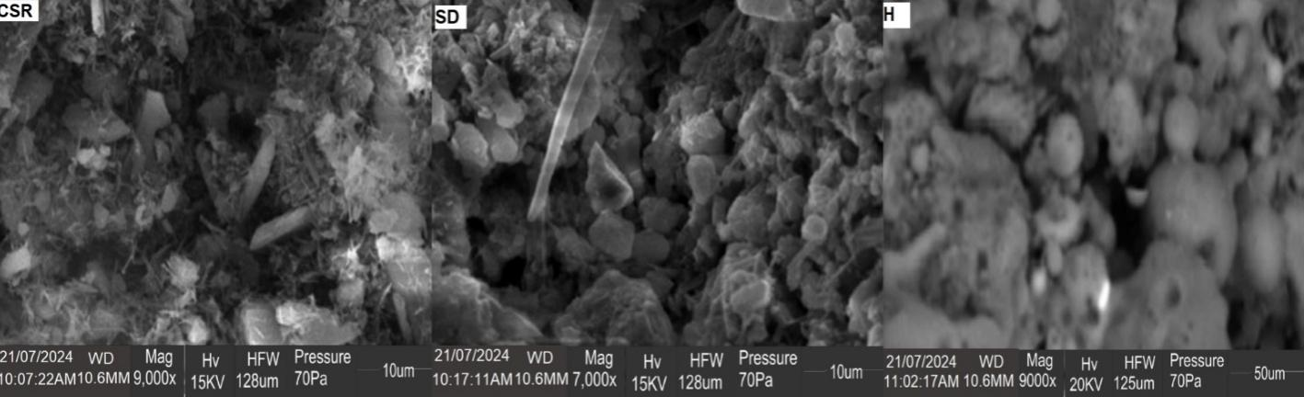
Figure1: SEM images for bio-polymer composites (CSR, SD and H)
The morphology of polymer bio polymer composite material depends on the processing conditions, nature components, weight fractions, and component melt viscosities. The Coconut shell residue (CSR), Saw dust (SD) and Hybrid (H) filler bio-polymer composites SEM images are shown in Figure1, the images showed rough and heterogenous surfaces from the various filler additions to polymer matrix. The micrographs supported the visual observation that the particle distribution was essentially homogeneous and that there was strong interfacial adhesion at the filler/matrix contact. The filler particles were not coming off but were still firmly linked to the matrix material, demonstrating this ideal bonding. Also at the constituents' bonding sites, void areas were not seen. In general, the micrographs demonstrate a notable impact of the filler elements on the composites. Reitman et al., (2019). Suggested that the reduction to finer particle sizes will greatly improve interfacial contact of the two distinct fillers used in the composites and the polymer matrix and in turn enhance the mechanical properties and moisture absorption. Ogudo, et al., (2021) noted a degree of homogeneity in agro-waste to LDPE composites and this was observed to influenced their moisture absorptivity as the hydrophobic and hydrophilic components of the materials played a significant role in the degradation of the composites.
3.1.2 FTIR Analysis
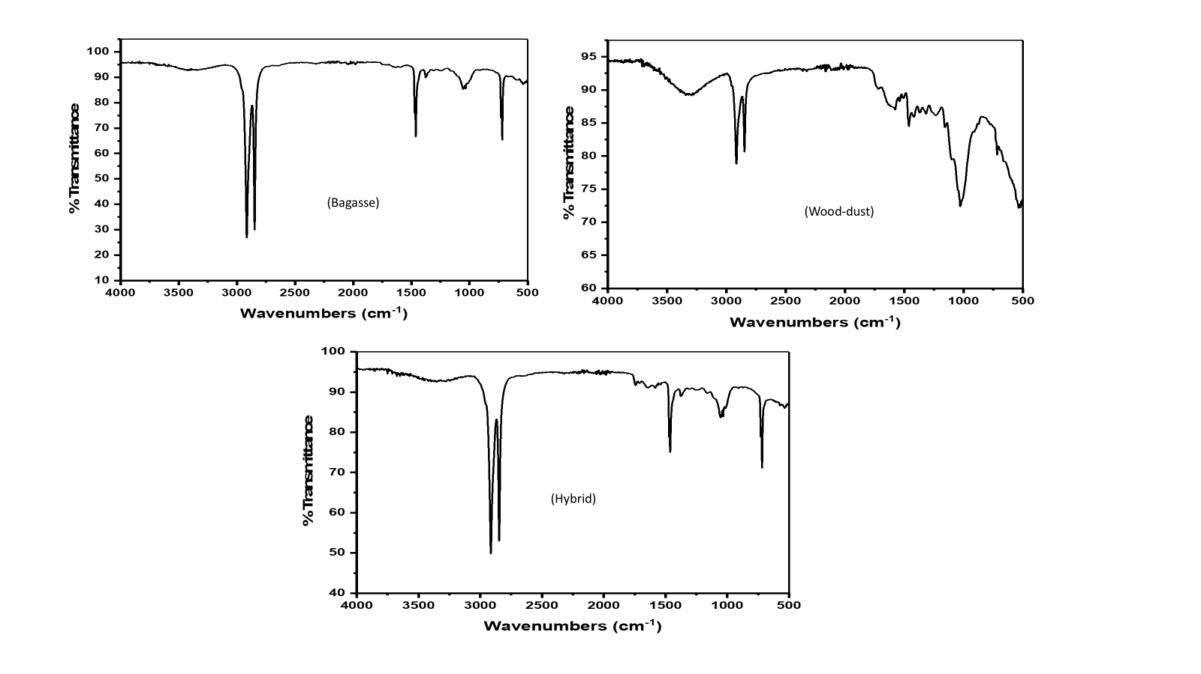
Figure 2: FTIR spectra for Coconut shell (CS), Saw dust (SD) and Hybrid (HB) bio-polymer composites
Figure 2. shows the FTIR spectra for Coconut shell (CS), Saw dust (SD) and Hybrid (HB) bio-polymer composites, it shows the characteristic peaks of polyethylene such as the C-H stretching vibrations between 2915 cm⁻¹ and 2848 cm^{−1,} the CH₂ bending vibrations from 1461 to 1501 cm⁻¹, and the vibrations from 716 to 1000 cm⁻¹, Also, a small peak at 1370 cm⁻¹ appears for the composites due to CH₃ symmetric deformation vibrations. The presence of OH 3500-3600 cm⁻¹ can be attributed to the hydroxyl groups from cellulosic component of the filler materials and also moisture absorbed during the preparation of the composite, similar frequencies were noted by Hamin et al., (2023) when they studied sugarcane bagasse as filler for polymer composites.
3.2 Mechanical properties
The following mechanical properties were determined for the prepared bio-polymer composites.

Figure 3: Hardness test for coconut shell (CS), saw dust (SD) and Hybrid (HB) bio-polymer composites
3.2.1 Hardness of bio-polymer composites
The hardness test was determined for the bio-polymer composites from Coconut shell (CS) and Saw dust (SD) filler materials and Hybrid (HB) made from both fillers and the hardness plot is shown in Figure 3, that the hardness of the bio-polymer composites was observed to increase for all the prepared composites as the filler concentration was increased. This is expected since the elasticity of the polymer matrix decreases as more filler material is added, resulting in the development of a more rigid polymer composite material. The polymer composites recorded values ranging between 50/50 to 90/10 filler ratios as 69.27-82.33 (Hv) for coconut shell (CS), 66.15- 77.84(Hv) for saw dust (SD) and 70.19-82.97 (Hv) for hybrid (HB) composites. Although the average hardness of the polymer composites is observed to increase with additional filler loads, individual variations are also seen to exist with the various ratios in part because of the inadequate phase interaction between the two highly cellulosic fillers and the polyethylene matrices. This outcome is consistent with Kundie et al., (2018), they found that the filler load had a significant impact and enhanced the hardness of prepared dental composites.

Figure 4: Average impact energy (J) for Coconut shell (CS), Saw dust (SD) and Hybrid (HB) bio-polymer composites

Figure 5: Impact strength (Jmm) for Coconut shell (CS), Saw dust (SD) and Hybrid (HB)
bio-polymer composites
3.2.2 Impact strength of bio-polymer composites
The average impact energy and impact strength for the prepared Coconut shell (CS) and Saw dust (SD) filler materials and Hybrid (HB) bio-polymer composites was determined, and the results are plotted in Figure 4 – 5. The maximum energy that the composites may absorb upon impact is determined by the impact strength. The impact energy measured in joules ranged from 50/50 to 10/90 ratios as follows 0.81-0.30 (J), 0.61-0.44(J) and 0.80-0.31(J) for Coconut shell (CS) and Saw dust (SD) filler materials and Hybrid (HB) bio-polymer composites while the impact strength ranged from 0.25-0.09 (Jmm), 0.19-0.14 (Jmm) and 0.25-0.10 (Jmm) for Coconut shell (CS) and Saw dust (SD) filler materials and Hybrid (HB) bio-polymer composites respectively. All the produced composites showed a gradual loss of this property as the concentration of the filler material was increased. The composition of the filler, the polymer, and the interfacial bonding between the filler and matrix all affect the impact properties of filler reinforced polymer composites (Navaranjan & Neitzert, 2017). The findings are in line with the report of Iyer & Torkelson, (2014) for injection-molded pure PHB and pure PLA composites produced using corn cob as filler materials. Corncob fillers were observed to disrupt the PHB-PLA matrix's continuity, preventing energy absorption and transmission when the impact force was applied. This reduced the composite's resistance to deformation and accelerated its failure (Iyer & Torkelson, 2014).

Figure 6: Tensile strength for coconut shell (CS), saw dust (SD) and Hybrid (HB) bio-polymer composites

Figure 7: Tensile modulus for coconut shell (CS), saw dust (SD) and Hybrid (HB) bio-polymer composites

Figure 8: % Elongation for coconut shell (CS), saw dust (SD) and Hybrid (HB) bio-polymer composites
3.2.3 Tensile properties of bio-polymer composites
The findings of the study on the tensile strength, tensile modulus and % elongation for Coconut shell (CS) and Saw dust (SD) filler materials and Hybrid (HB) bio-polymer composites are shown in Figures 6 - 8. Tensile properties, tensile strength, tensile modulus and elongation % showed a reduction as filler loading was increased. In light of decreased filler dispersion, higher agglomeration, and having to deal with a larger filler matrix interface. Betancourta & Cree (2017) reported that the filler to matrix link decreases with increasing filler load, along with a large rise in filler loading, the tensile modulus also increased. When filler loading is increased, the tensile modulus of the composites is increased because the load is effectively transferred to the filler particles, which absorb and transmit the stress loading significantly better. The tensile strength and modulus of the prepared Coconut shell (CS) and Saw dust (SD) filler materials and Hybrid (HB) bio-polymer composites increased with filler concentration, demonstrating this effect. The tensile properties were determined as follows for 10/90 and 50/50 ratio ranging from 24.09-9.02 (MPa) and 245.11-127.30 (MPa) for Coconut shell (CS), 22.03-9.31(MPa), 241.51-121.50 (MPa) for Saw dust (SD) and 23.04-8.01(MPa) and 244.08-126.27(MPa) for Hybrid (HB) polymer composites. The results show that the filler materials significantly affect the composite's tensile characteristics. Similar investigations on polymer composites were carried out by Owuamanam et al., (2021) for PLA/corncob composites and Arrakhiz et al., (2013) for polypropylene/clay composites, they produced results similar to those shown here, the tensile modulus was visibly improved by adding more filler material. Tazibt et al., (2023), in their study of the effect of hydroxyapatite (HAp) synthesized by the chemical precipitation process on the morphology and properties of composites based on poly (lactic acid) (PLA) as filler materials reported that the addition of 5 wt% of HAp into the PLA led to a slight improvement in both the thermal stability and tensile properties of the composite material in comparison with neat PLA and other composite samples. Indeed, the values of the tensile strength and modulus increased although, at a higher filler content ratio, a decrease in the properties of the PLA/HAp composites was observed, being more pronounced at 15 wt%. High ratios of HAP powder served as a filler to occupy the voids between polymer chains, contributing to a hardened structure. In this case, the microparticles tend to agglomerate, resulting in restricted lateral movement. Consequently, the contact area with the polymer diminishes, complicating the distribution of the filler among the chains. Additionally, the onset of cracking compromises tensile strength as the percentage of HAP powder filler increases. even though matrices may be strong enough to raise the modulus. Agglomerates constitute weak areas, so with load application and stress transfer to these weak areas, the bonds linking the agglomerated particles break and the stress is transferred back to matrix initiating cracks and stress concentrations and eventually leading to composite failure (Owuamanam and Cree (2020). The % elongation for the prepared composites were determined and ranged as follows from 10/90 to 50/50 ratio 8.21-7.06 (%), 8.03-7.16 (%), 7.92-6.17 (%), coconut shell (CS) and saw dust (SD) filler materials and hybrid (HB) bio-polymer composites. Increasing the concentration of fraction of filler material leads to reduction in the percentage of elongation for samples. This is due to the fact that the presence of fillers imparts the stiffening effect within the matrix and thus imposes a mechanical restraint on the composites (Tazibt et al., 2023).

Figure 9: % Moisture absorption for coconut shell (CS), saw dust (SD) and Hybrid (HB) bio-polymer composites

3.3 Moisture absorption capacity
Moisture tolerance of the prepared bio-polymer composites was studied and the results are presented in figure 9. for Coconut shell (CS), Saw dust (SD) and Hybrid (HB) composites. Statistical analysis was carried out using SPSS version 23. Since there was no need to transform the values, principal component analysis (PCA) and hierarchical cluster analysis (HCA) were carried out to identify the most influential components and also evaluate the composite with the best moisture tolerance. The results are shown in Tables 3 and 4 for total variance and component scores and figure 10. for dendrogram respectively.
Table 3: Total variance in principal component analysis (PCA)
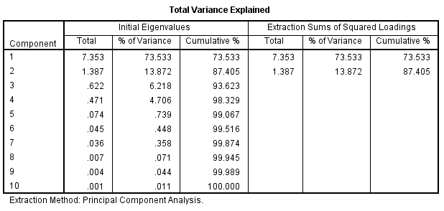
Table 4: Component scores in PCA
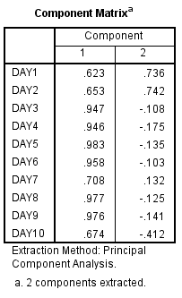

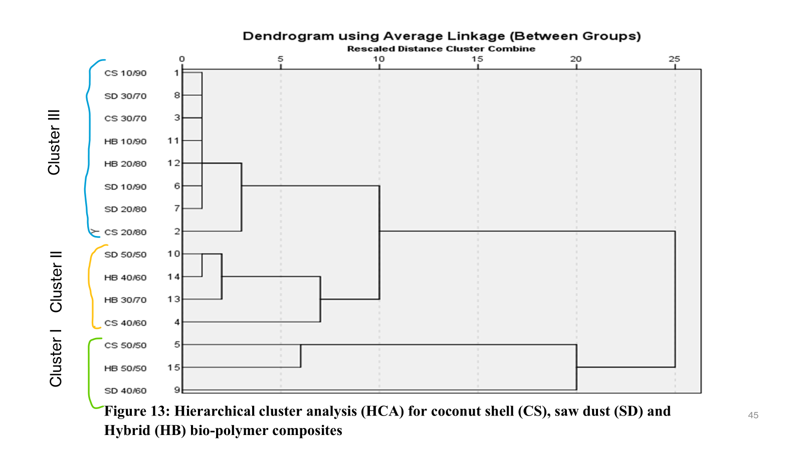

Figure 10: Hierarchical cluster analysis (HCA) for coconut shell (CS), saw dust (SD) and
Hybrid (HB) bio-polymer composites

4.0 CONCLUSION
The prepared composites showed a good interfacial bonding at the filler/matrix interface indicating a homogenous distribution of filler particles as was observed in S.E.M analysis even as hydrophilic (OH) groups were identified by FTIR at 3500cm-1. Increasing the filler concentrations greatly influenced the mechanical properties and moisture tolerance of the prepared composites, The filler ratios ranging from 10/90 to 30/70 are more tolerant to moisture. It is possible using the approach and waste materials, to obtain sustainable bio-polymer composites with stable and durable properties.
REFERENCE
1. Ali, C., Moon, H., Zheng, J., Qiu, Y., Tabassum, T., Jang, J. H., Abu-Omar, M., Scott, S. L., & Suh, S. (2020). Degradation rates of plastics in the environment. ACS Sustainable Chemistry & Engineering, 8(9), 3494-3511. (link unavailable)
2. Guna, V., Ilangovan, M., Hu, C., Venkatesh, K., & Reddy, N. (2019). Valorization of sugarcane bagasse by developing completely biodegradable composites for industrial applications. Industrial Crops and Products, 131, 25-31. (link unavailable)
3. Pilapitiya, P. G. C. N. T., & Ratnayake, A. S. (2024). The world of plastic waste: A review. Cleaner Materials. (link unavailable)
4. United Nations Environment Programme. (2024). Global tragedy. (link unavailable)
5. Owoyemi, J. M., Zakariya, H. O., & Elegbede, I. O. (2016). Sustainable wood waste management in Nigeria. Environmental Socio-economic Studies, 4(3), 1-9.
6. Sethuraman, G., Nizar, N. M. M., Muhamad, F. N., Suhair, T. A. S. T. M., Jahanshiri, E., Gregory, P. J., & Azam-Ali, S. (2020). Nutritional composition of black potato (Plectranthus rotundifolius (Poir.) Spreng.) (Synonym: Solenostemon rotundifolius). International Journal of Scientific & Engineering Research, 11(10), 1145-1150.
7. Yogitha, B., Karthikeyan, M., & Reddy, M. G. M. (2020). Progress of sugarcane bagasse ash applications in production of eco-friendly concrete–Review. Materials Today: Proceedings, 33, 695-699.
8. Owuamanam, S., & Cree, D. (2020). Progress of bio-calcium carbonate waste eggshell and seashell fillers in polymer composites: A review. Journal of Composites Science, 4(2), 70. (link unavailable)
9. Kundie, F., Azhari, C. H., Muchtar, A., & Ahmad, Z. A. (2018). Effects of filler size on the mechanical properties of polymer-filled dental composites: A review of recent developments. Journal of Physical Science, 29(1), 141-165.
10. Navaranjan, N., & Neitzert, T. (2017). Impact strength of natural fibre composites measured by different test methods: A review. MATEC Web of Conferences, 109, 01003.
11. Iyer, K. A., & Torkelson, J. M. (2014). Green composites of polypropylene and eggshell: Effective biofiller size reduction and dispersion by single-step processing with solid-state shear pulverization. Composites Science and Technology, 102, 152-160.
12. Arrakhiz, F. Z., Elachaby, M., Bouhfid, R., Vaudreuil, S., Essassi, M., & Qaiss, A. (2012). Mechanical and thermal properties of polypropylene reinforced with alfa fiber under different chemical treatment. Materials & Design, 35, 318-322.
13. Tazibt, N., Kaci, M., Dehouche, N., Ragoubi, M., & Atanase, L. I. (2023). Effect of filler content on the morphology and physical properties of poly(lactic acid)-hydroxyapatite composites. Materials, 16(2), 809.
14. Betancourt, N. G., & Cree, D. E. (2017). Mechanical properties of poly(lactic acid) composites reinforced with CaCO3 eggshell based fillers. Published online by Cambridge University Press.

