Original Research Article
Influence of Calcination Temperature on the Physicochemical Properties of Limestone from the Aktau Deposit

Abstract
Aims: To investigate the effect of calcination temperature on the physicochemical properties of carbonate rocks from the Aktau deposit in Karakalpakstan, with a focus on the relationship between firing temperature, lime reactivity, and microstructural characteristics.
Study Design: Experimental laboratory study with comparative analysis across different calcination temperatures.
Place and Duration of Study: Karakalpak Scientific Research Institute of Natural Sciences, Karakalpak Branch of the Academy of Sciences of the Republic of Uzbekistan, Nukus, from March to November 2024.
Methodology: Limestone samples from the Aktau deposit were calcined at 800, 900, 1000, 1100, and 1200 °C. Chemical composition was determined by standard wet chemistry methods. Thermal behavior was analyzed using thermogravimetric and differential thermal analysis. Functional groups were examined by infrared (IR) spectroscopy. Microstructural features were observed by scanning electron microscopy (SEM). The reactivity of the produced lime was evaluated according to hydration rate and temperature rise during slaking.
Results: Increasing calcination temperature above 1000 °C significantly enhanced the reactivity of lime, with maximum values observed at 1100 °C. SEM images revealed that higher temperatures led to coarser but more porous microstructures, improving water penetration during hydration. IR spectroscopy confirmed progressive decomposition of carbonates and formation of free CaO. Samples calcined at 800–900 °C retained partially decomposed calcite, resulting in lower reactivity. Impurity content, texture, and grain size were found to influence the hydration kinetics.
Conclusion: Calcination temperature plays a critical role in determining the physicochemical properties and reactivity of lime from the Aktau deposit. Optimal reactivity is achieved at 1100 °C due to favorable microstructural development. These findings can guide industrial processing parameters to produce lime with improved performance in construction and chemical applications.
Keywords: air binders, limestone, Aktau deposit, binding materials, mineral, carbonates, calcination temperature.
Introduction
Limestone represents one of the most abundant and economically valuable sedimentary rocks, primarily consisting of calcium carbonate (CaCO₃), which occurs in the crystalline forms of calcite and aragonite. Owing to its wide distribution, relatively low cost, and multifunctional properties, it plays a key role across numerous industries. In construction, limestone serves as the main raw material for lime, cement, and composite binders. In metallurgy, it is widely applied as a flux for removing impurities from molten metals, while in the chemical sector it provides a source of calcium oxide, calcium hydroxide, and other essential derivatives.
The processing of limestone typically involves calcination — the thermal decomposition of CaCO₃ into calcium oxide (CaO) with the release of CO₂. The temperature and duration of this process are decisive factors influencing decomposition efficiency and, consequently, the characteristics of the obtained lime. These include specific surface area, reactivity, phase composition, and particle morphology. Insufficient heating results in incomplete decomposition and low reactivity, whereas overheating leads to sintering, a decrease in activity, and deterioration of hydration and binding behavior.
Quicklime (CaO) is recognized as one of the oldest and most important binders used in construction. It is conventionally produced by heating limestone or dolomite within the temperature range of 900–1300 °C. During this stage, carbonate minerals decompose, CO₂ is released, and reactive lime is formed with distinct microstructural features. The microstructure has a direct influence on the performance of the material: underburnt lime retains low reactivity, while overburnt lime becomes too dense and loses activity. Hence, precise control of calcination parameters is required to obtain high-quality quicklime.
Many researchers have reported that calcination conditions substantially affect lime properties. For example, Qian et al. (2023) introduced a partial low-temperature calcination approach that promotes the formation of a core–shell structure, enhancing reactivity and cement strength. Pavia et al. (2023) demonstrated that higher temperatures tend to reduce activity and alter the microstructure of mortars. Zhang et al. (2023) emphasized that decreasing particle size accelerates CO₂ release and improves lime reactivity, while Desmiarti et al. (2022) showed that calcination at 1000 °C for 5 h results in CaO content exceeding 90%, indicating nearly complete decomposition.
Despite these findings, the calcination behavior of Aktau limestone has not yet been systematically studied. This deposit is characterized by a high CaCO₃ concentration, low magnesium carbonate, and minimal clay and silica impurities, which suggests a strong potential for producing reactive lime. Its unique mineral composition may influence decomposition kinetics, phase transitions, and the evolution of microstructure under different calcination conditions.
Given the current emphasis on sustainable construction practices and the importance of efficient utilization of local mineral resources, research on Aktau limestone is both timely and practically significant. The purpose of this work is to determine how calcination temperature affects the physicochemical characteristics of Aktau limestone and to establish the optimal conditions for obtaining highly reactive quicklime, using a combination of chemical, thermal, infrared, and SEM analyses.
2. Materials and Methods
The calcination process was carried out in two types of laboratory furnaces. For thermal treatment at temperatures not exceeding 1100 °C, a SNOL 1.6.2.5/11-I2 muffle furnace (220 V, 50 Hz, 3.0 kW, weight 78 kg) was applied. This unit provided a stable heating regime with deviations of no more than ±5 °C. For experiments at higher temperatures, a SEL-HORN R-8 L furnace equipped with silicon carbide (SiC) heating elements and a touchscreen control system was employed. Although the device is designed to reach 1500 °C, in the present study the working range was limited to 1300 °C. Uniform heat distribution was achieved by spiral SiC elements, and the temperature was controlled using a thermocouple combined with a digital regulator (accuracy ±5 °C). The selection of the furnace type was based on the required thermal conditions.
The heating rate in all experiments was maintained at 8–10 °C/min until the selected temperatures (800, 900, 1000, 1100, and 1200 °C) were reached. Each sample was kept at the target temperature for 30 min, after which controlled cooling was performed inside the closed furnace chamber in air at a rate of about 2–3 °C/min down to approximately 200 °C.
The feedstock material was limestone from the Aktau deposit, located near the right bank of the Amu Darya River, 45 km northwest of Beruni and about 1 km from the Tortkul–Nukus highway. During sampling, fragments with visible clay layers, organic inclusions, or iron oxides were deliberately avoided.
Bulk pieces of limestone were transported to the laboratory without pre-washing. The initial crushing was performed with a laboratory jaw crusher, producing a 10–20 mm fraction. The obtained material was sieved through a 5 mm mesh (GOST 6613-86). The weight of the batches was determined using mechanical lever household scales (capacity 10 kg, graduation 50 g). After calcination, samples were weighed on SF-400 electronic scales (capacity 10 kg, graduation 1 g), which were applied in cases where high accuracy was not critical.
For further characterization, a portion of calcined samples was ground manually. Preliminary comminution was done in a metal mortar, followed by fine grinding in a porcelain mortar to reduce external contamination. The powdered fraction was used for X-ray diffraction (XRD) and chemical tests, whereas larger fragments were retained for thermal investigations.
Several analytical methods were used to study phase and structural changes:
- Thermogravimetric (TGA) and differential thermal analysis (DTA): performed on a Shimadzu DTG-60 analyzer in an argon atmosphere (80 mL/min) using alumina crucibles. The sample mass was 5.477 mg, heating rate 10 °C/min from room temperature to 1000 °C.
- Fourier-transform infrared spectroscopy (FTIR): carried out on a Shimadzu IRSpirit-T spectrometer (Japan, 2022) to determine functional groups and chemical bonds.
- Scanning electron microscopy (SEM): conducted with a JEOL JSM-IT210 microscope to observe morphology, pore formation, and microstructural changes.
According to the TGA/DTA and FTIR data, complete decomposition of CaCO₃ was achieved above 1000 °C (Table 1). SEM micrographs revealed the development of pores, recrystallization, and grain boundary formation during calcination.
Table 1. Composition of CaCO₃ decarbonization products during calcination
Calcination temperature (°C) | CaO (%) | CO₂ (%) | Total (%)
Raw material | 55.49 | 42.38 | –
800 | 95.57 | 4.53 | 100.10
900 | 96.89 | 3.12 | 100.01
1000 | 98.42 | 1.59 | 100.00
1100 | 100.00 | – | 100.00
1200 | 100.00 | – | 100.00

3. Results and Discussion
The most effective and rapid approach for evaluating the influence of thermal treatment on the phase and chemical composition of the samples is infrared (IR) spectroscopy. In the IR spectrum of CaCO₃, three distinct and well-resolved absorption bands are observed in the mid-infrared region: at 713 cm⁻¹ (ν₄ – in-plane bending vibration of the CO₃ group), 874 cm⁻¹ (ν₂ – out-of-plane bending vibration of CO₃), and 1420 cm⁻¹ (ν₃ – asymmetric stretching vibration of CO₃) [5–7]. These characteristic peaks correspond to the fundamental vibrational modes of the carbonate ion and serve as reliable markers for identifying the presence and decomposition stage of calcium carbonate during heat treatment.
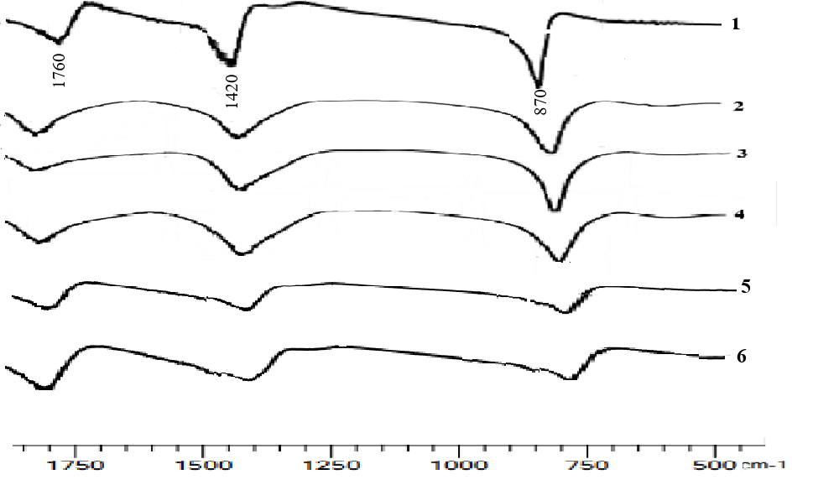
Fig. 1. IR absorption spectra of limestone from the Aktau deposit and lime after heat treatment: (1) natural limestone; (2) calcined at 800 °C; (3) calcined at 900 °C; (4) calcined at 1000 °C; (5) calcined at 1100 °C; (6) calcined at 1200 °C with a holding time of 30 min.
Infrared (IR) spectroscopic analysis (Fig. 1) revealed that the spectra of limestone from the Aktau deposit are characterized by distinct absorption bands at 870–860 cm⁻¹ (an intense, narrow band) and 1420–1430 cm⁻¹ (an intense, broad band), attributed to the vibrational modes of the CO₃²⁻ ion, which is indicative of the presence of calcium carbonate. This confirms that the limestone is composed predominantly of calcium carbonate. The IR spectra of samples calcined at 800–900 °C exhibit absorption bands at 1420–1430 cm⁻¹ corresponding to CaCO₃. At 1000 °C, the intensity of the CO₃²⁻ absorption bands decreases, and at temperatures of 1100–1200 °C the dissociation reaction is completed, resulting in the full conversion of calcium carbonate into calcium oxide (CaO).
The effect of thermal treatment on the properties of limestone from the Aktau deposit was also investigated using a DTG-60 derivatograph. Differential thermal analysis (DTA) and thermogravimetric (TG) curves were recorded at a heating rate of 10 °C/min in the temperature range from 25 to 1000 °C under an argon atmosphere, using an aluminum crucible and a sample mass of 5.477 mg (Fig. 2). According to the thermal analysis data, the DTA and TG curves revealed that in the temperature ranges of 28.93–552.83 °C, 552.88–806.39 °C, and 806.39–1001.76 °C, the mass loss amounted to 3.597%, 44.093%, and 1.150%, respectively. As can be seen, the most significant mass loss—44%—occurs in the second temperature interval.
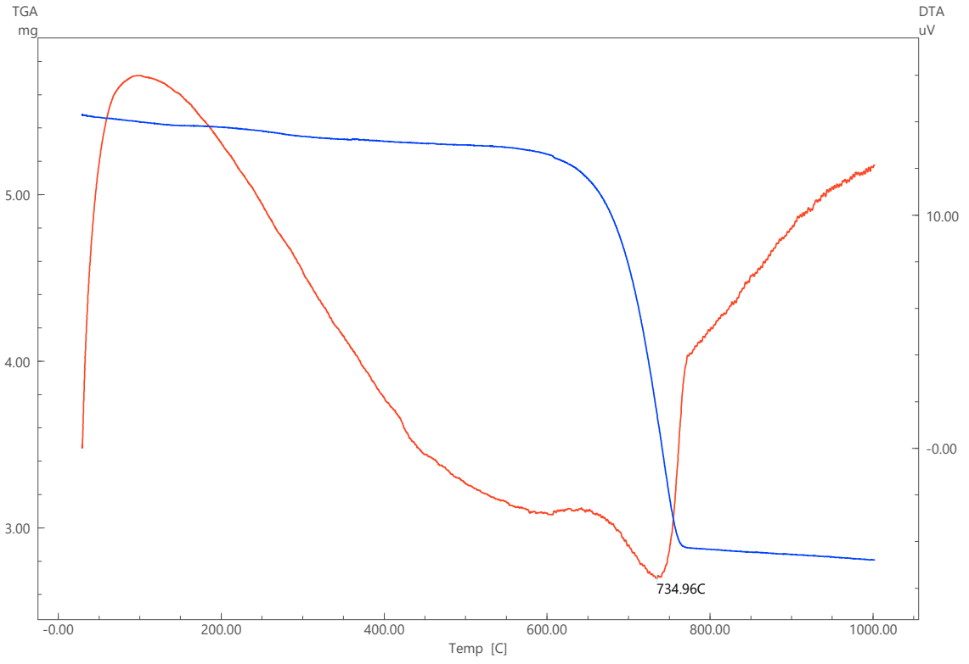
Fig. 2. Thermogram of the limestone sample from the Aktau deposit.
The DTA curve of this sample exhibits a more complex profile. This is due to the presence of thermal effects on the curve that are not associated with mass loss. Such variations occur both below and above the point of maximum mass loss rate. After the peak, the baseline shifts to a slightly lower position. The onset and end temperatures of this interval were refined by extrapolating the curves of the adjacent temperature intervals. The temperature of the thermal effect maximum, determined in this way, is 734.96 °C. This value primarily reflects the temperature of the reference material and the furnace environment. When a substance undergoes physicochemical transformations accompanied by heat absorption, its temperature during this period may be either higher or lower than that of the reference material. In the present case, an endothermic transformation occurs with the absorption of thermal energy from the heating furnace amounting to 550.34 J/g, and the temperature of the studied substance is approximately 100 K higher. Consequently, the peak of the endothermic effect in the sample corresponds to 842.95 °C (734.95 + 108 °C) and falls within the range of 825–930 °C reported in other studies. It should be noted that these results are influenced by various factors, such as the heating rate, sample mass, the presence of impurities in the analyzed substance, and its crystallochemical characteristics [8].
Analysis of the obtained data indicates that the studied sample contains a certain amount of Mg, which may be present in the form of magnesite or dolomite. At temperatures of 700–800 °C, magnesite decomposes according to:
MgCO₃ → MgO + CO₂↑
In dolomite (CaCO₃·MgCO₃), the decarbonation of MgCO₃ occurs earlier, at 650–750 °C, while CaCO₃ remains undecomposed, according to the reaction:
CaCO₃·MgCO₃ → CaCO₃·MgO + CO₂↑
Scanning electron microscopy (SEM) is an important tool in modern structural research, enabling high-precision visualization of the microstructure of lime minerals. SEM allows for the assessment of morphological changes on the surface of raw materials, as well as the processes of crystallite formation and bonding. In this study, a JEOL JSM-IT210 scanning electron microscope was used to analyze raw material samples. The samples were prepared under vacuum conditions and examined with high precision. SEM was employed to investigate the morphological structure of the minerals and the particle shapes. Each sample was scanned at different magnifications (from 100× to 10,000×) and subjected to chemical analysis using an electron beam.

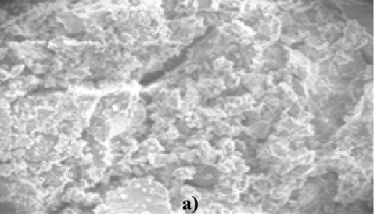 | 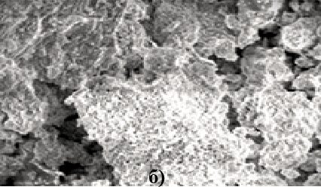 |  | 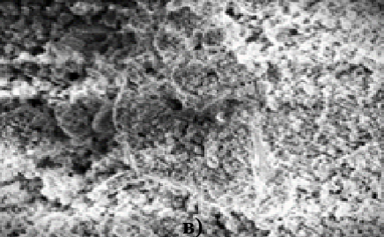
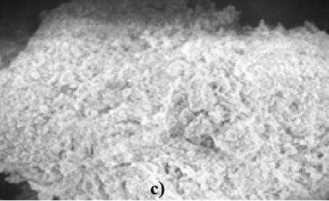 |  | 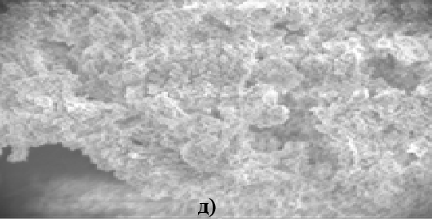
Fig. 3. SEM micrographs of the surface of limestone from the Aktau deposit and lime after heat treatment: (a) natural limestone; (b) sample calcined at 900 °C; (c) sample calcined at 1000 °C; (d) sample calcined at 1100 °C; (e) sample calcined at 1200 °C with a holding time of 30 min.
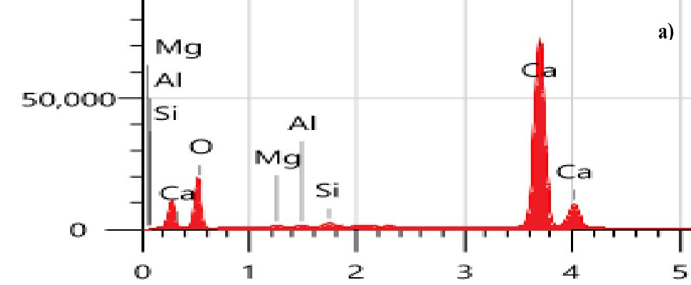 | 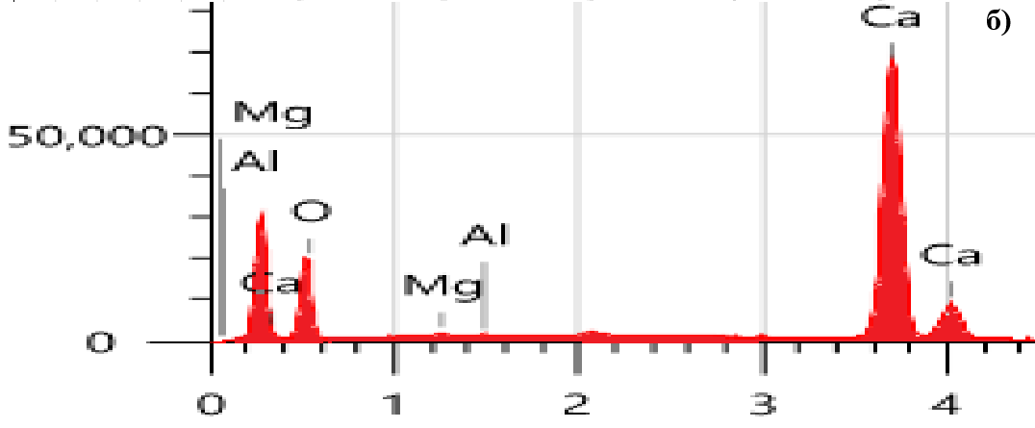 |  | 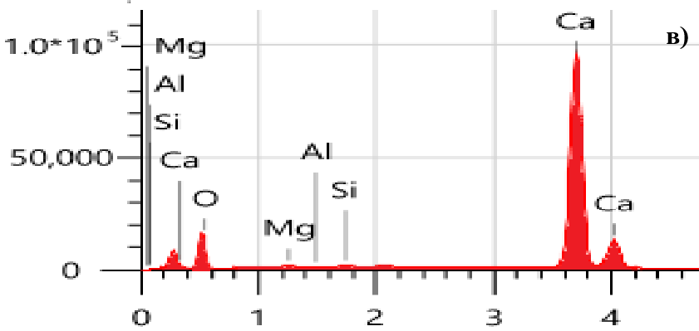
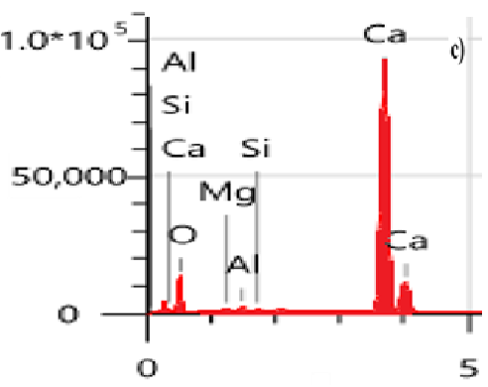 |  | 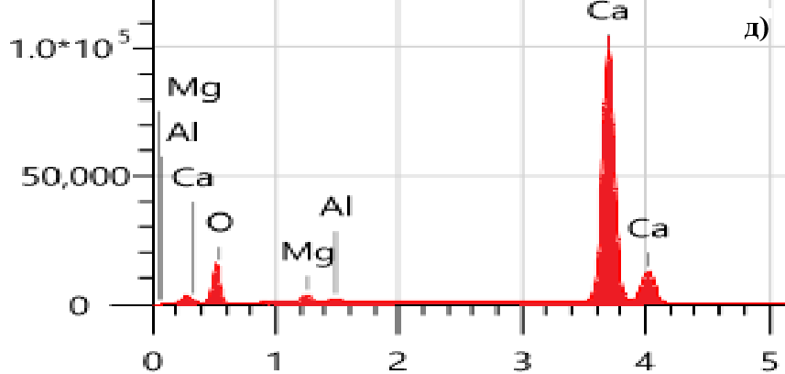
Fig. 4. Elemental composition of Aktau limestone samples calcined at different temperatures.
Based on the analysis results, the results revealed that the crystalline structure and morphological features of limestone samples calcined at different temperatures differ significantly from one another (Figs. 3–4). The microstructure is characteristic of carbonate minerals and the granular structure of calcium oxide. Decarbonation of limestone at low temperatures (800–850 °C) results in the formation of calcium oxide in the form of a spongy mass composed of crystallites approximately 0.2–0.3 μm in size, permeated by ultrafine capillaries with a diameter of about 8 × 10⁻³ μm. Increasing the calcination temperature to 900 °C, and especially to 1000 °C, results in the growth of calcium oxide crystallites to 0.5–2 μm and a significant decrease in specific surface area to 4–5 m²/g. At 1100–1200 °C, the microstructure exhibits a porous structure of calcium oxide, with possible residual carbonate and reaction products of impurities present in the raw material. Ultimately, the microstructure of the calcined limestone consists of a porous, granular structure of calcium oxide formed as a result of calcium carbonate decomposition.
Lime samples obtained at 1000 °C and above, while having the same chemical composition, differ in their degree of crystallization. As shown in Fig. 5, the samples calcined at 800–1000 °C exhibit a relatively loose and porous microstructure, which is characteristic of incomplete decomposition of calcium carbonate and the formation of less-ordered CaO crystals. With increasing calcination temperature, this looseness decreases, and the microstructure becomes denser and more homogeneous. At 1100–1200 °C, well-developed crystalline CaO structures are formed, indicating a higher degree of crystallinity and particle sintering.
Such structural evolution is consistent with the IR spectroscopy and thermal analysis data: the reduction in porosity at higher temperatures corresponds to the completion of the CaCO₃ → CaO transformation and the onset of sintering processes, which promote densification.

Fig. 5. Effect of calcination temperature on the specific surface area of the obtained lime.
The influence of calcination temperature on the specific surface area of lime is shown in Fig. 5. At lower temperatures (800–900 °C), the specific surface area remains relatively high (approximately 290–340 m²/g), due to the porous and loosely packed structure of the lime. A significant decrease in surface area is observed starting from 1000 °C, which is attributed to particle sintering and the densification of the microstructure. At 1200 °C, the surface area reaches its minimum (~140 m²/g), reflecting the formation of larger, well-crystallized CaO particles with reduced porosity.
This trend corresponds well with SEM observations and IR spectroscopy results, confirming that higher calcination temperatures lead to both structural densification and a higher degree of crystallinity.
4. Conclusion
This study demonstrates that the calcination temperature of limestone from the Aktau deposit exerts a decisive influence on the physicochemical properties of the resulting lime. At lower firing temperatures (around 800 °C), the decomposition of calcium carbonate is incomplete, leading to lower reactivity and a loose, porous microstructure. Increasing the calcination temperature to 1000–1100 °C ensures complete decomposition of CaCO₃, yielding lime with higher reactivity and a more homogeneous microstructure. However, further heating to 1200 °C promotes structural densification and particle sintering, which significantly reduce the material’s specific surface area and reactivity. These results provide valuable guidance for optimizing calcination parameters in the production of high-quality lime for construction and industrial applications.
References
- Volzhensky, A. V. (1986). Mineral binding materials (in Russian). Moscow: Stroyizdat, 64–68.
- Potapova, E. N. (2023). Technology of dry building mixes (in Russian). Moscow; Vologda: Infra-Engineering, 37–41.
- Asamatdinov, O. (n.d.). Influence of calcination temperature on the physicochemical properties of lime (in Russian).
- Turemuratov, Sh. N., & Nurumbetov, B. Ch. (2021). Influence of the carbonate calcium on processes of hydration structure-formation of lime–belite binding systems (in Russian). Science and Education in Karakalpakstan, Scientific Journal, (1), 96–101.
- Poduska, K. M., Regev, L., Boaretto, E., Addadi, L., Weiner, S., Kronik, L., & Curtarolo, S. (2011). Decoupling local disorder and optical effects in infrared spectra: Differentiating between calcites with different origins. Advanced Materials, 23(4), 550–554.
- Turemuratov, Sh. N., Kurbaniyazov, S. K., & Akeshova, M. M. (2013). Physico-mechanical properties of lime ware binding materials affected by applied substances and undergone hydrothermal treatment. Journal of Materials and Applications, 1179–1185.
- Turemuratov, Sh. N., Kurbaniyazov, S. K., & Akeshova, M. M. (2013). Influence of hydrothermal processing and applied substances on physicomechanical properties of lime ware binding materials. World Applied Sciences Journal, 23(9), 1151–1156.
- Shayakhmetov, A. U., Mustafin, A. G., & Massalimov, I. A. (2011). Features of thermal decomposition of oxide, peroxide, hydroxide, and calcium carbonate (in Russian). Bulletin of the Bashkir University, 16(1), 29–32.
- Smirenskaya, V. N., Antipova, S. A., & Sokolova, S. N. (2009). Chemical technology of binding materials (in Russian). Tomsk, 13–19.
- Turemuratov, Sh. N., Kurbaniyazov, S. K., & Akeshova, M. M. (2013). Influence of hydrothermal processing and applied substances on physicomechanical properties of lime ware binding materials. World Applied Sciences Journal, 23(9), 1151–1156.
- Tabunshchikov, N. P. (1974). Lime production (in Russian). Moscow: Khimiya, 279 p.

