Original Research Article
Assessment of the combined effect of cattle dung biochar and moderate amounts of mineral fertilizer on the agronomic performance of luffa cultivation in the northen of Côte d’Ivoire

.
ABSTRACT

Background: In Côte d'Ivoire, luffa cultivation is a source of nutrients and income generation for rural women. Luffa producers generally use mineral fertilizers such as NPK and urea to address soil fertility issues. However, excessive application of these mineral fertilizers reduces the agronomic efficiency of nutrients and significantly limits yields.
Aims: The aim of this research was to evaluate the effect of cattle dung biochar combined with a moderate quantity of mineral fertilizer on the production parameters of the luffa crop.
Methodology: A Fisher block design with four treatments (Zero fertilizer, Cattle dung biochar, Cattle dung biochar+Half conventional dose of mineral fertilizer and Conventional dose of mineral fertilizer) and tree replications was used. The effect of the treatments was evaluated on the number of fruits per plant, fruit weight, fruit production per plant and crop yield.
Results: The highest average number of fruits per plant (11.00 ± 1.00) was obtained with the conventional mineral fertilizer treatment. For the other parameters, the highest values were recorded for the treatment with biochar from cattle manure + ½ conventional dose of mineral fertilizer. The average values obtained for this treatment were 376.80 ± 37.06 g for fruit weight, 2637.66 ± 259.46 g for fruit production per plant, and 10.55 ± 1.03 t.ha⁻¹ for luffa crop yield.
Conclusion: Cattle dung biochar combined with a moderate dose of mineral fertilizer improved the agronomic performance of the luffa crop. Thus, this Integrated Soil Fertility Management technology is a relevant option for sustainable intensification of luffa cultivation.

Keywords: Biochar, Cattle dung, Luffa cylindrica, Integrated Soil Fertility Management, Côte d’Ivoire

1. INTRODUCTION

Native to the subtropical and tropical regions of Asia, Luffa cylindrica, commonly known as loofah, is an annual herbaceous climbing plant belonging to the Cucurbitaceae family (Tyagi et al., 2020; Qiao et al., 2022). It is cultivated in tropical and subtropical regions around the world, mainly for its fruit. Luffa cylindrica is a plant of great interest due to its multiple uses (Ogunyemi et al., 2020). Indeed, young fruits are edible when fresh or cooked (Sangh et al., 2012). They are rich in nutrients such as carbohydrates, proteins, vitamins, minerals, and dietary fiber (Qiao et al., 2022). In addition, the fruits and leaves of Luffa cylindrica are used in many traditional medicine treatments for various diseases (Ali, 2019). For example, the leaves are used to treat hemorrhoids, high blood pressure, and asthma (Sangh et al., 2012). The sponge from Luffa cylindrica is also used to make towels, mats, washcloths, sandals and engine filters (Oboh and Aluyor, 2009).
Despite its multifaceted importance, luffa cultivation in Côte d'Ivoire remains extensive and confined to the coastal zone and savanna region. Luffa cultivation faces several constraints that severely limit yields. The major production constraints include diseases, insect pests, rainfall variability caused by climate change, and low soil fertility. This low soil fertility is due to high land pressure, which limits the fallowing of agricultural plots for soil restoration. In addition, producers generally use mineral fertilizers such as NPK and urea to solve soil fertility problems (Mukenza et al., 2021). In addition to their high cost, the excessive application of these mineral fertilizers reduces the agronomic efficiency of nutrients and significantly limits yields (Gnahoua et al., 2023).
Thus, to ensure sustainable intensification of agriculture, it is necessary to implement agricultural technologies based on the use of bioavailable nutrients such as compost, manure and biochar (Gnahoua et al., 2017). Organic matter is one of the key factors in soil fertility (Abdoullahi et al., 2021). In recent years, several scientific studies have demonstrated the importance of biochar as an effective means of recycling agricultural and forestry waste to restore soil fertility (Kanouo, 2017; Manirakiza, 2021; Cissé, 2022; Cissé et al., 2022; Mounirou, 2022; Nyami et al., 2022; Saba et al., 2022; Saba, 2023; Yerima et al., 2023). The aim of this study was to evaluate the effect of cattle manure biochar combined with a moderate amount of mineral fertilizer on the production parameters of luffa cultivation.

2. material and methods

2.1 Study area

The study was conducted in the vegetable garden located near the botanical garden of the Péléforo GON COULIBALY University in Korhogo (Fig. 1). The city of Korhogo is in northern Côte d'Ivoire, between 9°29' and 9°53' north latitude and 5°36' and 6°49' west longitude (Sangaré et al., 2021). The climate is Sudanese and characterized by a dry season from November to April and a rainy season from May to October, with maximum rainfall in August (Soro et al., 2018). The dry season includes an Harmattan period from December to February. Annual rainfall ranges from 1,100 mm to 1,600 mm, with an average annual temperature of 27°C (Soro et al., 2018). The vegetation consists mainly of wooded savannahs, shrub savannahs, and sparse forests in some areas. There are classified forests and forest plots in the city and around villages, which are often sacred woods (Konaté et al., 2021). The relief is characterized by a succession of hills and plains, with a predominance of plateaus ranging in altitude from 300 to 500 m. Moderately or slightly denatured ferralitic soils and ferruginous soils are predominant (Diomandé et al., 2014). The current soil dynamics are very active. The surface horizons of these soils are gravelly, with a tendency to become depleted in fine particles (Siéné et al., 2020). The population, mainly Senufo and Malinké, is predominantly rural. They mainly grow corn, sorghum, yams, rice, cotton, and cashews (Sylla and Hauhouot, 2016). Due to overpopulation and lack of land in the densely populated area of Korhogo, the fallow period has been reduced and all usable lowlands are now occupied by urban farmers (Sylla and Hauhouot, 2016).

Fig. 1. Location of the study area

2.2 Material

The material used to conduct this study consists of plant material, technical equipment, and fertilizer. The plant material used in the experiment is the species Luffa cylindrica (Fig. 2). The technical equipment consists of:
- a traditional pyrolyzer (Fig. 3; Fig. 4) to produce biochar;
- an electronic scale for weighing fertilizers and crops;
- tools for tilling the soil and maintaining crops.

The fertilizing material consists of:
- NPK 10-12-32 + 3 (MgO) + 17 (SO3) fertilizer and calcium nitrate 15.5 - 0 - 0 + 26.3 (CaO) used as mineral fertilizer;
- cattle manure biochar, which was used as a biofertilizer (Fig. 5).
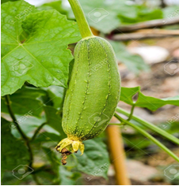 | 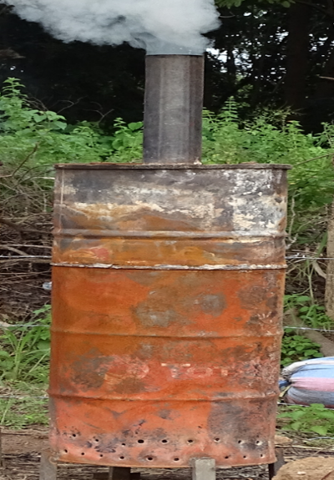
Fig. 2. Fruit of Luffa cylindrica | Fig. 3. Traditional pyrolyzer
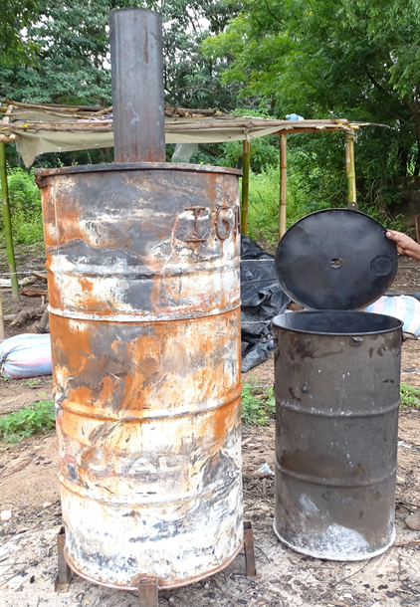 | 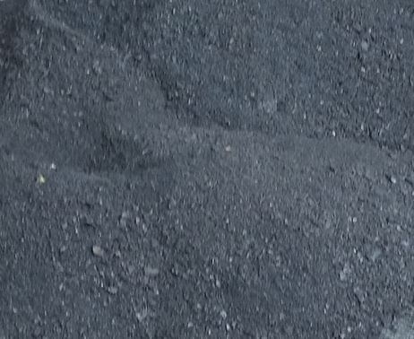
Fig. 4. Barrels from the traditional pyrolyzer | Fig. 5. Cattle manure biochar

2.3 Methods

2.3.1 Land preparation

The preparation of the land initially consisted of clearing the plot, mechanically tilling the soil, and making boards. Each board was 1.5 m long and 1 m wide, giving each board an area of 1.5 m². Next, given the topography of the experimental site, which is on a slope with a gradient of around 10%, an anti-erosion device was installed. This system consists of a protective dyke built around the plot to protect it from erosion and the leaching of mineral fertilizers that could be caused by runoff water. Finally, as Luffa cylindrica is a climbing plant, stakes were installed on each bed to allow the future plants to develop properly.

2.3.2 Biochar preparation

Biochar was obtained from dried cattle manure using a traditional pyrolyzer at a temperature of 500-700°C. The traditional pyrolyzer consists of a small barrel (combustion chamber) and a large barrel (fuel chamber or furnace). To produce biochar, the dried cattle manure is first placed in the small barrel. The small barrel containing the dried cattle manure is then closed and placed inside the large barrel containing the fuel (wood bundles, agricultural residues, etc.). Finally, the fuel is lit to trigger the pyrolysis process, which lasts between 8 and 12 hours. In this way, the incomplete combustion of the cattle manure is achieved by heating to obtain biochar.

2.3.3 Experimental setup

The experiment was conducted on a rectangular plot measuring 77 m² (11 m long and 7 m wide) using a Ficher block design (Fig. 6). There were three blocks (replications), each consisting of four elementary plots or experimental units. The experimental plot thus comprised 12 elementary plots. Each elementary plot was a rectangle 1.5 m long and 1 m wide, corresponding to an area of 1.5 m². The treatments applied in the elementary plots were:
- zero fertilizer (T0);
- cattle manure biochar (T1);
- cattle manure biochar + 1/2 conventional dose of mineral fertilizer (T2);
- conventional dose of mineral fertilizer (T3).

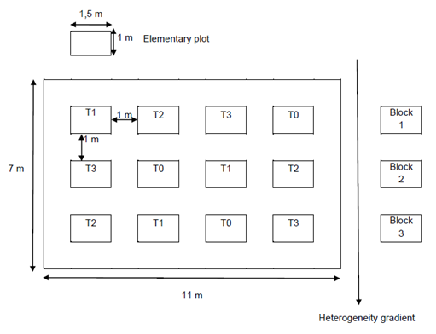
Fig. 6. Fisher Blocks Experimental Setup
T0: Zero-fertilizer; T1: Biochar from cattle manure; T2: Biochar from cattle manure + ½ dose of mineral fertilizer; T3: Conventional dose of mineral fertilizer.
2.3.4 Application of fertilizers

Cattle manure biochar was used as a base fertilizer at a rate of 1 kg per 1.5 m² plot. This corresponds to a dose of 6.5 t.ha⁻¹. For mineral fertilizer, the conventional dose applied per 1.5 m² plot consisted of 120 g of NPK and 30 g of calcium nitrate. Thus, half the dose of mineral fertilizer for a 1.5 m² plot corresponded to 60 g of NPK and 15 g of calcium nitrate. The mineral fertilizer was applied in several stages. For the conventional dose, 80 g of NPK (2/3 of the dose) and 15 g of calcium nitrate (1/2 of the dose) were applied during crop establishment. The second fraction of mineral fertilizer, consisting of 40 g of NPK (1/3 of the dose) and 15 g of calcium nitrate (1/2 of the dose), was applied by spreading during crop growth. For the half-dose of mineral fertilizer, this principle of fractionated application was respected in the same proportions.

2.3.5 Parameters studied

The parameters examined in this study were the number of fruits per luffa plant, the weight of each luffa fruit, the total weight of the fruits per luffa plant, and the yield of the luffa crop. The number of fruits per luffa plant was determined by counting. The weight of each luffa fruit was determined using electronic scales. The total weight of the fruits per luffa plant was obtained by weighing all the fruits produced by that plant. The yield of the luffa crop per plot corresponds to the ratio between the fruit production of all its plants and its surface area.
2.3.5 Data treatment and analysis

The collected data were treated with Statistical Package for Social Sciences (SPSS) software version 20.0. The averages of the parameters studied were determined and compared from one treatment to another by performing one-way analysis of variance (ANOVA 1) tests. The analysis of variance was performed at a threshold of α = 0.05 to determine the effect of the treatments on the different parameters. When a significant difference was observed for a given parameter, the Newman-Keuls test was performed to distinguish homogeneous groups.

3. results and discussion

3.1 Results

3.1.1 Effect of fertilizers on the number of fruits per plant

The average number of fruits per plant according to treatment is summarized in Table 1. Analysis of variance showed that the average number of fruits per plant varied significantly according to treatment (p-value = 0.01; α = 0.05). Thus, the average number of fruits per plant varied from 11.00 ± 1.00 in the conventional mineral fertilizer treatment to 5.33 ± 1.15 in the zero-fertilizer treatment. However, the values obtained for the treatments Biochar from cattle manure (7.33 ± 1.15), Biochar from cattle manure + ½ conventional dose of mineral fertilizer (7.00 ± 1.00) and Zero fertilizer (5.33 ± 1.15) did not show any significant difference.

Table 1. Average number of luffa fruits per plant according to treatment

Treatments | Average number of fruits
Zero-fertilizer (T0) | 5,33 ± 1,15 b*
Cattle manure biochar (T1) | 7,33 ± 1,15 b
Cattle manure biochar + ½ conventional dose of mineral fertilizer (T2) | 7,00 ± 1,00 b
Conventional mineral fertilizer dose (T3) | 11,00 ± 1,00 a
p-value | 0,01
*The numbers marked with the same letter are not significantly different at the α = 0.05 level.

3.1.2 Effect of fertilizers on fruit weight

The average weight of luffa fruits according to treatment is shown in Table 2. Analysis of variance revealed a significant difference (p-value < 0.001; α = 0.05) in the influence of treatments on average fruit weight. The average fruit weight ranged from 376.80 ± 37.06 g with the Biochar treatment of cattle manure + ½ conventional dose of mineral fertilizer to 201.10 ± 17.78 g with the Zero fertilizer treatment.

Table 2. Average weight of luffa fruits according to treatment

Treatments | Average fruit weight (g)
Zero-fertilizer (T0) | 201,10 ± 17,78 c *
Cattle manure biochar (T1) | 337,61 ± 80,40 ab
Cattle manure biochar + ½ conventional dose of mineral fertilizer (T2) | 376,80 ± 37,06 a
Conventional mineral fertilizer dose (T3) | 245,27 ± 57,88 bc
p-value | ˂ 0,001
*The numbers marked with the same letter are not significantly different at the α = 0.05 level.

3.1.3 Effect of fertilizers on fruit production per plant

The average total fruit mass per luffa plant according to treatment is summarized in Table 3. Analysis of variance showed that the average fruit production per luffa plant varied significantly (p-value < 0.001; α = 0.05) depending on the treatment. Thus, the average fruit production per plant ranged from 2637.66 ± 259.46 g for the Biochar from cattle manure + ½ conventional dose of mineral fertilizer treatment to 1263.66 ± 24.58 g for the Zero fertilizer treatment.

Table 3. Average fruit production per luffa plant according to treatments

Treatments | Average fruit production per plant (g)
Zero-fertilizer (T0) | 1263,66 ± 24,58 c*
Cattle manure biochar (T1) | 2414,33 ± 160,66 ab
Cattle manure biochar + ½ conventional dose of mineral fertilizer (T2) | 2637,66 ± 259,46 a
Conventional mineral fertilizer dose (T3) | 2200,33 ± 11,50 b
p-value | ˂0,001
*The numbers marked with the same letter are not significantly different at the α = 0.05 level.

3.1.4 Effect of fertilizers on yield

The average yield of luffa cultivation according to treatment is shown in Table 4. Analysis of variance showed that the average yield of luffa cultivation varies significantly (p-value < 0.001; α = 0.05) according to treatment. Thus, the average yield ranged from 10.55 ± 1.03 t.ha⁻¹ with the Biochar treatment of cattle manure + ½ conventional dose of mineral fertilizer to 5.05 ± 0.09 t.ha⁻¹ with the Zero fertilizer treatment.

Table 4. Average yield of luffa cultivation according to treatments

Treatments | Average yield (t.ha⁻¹)
Zero-fertilizer (T0) | 5,05 ± 0,09 c*
Cattle manure biochar (T1) | 9,65 ± 0,64 ab
Cattle manure biochar + ½ conventional dose of mineral fertilizer (T2) | 10,55 ± 1,03 a
Conventional mineral fertilizer dose (T3) | 8,80 ± 0,04 b
p-value | ˂0,001
*The numbers marked with the same letter are not significantly different at the α = 0.05 level.

3.2 Discussion

Sustainable crop intensification requires rational fertilization of agricultural plots (Baha, 2021). This involves applying mineral and/or organic fertilizers to compensate for the mineral deficiency of poor soils (Chabalier et al., 2006). The objective of this study was to evaluate the effect of cattle manure biochar combined with a moderate amount of mineral fertilizer on the production parameters of luffa cultivation.
The results of the experiment showed that all production parameters varied significantly depending on the treatments. For all production parameters, the lowest values were recorded for the zero-fertilizer treatment. The average values for this treatment were 5.33 ± 1.15 for the number of fruits per plant, 201.10 ± 17.78 g for fruit weight, 1263.66 ± 24.58 g for fruit production per plant, and 5.05 ± 0.09 t.ha⁻¹ for luffa crop yield. The poor agronomic performance of the control (zero fertilizer) compared to the biochar treatment indicates that biochar has a stimulating effect on luffa cultivation (Woolf et al., 2010).
Except for the number of fruits per plant, the highest average values for production parameters were obtained with the Biochar treatment using cattle manure + ½ conventional dose of mineral fertilizer. The average values for this treatment were 376.80 ± 37.06 g for fruit mass; 2637.66 ± 259.46 g for fruit production per plant; and 10.55 ± 1.03 t.ha⁻¹ for luffa crop yield. The high average values obtained with the treatment combining biochar and mineral fertilizer can be explained, on the one hand, by the compensation of the mineral deficit in the soil by the directly assimilable mineral fertilizer and, on the other hand, by the addition of biochar, which improves the agronomic efficiency of the mineral fertilizer (Vanlauwe et al., 2014). This result is like those of Gnahoua et al. (2017), who demonstrated a beneficial effect of applying poultry manure (5 t.ha-1) and NPK mineral fertilizer (100 kg.ha-1) on cassava crop yields in Côte d'Ivoire.
The high productivity of luffa in the treatment combining biochar and a moderate dose of mineral fertilizer could also be explained by the improvement in soil biological activity, soil water retention capacity, and increased agronomic efficiency of mineral elements through biochar (Ahmadou, 2019). This result is consistent with the observations of Vicky et al. (2016), who reported an increase in production of 64 g per plant for tomatoes and 289 g per plant for peppers in a treatment combining biochar and mineral fertilizer.
Technology combining biochar and mineral fertilizer in moderate doses could be a reasonable approach to ensuring sustainable intensification of luffa cultivation and other agricultural crops on poor soils. This opportunity is justified by the availability of bio-residues (manure, agricultural residues, domestic waste) in the Korhogo area and the accessibility of the traditional pyrolysis system. At the same time, this alternative appears to be a viable strategy for preserving the environment by reducing the negative externalities (pollution of ecosystems, reduction of biodiversity) associated with the excessive use of mineral fertilizers.
The adoption of this technology could be ensured by conducting agricultural experiments in a participatory approach involving farmers, agricultural extension agents, and research institutions. In addition, soil productivity could be improved using biopesticides, minimum tillage, legume association or rotation, and mulching to increase soil biological activity.

4. Conclusion

The combination of cattle manure biochar and a moderate dose of mineral fertilizer improved the agronomic performance of luffa cultivation compared to the application of a conventional dose of mineral fertilizer and the control without fertilizer. This agronomic performance induced by the treatment combining biochar and mineral fertilizer reflects an improvement in mineral status, soil biological activity, and agronomic efficiency of moderate doses of mineral fertilizer through the application of biochar. This technology could be a sustainable alternative for intensifying crops on poor soils, adapted to the social conditions of low-income farmers. However, adopting this technology requires strengthening producers' capacities in biochar production and implementation. This issue could be resolved by conducting multi-site trials using a participatory or integrated approach involving farmers.

DISCLAIMER (ARTIFICIAL INTELLIGENCE)
The authors hereby declare that NO generative AI technologies such as Large Language Models (ChatGPT, COPILOT, etc) and text to image generators have been used during writing of this manuscript.

References

Abdoullahi, I., Maliki, I. B., Bagari, I. S., Bouba, M. D., Mbassi, L. S., Sounya, J. B., Biyanzi, P. & Bobo, D. (2021). Optimization of soil fertilization in Ngaoundéré through the use of biochar: application to corn (Zea mays) cultivation, variety ATP-SR-Y. Journal of Food and Stability, 4 (5) : 1-14.
Ahmadou, A. (2019). Reduction of mycotoxicity in Malian agriculture through the use of biochar obtained from cashew industry by-products. [PhD Thesis]. University of Montpellier.
Ali, E. A.-S. (2019). Constituents and pharmacology of Luffa cylindrica. A review. IOSR Journal of Pharmacy, 9 (9) : 68-79.
Baha, E. S. (2021). Sustainable fertilization management (N, P, K) for the control of Fusarium culmorum induced dry rot of the collar in cereals. [PhD Thesis]. IBN Tofail University of Kenitra.
Chabalier, P.-F., Kerchove, V. V. D., & Macary, H. S. (2006). Guide to organic fertilization in Réunion. Réunion Chamber of Agriculture : Saint-Denis (Réunion).
Cissé, D. (2022). Effects of biochar-based amendments on agro-pedological parameters in a cotton-corn rotation in western Burkina Faso. [PhD Thesis]. University of Liège and Nazi BONI University of Bobo-Dioulasso.
Cissé, D., J. Cornelis, T., Traoré, M., Coulibaly, K., Saba, F., & Nacro, H. B. (2022). Agronomic performance of biochar-based amendments in farmers’ environment in western Burkina Faso. Agronomie Africaine, 34 (2) : 179-190.
Diomandé, L. B., Kanko, C., Tia, E. V., Koné, B., & Yao-Kouamé, A. (2014). Occurrence and chemical composition of essential oil from Lippia multiflora M. leaves (savanna tea) according to pH, carbon, nitrogen, and phosphorus content in soil in Guinean savanna areas in Côte d'Ivoire. Afrique Science, 10 (4) : 93-108.
Gnahoua, J.-B. G., Ettien, D. J. B., N’zué, B., Ebah, C., Koné, B., De Neve, S., & Boeckx, P. (2017). Intensification pathway for improvement of smallholder cassava production systems in southern Côte d’Ivoire. Experimental Agriculture, 53(1), 44–58. DOI :10.1017/S0014479716000041
Gnahoua, J.-B. G., Ouattara, M. L. M. S., Coulibali, Z., Diomandé, L. B., & Soro, Y. R. (2023). Integrated soil fertility management : a promising pathway for sustainable intensification of smallholder cotton farming systems in Côte d’Ivoire. Asian Journal of Research in Crop Science, 8 (1) : 51-58. DOI : 10.9734/AJRCS/2023/v8i1157
Kanouo, B. M. D. (2017). Production and use of biochar for the amendment of leached tropical red soils. [PhD Thesis]. Laval University.
Konaté, D., Fofana, L., & Touré, M. L. (2021). Sacred forest conservation facing with an aggressive urban dynamic in Korhogo. Revue Écosystèmes et Paysages (Togo), 1 (1) : 1-11.
Manirakiza, E. (2021). Combined application of pine biochar and mixed paper mill biosolids: an option for improving their agronomic efficiency. [PhD Thesis]. Laval University.
Mounirou, M. M. (2022). Comparative effect of fertilization based on biochar, organic fertilizer and chemical fertilizer on the mineral elements and the production of onion (Allium cepa L.). European Scientific Journal, 18 (24) : 47-67. DOI : doi.org/10.19044/esj.2022.v18n24p47
Mukenza, M. M., Mwenya, I. K., Kalumbu, J. T., Misonga, A. K., Kaleba, S. C., & Sikuzani, Y. U. (2021). Perception of the degradation of soil fertility and its management by farmers in the city of Kasenga in the Democratic Republic of Congo. Géo-Eco-Trop., 45 (2) : 211-220.
Nyami, B. L., Sudi, C. K., Lejoly, J., & Kalala, P. M. (2022). Effect of biochar on water retention and availability and mineral elements for plants in sandy soil in Kinshasa. Revue Africaine d'Environnement et d'Agriculture, 5 (3) : 19-29.
Oboh, I. O., & Aluyor, E. O. (2009). Luffa cylindrica- an emerging cash crop. African Journal of Agricultural Research, 4 (8) : 684-688.
Ogunyemi, T. C., Ekuma, C. M., Egwu, J. E., & Abbey, D. M. (2020). Proximate and mineral composition of sponge gourd (Luffa cylindrica) seed grown in South-Western Nigeria. Journal of Scientific Research and Reports, 26 (4) : 61-67. DOI: 10.9734/jsrr/2020/v26i430248
Qiao, S., Xu, Y., Hu, Q., Dong, W., He, S., Qi, X., & Sun, Y. (2022). Transcriptome analysis of sponge gourd (Luffa cylindrica) reveals candidate genes associated with fruit size. Agronomy, 12 (8) : 1818. DOI : https://doi.org/10.3390/agronomy12081810
Saba, F. (2023). Study of the effects of the combined use of biochar and microdose fertilisation on the agro-pedological properties of the western and north-central regions of Burkina Faso. [PhD Thesis]. University of Liège and Nazi BONI University of Bobo-Dioulasso.
Saba, F., Sawadogo, H., Cornelis, J.-T., Ouedraogo, A.-K., Cissé, D., Coulibaly, K., & Nacro, H. B. (2022). Fficient management of nutrient in zaï system using biochar and compost in central north region of Burkina Faso. Agronomie Africaine, 34 (1) : 101-115.
Sangaré, N., Doho, B. T. A., Kouakou, B., & Koffi, B. E. (2021). Urban dynamics and governance of peri-urban neighbourhoods in the city of Korhogo (Côte d'Ivoire) from 2002 to 2020. Revue de Géographie Tropicale et d’Environnement, 1 : 111-123.
Sangh, P., Amit, K., Neeraj, K. S., & JHA, K. K. (2012). Luffa cylindrica : an important medicinal plant. Journal of Natural Product and Plant Resourse, 2 (1) : 127-134.
Siéné, L. A. C., Doumbouya, M., Traoré, M. S., Condé, M., N’guettia, T. V. F., & Koné, M. (2020). Effect of four types of fertilizers on the growth and productivity of two maize genotypes (Zea mays L.) in the event of late planting in Korhogo in North-Central Côte d'Ivoire. International Journal of Biological and Chemical Sciences, 14 (1) : 55-68. DOI : 10.4314/ijbcs.v14i1.6
Soro, G., Koffi, N. M., Koné, B., Kouakou, Y. E., M’bra, K. R., Soro, P. D., & Soro, N. (2018). Use of plant protection products in market gardening around the drinking water supply dam in the town of Korhogo (northern Côte d'Ivoire): risks to public health. Environnement, Risques & Santé, 17 (2) : 155-163.
Sylla, D., & Hauhouot, C. (2016). Land use dynamics in the densely populated area of Korhogo based on a ‘pixel-by-pixel’ approach applied to LANDSAT TM/ETM⁺ images. Revue de Géographie Tropicale et d’Environnement, 2 : 31-39.
Tyagi, R., Sharma, V., Sureja, A.K., Das Munshi, A., Arya, L., Saha, D., & Verma, M. (2020). Genetic diversity and population structure detection in sponge gourd (Luffa cylindrica) using ISSR, SCoT and morphological markers. Physiology and Molecular Biology of Plants, 26 : 119–131. DOI : https://doi.org/10.1007/s12298-019-00723-y
Vanlauwe, B., Descheemaeker, K., Giller, K. E., Huising, J., Merckx, R., Nziguheba, G., Wendt, J., & Zingore, S. (2014). Integrated soil fertility management in sub-Saharan Africa : unravelling local adaptation. Soil, 1 : 491-508. DOI : https://doi.org/10.5194/soil-1-491-2015
Vicky, L., Hela, S., & Hani, A. (2016). Development of biochar conducive to the establishment of beneficial microflora in greenhouse-grown tomatoes and peppers. Final report/ Project # 811216/ Agri-Food Innovation Support Programme. Laval University : Quebec.
Woolf, D., Amonette, J. E., Street-Perrott, F. A., Lehmann, J., & Josephet, S. (2010). Sustainable biochar to mitigate global climate change. Nature Communications, 1 (56) : 1-9. DOI: https://doi.org/10.1038/ncomms1053
Yerima, A. Y. A., Djakba, S. B., & Nguetnkam, J. P. (2023). Effect of biochar and rice husk powder on maize (zea mays) productivity and soils in North Cameroon. African and Mediterranean Agricultural Journal-Al Awamia, 139 : 85-104. DOI: https://doi.org/10.34874/IMIST.PRSM/afrimed-i139.41154

