Original Research Article
Potential implications of extreme rainfall variability on ground traffic over Douala city of Cameroon

Abstract
This present work investigates the potential implications of extreme rainfall variability on ground traffic over Douala city using the Global Ensemble Forecast System (GEFS) model. Using this model, initialized and bounded for the forecast is derived from the hybrid GFS analysis; the rainfall episode was successfully simulated. The simulated precipitations have been compared favorably to the observation satellites in terms of spatial and total accumulated amounts. This model can improve significantly throughout the rainy seasons to successfully predict such disasters in the region and in Cameroon. In addition, the satellite images exhibit that there were precipitations thick on the territory of Cameroon and in particular Douala city and its surroundings. For the day of August 21, 2020, for example, a rainfall cumul of between 25 and 50 mm with a probability of ranging from 40 to 60% by the GEFS forecast model over more than half a day is the origin of the floods. The results show that extreme rainfall variability significantly disturbs land traffic in Douala city. They would help improve accident prevention and road transportation infrastructure caused by extreme events in this city.

Keywords Extreme rainfall variability; ground traffic; Douala city; Global Ensemble Forecast System model

- Introduction
Several recent studies have examined in detail the weather patterns that have produced extreme floods, and their predictability, around the world (Nchito, 2007; Houze et al. 2011; Webster et al. 2011). However, such a catastrophic flood deserves a closer look at the atmospheric environment that was the main cause of this extreme phenomenon. Such incidences of heavy rainfall should be monitored regularly to avoid heavy damage that may be caused by subsequent flash floods.
Various studies have been carried out aimed at monitoring heavy precipitation events using mesoscale models (Kumar et al. 2008; Singh et al. 2008; Chang et al. 2009; Medina et al. 2010). Such studies are very useful in Douala city where flooding episodes have been recurrent in recent times.
In Douala city, Cameroon in general, road transportation is the main mode of displacement for people and goods. Thus, it contributes to the fight against poverty and represents around 4% in current prices to the Gross Domestic Product (Nguesan et al. 2015; Annuaire Statistique du Cameroun 2015, Daïka et al. 2023). It is the central element of the Cameroonian economy (Transtat 2000; DSCE 2009).
This article essentially aims to analyze the extreme rainfall variability, between the months of June, July, August, and September 2020, of the equatorial region, in particular, Douala city in Cameroon, and to detect the influence of this extreme rainfall variability on the activities and accidents of road transportation in this city. It also aims to suggest how future disasters related to weather and climate phenomena in this part of the world could be better anticipated through the use of a mesoscale model such as the GEFS model. To achieve our objective, the outputs of the GEFS model are used to investigate the impact of extreme rainfall variability on activities and accidents of ground traffic in Douala city. It is not interested in updating all of the knowledge by returning to the pioneering works of climatology devolved to the Douala city (Mbane, 2015; Tanessong et al. 2017; Mboka et al. 2020; Vondou et al. 2021; Daïka et al. 2024; Daïka and Mbane, 2023), nor moreover to completing certain studies applied to this sub-area, such as the relations between climate-agronomy (Molua, 2006; Njouenwet et al. 2021).
Many studies have compared these datasets with in situ observations and evaluated the weather research and forecasting (GEFS) model (Augustin et al. 2022), including winds and precipitation. They proved that satellite rainfall products can be used as reference data for model validation without having a good knowledge of their associated errors. Zhou et al. (2016) compared the perturbations from an Ensemble Transform and an Ensemble Kalman Filter (EnKF) for the NCEP Global Ensemble Forecast System and exhibited that a rescaling of the EnKF initial perturbations and/or tuning of the stochastic total tendency perturbation (STTP) scheme is required when STTP is applied using the EnKF based perturbations. However, Buizza et al. (2005) performed a clean comparison between two perturbation generation schemes: the ensemble transformation with rescaling based scheme and the operational NCEP hybrid assimilation EnKF-based scheme.
The rest of the paper is given as follows: In section 2, the study area and acquisition data are presented. In section 3, we describe the methodology. In section 4, the results and the discussions are given. And we conclude in section 4.
- Study area and acquisition Data
2.1- Study area
Douala is a cameroonian seaside town, located on the Wouri river estuary and open to the atlantic ocean, with geographical coordinates 4° 03′ 26″ N and 9° 41′ 48″ E and extends an area of about 410 km²(Figure 1). It is one of the most densely populated cities in Cameroon. Its demographic growth rate is very high because the populations of all the other localities of the country converge towards this city. Its climate is of the humid equatorial type characterized by abundant rainfall of the order of 2500 to 4000 mm per year and is mainly linked to its geographical position. The relative humidity is very high all year round (90 to 100% in the rainy season and 70 to 80% in the dry season) and the low-intensity winds generally blow in the south-west-south and south-south-west directions.
Douala city is located on volcanic slopes, with sediments of rocky origin along the coast. The soil is of highly desaturated ferralitic type with a dominant yellow color (Seagalen, 1967; Muller, 1978). As soon as it rains, it quickly increases in volume, saturation is speedily reached on the surface and flooding ensues.
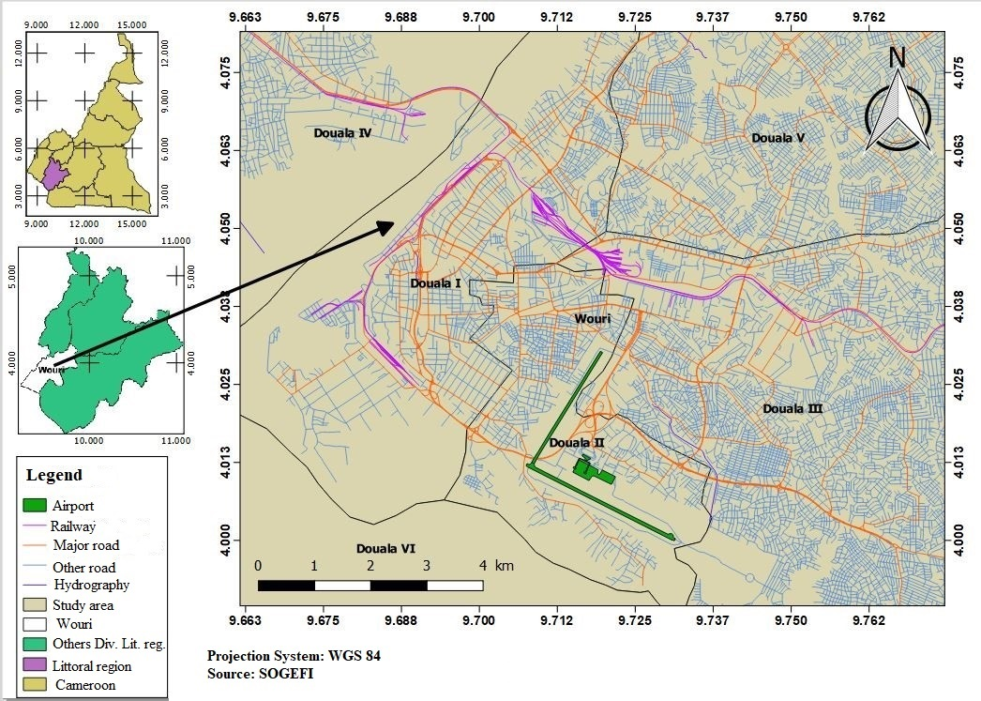
Figure 1: Map of the study area
2.2- Acquisition Data
This works focused on data from Douala city. This latter faces several environmental challenges fueled partly by the pressures caused by human activities through economic activities, such as economic development, demographic changes, housing development, road construction for transportations, etc.
- Methodology
3.1-Description of Global Forecast System Ensemble (GEFS) Model
The Global Forecast System Ensemble (GEFS) is one of the most important components of NOAA's Operational Environmental Forecast Operational Systems (Augustin et al. 2022), since its implementation in 1993, provides GEFS ensemble data to the Large Global Interactive Ensemble (TIGGE) of The Observing system research and Predictability Experiment (THORPEX). The GEFS forecasting competence has been significantly improved since then, benefiting from the best level of the initial disturbance generation of the set, a higher resolution of the model, and a larger size of the set (Xiaqiong et al. 2017; Yuejian et al. 2017). The horizontal resolution of the GEFS passes between about 52 km for the first 8 days of the forecast and about 70 km for the next 8 days at around 34 km and 52 km, respectively (Zhou et al. 2016).
3.2- Method
Rainfall forecasts from the GEFS forecast (Hamill et al. 2013) for medium-range predictions in Cameroon have been used. Initial conditions for the forecast in the Global Ensemble Forecast System (GEFS) model are derived from the hybrid GFS analysis. The operational forecasts are generated at every 6 h from 0000, 0600, 1200, and 1800 UTC initial conditions. The reforecasts are generated daily at 0000 UTC using only 10 perturbations and a single control initial condition.
4- Results and Discussion
4.1- Rainfall variability using GEFS Model over the Douala city
Figure 2 shows the daily precipitation variability of July 29-31, 2020 by GEFS Model. It displays that heavy rains are forecast by this model in Chad (> 50mm) and weak towards the Littoral region of Cameroon (1 to 5 mm). The total precipitation variability forecast by the GEFS model up to 00 + 1UTC of July 29-31, 2020 has been illustrated in Figure 3. It is average to Littoral region of Cameroon (25 mm). The maximum occurred in eastern Chad and western Cameroon (100 mm). This precipitation would product from complex interactions between the continent and the ocean leading to the strong convective activity of the West African monsoon in this region. The GEFS model successfully detects precipitation around the area of interest from 00+ 1 UTC July 29-31, 2020. This model well bounds the precipitation zone.
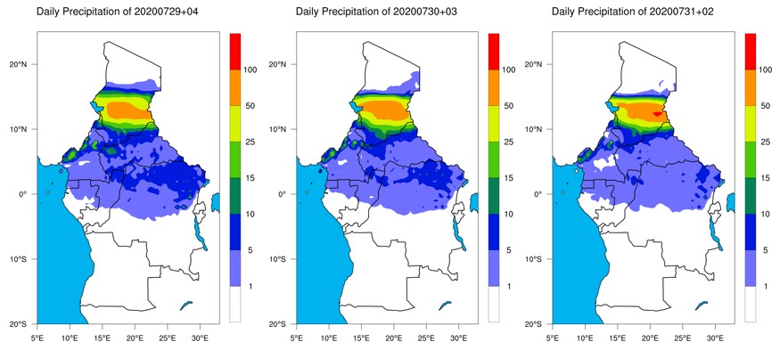
Figure 2: Daily precipitation variability of July 29-31, 2020
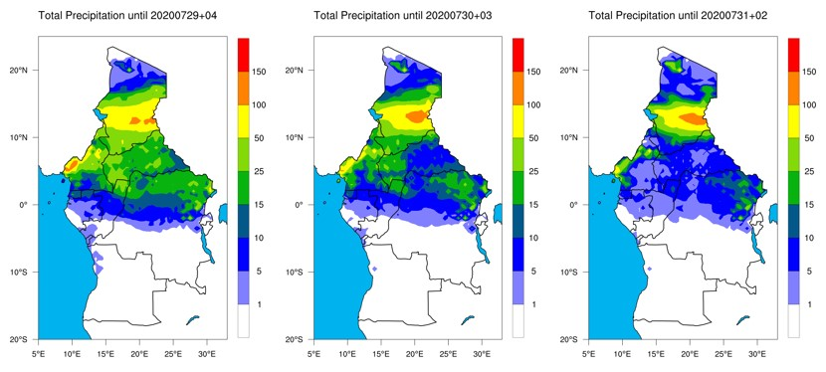
Figure 3: Total precipitation variability up to 00 + 1UTC of July 29-31, 2020.
Figure 4 illustrates the daily precipitation variability of August 17-19, 2020. It predicts daily rainfall with a height of about 25 mm in Douala city and its surroundings. The total precipitation variability of August 17-19, 2020 has been represented in Figure 5. It forecasted a rainfall cumul of a height of around 50 to 100mm for this day in the Littoral region and its surroundings.
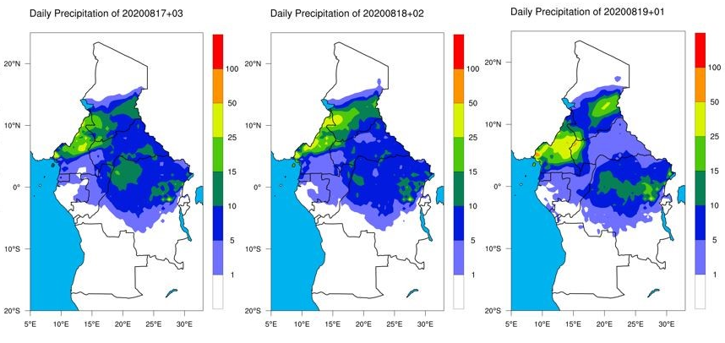
Figure 4: Daily precipitation variability of August 17-19, 2020
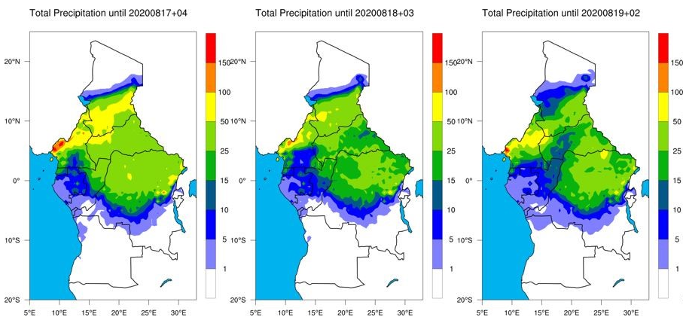

Figure 5: Total precipitation variability of August 17-19, 2020 at 00+1 UTC
Figure 6 illustrates the daily precipitation variability on 20-21 august 2020 at 06UTC, 12UTC, 18UTC and 00UTC. It shows that daily rainfall with a height of about 25 mm and variable in Douala and its surroundings. The total precipitation variability of August 20-21, 2020 at 06UTC, 12UTC, 18UTC and 00UTC has been displayed in Figure 7. It shows a rainfall cumul of a height of around 50 to 100mm for this day in the Littoral region and its surroundings. The GEFS model successfully detects precipitation around the area of interest of August 20-21, 2020 at 06UTC, 12UTC, 18UTC and 00UTC 00+ 1 UTC August 20-21, 2020 and well bounds the precipitation zone.
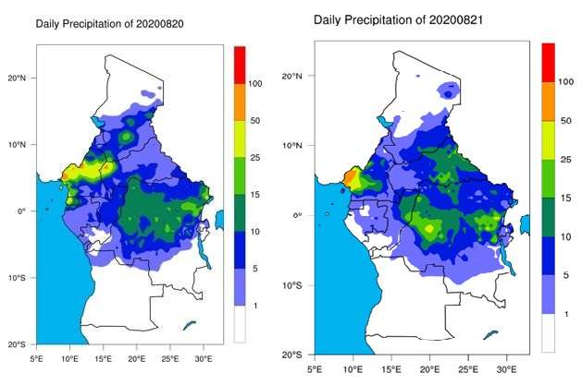
Figure 6: Daily precipitation variability on 20-21 august 2020 by GEFS Model.
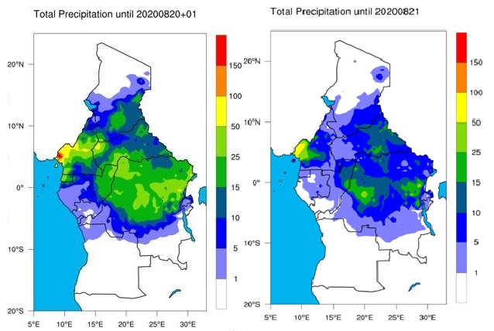
Figure 7: Total precipitation variability of August 20-21, 2020 at 00+1 UTC

4.2- Rainfall cumul variability obtained by time series of daily precipitation and satellites images
Figure 8 displays the time series of daily precipitation of 24 hour amounts ending at observation time for the months of June, July, August and September 2020. Daily precipitation data in this Figure 8 is estimated using satellites and comes from National Oceanic & Atmospheric Administration (National Environmental Satellite, Data, and information service, Current Location: Elev: 43 ft. Lat: 4.0200° N Lon: 9.7200° W, Station: DOUALA, CM CM000004910). They allowed us to highlight the curves of daily precipitation over Douala city. Therefore, it observes that in our study area, between 3.30ºN and 6ºN, the recorded rainfall is more frequent and long from June to September (period of the passage of the monsoon). During this monsoon period, it corresponds to the peak of the wet season June-July-August-September (JJAS). This is consistent with the dynamic of the unimodal rainfall distribution in these zones.
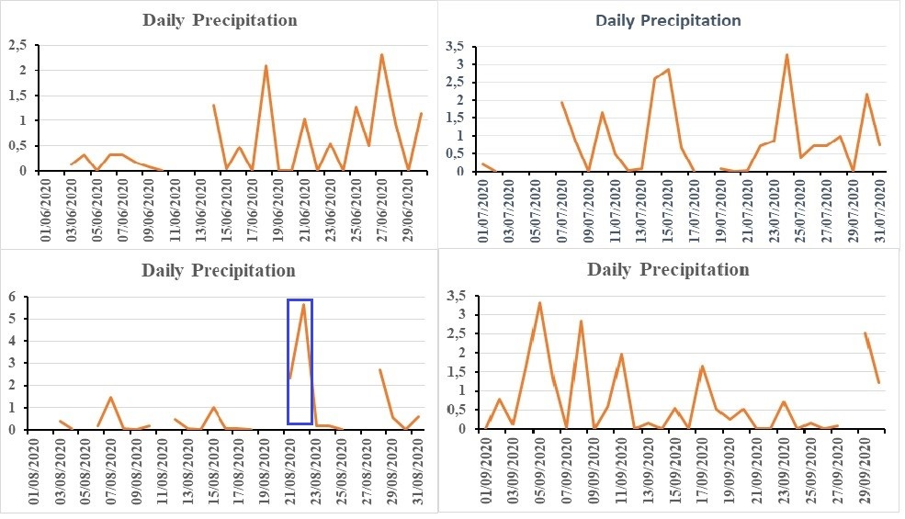
Figure 8: Time series of daily precipitation
Figure 9 and Figure 10 exhibit the rainfall images observed for the day of August 2, 2020, in Cameroon and august 21, 2020 in Douala city respectively, detected by 04 different satellites (IMERG Satellite, ARC2 Satellite, ERA5 Satellite, and TAMSAT Satellite). In these Figures 9 and 10, the red colors appearing indicate that the precipitation is all the more intense as it is thick. These characteristics prove the presence of cumulonimbus clouds, accompanied by thunderstorms and lightning, in this area.
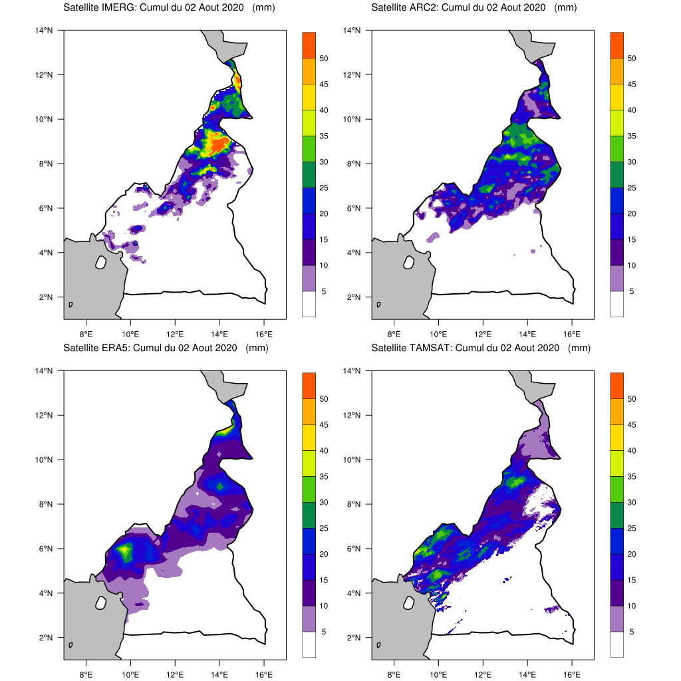

Figure 9: Rainfall observed in Cameroon for the day of August 2, 2020 by the satellites: IMERG Satellite (top left), ARC2 Satellite (top right), ERA5 Satellite (bottom left) and TAMSAT Satellite (bottom right).
According to Figure 9, in Douala city and its surroundings, Satellite IMERG estimated the amount of rainfall to vary between 0 and 15 mm with a resolution of 0.1° including about 10 km on the side; Satellite ARC2 in turn saw a rainfall cumul of between 0 and 5 mm with a resolution of 0.1° including about 10 km on the side; Satellite ERA5 records a rainfall cumul of 05 to 10 mm with a resolution of 0.25° including about 25 km on the side and in the TAMSAT Satellite, the observed cumul amount is 10 to 25 mm of precipitation with a resolution of 0.03 ° x 0.03 ° including about 03 km on the side. As for the analysis of the outputs of GEFS model, the rainfall cumul provided is 05 and 10 mm (Figure 2).
In view of all the above, it can be seen that the result obtained by the re-analysis of the GEFS model gives a rainfall cumul that is in the interval between 10 and 25 mm excluded. Compared to that observed by these 04 different satellites, the majority has confirmed the values between 05 and 10 mm.
It is concluded that the GEFS model with a resolution of 50 km was able to observe what a 03 km high resolution satellite (TAMSAT) saw. As a result, the GEFS model and the TAMSAT satellite are suitable tools that can allow the prediction of this type of disaster.
According to Figure 10, in Douala city, the IMERG satellite estimates a rainfall cumul between 25 and 50mm, the ARC2 satellite estimates a rainfall cumul between 15 and 35mm, the TMSAT satellite estimates a rainfall cumul between 25 and 50mm and the rainfall cumul in the ERA5 satellite is between 5 and 10mm.
The consistency of rainfall cumul between the GEFS model forecasted with the observations of the IMERG, ARC2 and TAMSAT satellites is due to the small resolutions of these satellites. On the other hand, for the ERA5 satellite, it has a cumul not too much in the cumul interval provided by the GEFS model because of its high resolution and therefore less favorable to detecting a local phenomenon.
Thus, the GEFS model makes it possible to predict rain events that have caused flooding over Douala city as confirmed by the results obtained at the end of this work. In addition, this model also makes it possible to follow the evolution in time and space of this rainy event on this city despite their high resolution which is about 56 km. Three satellites (IMERG, ARC2 and TAMSAT) confirm the weather forecasts made by the GFES model on the day of August 21, 2020. Thus, it shows the reliability of the forecasts of this model on the advent of precipitation in Douala city. Nevertheless, the ERA5 satellite did not give the same results during its observation because of its high resolution.
The floods that occurred on August 21, 2020 over Douala city are due to the significant of rainfall cumul recorded that day, also because of the geographical discontinuities (heating differs according to the nature of the ground, Mount Cameroon effects, etc.) covered by the city but also its urbanization.
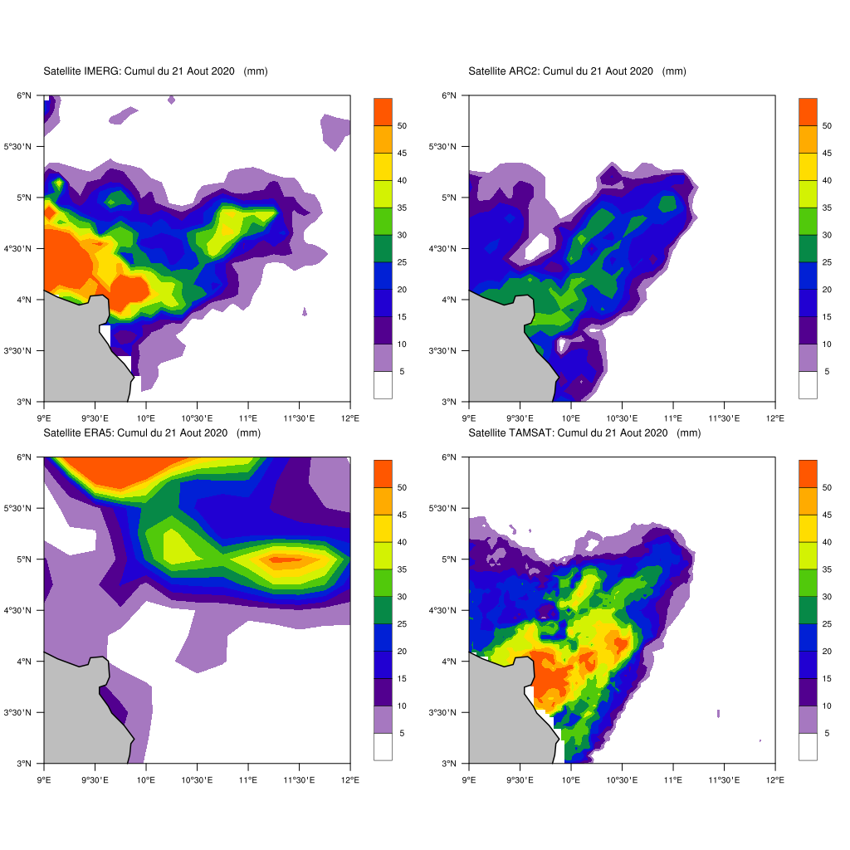
Figure 10: Precipitation Cumul observed in Littoral region of Cameroon for the day of August 21, 2020 by the satellites: IMERG Satellite (top left), ARC2 Satellite (top right), ERA5 Satellite (bottom left) and TAMSAT Satellite (bottom right).

4.3- Potential implications of extreme rainfall variability on ground traffic over the Douala City of Cameroon
Given these results, the city was flooded by the extreme precipitation. The latter has strong guidance on this region, compared to other phenomena or systems that can occur at the local scale. These floods are explained by the fact that rainwater cannot infiltrate and accumulates on the ground surface due to infrastructure and the nature of the soil, which leads to its compaction and waterproofing (Hardoy et al., 2001; Douglas et al., 2008; Engel et al., 2017).
Urban travel is provided by buses, motorcycle taxis, shared taxis and minibuses called cargos. They often cause accidents due to weather conditions such as rainfall. These can overwhelm roads and flood underpasses and homes. Floods cause scouring and gullying of roads. They damage or weaken the foundations of the railway tracks and cause overflows on the rails and mudslides which damage the tracks (Rosseti, 2002 and Marjorie et al.2009).
In addition, episodes of heavy rainfall disrupt the entire road transportation system, including the transport of goods, people, and properties.
As intense precipitation events lead to loss of traction and control, delays, reduced speeds, stress on vehicle parts and tires, wet pavement, splashed roads, detours, hard braking, and uneven road washouts (Daïka et al.2024). As of August 21, 2020, for example, the Littoral region of Cameroon recorded major floods causing various damages and causing economic losses in cross-border exchanges. Since that day, the populations of this region have suffered the inconveniences linked to the phenomenon aroused.
- Conclusion
This work proves that extreme rainfall variability has enormous consequences on ground traffic in the Littoral region. This region, located at the Wouri River estuary and open to the Atlantic Ocean, with geographical coordinates of 4° 03′ 26″ N and 9° 41′ 48″ E, receives abundant rainfall during the june, July, August and September period due to the flow of ocean winds. However, the region is crossed by the cooler winds from the Saint Helena anticyclone which join the warmer winds from the Saharan depressions at the level of the InterTropical Discontinuity (ITD). The ITCZ located further south of the ITD creates the area of instability, leading to favorable conditions for the development of vertically spreading clouds. Analyzes and/or re-analyses of model GEFS outputs on different spatio-temporal scales (synoptic and local) have been made to better assess the risk of occurrence of the instabilities that caused this event in the Douala city and its surroundings. Thus, after these analyses, the results illustrate the rainfall cumul over Douala city and the verification of the reliability of the results by satellite observations (IMERG, ARC2, TAMSAT and ERA5) was followed. For example, for the day of August 21, 2020, a rainfall cumul of between 25 and 50 mm with a probability of ranging from 40 to 60% by the GEFS forecast model over more than half a day is the origin of the floods. At the end of this work, the result effectively shows that extreme rainfall variability greatly affects road transportation activities and accidents in the littoral region of Cameroon.

Ethics, Consent to Participate, and Consent to Publish declarations:
No applicable.
Clinical trial number:
No applicable
Data Availability declaration
We have the materials, all the raw and processed data and result products. We can provide the processed data and documents if it is required.
References
Annuaire Statistique du Cameroun (2015) Institut National de la Statistique, Edition 2015
Augustin, D., Pascal, I.M., Oumarou, M.M., et al., 2022. Analysis of Weather Conditions for Aerial Security and Optimization in Maroua-Salak. Atmospheric and Climate Sciences, 12, 172-188. https://doi.org/10.4236/acs.2022.121012
Buizza, R., Houtekamer, P. L., Pellerin, G., et al., 2005. A comparison of the ECMWF, MSC, and NCEP global ensemble prediction systems. Mon. Wea. Rev., 133, 1076–1097, doi:10.1175/MWR2905.1.
Chang, H.I., Kumar, A., Niyogi, D., et al., 2009. The role of land surface processes on the mesoscale simulation of the July 26, 2005 heavy rain event over Mumbai, India. Glob Planet Change 67:87–103
Daïka, A., Igri, M. P., Messanga, E. H.,et al., 2024. Impact of extreme rainfall variability and changes on Ground Traffic in Cameroon. Theoretical and Applied Climatology, https://doi.org/10.1007/s00704-023-04801-w
Daïka, A., Igri, M. P., Taguemfo, K.J., et al., 2023. Impact assessment of the West African Monsoon on convective precipitations over the far north region of Cameroon. Advances in Space Research, https://doi.org/10.1016/j.asr.2022.04.044
Daïka, A., Mbane, B.C., 2023. Analysis of Wind Shear Variability and Its Effects on the Flights Activities at the Garoua Airport. J. Extreme Events, 8(4), 2250006, https://doi.org/10.1142/S2345737622500063
DSCE, 2009 : Cadre de référence de l’action gouvernementale pour la période 2010-2020, Document de Stratégies pour la Croissance et l'Emploi, page 174
Douglas, I., Alam, K., Maghenda, M., et al., 2008. Unjust waters: Climate change, flooding and the poor in Africa. Environ. Urban. 20, 187–205, doi: 10.1177/0956247808089156
Engel, T., Andreas, H. F., Knippertz, P., et al., 2017. Extreme Precipitation in the West African Cities of Dakar and Ouagadougou: Atmospheric Dynamics and Implications for Flood Risk Assessments. Journal of Hydrometeorology, 18, 2937-2957
Hamill, T. M., Bates, G.T., Whitaker, J. S., et al., 2013. NOAA’s second-generation global medium-range ensemble forecast dataset. Bull. Amer. Meteor. Soc., 94, 1553–1565, doi:10.1175/BAMS-D-12-00014.1
Hardoy, J. E., Mitlin, D., Satterthwaite, D., 2001. Environmental Problems in an Urbanizing World: Finding Solutions in Cities in Africa, Asia and Latin America. Earthscan, 464 pp.
Houze, R.A., Ramussen, K.L., Medina, S., et al., 2011. Anomalous atmospheric events leading to the summer 2010 floods in Pakistan. Bull. Am. Meteorol. Soc. 92:291–298
Jiang, Y., Zhou, L., Tucker, C.J., et al., 2019. Widespread increase of boreal summer dry season length over the Congo rainforest. Nat. Clim. Change 9 (8): 617–622.
Kumar, A., Dudhia, J., Rotunno, R.M., et al., 2008. Analysis of the 26 July 2005 heavy rain event over Mumbai, India using the Weather Research and Forecasting (WRF) model. Q J R Meteorol Soc 134:1897–1910
Marjorie, M., Scott, S., Peterson, T.C., et al., 2009. Les implications des changements de conditions météorologiques et climatiques pour le transport de surface aux Etats-Unis d’Amérique. Bulletin de l’OMM 58 (2).
Mbane, B. C., 2015. Earth’s Atmosphere Dynamic Balance Meteorology. Scientific Research Publishing Inc., USA, 110 p.
Mboka, J.J.M., Kouna, B.S., Chouto, S.,et al., 2020. Simulated impact of global warming on extreme rainfall events over Cameroon during the 21st century. Weather, 76(10): 347-353, https://doi.org/10.1002/wea.3867
Medina, S., Houze, R.A., Kumar, A., et al., 2010. Summer monsoon convection in the Himalayan region: terrain and land cover effects. Q J R Meteorol Soc 136:593–616
Molua, E., 2006. Climatic Trends in Cameroon: Implications for Agricultural Management. Clim. Res., 30, 255–262
MÜLLER, J-P., 1978. La séquence verticale d’organisation des horizons meubles des sols
ferralitique camerounais : variation en latitude en fonction du pédoclimat et de l’âge des sols.
Cahiers de l’ORSTOM, série Pédologie, vol. XVI, n°1, pp. 73-82.
Munzimi, Y.A., Hansen, M.C., Adusei, B. et al., 2015. Characterizing Congo basin rainfall and climate using Tropical Rainfall Measuring Mission (TRMM) satellite data and limited rain gauge ground observations. J. Appl. Meteorol. Climatol. 54 (3): 541–555.
Nchito, W. S., 2007. Flood risk in unplanned settlements in Lusaka. Environ. Urban., 19, 539–551, doi:10.1177/0956247807082835
Nguessan, K. J., Kane, R., Kabanguka, J. K., 2015. Cameroun, Note sur le secteur des transports, Groupe de la banque africaine de développement, Département des transports, du développement urbain et des TIC. Page 44
Njouenwet, I., Vondou, D.A., Ashu, S.V.N., et al., 2021. Contributions of Seasonal Rainfall to Recent Trends in Cameroon’s Cotton Yields. Sustainability, 13, 12086. https://doi.org/10.3390/su132112086
Raghavendra, A., Zhou, L., Jiang, Y., et al., 2018. Increasing extent and intensity of thunderstorms observed over the Congo Basin from 1982 to 2016. Atmosph. Res. 213, 17–26. https://doi.org/10.1016/j. atmosres.2018.05.028
Rosseti, M.A., 2002. Potential impacts of Climate change on rail roads. In “The potential impacts of Climate change on Transportation: Workshop Summary. US Dept. of Transportation, Workshop, 1st-2 October .http://climate.volpe.dot.gov/workshop1002/”.
Seagalen, P., 1967. Les sols et la géomorphologie du Cameroun. Les cahiers ORSTOM. Série Pédologie, p.137-187

Singh, R., Pal, P.K., Kishtawal, C.M., et al., 2008. Impact of atmospheric infrared sounder data on the numerical simulation of a historical Mumbai rain event. Weather Forecast 23:891–913
Tanessong, R.S., Vondou, D.A., Yepdo, D.Z., et al., 2017. WRF high resolution simulation of an extreme rainfall event over Douala (Cameroon): a case study. Model. Earth Syst. Environ. DOI 10.1007/s40808-017-0343-7
Transtat (2000) Bulletin Statistique des Transports 2000, Ministère des Transports
Vondou, D.A., Guenang, G.M., Djiotang, T.L.A., et al., 2021. Trends and Interannual Variability of Extreme Rainfall Indices over Cameroon. Sustainability, 13, 6803. https://doi.org/10.3390/su13126803
Webster, P.J., Toma, V.E., Kim, H.M., 2011. Were the 2010 Pakistan floods predictable? Geophys Res Lett. doi:10.1029/2010GL046346
Xiaqiong, Z., Yuejian, Z., Dingchen, H., et al., 2017. NCEP NOTES: Performance of the New NCEP Global Ensemble Forecast System in a Parallel Experiment. Weather and Forecasting, 32, 1989-2004. https://doi.org/10.1175/WAF-D-17-0023.1
Yuejian, Z., Xiaqiong, Z., Malaquias, P., et al., 2017. Impact of Sea Surface Temperature Forcing on Weeks 3 and 4 Forecast Skill in the NCEP Global Ensemble Forecasting System. Weather and Forecasting, 32, 20159-20174. DOI: 10.1175/WAF-D-17-0093.1
Zhou, X., Zhu, Y., Hou, D., et al., 2016. A Comparison of Perturbations from an Ensemble Transform and an Ensemble Kalman Filter for the NCEP Global Ensemble Forecast System. Weather and Forecasting, 31, 2057–2074. https://doi.org/10.1175/WAF-D-16-0109.1

