Case report
Cryptogenic Stroke with Isolated Cranial Nerve Deficits Attributable to a Small PFO: Successful Management with Cocoon Occluder

Abstract
Patent foramen ovale (PFO) is present in approximately 20–25% of the general population but is implicated in only a small subset of ischemic strokes, particularly in young adults with cryptogenic events. Stroke in individuals under 45 years accounts for only 10–15% of all ischemic strokes, and PFO-related presentations with isolated cranial nerve involvement are exceptionally rare. We report a 40-year-old male who presented with acute slurring of speech and deviation of the mouth to the left. Neurological examination revealed dysarthria and tongue deviation without motor weakness. Magnetic resonance imaging demonstrated acute non-hemorrhagic infarcts in the right inferior frontal gyrus and right post-central gyrus. Transthoracic echocardiography with bubble contrast revealed right-to-left shunting during Valsalva, and transesophageal echocardiography confirmed a 4-mm PFO. The patient underwent successful transcatheter closure using a Cocoon 30/30 occluder device under transesophageal and fluoroscopic guidance, with no residual shunt post-procedure. This case underscores the clinical relevance of small but hemodynamically significant PFOs in young patients with cryptogenic stroke. While PFO is relatively common, paradoxical embolism is an uncommon cause of stroke, and isolated cranial nerve presentations are particularly unusual. Recent randomized controlled trials, including RESPECT, CLOSE, and REDUCE, support PFO closure in carefully selected patients to reduce recurrence. Early recognition and timely intervention remain essential for optimal outcomes in young adults presenting with cryptogenic stroke and provokable right-to-left shunting.

Keywords: Patent foramen ovale, cryptogenic stroke, young adult, dysarthria, Cocoon occluder, transcatheter closure

Introduction
Patent foramen ovale (PFO) persists in approximately 20–25% of adults [1]. While usually benign, it may permit paradoxical embolism, especially under conditions of transient right atrial pressure elevation. Stroke in individuals under 45 years accounts for 10–15% of ischemic strokes, and up to 40–50% of these are cryptogenic [2–5]. PFO is over-represented in this subset, with a prevalence of nearly 50% among young patients with cryptogenic stroke, compared with 20% in matched controls [5].
Despite this epidemiological link, absolute cases of clinically significant PFO-related stroke remain rare. Moreover, neurological presentations limited to cranial nerve involvement, such as isolated dysarthria and tongue deviation without hemiparesis, are distinctly uncommon [6–8]. Most embolic strokes associated with PFO affect middle cerebral artery territories, manifesting with hemiparesis, aphasia, or visual field deficits.
We report a rare case of cryptogenic cortical stroke in a 40-year-old male with a small but functionally significant PFO, successfully managed with Cocoon device closure.

Case Presentation
A 40-year-old male presented with acute slurring of speech and deviation of the angle of the mouth to the left. Neurological examination revealed dysarthria (cranial nerves IX–X involvement) and tongue deviation to the left (cranial nerve XII involvement), without motor weakness. MRI brain showed acute non-hemorrhagic infarcts in the right inferior frontal gyrus and right post-central gyrus, with ADC restriction and no blooming on GRE, consistent with acute non-hemorrhagic infarction. Multiple discrete FLAIR hyperintensities in bilateral frontoparietal lobes involving centrum semiovale, corona radiata, and periventricular white matter were noted, suggestive of chronic small vessel ischemic changes (Fazekas grade 1).
Echocardiography showed no regional wall motion abnormalities (EF 60%). Bubble contrast study revealed negative contrast in the right atrium with shunting during Valsalva. Transesophageal echocardiography (TEE) confirmed a 4-mm PFO with left-to-right shunt and provokable reversal during Valsalva. The patient underwent TEE-guided PFO closure under local anesthesia via RFV, LFA, and LFV access. A sizing balloon confirmed a 4-mm PFO. A Cocoon 30/30 device was deployed under TEE and fluoroscopic guidance. Post-deployment imaging showed stable positioning, no arrhythmia, tricuspid regurgitation, peridevice leak, or heart block. Post-procedure echocardiography demonstrated no residual shunting, with the device in situ. The patient remained stable and was transferred to ICCU for monitoring.

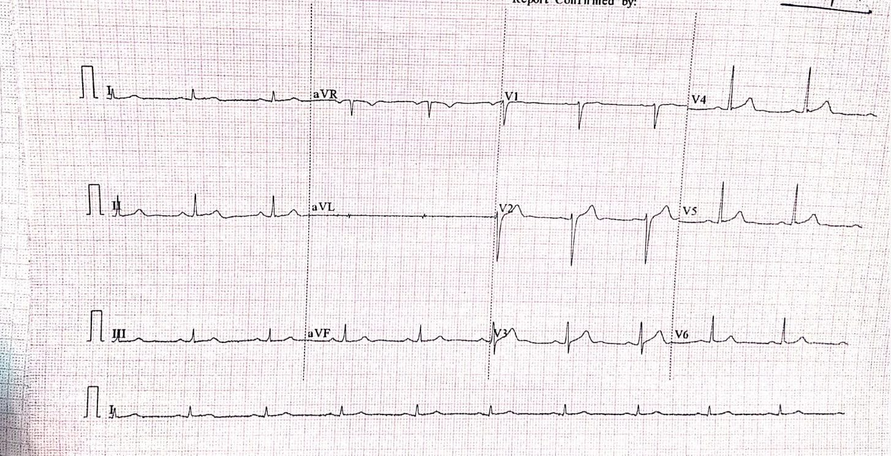
Figure 1: 12 lead standardised ECG : Normal sinus Rhytm ,no Significant ST T changes 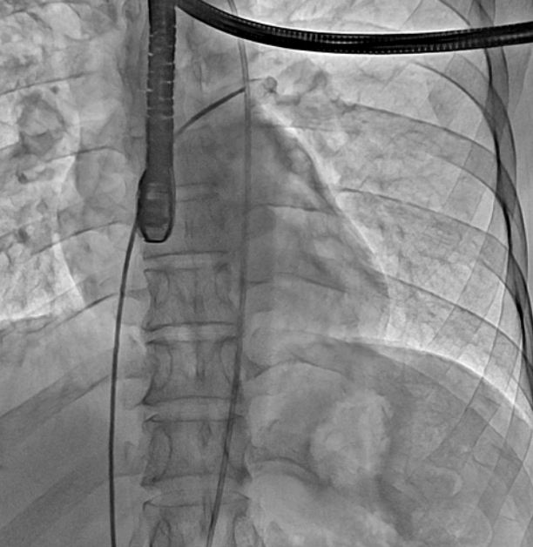 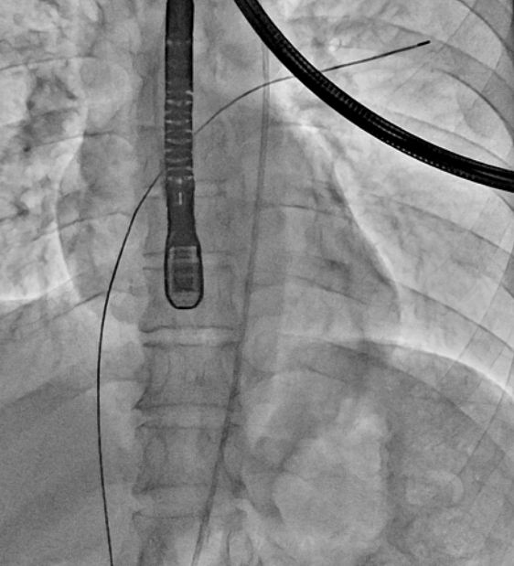 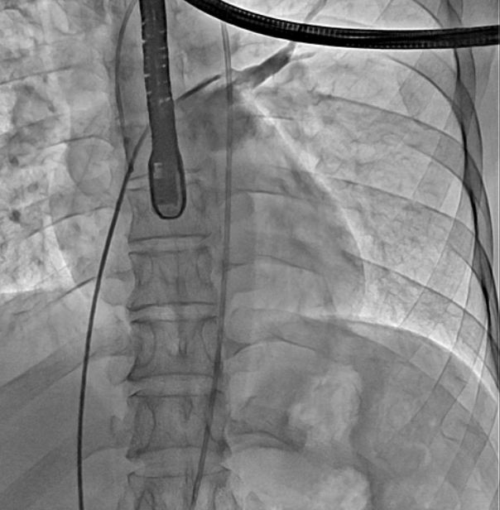 ( a) ( b) (c)
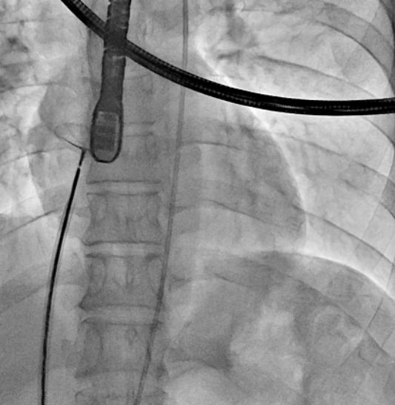 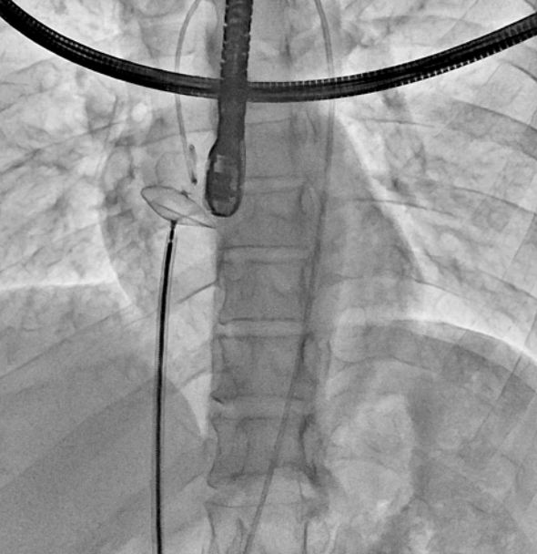 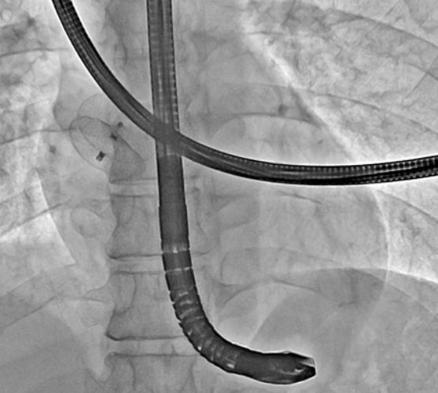 (d) ( e) ( f)

Figure 2a: Fluoroscopic image showing catheter positioning across the interatrial septum.
Figure 2b: The catheter is advanced into the right atrium into LA through PFO under fluoroscopic guidance.
Figure 2c: MPA passed through RA → LA → LSPV and LA shoot taken
Figure 2d: Balloon sizing of the PFO tunnel prior to device deployment
Figure 2e: Now Amplatzer Superstiff wire passed into LA and sizing balloon inflated COCOON Device No 30/30 passed through delivery sheath and kept across PFO
Figure 2 f :Final fluoroscopic image Device position confirmed Properly adhering to rims.with fully opened both disc .

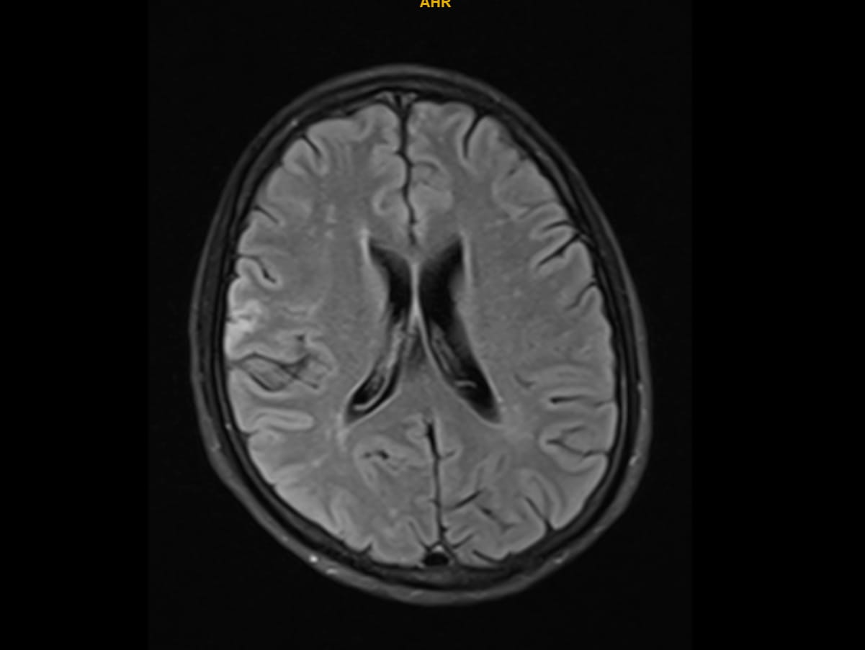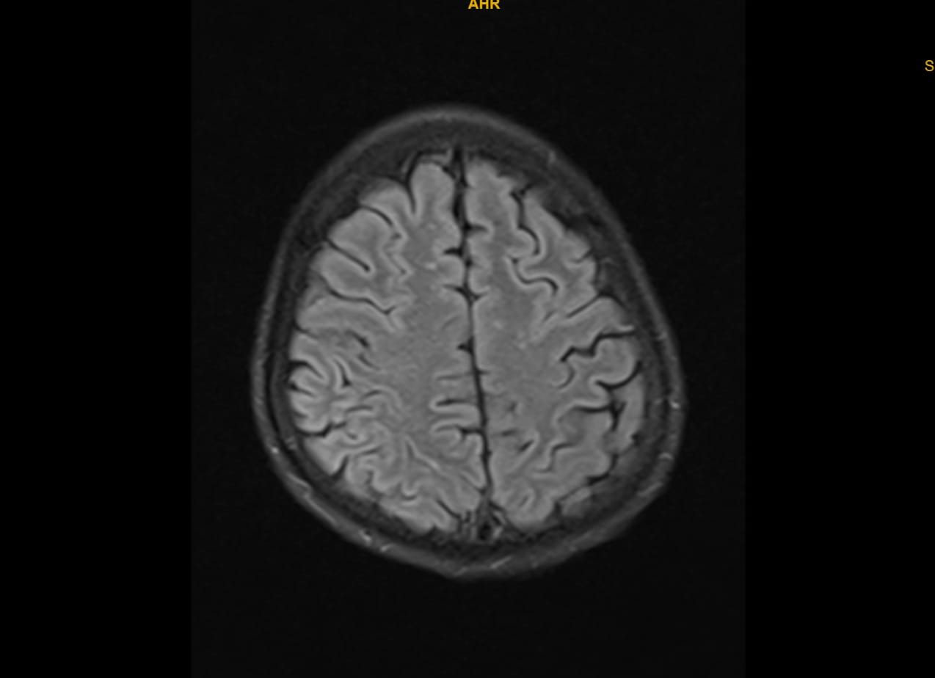
(a) (b)
Figure 3 a and b : MRI revealed acute non-hemorrhagic infarcts in the right inferior frontal gyrus and right post-central gyrus. Diffusion-weighted imaging showed hyperintensity with corresponding ADC restriction, confirming acute ischemia. No blooming on GRE ruled out hemorrhage. FLAIR sequences demonstrated chronic small vessel ischemic changes (Fazekas grade 1)

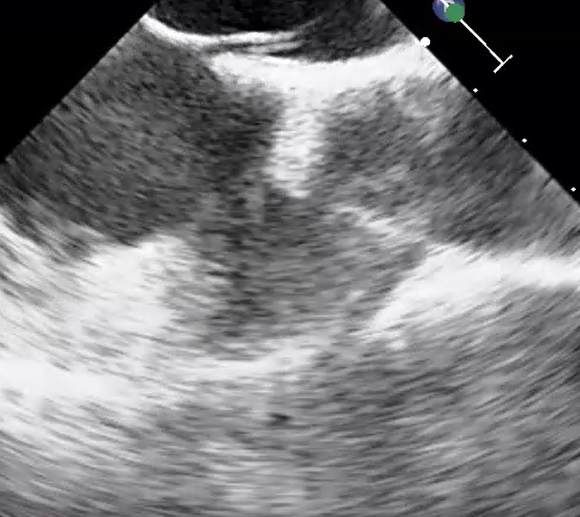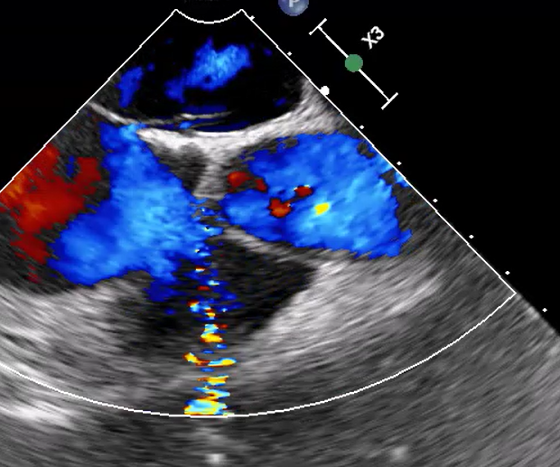
- (b)
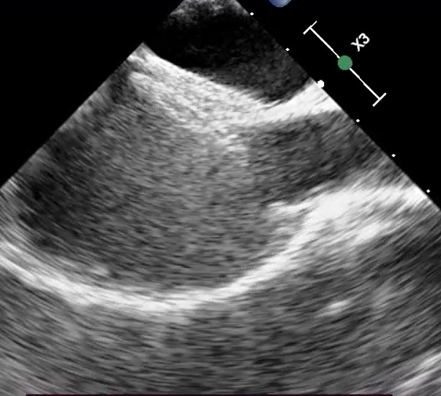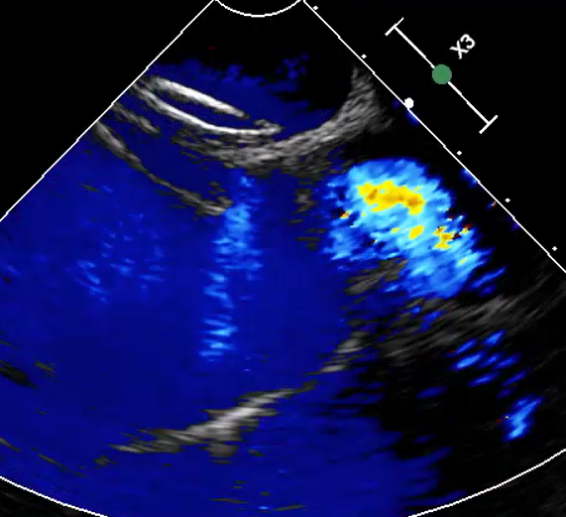
(c) (d)
Figure 4 a and b ): TEE image showing PFO of 4 mm with shunt across PFO
c and d ) TEE images post deployment of PFO device with no residual shunt across device
Video Legend1 : PFO Bubble contrast Study

Video Legend 2: MRI Loop

Discussion
This case underscores the rarity of PFO-related cortical stroke in young adults. Although PFO is common, only a small fraction of cryptogenic strokes are directly attributable to paradoxical embolism [9–11]. Our patient’s neurological presentation was unusual, with dysarthria and cranial nerve involvement without hemiparesis, which is seldom described [6–8].
Small PFOs can still be pathogenic when provokable right-to-left shunting occurs, particularly during Valsalva [12–14]. Multiple randomized controlled trials (RESPECT, CLOSE, REDUCE) have shown that device closure significantly reduces the risk of recurrent stroke compared to medical therapy in carefully selected patients [2,4,13].
The Cocoon occluder, used in this patient, features a platinum nanocoating on nitinol mesh, designed to reduce nickel ion release and enhance biocompatibility [15]. Post-closure complications such as atrial fibrillation are well-documented, but our patient remained free of arrhythmia [16–18]. Dual antiplatelet therapy followed by single antiplatelet therapy is advised post-closure [19,20].

Conclusion
PFO is common, but PFO-related stroke in young adults is rare, and even rarer are presentations limited to dysarthria and cranial nerve involvement. This case illustrates that small PFOs with dynamic right-to-left shunting can be pathogenic, and timely closure can be lifesaving. Careful patient selection, guided by clinical, imaging, and echocardiographic findings, remains essential.

References
1. Hagen PT, Scholz DG, Edwards WD. Incidence and size of patent foramen ovale during the first 10 decades of life. Mayo Clin Proc. 1984;59:17–20.
2. Saver JL. Cryptogenic stroke. N Engl J Med. 2016;374:2065–2074.
3. Handke M, Harloff A, Olschewski M, Hetzel A, Geibel A. Patent foramen ovale and cryptogenic stroke in older patients. N Engl J Med. 2007;357:2262–2268.
4. Søndergaard L, Kasner SE, Rhodes JF, et al. Patent Foramen Ovale Closure or Antiplatelet Therapy for Cryptogenic Stroke (REDUCE). N Engl J Med. 2017;377:1033–1042.
5. Lechat P, Mas JL, Lascault G, et al. Prevalence of PFO in young patients with ischemic stroke. N Engl J Med. 1988;318:1148–1152.
6. Bogousslavsky J, Caplan LR, editors. Stroke Syndromes. Cambridge Univ Press; 2001.
7. Nedeltchev K, et al. Ischemic stroke in young adults: predictors of outcome and recurrence. Neurology. 2005;65:1502–1508.
8. Putaala J, et al. Characteristics of ischemic stroke in young adults. Stroke. 2009;40:1190–1199.
9. Kent DM, Ruthazer R, Weimar C, et al. An index to identify stroke-related vs incidental PFO in cryptogenic stroke. Neurology. 2013;81:619–625.
10. Kent DM, et al. RoPE Study. Trials. 2011;12:185.
11. Koton S, et al. Young stroke registry data: rare presentations. Stroke. 2012;43:3171–3177.
12. Mas JL, Derumeaux G, Guillon B, et al. CLOSE trial. N Engl J Med. 2017;377:1011–1021.
13. Saver JL, Carroll JD, Thaler DE, et al. RESPECT trial long-term results. N Engl J Med. 2017;377:1022–1032.
14. Homma S, Sacco RL, Di Tullio MR, et al. PFO and stroke: a meta-analysis of case-control studies. Ann Intern Med. 2002;136:891–902.
15. Vascular Innovations. Cocoon PFO Occluder specifications. [Device brochure].
16. Kent DM, et al. Risk of atrial fibrillation after PFO closure. JAMA. 2021;326:1879–1887.
17. Wintzer-Wehekind J, et al. New-onset atrial fibrillation after PFO closure: pooled analysis. JAHA. 2024.
18. Berthet K, et al. Incidence of AF post-PFO closure: systematic review. Stroke. 2020;51:152–159.
19. Pristipino C, et al. Antithrombotic therapy after PFO closure. EuroIntervention. 2019;14:1389–1396.
20. Carroll JD, Saver JL, Thaler DE, et al. Device closure of PFO in cryptogenic stroke: expert consensus. J Am Coll Cardiol. 2022;79:100–112.

