Effects of Organic and Bio-Organic Fertilizer Applications on Cotton Yield and Soil Health in Saline-Alkaline and Compacted Soils: Sustainable Agriculture Approaches

Abstract
Saline-alkaline and compacted soils are among the major constraints limiting agricultural productivity, particularly in arid and semi-arid regions. These conditions adversely affect cotton yield by degrading soil structure, reducing water-holding capacity, slowing nutrient cycling, and decreasing microbial activity. In recent years, organic and bio-organic fertilizer applications have gained attention due to their potential to reduce chemical fertilizer use and improve soil health. Bio-organic fertilizers combine the benefits of inputs such as farmyard manure, compost, biochar, microbial inoculants, and mineral-based humates, enhancing the physical, chemical, and biological properties of soil. Reviewed studies indicate that these applications reduce soil bulk density, salinity, and pH while increasing organic matter content, macro-nutrient levels (N, P, K), and soil moisture. These improvements positively influence cotton root development, nutrient uptake, and yield components, potentially leading to increased productivity. Furthermore, the integration of conservation tillage practices with organic/bio-organic fertilizers emerges as an effective strategy for sustainable cotton production under arid conditions. This review holistically examines the effects of organic and bio-organic fertilizer applications on cotton yield and soil health in saline-alkaline and compacted soils, providing recommendations to guide future research in sustainable agriculture.

Keywords: Bio-organic fertilizer, organic matter, cotton yield, soil health, sustainable agriculture, saline soils, soil compaction

- Introduction
Soil degradation is a critical global issue that significantly limits agricultural productivity and adversely affects economic development worldwide (Bing, 2015). Various factors, including excessive fertilizer use, improper agricultural practices, and heavy machinery, can lead to problems such as soil compaction and salinization (Jiang, 2019). These issues are particularly pronounced in arid regions, where they cause structural deterioration of the soil, reduce water-holding capacity, disrupt nutrient cycling, and decrease microbial activity (Margenot, 2018). Consequently, soil fertility declines, fertilizer efficiency decreases, and ultimately crop yield and quality are compromised.

Addressing these complex challenges and sustainably improving soil health, while reducing chemical fertilizer dependence and enhancing agricultural productivity, has increasingly emphasized the use of organic materials and conservation tillage practices (Qaswar, 2020). Bio-organic fertilizers—including farmyard manure, compost, biochar, microbial inoculants, and mineral-based potassium humates—combine the benefits of traditional organic fertilizers and microbial agents, demonstrating substantial potential for improving the physical, chemical, and biological properties of soils (Hanji, 2025; He, 2023; Qaswar, 2020; Polthanee, 2015; Ma, 2022; Wan, 2021).

The primary effects of these approaches are as follows:
- Improvement of Soil Structure: Organic materials reduce soil bulk density (compaction) and increase soil porosity, facilitating air and water movement. This supports root development and enhances plant access to nutrients.
- Increase in Soil Nutrients and Organic Matter: Organic fertilizers provide direct inputs of organic matter and minerals, significantly increasing soil organic content and levels of nitrogen (N), phosphorus (P), and potassium (K). They also stimulate nutrient cycling and enhance populations of phosphate- and potassium-solubilizing bacteria that convert unavailable nutrients into plant-accessible forms.
- Salinity and pH Regulation: Bio-organic fertilizers tend to reduce soil salinity and pH. Components such as humic acids can bind sodium ions, while organic acids released during decomposition can lower soil pH.
- Enhanced Soil Microbial Activity: The addition of organic materials substantially increases the abundance and activity of soil microorganisms, including bacteria, fungi, and actinomycetes. These microbes play critical roles in nutrient mineralization and release, stabilization of soil structure, and production of growth-promoting hormones.
- Improved Water-Holding Capacity: Organic matter enhances soil water retention, improving plant resistance to water stress, particularly under arid conditions.
- Increased Crop Yield: The combined benefits of these improvements result in significant increases in plant height, stem diameter, single boll weight, and overall cotton yield.

Soil salinity is a critical global problem that severely limits agricultural productivity and economic development. In China, the Xinjiang region is among the most affected areas, with approximately 13.36 million hectares of saline soils. About 33.3% of this area consists of arable land affected by varying degrees of salinity, with light, moderate, and severe saline soils covering 28.86%, 7.72%, and 1.13% of the land, respectively (Qingwei, 2021). Xinjiang, one of the world’s largest cotton-producing regions, faces major challenges in cotton cultivation, including imbalanced fertilization practices—particularly excessive nitrogen and phosphorus application combined with insufficient potassium and organic fertilizer use. These practices exacerbate soil salinity, reduce fertilizer efficiency, and negatively affect cotton yield and quality (Qingwei, 2021).

Soil compaction is a prominent form of soil degradation that causes significant declines in agricultural land quality and limits overall production capacity. The southern regions of Xinjiang experience extremely arid climates where evaporation exceeds precipitation, leading to the upward movement of deep saline water toward the soil surface through evaporation or plant transpiration, resulting in secondary salinization (Qingwei, 2021). Saline-alkaline soils contain high concentrations of sodium and chloride ions, which disperse soil particles, disrupt soil aggregate structure, reduce permeability, and cause soils to be sticky when wet and hard when dry. In this context, improving soil quality has become a critical concern for current land use and management (Qiang, 2025; Yang, 2021; Bing, 2015; Jiang, 2019).

Bio-organic fertilizers and other organic materials, which combine the benefits of traditional organic fertilizers and microbial agents, offer a promising solution to these challenges. These materials not only reduce dependence on chemical fertilizers but also improve soil fertility, activate nutrient cycling, and enhance crop yield and quality. This review aims to examine the effects of bio-organic fertilizers and various organic materials on cotton yield and soil health in saline-alkaline and compacted soils based on the latest studies.

2. Characteristics of Saline-Alkaline Soils and Their Effects on Agricultural Production
Soil salinity is a fundamental environmental issue that severely limits agricultural production globally (Jiang, 2019). Saline-alkaline soils contain high concentrations of sodium (Na⁺) and chloride (Cl⁻) ions. These ions strongly disperse soil particles, disrupting soil aggregate structure. As a result, soil permeability and water-holding capacity decrease, and the soil becomes sticky when wet and hard when dry (Jiang, 2019; Wang, 2018; Bing, 2015). This inhibits root development, restricts nutrient uptake, and suppresses overall plant growth. Challenges in cotton cultivation are particularly associated with imbalanced fertilization practices. Excessive application of nitrogen and phosphorus combined with insufficient potassium and organic fertilizer use further exacerbates soil salinity, reduces fertilizer efficiency, and negatively impacts cotton yield and quality (Wang, 2018). Consequently, crop productivity declines and production costs increase.
+
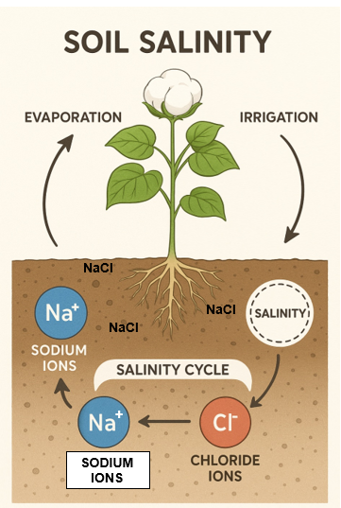
Figure 1. Formation Cycle of Saline Soils

Salinity and Alkaline Characteristics: These soils contain high levels of sodium (Na⁺) and chloride (Cl⁻) ions. These ions have the ability to disperse soil particles, disrupting the physical structure of the soil. Soil pH is generally high, which hinders the uptake of nutrients by plants (Jiang, 2019).

High Bulk Density and Low Porosity (Compaction): Factors such as excessive fertilizer use, improper agricultural practices, and heavy machinery can lead to soil compaction. Saline-alkaline soils typically have high bulk density, meaning the soil is more tightly packed. This compaction reduces natural porosity and restricts air and water movement (Jiang, 2019; Bing, 2015).

Low Water-Holding Capacity: Structural degradation and compaction reduce the soil’s ability to retain water. This makes plants more susceptible to water stress, especially in arid regions (Liu, 2023).

Low Organic Matter and Nutrient Content: Improper fertilization, particularly insufficient potassium and organic fertilizer use, exacerbates soil salinization and negatively affects nutrient cycles. Soils of this type generally have low levels of organic matter and essential nutrients such as nitrogen (N), phosphorus (P), and potassium (K) (Liu, 2023; Bing, 2015).
Low Permeability and Impaired Water Movement: Sodium ions disperse soil particles, disrupt aggregate structure, and reduce soil permeability. This causes soils to be sticky when wet and hard when dry. Deep saline waters can rise to the surface through evaporation or plant transpiration, causing secondary salinization (Liu, 2023).

Reduced Microbial Activity: Soil compaction disrupts carbon and nitrogen cycles, impedes organic matter mineralization, and decreases microbial activity (Margenot, 2018).

Impacts on Agricultural Production
- Reduced Yield and Quality: Saline-alkaline soil conditions directly hinder plant growth and development, reducing crop yield and quality. Severe salinity can impede root growth, boll formation, and overall productivity, while disrupting physiological processes and causing fruit (boll) drop (Chen, 2022; Yiling, 2018; Wang, 2018).
- Impeded Plant Growth: Soil compaction severely restricts root growth and decreases oxygen availability. Reduced root viability and cellular respiration lead to insufficient energy levels and a diminished ability to absorb nutrients from the soil. This negatively affects the development of above-ground plant parts as well (Wang, 2018).
- Reduced Fertilizer Efficiency and Increased Costs: The soil’s decreased nutrient and water-holding capacity requires higher fertilizer inputs, increasing production costs. Excessive or improper chemical fertilizer use accelerates soil degradation and further lowers fertilizer efficiency (Ahmed, 2017).
- Environmental Pollution and Erosion: Soil compaction and degradation contribute to erosion and nutrient loss, increasing environmental pollution (Ahmed, 2017).

These issues pose a threat to global food security and present significant challenges for sustainable agricultural development. Therefore, improving soil quality has become a critical concern for current land use and management.

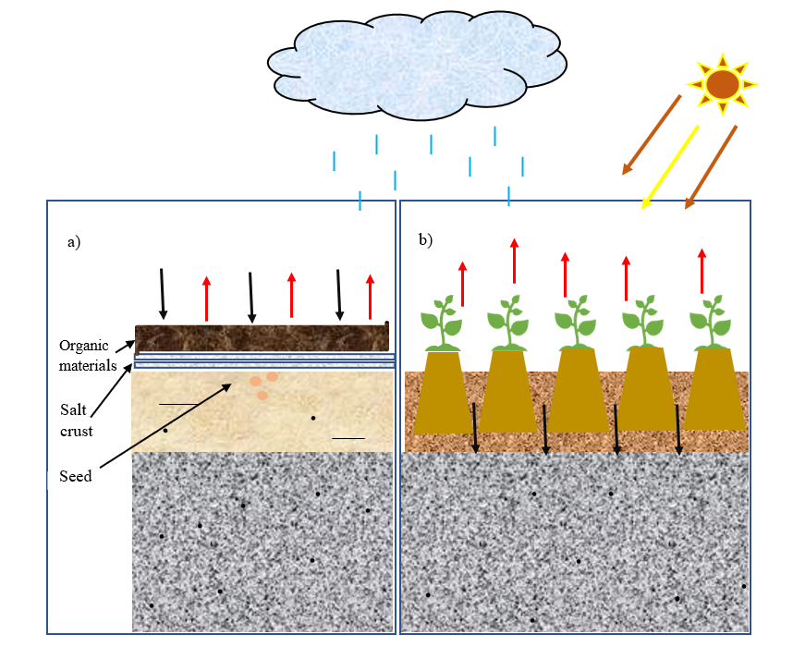
Figure 2. a) Use of organic materials in saline soils, b) Visual representation of soil structure improvement and yield increase over time

3. Effects of Bio-Organic Fertilizers and Organic Materials on Soil Physical and Chemical Properties
The application of bio-organic fertilizers and various organic materials results in significant improvements in the physical and chemical properties of saline-alkaline soils. These enhancements positively affect soil structure, nutrient cycling, and overall soil health, thereby increasing agricultural productivity (Gu, 2022; Zhou, 2019).

Soil Bulk Density and Porosity
Bio-organic fertilizer application has been shown to significantly reduce soil bulk density. Results indicate an average reduction of 15.84% compared to the control group (Xia et al., 2025). This decrease in bulk density was particularly pronounced in lightly saline-alkaline soils, suggesting that soils with different salinity levels respond differently to bio-organic fertilizer application. The use of organic materials—including farmyard manure, biochar, microbial fertilizers, commercial organic fertilizers, and mineral-based potassium humates—generally decreased soil bulk density and increased porosity. Farmyard manure and biochar, in particular, showed notable improvements in reducing bulk density and enhancing porosity. The mechanisms behind these improvements are multifaceted: microbial activity in bio-organic fertilizers, such as Bacillus subtilis, promotes the secretion of mucopolysaccharides, which enhance soil macroaggregate formation and reduce bulk density. Additionally, humic acids provided by bio-organic fertilizers chelate Na⁺ ions, while organic acids released during decomposition lower soil pH. Conservation tillage practices also contribute to improved porosity and reduced bulk density (Xia et al., 2025).

pH and Salinity
Bio-organic fertilizer application consistently reduced soil pH across all salinity levels from 2022 to 2023 compared to the control group, with the reduction proportional to the application rate. The average pH decrease was recorded as 7.5% (Xia et al., 2025). Bio-organic fertilizers effectively reduced soil salinity, achieving an average decrease of 53.86%, with the extent of reduction dependent on fertilizer dosage (dose-dependent response). Improvements in the second year were more pronounced than in the first, suggesting cumulative effects of continuous fertilizer application. Application of organic materials (farmyard manure, microbial fertilizer, commercial organic fertilizers, and mineral-based potassium humates) significantly decreased soil pH, electrical conductivity, and water-soluble salt content. In contrast, biochar application tended to increase these indicators, likely due to its inherent alkalinity. Poultry manure reduced soil pH because of its acidic nature (Xia et al., 2025).

Soil Moisture and Nutrient Content
A 2025 study reported that bio-organic fertilizer application significantly increased soil moisture content at all salinity levels, with an average increase of 36.72% compared to the control (Xia et al., 2025). Similarly, soil organic matter (58.4%), nitrogen (59.4%), phosphorus (77.9%), and potassium (88.7%) levels also increased (Xia et al., 2025). These improvements were positively correlated with fertilizer application rates and exhibited cumulative effects over the two-year experimental period. In lightly saline-alkaline soils, increases in organic matter and nutrient content were most pronounced, likely due to lower salt stress allowing for better root decomposition and nutrient release (Xia et al., 2025). Farmyard manure outperformed other materials in nutrient improvement due to its high microbial and enzyme content. Poultry manure also enhanced nutrient availability by supplying macro- and micronutrients (Xia et al., 2025). Conservation tillage practices further contributed to increased soil organic matter and nutrient levels (N, P, K).
4. Effects of Bio-Organic Fertilizers and Organic Materials on Cotton Yield
The application of bio-organic fertilizers and organic materials substantially increases cotton yield, supporting sustainable agricultural production in saline-alkaline soils. One study reported that bio-organic fertilizer application increased cotton yield by an average of 50.32%, contributing significantly to yield improvement (Xia et al., 2025). The use of organic materials generally enhanced cotton growth and yield components, including plant height, stem diameter, fresh/dry weight, boll weight, and total yield (Xia et al., 2025). High yields in agriculture are associated with improved soil structure, better nutrient availability, and strengthened root-soil interactions. However, under severe salinity conditions, yield increases may be limited, as high salt levels negatively affect root development and boll formation. Conservation tillage practices are effective in enhancing cotton yield and yield components (Xia et al., 2025).

Soil microbial populations form the basis of the beneficial effects of organic materials on soil quality and plant growth. Application of organic materials significantly increased the abundance of bacteria, fungi, and actinomycetes in the soil. Another important consideration is that rising temperatures and changing precipitation patterns due to climate change can exacerbate the effects of irrigation methods on pest populations. Topal et al. (2024) reported that drip irrigation reduced soil surface and air humidity, making conditions less favorable for pests, whereas furrow irrigation increased moisture and pest density. These findings suggest that integrating drip irrigation with hairy cotton varieties as a pest management strategy can support sustainable cotton production while reducing the use of chemical pesticides (Topal et al., 2024).

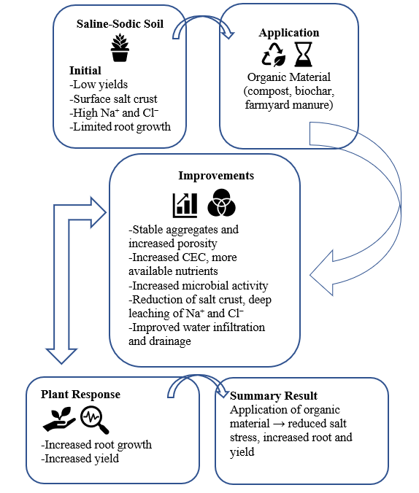
Figure 3. Effects of organic material application on saline-sodic soil and plant yield
5. Optimal Application Rates and Sustainability
Determining optimal application rates is critical for maximizing the efficiency of bio-organic fertilizers and organic materials and for promoting sustainable agricultural practices (Lin, 2024; Xia et al., 2025; Liu, 2023). For bio-organic fertilizers, the most suitable application rate for cotton fields with light, moderate, and severe salinity was found to correspond to a 60% reduction in chemical fertilizer use. However, it is emphasized that this optimal rate may vary depending on long-term applications, changes in soil fertility, and environmental conditions, highlighting the need for more comprehensive research (Xia et al., 2025). Application of 10 t ha⁻¹ poultry manure combined with a conservation tillage system is recommended as an appropriate practice for sustainable cotton production and soil health improvement under arid climate conditions (Xia et al., 2025). The use of bio-organic fertilizers and organic materials offers important benefits such as reducing dependency on chemical fertilizers, enhancing soil fertility, and improving crop yield and quality. This dual benefit underscores the potential of bio-organic fertilizers as a sustainable alternative for managing saline-alkaline soils. These practices are also aligned with sustainable agricultural development goals.

6. Conclusion
Research indicates that bio-organic fertilizers and various organic materials have high potential to improve both soil properties and cotton yield in fields affected by salinity stress, especially in arid and semi-arid regions. These applications reduce soil bulk density, salinity levels, and pH, while increasing soil moisture, organic matter content, and key nutrient levels (nitrogen, phosphorus, potassium). These improvements result in statistically significant increases in cotton yield. Previous studies show that applying bio-organic fertilizers with a 60% reduction in chemical fertilizers provides optimal outcomes for yield and soil health across areas with varying salinity levels. However, it is understood that this optimal rate may vary over time due to long-term applications, temporal changes in soil fertility, and environmental factors. Therefore, future research should be supported by long-term monitoring trials, optimization of dynamic application rates, and detailed examination of soil–microorganism–plant interaction mechanisms. These findings demonstrate that the use of bio-organic fertilizers and organic materials can make a significant contribution to sustainable agricultural systems in salinity-affected areas, particularly for cotton cultivation, by enhancing both productivity and soil quality.

References
Ahmed, M., Rauf, M., Mukhtar, Z. & Saeed, N. A. Excessive use of nitrogenous fertilizers: An unawareness causing serious threats to environment and human health. Environ. Sci. Pollut. Res. 24, 26983–26987 (2017).
Bing, H. Cyclic freeze–thaw as a mechanism for water and salt migration in soil. Environ. Earth Sci. 74, 675–681 (2015).
Chen, Z. J. et.al. Effects of lignite bioorganic product on sunflower growth, water and nitrogen productivity in saline-sodic farmlands at Northwest China. Agric. Water Manage. 271, 9 (2022).
De Battisti, D. Stress-resistance traits disrupt the plant economics-decomposition relationship across environmental gradients in salt marshes. Estuar. Coast. Shelf Sci. 258, 107391 (2021).
Margenot, A. Methodological recommendations for optimizing assays of enzyme activities in soil samples. Soil Biol. Biochem. 125, 350–360 (2018).
Ma, L. Effects of continuous chemical fertilizer application and straw returning on soil enzyme activity, bacterial community and co-occurrence patterns in a fluvo-aquic soil. J. Plant. Nutr. Fertilizers. 28, 1353–1363 (2022).
He, Y. W. Response characteristics of antibiotic resistance genes and bacterial communities during agricultural waste composting: focusing on biogas residue combined with Biochar amendments. Bioresour Technol. 372, 9 (2023).
Hanji, X. Study of the mechanism by which Bacillus subtilis improves the soil bacterial community environment in severely salinealkali cotton Ffelds. Sci. Total Environ. 958, 178000 (2025).
Gu, Y. Effect of different Biochar particle sizes together with bio-organic fertilizer on rhizosphere soil microecological environment on saline–alkali land. Front. Environ. Sci. 10, 949190 (2022).
Liu, G. Effects of organic fertilizer application on the improvement of saline soils: meta analysis. J. Agric. Resour. Environ. 40, 86 (2023).
Lin, S. D. Assessing the influence of water fertilizer, and climate factors on seed cotton yield under mulched drip irrigation in Xinjiang agricultural regions. Eur. J. Agron. 152, 127034 (2024).
Jiang, Q. Characterising dryland salinity in three dimensions. Sci. Total Environ. 682, 190–199 (2019).
Topal, R., Beyyavaş, V., & Mutlu, Ç. (2024). Impact of irrigation methods and two cotton varieties on sucking pest populations in Şanlıurfa, Türkiye. International Journal of Entomology Research, 9(12), 179–188.
Polthanee, A. Effect of pistia stratiotes, cattle manure and wood vinegar (pyroligneous acid) application on growth and yield of organic rainfed rice. Paddy Water Environ. 13, 337–342 (2015).
Wang, R. Soil salinity, sodicity and cotton yield parameters under different drip irrigation regimes during saline wasteland reclamation. Agric. Water Manage. 209, 20–31 (2018).
Wan, C. Effects of different organic fertilizer substitutions on soil physical and chemical properties and rapeseed yield in Erhai lake basin, China. J. Agro-Environment Sci. 40, 2494–2502 (2021).
Qaswar, M. Yield sustainability, soil organic carbon sequestration and nutrients balance under long-term combined application of manure and inorganic fertilizers in acidic paddy soil. Soil Tillage. Res. 198, 104569 (2020).
Qingwei, Z. Spatiotemporal characteristics of different degrees of salinized cultivated land in Xinjiang in recent ten years. J. Univ. Chin. Acad. Sci. 38, 341 (2021).
Qiang, X. Effect of the Biochar interlayer on saline wasteland desalination and the development of Suaeda Salsa roots. Environ. Technol. Innov. 37, 103976 (2025).
Xia, H., Liu, H., Gong, P., Li, P., Xu, Q., Zhang, Q., ... & Meng, Q. (2025). Applying bio-organic fertilizer improved saline alkaline soil properties and cotton yield in Xinjiang. Scientific Reports, 15(1), 13235.
Zhou, M. Additional application of aluminum sulfate with different fertilizers ameliorates saline-sodic soil of Songnen plain in Northeast China. J. Soils Sediments. 19, 3521–3533 (2019).
Yang, J. Effects of deep Ploughing-rotary tillage combined with organic fertilizer on black soil physical properties. Chin. J. Soil Sci. 52, 1290–1298 (2021).
Yiling, S. Effects of reduced chemical fertilizer with application of bio-organic fertilizer on rape growth, microorganism and enzymes activities in soil. J. Soil Water Conserv. 32, 352–360 (2018).

