Assessing the growth performance of paddy straw mushroom (Volvariella volvacea (Bull.) Singer 1951) on locally available agro-waste

Abstract
Volvariella volvacea (Bull.) Singer (1951), or paddy straw mushroom, is an edible mushroom cultivated in tropical and subtropical regions. It is usually grown on lignocellulosic agricultural waste as a substrate. Three types of agricultural waste have been used as growing substrates: paddy straw, sawdust, and banana leaves. All these wastes were soaked in water for 24 hours, prepared and packaged in plastic bags and then sterilized in an autoclave at 120°C for 1 hour 30 minutes under a pressure of 1 atm. After sterilization, the substrate was cooled to 35-37°C at room temperature and inoculation was carried out aseptically in a laminar flow hood, using 10% spawn to substrate mass. The data were statistically analysed by analysis of variance (ANOVA) at the 5% level with SPSS software to determine if there is a significant difference between the fruiting body diameter, the number of fruiting bodies, the wet weight of fruiting bodies and the biological efficiency of Volvariella volvacea on three different culture media. Cultivation results shown that mycelium fills the surface of the culture medium 7 days after inoculation for paddy straw and sawdust media, followed by banana leaves the next day. The mycelium then develops into a fruiting body (primordia) after 9 to 11 days of inoculation. The first harvest at the egg stage occurs 14 days after inoculation for sawdust and paddy straw, and 15 days after inoculation for banana leaves while the first harvest at the mature stage occurs 2 to 3 days after that of the egg stage for each substrate. The results also show that among the 3 substrates used for the cultivation of V. volvacea, sawdust recorded the best results in terms of number of fruiting bodies (8), fresh weight (36.7 g), diameter of fruiting body (2.57 cm) and biological efficiency (12.63%). Statistical analysis (p < 0.05) showed no significant difference in these parameters among different substrates.
Key words: Paddy straw mushroom, Volvariella volvacea, banana leaves, sawdust, paddy straw, growing media, fruiting body.

Introduction
Paddy straw mushroom (Volvariella volvacea) being the third most important cultivated mushroom in the world is well known for its pleasant flavour and taste. No other vegetable or cultivated mushroom can be served as a table dish within a short time from its planting, but V. volvacea can do this as it comes to harvest on 10th day. In tropical Africa, of over 300 species of edible mushrooms recorded, very few are cultivated artificially (Hennebert and Simon, 1989). In addition, very few articles on the cultivation of mushrooms are available (Dibaluka, 2005). The cultivation of mushrooms in Africa is mainly based on exotic species from northern countries, whose cultivation parameters are perfectly controlled (Eyi-Ndong H, 2009). However, some researchers have been able to domesticate edible wild species from tropical Africa (Heim and Cailleux, 1965; Mosibono et al., 1991; Isikhuemhen and Okhuoye, 1999; De Kesel et al., 2002; Belewu, 2002 and 2003; Dibaluka, 2005; Belewu and Belewu, 2005; Apetorgbor et al., 2015; Ajikah et al., 2019). In Africa generally, mycelium production is the limiting factor (Diansambu Makanua et al., 2015), as it requires a high-performance sterile laboratory and specific knowledge. The technology for obtaining the "spawn" is delicate, if it contains bacteria or other fungi, the production is low, even if the cultivation conditions are correct (Obodai et al., 2003). This problem clearly explains the unavailability of wild mushroom seeds during the dry season. Studies on the most suitable agricultural residues for the cultivation of wild mushrooms are also very limited. However, in the studies conducted by Belewu, (2001), Belewu and Ademilola (2002), Belewu (2002; 2003), Belewu and Lawal (2003), agricultural wastes such as sawdust, cotton waste, cocoa bean hulls and sawdust-Gliricidia mixture were identified as suitable substrates for the cultivation of edible wild macrofungi. Paddy straw, water lily leaves and banana leaves are also implicated (Oei, 2003).
Among the wild edible mushrooms that can be cultivated, Volvariella volvacea is one of the fastest growing with a total cultivation cycle of 4 - 5 weeks under favorable conditions (Ajikah et al., 2019). The homothallic nature of this mushroom allows its self-fertile uninucleate haploid spores to germinate and produce mycelium (Ahlawat and Tewari, 2007) (Fig. 1). It can be grown relatively rapidly on pure, non-composted substrates such as paddy straw and cotton waste or other cellulosic organic waste (Ahlawat & Kumar, 2005).

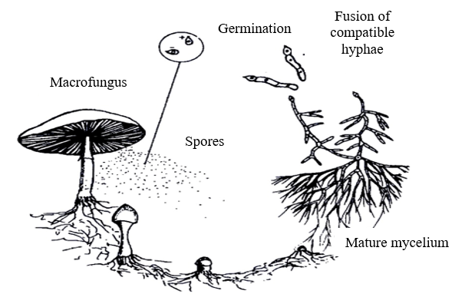
Mature mycelium

Figure 1: Life cycle of macrofungi in the natural environment (Oei, 2005)
Volvariella volvacea, commonly known as paddy straw mushroom or Chinese mushroom, belongs to the Pluteaceae (Kotl. & Pouz) family of Basidiomycetes (Singer, 1961). It is an edible mushroom of tropical and subtropical regions, first cultivated in China in 1822 (Chang, 1969). Initially, this mushroom was known as "Nanhua mushroom," after the Nanhua Temple located in Guangdong Province, northern China. Originally, paddy straw mushroom was cultivated by Buddhist monks for their own consumption, but in 1875, it was sent as a tribute to the royal family. Its cultivation is believed to have begun before the 18th century, nearly 300 years ago (Chang, 1977). Between 1932 and 1935, this mushroom was introduced to the Philippines, Malaysia, and other South Asian countries by the Chinese (Baker, 1934; Chang, 1974).
Despite its worldwide reputation, highly prized for its taste, high nutritional value and medicinal properties, Volvariella volvacea is rarely cultivated in Africa even though local communities living around forests appreciate it by actively seeking it. This limitation is due to its low biological efficiency in terms of conversion of growth substrate into fruiting bodies, sensitivity to low temperatures and an imprecise sexual profile which has limited the selection of improved strains (Ajikah, 2019). The biological efficiency of Volvariella volvacea remains relatively low, generally around 20%, while it is often between 100 and 150% compared to other cultivable edible mushrooms species (Bao, 2010).
However, two trials of Volvariella volvacea cultivation on local agricultural waste were carried out in Nigeria. For the first, the species was cultivated on pure substrate of banana leaves with a biological efficiency of 5.21% and a total fresh fruiting weight of 2.5 kg (Belewu & Belewu, 2005) and for the second, the species was cultivated on pure substrates of paddy straw, sawdust, raffia palm trunk and palm bunch waste. The results of this second study showed that only sawdust showed good growth performance with a total fresh fruiting weight of 107.2 g while the other substrates had only recorded simple mycelial growth (Ajikah, 2019).
In Uganda, the cultivation of wild macrofungi from Bugoma Conservancy, Kyangwali District/Hoima County was tested by Nakalembe (2018). Wild strains of P. Cornucopiae var. citrinopileatus and Pleurotus sp2 were tested using local materials such as peanut shells, sugarcane bagasse, banana peels, coffee pods, and bean straw as substrates. This trial resulted in the domestication of wild strains of P. Cornucopiae var. citrinopileatus and Pleurotus sp2 with good growth performance on peanut shells and bean straw substrates. However, no study on the cultivation of Volvariella volvacea has been carried out, certainly for the reasons mentioned above. The objective of this study is to assess the growth performance of Volvariella volvacea on three local agricultural wastes.

Material and methods

Materials collection
The paddy straw and banana leaves were collected from farmers, while the sawdust come from a carpentry workshop. The sorghum grains used to produce V. volvacea spawn were bought at the market. The relevance and motivation for this cultivation trial are drawn from the results obtained from ethnomycological surveys on wild edible mushrooms in the Mpanga forest, at the end of which, the wild edible cultivable species most appreciated by local communities was Volvariella volvacea, locally called “Akasukusuku”.

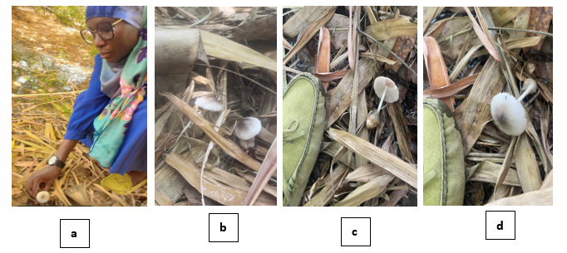
Photo 1: V. volvacea harvesting
a. harvest of one species; b. Top view of two species; c. Internal view of a species; d. External view of a species.

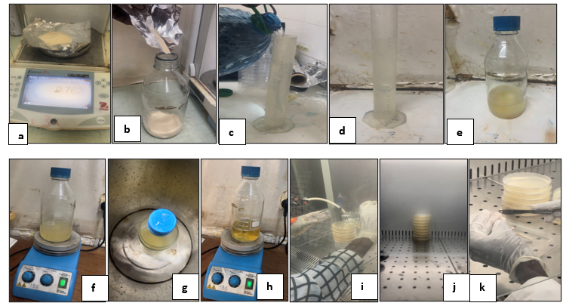
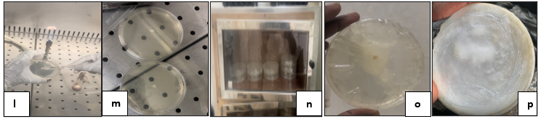

Photo 2: Process of obtaining a pure culture of V. volvacea:
a. Weighing the agar; b. Pouring the agar into a clean glass container; (c and d). Measuring 250 L of distilled water into a test tube ; e. Mixing distilled water with agar (culture medium); f. Homogenization of the culture medium before sterilization; g. Sterilization of the culture medium; h. Homogenization of the culture medium after sterilization; i. Pouring the culture medium into the petri dishes; j. Petri dishes filled with culture medium; k. Cutting of fresh fruiting tissues of Volvariella volvacea ; l. deposit of fresh tissue on the culture medium ; m. inoculation of two Petri dishes with fresh tissue; n. Incubation of Petri dishes ; o. Mycelium growth after 4 days of incubation ; p. Mycelium growth after 10 days of incubation.

Preparation of agar media and obtaining pure culture of V. volvacea
The culture medium was prepared according to the manufacturer's instructions (39 g of agar to 1 L of distilled water). Thus, 9.75 g of agar was added to 250 ml, the whole was homogenized using a stirrer before being autoclaved at 121 °C for 15 min. After cooling, the medium was homogenized again before being distributed into Petri dishes. Fresh fruiting body tissues of Volvariella volvacea were cut with a small sterile knife (Jonathan et al., 2009) and aseptically inoculated (laminar flow hood) onto the agar medium in the Petri dishes. These Petri dishes were then placed in an incubator to allow the mycelium to grow on the dishes after 10 days of incubation.

Seedling culture or preparation of spawn
V. volvacea spawn was produced from sorghum grains. The grains were cooked for 25 minutes, drained and before being transferred to well-drained bottles. The bottles were then sealed with cotton and covered with aluminum foil before being autoclaved at 121 °C for 20 minutes, then cooled to room temperature. Inoculation of the seed substrate with the mycelium from the pure agar culture was carried out under strict aseptic conditions, under a laminar flow hood where the inoculum collection and transfer equipment were sterilized by a Bunsen burner flame. Incubation of the sorghum grains (27°-29°C, 15 days) was carried out in the dark, in an incubation chamber.
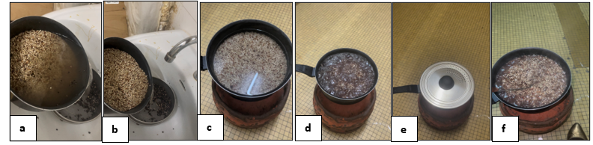
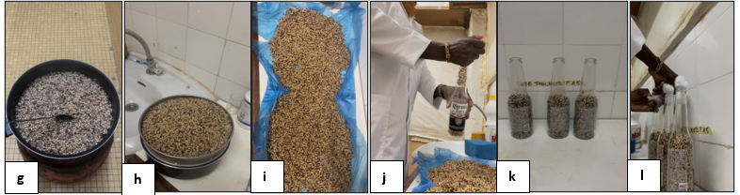

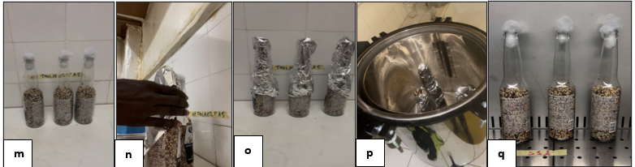
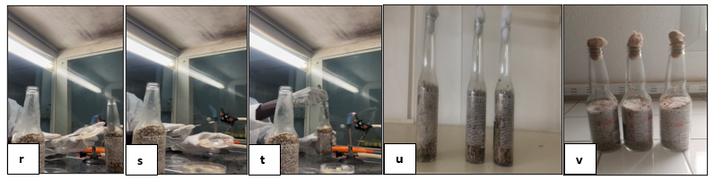
Photo 3: Process for obtaining spawn or seeds of V. volvacea:
(a and b). Washing of sorghum grains; (c, d, e, f and g). Cooking sorghum grains; (h and i). Draining and squeezing dry of sorghum grains; (k and l). Transferring the sorghum grains into well-drained bottles; (l and m). Sealing bottles with cotton; (n and o). Covering the bottles with aluminum foil; p. Sterilization of sorghum grain; q. Cooling bottles; (r, s and t) Inoculation of the seed substrate with the mycelium of the pure agar culture; u. Bottles installed in the incubation chamber; v. Mycelium growth after 15 days of incubation.

Preparation of the production substrate
Three growing media were prepared and packaged in plastic bags: banana leaves, paddy straw, and sawdust. These agro-wastes were chosen based on their availability and water retention capacity. To reduce the size of the organic matter, make it homogeneous, and facilitate contact with microorganisms (Crawfod et al., 1983), the rice straw and banana leaves were cut into 1 cm pieces. All of these wastes were soaked in tap water for 24 hours. The bags were filled into heat-resistant polyethylene bags (19 x 28 cm) called fruiting bales, each containing 500 g of substrate. For the sanitation of fruiting substrates, the method used was sterilization in an autoclave at 120°C for 1 hour 30 minutes under a pressure of 1 atm.

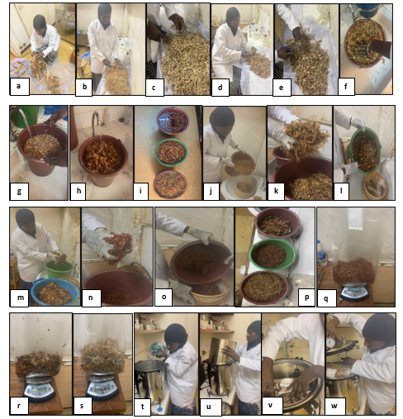
Photo 4: Substrate preparation process:
a. Separation of banana leaves from their stem; (b and c). Cutting paddy straw; (e and f). Cutting banana leaves; (f, g and h). Washing substrates; i. Soaking substrates; (j, k, l, m, n and o). Water filtration and substrate wiping; p. Wiped substrates; (q, r and s). Weighing substrates; (t and u) Preparing the autoclave; (v and w). Storage of substrate bags in the autoclave for sterilization.

Inoculation of spawn in the substrate
After sterilization, the substrate was cooled to 35-37°C at room temperature. Inoculation was carried out aseptically in a laminar flow hood, using 10% spawn to substrate mass, uniformly mixed with the substrate by stirring. The sterile substrate bags were sealed using a bag sealer to prevent the entry of pathogenic microorganisms. The transparent substrate bags were transported to the incubation chamber for optimal growth under temperature and relative humidity controlled by a hygro-thermometer.
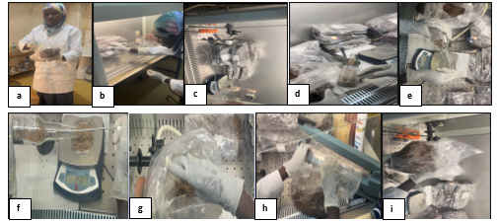

Photo 5: Inoculation of culture substrates with spawn or seeds of V. volvacea:
(a and b). Cleaning the substrate bags with alcohol before inoculation; (c and d). Preparation for inoculation; (e and f). Weighing seed; g. Inoculation of substrate bags with seed; h. Sealing substrate bags; i. Mixing seed with the substrate.

Incubation of cultures
Incubation took place in a room in total darkness. The substrate bags were placed on shelves. Limited lighting was allowed in the spawn culture room, an ambient temperature of approximately 30 °C and a relative humidity between 65 and 75% were obtained by spraying the bags two to three times a day with clean water (Ajikah et al., 2019). Once the mycelium was colonized, the substrate bags were placed side by side on the shelves, open at the upper end, taking care not to place them on top of each other, as this would generate heat. The room was continuously humidified using a humidifier

Fruiting and harvesting
The bales containing the primordia were moved to a fruiting chamber where favorable conditions for fruiting were met, including low light, high humidity (80-85%), and temperatures of 30-35 °C, while allowing good air circulation and always keeping the substrate bags side by side on the shelves. Relative humidity and temperature were monitored using a hygro-thermometer. Fruiting of the paddy straw macrofungus occurred in three stages: pinhead or primordia, bud or egg, and maturity (Chang and Quimio, 1989). Harvesting was carried out at the maturity stage to obtain a measurement of the maximum diameter of the fruiting body and at the egg or bud stage since at this stage, the macrofungus is more appreciated in the market (Reyes, 2000).
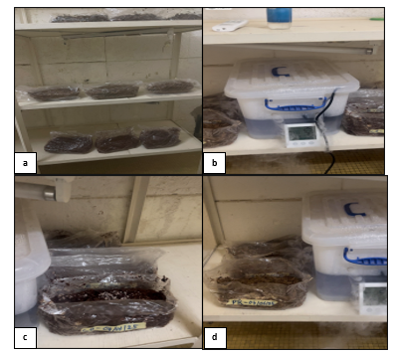

Photo 6: Incubation and fruiting rooms:
a. Installing substrate bags on the shelves for incubation; (b, c and d). Opening and installing the substrate bags side by side for fruiting.

Experimental design
The factor studied here was the substrate. The effect of three culture substrates on the growth performance of Volvariella volvacea fruit bodies was evaluated.
The following split-plot design was used with three replicates:
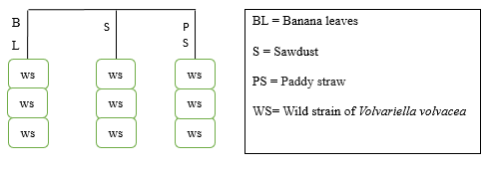

The model above shows that the wild strain of Volvariella volvacea (WS) was tested on all three types of substrates (BL, S and PS) with three replications.

Data analysis
The growth performance of Volvariella volvacea was evaluated through parameters that were collected during the production of the paddy straw macrofungus, including fruiting body diameter (cm), number of fruiting bodies and fresh weight (g). The biological efficiency of the rice straw macrofungus on the different substrates was also calculated according to the formula (Apetorgbor et al., 2015), taken up by (Ajikah et al., 2019):
Biological efficiency (%) = total fresh weight of fruiting body / weight of dry substrate X 100
The data were statistically analysed by analysis of variance (ANOVA) at the 5% level with SPSS software to determine the significant differences between the fruiting body diameter, the number of fruiting bodies, the wet weight of fruiting bodies and the biological efficacy of Volvariella volvacea on three different culture media.

Results

Mycelium growth and fruiting body formation
Paddy straw macrofungi cultivation involves two stages: mycelium formation and fruiting body formation (Samarawira, 1979). Cultivation results using three different culture media show that mycelium fills the surface of the culture medium 7 days after inoculation for paddy straw and sawdust media, followed by banana leaves the next day. The mycelium then develops into a fruiting body (primordia) after 9 to 11 days of inoculation. The first harvest at the bud/egg stage occurs 14 days after inoculation for sawdust and paddy straw, and 15 days after inoculation for banana leaves. The first harvest at the mature stage occurs 2 to 3 days after that of the bud/egg stage for each substrate. Harvesting was completed 35 days after inoculation, with 14 harvests for each substrate.

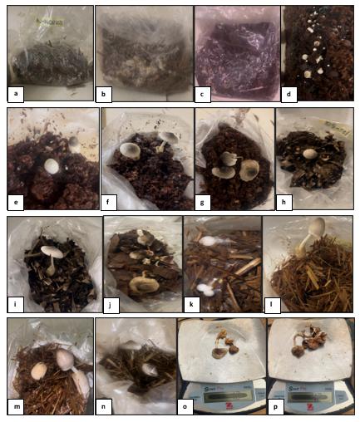
Photo 7: Mycelium formation and different stages of fruiting body formation on the three types of substrates:
a. Mycelium formation on banana leaf substrate; b. Mycelium formation on paddy straw substrate; c. Mycelium formation on sawdust substrate; (d and e). Pinhead or primordia formation on sawdust substrate; f. Formation of fruiting bodies at the bud or egg stage on sawdust substrate; g. Formation of fruiting bodies at the mature stage on sawdust substrate; h. Pinhead or primordia formation on banana leaves substrate; i. Formation of fruiting bodies at the bud or egg stage on banana leaf substrate; j. Formation of fruiting bodies at the mature stage on banana leaves substrate; k. Pinhead or primordia formation on paddy straw substrate; l. Formation of fruiting bodies at the bud or egg stage on paddy straw substrate; m. Formation of pinheads or primordia and fruiting bodies at the bud or egg stage on paddy straw substrate; n. Formation of fruiting bodies at the mature stage on paddy straw substrate; o. Weighing fruiting bodies at the bud or egg stage; p. Weighing of fruit bodies at the mature stage.

Number of fruiting bodies
The number of fruiting bodies produced during the 14 days of harvesting was demonstrated (Fig. 2). The results showed that using paddy straw and sawdust as substrate resulted in the highest number of fruiting bodies on the 3rd and 4th day of harvesting while the 7th day of harvest resulted in the highest number of fruiting bodies on banana leaf substrate. These numbers were 5, 8 and 4 respectively at the peak number of fruiting bodies on paddy straw, sawdust and banana leaf substrates. Statistical analysis (p < 0.05) showed no significant difference between the number of fruiting bodies on the different substrates.

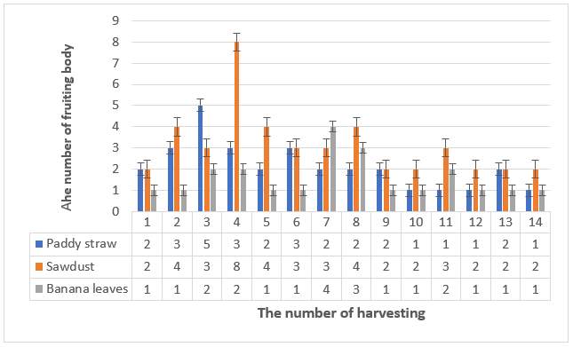

Figure 2: The number of fruiting body on paddy straw, banana leaves and sawdust in 14 days of harvesting.

Diameter of fruiting body
The average fruiting body diameter expresses the quality of cultivated paddy straw macrofungi, as shown in Fig. 3. The longest average fruiting body diameter was obtained from sawdust substrates, followed by paddy straw and banana leaves, with 2.57 cm, 2.09 cm and 1.89 cm, respectively. Statistical analysis (p < 0.05) showed no significant difference in fruiting body diameter among different substrates.

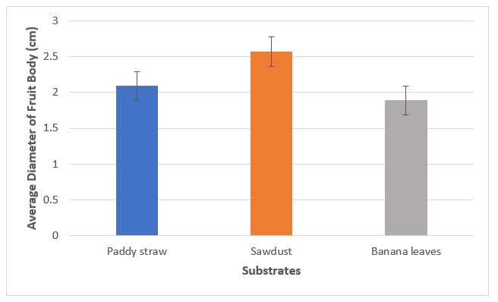

Figure 3: Diameter of fruiting body on paddy straws, banana leaves and sawdust substrates.

Weight of fruiting bodies
The weight of fruiting bodies on different substrates was measured (Fig. 4). The heaviest fruiting bodies were obtained on sawdust substrate with 36.7 grams on the 4th day of harvest, followed by 22.3 grams on the 3rd day for paddy straw and 18.5 grams on the 7th day for banana leaves. In addition, the total weight of the heaviest fruiting bodies was obtained on sawdust substrate, followed by paddy straw and banana leaves, with 181.8 grams, 98.5 grams and 74.2 grams respectively. Statistical analysis (p < 0.05) showed no significant difference in fruiting body weight between substrates.

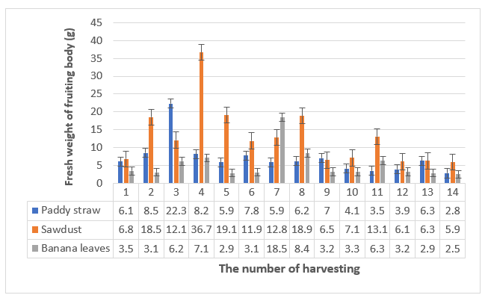

Figure 4: Weight of fruiting body of paddy straw mushroom growth on various substrates.

Biological efficiency (BE)
The biological efficiency of paddy straw macrofungi grown on different substrates is shown in Fig. 5. The results show that the highest BE is obtained on sawdust, paddy straw and banana leaf substrate, with 12.63%, 7.41% and 6.14% respectively. Statistical analysis (p < 0.05) showed no significant difference in BE when paddy straw macrofungi are grown on different substrates.

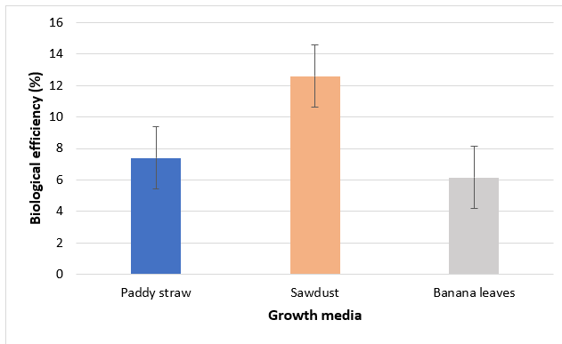

Figure 5: Biological efficiency of paddy straw mushroom cultivation using 3 different growth media.

Discussion
Mycelial growth is an important phase in mushrooms cultivation. Using banana leaves as a substrate, it took 8 days for the mycelia to fully develop, while the paddy straw and sawdust substrate required 7 days. These results are almost similar to those of Quimio et al., (1990), Okhuoya et al. (2005) and Zikriyani et al. (2018). They reported that the carbon and nitrogen content of the substrates plays an important role in the growth of V. volvacea mycelia. In addition, pH and temperature also favor the growth of mycelia (Akinyele and Adetuyi, 2005).
The fruiting body production curve and its characteristics were similar in the three different lignocellulosic agricultural wastes. Only the peak production periods and fruiting body characteristics differed. The increase in the number of fruiting bodies is explained by the presence in the culture media of macronutrients essential for fruiting body production (potassium, calcium, phosphorus, magnesium, nitrogen, and sodium). These essential nutrients generally combine in various media to stimulate fruiting body formation and development of V. volvacea (Stamets, 2001).
Cultivation of paddy straw mushroom using sawdust as a substrate yielded the best results in terms of fruiting body number, diameter, wet weight, and biological efficiency. This is because the nutrients in the substrates are optimal for fruiting body formation and result in paddy straw mushroom with the highest fruiting body number, wet weight, biological efficiency, and diameter. The dry paddy straw substrate contained 27% hemicellulose, 39% cellulose, and 12% lignin. The sawdust substrate contains 16% hemicellulose, 46% cellulose and 30% lignin (Quirino, 2000) while banana leaves contain only 24.19% cellulose, 24.04% hemicellulose (Belewu and Belewu, 2005) and 13.3% lignin (Oliveira et al., 2009). Paddy straw is a natural substrate for paddy straw mushroom (Fasidi, 1996) and contains lignocellulose. Temperature and relative humidity also play an important role in fruiting body formation. The relative humidity of paddy straw macrofungi cultures is 85 - 99%, with an average of 91.9% (Zikriyani et al., 2018). During cultivation, the minimum relative humidity and temperature for paddy straw macrofungi growth were 80% and 27.5 °C, respectively, and the maximum relative humidity and temperature were 98% and 35.2 °C, respectively. The average daily relative humidity and temperature during cultivation were 90.5% and 30.6 °C, respectively, which are sufficient for paddy straw mushroom cultivation.
The highest biological efficiency was 12.63% for sawdust, followed paddy straw (7,41%) and banana leaves (6.14%). This result is close to that of Belewu and Belewu (2005) for banana leaves as a pure substrate (5.21%) but higher than that of Ajikah et al. (2019) for sawdust as a pure substrate (10%). This result is, however, lower than that of Quimio et al., (1990) for paddy straw as a composted substrate (15%) and that of Zikriyani et al. (2018) for the same pure substrate (7.93%). This is because composting plays an important role in the decomposition of polymers in the culture media, such as hemicellulose and cellulose, into monomers such as xylose and glucose. These monomers are used as nutrients for metabolism and fruiting body formation on paddy straw mushroom (Chang and Miles, 2004).
Conclusion
Among the three local substrates used in the cultivation of Volvariella volvacea, sawdust recorded the best biological performance in terms of number of fruiting bodies (8), diameter (2,57 cm), wet weight (36,7 grams) and biological efficiency (12,63 %). However, statistical analysis (p < 0.05) showed no significant difference in the evaluated parameters between the different substrates. Cultivation of V. volvacea on composted substrates can certainly improve growth performance and even yield, opening up prospects for large-scale cultivation for commercial purposes. Further research is also needed to develop suitable processing technology and encourage African scientists to deepen their knowledge of paddy straw mushroom and better exploit its nutritional and medicinal benefits.

REFERENCES
AHLAWAT, O. P., & TEWARI, R. P., 2007. Cultivation technology of paddy straw mushroom (Volvariella volvacea).
AHLAWAT, O.P. AND KUMAR, S., 2005. Traditional and modern cultivation technologies for the paddy straw mushroom (Volvariella spp.). Frontiers in Mushroom Biotechnology (Rai, R.D., Upadhyay, R.C. and Sharma, S.R., (Eds.), 157-164 pp.
AJIKAH, L. B., ABASI, M. A., SANNI, R. O., & WALTER, O. J., 2019. Assessing the growth performance of Volvariella volvacea on local homemade substrate. Int J Recent Innov Acad Res, 3(6), 108-115.
AKINYELE, B. J., & ADETUYI, F. C., 2005. Effect of agro wastes, pH and temperature variation on the growth of Volvariella volvacea. African Journal of Biotechnology, 4(12).
APETORGBOR, A. K., APETORGBOR, M. M. AND DERKYI, N. S. A., 2015. Comparative studies on growth and yield of oil palm mushroom, Volvariella volvacea (Bull. Ex. Fr.) Sing. On different substrates. Greener Journal of Agricultural Sciences 5:177-189.
BAKER, J. A., 1934. Mushroom growing in Province Wellesley & Penang.
BAO, D.P., ZHAO, G.P. AND TAN, Q., 2010. Draft Sequence of the Volvariella volvacea
Genome. Acta Eduis Fungi, 17(1): 3-5.
BELEWU, M. A., 2001. Effect of fungus (Volvariella volvacea) treated cotton waste as a replacement for cotton seed cake and meal by WAD goat. Trop. J. Anim. Sci. 4(1): 93-98.
BELEWU, M. A., 2002. Conversion of Mansonia saw-dust and cotton plants by-product into feed by white rot fungi (Pleurotus sajor caju). J. Sci. Agric. Food Tech. Environ. 1(2): pp.???
BELEWU, M. A., 2003. Nutritional qualities of corn cobs and waste paper incubated with edible mushroom (Pleurotus sajor caju). Nig. J. Anim. Prod. Vol. 30(1): 20-25.
BELEWU MA, ADEMILOLA., 2002. Digestibility response of WAD goats to mushroom (Volvariella volvacea) treated cotton waste. Moor J. Agric. Res. 3(1): 83-86.
BELEWU, M. A, LAWAL RA., 2003. Studies of the cultivation of edible mushroom (Pleurotus pulmonarium) on cocoa bean shell and saw-dust – Gliricidia mixture. Res. Comm. Microbiol. 1(2): 68-71.
BELEWU, M. A., & BELEWU, K. Y., 2005. Cultivation of mushroom (Volvariella volvacea) on banana leaves. African journal of Biotechnology, 4(12).
CHANG, K. C., 1969. Fengpitou, Tapenkeng, and the prehistory of Taiwan.
CHANG, C. L., 1974. Finding prototypes for nearest neighbor classifiers. IEEE Transactions on Computers, 100(11), 1179-1184.
CHANG, S. T., 1977. The origin and early development of straw mushroom cultivation. Economic botany, 31(3), 374-376.
CHANG, S. T. AND MILES, P. G., 2004. Cultivation, nutritional value, medicinal effect, and
environmental impact. 2ed. CRC Press. USA.
CHANG, S. T. AND QUIMIO, T. H., 1989. Tropical mushrooms, biological nature and cultivation methods. The Chinese University Press. Hongkong. crates. Mycologist 14:174-176.
CRAWFORD, D. L., POMETTO III, A. L., & CRAWFORD, R. L., 1983. Lignin degradation by Streptomyces viridosporus: isolation and characterization of a new polymeric lignin degradation intermediate. Applied and Environmental Microbiology, 45(3), 898-904.
DE KESEL, A., CODJIA, J.T.C. & YOROU, S.N., 2002. Guide to Edible Fungi in Benin. Cotonou, Republic of Benin, National Botanical Garden of Belgium and International Center for Integrated Eco-development (CECODI), Coco Multimedia Print: 275 p.
DIANSAMBU, M. I., DIBALUKA, M. S., LUMANDE, K.J. & DEGREEF, J., 2015. Culture de trois espèces fongiques sauvages comestibles du Groupement de Kisantu (R.D. Congo) sur des substrats ligno-cellulosiques compostés, Afrique SCIENCE 11(3) (2015) 241 - 261 241 ISSN1813-548X, http://www.afriquescience.info
DIBALUKA, M.S., 2005. Inventory of macromycetes in the forest of Lac de Ma Vallée (Kinshasa) and test of cultivation of some edible species, Unpublished dissertation: Faculty of Sciences, University of Kinshasa (DR Congo), 200p.
DIBALUKA, S.M., LUKOKI, F.L., DE KESEL, A. AND DEGREEF, J., 2010. Cultivation trials of some edible lignocellular fungi from the Kinshasa region (DR Congo) on various lignocellulosic substrates. Biotechnol Agron. Soc. About 417-422.
EYI-NDONG, H., 2009. Study of the mushrooms of the humid dense forest consumed by the populations of northern Gabon, Thesis submitted to obtain the degree of Doctor in Biological Sciences October 2009: 16p
FASIDI, I. O., 1996. Studies on Volvariella esculenta (Mass) Singer: cultivation on agricultural wastes and proximate composition of stored mushrooms. Food Chemistry, 55(2), 161-163.
HEIM, R., & CAILLEUX, R., 1965. Culture industrielle d'une psalliote tropicale dans les régions chaudes.
HENNEBERT, G. L. & SIMON, L., 1989. Etude de substrats artificiels pour la culture de champignons comestibles orientaux et tropicaux, Rapports provisoire 1985-1986 laboratoire de Mycologie systématique et appliquée, Fac. Sc. Agro. UCL, 35-93.
ISIKHUEMHEN, O. S, OKHUOYA, J.A., 1999. Cultivation of Pleurotus tuber regium (Fr) Singer for production of edible sclerotia on agricultural wastes. Mushroom Biology and Mushroom Products. Royese (ed) Penn. State. Univ
JONATHAN, S.G., BAWO, D.D.S., ADEJOYE, D.O. AND BRIYAI, O.F., 2009. Studies on biomass production in Auricularia polytricha collected from Wilberforce Island, Bayelsa State, Nigeria. American Journal of Applied Sciences, 6(1): 182-186.
MOSIBONO E.E., HABARI M.H. & PAULUS J.J., 1991. Essai de culture mycélienne de quelques champignons comestibles zaïrois sur milieu semi-synthétique. Tropicultura, 9, 138-139.
NAKALEMBE, I., 2018. Studies on cultivation of the edible indigenous mushrooms grown on different agro-residues, Makerere-AIDS-ARM-Science-Day-CoVAB. Cattegory: Science, Biology, Biochemistry, January 30, 2018.
OBODAI, M., CLELAND, O. J. & VOWOTER, K., 2003. Comparative study on growth and yield of Pleurotus ostreatus mushroom on different lignocellulosic by-products. J. Ind. Microbiol. Biotechnol. 30, 146-149.
OEI, P., 1993. The cultivation of mushrooms. Technical Guide, Amsterdam, Netherlands, CTA, TOOL, FGRET., 318 p.
OEI, P., 2003. Mushroom cultivation. 3rd ed. Leiden, The Netherlands, Backhuys Publishers, 208-211
OKHUOYA, J. A., AKPAJA, E. O., & OGHENEKARO, A., 2005. Cultivation of Lentinus squarrosulus (Mont.) Singer on sawdust of selected tropical tree species. International Journal of Medicinal Mushrooms, 7(3).
OLIVEIRA, L., EVTUGUIN, D. V., CORDEIRO, N. AND SILVA, A. M. S., 2009. Chemical composition and lignin structural feature of banana plant leaf shealth and rachis. Characterization of Lignocellulosic Materials: 71-188.
QUIMIO, T. H., 1990. Technical guidelines for mushroom growing in the tropics. Food and Agriculture Organization of the United Nations. Rome, 7, 62-70.
QUIMIO, T. H., CHANG, S. T. AND ROYSE, D. J., 1990. Technical guide for mushroom growing in the tropics. Plant Production and Protection Paper. FAO. Rome, Italia.
REYES, R. G., 2000. Indoor cultivation of paddy straw mushroom, Volvariella volvacea, in crates. Mycologist, 14(4), 174-176.
SAMARAWIRA, I., 1979. A classification of the stages in the growth cycle of the cultivated paddy straw mushroom (Volvariella volvacea singer) and its commercial importance. Economic Botany, 33(2), 163-171.
SINGER, R., 1961. Mushrooms and truffles: 272-14.
STAMETS, P., 2001. A novel approach to farm waste management. Mushroom Journal.
Winter. 22 p.
ZIKRIYANI, H., SASKIAWAN, I. AND MANGUNWARDOYO, W., 2018. Utilization of agricultural waste for cultivation of paddy straw mushrooms (Volvariella volvacea (Bull.) Singer 1951). International Journal of Agricultural Technology 14(5): 805-814

