Original Research Article

A Comprehensive Pharmacognostical Evaluation and Phytochemical Profile of Upodika (Basella rubra Linn.)

ABSTRACT
Basella rubra L. (Basellaceae), commonly known as Indian or Malabar spinach belongs to family Basellaceae, is an herbaceous annual or biennial climbing herb found in tropical and sub-tropical areas. Upodika (Basella rubra Linn.) is known for its health-promoting properties, including antioxidant, antimicrobial, antiproliferative, and anti-inflammatory activities. Traditionally, it has been used for its potential in treating various conditions such as cancer, viral infections, ulcers, high cholesterol, wounds, liver disorders, and blood-related ailments. The present study intended with various phytochemical screening and pharmacognostic studies on Upodika (Basella rubra Linn.) Preliminary phytochemical evaluation of the aqueous extracts revealed that presence of carbohydrate, proteins, flavonoids, saponin, phenol content, tannins and glycosides. Pharmacognostic investigations and physicochemical evaluation like total Ash value, water soluble ash, acid insoluble ash, foreign matter, water soluble extractive value and alcohol soluble extractive value performed in the present study to exhibit quick identification of the drug and are particularly useful in the case of powdered forms and also contribute towards establishing Pharmacopoeial standards for the specified plant.
Keywords: Upodika, Basella rubra, phytochemical, pharmacognostical

INTRODUCTION
Basella rubra L., commonly known as Malabar spinach or Indian spinach, is an annual leafy green vegetable that belongs to the Basellaceae family of the Caryophyllales order (Fadhila et al., 2024). It is widely distributed in the tropics and often cultivated in warm temperate areas of both the eastern and western hemisphere. Watt stated that it is cultivated in almost whole of India, especially in lower Bengal and Assam where it is an important part of diet (Winters, 1963). Due to easy adaptation to a variety of soils and climates Malabar spinach is considered one of the best tropical spinaches throughout the tropical world (palada & Crossman, 1999).
Basella rubra has a fleshy stem that is stout at the base and becomes slender and much-branched towards the top. It is very long, succulent, glabrous, and exhibits a high degree of branching. The leaves are axillary, dark green, broadly ovate or acuminate, thick, and apiculate, often with a cordate base. The flowers are white, pink, or red in colour, sub-sessile or sessile, and occur in few lax pedunculate spikes. Bracts are small and scaly, while the bracteoles are acute and longer. The fruit is black or dark purple, enclosed within a persistent fleshy calyx, although it may also appear small and red or black. The seeds are black, globose, and ovate in shape with an acute tip (Almeida, 2003).
Basella rubra is used in ethnoveterinary medicine to treat retained afterbirth, anaplasmosis, gonorrhoea, and balanitis. The aerial parts are consumed as a vegetable with health benefits, showing antifungal, anti-inflammatory, demulcent, diuretic, and laxative properties. It aids in digestive disorders, anaemia, acne, aphthae, and skin diseases.
The plant’s mucilage is used in Thai traditional medicine for bruises, ringworm, labour assistance, and cosmetic applications. It is also used to treat cancer, indigestion, insomnia, burns, tumours, bleeding, and to promote weight gain. Traditionally, it enhances fertility in both men and women and supports childbirth by easing labour and stimulating contractions.
Basella rubra is used to treat mouth ulcers, hernia, eczema, ulcers, bleeding piles, and whooping cough. It also improves Vitamin A levels in at-risk populations. Reported pharmacological properties include analgesic, androgenic, and anticonvulsant effects (Sharma & Behera, 2022).

MATERIALS AND METHODS:
- Collection of plant material and storage:
The seeds of the drug i.e. Basella rubra Linn. were grown on the field at Narela, Delhi. They were sown in June when monsoon season was to be arrived as it requires proper moisture in the soil for growing. The seeds were grown to proper succulent plants in around 2 months. Then the stem and leaf parts were collected and dried under shade.
The sample was taxonomically identified and authenticated by Raw Material Herbarium and Museum (RHMD), CSIR-National Institute of Science Communication and Information Resources (CSIR-NISCAIR) with reference no. NISCAIR/RHMD/Consult/2021/4148-49.
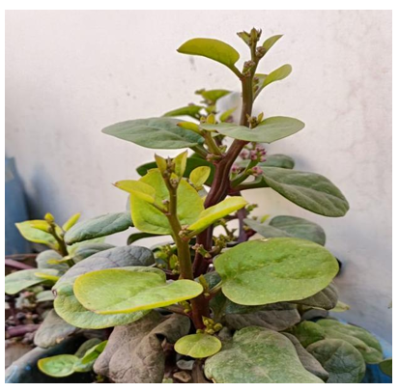
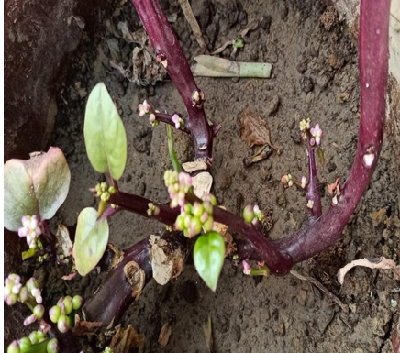
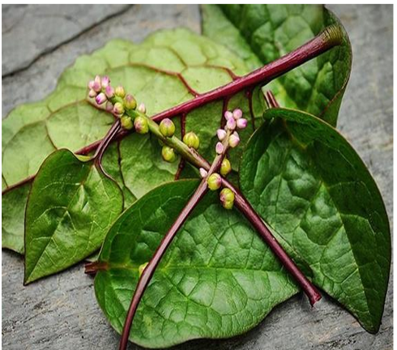
Figure 3: Basella rubra L. Fleshy green leaves
Figure 2: Basella rubra L. Purplish stem
Figure 1: Basella rubra L. Leaves and Stem

- Pharmacognostical studies (Anonymous, 2008)
Macroscopic evaluation of Upodika (Basella rubra Linn.) was conducted at the Pharmacognosy Laboratory, Department of Dravyaguna, A&U Tibbia College and Hospital. Organoleptic characteristics such as size, shape, colour, odour, taste, and texture were examined using sense organs, a magnifying lens, and measuring tools. Microscopic evaluation was also performed to identify key histological features through transverse section and powder microscopy.

- Powder microscopy
Microscopic evaluation of Upodika (Basella rubra Linn.) powder was carried out as per the Ayurvedic Pharmacopoeia of India. A fine powder (80 mesh) was soaked in a 30:70 ethanol-distilled water solution for two days with frequent shaking, then washed to obtain a clear pellet. Multiple Slides were prepared using layers from the pellet, covered with coverslips, and examined under an Axiocam ICc5 microscope at 5X, 10X, and 40X magnifications to study microscopic characteristics.

- Physicochemical study

Physicochemical evaluation of powder of Upodika (Basella rubra Linn.) was performed as per guidelines mentioned in API (Anonymous, 1999)

- Determination of Foreign Matter
A 100 g of sample (unless otherwise specified) was taken and spread in a thin layer on a suitable platform. Examined in daylight with unawed eye or using 6x or 10x magnifying glass and separate the foreign matter. An appropriate sieve was used where necessary, and dust or mineral admixtures were separated using a 250 μm sieve.

- Determination of Total Ash
About 3 g of powder of Upodika (Basella rubra Linn.) was weighed in tarred silica crucible and incinerated at a temperature not exceeding 4500 C until free from carbon. It was then cooled under desiccator and weighed.

- Determination of Moisture Content (Loss on Drying)
About 10 g of Upodika (Basella rubra Linn.) powder was taken in a tarred evaporating dish and dried at 105°C for 5 hours. It was then weighed at one-hour interval until difference between two successive weighing was not more than 0.25%. Constant weight was confirmed when two consecutive weighing after drying for 30 minutes and cooling for 30 minutes in a desiccator.

- Determination of Extractive Values

- Determination of Alcohol Soluble Extractive
Appro. 5 g of Upodika (Basella rubra Linn.) powder was macerated with 100 ml of alcohol in a closed flask for 24 hours, shaken frequently during the first 3 hours, and left to stand for the remaining 18 hours. The mixture was then filtered, and the filtrate evaporated to dryness in a tarred dish. It was dried at 105°C to constant weight and then weighed, with precautions taken to prevent solvent loss.

- Determination of Water-Soluble Extractive
Approx. 5 g of Upodika (Basella rubra Linn.) powder was macerated with 100 ml of water in a closed flask for 24 hours, shaken frequently during the first 3 hours, and left to stand for the remaining 18 hours. The mixture was then filtered, and the filtrate was evaporated to dryness in a tarred shallow dish. It was dried at 105°C to constant weight and weighed.

- Phytochemical study⁶
Phytochemical analysis of powder of Upodika (Basella rubra Linn.), was done at Dr. B.R. Ambedkar Centre for Biomedical Research, Delhi University. The following experiments were conducted on the leaf and stem extracts of Upodika (Basella rubra Linn.), and their respective chemical constituent fractions were tested for the presence of different secondary metabolites such as total alkaloids, flavonoids, carbohydrates, glycosides, flavonoids, phenolic content, tannins, saponins, and steroids.

- Test for alkaloids: Mayer’s Test: 2 ml of test Solution was taken in a test tube to which 2 ml of the Mayer’s reagent (Potassium Mercury Iodide solution) was added. A White or Pale-Yellow precipitate if formed indicated the presence of Alkaloids except with Alkaloids of the Purine groups and few others.

- Test for Glycosides: Killer-killian ’s test: The aqueous extract of powder of Upodika (Basella rubra Linn.) was dissolved in glacial acetic acid respectively and after cooling, 2 drops of 0.1 % ferric chlorides solution were added to them. These contents were transferred to test tubes containing 2 ml of conc.H2SO4. A reddish-brown colour ring at the junction of two layers indicated presence of Glycosides.

- Test for Flavonoids: Ferric Chloride Test: In a test tube containing about 1 ml of alcoholic extract of powder of Upodika (Basella rubra Linn.), a few drops of neutral FeCl2 solution (0.1 %) were added respectively. Formation of blackish red colour indicated the presence of flavonoids.

- Test for Tannins: Ferric Chloride Test: The extract (50 mg) of sample was dissolved in 5 ml of distilled water. To these few drops of neutral 0.1% FeCl₂ solution were added respectively. A dark green or black colour precipitate indicated the presence of tannins.

- Test for Saponins: A drop of sodium bicarbonate was added in the test tube containing 50 ml extract of powder of Upodika (Basella rubra Linn.). The mixture was vigorously shaken and kept for two minutes. Absence of honeycomb like froth indicated the absence of saponins. Presence of honeycomb like froth indicated the presence of saponins.

- Test for Carbohydrates:

- Molisch’s Test: 2 ml of test solution was added in a test tube, 2 ml of Molisch's reagent was added and thoroughly shaken, and then about 1 ml. of concentrated H₂SO₄ was poured from the test tube's side and allowed to stand for one minute. If a purple colour ring formed at the junction of the two layers, it indicated that the presence of carbohydrate.
- Fehling solution test: It consists of two solutions that are combined in situ and is commonly used for reducing sugars. Fehling solution A contains 0.5 percent copper sulphate while Fehling solution B contains Sodium Potassium Tartrate. Equal volumes of Fehling A and B solutions (1 ml each) were combined and 2 ml of aqueous solution of drug was added before boiling for 5-10 minutes on a water bath.

- Test for Amino acids (Million’s test):
Ninhydrin test: The Ninhydrin test is used to detect alpha-amino acids and proteins with free amino groups in them. The creation of a complex between two ninhydrin molecules and the nitrogen of a free amino acid imparts a characteristic deep blue or pale-yellow colour to protein solution when heated with ninhydrin molecules.

- Test for Phenolic content:
The extract was taken in water and warmed; to this 2 ml of ferric chloride solution was added and observed for the formation of green and blue colour.

RESULT
- Pharmacognostical study of Upodika (Basella rubra Linn.)

- Macroscopic study of Upodika (Basella rubra Linn.) Leaf and Stem
The leaves of Upodika (Basella rubra Linn.) are simple, alternate, sub-succulent, cordate to broadly ovate, 2 to 7 cm in length, 2 to 4.5cm in breadth, acute, entire, glabrous, glistening, reticulate, lateral veins obscure, dark green above, faint below. Older leaves develop a purple pigment starting at the base of the leaf and work towards the end. The dried stem of Upodika (Basella rubra Linn.) was reddish-purple and compressed. Mature stem is fibrous, hard to break up by hand, soft, winged, and triangular.

Table 1 : Organoleptic features of Upodika (Basella rubra Linn.) Leaves and Stem Powder

S. no. | Character | Upodika (Basella rubra Linn.)
 | Sparsha (Touch) | Snigdha (smooth)
 | Roopa (Colour) | Dark green with reddish shade
 | Rasa (taste) | Madhura
 | Gandha (Odor) | No particular smell

- Cross sectional microscopic view of Upodika (Basella rubra Linn.) Leaf and Stem:

T.S. of Leaf: The transverse section of the midrib shows distinct upper and lower epidermis without trichomes, followed by 2–3 layers of collenchyma and collateral vascular bundles surrounded by 7–10 layers of parenchyma with small intercellular spaces. Prismatic and rosette calcium oxalate crystals, measuring 50–60 µ, are scattered in the lower region. The lamina has single-layered epidermis, polygonal upper cells, anisocytic and paracytic stomata, mucilaginous cells in the lower epidermis, and centrally placed vascular bundles.

T.S. of stem: The transverse section of the stem reveals a thin cuticle with a single-layered epidermis of circular to oval cells and no trichomes. The cortex consists of 7–8 layers of polygonal parenchyma. Non-continuous 3–4 layered perivascular tissues surround collateral vascular bundles containing long fibres and diverse pitted and scalariform vessels
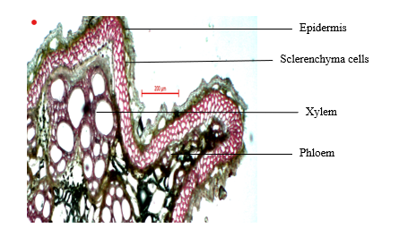

Figure 4: Stem, T.S. at 40X showing Epidermis, Sclerenchymatous cells, Xylem and Phloem

- Powder microscopy
The leaf anatomy exhibits polygonal epidermal cells with veins supported by an isocytic stomata. Vascular tissues contain pitted, scalariform, and reticulate vessels along with fibres. Groups of parenchyma cells are present, accompanied by mucilaginous cells. Calcium oxalate crystals occur in both prismatic and rosette forms, scattered throughout the tissues.

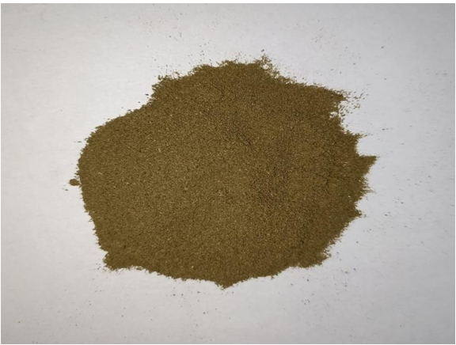

Figure 5: Basella rubra Leaves and Stem Powder

Figure 6: A. Leaf powder at 40X stained in safranin showing Group of parenchyma cells, rosette type calcium crystals, Calcium oxalate crystals, Mucilaginous cell B. Leaf epidermis at 40X stained in safranin showing anisocytic type stomata, epidermal cells, Stomatal pore, Stomata guard cell C. Scalariform vessels, Pitted vessels D. Calcium oxalate crystals

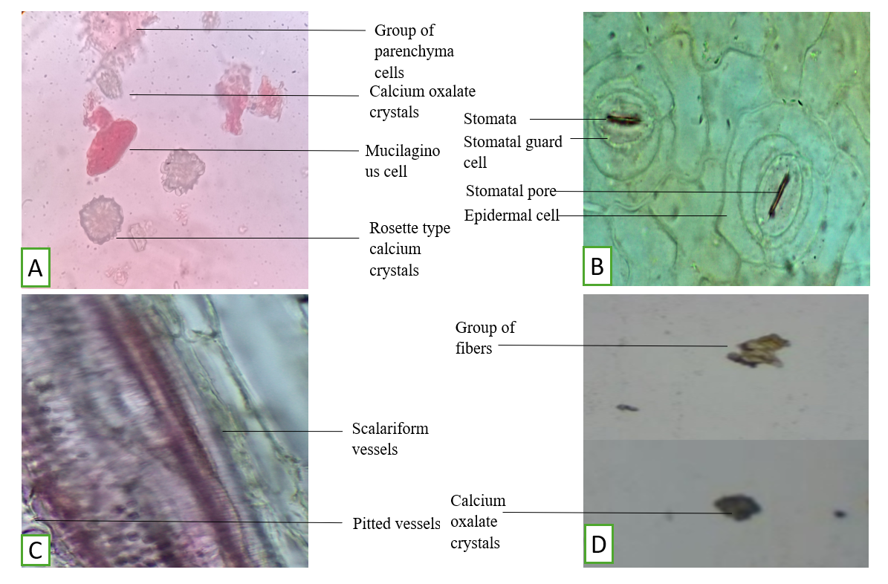

- Physiochemical and phytochemical: -

Table 2 : Physicochemical study of Upodika (Basella rubra Linn.) Leaves and Stem Powder
S. No. | Test | Upodika (Basella rubra Linn.) | Standard As Per QSIMP
 | Foreign matter | 2% | ≤ 5%
 | Total Ash | 10.42% | ≤ 12%
 | Acid Insoluble Ash | 1.1% | ≤ 2%
 | Water Soluble ash | 19.29% | -
 | Extractive Value (water soluble) | 25.46% | >23%
 | Extractive Value (alcohol soluble) | 16% | >8%

Table 3 : Phytochemical Study of Upodika (Basella rubra Linn.) Leaves and Stem Powder

Name of Test | Test used | Aqueous extract of Upodika (Basella rubra Linn.)
Carbohydrate | Molisch Test | +
Carbohydrate | Fehling Test | +
Alkaloid | Mayer’s test | -
Amino Acid | Ninhydrin test | +
Protein | Million’s Test | +
Saponin | Foam test | +
Glycosides | Borntrager’s test | +
Phenolic Compound | Phenolic test | +
Tannins | FeCl₃ Solution Test | +

DISCUSSION
In Ayurveda, Upodika (Basella rubra Linn.) is described as a leafy vegetable with important medicinal and nutritional value. It is primarily attributed with Madhura rasa (sweet taste), Snigdha guna (unctuous quality), and Shita virya (cool potency), making it Brimhana (nourishing) and Balya (strength-promoting) in nature. Classical Ayurvedic texts emphasize its utility in alleviating Pitta disorders due to its cooling effect, and in promoting tissue nourishment (Dhatu poshana) owing to its sweet taste and unctuous nature.
The present study on Upodika (Basella rubra Linn.) provides comprehensive pharmacognostical, physicochemical, and phytochemical data that establish reliable diagnostic and quality control parameters for the drug. Macroscopic features such as cordate, glabrous leaves with dark green upper and reddish-purple pigmentation, along with fibrous triangular stems, serve as distinguishing markers, while microscopic characteristics including collateral vascular bundles, mucilaginous cells, anisocytic and paracytic stomata, and prismatic and rosette calcium oxalate crystals further confirm its identity. Organoleptic attributes such as smooth texture (Snigdha), sweet taste (Madhura), and absence of odour are consistent with Ayurvedic descriptions of Upodika as a cooling (Shitavirya), nourishing (Brimhana), and strength-promoting (Balya) herb. The physicochemical evaluation revealed that all parameters were within the permissible limits prescribed by QSIMP, indicating good quality and purity of the drug. The foreign matter was found to be 2%, well below the maximum limit of 5%, suggesting minimal contamination. The total ash value (10.42%) and acid-insoluble ash (1.1%) also remained within the standard limits (≤12% and ≤2% respectively), confirming the presence of natural inorganic constituents with negligible earthy or siliceous impurities. The water-soluble ash was 19.29%, which, although not specified in QSIMP, denotes a significant proportion of water-soluble salts that may have therapeutic significance. The extractive values further supported the quality of the drug, with the water-soluble extractive recorded at 25.46% (standard >23%) and the alcohol-soluble extractive at 16% (standard >8%), both exceeding the required limits. These findings indicate that Basella rubra contains an appreciable amount of bioactive principles extractable in both aqueous and alcoholic media, highlighting its richness in secondary metabolites such as glycosides, phenolics, tannins, and flavonoids. Phytochemical screening of the aqueous extract demonstrated the presence of carbohydrates, proteins, amino acids, glycosides, saponins, phenolic compounds, and tannins, while alkaloids were absent. These findings justify its nutritive and medicinal uses, as carbohydrates and proteins support its role as a food-medicine, saponins suggest antimicrobial and immunomodulatory activities, phenolics and tannins highlight antioxidant and wound-healing properties, and glycosides indicate diverse pharmacological potential. Importantly, the absence of alkaloids suggests a safer pharmacological profile compared to many potent herbal drugs.
CONCLUSION
India is recognized for its vast biodiversity and is one of the largest producers of medicinal plants. However, a significant limitation in leveraging this potential on the global stage is the insufficient standardization and scientific validation of herbal drugs. The absence of well-established pharmacognostical and physicochemical parameters poses challenges in ensuring the identity, purity, and quality of medicinal plant materials. Therefore, the present study aims to establish standardized profiles for selected plant species in accordance with Ayurvedic Pharmacopoeia of India guidelines. This is a critical step toward ensuring the safe and effective use of herbal medicines and promoting their acceptance in the global market.
REFERENCES
- Anonymous, The Ayurvedic Pharmacopoeia of India, Ministry of Health and Family welfare, Department of AYUSH, Government of India, New Delhi, ed. 1st (2008), Part 2, Vol 1, pg 136-139.
- Anonymous, the Ayurvedic Pharmacopoeia of India, Part-I, Vol. 1-4, Govt. of India, Dept. of ISM and H. New Delhi; 1999;155-56
- Fadhila FR, Umar A, Chandren S, Apriandanu DO, Yulizar Y. Biosynthesis of CoCr2O4/ZnO nanocomposites using Basella alba L. leaves extracts with enhanced photocatalytic degradation of malachite green in aqueous media. Chemosphere. 2024;352: 141215.
- Harold F. Winters July Ceylon spinach (Basella rubra). Economic Botany, 1963; 17(3): 195-199
- Palada MC, Crossman SMA. Evaluation of tropical leaf vegetables in the Virgin Islands. Perspectives on new crops and new uses, ASHS press, Alexandria, VA, 1999; 388-393.
- Almeida MR. Flora of Maharashtra. Blatter Herbarium, St. Xavier’s College, Mumbai 2003;4:278.
- Sharma A, Behera B. A review on upodika (Basella rubra Linn.)-an Ayurvedic nutraceutical with enormous medicinal value. World Journal of Pharmaceutical Research. 2022 May 6;11(9):237-59.

