Review Article
Silk Protein Materials: Characteristics and Applications in Food Industries

Abstract

Sericulture is an agro-industrial endeavor that aims to produce silk thread and textile goods from the cocoons of the silkworm, Bombyx mori L. Silk primarily consists of two proteins, fibroin and sericin, which represent 75 and 25 percent, respectively. These proteins have widespread applications across various sectors, particularly in textiles, cosmetics, biomedical fields, biotechnology, and the food industry. The functional characteristics of these proteins, which include antibacterial, antioxidant, biodegradable, and water vapor permeable properties, render them highly suitable for use in the food sector. Sericin, known for its emulsifying and film-forming abilities, can enhance the texture, stability, and shelf life of food items such as salad dressings, sauces, and confectioneries. Fibroin, recognized for its superior mechanical and gas barrier properties, can serve as a sustainable alternative to synthetic materials like plastic in food packaging.

Key words: Sericin, Fibroin, food, packaging.
Introduction

Sericulture is an agro-industrial endeavor that aims to produce silk thread and textile goods from the cocoons of the silkworm, Bombyx mori L. Silk primarily consists of two proteins, fibroin (SF) and sericin (SS), which represent 75 and 25 percent, respectively. These proteins have widespread applications across various industries. The functional characteristics of these proteins, including antibacterial, antioxidant, biodegradable, and water vapor permeable properties, render them highly suitable for use in the food sector. Sericin, known for its emulsifying and film-forming abilities, can enhance the texture, stability, and shelf life of food items such as salad dressings, sauces, and confectioneries. Fibroin, recognized for its superior mechanical and gas barrier properties, can serve as a sustainable alternative to synthetic materials like plastic in food packaging (Seo et al., 2023).

Textile industry

Food industry
Cosmetics
industry
Silk proteins

Biotechnology
Biomedical
fields

Picture 1 : The picture shows the various industries where fibroin (SF) and sericin (SS) found

Sericin and its characteristics

• Sericin, which is a byproduct of the textile and silk industries, has the potential to be a sustainable source of protein.

•In silk, sericin functions as a binder for filaments, providing essential structural integrity necessary for survival.

•It is estimated that 400,000 tons of dry cocoons produced globally yield 50,000 tons of sericin, which is often discarded into wastewater.

•This disposal results in a significant chemical and biological oxygen demand, along with water contamination.

•The extraction and utilization of sericin could lead to substantial economic, social, and environmental benefits, particularly in countries like China, India, and Brazil, where sericulture is practiced.

•Sericin has numerous beneficial applications, ranging from uses in the cosmetic and medical industries to serving as a valuable food ingredient.

•Sericin exhibits excellent reactivity and a wide array of biological functions, including biodegradability, biocompatibility, antibacterial properties, and antioxidative effects.

•Sericin comprises 18 amino acids, which include positively and negatively charged, aromatic, polar, and non-polar amino acids. These characteristics make sericin advantageous for various applications, especially in the food sector.

FORMS OF SERICIN(Saha et al., 2019).

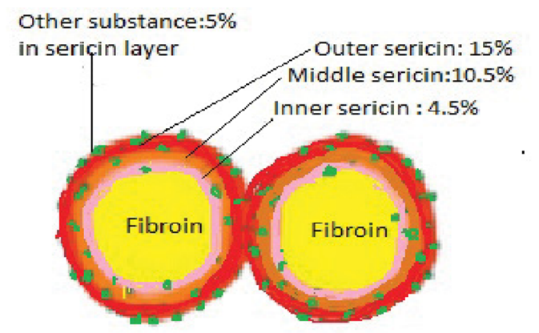

Picture 2 : Structure of silk fiber showing fibroin core surrounded by layered sericin

- Sericin A:
- It dissolves in water at a temperature of 60 ˚C, taking on a random coil structure, which corresponds to the outermost layer and features filaments aligned in the direction of the fiber.

- Sericin B:
- It exists within the middle layer and is soluble in water at a temperature of 60 ˚C; however, it exhibits filaments oriented in a cross direction to the fiber.

- Sericin C:
- It is the innermost layer that is in contact with SF; this layer exhibits longitudinal filaments and necessitates temperatures exceeding 83 ˚C for solubilization.

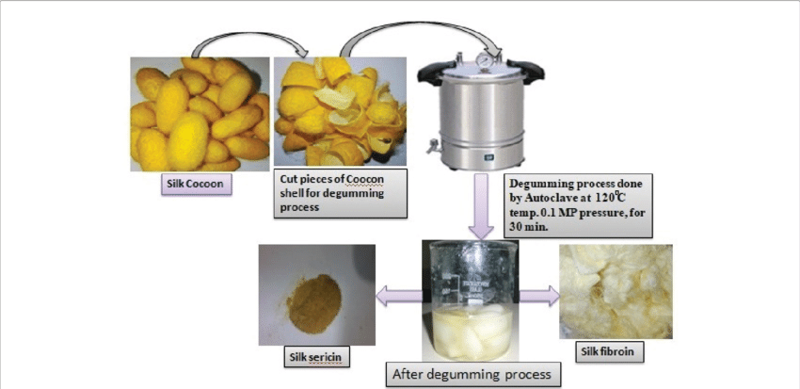
Picture 3 : Extraction process of sericin from silk cocoons

The silk cocoons are cut into segments for the degumming process, which is carried out using an autoclave at a temperature of 120 ˚C and a pressure of 0.1 MP for a duration of 30 minutes. Following the degumming process, silk sericin and silk fibroin are extracted. (Saha et al., 2019).
.
Table 1 : Different techniques for extraction of sericin from cocoon ( (Seo et al., 2023)
Sl. No | Extraction Technique | Raw material | Molecular weight
1 | Autoclave at 120 °C for 60min | Cocoon | 10–200 kDa
2 | 0.2% Na₂CO₃ solution heated at 95 °C for 120min | Cocoon | 6 and 67 kDa
3 | 1.25% citric acid solution heated for 30 min 0.2% Na₂CO₃ solution 8 M urea solution | Cocoon | 20–220 kDa 50–150 kDa
4 | Heating at 110 °C for 30min | Cocoon | 65 kDa
5 | Hot water at 80 °C and 120 °C | Cocoon | 20–400 kDa
6 | Distilled water and bromelain solution heated at 55 °C for 60 min | Cocoon | 10–250 kDa
7 | Autoclave at 120 °C for 30min Heated at 100 °C for 10min | Cocoon | 12–66 kDa
8 | Autoclave at 120 °C for 40min | Cocoon | 20–400 kDa

3. Fibroin and its characteristics

- The SF filaments that are spun exist in pairs, surrounded by SS, which presents a smooth triangular cross-section when examined under a microscope.
- A light (L) chain polypeptide and a heavy (H) chain polypeptide, when linked by a single disulphide bond at the C-terminus of the H-chain, form an H-L complex that constitutes silk fibroin.
- This intricate structure also associates with the glycoprotein P25 in a molar ratio of 6:6:1 through hydrophobic interactions, ultimately resulting in the formation of a primary micellar unit. These units facilitate the transport of significant quantities of fibroin through the lumen of the silk glands to the spinnerets prior to being spun into fibers.
- The H-chains organize themselves into β-sheets, which constitute the crystalline region of the fiber.
- It is primarily composed of glycine, alanine, serine, tyrosine, valine, aspartic acid, phenylalanine, glutamic acid, threonine, isoleucine, leucine, proline, arginine, lysine, and histidine.
- The chains are predominantly made up of glycine and alanine, along with various other amino acids. Naturally produced fibroin exhibits an exceptionally high tensile strength ranging from 300 to 700 MPa, in addition to possessing significant breaking strain and durability.
- Silk fibroin (SF) can be acquired in various morphologies following different treatments, including fibers, solutions, powders, films, and gels.
- SF is non-toxic and demonstrates excellent biocompatibility and degradability, making it extensively utilized in the food and medical industries.
- SF also provides remarkable physical properties, such as outstanding toughness and tensile strength (Lin et al., 2022).

Chart 1 : Silk fibroin manufacturing process

Silk fibroin was obtained from the cut cocoons of Bombyx mori.

The cocoons were immersed in an alkaline sodium carbonate solution to eliminate soluble sericin.

The insoluble fibroin was subsequently extracted from its container, rinsed with MilliQ water, and allowed to dry at room temperature.

The insoluble fibroin, often referred to as "degummed" fiber, was subsequently dissolved in a highly concentrated lithium bromide solution.
Uses of silk proteins in food industry

Other chaotropic salts, including calcium chloride, can also be utilized instead of lithium bromide.
The solubilized fibroin solution was then dialyzed in a water bath to remove the salt

The fibroin solution that had been solubilized was subsequently dialyzed in a water bath to eliminate the salt

The concentrations of silk fibroin solutions are established by utilizing standard solutions of bicinchoninic acid (BCA).

Silk fibroin demonstrates high solubility and stability in water at a concentration of 50 mg/mL across all tested timeframes and conditions in the protein assay involving silk fibroin.
Picture 4 : Structure of fibroin and sericin (Seo et al., 2023)
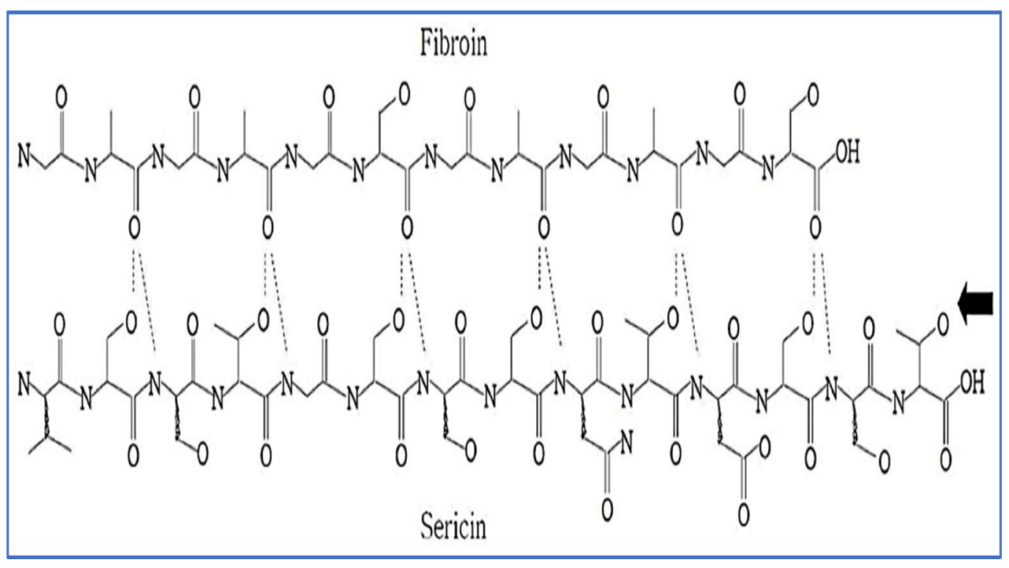

Picture 5 : Uses of silk proteins in food industry
2. Food packaging
1. Food coating material

Silk proteins

4. Food supplement
3. Food sensor

- Reports indicate that over 800 million individuals are experiencing starvation globally, with more than 40% of newly packaged food and locally sourced products being wasted.
- Given that 30% of food in retail environments remains uneaten, extending the shelf life of the global food supply at room temperature by merely one week would significantly benefit the agriculture and food manufacturing industries, while also substantially reducing the global waste stream.
- In response to the increasing concern regarding plastic pollution, natural food-packaging materials that are biodegradable have been identified as alternatives to synthetic polymers.
- Synthetic polymers, being non-biodegradable and nonrenewable, contribute to environmental pollution.
- The challenges posed by synthetic polymers can be mitigated through the use of biodegradable polymers.
- Moreover, in addition to their biodegradable characteristics, biopolymers possess other advantageous properties, including wide availability, renewability, and nontoxicity, and can be directly sourced from various natural materials.
- Consequently, research is being conducted on different types of biopolymers concerning their characterization, properties, and the advancement of biopolymers in food packaging utilizing raw materials such as proteins, lipids, and polysaccharides to substitute synthetic polymers. Among these, protein-based materials can provide environmental compatibility while also improving food quality and extending shelf life.
Limitations:
•In addition to its potential health benefits, sericin has certain limitations that render it unsuitable for application in the food industry.

•This limitation also extends to its use in food packaging, which is hindered by its weak mechanical properties due to the self-aggregation process of sericin, leading to insufficient mechanical strength.

•Furthermore, its hydrophilic characteristics make it unsuitable for environments with water, representing a significant drawback that limits its application across various industries.

•Additionally, the low solubility of powdered sericin in solvents and the unpleasant odor associated with silkworm chrysalises pose challenges to its unrestricted use in healthy and functional foods and additives.

•Given these factors, modifying sericin's properties to improve its water solubility and eliminate undesirable odors is a crucial objective for researchers.

•The application of Maillard reaction techniques to food-related proteins has been shown to effectively enhance the functional properties of food items, resulting in improved emulsifying and antioxidant capabilities.

•Moreover, some researchers have employed the glycation method to augment the use of sericin in functional foods.

•Additionally, the pupal odor of sericin can be specifically eliminated through glycation, replaced by a subtly sweet and mellow fragrance.

•Consequently, the glycation technique has demonstrated a range of application possibilities for sericin as a functional food, health food, or food additive, while also supporting the sustainable development of the silk industry.

•An allergic reaction to food occurs when the immune system identifies certain proteins in food as foreign and mounts a defense against them. Adverse reactions to these foods can be attributed to protein additives.

•It has been reported that sericin, as a natural biomaterial, is safe for biological systems, exhibiting low immunogenicity and eliciting minimal allergic responses.

- The food application of sericin has been reported in 56 patents and a few examples of the interesting applications of sericin in the food industries are as follows;

Table 2 : Patents related to the use of sericin in food and beverages, highlighting its applications in drinks, health foods, taste modification, and diabetic-friendly products
Patent No.
CN103126028A | A method for preparation of silkworm sericin drinks
JP2012217442 | Inhibitor of bitter or astringent taste for beverages or foods, using a casein phosphopeptide or sericin as an active ingredient
JP2000184868 | Food drinking water containing sericin and/or sericin hydrolysate
CN107080260 | Utilization of sericin peptide for making silk gum health food
JP2004269395 | A composition containing sericin with hypotensive action
CN105524762 | The use of sericin peptide for rehydrating the rose flower used for making rose-flavored wine
CN103918853A | Using sericin peptide as an ingredient for making a low-sugar probiotic dextrose candy that is suitable for consumption by diabetics

Silk Fibroin as Edible Coating for Perishable Food Preservation(Marelli et al., 2016)
- •Numerous perishable fruits and vegetables exhibit significant metabolic activity and are highly susceptible to microbial contamination, leading to a reduced shelf-life, fungal deterioration, color alteration, and undesirable flavors.
- •Up to now, various methods have been investigated to prolong the postharvest lifespan of fruits and vegetables (for instance, cryopreservation, application of synthetic chemical fungicides, modified atmosphere packaging, osmotic treatments, hypobaric and thermal treatments).
- •In this context, the development of an edible coating offers an alternative approach to enhance crop freshness by merging prolonged storage durations with ease of handling.
- Generally, food coatings ought to be mechanically durable matrices containing hydrophobic groups to ensure low permeability to oxygen and water vapor (i.e., regulating the respiration rate of fruits and maintaining firmness). They should also possess biocompatibility, biodegradability, antibacterial and antifungal properties, membrane-forming ability, and safety (i.e. edible and not allergenic) should also be compelling properties for an edible coating materials

Chart 2 : Method of strawberry dip coating

Strawberries underwent dip coating for 1, 2, and 4 times (referred to as D1, D2, and D4) in a 60mm deep silk suspension at a temperature of 4 °C, ensuring that the entire surface of the strawberries, including their calyx and epicalyx, was fully immersed in the suspension

The solubilized fibroin solution was then dialyzed in a water bath to remove the salt

The dipping process lasts for 10 seconds each, after which the strawberries were dried by suspending them from the peduncle for 4 hours at a temperature of 22 °C and a relative humidity of 38%.

Silk fibroin as a coating to manage strawberries’ postharvest physiology

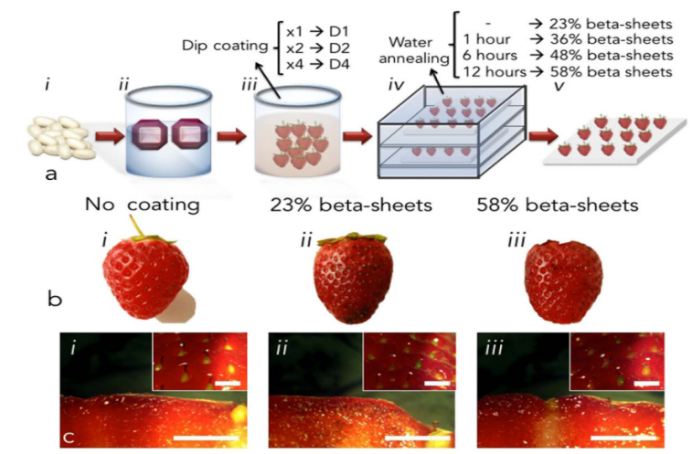
Fig. 1. Coating of perishable fruits with edible silk fibroin

In this research, Marelli and his colleagues documented the application of silk fibroin suspension as an edible coating material for the preservation of perishable fruits. Silk fibroin is typically regarded as flavorless and odorless, attributes that are advantageous for food coating and packaging purposes. A silk fibroin suspension was employed to coat freshly harvested strawberries using the dip coating method (Fig. 1a).

The thickness of silk fibroin coatings, which ranged from 27 to 35 μm, was not statistically significantly affected (p > 0.05) by the number of dip coating steps. In contrast, the post-process of water annealing had a substantial impact on the properties of the silk fibroin coatings, as it increased the relative content of beta-sheet structures from 23 ± 2% (for untreated coatings) to 58 ± 5% (for coatings subjected to water vapor for 12 hours). The influence of water annealing duration on the relative beta-sheet content of silk fibroin coatings was noted. No alterations in the microscopic morphology of silk fibroin materials subjected to water annealing were observed through scanning electron microscopy analysis. Crystal violet dye was employed to stain the silk fibroin coating. Representative macroscopic images of stained strawberries, both uncoated and coated with silk fibroin edible materials, displayed an increase in beta-sheet content are presented in Fig. 1b i, ii and iii, respectively.

The staining with crystal violet is hardly discernible on the surface of the coated strawberries (indicated by black dots) because of the coating's thickness, which is only a few microns. Furthermore, stereoscopic microscopy examining both the surface and the cross-section of the crystal violet-stained strawberries that were coated with silk fibroin materials revealed no alterations in the fruit's appearance when compared to the uncoated control (Fig. 1c).

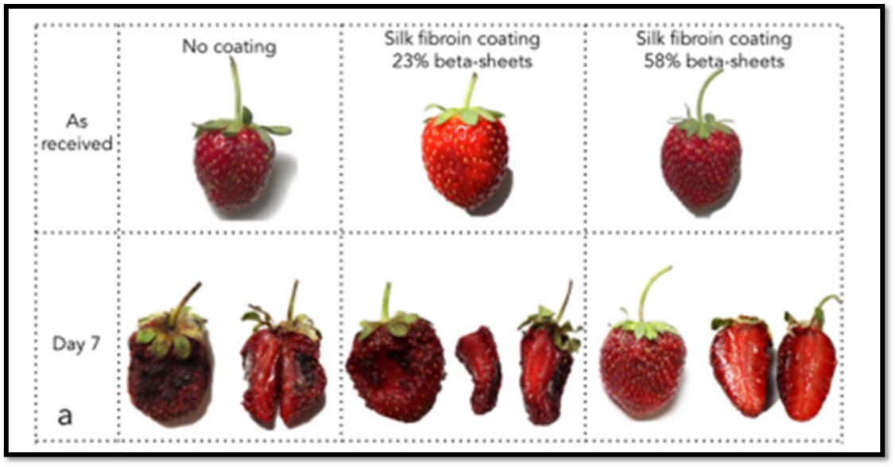

Fig. 2. Time-lapse of strawberries ripening

The effectiveness of silk fibroin edible coatings in regulating the postharvest physiology of strawberries was assessed based on the number of coating applications and the beta-sheet content of silk fibroin. The external and internal evaluations of the aging process of representative strawberries, in relation to the number of dip coating applications and the silk beta-sheet content, are illustrated in Fig. 2. An extended preservation of strawberry tissues was associated with an increase in the number of coating applications and a longer water annealing process (i.e., increased beta-sheet content). This was evidenced by a time-dependent decrease in shading from the original red color and alterations in the original morphology. Furthermore, a greater number of coating applications and elevated beta-sheet content likely contributed to the down-regulation of microbial growth, as indicated by a reduction in decay caused by fungi and mold. This was further corroborated by the examination of the time-dependent decay of the strawberries' flesh. An increased beta-sheet content in silk fibroin coatings was linked to improved preservation of the internal tissue of strawberries.

Silk fibroin as coating for climacteric fruits
Climacteric fruits, including apples, bananas, and tomatoes, undergo ripening through the production of ethylene and an increase in cellular respiration. The climacteric event is characterized by alterations in fruit color and the synthesis of sugars in the extracellular environment. To assess the effectiveness of a silk-based coating for climacteric fruits, the ripening process of bananas was analyzed by comparing silk-coated fruits with those that were not coated (Fig. 4). The fruits were stored at a temperature of 22 °C and a relative humidity of 38% (RH) in their original state (No coating) and after being coated with water-annealed silk fibroin materials (tWA= 12h, Silk fibroin coating). Throughout the entire experiment, bananas were suspended from their respective stems. Time-lapse photography of the ripening bananas demonstrated that the silk coating reduced the rate of ripening. The beta-sheet content of the silk fibroin used for coating the climacteric fruits did not influence the ripening process (data not shown). An examination of the firmness of silk-coated bananas indicated that the coating slowed down the ripening process compared to the uncoated control group at day 9 post-coating. Furthermore, a morphological analysis of the flesh of both non-coated and coated bananas at day 9 following the silk coating treatment showed that the application of the silk coating resulted in better preservation of the fruit. The flesh of non-coated bananas exhibited a brown coloration, whereas the silk-coated fruits maintained a tallow-like flesh, suggesting a reduced ripening rate in the silk-coated samples.
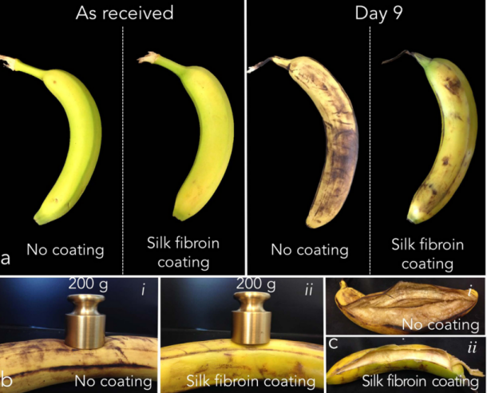
Fig. 3. Evaluation of bananas ripening with and without crystalline silk coating

Fruits were maintained at a temperature of 22 °C and a relative humidity of 38% as they were received (without any coating) and after being coated with silk fibroin materials. Throughout the entire experiment, bananas were suspended from their respective stems. (a) Time-lapse photography of the ripening process of bananas demonstrated that the silk fibroin coating reduced the rate of ripening. (b) An examination of the turgidity of silk fibroin-coated bananas (i) was conducted in comparison to uncoated controls. Turgidity was assessed qualitatively by applying a dead weight (200 g) to the surface of the fruit. (ii) This test was performed on day 9 following the application of the coating. The silk fibroin-coated bananas exhibited increased firmness when compared to the uncoated control. (c) Photographs of the internal flesh of non-coated (i) and silk fibroin-coated (ii) bananas were taken on day 9 after the coating treatment. The flesh of the non-coated banana displayed a brown coloration, whereas the silk fibroin-coated fruits maintained a pale flesh, indicating a reduced ripening rate for the silk fibroin-coated samples.

In conclusion, they have shown that silk fibroin serves as an effective, water-soluble coating that improves the freshness of perishable food items. The water-based processing and edible characteristics of this material render the method a promising alternative for preservation using a naturally sourced substance. Silk polymorphism can be utilized to customize the properties of the coating, influencing the interaction between silk fibroin, water evaporation, and food spoilage. The capacity to consume silk or enhance coatings with stable biomacromolecules further increases the practicality of functional coatings, which could be designed to impart therapeutic benefits to consumable products without the need for complex chemical processes, while simultaneously performing the preservation function.

Application of sericin‐based edible coating material for postharvest shelf‐life extension and preservation of tomatoes (Tarangini et al., 2022)

Throughout the duration of the study, measurements were taken at different time intervals for weight loss, fruit firmness, total soluble solids (TSS), titratable acidity (TA), pH, lycopene content, total phenolic content (TPC), total antioxidant capacity (TAC) using the DPPH assay, water vapor permeability (WVP), and respiration rate.

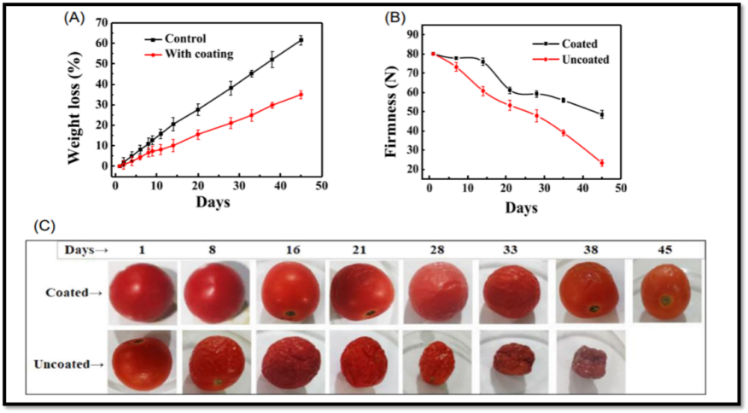
Fig. 4. The impact of sericin-based edible coating on (A) weight loss and (B) firmness over a storage period of 45 days at 25 °C is presented. Images of tomatoes, both coated and uncoated, are shown in (C)
In general, fruits tend to experience an increase in weight loss during storage. The primary mechanism behind weight loss in fresh fruits and vegetables is attributed to transpiration and respiration processes. The loss of water from fruits leads to weight reduction, which results in textural changes and surface shrinkage. This occurrence negatively impacts the shelf life of fruits and vegetables. Surface coatings can offer protection to fruits by minimizing the transpiration process. The sericin-based edible coating utilized in this study effectively decreased the weight loss rate in tomatoes. The weight loss observed in the tested tomatoes is illustrated in Fig. 5. The recorded weight loss was approximately 35% for the coated tomatoes, while it reached around 61% for the control samples, which were uncoated, after a storage period of 45 days. Typically, edible coating materials based on proteins and polysaccharides do not create efficient water-vapor barriers and may not significantly aid in reducing weight loss. However, the sericin-based coating examined in this study demonstrated a reduction in the weight loss rate, which can be ascribed to its hydrophobic properties.

The firmness of fruit is an important factor that influences its quality and acceptability. Figure 5B illustrates that the firmness of the fruit decreased over the storage period for both coated and uncoated tomatoes. Notably, a significant difference was observed in uncoated tomatoes after Day 14, with a consistent decline noted from Day 21 to Day 45. This decline may be attributed to the appearance of slight wrinkles on the tomatoes (Figure 5C) observed on Day 21 for the coated variety. In contrast, uncoated tomatoes experienced a pronounced and steady decrease in firmness, with the onset of wrinkles detected on Day 4 and complete wrinkling by Day 8 (Figure 5C). Additionally, at the conclusion of the 45-day storage period, coated tomatoes demonstrated an average firmness value of 49.9 N, whereas uncoated samples recorded a firmness of 24.52 N (Figure 5B). The primary reason for the loss of firmness in uncoated tomatoes is likely due to the disassembly of the primary cell wall and middle lamella. These processes are integral to the natural ripening of tomatoes, where increased water loss from the cuticle accelerates cell wall disassembly. With the application of a sericin-based edible coating, it can be concluded that the loss of firmness was significantly mitigated (Figure 5B), resulting in delayed ripening and better control of softness during storage under ambient conditions.
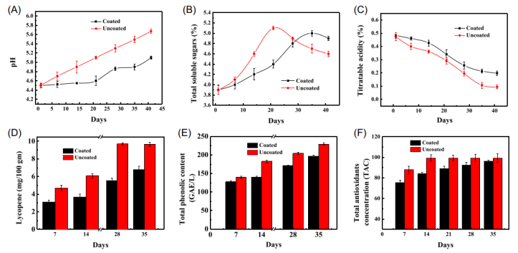
Fig. 5. The parameters monitored in tomatoes coated with a sericin-based edible coating at 25°C included (A) pH, (B) total soluble sugars (TSS), (C) titratable acidity (TA), (D) lycopene content, (E) total phenolic content (TPC), and (F) total antioxidants concentration (TAC). Uncoated fruits were used as the control.

The beneficial effects of sericin-based edible coating were consistently observed through the analysis of pH, total soluble solids (TSS), titratable acidity (TA), lycopene levels, total phenolic concentration (TPC), and the DPPH assay (Fig. 5A–F).

Eco-friendly prebiotic dessert featuring sericin derived from Bombyx mori L.(Matran et al., 2022)

The primary aim of this study was to create a low-energy, sustainable prebiotic dessert containing sericin, derived from B. mori, which is free from sugar and suitable for individuals seeking a healthy diet as well as those requiring foods for specific nutritional needs, such as diabetes, dysphagia, and inflammatory conditions.

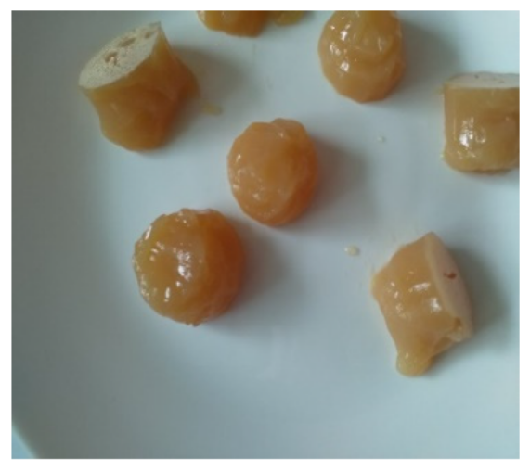

Fig. 6. The jellies prepared following recipe1, after being stored in the refrigerator for 8 hours.
- The jellies produced following recipe 4 are comparable to those derived from recipe 1

- The white layer present on the surface of some jellies signifies the foam that develops after the incorporation of lemon juice

- The sensory characteristics of the jellies obtained according to recipes 1 and 4 are:
appearance—gelatinous mass with a soft consistency, color—light brown, opalescent, smell/taste—pleasant, specific to apple juice. The opalescence is imparted by pectin.

It is concluded that a dietetic and sustainable dessert made with sericin derived from Bombyx mori can be certified as organic and is simple to prepare and consume, even for individuals with dysphagia or dental issues.The dessert is prebiotic, high in fiber, and low in caloric content. Given its health advantages, the effectiveness of the premix and the dessert (jelly) may be investigated preclinically in a prospective manner, for the management of diabetes, obesity, cholesterol reduction, cancer prevention, inflammatory skin conditions (such as atopic dermatitis and psoriasis), or any other chronic inflammatory ailment.

Effect of sericin coating on reducing browning of fresh-cut mango cv. ‘Nam Dok Mai No. 4
The occurrence of browning in fresh-cut produce is attributed to polyphenoloxidase (PPO; EC.1.10.3.1), peroxidase (POD; EC 1.11.1.7), and phenylalanine ammonialyase (PAL; E.C. 4.3.1.5), which are associated with discoloration (browning) as well as alterations in the texture and flavor of fruits (Vamos-Vigyazo 1981).PPO rapidly oxidizes o-diphenols into o-quinones, leading to the eventual production of browning pigments through a non-enzymatic pathway (Alberio et al., 2015).Various chemical antibrowning agents have been evaluated for their ability to inhibit PPO activity in fruits and vegetables. Among these, sulfites are recognized as one of the most potent inhibitors of browning (Chen et al., 2000); however, the U.S. Food and Drug Administration (FDA) has banned the use of sulfites for browning inhibition due to potential adverse health effects (Coetzer et al., 2001).Recently, there has been a growing interest in the application of natural antibrowning agents, including honey, aloe vera gel, pineapple juice, whey protein, seaweed extracts, and rice bran extracts (Chen et al., 2000; Valverde et al., 2005; Chaisakdanugull et al., 2007; Yi and Ding; 2014, Alberio et al., 2015; Augusto et al., 2016; Sukhonthara et al., 2016).

The FDA has officially added sericin protein and its derivatives to the "Generally Recognized as Safe - GRAS" list (Food and Drug Administration, 2001). This agent is primarily known for its antioxidant and antibrowning properties, which is why it has been suggested as a functional food. Nevertheless, the application of commercial foods containing this protein or any related products remains limited, with instances such as the incorporation of sericin in salad dressing (Takechi et al., 2011) and its use to reduce the specific volume and enhance the crust color of bread (Takechi and Takamura, 2014). The present study concentrated on the impact of sericin coating on minimizing browning in fresh-cut mango cv. ‘Nam Dok Mai No. 4’.

The study examined the impact of a sericin-based edible coating on the prevention of browning in fresh-cut ‘Nam Dok Mai No.4’ mangoes during storage.The mangoes were sliced both longitudinally and cross-sectionally, after which the fresh-cut pieces were immersed in either a sericin solution or distilled water (serving as the control). These samples were then placed in a rigid plastic container and stored at 10°C to promote browning.The findings indicated that the fruit samples coated with sericin exhibited lower browning scores, browning indices, and enzymatic browning activities in comparison to the control group. Additionally, the fresh-cut mangoes treated with the sericin solution displayed higher L* color values than those in the control group.The hue angle and chroma values of the samples that received sericin treatment remained stable, whereas the untreated mangoes experienced a gradual decline during storage. Furthermore, the sericin treatment resulted in a reduction of enzymatic browning activities associated with polyphenol oxidase, peroxidase, phenylalanine ammonia-lyase, as well as a decrease in phenolic content. Conversely, no significant differences were observed in firmness and ascorbic acid content between the treatment and control groups. The mangoes treated with sericin had a shelf life of 3 days, while the control group had a shelf life of only 1 day (Chimvaree et al., 2019).

Development of Bread Supplemented with the Silk Protein Sericin
Sericin possesses a distinctive amino acid profile. It has a notably high concentration of serine, ranging from 33% to 39%, while over 40% of sericin consists of hydroxyamino acids, including both serine and threonine. Consequently, sericin demonstrates significant hydrophilicity and water retention capabilities, along with a strong affinity for other proteins (Rainer, 1998). Furthermore, sericin is a resilient protein that is not easily broken down by proteases (Kato, 2012). In 1998, the Japanese Association for Dietary Fiber Research defined "food ingredients that are difficult to digest or absorb in the human small intestine and provide a physiological benefit that supports good health through the digestive system" as "luminacoids," referring to substances with various physiological characteristics. Among these substances, resistant protein (RP) is the sole protein component. RP not only has a well-recognized role as a nutrient (serving as essential amino acids or a nitrogen source) but also provides a physiological function that is beneficial for maintaining good health through the digestive tract due to its relatively low digestibility. Among its diverse physiological roles, sericin has been shown to alleviate constipation (Sasaki et al., 2000a), inhibit colorectal cancer (Sasaki et al., 2000b; Zhaorigetu et al., 2001; Zhaorigetu et al., 2007), reduce skin cancer (Zhaorigetu et al., 2003b), and exhibit cell-activating/cytoprotective properties (Terada et al., 2002; Terada et al., 2005; Ohnishi et al., 2012), as well as promote adiponectin levels (Okazaki et al., 2010). Additionally, supplements that provide physiological benefits have been effectively utilized in practice.

Although sericin has been proposed as a beneficial food component due to its diverse functionalities (Jin-hong et al., 2007), there have been limited studies thus far that have examined the effective incorporation of sericin into everyday foods. The aim was to develop bread enriched with sericin to encourage the efficient intake of the silk protein sericin and to assess the performance of bread baking with the addition of sericin, particularly regarding its impact on the structure and taste of the bread. The inclusion of sericin led to a reduction in specific volume and a darker crust color of the bread. Other physical characteristics did not show any significant differences. Sensory assessments indicated that bread containing up to 2 g of sericin was generally preferred. Through a thorough analysis of specific volume, crust color, and preference ratings from sensory evaluations, it was concluded that the ideal quantity of sericin to be added was 2 g. Additionally, it was found that approximately 330 mg of sericin can be consumed in a single slice of bread. Consequently, sericin-enriched bread is regarded as a favorable processed food that facilitates the effective consumption of sericin (Takechi et al., 2014).

Conclusion
Natural biomaterials such as proteins, lipids, resins, and polysaccharides are frequently utilized in the food industry for packaging purposes. Furthermore, silk proteins, including sericin and fibroin, are currently being investigated as materials for food coatings, packaging, functional foods, and food additives. Sericin possesses emulsifying and film-forming characteristics that can enhance the texture, stability, and shelf life of food items such as salad dressings, sauces, and confectioneries. On the other hand, fibroin, known for its remarkable mechanical and gas barrier properties, serves as a sustainable alternative to synthetic materials like plastic in food packaging. Therefore, these protein-based materials hold significant potential for commercial exploitation to address issues related to food quality and the shelf life of fruits and vegetables within the food industry.

DISCLAIMER (ARTIFICIAL INTELLIGENCE)
Author(s) hereby declare that NO generative AI technologies such as Large Language Models (ChatGPT, COPILOT, etc) and text-to-image generators have been used during writing or editing of this manuscript.

COMPETING INTERESTS
Authors have declared that no competing interests exist.

REFERENCES:
Alberio, G. R. A., Muratore, G., Licciardello, F., Giardina, G., & Spagna, G. (2015). Aloe vera extract as a promising treatment for the quality maintenance of minimally-processed table grapes. Food Sci. Technol. (Campinas), 35, 299–306.

Chen, L., Mehta, A., Berenbaum, M., Zangerl, A. R., & Engeseth, N. J. (2000). Honeys from different sources as inhibitors of enzymatic browning in fruit and vegetable homogenates. J. Agric. Food Chem, 10, 4997–5000.

Chimvaree, C., Aree, C. W., Supapvanich, S., Charoenratd, T., Tepsorne, P. R. & Boonyaritthongchai, P. (2019). Effect of sericin coating on reducing browning of fresh cut mango cv. ‘Nam Dok Mai No.4’. Agric. Nat. Resour., 53, 521-526.

Coetzer, C., Corsini, D., Love, S., Pavek, J., & Tumer, N. 2001. Control of enzymatic browning in potato (Solanum tuberosum L.) by sense and antisense RNA from tomato polyphenol oxidase. J. Agric. Food Chem, 49, 652–657.

Jin-hong, W., Zhang, W., & Shi-Ying, X. (2007). Preparation and characterization of sericin powder extracted from silk industry wastewater. Food Chem., 103, 1256-1262.

Kato, N. (2012). Nutritional studies of preventive food factors against diseases through functions in the intestine. Nippon Eiyo Shokuryo Gakkaishi., 65, 253-260.

Marelli, B., Brenckle, M. A., Kaplan, D. L. & Omenetto, F. G. (2016). Silk fibroin as edible coating for perishable food preservation. Sci. Rep., 6,1-11.

Matran, I. M., Matran, C., & Tarcea, M. (2022). Sustainable prebiotic dessert with sericin produced by Bombyx mori worms. Sustainability, 15(110), 1-12.

Ohnishi, K., Murakami, M., Morikawa, M., & Yamaguchi, A. (2012). Effect of the

silk protein sericin on cryopreserved rat islets. J. Hepatobiliary Pancreat. Sci., 19, 354-60.

Okazaki, Y., Kakehi, S., Xu, Y., Tsujimoto, K., Sasaki, M., Ogawa, H., & Kato, N. (2010). Consumption of sericin reduces serum lipids, ameliorates glucose tolerance and elevates serum adiponectin in rats fed a high-fat diet. Biosci. Biotechnol. Biochem., 74, 1534-1538.

Sasaki, M., Yamada, H., & Kato, N. (2000a). A resistant protein, sericin improves atropine-induced constipation in rats. Food Sci. Technol. Res., 6, 280-283.

Sasaki, M., Kato, N., Watanabe, H., & Yamada, H. (2000b). Silk protein, sericin, sup presses colon carcinogenesis induced by 1,2-dimethylhydrazine in mice. Oncol. Rep., 7, 1049-52.

Seo, S, J., Das, G., Shin, H. S., & Patra, J. K. (2023). Silk sericin protein materials: characteristics and applications in food-sector industries. Int. J. Mol. Sci., 24,1-27.

Tarangini, K., Kavi, P., & RAO, K. J. (2022). Application of sericin‐based edible coating material for postharvest shelf‐life extension and preservation of tomatoes. eFood, 14,1-12.

Takechi, T., & Takamura, H. (2014). Development of bread supplemented with the silk protein sericin. Food Sci. Technol. 20: 1021–1026.

Terada, S., Nishimura, T., Sasaki, M., Yamada, H., & Miki, M. (2002). Sericin, a protein derived from silkworms, accelerates the proliferation of several mammalian cell lines including a hybridoma. Cytotechnology, 40, 3-12.

Terada, S., Sasaki, M., Yanagihara, K., & Yamada, H. (2005). Preparation of silk protein sericin as mitogenic factor for better mammalian cell culture. J. Biosci. Bioeng., 100, 667-671.

Vamos-Vigyazo, L. (1981). Polyphenol oxidase and peroxidase in fruits and vegetables. CRC Crit. Rev. Food Sci. Nutr. 15, 49–127.

Zhaorigetu, S., Sasaki, M., Watanabe, H., & Kato, N. (2001). Supplemental silk protein, sericin, suppresses colon tumorigenesis in 1,2-dimethylhydrazine-treated mice by reducing oxidative stress and cell proliferation. Biosci. Biotechnol. Biochem., 65, 2181-2186.

Zhaorigetu, S., Yanaka, N., Sasaki, M., Watanabe, H., & Kato, N. (2003b). Silk protein, sericin, suppresses DMBA-TPA-induced mouse skin tumorigenesis by reducing oxidative stress, inflammatory responses and endogenous tumor promoter TNF-alpha. Oncol. Rep., 10, 537-43.

Zhaorigetu, S., Sasaki, M., and Kato, N. (2007). Consumption of sericin suppresses colon oxidative stress and aberrant crypt foci in 1,2-dimethylhydrazine-treated rats by colon undigested sericin. J. Nutr. Sci. Vitaminol., 53, 297-300.

Saha, J., Md. Ibrahim, H., Mondal, Md. Sheikh, R. K., & Md. Habib, A. (2019). Extraction, Structural and Functional Properties of Silk Sericin Biopolymer from Bombyx mori Silk Cocoon Waste. J Textile Sci Eng. 9(1),1-5.

