Systematic Review
Urinary and Blood microRNAs miR-21, miR-141, and miR-375 as Potential Diagnostic Biomarkers for Prostate Cancer: A Systematic Review and Meta-Analysis

ABSTRACT

Aims: To evaluate, compare, and accurately synthesize the diagnostic performance of circulating microRNAs miR-21, miR-141, and miR-375 as non-invasive biomarkers for prostate cancer, both individually and in combination, to determine their added value compared to conventional methods (PSA and biopsy) and to provide robust conclusions from heterogeneous literature data.
Background: Prostate cancer represents a major public health challenge, with diagnostic limitations related to prostate-specific antigen (PSA) testing. In response to these challenges, circulating microRNAs, particularly miR-21, miR-141, and miR-375, emerge as promising non-invasive biomarkers that could improve early prostate cancer detection.
Methods: A meta-analysis was conducted, and publications from January 2008 to April 2025 were selected from PubMed, Embase, ScienceDirect, and Scopus databases. Pooled measures of sensitivity, specificity, area under the ROC curve (AUC), likelihood ratios, and diagnostic odds ratios (DOR) were calculated using a bivariate random-effects model. A subgroup analysis was performed to explore sources of heterogeneity.
Results: A total of 25 eligible studies, with 27 datasets, comprising 2,697 participants (1,525 prostate cancer patients and 1,172 controls) were analyzed. miR-21 demonstrated the highest diagnostic performance, with pooled sensitivity and specificity of 0.87 and 0.86, respectively, and an AUC of 0.92. miR-141 showed slightly lower performance, with an AUC of 0.87. Although less robust, miR-375 still exhibited moderate diagnostic value, yielding an AUC of 0.88. The combination of all three miRNAs achieved an overall diagnostic accuracy of 0.82 for sensitivity and 0.86 for specificity, with an AUC of 0.91. Subgroup analyses revealed that whole blood performed best (AUC = 0.91), albeit with substantial heterogeneity (I² = 91.8%).
Conclusion: These findings highlight the strong potential of circulating miRNAs as promising diagnostic tools for prostate cancer, outperforming conventional PSA testing. However, standardized prospective studies remain necessary before clinical implementation can be recommended.

Keywords: Prostate cancer; microRNA; liquid biopsy; diagnosis; meta-analysis.

1. INTRODUCTION

Prostate cancer (PCa) is one of the most common malignancies in men, with marked geographical disparities in incidence and outcomes. In contrast, mortality rates are particularly high in the Caribbean and sub-Saharan Africa, highlighting disparities in access to screening and early treatment (Bray et al., 2024). When diagnosed at a localized stage, PCa demonstrates a five-year relative survival rate approaching 100%, underscoring the critical importance of early screening for improving both survival outcomes and quality of life (Bryzgunova et al., 2019).
Current screening primarily relies on digital rectal examination, ultrasonography, and most notably prostate-specific antigen (PSA) testing. Although widely adopted since the 1990s, PSA testing suffers from limited specificity (Daniyal et al., 2014). At the conventional 4 ng/mL threshold, its sensitivity drops to 20.5%, resulting in a high false-positive rate, an estimated 75% overdiagnosis rate, and frequent unnecessary invasive biopsies (Bill-Axelson et al., 2008; Nogueira et al., 2009). These procedures may lead to complications (pain, infections, hematuria) and significantly impact quality of life (Balázs et al., 2021; Rosario et al., 2012).
To develop more accurate and less invasive diagnostic approaches, research has focused on molecular biomarkers, particularly microRNAs (miRNAs). These small non-coding RNA molecules play a key role in post-transcriptional gene expression regulation and are involved in biological processes such as cell proliferation, apoptosis, and differentiation. Their abnormal expression is commonly observed in various cancers, including PCa (Di Leva et al., 2014).
miRNAs play a dual role in tumor development: oncogenic miRNAs (oncomiRs) and tumor-suppressor miRNAs (tsmiRs). OncomiRs promote cancer development by upregulating oncogene expression and/or downregulating tumor suppressor genes (Liu et al., 2013). miRNA expression profiling has revolutionized PCa diagnosis with improved specificity, as it provides insights into tumor lineage, cancer stage, and tumor grade (Lu et al., 2005).
miRNAs are detectable in biological fluids (blood, urine, saliva) in three distinct forms: as free circulating molecules, bound to protein complexes, or encapsulated within exosomes. These extracellular vesicles enhance miRNA stability, reinforcing their potential as liquid biopsy biomarkers. Furthermore, miRNA expression patterns appear to be cancer-type and stage-specific, providing added value for diagnostic stratification (Bilal et al., 2022).
However, despite their potential, findings regarding certain miRNAs remain inconsistent. Persistent challenges include the standardization of sampling methods, quantification procedures, and data normalization. Among the numerous miRNAs studied, miR-21, miR-141, and miR-375 have been most frequently identified as being dysregulated in PCa (Gao et al., 2016; Guan et al., 2016; Huang et al., 2015; Ibrahim et al., 2019; Joković et al., 2022; Kotb et al., 2014; Li et al., 2016; Nitusca et al., 2022b, 2022a; Osipov et al., 2016; Porzycki et al., 2018; Ye et al., 2020). Their variable expression patterns across different sample types and populations underscore the need for a critical synthesis of the scientific literature.
In this context, the present study conducts a systematic review and meta-analysis of available data on miR-21, miR-141, and miR-375 to evaluate their diagnostic performance in prostate cancer both individually and in combination across different biological fluids. The objective was to assess the added value of these miRNAs as non-invasive biomarkers compared to conventional diagnostic approaches, particularly PSA testing and biopsy.

2. Methodology

This meta-analysis was conducted in accordance with the PRISMA (Preferred Reporting Items for Systematic Reviews and Meta-Analyses) guidelines (Page et al., 2021).
To avoid duplication, we first verified the existence of similar systematic reviews and meta-analyses by searching the Cochrane Library and the PROSPERO registry. As our protocol was not prospectively registered in PROSPERO, this step also ensured transparency in the research process.

2.1 Search Strategy
A systematic literature search was conducted in PubMed, ScienceDirect, Embase, and Scopus for articles published between January 1, 2008, and April 30, 2025. The search strategy combined Medical Subject Headings (MeSH) terms and keywords: "microRNA" OR "miRNA" OR "miR" OR "hsa-miR"; "circulating" OR "plasma" OR "exosomes" OR "serum" OR "urine"; Disease terms: "prostate cancer" OR "prostate carcinoma"; Diagnostic parameters: "diagnosis" OR "sensitivity" OR "specificity".

2.2. Eligibility criteria
This meta-analysis included studies involving patients with prostate cancer (PCa) that met the following criteria:
- Population: Studies involving patients diagnosed with prostate cancer (PCa), with diagnosis confirmed by prostate biopsy (reference standard).
- Index test: Evaluation of circulating microRNAs miR-21, miR-141, and miR-375 using quantitative real-time PCR (qRT-PCR) from biological fluids (serum, plasma, urine), exosomes, or whole blood cells.
- Comparator: Studies including control groups composed of healthy individuals or patients with benign prostatic hyperplasia (BPH) (case–control design).
- Reference standard: Histopathological confirmation of PCa based on prostate biopsy, consistent with international urology guidelines (AFU, EAU, AUA, NCCN).
- Outcomes: Studies reporting sufficient data to construct 2×2 contingency tables (TP, FP, TN, FN) for diagnostic accuracy analysis with explicitly defined case criteria.
- Study types: Original, peer-reviewed articles published in English or French.

2.3. Exclusion Criteria

The following studies were excluded:
- Animal studies.
- Studies with insufficient data for calculating sensitivity and specificity.
- Redundant publications, including:
- Studies reporting data already described in other articles
- Systematic reviews and meta-analyses.
- Incomplete datasets.
- Studies with sample sizes <25 (to minimize bias in pooled analyses) (Beets et al., 2023).

2.4. Data Extraction Procedures

The following data were systematically extracted from the selected studies:
- Study identification: First author, publication year, country of participant recruitment.
- Study design: Sample type (serum, plasma, urine, exosomes, PBMCs), control group composition (healthy individuals or BPH patients), sample size.
- miRNA analysis: Investigated biomarker miRNAs (miR-21, miR-141, miR-375),
- Diagnostic performance metrics:
- Sensitivity (SEN) and specificity (SPE),
- Area under the curve (AUC),
- Contingency table data: true positives (TP), false positives (FP), false negatives (FN), true negatives (TN).

2.5. Assessment of Methodological Quality

The methodological quality of included studies was assessed using the QUADAS-2 tool (Quality Assessment of Diagnostic Accuracy Studies) (Whiting et al., 2011) through Cochrane's Review Manager software version 5.4.1 (review file format .rm5) (RevMan, 2024). The QUADAS-2 evaluation covered four key domains: patient selection, the index test, the reference standard, and flow/timing, which collectively determine risk of bias. The first three domains were additionally used to assess review applicability. Studies were classified as having low risk of bias when all signaling questions received "yes" responses, while any "no" response indicated potential bias. An "unclear" risk designation was applied when insufficient or ambiguously reported data prevented definitive judgment, ensuring appropriate methodological appraisal. The first three domains (selection, index test, reference standard) were additionally used to evaluate review applicability.

2.6. Statistical Analyses
Current diagnostic guidelines for prostate cancer, as established by leading professional societies including the French Association of Urology (AFU), European Association of Urology (EAU), American Urological Association (AUA), and National Comprehensive Cancer Network (NCCN) define a prostate cancer case based on the following diagnostic tests: prostate-specific antigen (PSA) levels, digital rectal examination (DRE), free/total PSA ratio, multiparametric magnetic resonance imaging (mpMRI), and biopsy with Gleason score and ISUP grade classification (Merriel et al., 2019; Poppel et al., 2021; Wei et al., 2023).
We evaluated the diagnostic performance of prostate cancer biomarkers miR-21, miR-141, and miR-375 using the tests (PSA, DRE, free/total PSA ratio, mpMRI, and biopsy) as the reference standard.
Multiple miRNA quantification techniques were examined across biological fluids (serum, plasma, urine). RT-qPCR emerged as the most suitable method for miRNA analysis, valued for its sensitivity, specificity, and applicability in targeted clinical assays. While NGS sequencing and microarrays provide comprehensive miRNA profiling, digital droplet PCR (ddPCR) enables absolute quantification particularly advantageous for low-abundance biomarkers. The selection of analytical methodology directly influences result robustness and must be carefully considered when interpreting data for meta-analytic synthesis (Moldovan et al., 2014).
All statistical analyses were performed using Stata version 17.0 (StataCorp, College Station, Texas, USA) with the metandi, meta, and midas commands. Study outcomes were extracted into 2×2 contingency tables (true positives, false positives, true negatives, false negatives). We employed a random-effects model to calculate pooled positive and negative likelihood ratios (LR+ and LR-, respectively) with corresponding 95% confidence intervals. Here, LR+ indicates the probability of a positive test result in patients with PCa, while LR- reflects this probability in disease-free individuals (Nitusca et al., 2022a). Between-study heterogeneity was assessed using Cochrane's Q test and quantified via the I² statistic (Higgins & Thompson, 2002). Heterogeneity levels were categorized as: very low (I² < 25%), low (I² = 25-50%), moderate-to-high (I² = 50-75%), very high (I² > 75%).
Pooled sensitivity (SEN) and specificity (SPE), diagnostic odds ratio (DOR), and the area under the summary receiver operating characteristic curve (SROC-AUC) with 95% confidence intervals were estimated using a bivariate mixed-effects binomial model (Reitsma et al., 2005). This model enables simultaneous analysis of SEN and SPE while accounting for their inherent correlation and between-study variability, making it particularly suitable for diagnostic accuracy meta-analyses. Higher AUC values indicate superior discrimination between high-risk and low-risk patients. Diagnostic performance was categorized into three tiers based on AUC values: low accuracy (AUC < 0.70), moderate accuracy (AUC = 0.70–0.90), high accuracy (AUC = 0.90–1.00).
The diagnostic odds ratio (DOR) serves as a comprehensive metric of test performance, incorporating both sensitivity (SEN) and specificity (SPE). A DOR of 1 indicates no diagnostic value, reflecting the test's inability to discriminate between affected and unaffected patients. Values between 1 and 10 suggest limited discriminatory capacity, while DOR >10 demonstrates moderate-to-high diagnostic utility with more reliable differentiation between positive and negative cases. Specifically, DOR >20 indicates good diagnostic performance and DOR >100, reflects excellent accuracy. Notably, DOR interpretation must consider clinical context and disease prevalence, as these factors significantly influence its clinical applicability (Reitsma et al., 2005). To investigate potential sources of heterogeneity, we performed subgroup analyses. Publication bias was assessed using Deeks' funnel plot asymmetry test (Deeks et al., 2005). Additionally, Fagan's nomogram was employed to quantify post-test probability (Fagan, 1975).
3. results

3.1. Documentary research and study characteristics
The initial database search identified 2,427 articles. Following duplicate removal and title/abstract screening, 127 articles were selected for full-text assessment. Of these, 37 articles qualified for qualitative analysis. Among the 90 excluded studies: 24 were reviews/meta-analyses, 41 involved animal/cell line research, and 25 lacked sufficient diagnostic accuracy data. After full-text evaluation, 12 additional articles were excluded from quantitative meta-analysis due to insufficient data for calculating true positives (TP), false positives (FP), true negatives (TN), and false negatives (FN). The final analysis included 25 articles encompassing 27 studies (two articles investigated two distinct populations). The PRISMA flowchart (Fig. 1) details the selection process, while Table 1 summarizes: Key study characteristics, contingency data (TP, FP, FN, TN), corresponding sensitivity (SEN) and specificity (SPE) values.
The 27 included studies comprised a total of 2,697 participants (1,525 PCa patients and 1,172 controls). The number of studies evaluating miR-21, miR-141, and miR-375 were 12, 12, and 11, respectively.
Most studies reported significantly higher expression levels of miR-21, miR-141, and miR-375 in PCa patients compared to controls. These miRNAs were primarily analyzed in urine, plasma, peripheral blood mononuclear cells (PBMCs), and serum samples from both PCa patients and control groups. The studies investigating these miRNAs were published between 2008 and 2025.

Fig. 1. PRISMA diagram for study selection.
PRISMA (Preferred Reporting Items for Systematic Reviews and Meta-Analyses).

Table 1. Characteristics of included studies

Author Year | Country | Control group | Case size | Control size | Sample | Diagnosis Method | Biomarker (test index) | SEN (%) | SPE (%) | TP | FP | TN | FN | AUC
Nobrega et al., 2025 | Brazil | HP | 30 | 15 | Plasma | RT-qPCR | miR-21 | 78.00 | 64.00 | 23 | 5 | 10 | 7 | 0.74
Gunawan et al., 2023 | Indonesia | BPH | 20 | 20 | Urinary (exosomes) | RT-qPCR | miR-21 | 100 | 75.00 | 20 | 5 | 15 | 0 | U
Giglio et al., 2021 | Italiy | BPH | 45 | 65 | Plasma | ddPCR | miR-21 | U | U | U | U | U | U | 0.68
Kim et al., 2021 | Korea | BPH | 38 | 8 | Plasma (exsosomes) | RT-qPCR | MiR-21 | U | U | U | U | U | U | 0.64
Ciszkowicz et al., 2020 | Poland | BPH | 40 | 62 | Serum | RT-qPCR | miR-21 | 50.00 | 92.00 | 20 | 5 | 57 | 20 | 0.75
Ghorbanmehr et al., 2019 | Iran | BPH; HP | 23 | 42 | Urine | RT-qPCR | miR-21 | 81.00 | 88.00 | 19 | 5 | 37 | 4 | 0.76
Ibrahim et al., 2019 | Egypt | BPH; HP | 50 | 80 | Plasma | RT-qPCR | miR-21 | 95.50 | 90.00 | 48 | 8 | 72 | 2 | 0.96
Porzycki et al., 2018 | Poland | HP | 20 | 8 | Serum | RT-qPCR | miR-21 | 90.00 | 75.00 | 18 | 2 | 6 | 2 | 0.86
Endzeliņš et al., 2017 | Latvia | BPH | 50 | 22 | Plasma (exsosomes) | RT-qPCR | MiR-21 | U | U | U | U | U | U | 0.67
Foj et al., 2017 | Spain | HP | 60 | 10 | Urine (exosomes) | RT-qPCR | MiR-21 | U | U | U | U | U | U | 0.71
Stuopelytė et al., 2016 | Lithuania | BPH | 143 | 23 | Urine | RT-qPCR | miR-21 | 47.83 | 76.22 | 68 | 5 | 18 | 75 | 0.63
Yang et al., 2016 | China | BPH | 92 | 85 | Whole blood | RT-qPCR | miR-21 | 93.50 | 92.90 | 86 | 6 | 79 | 6 | 0.97
Yang et al., 2016 | China | HP | 92 | 97 | Whole blood | RT-qPCR | miR-21 | 94.60 | 92.80 | 87 | 7 | 90 | 5 | 0.98
Gao et al., 2016 | China | BPH | 57 | 28 | Plasma | RT-qPCR | miR-21 | 87.70 | 75.00 | 50 | 7 | 21 | 7 | 0.80
Huang et al., 2015 | China | HP | 75 | 75 | Whole blood | RT-qPCR | miR-21 | 87.50 | 85.70 | 66 | 11 | 64 | 9 | 0.83
Emamvirdizadeh et al., 2015 | Iran | HP | 70 | 30 | Urine | RT-qPCR | miR-21 | 64.29 | 100 | 45 | 0 | 30 | 25 | 0.64
Kotb et al., 2014 | Egypt | BPH | 10 | 10 | Serum | RT-qPCR | miR-21 | 90 | 90 | 9 | 1 | 9 | 1 | U
Yaman Agaoglu et al., 2011 | Turkey | HP | 51 | 20 | Plasma | RT-qPCR | MiR-21 | U | U | U | U | U | U | 0.88
Canatan et al., 2022 | Georgia | HP | 20 | 20 | Plasma | RT-qPCR | miR-141 | 100 | 83.30 | 20 | 3 | 0 | 17 | 0.92
Zabegina et al., 2021 | Russia | HP | 55 | 30 | Plasma | RT-qPCR | MiR-141 | 74.55 | 60.00 | 41 | 12 | 18 | 14 | 0.64
Kim et al., 2021 | Korea | BPH | 38 | 8 | Plasma (exsosomes) | RT-qPCR | MiR-141 | U | U | U | U | U | U | 0.52
Ciszkowicz et al., 2020 | Poland | BPH | 40 | 62 | Serum | RT-qPCR | miR-141 | 92.00 | 66.00 | 37 | 21 | 41 | 3 | 0.85
Jin et al., 2020 | China | BPH | 31 | 31 | Plasma | RT-qPCR | miR-141 | U | U | U | U | U | U | 0.89
Ghorbanmehr et al., 2019 | Iran | BPH; HP | 23 | 42 | Urine | RT-qPCR | miR-141 | 81.00 | 86.00 | 19 | 6 | 36 | 4 | 0.85
Ali et al., 2018 | Egypt | HP | 30 | 30 | Serum | RT-qPCR | miR-141 | 93.33 | 80.00 | 28 | 6 | 24 | 2 | 0.91
Guo et al., 2018 | China | HP | 72 | 34 | Serum | RT-qPCR | miR-141 | 87.50 | 100 | 63 | 0 | 34 | 9 | 0.93
Porzycki et al., 2018 | Poland | HP | 20 | 8 | Serum | RT-qPCR | miR-141 | 65.00 | 88.00 | 13 | 1 | 7 | 7 | 0.83
Li et al., 2016 | China | HP | 51 | 40 | Serum (exsosomes) | RT-qPCR | miR-141 | 80.00 | 70.97 | 41 | 12 | 28 | 10 | 0.87
Osipov et al., 2016) | Russia | HP | 48 | 47 | Plasma | RT-qPCR | miR-141 | 56.25 | 100 | 27 | 0 | 47 | 21 | 0.80
Kachakova et al., 2015 | Bulgaria | BPH | 56 | 12 | Plasma | RT-qPCR | miR-141 | 50.00 | 71.20 | 28 | 3 | 9 | 28 | 0.51
Kelly et al., 2015 | Irland | BPH | 75 | 27 | Whole blood | RT-qPCR | miR-141 | 94.00 | 73.00 | 70 | 7 | 20 | 5 | 0.65
Cheng et al., 2013 | United States | HP | 25 | 25 | Serum | RT-qPCR | miR-141 | U | U | U | U | U | U | 0.90
Yaman Agaoglu et al., 2011 | Turkey | HP | 51 | 20 | Plasma | RT-qPCR | MiR-141 | U | U | U | U | U | U | 0.56
Mitchell et al., 2008 | United States | HP | 25 | 25 | Serum | RT-qPCR | miR-141 | 60.00 | 100 | 15 | 0 | 25 | 10 | 0.91
Nobrega et al., 2025 | Brazil | HP | 30 | 15 | Plasma | RT-qPCR | MiR-375 | 61.00 | 93.00 | 18 | 1 | 14 | 12 | 0.82
Abramovic et al., 2021 | Croatie | BPH | 65 | 58 | Plasma | ddPCR | miR-375 | 40.00 | 80.70 | 26 | 11 | 47 | 39 | 0.62
Li et al., 2021 | China | HP | 49 | 25 | Urine (exosomes) | RT-qPCR | MiR-375 | U | U | U | U | U | U | 0.79
Li et al., 2021 | China | BPH | 49 | 29 | Urine (exosomes) | RT-qPCR | MiR-375 | U | U | U | U | U | U | 0.70
Ciszkowicz et al., 2020 | Poland | BPH | 40 | 62 | Serum | RT-qPCR | miR-375 | 73.00 | 90.00 | 29 | 6 | 56 | 11 | 0.78
Jin et al., 2020 | China | BPH | 31 | 31 | Plasma | RT-qPCR | miR-375 | U | U | U | U | U | U | 0.88
Mowayeiz et al., 2019 | Iraq | BPH | 70 | 70 | Whole blood | RT-qPCR | miR-375 | 96.00 | 94.00 | 67 | 4 | 66 | 3 | 0.96
Dülgeroğlu & Eroğlu, 2019 | Turkey | BPH; HP | 33 | 35 | Serum | RT-qPCR | miR-375 | 76.00 | 74.00 | 25 | 9 | 26 | 8 | 0.78
Bidarra et al., 2019 | Portugal | HP | 252 | 52 | Plasma | RT-qPCR | miR-375 | U | U | U | U | U | U | U
Porzycki et al., 2018 | Poland | HP | 20 | 8 | Serum | RT-qPCR | miR-375 | 100 | 75.00 | 20 | 2 | 6 | 0 | 0.91
Endzeliņš et al., 2017 | Latvia | BPH | 50 | 22 | Plasma (exsosomes) | RT-qPCR | MiR-375 | U | U | U | U | U | U | 0.68
Foj et al., 2017 | Spain | HP | 60 | 10 | Urine (exosomes) | RT-qPCR | MiR-375 | U | U | U | U | U | U | 0.80
Gao et al., 2016 | China | BPH | 57 | 28 | Plasma | RT-qPCR | miR-375 | 75.40 | 75.00 | 43 | 7 | 21 | 17 | 0.76
Stuopelyte et al., 2016 | Lithuania | BPH | 143 | 85 | Urine | RT-qPCR | miR-375 | 94.00 | 39.00 | 135 | 52 | 33 | 8 | 0.68
Stuopelyte et al., 2016 | Lithuania | BPH | 72 | 85 | Urine | RT-qPCR | miR-375 | 58.00 | 92.00 | 42 | 7 | 78 | 30 | 0.80
Kachakova et al., 2015 | Bulgaria | BPH | 59 | 16 | Plasma | RT-qPCR | miR-375 | 81.30 | 72.90 | 48 | 4 | 12 | 11 | 0.81
Haldrup et al., 2014 | Denmark | BPH | 31 | 13 | Serum | RT-qPCR | miR-375 | 23.00 | 100 | 7 | 0 | 13 | 24 | 0.65
Cheng et al., 2013 | United States | HP | 25 | 25 | Serum | RT-qPCR | miR-375 | U | U | U | U | U | U | 0.77
*Abbreviations: U: Unspecified; BPH: patients with Benign Prostate Disease; HP: Healthy People; TP: True Positive; FP: False Positive; FN: False Negative; TN: True Negative; SEN: Sensitivity; SPE: Specificity.

3.2. Methodological Quality Assessment

Study quality was evaluated using the QUADAS-2 tool (Fig. 2A), with individual study risk of bias presented in Fig. 2B. The QUADAS-2 assessment demonstrated: low risk of bias in >80% of studies for reference standard and flow/timing domains; minimal applicability concerns (<15% of studies) across all evaluation domains (Fig. 2A-B).
No studies were excluded based on QUADAS-2 results to maintain comprehensive evidence synthesis.
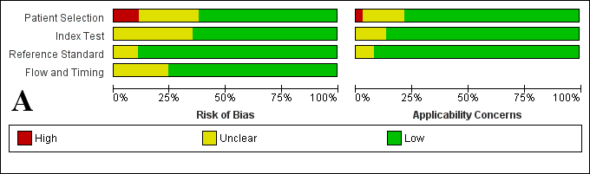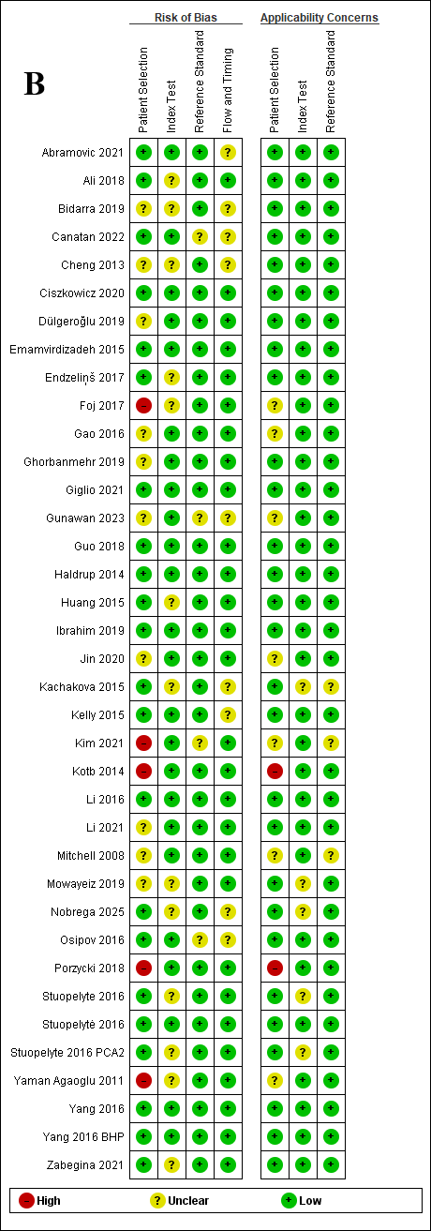

Fig. 2. QUADAS assessment for eligible studies
(A) Risk of bias and applicability concerns summary. (B) Risk of bias and applicability concerns each included study.
3.3. Diagnostic Performance of Circulating miRNA Profiling (miR-21, miR-141, and miR-375) in Prostate Cancer

3.3.1. Diagnostic Value of miR-21 for Prostate Cancer

The meta-analysis of sensitivity and specificity estimates from twelve eligible studies investigating miR-21 (n=1,277 participants) revealed significant heterogeneity (I²=94.38% for sensitivity, I²=64.62% for specificity, P<.001), as shown in Fig. 3A. The forest plot of paired ROC curves is presented in the same figure. Overall analysis yielded a pooled sensitivity of 0.87 (95% CI: 0.76-0.94) and specificity of 0.86 (95% CI: 0.80-0.91), with an area under the ROC curve (AUC) of 0.92 (95% CI: 0.90-0.94) (Fig. 4A), indicating high diagnostic performance for miR-21 in prostate cancer detection.
Based on the pooled estimates, the following likelihood ratios were calculated: a positive likelihood ratio (LR+) of 6.4 (95% CI: 4.3–9.6) and negative likelihood ratio (LR−) of 0.15 (95% CI: 0.08–0.29), yielding a diagnostic odds ratio (DOR) of 43 (95% CI: 19–100). Assuming a pre-test probability (prevalence) of 25%, the post-test probability of prostate cancer following a positive test result increased to approximately 68% (red line), while it decreased to about 5% following a negative test result (blue line) (Fig. 5A).

3.3.2. Diagnostic Performance of miR-141 in Prostate Cancer

Twelve studies involving 892 participants were included in the miR-141 analysis. The pooled sensitivity and specificity were estimated at 0.78 (95% CI: 0.67-0.86) and 0.87 (95% CI: 0.67-0.95), respectively, with an area under the ROC curve (AUC) of 0.87 (95% CI: 0.84-0.90) (Fig. 4B), indicating moderate to good diagnostic performance. Heterogeneity analysis revealed substantial variability across studies for both sensitivity (I² = 86.03%, P < .001) and specificity (I² = 81.03%, P < .001) (Fig. 3B).
From the combined estimates, the pooled positive likelihood ratio (LR+) was 5.8 (95% CI: 2.1-15.9), while the negative likelihood ratio (LR-) was 0.25 (95% CI: 0.16-0.40), yielding a diagnostic odds ratio (DOR) of 23 (95% CI: 7-90). Assuming a pre-test probability of 25%, the post-test probability of prostate cancer following a positive test result increased to approximately 66% (red line), whereas a negative test result reduced the probability to about 8% (blue line) (Fig. 5B).

3.3.3. Diagnostic Performance of miR-375 in Prostate Cancer

Eleven studies involving 1,095 participants were included for miR-375 analysis. The combined estimates demonstrated a sensitivity of 0.76 (95% CI: 0.58-0.88) and specificity of 0.84 (95% CI: 0.73-0.92), with an area under the ROC curve (AUC) of 0.88 (95% CI: 0.85-0.90) (Fig. 4C), indicating moderate overall diagnostic accuracy. Considerable heterogeneity was observed for both sensitivity (I² = 93.73%, P < .001) and specificity (I² = 91.71%, P < .001) (Fig. 3C), suggesting substantial variability across the included studies.
The pooled positive and negative likelihood ratios (LR+ and LR-) were 4.8 (95% CI: 2.9-8.2) and 0.29 (95% CI: 0.18-0.51) respectively, yielding a diagnostic odds ratio (DOR) of 17 (95% CI: 8-38). Using a pre-test probability (prevalence) of 25%, the post-test probability of prostate cancer following a positive test result increased to approximately 62% (red line), while a negative test result reduced the probability to about 9% (blue line) (Fig. 5C).

3.3.4. Diagnostic Performance of Combined miR-21, miR-141, and miR-375

A meta-analysis of sensitivity and specificity estimates from all 27 eligible studies (n=2,697 participants) revealed significant between-study heterogeneity (I²=92.30% for sensitivity, I²=80.75% for specificity). ROC curve analysis for the three-miRNA panel demonstrated a pooled sensitivity of 0.82 (95% CI: 0.75-0.88) and specificity of 0.86 (95% CI: 0.81-0.90), with an AUC value of 0.91 (95% CI: 0.88-0.93; Fig. 4C), indicating good overall diagnostic accuracy for the combined miRNA signature.

3.4. Subgroup Analyses

We investigated potential sources of heterogeneity in the area under the ROC curve (AUC) through subgroup analyses stratified by sample type (serum, plasma, urine, whole blood) and control group composition (healthy men versus benign prostatic hyperplasia patients). These analyses identified these criteria as key heterogeneity factors in our meta-analysis.
Studies using plasma or whole blood showed marked variability (I² = 88.4% and 91.8%, respectively), contrasting with more homogeneous results from serum-based studies (I² = 51.0%). The inter-subgroup differences were statistically significant (P < .001), indicating that sample type substantially influences miRNA diagnostic performance, particularly regarding AUC values. Notably, miRNA diagnostic value was highest in whole blood (AUC = 0.91), followed by serum (AUC = 0.86), underscoring the importance of standardizing biological sampling protocols to enhance reproducibility and reliability in future research (Table 2).
Control group type (BPH versus healthy) emerged as another critical heterogeneity factor. Diagnostic performance showed significantly greater consistency with healthy controls (I² = 86.7%, P < .001) compared to BPH controls (I² = 92.4%, P < .001). While overall heterogeneity remained high (I² = 90.8%, P < .001), the subgroup stratification highlights the importance of control group selection for result robustness (Table 2).
This comprehensive analysis reveals that both sample matrix and control group selection substantially impact miRNA biomarker performance, with whole blood showing superior diagnostic potential despite its greater variability. These findings emphasize the need for standardized protocols in future translational studies to optimize the clinical utility of miRNA-based prostate cancer detection.

Table 2: Subgroup analyses by type of control and sample using AUC values (95% CI)

Category | subgroup | AUC (CI 95%) | Number of of studies | Heterogeneity  (I², P-value) | Heterogeneity between groups
Type of control | BPH | 0.77 (0.71–0.84) | 13 | 92.4%, P < .001 | P = .03
Type of control | HP | 0.86 (0.81–0.91) | 13 | 86.7%, P < .001 | P = .03
Type of control | Global | 0.81 (0.78–0.89) | 26 | 90.8%, P < .001
Type of sample | Plasma | 0.77 (0.69–0.85) | 8 | 88.4%, P < .001 | P < .001
Type of sample | Serum | 0.86 (0.83–0.90) | 8 | 51.0%, P = .021 | P < .001
Type of sample | Urine | 0.73 (0.66–0.80) | 5 | 65.4%, P =.013 | P < .001
Type of sample | Whole blood | 0.91 (0.86–0.98) | 5 | 91.8%, P < .001 | P < .001
Type of sample | Global | 0.81 (0.78–0.88) | 26 | 90.8%, P < .001

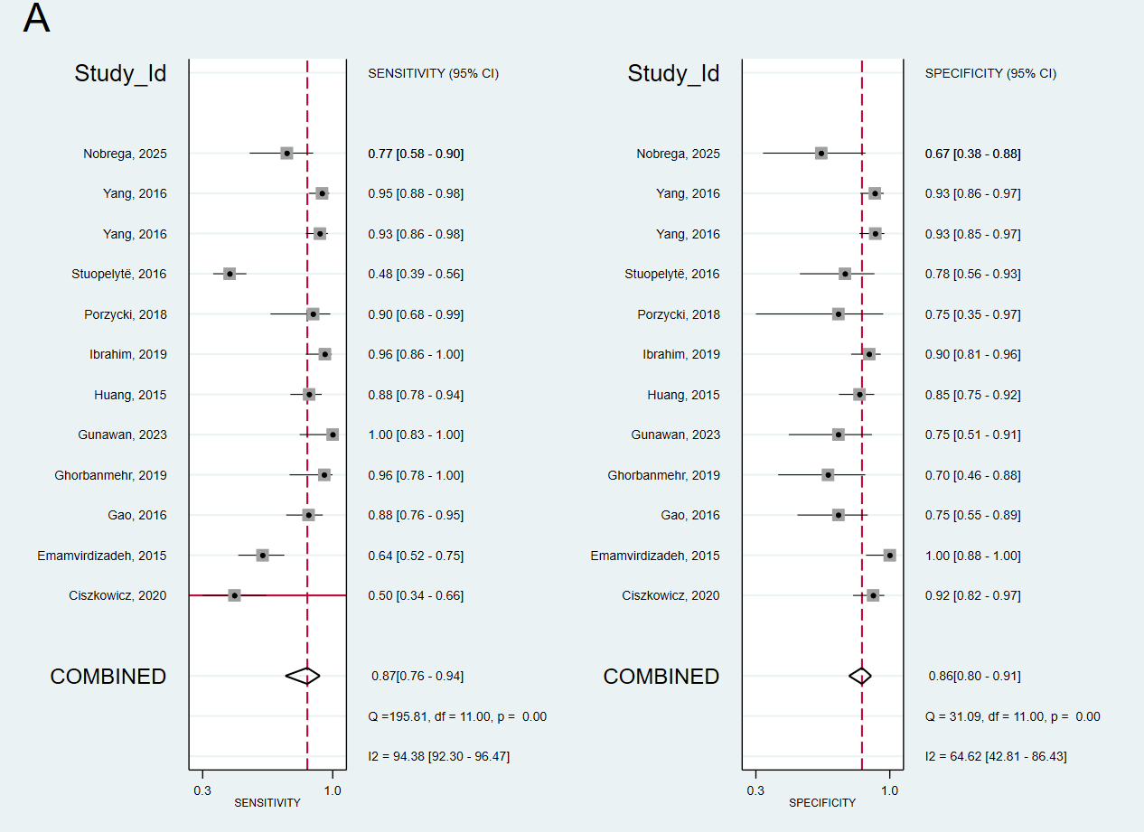

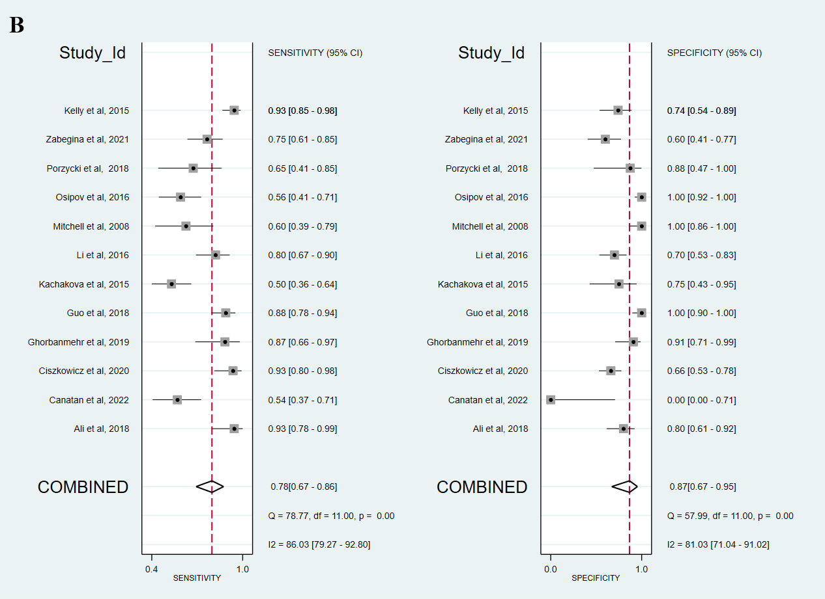
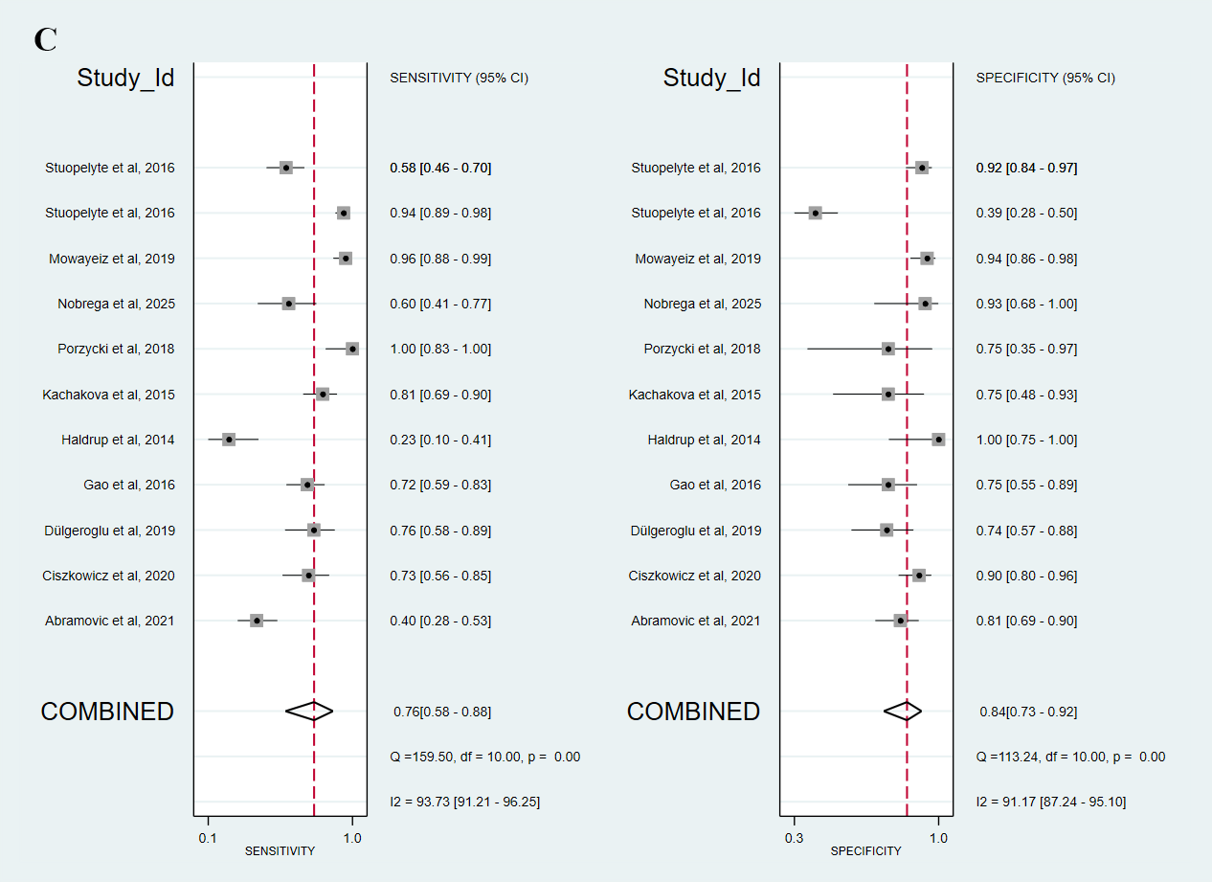

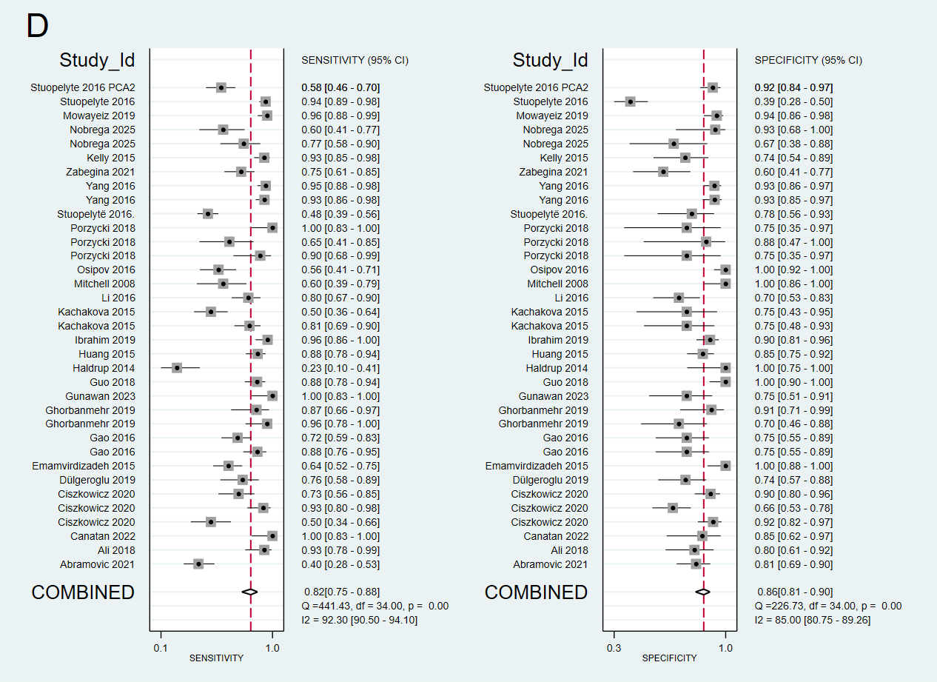

Fig. 3: Displays paired forest plots of sensitivity and specificity in discriminating against prostate cancer (PCa) patients from healthy/benign subjects.
(A) miR-21, (B) miR-141, (C) miR-375, (D) combined miR-21/miR-141/miR-375 panel The plots present diagnostic probabilities with 95% confidence intervals, where pooled sensitivity and specificity estimates are indicated by diamond symbols.
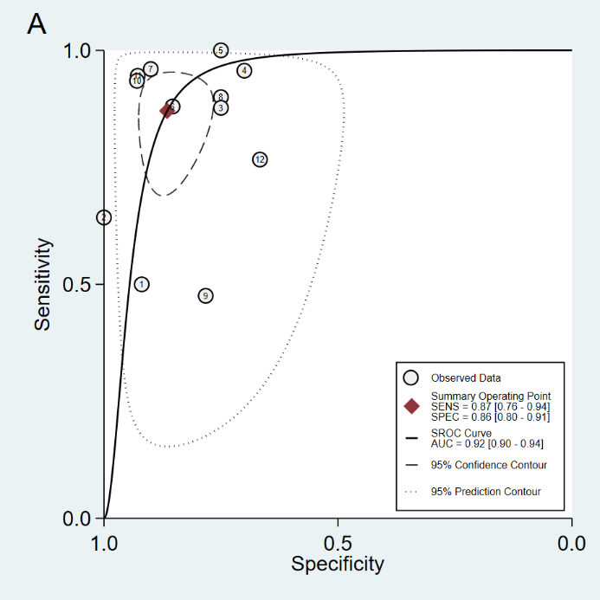

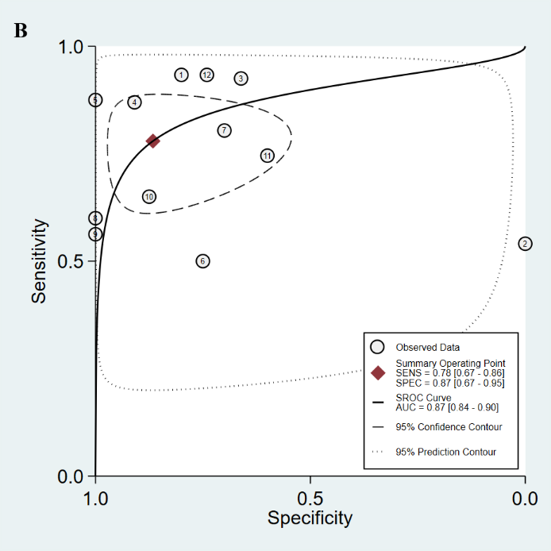

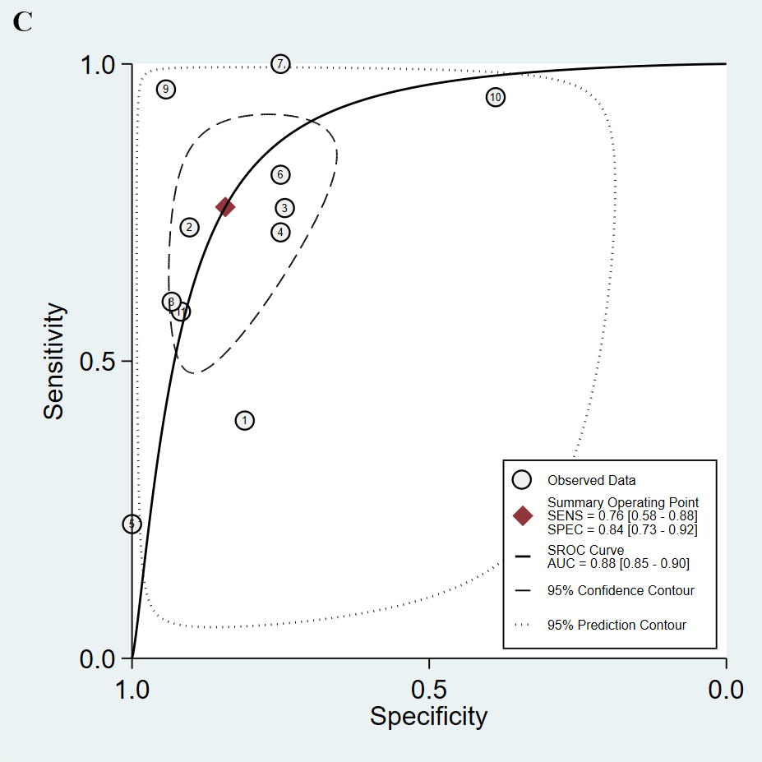

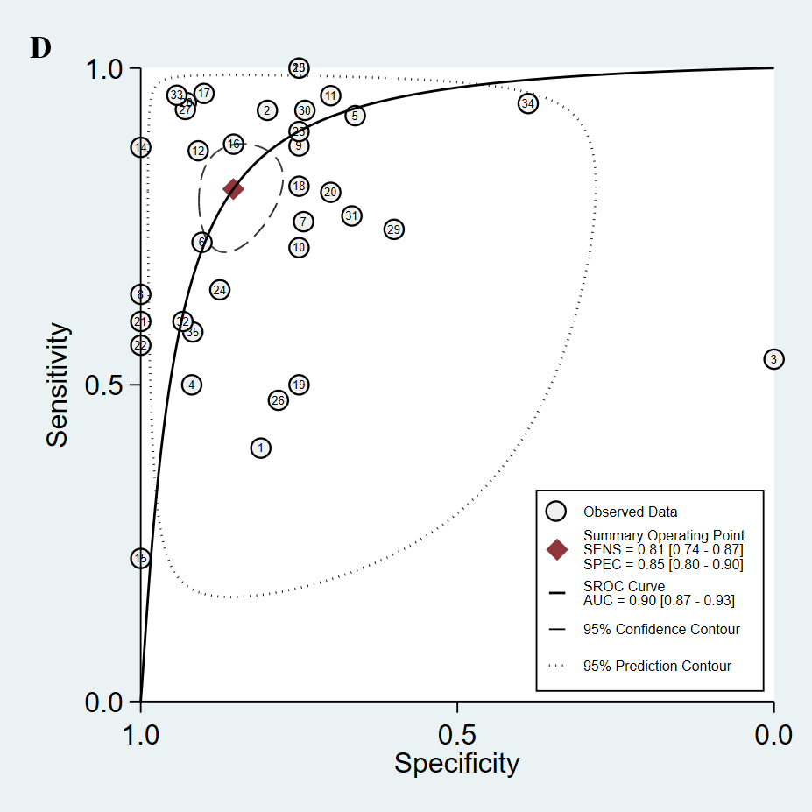

Fig. 4: Summary ROC curve with confidence and prediction regions around means operating sensitivity and specificity point.
Note: (A) miR-21, (B) miR-141, (C) miR-375 and (D) miR-21, miR-141 and miR-375 combinaison.
Abbreviations: AUC = area under curve; SROC = summary receiver- operating characteristic; SENS = sensitivity; SPEC = specificity.
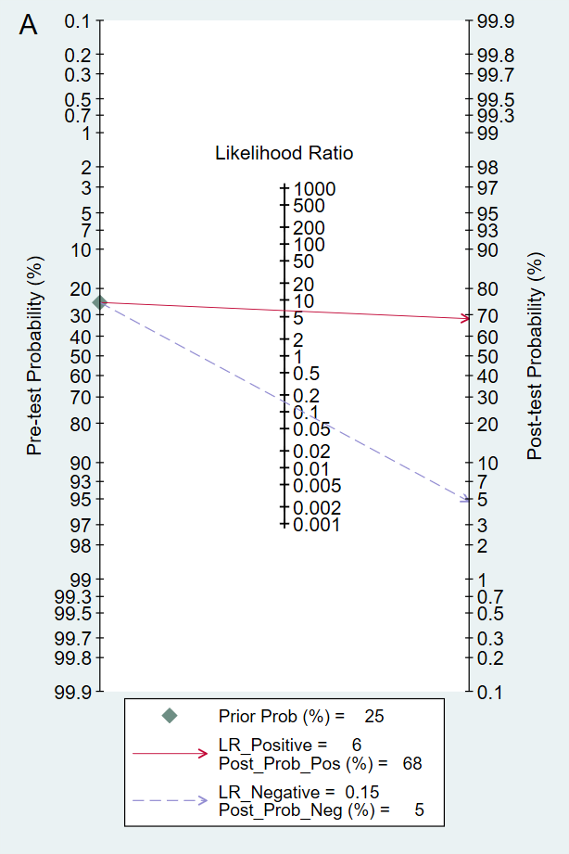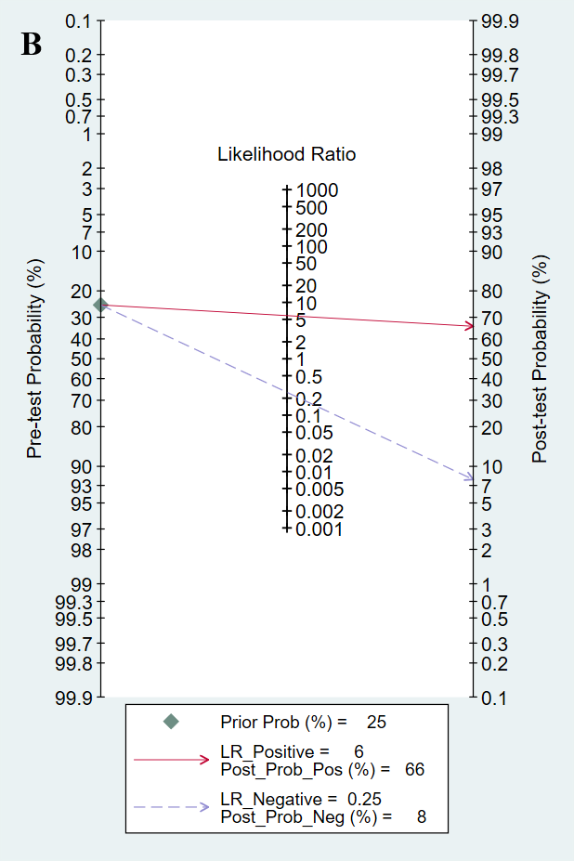

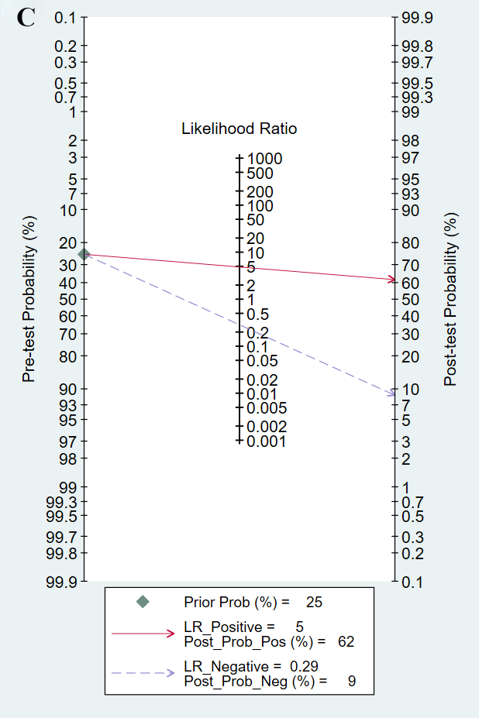

Fig. 5: Post-Test Probability Assessment Using Fagan's Nomogram
Note: (A) miR-21, (B) miR-141, (C) miR-375 and miR-21. (a) goodness of fit based on residuals, (b) bivariate normality, (c) influence analysis, and (d) outlier detection.
3.5. Publication Bias

Fig. 6 displays the residual analysis from the bivariate model evaluating the diagnostic performance of miR-21, miR-141, and miR-375. The results demonstrate that the bivariate model shows satisfactory fit to the data, meets the assumption of bivariate normality, and does not appear to be unduly influenced by any individual studies. These findings support the robustness and statistical validity of the meta-analysis results for these three miRNAs.
Regarding publication bias, Deeks' funnel plots (Fig. 7) suggest an absence of significant publication bias, as evidenced by the observed funnel plot symmetry. This visual assessment is corroborated by formal asymmetry tests showing non-significant P-values: .11 for miR-21, .12 for miR-141, and .99 for miR-375, indicating no detectable bias for any of the biomarkers.
The combination of graphical assessment and statistical testing provides comprehensive evidence that the meta-analysis results are not substantially affected by publication bias. The symmetric distribution of study estimates around the pooled effect size, particularly for miR-375, further strengthens confidence in the validity of our findings. These results suggest that the diagnostic accuracy estimates presented in this meta-analysis are robust and representative of the available evidence.
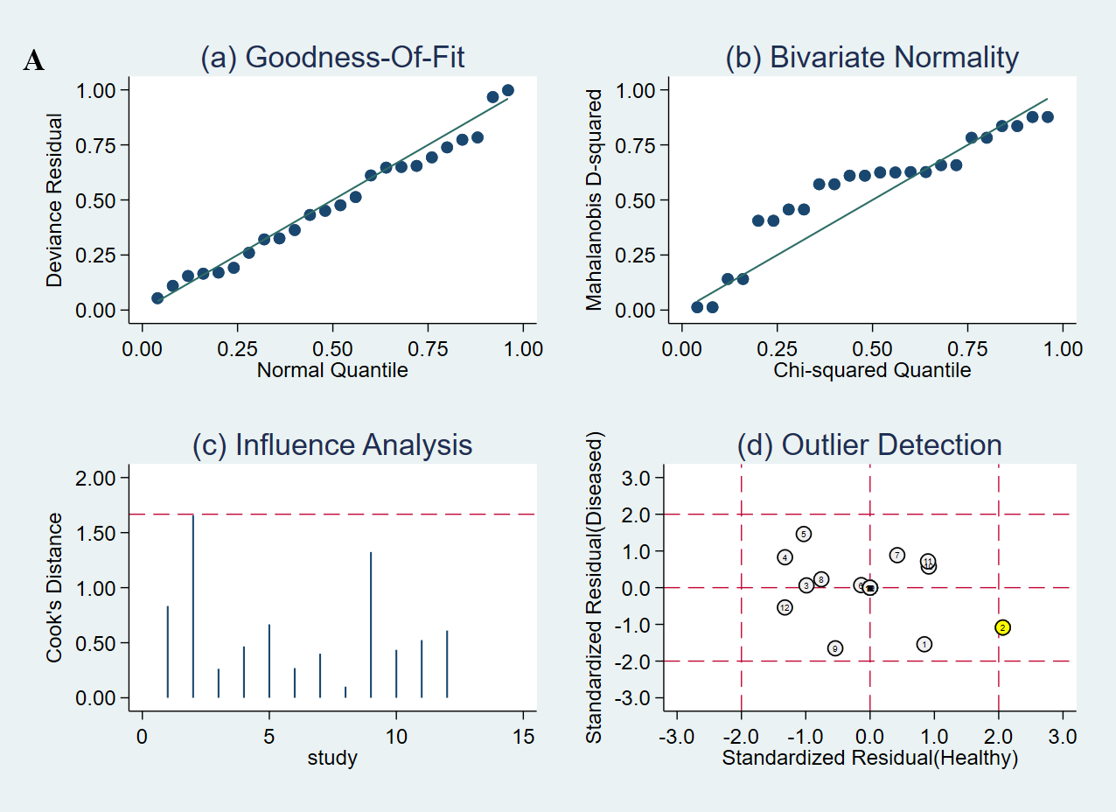

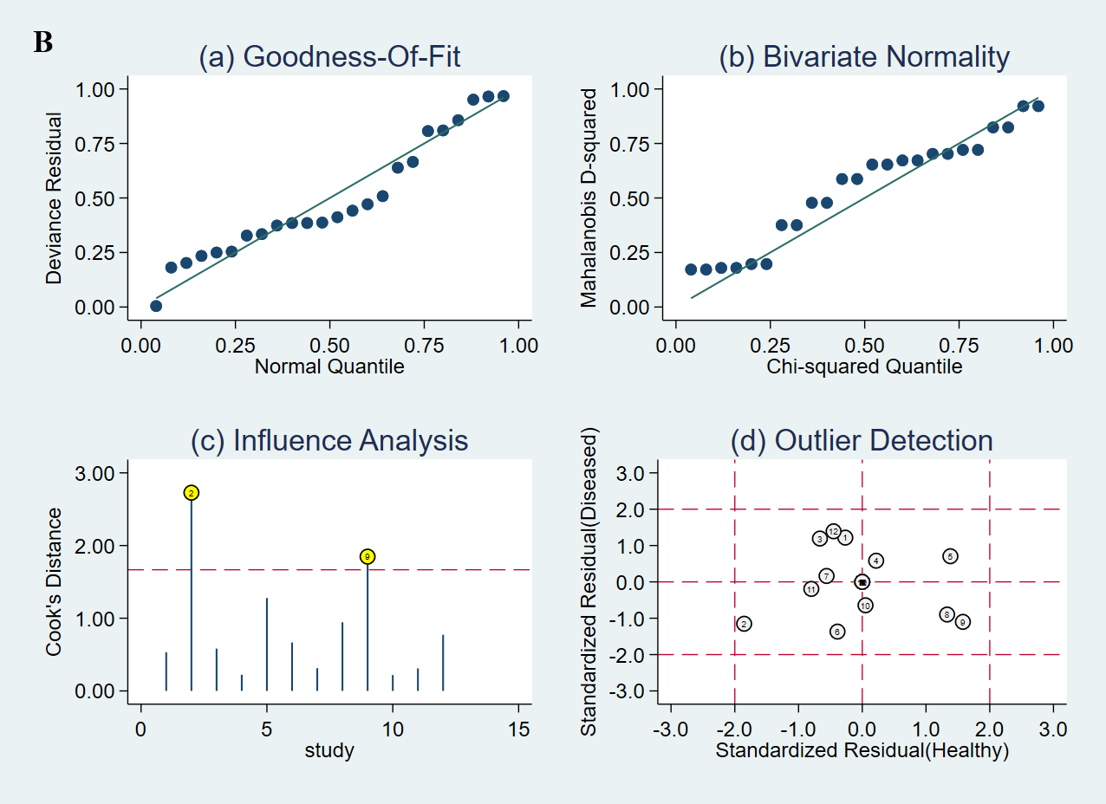
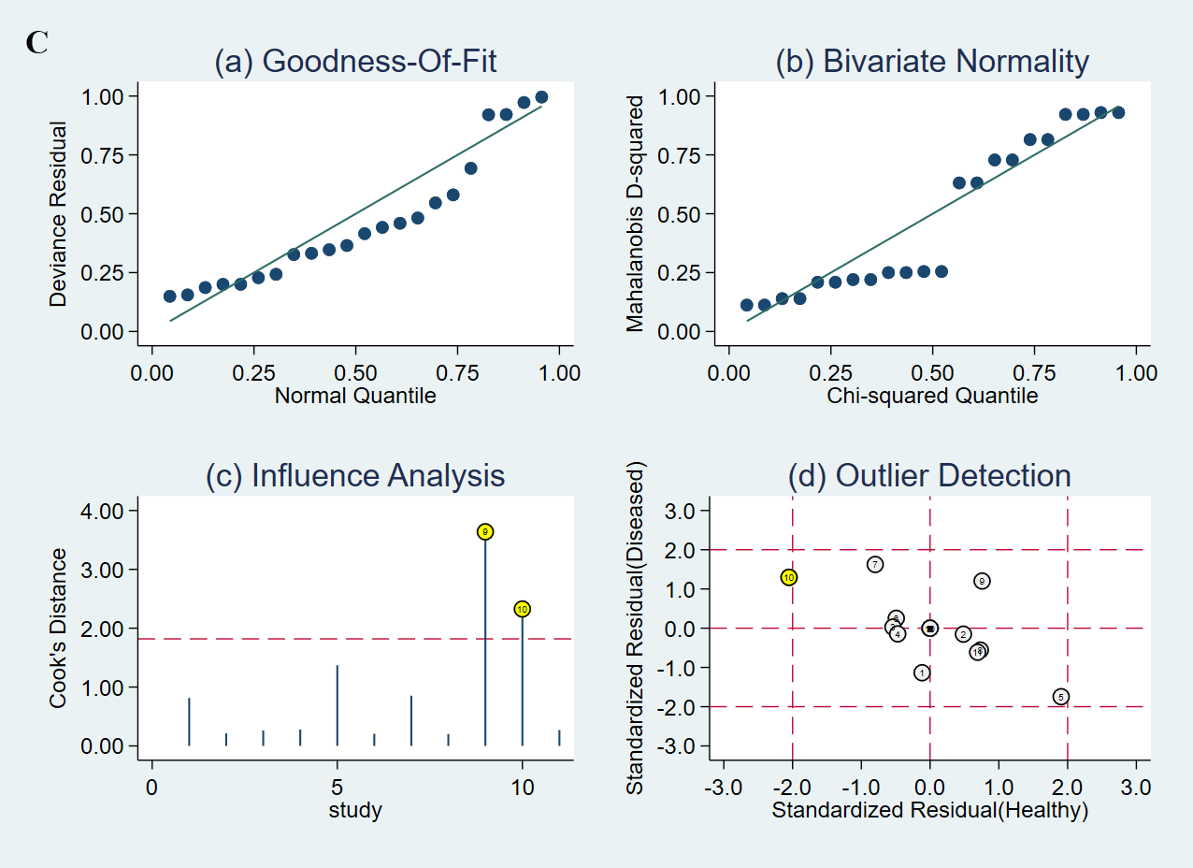
Fig. 6: Model Verification for miR-21 (A), miR-141 (B), and miR-375 (C) Studies
(a) goodness of fit based on residuals, (b) bivariate normality, (c) influence analysis, and (d) outlier detection.

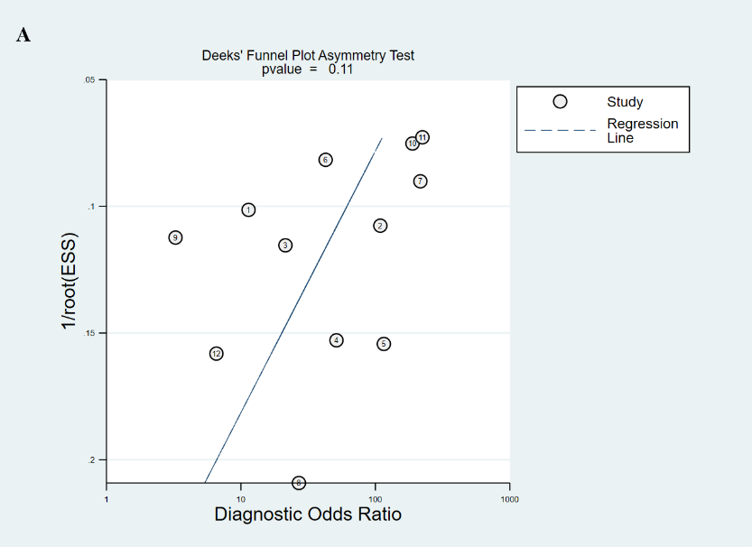
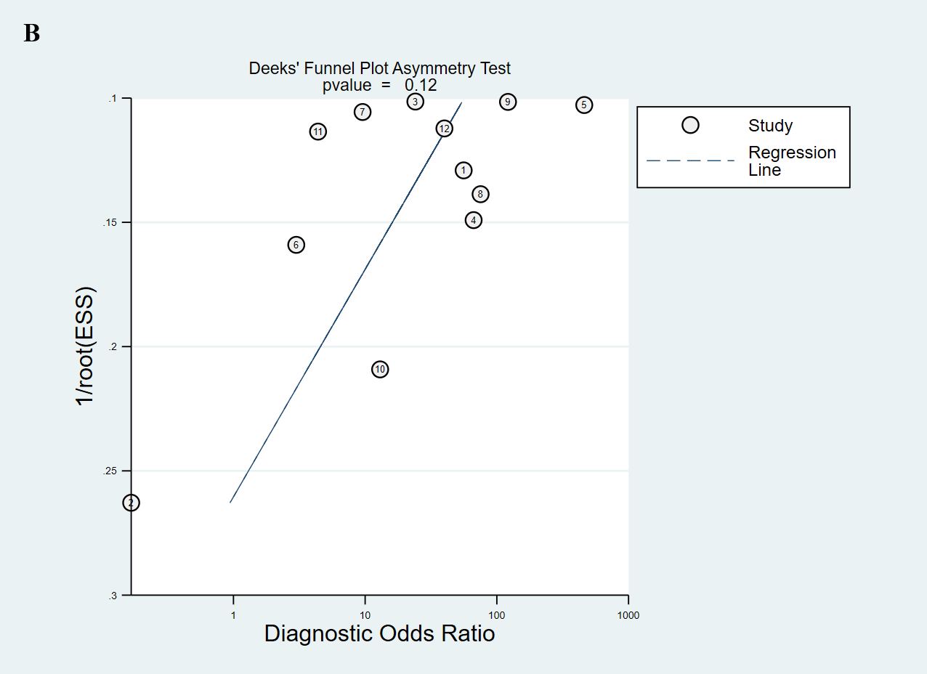
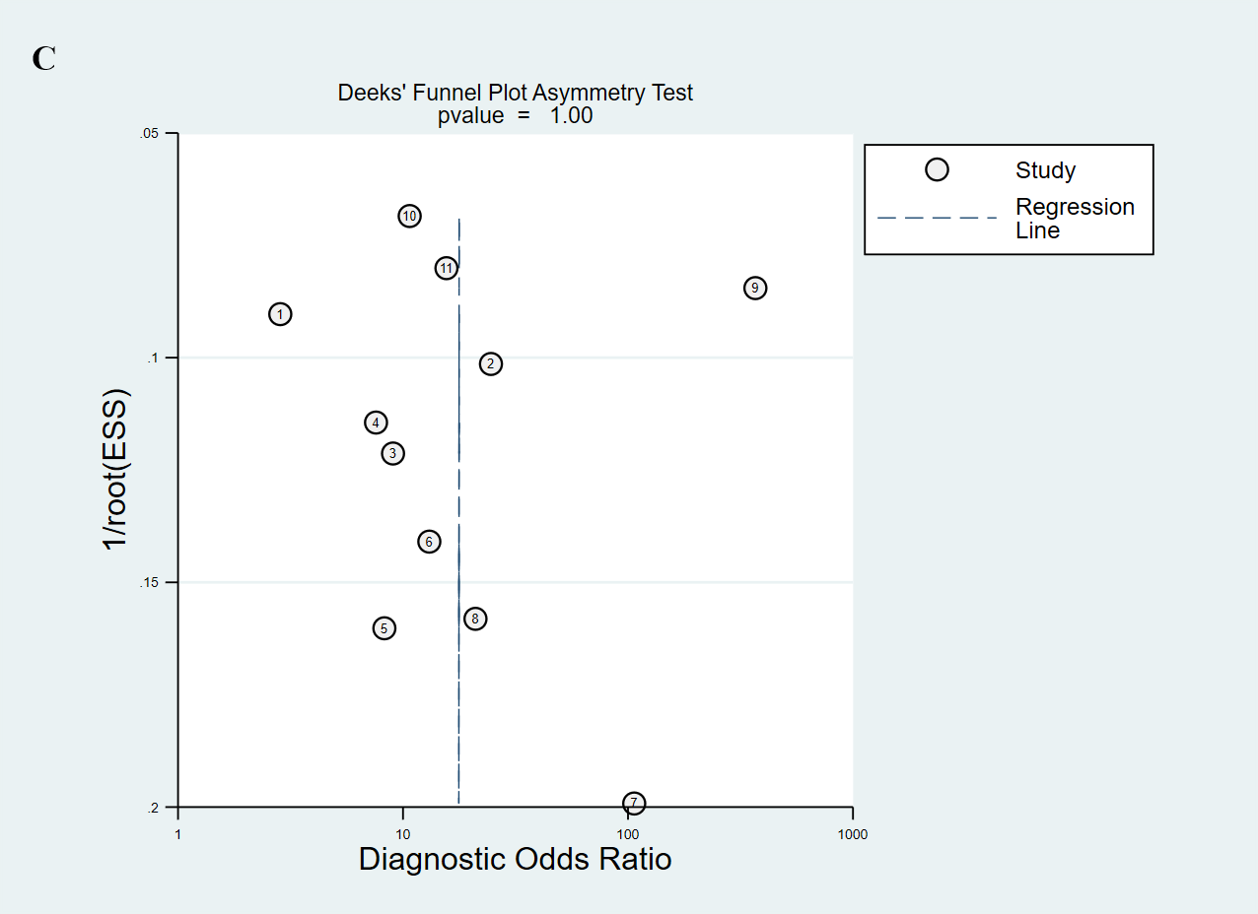
Figure 7: Deeks’ funnel plots asymmetry test.
Note: (A) miR-21, (B) miR-141 and (C) miR-375.
4. discussion

Prostate cancer (PCa) is currently and increasingly a global health issue. It is the second most common cancer in men and the third most common in older adults. It progresses rapidly and has a high mortality rate.
The aim of our meta-analysis was to evaluate the diagnostic value of circulating microRNAs in PCa. We found several miRNAs of interest in the literature, three of which were notable for their frequency and the relatively inconsistent data available on their function (Guan et al., 2016; Ibrahim et al., 2019; Joković et al., 2022; Li et al., 2016; Nitusca et al., 2022b, 2022a; Osipov et al., 2016; Porzycki et al., 2018; Ye et al., 2020).
In previous meta-analyses, the performance of each of these microRNAs was examined separately (Nitusca et al., 2022b, 2022a; Zhang et al., 2022; Zhou & Zhu, 2019), but our meta-analysis is innovative in evaluating these miRNAs in combination and in comparison, to traditional diagnostic tests, and in optimizing detection by evaluating the most appropriate biological matrix for analysis.
In total, our analysis included 27 studies in 25 articles, involving 2,697 participants, with 12 studies on miR-21, 12 on miR-141, and 11 on miR-375. Our results suggest that each of the biomarkers studied has excellent diagnostic efficacy. In the case of miR-21, we obtained a combined sensitivity of 0.87, ranging from 0.76 to 0.94, a specificity of 0.86, with a range of 0.80 to 0.91, a diagnostic odds ratio of 43, and a particularly high area under the ROC curve of 0.92. In terms of miR-141, these values were 0.78 with a range of 0.67 to 0.86, 0.87, and a range of 0.67 to 0.95, 23, and 0.87, respectively. For miR-375, the corresponding values were 0.76 (0.58 to 0.88) for SEN, 0.84 (0.73 to 0.92) for SPE, with a DOR of 17 and an AUC of 0.88. These results suggest a high potential for distinguishing patients with PCa from healthy individuals or patients with BPH. Furthermore, a meta-analysis by Zhou and Zhu in 2019 also presents exceptional results for miR-21 with a sensitivity of 91%, specificity of 88%, DOR of 77.6, and AUC of 0.95, highlighting miR-21 as an extremely promising non-invasive marker (Zhou & Zhu, 2019). These results are consistent with another study by Zhang et al. in 2022, which reported a sensitivity of 86%, specifically 90%, DOR of 52, and AUC of 0.94, also confirming superior diagnostic efficacy (Zhang et al., 2022).
The robustness of miR-21's high and consistent performance in multiple independent meta-analyses strongly validates its clinical value. The diagnostic accuracy of the biomarker appears to be similar across populations and study designs, as reflected by SEN 87%, SPE 86%, DOR 43, and AUC 0.92, which were like the respective parameters in previous large studies. miR-21 maintained good specificity (86-90% in all studies), making it suitable for avoiding unnecessary biopsies in the clinical setting.
Regarding miR-141, Ye et al. in 2020 described diagnostic performance inferior to our results, with a combined sensitivity of 70% and specificity of 73%, a DOR of 9.94, and an AUC of 0.83, indicating moderate diagnostic accuracy (Ye et al., 2020). However, more promising results were reported by Nitusca et al. in 2022 in their meta-analysis, with a sensitivity of 78% and a high specificity of 96%, yielding a DOR of 89 and an AUC value of 0.87. However, the substantial heterogeneity of the studies, as suggested by the wide CIs, prevents generalized conclusions (Nitusca et al., 2022a). Studies on miR-141 have been reported mainly in metastatic contexts, which probably explains the differences in miR-141 performance stratified by stage and sample types.
For miR-375, Nitusca et al. conducted a meta-analysis dedicated to prostate cancer in 2022. However, for seven studies, the sensitivity was 76%, the specificity was 83%, the DOR was 16, and the AUC was 0.87 (indicating a moderately lower but still acceptable diagnostic value compared to miR-21) (Nitusca et al., 2022b). These data are consistent with our results (SEN 76%, SPE 84%, DOR 17, AUC 0.88), further confirming the reliability of miR-375 performance across various types of analysis.
Overall, these observations indicate that miR-21 was the most superior indicator for diagnosis, followed by miR-375 and miR-141. Such remarkable heterogeneity among studies (I² = 86.03–94.38% for sensitivities and 64.62–91.71% for specificities) highlights the need for a standard analytical threshold and consistent inclusion criteria for the optimal validation of these noninvasive biomarkers.
Our results indicate that these miRNAs have greater diagnostic value than prostate-specific antigen (PSA), a tool currently used for screening prostate cancer. PSA is moderately sensitive (60-80%) but has low specificity (20-40% for different cut-offs) with a high number of false positives, leading to overdiagnosis and unnecessary procedures such as biopsies. The current diagnostic gold standard is systematic transrectal ultrasound-guided biopsy, an invasive technique with rather poor performance (sensitivity 60-70% for clinically significant cancers and specificity > 80%) (Borghesi et al., 2017). MRI-guided targeted biopsies, however, represent a significant improvement (sensitivity of 85-90% if high-grade tumors are primarily targeted (Ahmed et al., 2017), but they are costly, technically demanding, and may pose a risk to patients. Circulating microRNAs, on the other hand, represent a potential non-invasive alternative.
These results underscore the value of miRNAs as adjuncts to diagnostic strategies and as components of biopsies that better refine patient selection to minimize unnecessary invasive efforts. Our observations are in concordance with those of Bertoli et al. in 2016 and Cochetti et al. in 2020, supporting miRNAs hold promise as a successful candidate for the determination of clinically significant PCa, with significantly enhanced patient acceptability and accessibility relative to current pathways (Bertoli et al., 2016; Cochetti et al., 2020).
Our meta-analysis with an expanded data set up to April 2025 confirms and quantitatively updates these conclusions and demonstrates that specific circulating miRNAs, either alone or in combination, can outperform FFA in the diagnosis of PCa. Interestingly, the 3-miRNA panel (miR-21, miR-141, miR-375) can offer improved diagnostic accuracy (AUC = 0.91), pooled sensitivity (82%), and specificity (86%). These performance measures rank this multi-miRNA signature among a strong standalone PSA substitute or a complementary tool to PSA in a combined screening setting.
Inter-study heterogeneity remained substantial despite the observed diagnostic performance. Area under the ROC curve (AUC) was re-examined by subgroup analysis to identify its sources. Subgroup analyses were conducted. In contrast to sensitivity and specificity, performance is not dependent on the cut-offs used in individual studies, and the AUC offers a threshold-independent quantity of diagnostic accuracy that is therefore more robust for comparisons amongst heterogeneous subgroups.
Sub analysis identified that the type of biological matrix, plasma, serum, or urine, has a significant influence on the diagnostic performance. There were statistically significant differences between the sample types. Serum had an acceptable diagnostic performance (AUC = 0.86) and moderate between-study heterogeneity (I² = 51%), with the implication of being more robust and reproducible. Plasma and urine, on the other hand, demonstrated a low overall diagnostic accuracy (AUC ≤ 0.77), interspersed with high heterogeneity (I² = 88.4% and I² = 65.4%, respectively) and in a sense which did not allow their reliable use. Whole blood was rather paradoxically the medium returning the highest AUC of 0.91, yet it had significant heterogeneity (I² = 91.8%), meaning that studies did not agree very well together.
Our data agree with the work of Zhang et al. in 2022, who reported an AUC of 0.94 for circulating microRNAs, higher discriminative capacity in serum than in plasma (Zhang et al., 2022). In contrast to plasma, which is sensitive to anticoagulants, and urine, whose composition may present with different hydration status, pH, or conditions of collection, using the serum is by far the best stability condition for microRNA quantification (Yin et al., 2016).
Also, the type of control group influenced the sensitivity of the diagnosis significantly (P = 0.03). Our results demonstrated that healthy individuals yielded a higher diagnostic accuracy (AUC = 0.86) as the control group than that observed with benign prostatic hyperplasia (BPH) (AUC = 0.77). Such findings are in line with the results of Zhou and Zhu in 2019, showing that diagnostic accuracy decreased when the control group was composed of patients being diagnosed with benign disorders of the prostate and AUC decreased from 0.86 to 0.78 (Zhou & Zhu, 2019). Several other studies also showed evidence that BPH and PC share molecular profiles and/or microRNA expression signature the same as that of PC patients, leading to reduced discrimination of diagnostic tests (Manoj et al., 2023).
Finally, publication bias was not evident from Deeks’ tests (P values higher than 0.1 for all markers), validating the finding despite continued variance among studies. In addition, the bivariate modeling method provided a good fit of the model, and the residuals were normally distributed, endorsing the methodological soundness of the present meta-analysis. The methodological quality of included studies was generally rated as at most 1 positive in the QUADAS-2 tool.
There are some limitations in this study. The notable heterogeneity among studies, diagnostic threshold variability, and lack of cohort harmonization can impair the generalizability of the results. Moreover, most of the studies included had a single-center design with small sample sizes. Independent external validation was included in only a small number of studies, which limits the immediate clinical usefulness of the findings.
5. Conclusion

Despite conflicting results reported in the literature, our meta-analysis demonstrated that circulating microRNAs show good potential as diagnostic biomarkers for prostate cancer.
Of the three microRNAs we evaluated, miR-21 is by far the most effective in terms of tumor diagnosis, with its excellent AUC and likelihood ratios. MiR-141 and miR-375 also achieved encouraging levels, but their diagnostic performance was slightly lower, as indicated by a relatively lower DOR and a more moderate AUC.
The heterogeneity observed was likely due to methodological variability, the type of sample analyzed, analytical procedures, or population-related issues. These biomarkers have clear potential to improve existing methods for screening and early diagnosis of prostate cancer, particularly as a complement to the PSA test.

However, new large-scale multicenter studies could verify the usefulness of these factors in routine practice and clarify their role in the diagnostic algorithm.
.
DEFINITIONS, ACRONYMS, ABBREVIATIONS

PCa: Prostate Cancer
PRISMA: Preferred Reporting Items for Systematic Reviews and Meta-Analyses)
PSA: Prostate Specific Antigen
CI: Confidence Interval
RNA: RiboNucleic Acid
miR-/miRNA/microRNA: micro- RiboNucleic Acid
OncomiRs: Oncogenic microRNAs
TsmiRs: Tumor suppressor microRNAs
PCR: Polymerase Chain Reaction
MeSH: Medical Subjective Heading
BPH: Patients With Benign Prostate Disease
HP: Healthy People
TP: True Positive
FP: False Positive
FN: False Negative
TN: True Negative
SEN: Sensitivity
SPE: Specificity
SG: Gleason Score
AUC: Area Under the Curve
QUADAS2: Quality Assessment tool for Diagnostic Accuracy Studies 2
LR: Likelihood Ratios
SROC: Summary Receiver Operating Characteristic
DOR: Diagnostic Odds Ratio

COMPETING INTERESTS DISCLAIMER:
Authors have declared that they have no known competing financial interests OR non-financial interests OR personal relationships that could have appeared to influence the work reported in this paper.

References

Abramovic, I., Vrhovec, B., Skara, L., Vrtaric, A., Nikolac Gabaj, N., Kulis, et al. (2021). MiR-182-5p and miR-375-3p Have Higher Performance Than PSA in Discriminating Prostate Cancer from Benign Prostate Hyperplasia. Cancers, 13(9), 2068. https://doi.org/10.3390/cancers13092068

Ahmed, H. U., El-Shater Bosaily, A., Brown, L. C., Gabe, R., Kaplan, R., Parmar, M. K., et al. (2017). Diagnostic accuracy of multi-parametric MRI and TRUS biopsy in prostate cancer (PROMIS): A paired validating confirmatory study. Lancet (London, England), 389(10071), 815–822. https://doi.org/10.1016/S0140-6736(16)32401-1

Ali, R., El Tabbakh, S., El Delgawy, W., Kotb, A., & Desouky, M. N. (2018). microRNA-141 as a diagnostic and prognostic biomarker for prostate cancer in Egyptian population: Pilot study. African Journal of Urology, 24(4), 347–352. https://doi.org/10.1016/j.afju.2018.11.006

Balázs, K., Antal, L., Sáfrány, G., & Lumniczky, K. (2021). Blood-Derived Biomarkers of Diagnosis, Prognosis and Therapy Response in Prostate Cancer Patients. Journal of Personalized Medicine, 11(4), 296. https://doi.org/10.3390/jpm11040296

Beets, M. W., Weaver, R. G., Ioannidis, J. P. A., Pfledderer, C. D., Jones, A., von Klinggraeff, L., & Armstrong, B. (2023). Influence of pilot and small trials in meta-analyses of behavioral interventions: A meta-epidemiological study. Systematic Reviews, 12(1), 21. https://doi.org/10.1186/s13643-023-02184-7

Bertoli, G., Cava, C., & Castiglioni, I. (2016). MicroRNAs as Biomarkers for Diagnosis, Prognosis and Theranostics in Prostate Cancer. International Journal of Molecular Sciences, 17(3), 421. https://doi.org/10.3390/ijms17030421

Bidarra, D., Constâncio, V., Barros-Silva, D., Ramalho-Carvalho, J., Moreira-Barbosa, C., Antunes, L., et al. (2019). Circulating MicroRNAs as Biomarkers for Prostate Cancer Detection and Metastasis Development Prediction. Frontiers in Oncology, 9, 900. https://doi.org/10.3389/fonc.2019.00900

Bilal, M., Javaid, A., Amjad, F., Youssif, T. A., & Afzal, S. (2022). An overview of prostate cancer (PCa) diagnosis: Potential role of miRNAs. Translational Oncology, 26, 101542. https://doi.org/10.1016/j.tranon.2022.101542

Bill-Axelson, A., Holmberg, L., Filén, F., Ruutu, M., Garmo, H., Busch, C., et al. (2008). Radical Prostatectomy Versus Watchful Waiting in Localized Prostate Cancer: The Scandinavian Prostate Cancer Group-4 Randomized Trial. JNCI Journal of the National Cancer Institute, 100(16), 1144–1154. https://doi.org/10.1093/jnci/djn255

Borghesi, M., Ahmed, H., Nam, R., Schaeffer, E., Schiavina, R., Taneja, S., et al. (2017). Complications After Systematic, Random, and Image-guided Prostate Biopsy. European Urology, 71(3), 353–365. https://doi.org/10.1016/j.eururo.2016.08.004

Bray, F., Laversanne, M., Sung, H., Ferlay, J., Siegel, R. L., Soerjomataram, I., et al. (2024). Global cancer statistics 2022: GLOBOCAN estimates of incidence and mortality worldwide for 36 cancers in 185 countries. CA: A Cancer Journal for Clinicians, caac.21834. https://doi.org/10.3322/caac.21834

Bryzgunova, O. E., Zaporozhchenko, I. A., Lekchnov, E. A., Amelina, E. V., Konoshenko, M. Y., Yarmoschuk, S. V., et al. (2019). Data analysis algorithm for the development of extracellular miRNA-based diagnostic systems for prostate cancer. PloS One, 14(4), e0215003. https://doi.org/10.1371/journal.pone.0215003

Canatan, D., Yılmaz, O., Sonmez, Y., Cim, A., Baykara, M., Savas, M., et al. (2022). Use of MicroRNAs as biomarkers in the early diagnosis of prostate cancer. Acta Bio-Medica: Atenei Parmensis, 93(3), e2022089. https://doi.org/10.23750/abm.v93i3.11642

Cheng, H. H., Mitchell, P. S., Kroh, E. M., Dowell, A. E., Chéry, L., Siddiqui, J., et al. (2013). Circulating microRNA profiling identifies a subset of metastatic prostate cancer patients with evidence of cancer-associated hypoxia. PloS One, 8(7), e69239. https://doi.org/10.1371/journal.pone.0069239

Ciszkowicz, E., Porzycki, P., Semik, M., Kaznowska, E., & Tyrka, M. (2020). MiR-93/miR-375: Diagnostic Potential, Aggressiveness Correlation and Common Target Genes in Prostate Cancer. International Journal of Molecular Sciences, 21(16), 5667. https://doi.org/10.3390/ijms21165667

Cochetti, G., Rossi de Vermandois, J. A., Maulà, V., Giulietti, M., Cecati, M., Del Zingaro, et al. (2020). Role of miRNAs in prostate cancer: Do we really know everything? Urologic Oncology, 38(7), 623–635. https://doi.org/10.1016/j.urolonc.2020.03.007

Daniyal, M., Siddiqui, Z. A., Akram, M., Asif, H. M., Sultana, S., & Khan, A. (2014). Epidemiology, etiology, diagnosis and treatment of prostate cancer. Asian Pacific Journal of Cancer Prevention: APJCP, 15(22), 9575–9578. https://doi.org/10.7314/apjcp.2014.15.22.9575

Deeks, J. J., Macaskill, P., & Irwig, L. (2005). The performance of tests of publication bias and other sample size effects in systematic reviews of diagnostic test accuracy was assessed. Journal of Clinical Epidemiology, 58(9), 882–893. https://doi.org/10.1016/j.jclinepi.2005.01.016

Di Leva, G., Garofalo, M., & Croce, C. M. (2014). microRNAs in cancer. Annual Review of Pathology, 9, 287–314. https://doi.org/10.1146/annurev-pathol-012513-104715

Dülgeroğlu, Y., & Eroğlu, O. (2019). Diagnostic performance of microRNAs in the circulation in differential diagnosis of BPH, chronic prostatitis and prostate cancer. Turkish Journal of Biochemistry, 44(4), 417–425. https://doi.org/10.1515/tjb-2018-0198

Emamvirdizadeh, A., Jamshidian, F., Entezari, M., Nooraei, S., & Hashemi, M. (2015). Non-invasive Prostate Cancer Detection by Measuring Expression Level of miR-21 and miR-214 in Urine. International Journal of Cancer Management, 14(6), Article 6. https://doi.org/10.5812/ijcm.110014

Endzeliņš, E., Berger, A., Melne, V., Bajo-Santos, C., Soboļevska, K., Ābols, A., Rodriguez, et al. (2017). Detection of circulating miRNAs: Comparative analysis of extracellular vesicle-incorporated miRNAs and cell-free miRNAs in whole plasma of prostate cancer patients. BMC Cancer, 17(1), 730. https://doi.org/10.1186/s12885-017-3737-z

Fagan, T. J. (1975). Letter: Nomogram for Bayes’s theorem. The New England Journal of Medicine, 293(5), 257. https://doi.org/10.1056/NEJM197507312930513
Foj, L., Ferrer, F., Serra, M., Arévalo, A., Gavagnach, M., Giménez, N., et al. (2017). Exosomal and Non-Exosomal Urinary miRNAs in Prostate Cancer Detection and Prognosis. The Prostate, 77(6), 573–583. https://doi.org/10.1002/pros.23295

Gao, Y., Guo, Y., Wang, Z., Dai, Z., Xu, Y., Zhang, W., et al. (2016). Analysis of circulating miRNAs 21 and 375 as potential biomarkers for early diagnosis of prostate cancer. Neoplasma, 63(4), 623–628. https://doi.org/10.4149/neo_2016_417

Ghorbanmehr, N., Gharbi, S., Korsching, E., Tavallaei, M., Einollahi, B., & Mowla, S. J. (2019). miR-21-5p, miR-141-3p, and miR-205-5p levels in urine-promising biomarkers for the identification of prostate and bladder cancer. The Prostate, 79(1), 88–95. https://doi.org/10.1002/pros.23714

Giglio, S., De Nunzio, C., Cirombella, R., Stoppacciaro, A., Faruq, O., Volinia, S., et al. (2021). A preliminary study of micro-RNAs as minimally invasive biomarkers for the diagnosis of prostate cancer patients. Journal of Experimental & Clinical Cancer Research: CR, 40(1), 79. https://doi.org/10.1186/s13046-021-01875-0

Guan, Y., Wu, Y., Liu, Y., Ni, J., & Nong, S. (2016). Association of microRNA-21 expression with clinicopathological characteristics and the risk of progression in advanced prostate cancer patients receiving androgen deprivation therapy. The Prostate, 76(11), 986–993. https://doi.org/10.1002/pros.23187

Gunawan, R. R., Astuti, I., & Danarto, H. R. (2023). miRNA-21 as High Potential Prostate Cancer Biomarker in Prostate Cancer Patients in Indonesia. Asian Pacific Journal of Cancer Prevention: APJCP, 24(3), 1095–1099. https://doi.org/10.31557/APJCP.2023.24.3.1095

Guo, X., Han, T., Hu, P., Guo, X., Zhu, C., Wang, Y., et al. (2018). Five microRNAs in serum as potential biomarkers for prostate cancer risk assessment and therapeutic intervention. International Urology and Nephrology, 50(12), 2193–2200. https://doi.org/10.1007/s11255-018-2009-4

Haldrup, C., Kosaka, N., Ochiya, T., Borre, M., Høyer, S., Orntoft, T. F., et al. (2014). Profiling of circulating microRNAs for prostate cancer biomarker discovery. Drug Delivery and Translational Research, 4(1), 19–30. https://doi.org/10.1007/s13346-013-0169-4

Higgins, J. P. T., & Thompson, S. G. (2002). Quantifying heterogeneity in a meta-analysis. Statistics in Medicine, 21(11), 1539–1558. https://doi.org/10.1002/sim.1186

Huang, W., Kang, X.-L., Cen, S., Wang, Y., & Chen, X. (2015). High-Level Expression of microRNA-21 in Peripheral Blood Mononuclear Cells Is a Diagnostic and Prognostic Marker in Prostate Cancer. Genetic Testing and Molecular Biomarkers, 19(9), 469–475. https://doi.org/10.1089/gtmb.2015.0088

Ibrahim, N. H., Abdellateif, M. S., Kassem, S. H.-A., Abd El Salam, M. A., & El Gammal, M. M. (2019). Diagnostic significance of miR-21, miR-141, miR-18a and miR-221 as novel biomarkers in prostate cancer among Egyptian patients. Andrologia, 51(10), e13384. https://doi.org/10.1111/and.13384

Jin, W., Fei, X., Wang, X., Chen, F., & Song, Y. (2020). Circulating miRNAs as Biomarkers for Prostate Cancer Diagnosis in Subjects with Benign Prostatic Hyperplasia. Journal of Immunology Research, 2020, 5873056. https://doi.org/10.1155/2020/5873056

Joković, S. M., Dobrijević, Z., Kotarac, N., Filipović, L., Popović, M., Korać, A., et al. (2022). MiR-375 and miR-21 as Potential Biomarkers of Prostate Cancer: Comparison of Matching Samples of Plasma and Exosomes. Genes, 13(12), 2320. https://doi.org/10.3390/genes13122320

Kachakova, D., Mitkova, A., Popov, E., Popov, I., Vlahova, A., Dikov, T., et al. (2015). Combinations of Serum Prostate-Specific Antigen and Plasma Expression Levels of let-7c, miR-30c, miR-141, and miR-375 as Potential Better Diagnostic Biomarkers for Prostate Cancer. DNA and Cell Biology, 34(3), 189–200. https://doi.org/10.1089/dna.2014.2663

Kelly, B. D., Miller, N., Sweeney, K. J., Durkan, G. C., Rogers, E., Walsh, K., et al. (2015). A Circulating MicroRNA Signature as a Biomarker for Prostate Cancer in a High Risk Group. Journal of Clinical Medicine, 4(7), 1369–1379. https://doi.org/10.3390/jcm4071369

Kim, J., Cho, S., Park, Y., Lee, J., & Park, J. (2021). Evaluation of micro-RNA in extracellular vesicles from blood of patients with prostate cancer. PloS One, 16(12), e0262017. https://doi.org/10.1371/journal.pone.0262017

Kotb, S., Mosharafa, A., Essawi, M., Hassan, H., Meshref, A., & Morsy, A. (2014). Circulating miRNAs 21 and 221 as biomarkers for early diagnosis of prostate cancer. Tumour Biology: The Journal of the International Society for Oncodevelopmental Biology and Medicine, 35(12), 12613–12617. https://doi.org/10.1007/s13277-014-2584-7

Li, Z., Li, L.-X., Diao, Y.-J., Wang, J., Ye, Y., & Hao, X.-K. (2021). Identification of Urinary Exosomal miRNAs for the Non-Invasive Diagnosis of Prostate Cancer. Cancer Management and Research, 13, 25–35. https://doi.org/10.2147/CMAR.S272140

Li, Z., Ma, Y.-Y., Wang, J., Zeng, X.-F., Li, R., Kang, W., & Hao, X.-K. (2016). Exosomal microRNA-141 is upregulated in the serum of prostate cancer patients. OncoTargets and Therapy, 9, 139–148. https://doi.org/10.2147/OTT.S95565

Liu, X., Chen, X., Yu, X., Tao, Y., Bode, A. M., Dong, Z., et al. (2013). Regulation of microRNAs by epigenetics and their interplay involved in cancer. Journal of Experimental & Clinical Cancer Research, 32(1), 96. https://doi.org/10.1186/1756-9966-32-96

Lu, J., Getz, G., Miska, E. A., Alvarez-Saavedra, E., Lamb, J., Peck, D., et al. (2005). MicroRNA expression profiles classify human cancers. Nature, 435(7043), Article 7043. https://doi.org/10.1038/nature03702

Manoj, A., Ahmad, M. K., Prasad, G., Kumar, D., Mahdi, A. A., & Kumar, M. (2023). Screening and validation of novel serum panel of microRNA in stratification of prostate cancer. Prostate International, 11(3), 150–158. Embase. https://doi.org/10.1016/j.prnil.2023.06.002

Merriel, S. W. D., Hetherington, L., Seggie, A., Castle, J. T., Cross, W., Roobol, M. J., et al. (2019). Best practice in active surveillance for men with prostate cancer: A Prostate Cancer UK consensus statement. Bju International, 124(1), 47–54. https://doi.org/10.1111/bju.14707

Mitchell, P. S., Parkin, R. K., Kroh, E. M., Fritz, B. R., Wyman, S. K., Pogosova-Agadjanyan, et al. (2008). Circulating microRNAs as stable blood-based markers for cancer detection. Proceedings of the National Academy of Sciences, 105(30), 10513–10518. https://doi.org/10.1073/pnas.0804549105

Moldovan, L., Batte, K. E., Trgovcich, J., Wisler, J., Marsh, C. B., & Piper, M. (2014). Methodological challenges in utilizing miRNAs as circulating biomarkers. Journal of Cellular and Molecular Medicine, 18(3), 371–390. https://doi.org/10.1111/jcmm.12236

Mowayeiz, K. J., Hasan, N. A., Hussein, A. G., Al-Wasiti, E. A. R., & Al-Nasiri, U. S. (2019). The Serum Micro RNA-375 utility to diagnosis of men with prostate cancer in Iraq. Indian Journal of Public Health Research and Development, 10(7), 1425–1430. Embase. https://doi.org/10.5958/0976-5506.2019.01791.1

Nitusca, D., Marcu, A., Seclaman, E., Bardan, R., Sirbu, I. O., Balacescu, O., et al. (2022a). Circulating microRNA-141 as a Biomarker for Prostate Cancer: A Systematic Review and Meta-Analysis. Timisoara Med, 2022(2), Article 2. https://doi.org/10.35995/tmj20220204

Nitusca, D., Marcu, A., Seclaman, E., Bardan, R., Sirbu, I. O., Balacescu, O., et al. (2022b). Diagnostic Value of microRNA-375 as Future Biomarker for Prostate Cancer Detection: A Meta-Analysis. Medicina, 58(4), 529. https://doi.org/10.3390/medicina58040529

Nobrega, M., Reis, M. B. dos, Souza, M. F. de, Furini, H. H., Costa Brandão Berti, F., Souza, I. L. M., et al. (2025). Comparative analysis of extracellular vesicles miRNAs (EV-miRNAs) and cell-free microRNAs (cf-miRNAs) reveals that EV-miRNAs are more promising as diagnostic and prognostic biomarkers for prostate cancer. Gene, 939, 149186. https://doi.org/10.1016/j.gene.2024.149186

Nogueira, L., Corradi, R., & Eastham, J. A. (2009). Prostatic specific antigen for prostate cancer detection. International Braz J Urol: Official Journal of the Brazilian Society of Urology, 35(5), 521–529; discussion 530-532. https://doi.org/10.1590/s1677-55382009000500003

Osipov, I. D., Zaporozhchenko, I. A., Bondar, A. A., Zaripov, M. M., Voytsitskiy, V. E., Vlassov, V., et al. (2016). Cell-Free miRNA-141 and miRNA-205 as Prostate Cancer Biomarkers. Advances in Experimental Medicine and Biology, 924, 9–12. https://doi.org/10.1007/978-3-319-42044-8_2
Page, M. J., McKenzie, J. E., Bossuyt, P. M., Boutron, I., Hoffmann, T. C., Mulrow, C. D., et al. (2021). The PRISMA 2020 statement: An updated guideline for reporting systematic reviews. PLOS Medicine, 18(3), e1003583. https://doi.org/10.1371/journal.pmed.1003583

Poppel, H. V., Roobol, M. J., Chapple, C. R., Catto, J. W. F., N’Dow, J., Sønksen, J., et al. (2021). Prostate-specific Antigen Testing as Part of a Risk-Adapted Early Detection Strategy for Prostate Cancer: European Association of Urology Position and Recommendations for 2021. European Urology, 80(6), 703–711. https://doi.org/10.1016/j.eururo.2021.07.024

Porzycki, P., Ciszkowicz, E., Semik, M., & Tyrka, M. (2018). Combination of three miRNA (miR-141, miR-21, and miR-375) as potential diagnostic tool for prostate cancer recognition. International Urology and Nephrology, 50(9), 1619–1626. https://doi.org/10.1007/s11255-018-1938-2

Reitsma, J. B., Glas, A. S., Rutjes, A. W. S., Scholten, R. J. P. M., Bossuyt, P. M., & Zwinderman, A. H. (2005). Bivariate analysis of sensitivity and specificity produces informative summary measures in diagnostic reviews. Journal of Clinical Epidemiology, 58(10), 982–990. https://doi.org/10.1016/j.jclinepi.2005.02.022

RevMan. (2024). Review Manager Version 5.3. Copenhagen: The Nordic Cochrane Centre, The Cochrane Collaboration). Retrieved July 7, 2025, from https://www.cochrane.org/authors/handbooks-and-manuals/style-manual/references/reference-types/software?utm_source=chatgpt.com

Rosario, D. J., Lane, J. A., Metcalfe, C., Donovan, J. L., Doble, A., Goodwin, L., et al. (2012). Short term outcomes of prostate biopsy in men tested for cancer by prostate specific antigen: Prospective evaluation within ProtecT study. The BMJ, 344, d7894. https://doi.org/10.1136/bmj.d7894

Stuopelyte, K., Daniunaite, K., Bakavicius, A., Lazutka, J. R., Jankevicius, F., & Jarmalaite, S. (2016). The utility of urine-circulating miRNAs for detection of prostate cancer. British Journal of Cancer, 115(6), 707–715. https://doi.org/10.1038/bjc.2016.233

Stuopelytė, K., Daniūnaitė, K., Jankevičius, F., & Jarmalaitė, S. (2016). Detection of miRNAs in urine of prostate cancer patients. Medicina (Kaunas, Lithuania), 52(2), 116–124. https://doi.org/10.1016/j.medici.2016.02.007

Wei, J. T., Barocas, D., Carlsson, S., Coakley, F., Eggener, S., Etzioni, R., et al. (2023). Early Detection of Prostate Cancer: AUA/SUO Guideline Part I: Prostate Cancer Screening. The Journal of Urology, 210(1), 46–53. https://doi.org/10.1097/JU.0000000000003491

Whiting, P. F., Rutjes, A. W. S., Westwood, M. E., Mallett, S., Deeks, J. J., Reitsma, J. B., Leeflang, M. M. G., et al. (2011). QUADAS-2: A revised tool for the quality assessment of diagnostic accuracy studies. Annals of Internal Medicine, 155(8), 529–536. https://doi.org/10.7326/0003-4819-155-8-201110180-00009

Yaman Agaoglu, F., Kovancilar, M., Dizdar, Y., Darendeliler, E., Holdenrieder, S., Dalay, N., et al. (2011). Investigation of miR-21, miR-141, and miR-221 in blood circulation of patients with prostate cancer. Tumour Biology: The Journal of the International Society for Oncodevelopmental Biology and Medicine, 32(3), 583–588. https://doi.org/10.1007/s13277-011-0154-9

Yang, B., Liu, Z., Ning, H., Zhang, K., Pan, D., Ding, K., et al. (2016). MicroRNA-21 in peripheral blood mononuclear cells as a novel biomarker in the diagnosis and prognosis of prostate cancer. Cancer Biomarkers: Section A of Disease Markers, 17(2), 223–230. https://doi.org/10.3233/CBM-160634

Ye, Y., Yuan, X.-H., Wang, J.-J., Wang, Y.-C., & Li, S.-L. (2020). The diagnostic value of miRNA-141 in prostate cancer: A systematic review and PRISMA-compliant meta-analysis. Medicine, 99(22), e19993. https://doi.org/10.1097/MD.0000000000019993

Yin, C., Fang, C., Weng, H., Yuan, C., & Wang, F. (2016). Circulating microRNAs as novel biomarkers in the diagnosis of prostate cancer: A systematic review and meta-analysis. International Urology and Nephrology, 48(7), 1087–1095. https://doi.org/10.1007/s11255-016-1281-4

Zabegina, L., Nazarova, I., Nikiforova, N., Slyusarenko, M., Sidina, E., Knyazeva, M., et al. (2021). A New Approach for Prostate Cancer Diagnosis by miRNA Profiling of Prostate-Derived Plasma Small Extracellular Vesicles. Cells, 10(9), 2372. https://doi.org/10.3390/cells10092372

Zhang, W. T., Zhang, G. X., Zhao, R. Z., & Gao, S. S. (2022). The potential diagnostic accuracy of circulating microRNAs for prostate cancer: A meta-analysis. Actas Urologicas Espanolas, 46(3), 138–149. https://doi.org/10.1016/j.acuroe.2021.05.005.

Zhou, H., & Zhu, X. (2019). MicroRNA-21 and microRNA-30c as diagnostic biomarkers for prostate cancer: A meta-analysis. Cancer Management and Research, 11, 2039–2050. https://doi.org/10.2147/CMAR.S189026.

