Comparative evaluation of the potential antioxidant activity of Costus afer aqueous stem extract and Vitamin C supplement on liver of male Swiss mice subjected to sub-chronic exposure of dichlorvos.

Abstract
Aim: Evaluation of the potential antioxidant activity of Costus afer aqueous stem extract and Vit. C supplement on liver in male Swiss mice subjected to sub-chronic exposure of dichlorvos.
Study Design: The study was a completely randomized design employing relevant statistical tools for analysis and interpretation.
Place and Duration of Study: The study was carried out in the Department of Animal and Environmental Biology, Rivers State University. The experiment lasted for 35 days between April and June 2023.
Methodology: A total of 30 Swiss male mice were randomly selected into 6 groups (n=5). Group A was
the control, B received Dichlorvos@25mg/kg/bw/day, C & D received 100% vitamin C and Costus afer stem extract respectively at 250mg/kg/bw/day only. Groups E & F were coadministered Dichlorvos @25mg/kg/bw/day with Vitamin C and 100% extract of Costus afer at 250mg/kg/bw/day respectively. At the end of the treatment period, blood samples were collected for analysis. Histological sections of the liver were mounted on slides, stained with hematoxylin and eosin (H&E). Photomicrographs were generated.
Results: All liver biomarkers examined increased significantly (p=0.05) in group B administered
Dichlorvos only but decreased in groups administered the vit C and Costus afer respectively.
This significant (p=0.05) increase is validated by the histopathological observation of clusters of inflammatory hepatocytes, apopototic hepatocytes and distorsion of the hepatocyte architecture in these animals. Groups E and F (Fig1E and Fig1F) showed epithelium with hepatocytes undergoing accelerated mitotic division an indication of regeneration activity.
Conclusion: It could be concluded that Costus afer stem extract has sufficient antioxidant activity, However, further investigation is required.
Keywords: antioxidants, biomarkers, Costus afer, pesticides,Vitamin C

- INTRODUCTION
Environmental pollution is a universal phenomenon with its outcome having a worrisome effect on human health. The present situation of pesticides usage is a man-made calamity although the adverse effect especially on non-target organisms seem to surpass its benefit on Agriculture and the environment.
Over the years, scientists, researchers focused on improving the quality of life of people through new formulations of insecticides and pesticides targeting specifically different breeds of pests with the mission of providing basic food needed in the world for growing population and a vector free environment. There is a huge body of evidence on the relation between exposure to pesticides and elevated rate of chronic diseases such as different types of cancers, diabetes, neurodegenerative disorders like Parkinson, Alzheimer, and amyotrophic lateral sclerosis (ALS), birth defects, and reproductive disorders [1, 2]. Plants and fruits contain bioactive compounds which possess antioxidant properties. Antioxidants are essential to scavenge and neutralize harmful reactive oxygen species. Though, reactive oxygen species are beneficial in the body, excessive generation and lack of proper scavenging may pose a threat. Man-made chemicals such as pesticides, heavy metals, and carbon combustion products are major contributors and chronic exposure may lead to disease processes through oxidative stress. Hepatic disease remains a global health issue. However, an appreciable amount of hepatic protective drugs from ethnomedicine used in treating serious liver disorders remain scientifically unresolved and hence the search for natural antioxidants. Literature has constantly shown that hepatoprotective effects are associated with plant extract rich in antioxidants [3,4].
The plant, Costus afer commonly known as Monkey sugar cane or bush cane is reported to be endowed with medicinal properties. It is known as Okpete or Okpoto in Igbo land, Kakizawa in Hausa, irekeomode in Yoruba, all in Nigeria. The parts of this plant- stem, leaves, roots are implicated in the treatment of diseases such as artritis, malaria, cough, sore throat, haemorrhoids, diuretics and an antidote for poison [5,6,7,8,9].
Studies have reported that all these parts contain chemical compounds that could be used in the alleviation of oxidative stress related conditions [2,10] and implicated to have anti-inflammatory and analgestic effects [11,12].
[13] reported Costus afer leaves extract significantly prevented streptozotocin effect on the superoxide dismutase in the hepatic tissue compared to control diabetic rats with improvement in other plasma biochemical parameters towards the normal ranges in the control. However, there is dearth of scientific report on the hepatoprotective properties of Costus afer stem, hence, the focus of this study.
2.0 Materials and methods

2.1 Study Location
This study was carried out in the Animal house, Department of Animal and Environmental Biology of Rivers State University, Nkpolu-Oroworukwo Port Harcourt, 6058’49”E. Nigeria. GPS 4047*50**N 6058’49”E.

2.2 Animal Care and Management
A total of 30 adult male Swiss mice (22.04±0.31g) were purchased from the animal house of Animal and Environmental Biology in Rivers State University, Nkpolu-Oroworukwo Port Harcourt, Rivers State, Nigeria. The mice were housed in wire mesh cages under standard conditions (12hrs:12hd) and allowed to acclimatize for 14 days before the commencement of the experiment. The mice were fed with standard pellet and clean cool water. All experiments were conducted according to the institutional protocols of animal care at Rivers State University, Port Harcourt, and the standard procedure for ethical treatment of Laboratory animals.

2.3 Experimental Design
The mice were separated into 6 groups (A-F) of 5 mice each. Group A served as the control. Group B was administered Dichlorvos @ 25mg/kg/bw/day, group C received 100% vitamin C supplement at 250mg/kg/bw/day only while group D received 100% Costus aferstem extract at 250mg/kg/bw/day only. Group E were coadministered 25mg/kg/bw/day of Dichlorvos with 100% Vitamin C supplement at 250mg/kg/bw/day and Group F were coadministered 25mg/kg/bw/day of Dichlorvos with 100% Vitamin C supplement at 250mg/kg/bw/day
2.4 Biochemical Analysis of Liver Biomarkers:
Blood samples were collected individually by cardiac puncture into sterile tubes and the serum separated at 2500 g for 10 min and stored. The determination of Alanine aminotransferase (ALT), Aspartate aminotransferase (AST) and Alkaline Phosphatase (ALP) were assayed according to Sigma Diagnostics based on the procedure of [14,15,16,17].
2.5. Histopathological evaluation of the Liver: Known weight of about 0.5g of liver was fixed in 10% formalin and processed according to the protocol described by [17,18] and sectioned with a Digital Microtome Model A O Spencer No. 820 at 5um thick. The sections were stained with Hematoxylin and Eosin (H &E) and photomicrographs generated with a digital Microscope Biosphere Miller B with an image processor DN2 – Microscopy Image processing Software [26] at X400 magnification.
2.6. Statistical analysis: The results were statistically analyzed and expressed as mean + standard deviation (SD). For the comparison between groups, the one-way analysis of variance (ANOVA) was done with Microsoft excel 365 software.
3.0 Results
Table.1: Levels of hepatic enzymes in mice exposed to Costus afer, vit C and DDVP
Groups | AST(IU/L) | ALT(IU/L) | ALP(IU/L) | GLU(mmol/l)
A | 42.2±1.48^{b} | 35.8±1.09^{b} | 38.1±1.52^{b} | 6.61±2.20ª
B | 61.4±2.07ª | 44.8±1.32ª | 47.2±0.84ª | 3.52±0.18^{c}
C | 16.8±0.84^{d} | 16.8±1.48^{d} | 26.2±1.22^{c} | 5.26±0.15^{b}
D | 20.4±1.14^{d} | 19.2±2.17^{d} | 27.4±1.81^{c} | 6.63±0.13ª
E | 25.1±2.12^{d} | 16.8±1.13^{d} | 25.7±1.58^{c} | 5.44±0.34^{b}
F | 32.8±1.31^{c} | 24.8±1.64^{c} | 22.8±1.92^{bc} | 5.94±0.21^{b}

The level of hepatic enzymes in hepatotoxicity is shown in table 1.
The level of AST was 42.2±1.48(iu/l) in the control group. This increased significantly (p<0.05) to 61.4±2.07(iu/l) in group B gavaged DDVP only. Group C and D gavaged Vit C supplement and Costus afer respectively recorded a significant decrease in AST concentration to more than 50% of the level in group B. Upon the coadministration of DDVP and Vit C in group E and DDVP with Costus afer in group F, a significant decrease was also recorded when compared with group B, but there was no significant difference in AST values between group C, D and E.
Group B had a significantly increased ALT concentration of 44.8±1.32(iu/l) compared to group A with 35.8±1.09(iu/l). All other groups recorded values that significantly decreased to more than 50% of Group B values. This trend was also recorded in ALP concentration. However, for glucose level, group B had the least value of 3.52±0.18mmol/l which is about 50% of the value in the control group and group D admonistered Costus afer only. Groups C, E, F had same range of values that are not significantly different from the control group.
4.2: Histopathological assessment of Swiss Mice exposed to DDVP and co-administered Vitamin C and Costus afer stem extract
Group A was the control. The Liver Epithelium shows normal hepatocyte architecture. (NHA).The epithelium is populated by hepatocytes.
Group B animals exposed to DDVP only.The epithelium shows clusters of inflammatory cells, hepatocytes undergoing apoptosis, hepatocyte distortion and other pathological changes, apoptotic and necrotic cells.
Group C shows mice epithelium exposed to Costus afer stem extract only. Hepatocytes showed normal architecture with central portal vein.
Group D: H&E liver Epithelium of mice exposed to Vitamin C only .Epithelium shows active mitotic hepatocytes,
Group E: H&E mice epithelium exposed to DDVP and Vitamin C.:.Inflammation of hepatocytes (IC) observed . Hepatocytes undergoing active mitotic division (DC)
Group F:H&E epithelium of mice exposed to DDVP and Costus afer. Hepatocyte inflammation, apoptotic cell and hepatocyte architecture distortion

Fig 1(A-F) : A. Control liver section showing normal hepatic architecture (NHA), H&E stain, ×400.
B. Liver section from DDVP-treated group displaying central inflammatory cells (CIC) and areas of congestion (AC), H&E stain, ×400.
C. Liver section showing normal hepatocytes (NH) and central vein (CV), H&E stain, ×400.
D. Liver section highlighting central vein (CV) surrounded by normal hepatic tissue, H&E stain, ×400
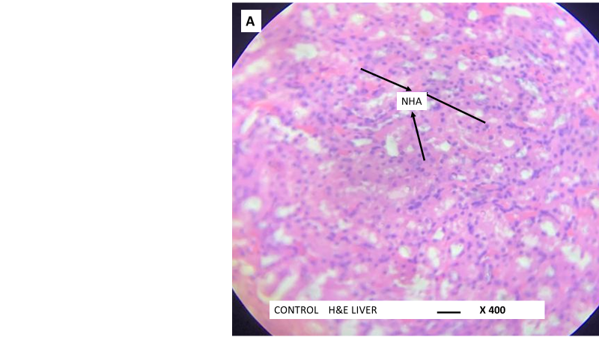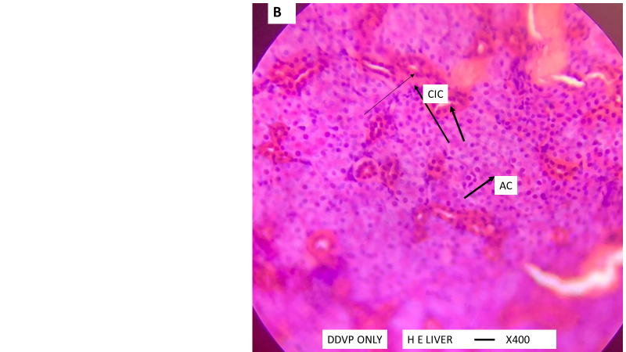
D
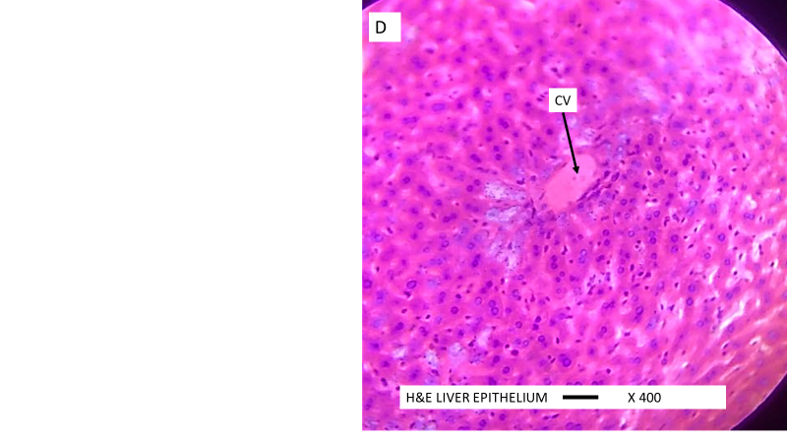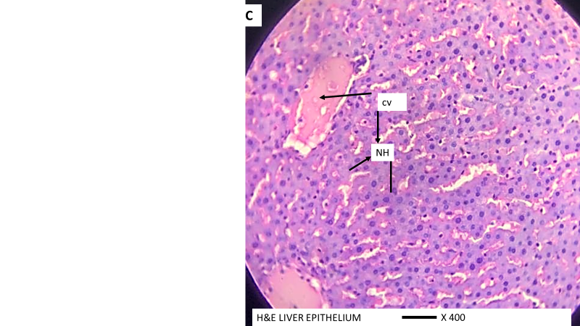
C

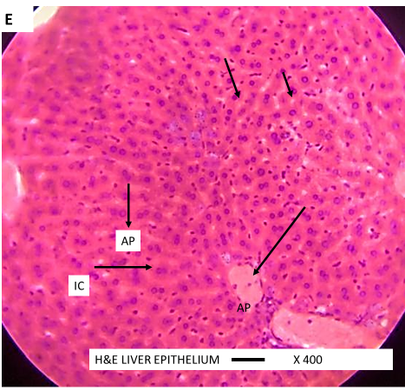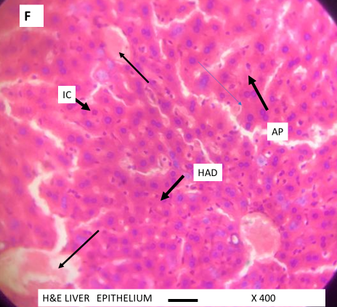

4.0 Discussion
The role of the liver is so critical in xenobiotic metabolism so assessment of its biomarkers is an indispensable tool in evaluation of liver toxicity. The damaging effect of free radicals to the liver is increased during exposure to Xenobiotics such as pesticides. An injury in the liver leads to leakage and increase of enzymes such as Alanine aminotransferase ( ALT), Aspartate aminotransferase (AST) and ALP which serves as biomarkers for the detection of liver damage in the serum [10,19]. In this study, there was 45% increase of AST, the liver injury most specific enzyme, there was 25% of ALT above the control levels in the group B animals administered DDVP only. This significant (p<0.05) increase is validated by the histopathological observation of clusters of inflammatory hepatocytes, apopototic hepatocytes and distorsion of the hepatocyte architecture in these animals. The result is inline with previous research works [20] [21] where significant increase (p<0.05) in AST, ALT and ALP above the control level in groups administered dichlorvos only were also reported. Analysis of AST and ALT in groups E administered vitamin C suspension along with DDVP revealed a 41% and 55% decrease in AST and ALT respectively, significantly (p<0.01) below the control levels.
Group F administered Costus afer and DDVP showed significant (p<0.05) decrease of 23% and 33% of AST and ALT below control levels respectively.
The histopathological micrographs of Groups E and F (Fig1E and Fig.1F) showed epithelium with hepatocytes undergoing accelerated mitotic division an indication of regeneration activity. This shows that vitamin C and Costus afer possess therapeutic ingredients for healing and regeneration of damaged hepatocytes. Based on the observations of their activities on the liver injury biomarkers and the histopathological micrographs, it could be concluded that Costus afer stem extract has sufficient antioxidant activity, However, further investigation is required.

References
- Mostafalou S, Abdollahi M. Pesticides and human chronic diseases: evidences, mechanisms, and perspectives. Toxicol Appl Pharmacol. 2013 Apr 15;268(2):157-77. doi: 10.1016/j.taap.2013.01.025. Epub 2013 Feb 9. PMID: 23402800.
- Obulor, A.O. & Orlu, E.E. (2018). Inhibitory activity of lycopnen on cypermethrin-induced hepatotoxicity and liver injury in male Sprague-Dawley rats. Journal of Pharmacy and Biological Sciences, 13(1),63-73..
- Pandit, A. (2012). Drug-Induced Hepatotoxicity: A Review. Journal of Applied Pharmaceutical Science. https://doi.org/10.7324/JAPS.2012.2541
4. Ksiksi, T., Hamza, A.A. (2012). Antioxidant, Lipoxygenase and Histose Deacetylase inhibitory activities of Acridocarbus orientalis from AI Ain and Oman. Molecules, 17,12521-12532
5. Nwankpa, P.,Amanahu, L.C,.Uche, M.E., &Ekweogu, C.N. (2023). Effects of Aqueous Stem extract of Costus afer on some biochemical parameters in male albino wistae rats. World Journal of Pharmaceutical and medical research, 9(7), 56-59.
6. Shankar, Mani(2016.). importance and uses of medicinal plants- an overview, the Asian conference on sustainability, energy,and the environment 2013 official conference proceeding Osaka, Japan 606. Internationaljournalof Preclinical and Pharmaceutical research, 7:67.
7. Parsaeinmehr, A., Martinez-Chapa,S.O., Parra-Saldivar, R (2017). Medicinal plants versus skin disorders: a survey from ancient to modern herbalism. The microbiology of skin, soft tissue, bone and joint infections, 2(13); 205-221
8. Oliver, B. Ibadan: Nigerian college of Arts, Sci and Tech, university Press Nigeria: 1960 Medicinal Plants in Nigeria, 1-33.
9. Sonibare, M.A., Isola, A.O. Akinmurele, O.J. (2023). Pharmacognostic standardization of the leaves of Costus aferkerGawl. (Zingiberaceae) and Palisota hirsute (Thunb.) K Schum (Commelinaceae). Future journal of Pharmceutical Sciences, 9, 19-23.
10. Ukpabi, C., Kingsley, N.A., Ndukwe, O.K., Agwu, A. (2013) Phytochemical Composition of Costus Afer Extract and Its Alleviation of Carbon Tetrachloride – induced Hepatic Oxidative Stress and Toxicity, International Journal of Modern Botany 2(5):120-126.
11. Anyasor, G.N., Fumilayo, O.,Odutola, O.,Olugbenga, A and Obuotor (2015).evaluation of costus afer Ker gawl. In vitroanti-inflammatory activity and its chemical constituents identified using gas chromatography masspectrometryanalysis. Journal of coastal life Medicine,3(2), 132-138.
12. Ijioma, S.N., Nwosu, C.O., emelike, C.U., Okafor, A.I. &Nwankwo, A.A. (2014)Antinociceptive Property of Costus afer Ker gawl stem juice and ethanol leaf exract in albino rats. Comprehensive Journal of Medical Science, 3(2):132-138.
13.Tchamgoue, A. D., Tchokouaha, L. R. Y., Tsabang, N., Tarkang, P. A., Kuiate, J. R., & Agbor, G. A. (2018). Costus afer Protects Cardio-, Hepato-, and Reno-Antioxidant Status in Streptozotocin-Intoxicated Wistar Rats. BioMed research international, 2018, 4907648. https://doi.org/10.1155/2018/4907648
- Orlu, E.E. and U.U. Gabriel, 2011b. Liver and plasma biochemical profile of male Clariasgariepinus (Burchell 1822) broodstock exposed to sublethal concentrations of aqueous leaf extracts of Lepidagathis alopecuroides (Vahl). Am. J. Scient. Res. Issue, 26:
106-115.
15 B.ergmeyer, H.U., M. Herder and R. Rej 1986a. International Federation of Clinical Chemistry (IFCC) Scientific Committee,
Analytical Section: Approved recommendation (1985) on IFCC methods for the measurement of catalytical concentration of enzymes, Part 2. IFCC method for aspartate aminotransferase. J. Clin. Chem. Clin. Biochem., 24: 497-510.
16. McComb, R.B. and G.N. Bowers, 1972. Study of optimum buffer conditions for measuring alkaline phosphatase activity in human serum.Clin. Chem., 18: 97-104
17 Obulor ,, A.O and Orlu, E.E (2018) Inhibitory Activity of Lycopene on Cypermethrin- Induced Hepatotoxicity and Liver Injuryin Malesprague-Dawley Rats. IOSR Journal of Pharmacy and Biological Sciences (IOSR-JPBS) 13.1: 63-73.
18 Wekhe-Emenike, Aruchi, Eme Efioanwan Orlu, and Adetutu Olubunmi Obulor. 2022. “Duration Dependent Impact of Aspartame and Sacoglottis Gabonensis on the Liver of Swiss Mice”. Journal of Advances in Biology & Biotechnology 25 (4):39-49.
19 Ezejiofor, A.N., Orish, C.N. &Orisakwe, O.E.(2013). Effect of aqueous leaves extract of Costus afer Ker Gawl (Zingiberaceae) on the liver and kidney of male albino wistarrat. Ancient Science of Life, 33(1),4-9.
20 Iboroma, M., Orlu, E.E., Ebere, N & Obulor A.O. (2018). Androgenic and antioxidant activity of stelleria media on rat following sub-chronic exposure to dichlorvos. Journal of Pharmacy and Biological Sciences, 6(1),38-46.
- Obulor, A.O., & Orlu, E.E. (2021). Comparative Evaluation of Different Local Spices on Hepatic Functions in Male Mice Exposed to Lambda-Cyhalothrin. Asian Journal of Biology.13(4),61-70.

