Original Research Article
Study of Traditional Brackish Water Crab Traps of Ratnagiri, Maharashtra, India

Abstract
The present study explores the various types of brackish water crab traps used in the coastal region of Ratnagiri, Maharashtra. Seven different types of crab traps from seventeen coastal villages were observed and studied regarding design aspects, construction, operation methods, etc. The data was analyzed to check the relationship between the catch rate per trip and the duration of the trap in water, as well as the position of the entrance from the bottom of the trap. The result showed that the ring trap, full metal body trap, fixed cylindrical trap, and umbrella crab trap had a positive relation with respect to catch and duration of trap in water. A positive relation was observed with catch and position of the entrance from the bottom for the fixed cylindrical trap, foldable cylindrical trap and metal-framed box trap. Among all the seven traps, the fixed cylindrical trap and umbrella crab trap were the most efficient crab traps with respect to catch used in Ratnagiri, Maharashtra.
Keywords: Bait, Catch, Traditional crab trap, Efficacy, Ratnagiri.
Introduction
Crab traps are used to attract and catch crabs for economical and recreational purposes. In crab traps the crab’s instincts are utilized to trap crabs. In crab traps, once the crab enters the trap, then there will be no escape point for the crab. Different kinds of baits are used to attract crabs towards the trap (Prabhu et al., 1954). In crab traps there are no escape vents for the crab except the mouth opening from which they enter the trap (Devid et al., 2006). Using traditional methods such as traps, these methods in operation of catching crabs give twice as much return per unit of investment when compared to the advanced mechanical methods (Hein et al., 1998). When looking at the capture process of traps targeting aquatic organisms, there are factors that fishers can control and others that they cannot. Examples of those beyond their control are the physical parameters of the fishing ground, such as depth, water temperature, or type of substrate; and the physiological condition of the target organism, such as hunger state or molting stage. Factors that can be controlled include the attractiveness of the bait used and the design of the fishing gear employed (Miguel et al., 2012). Traps have long been an effective method for harvesting crustaceans. They are simple, inexpensive, and compact, allowing many to be stacked on small boats. As passive fishing gear, traps are set on the seafloor and left unattended for extended periods. The target organisms are commonly lured towards them using bait, and it is the attractiveness of this bait that is most important and will determine the quantity and quality of the catch (Miguel et al., 2012). Depending on the type of crab being fished for, geographic location, and personal preference, a variety of traps are used (William et al., 1998). Because commercial operation is very tough and dangerous, it is very essential that commercial crab traps catch optimum crabs to be able to turn a profit (Guillory et al., 1996). Compared to the normal traps, commercial crab traps are large in size; some traps can easily be over 60" in diameter; therefore, the traps are able to hold a larger number of crabs than traditional crab traps (Charlie et al., 1998). Crab traps first appeared in Louisiana in the early 1950's and by the middle 1960's had replaced drop nets and trot lines as the dominant gear in the commercial blue crab, Callinectes sapidus, fishery (Guillory et al., 1996). Vinyl-coated 3.81 cm (1.5 inches) hexagonal or square mesh traps are currently used almost exclusively by commercial crab fishermen in Louisiana and along the Gulf of Mexico. There are, however, other commercially available wire meshes that could be used for crab traps.
In India, in the lower stretch of river Ganga Crab traps are commonly used (Bhattacharjya et al., 2005). In upper Sundarban, to catch crab Scylla serrata ‘Chak Jal’ is majorly used (Pravin et al., 2011). In Maharashtra, for catching crabs, various types of crab traps are used. To the local people Scylla serrata is an important food species. It attempts to address the differences and similarities between the information provided by fishers with published biological data about mud crabs. Local people use crab traps for capturing the crabs. Crab fishing is done with the help of handmade traps. A trap called a 'Zila' in Konkani consists of a circular ring, made of metal. With another rod running across the diameter. A loose hanging net is secured to one side of the ring (Nirmale et al.,2012). Fisheries sector plays an important role in the socio-economic development of the fishermen community. To improve the socio-economic status and livelihood of fishermen there is need to study the baseline information (Banasure et. al., 2023). Therefore, the present study is an attempt to document the variations observed with respect to design, material, dimensions, mode of operation, etc. of existing brackish water crab traps in Ratnagiri block.
Methodology
The present study focused on the design, fabrication, operation, cost, and catch rate of brackish water crab traps in Ratnagiri block, Maharashtra, India. Conducted from December 2021 to June 2022, the study covered 17 villages near brackish water bodies in Ratnagiri district, which has a 187 km coastline and covers 8,249 km². The surveyed villages included Pandharamaad, Purngad, Adivare, Pawas, Murugvada, Jaygad, Mirya, Bhagvati Bandar, Zadgaon, Shirgaon, Nevare, Aare-ware, Kasarveli, Dhamanse, Kalbadewi, Warawde, and Kasheli. Data on trap fishing in Ratnagiri was collected through interviews with fishermen, field observations, and a detailed questionnaire covering trap design, construction, operation, and catch. Surveys across selected villages documented various brackish water crab traps and their usage. The local name of the trap, its height, weight, dimensions, material, depth, shape, type of bait used, thickness of material, cost, durability, habitat of operation (river, pond, lake, reservoir), operational timing of the trap, mean catch rate, and the season for trap fishing were all collected and recorded for the evaluation of traditional brackish water crab traps.
The photos and 3-D diagrams depict the details of the conventional brackish water crab trap that was used for the study. The AutoCAD software is used to create the 3-D diagrams. The design particulars of traditional freshwater fish traps were prepared and presented as per FAO catalogue of Limited Fishing Gear (Nedelec, 1975). To check the relation of catch (kg) per trip with duration of trap in water (min), size of entrance (cm) and position of entrance from the bottom of the trap (cm), data were collected from the fishermen with respect to the above-mentioned factors, and by analyzing the data R² value was calculated (Naimullah et al., 2019).
Results
Traditional brackish water crab traps in Ratnagiri
It was observed that seven varieties of crab traps were used in Ratnagiri block namely Ring trap, Foldable cylindrical trap, Full metal body trap, Fixed cylindrical trap, Metal frame box trap, Perforated plastic box trap and Umbrella crab trap. Based on the structure, all the traps were divided into opened traps and closed traps.
1. Opened traps
Ring trap (Zile)
The ring trap ‘zile’ was observed in many villages, such as Mirya, Zadgaon, Shirgaon, Kasarveli, Aare ware, Nevre, Dhamanse, Malgund, Jaigad, Gaonkhadi, Adivare and Kasheli, Bhagvati Bandar, etc., in Ratnagiri block.
The trap was ring-shaped and made of either iron or aluminum, with an inner diameter of 40 ± 0.03 cm and a metal thickness of 0.9 ± 0.01 cm. Two bait ropes (PE, 3 mm) were attached across the ring in a criss-cross pattern at a 90° angle to fix the bait, each measuring 40 ± 0.03 cm in length. Three supporting ropes (PE, 3 mm), each 51 ± 0.03 cm long, were evenly spaced around the ring and tied together at the top, connecting to a lifting rope of 383 ± 0.03 cm length. The ring was fully covered by a cone-shaped net made of PE material (1 mm thick) with a mesh size of 30 mm and a depth of 50 ± 0.04 cm, giving the trap its conical form. The net was attached to the ring using nylon twine (PE, 1 mm). The total weight of the trap was approximately 600 g, making it lightweight and easy to handle by a single person. The construction cost of the trap ranged between Rs. 150–200, while the market price was Rs. 450–500. The trap was durable for around 4 years when made with an iron ring and up to 7 years with an aluminum ring. In a single operation lasting 20 to 30 minutes, the trap (locally known as zile) could catch 1 to 2 crabs.
Operations were conducted between late low tide and early high tide, primarily in the early morning for 4–5 hours and at night for 4–6 hours. The operational depth ranged from 4 to 5 feet. Fishermen deployed traps either directly from land by throwing them like a disc or by using traditional small vessels locally known as pagaar, which allowed them to cover larger areas of brackish water. Commonly used baits included chicken legs, intestines, and goat ears, with eel and shark also recommended for improved catch efficiency. Attracted by the bait’s scent, crabs approached the traps and began feeding. Fishermen then hauled the traps using skillful techniques; due to the height of the net attached to the ring, crabs fell to the bottom and became trapped. Floats were attached to the ends of lifting ropes for easy identification and to prevent conflicts between fishermen. After placing traps in the water, fishermen would haul and reinstall each one every 30 minutes, repeating this cycle three times per operation. Hauling a single trap typically took 20–30 minutes. Each trap yielded approximately 400 g of crabs per haul, amounting to 10–25 kg per operation, depending on the number of traps used (often 1–120). The total operation time, including setting traps, hauling, tying baits, and securing crab claws, lasted 4–6 hours. Crabs were stored in durable plastic or nylon bags after being tied to prevent fighting. After each operation, traps were left out to sun-dry to prevent rusting, and metal rings were painted to extend trap lifespan.

2. Closed trap
Fixed cylindrical trap
The cylindrical fix trap observed in Ratnagiri block. In Ratnagiri block, this trap was observed in Adware, Kasheli and Purnagad. It is observed that fishermen have 2 to 4 crab traps.
The shape of the trap was cylindrical (Fig 2). This trap had two circular entrances and was constructed using an iron rod, three metal rings, and three metal rods. It measured 72 ± 0.72 cm in length, 32 ± 0.53 cm in height, and 33 ± 0.52 cm in width. The metal rings had a diameter of 30 ± 0.53 cm. The outer and inner entrance diameters were 18 ± 0.139 cm and 12 ± 0.33 cm, with entrance lengths of 28 ± 0.11 cm and 26 ± 0.33 cm. A 1 mm PE net with a 30 mm mesh size covered the metal frame. The bait rope (7 ± 0.54 cm long) was attached at the center of the trap, positioned 37 ± 0.60 cm from the entrance. Entrance height from the base was 12 ± 0.45 cm. The iron rod was 7 mm thick, and the trap weighed 3.5 kg. A lifting rope (PE, 3 mm) of 241 ± 10.1 cm was used for hauling. The trap had a solid metal frame, cost Rs. 500–600, and was easily portable. On average, it caught 6–8 crabs per operation and was durable for 4–6 years. Operations were carried out early in the morning or late at night, with traps installed at high tide during these times. The operation site had a depth of 4 to 5 feet, and each session lasted 4 to 6 hours. Fishermen conducted two operations per day. Traps were placed in the water from the shore, and the lifting rope was tied to a fixed object for support. Stones were placed around the trap to stabilize it, as its lightweight made it unstable in strong currents. Traps were installed either by hand or using small vessels. Common baits included chicken legs, intestines, and goat ears, while eel and shark were also recommended for a better catch. Crabs, attracted by the bait, entered through two entrances and were unable to escape due to the entrance height. Floats were attached to the end of each lifting rope for identification. Fishermen hauled the traps using the rope and typically caught 5 to 8 crabs per trap, weighing around 1200 g. The crabs were tied to prevent fighting and stored in durable plastic or nylon bags.

Foldable cylindrical trap
The foldable cylindrical trap is observed in coastal villages of Ratnagiri block. This is the modern type crab trap. In Ratnagiri block, this trap was observed in Kalbadevi village. It is observed that fishermen have 1 - 2 crab traps.
The shape of the trap was cylindrical (Fig 3). The trap featured two circular, funnel-shaped entrances for crab entry. It was built in the shape of a cylinder out of metal wire and covered with 1 mm PE netting. The trap had a mesh size of 30 mm and was 73 ± 0.37 cm in length. The sizes of the inner entrances were 15 ± 0.30 cm and 15.7 ± 0.30 cm, while the exterior entrances were 38 ± 0.25 cm and 38.2 ± 0.28 cm. The lengths of the funnels were 20 ± 0.26 and 20 ± 0.29 cm. The entrance was placed 15 ± 0.02 cm above the base, and the bait was tied at the center with a 12.5 ± 0.04 cm rope. Because it lacked a sturdy frame, the trap, which weighed 0.600 kg, was lightweight and foldable for convenient transportation. For hauling, a 276 ± 0.08 cm (PE, 3 mm) lifting rope was utilized. Each trap cost 600 rupees and lasted for four to six years. The traps were easy for fishermen to handle and transport, and they caught an average of four to six crabs per operation. Traps were set up at high tide and operations were carried out either early in the morning or late at night. Each session lasted five to seven hours, and the operating ground depth varied from five to six feet. Every day, fishermen carried out two operations. The lifting rope was fastened to a stationary item for stability as the traps were set from land. Because the trap was lightweight and unsteady in strong currents, stones were positioned around it to stabilize it. Traps were set up manually or with the aid of small boats. Goat ears, chicken legs, and intestines were common baits; occasionally, eels or sharks were used for a better catch. Attracted by the bait, the crabs entered through two entrances and were unable to leave because of the height of the entry. For identification purposes, floats were fastened to the end of every lifting rope. Fishermen hauled the traps at the end of the operation and usually caught 4–7 crabs, each weighing about 600g. To keep them from fighting, the crabs were tethered and kept in sturdy nylon or plastic sacks.

Metal frame box trap
Metal frame box trap observed in coastal villages in Ratnagiri block. This is the modern type crab trap. In Ratnagiri block, this trap was observed in Zadgaon village. It is observed that fishermen have 1 - 2 crab traps.
The trap was found in rectangular shape (Fig 4). This trap measured 45 ± 0.40 cm in length, 26 ± 0.40 cm in width, and 30 ± 0.35 cm in height. It had a solid iron frame with 6 mm thick metal rods, providing good stability during operation. Two circular entrances were present for crab entry. The outer entrance diameters were 16 ± 0.19 cm and 16.2 ± 0.17 cm, while the inner entrance dimensions were 8 ± 0.8 cm and 8.3 ± 0.8 cm. Entrance height from the base was 13 ± 0.12 cm. The frame was covered with 1 mm PE netting (mesh size 30 mm), secured using nylon twine. A 10 ± 0.20 cm bait rope (PE, 3 mm) was tied at the center of the trap. For hauling, a 240 ± 0.07 cm lifting rope (PE, 3 mm) was attached at the upper central part. The trap weighed 2.2 kg and cost Rs. 400, making it affordable and easy to handle. Its durability was estimated at 3–4 years.
Operations were carried out early in the morning and late at night, with traps installed during high tide. The operational depth was 5 to 6 feet, and each session lasted 2 to 3 hours, covering site selection, baiting, trap installation, hauling, and catch collection. Duration varied based on the number of traps owned. Fishermen conducted two operations per day, either by hand or using a traditional boat called pagar, which was used for all related activities. Traps were deployed from land, with the lifting rope tied to a fixed object for support. Stones were placed around the trap for stability in running water. Traps were installed with or without vessels. Common baits included chicken legs, intestines, and goat ears, while eel and shark were also recommended for better catches. Crabs entered the trap through two entrances and, due to their height, could not escape once inside. Floats were attached to the end of the lifting rope for easy identification. Traps were hauled by rope, yielding 400–600 g of crabs per trap per operation. Crabs were tied to prevent fighting and stored in durable plastic or nylon bags. After each operation, traps were sun-dried to prevent rust, and fishermen painted the metal rings to extend trap life.

Full metal body trap
Full metal body trap observed in coastal villages in Ratnagiri block. This is the modern type crab trap. In Ratnagiri block, this trap was observed in Kalbadevi village. It is observed that fishermen have 1 - 2 crab traps.
The trap was observed in rectangular shape (Fig 5). This iron trap featured a solid metal frame and two square-shaped entrances. It measured 70 ± 0.20 cm in length, 46 ± 0.20 cm in width, and 42 ± 0.21 cm in height. The entrance sizes were 10 ± 0.12 cm and 10.6 ± 0.11 cm, with entrances positioned 24 ± 0.31 cm above the base. The trap had a mesh size of 30 mm and weighed approximately 3.5 kg, making it slightly heavier than other crab traps. A bait rope (8.8 ± 0.03 cm long) was attached at the center of the trap, located 18 ± 0.04 cm from the entrance. A 214 ± 0.08 cm lifting rope (PE, 3 mm) was also attached at the center for hauling. The trap was foldable and cost Rs 600. It was easily portable and typically yielded 4–6 crabs per operation. Durability was estimated at 4–6 years. The metal frame made the trap strong and stable, allowing it to withstand strong currents. Its heavy weight improved underwater stability. The average catch per operation was 4 to 6 crabs, weighing around 500–600 g. Trap durability was observed up to 4 years.
Operations were conducted early in the morning or late at night during high tide, with traps installed at depths of 5 to 6 feet. Fishermen threw the trap directly from the land, performing 2 to 3 operations daily, each lasting 2 to 4 hours. A lifting rope was attached at the center for hauling, with a colored float fixed at the end for identification. Common baits included chicken legs, intestines, and goat ears, while eel and shark were also recommended for better catches. Crabs entered through the raised entrances and were unable to escape once inside. After hauling, crabs were tied to prevent fighting and stored in strong plastic or nylon bags. Traps were reused after drying and maintenance.

Perforated plastic box trap
Perforated plastic box trap was observed in Ratnagiri block. This is a homemade crab trap. In Ratnagiri block, this trap was observed in Dhamanse, Pawas, Kasarveli etc. It was observed that fishermen have 3 to 6 crab traps.
The trap was found in rectangular shape (Fig 6). The trap was made up of keychain waste like plastic cans, plastic water bottles etc. The trap was found with one entrance. Entrance was in a conical and circular shape. Length of the trap was 25 ± 0.59 cm, width of the trap was 22 ± 0.71 cm. Height of the trap was 14 ± 0.4 cm, diameter of entrance was 8 ± 0.52 cm, length of the entrance of the trap was 10 ± 0.73 cm. The position of the entrance from the base of the trap was 2 ± 0.04 cm. Plastic bottle was used as a bait container in this trap. Length of the bait container was 9 ± 0.56 cm, weight of the trap was 100 g. Lifting rope was attached to the trap. Length of the lifting rope (PE, 3mm) was 240 ± 0.03 cm. Due to the plastic body, trap was extremely light weight. Due to its lightweight, trap was easy to handle and carry by the fisherman. The trap was highly durable up to 6 to 76 years. The trap was free of cost.
Operations were conducted early in the morning or late at night during high tide, at depths of 5 to 6 feet. Each operation lasted 2 to 3 hours, involving site selection, baiting, trap installation, hauling, and catch collection. Duration varied based on the number of traps used. Fishermen typically carried out two operations per day. Traps were installed from land or using small vessels. Due to their light weight, stones were placed around the traps for added stability in strong currents. Multiple holes were made in the traps to allow water drainage. The lifting rope was tied to a fixed object for support. Common baits included chicken legs, intestines, and goat ears; eel and shark were also suggested for higher catches. Crabs entered the trap through two entrances and were unable to escape once inside. Each trap yielded about 400–600 g of crabs per operation. Catches were stored in durable plastic or nylon bags, and crabs were tied to prevent fighting before storage.
Umbrella crab trap
Trap observed in Ratnagiri block. This is the modern type crab trap. In Ratnagiri block, this trap was observed in Varavade village. It was observed that fishermen have one to two crab traps.
The trap was found in umbrella shaped (Fig 7). Shape of the trap entrance was in circular and conical shape. Length of the trap was 60 ± 0.55 cm, height of the trap was 30 ± 0.35 cm, diameter of outer entrance was 13 ± 0.52 cm and diameter of inner entrance was 8 ± 0.23 cm. Length of the entrance of the trap was 11 ± 0.73 cm and length of the bait rope was 9 ± 0.56 cm. Weight of the trap was 300 g. Lifting rope was attached to the trap. Length of the lifting rope (PE, 3mm) was 240 ± 0.07 cm. Height of that entrance from the base was 8 ± 0.06 cm. The trap was made up of metal wire. Net (PE, 1 mm) was covered on that metal wire to form an umbrella shape. The mesh size was observed to be around 10 mm. Due to the absence of a metal solid frame; the trap was light weight. Due to its lightweight, trap was easy to handle and carry by the fisherman. Cost of the trap was Rs 800.
Operations were carried out early in the morning or late at night, with trap installation timed to coincide with high tide. The operational depth was 5–6 feet, and each session lasted 5–7 hours. Fishermen typically completed two operations per day, deploying traps either from land or using small vessels. After installation, the lifting rope was tied to a fixed object for support, and stones were placed around the trap to improve stability, especially in strong currents due to the trap’s lightweight nature. Common baits included chicken legs, intestines, and goat ears, while eel and shark were also recommended for better catch rates. Crabs were attracted to the bait and entered through eight trap entrances. The entrance design prevented escape once they fell to the trap’s base. Floats were attached to the lifting rope for identification. Each trap yielded around 8–10 crabs per operation, weighing approximately 700 g. Catches were stored in strong plastic or nylon bags, and crabs were tied before storage to prevent fighting.
In the analysis, it was observed that all the seven trap entrances were significantly different (P < 0.05) (Fig 9). One-way ANOVA statistical test was applied to the data of the catch of the crab traps (30 samples). In the analysis, it was observed that all the seven traps caught (kg) were significantly different (P < 0.05) (Fig 8). It was observed that Fixed cylindrical trap and Umbrella crab trap have the greatest catch (kg), among all the locally available crab traps and for diameter of entrance, Ring trap Zile trap has the greatest diameter of entrance among all the crab traps.
From the analysis the relationship between the catch (kg) per trip and duration of trap in water (min) was estimated. It was observed that Ring trap had positive relation between catch (kg) per trip and duration of trap in water (min) (R² = 0.81). Full metal body trap had positive relation between catch (kg) and duration of trap in water (min) (R² = 0.86). Foldable cylindrical trap had no relation between catch (kg) and duration of trap in water (min) (R² = 0.02). Fixed cylindrical trap had positive relation between catch (kg) and duration of trap in water (min) (R² = 0.83). Metal framed box trap had no relation between catch (kg) and duration of trap in water (min) (R² = 0.0). Perforated plastic box trap had no relation between catch (kg) and duration of trap in water (min) (R² = 0.3). Umbrella crab trap had positive relations between catch (kg) and duration of trap in water (min) (R² = 0.80) (Fig 10). There was no relation observed of catch (kg) per trip and size of entrance (Fig 11). Position of the entrance from the bottom of the trap (cm) was observed significantly different in all types of traditional crab trap (P < 0.5). Types of traps having single entrance and multiple entrances were not compared for estimating relation because they were significantly different from each other i.e., Ring trap, Umbrella crab trap and Perforated plastic box trap. Traps with common number of entrances were analysed. It was observed that positive relation of catch (kg) per trip and position of entrance from the bottom of the trap (cm) (R² = 0.69) (Fig 12)
Discussion
Most prominently used crab trap in Ratnagiri block was Zile. The shape of the crab trap Zile was in ring shape. Diameter of the ring was 40cm. Ring was made up from iron. Thickness of ring was 0.5 cm. Two bait rope (nylon ropes, PE, 3mm) were attached in criss cross manner at the end, on the inside of the ring to fix the bait. The ring was covered by the net with 3.3 cm mesh size. Height of that net was 50cm. After attaching the net to that ring the trap looked like cone shaped. Zile was cost around Rs 400 for construction, which was cost Rs 500 in local market. Durability of these traps was around 4 years with iron ring and 7 years with Aluminium ring. The Mahul fishing village is one of the major fishing center in Mumbai, which is densely covered with mangroves. Mahul is an intertidal undulated area, where crab fishing using ring traps was a commercial activity. Crab ring traps were locally known as Fug/pug. The design of the trap is simple with a bag of mesh/webbing with polyamide/polyethylene monofilament/ multifilament on a circular metal ring made of steel plate/iron rod attached by a bridle to a pulling cord. The metallic ring was 30 - 80 cm in diameter with a webbing (0.32 mm) of mesh size of 20-60 mm. Floats made of thermocol were attached with ring having dimensions ranging from 8x4x2 – 15x13x6 cm. Since the design of the crab ring trap was simple, the fabrication costs were around Rs. 200-300/. Lifespan of a trap was 4-5 years. (Manju et al., 2020).
Plastic container crab trap was observed in Ratnagiri block. Trap was made up from plastic container. The trap was found in a rectangular shape. Length of the trap was 25 ± 0.59 cm, width of the trap was 23 ± 0.71 cm. Height of the trap was 14 ± 0.4 cm, diameter of entrance was 8 ± 0.52 cm and length of the entrance of the trap was 11 ± 0.73 cm. Plastic rectangular trap was operated in Georgia. A 15cm diameter hole was cut in the top of a plastic 18.9-liter ethanol container. One centimeter mesh netting was attached around the opening at the top to prevent whelks from crawling out. Two centimeter holes were drilled in the sides of the container. A 2.54 cm layer of concrete was poured in the bottom of the trap to aid in sinking and to provide resistance to movement in currents. A wire mesh bait box was attached to the inside bottom of the trap. This trap was representative of traps currently used in the waved whelk, Buccinum undatum Linnaeus, 1758, fishery in Ireland (Power et al. 2002)
In this study, most of the crab traps were made up of iron frames. Polyethylene nets were covered on that metal frame. The 3mm diamond shaped mesh was used for these traps. Yellow color 6mm nylon rope was used for the traps for hauling purposes. Bait was tied with the help of nylon rope for each trap. In Georgia, standard crab traps were used. The trap was in cube shape made of vinyl-coated wire mesh. It had four entrance funnels, one on each of the sides for organisms to enter. A wire mesh bait box was attached to the bottom in the center of the trap. Steel rebar (reinforcement rods) was attached to the bottom of the trap to aid in sinking and provide resistance to movement in currents (Jacob et al., 2006).
In Ratnagiri block, Chicken leg, chicken intestine and ear of goat were used as common bait for the trap to attract crabs. Eel and shark were also recommended by the fisherman for great catch. In Mahul, Mahul fishing village fish waste and poultry waste ware used as bait which is attached at the center of these traps (Manju et al., 2020). In modified crab traps, chicken leg, chicken intestine and ear of goat were used as bait and the result was more crabs get attracted towards the crab trap. The efficiency of different bait (blue crabs -Callinectes sapidus, menhaden -Brevoortia tyrannus, and a combination of both) was investigated in Georgia. Ninety-two crabs were caught during this experiment: 75 spider crabs and 17 blue crabs. All blue crabs were caught in crab traps baited with fish. The majority of the spider crabs (60%) were caught in crab traps baited with fish, while 33% were caught in crab traps baited with crab and fish. Only 5% of spider crabs were obtained in crab traps baited with crabs (Todd et al., 2001). The length and catch rate shows the large effect size similarly 60% of the catch depends on the length of trap (Banasure et. al., 2022). As well as the catch does not depend on the funnel design of traps (Banasure et. al., 2022).
It was observed that there was no relation between catch (kg) per trip and entrance of trap(cm) but positive relation was observed between catch and position of entrance from the base of the trap. In Vietnam, specifically in the province of Trana et al. (2020) investigated the effects of the trap entrance designs on the catch efficiency of the swimming crab Charybdis feriata fishery. It was found that the modified one-entrance trap had a 24% higher catch rate. In the second experiment, catch rates of one-entrance traps with green or yellow entrance-netting were compared, and it was found that the catch rates increased by 31%. (yellow netting). It was observed that Ring trap, full metal boy trap, fixed cylindrical trap and umbrella crab trap have positive relation between catch (kg) per trip and duration of trap in water. Naimullah et al. (2019) studied the Effect of soaking time on targets and bycatch species catch rates in fish and crab trap fishery in the southern East China Sea. Important data, such as those influencing catch rates, bycatch species, and the impact of trap soaking time (SKT), are lacking in management strategies for trap fisheries in the Taiwan Strait (TS). Authors looked into Taiwanese crab and fish trap vessel logbooks and voyage data recorder data as a result. Regardless of the type of trap, the best target species catch rates were obtained for an SKT of 48 hours. While the bycatch rates for fish traps were unaffected by the SKT, the bycatch rates for crab traps were found to be higher when the SKT was longer than 48 h. By planning harvest strategy, managing space and time, and reducing bycatch, these findings could help implement sustainable trap fishing.
Conclusion
Traditional brackish water crab traps used in Ratnagiri block are seasonal and are made from metal bodies. The traps were used in the coastal villages of Ratnagiri mostly for food and as hobby but very few people operated traps for economic purposes. The study will be documented knowledge of all the various types of traditional brackish water crab traps. This study could help the fisherman to modernize their crab traps to escalate their earnings.
References
Anraku, K., Archdale, M. V., Cortes, B. M., & Espinosa, R. A. (2001). Crab trap fisheries: capture process and an attempt on bait improvement. UPV J. Nat. Sci., 6, 121–129.
Archdale, M. V. (2012). Development of trapping gear and methods for swimming crabs. Crabs: Anatomy, Habitat and Ecological Significance, 27–47.
Arthur, C., Friedman, S., Weaver, J., Van Nostrand, D., & Reinhardt, J. (2020). Estimating the benefits of derelict crab trap removal in the Gulf of Mexico. Estuaries and Coasts, 43(7), 1821–1835.
Babatunde, E. E. (2009). Assessment of crab trap selectivity and efficiency in a tropical riparian swamp. African Journal of Biotechnology, 8(18), 4680–4684.
Banasure, A. R., Sadawarte, R. K., Chavan, B. R., Mulye, V. B., Koli, J. M., Sadawarte, V. R., Adakney, S. R., & Nagvekar, M. S. (2022). Comparative analysis of traditional freshwater fish traps used for fishing in Ratnagiri, Maharashtra. Journal of Indian Fisheries Association, 49(1), 66–72.
Banasure, A. R., Sadawarte, R. K., Chavan, B. R., Mulye, V. B., Koli, J. M., Sadawarte, V. R., & Adakney, S. R. (2023). Socio-economic study of traditional trap fishers in Ratnagiri District, Maharashtra. Journal of Experimental Zoology India, 26(1), 943–947.
Biehl, T. M., Dantas, D. V., & de Farias, E. G. G. (2019). Influence of crab trap geometry and wind direction over the catch fluctuations in a neotropical coastal lagoon. Journal of FisheriesSciences.com, 13(1), 0–0.
Breen, P. A. (1987). Mortality of Dungeness crabs caused by lost traps in the Fraser River Estuary, British Columbia. North American Journal of Fisheries Management, 7(3), 429–435.
Broadhurst, M. K., Butcher, P. A., & Cullis, B. R. (2014). Effects of mesh size and escape gaps on discarding in an Australian giant mud crab (Scylla serrata) trap fishery. PLoS One, 9(9), e106414.
Christian, P. A., Rawson Jr, M. V., & Shierling, T. D. (1987). Effectiveness of six trap types and other factors for harvesting premolt blue crabs (Callinectes sapidus) in a Georgia tidal creek. North American Journal of Fisheries Management, 7(1), 63–70.
Cyr, C., & Sainte-Marie, B. (1995). Catch of Japanese crab traps in relation to bait quantity and shielding. Fisheries Research, 24(2), 129–139.
Dorcas, M. E., Willson, J. D., & Gibbons, J. W. (2007). Crab trapping causes population decline and demographic changes in diamondback terrapins over two decades. Biological Conservation, 137(3), 334–340.
Funde, A. B., Naik, S. D., & Mohite, S. A. (2009). Catch particulars of mudcrab, Scylla spp. of Ratnagiri coast, Maharashtra. Aquaculture 10(1):17–25
Funde, A. B., Naik, S. D., Pawar, A. S., & Hotekar, S. P. (2013) Comparative efficiency of mudcrab fishing methods in and around Ratnagiri, Maharashtra. Aquaculture 14(1&2):25–34
Guillory, V., & Prejean, P. (1997). Blue crab, Callinectes sapidus, trap selectivity studies: mesh size.
Gumilar, I., Supriadi, D., Shabrina, N., & Khan, A. M. (2020). Proportion and total of commodities blue swimming crab (Portunus pelagicus Linnaeus, 1758) catches in Gebang Mekar Village, Cirebon Regency, West Java using crab gillnet and collapsible crab trap. Asian Journal of Fisheries and Aquatic Research, 8, 28–33.
Hammerschmidt, P. C., & Benefield, R. L. (1986). Number and distribution of crab traps in Texas bays. Texas Parks and Wildlife Department, Coastal Fisheries Branch.
Karthy, A., Neethiselvan, N., Sundaramoorthy, B., Shanmugam, S. A., Ravikumar, T., & Mol, C. B. (2017). Comparison of catching efficiency of serial collapsible crab traps with crab gill net operated along the Gulf of Mannar, India. Journal of Experimental Zoology India, 20(2), 1231–1237.
Kunsook, C., Sangpaiboon, P., Bhudtharak, S., Sangsri, P., & Kathinsri, S. (2017). Comparative in effective of mesh size of collapsible crab trap to blue swimming crab fishery at Kung Krabaen Bay, Chanthaburi Province. Burapha Science, 22, 96–109.
Maitland, D. P. (2002). Convergent design of Caribbean and Philippine bamboo land-crab traps. Journal of Crustacean Biology, 22(2), 497–501.
Mariappan, S., Neethiselvan, N., Sundaramoorthy, B., Athithan, S., & Ravikumar, T. (2016). Comparison of catching efficiency of collapsible serial fish traps baited with two different baits. Journal of Experimental Zoology India, 19(1), 597–601.
Miller, R. J. (1980). Design criteria for crab traps. ICES Journal of Marine Science, 39(2), 140–147.
Muki-iopadhyay, P. K., & Das, D. (1992). Country research and extension programs. Rice-fish Research and Development in Asia, 24, 255.
Naimullah, M., Lee, W. Y., Wu, Y. L., Chen, Y. K., Huang, Y. C., Liao, C. H., & Lan, K. W. (2022). Effect of soaking time on targets and bycatch species catch rates in fish and crab trap fishery in the southern East China Sea. Fisheries Research, 250, 106258.
Nando, R., Brown, A., & Rengi, P. Effect of old meat fish bait decay Pari (Trigon sephen) to catch Bubu crab (trap) in village depths Echo Nine River District City Province Dumai Riau (Doctoral dissertation, Riau University).
Nguyen, K. Q., & Winger, P. D. (2019). A trap with light-emitting diode (LED) lights: evaluating the effect of location and orientation of lights on the catch rate of snow crab (Chionoecetes opilio). Aquaculture and Fisheries, 4(6), 255–260.
Page, J. W., Curran, M. C., & Geer, P. J. (2013). Characterization of the bycatch in the commercial blue crab pot fishery in Georgia, November 2003–December 2006. Marine and Coastal Fisheries, 5(1), 236–245.
Puspito, G. (2013). Design of entrance and escape gaps in collapsible trap for mangrove crabs Scylla sp. Aquaculture, Aquarium, Conservation & Legislation, 6(4), 407–414.
Rau, N. (1976). FAO catalog of small-scale fishing gear.
Recicar, T., & Power, A. J. Quantitative comparison between the Chesapeake Bay conch pot and the standard crab trap for.
Risamasu, F. J. L., Tallo, I., & Sine, K. G. Analysis of mangrove crab (Scylla sp) catch caught by trap in different construction as operated in Oebelo Village Waters, Central Kupang Sub-district, Kupang Regency.
Rook, M. A., Lipcius, R. N., Bronner, B. M., & Chambers, R. M. (2010). Bycatch reduction device conserves diamondback terrapin without affecting catch of blue crab. Marine Ecology Progress Series, 409, 171–179.
Salthaug, A., & Furevik, D. M. (2004). Size selection of red king crabs, Paralithodes camtschaticus, in traps with escape openings. Sarsia, 89(3), 184–189.
Songrak, A., Bodhisuwan, W., & Thapanand-Chaidee, T. (2013). Selectivity of traps for blue swimming crab in Trang province. Maejo International Journal of Science and Technology, 7, 36.
Stearns, G., Conrad, R., Winfrey, D., Shippentower-Games, N., & Finley, D. (2017). Dungeness crab trap catch efficiency related to escape ring location and size. North American Journal of Fisheries Management, 37(5), 1039–1044.
Stevens, B. G. (2021). The ups and downs of traps: environmental impacts, entanglement, mitigation, and the future of trap fishing for crustaceans and fish. ICES Journal of Marine Science, 78(2), 584–596.
Sturdivant, S. K., & Clark, K. L. (2011). An evaluation of the effects of blue crab (Callinectes sapidus) behavior on the efficacy of crab pots as a tool for estimating population abundance. Fishery Bulletin, 109(1), 48.
Tran, P. D., Nguyen, L. T., To, P. V., & Nguyen, K. Q. (2020). Effects of the trap entrance designs on the catch efficiency of swimming crab Charybdis feriata fishery. Fisheries Research, 232, 105730.
Willits, F. K., Theodori, G. L., & Luloff, A. E. (2016). Another look at Likert scales. Journal of Rural Social Sciences, 31(3), 6.
Wood, R. C. (1997). The impact of commercial crab traps on northern diamondback terrapins, Malaclemys terrapin terrapin. In Proceedings: Conservation, Restoration, and Management of Tortoises and Turtles—An International Conference (pp. 21–27). New York: New York Turtle and Tortoise Society.

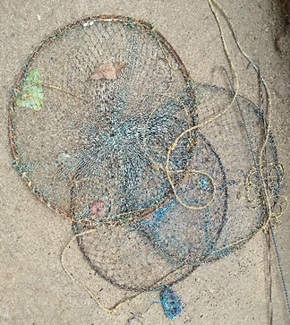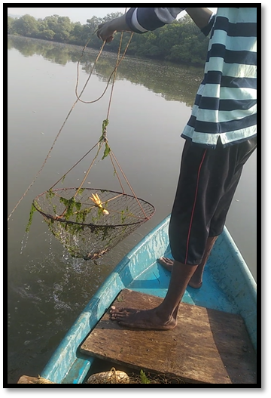
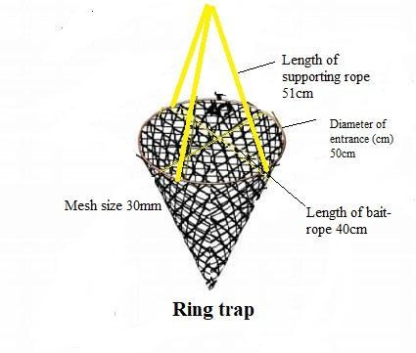
Fig. 1. Dimensions of ring trap (Zile)

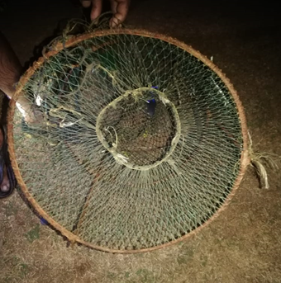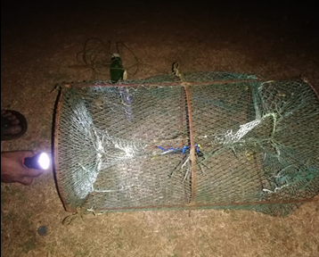
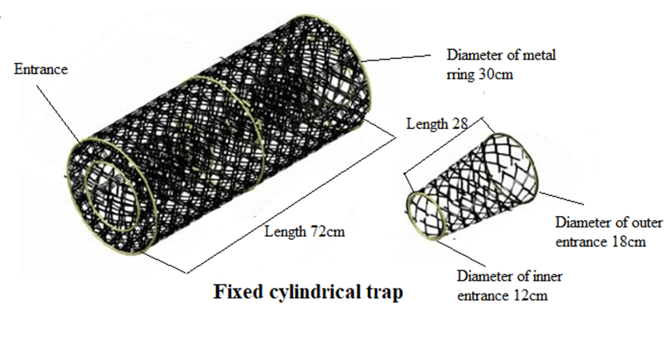
Fig.2. Fixed Cylindrical Trap

Dimensions of Trap

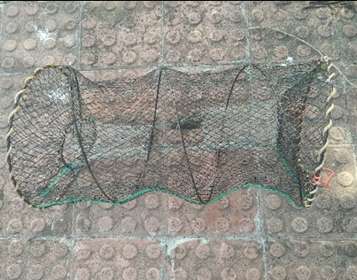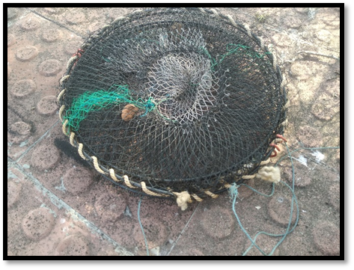
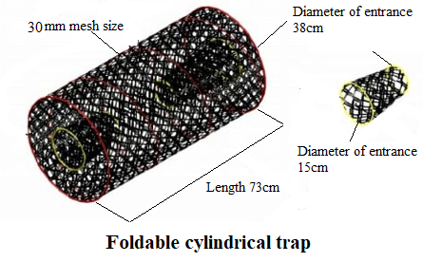
Fig. 3. Foldable Cylindrical Trap

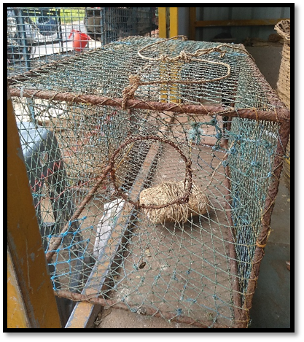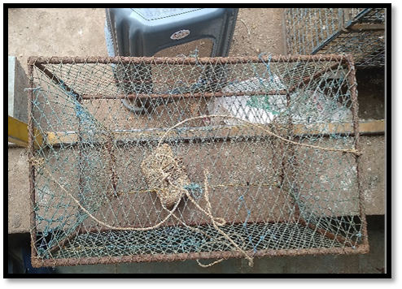
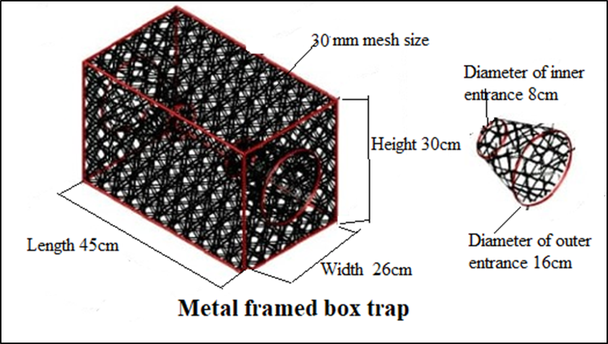
Fig. 4. Metal frame box trap

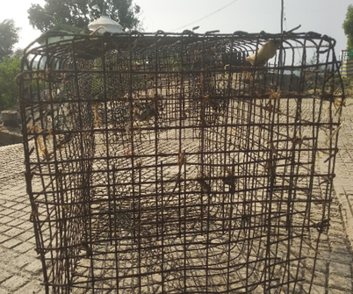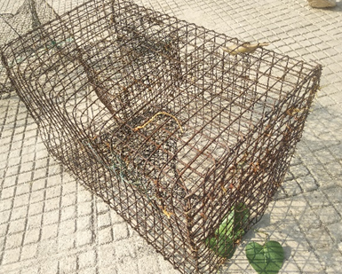
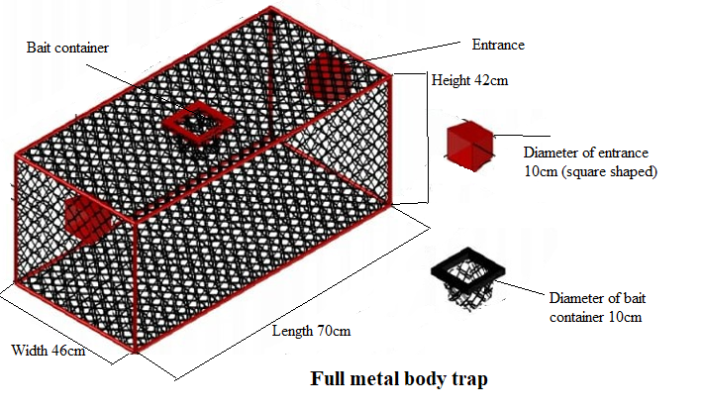
Fig.5- Full Metal Body Trap

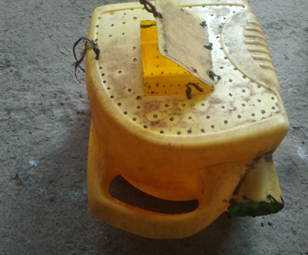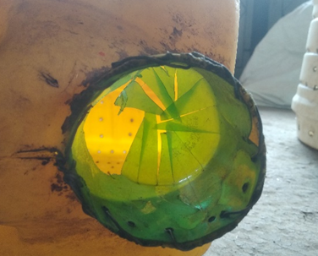
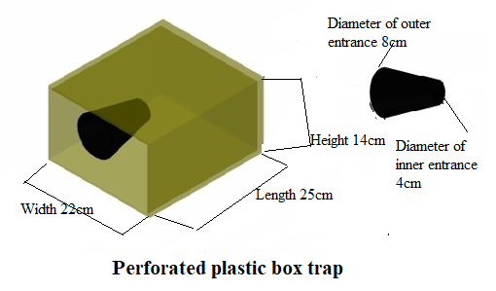

Fig. 6. Perforated Plastic Box Trap

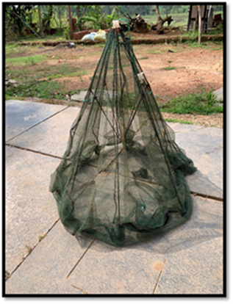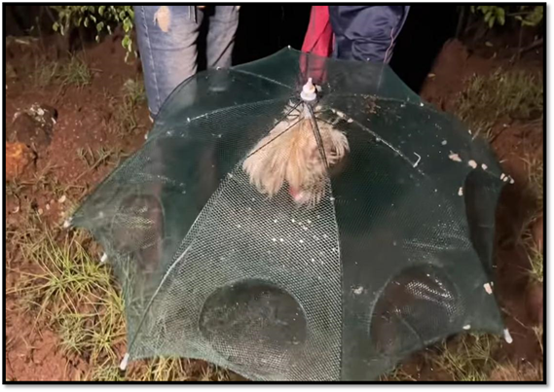
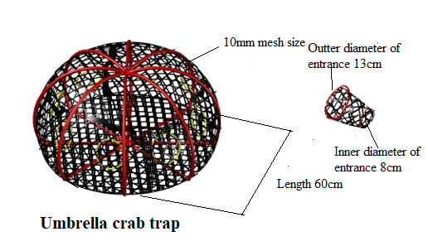
Fig. 7. Umbrella Crab Trap

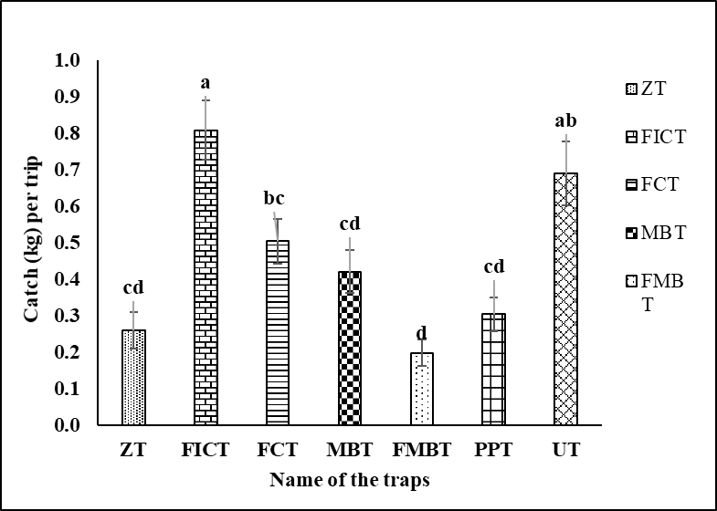
Fig. 8. Catch (kg) rate of the traditional traps

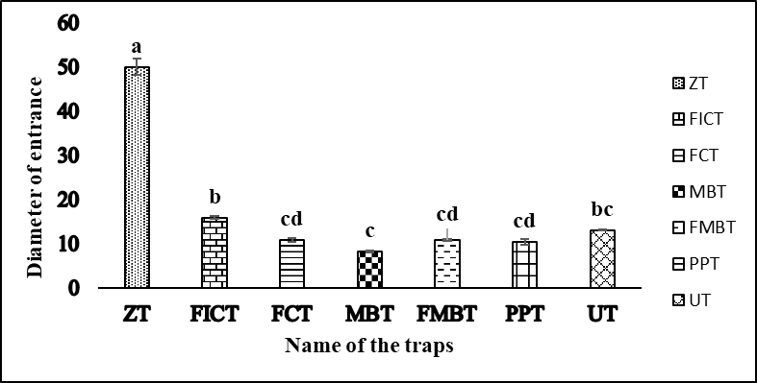
Fig. 9. Diameter of entrance of the traditional traps

Plate 5.1.1 Ring trap (Zile) found in Ratnagiri

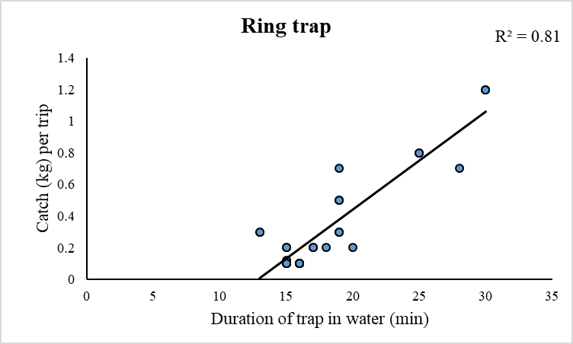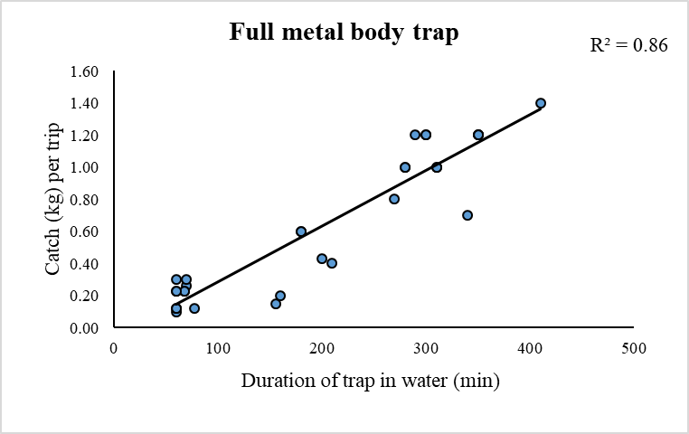
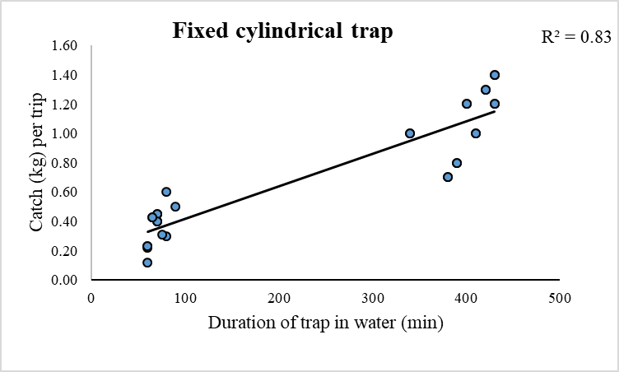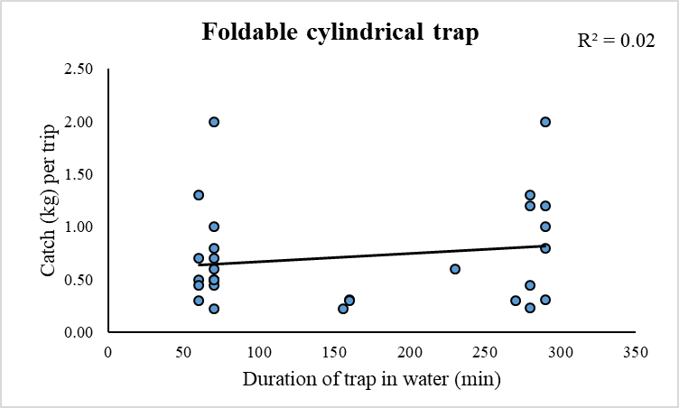
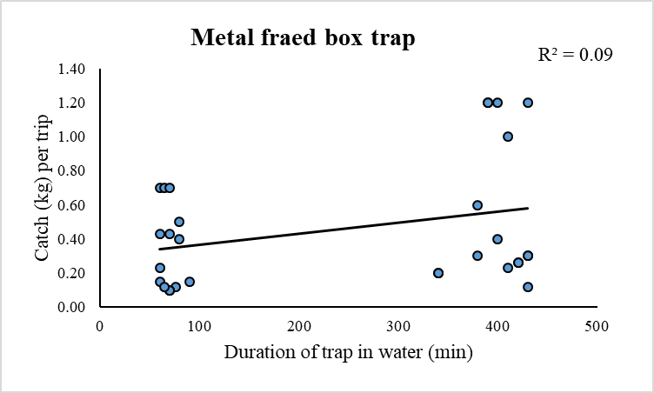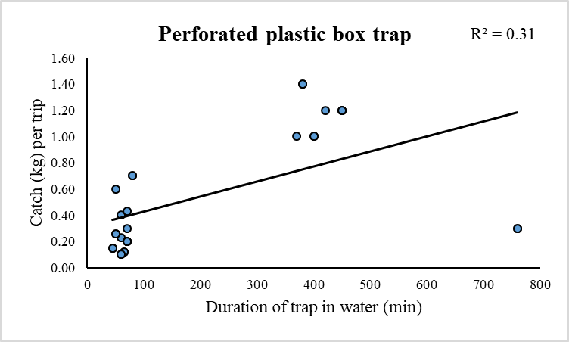
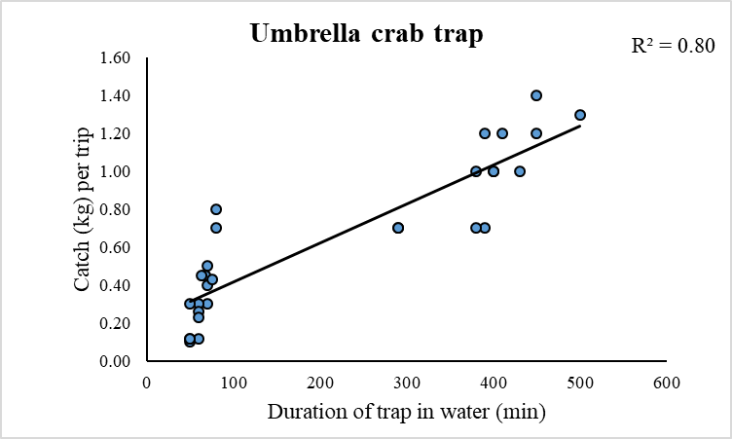

Fig. 10: Relation between catch (kg) per trip and duration of trap in water (min)
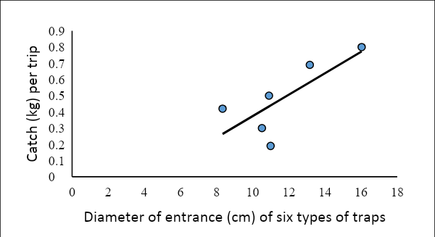

Fig. 11 - Relation between catch (kg) per trip and size of entrance (cm)

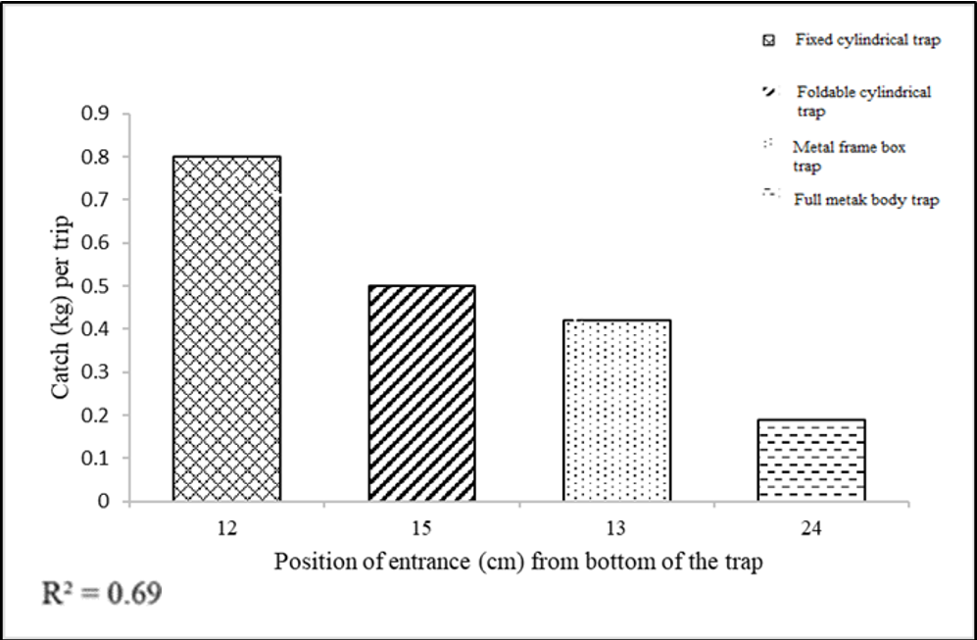
Fig. 12. Relation between catch (kg) per trip and position of entrance from the bottom of the trap (cm)

