Case report
Maternal Survival Following Clostridium septicum Sepsis in Pregnancy:
A Rare Case Report

.

ABSTRACT

Aims:
Clostridium Septicum sepsis in pregnancy is exceedingly rare and highly fatal, with only two previously reported maternal survivors. We present a third case, highlighting the importance of early recognition, aggressive management, and multidisciplinary care which ultimately led to a full recovery.
Presentation of Case:
A 30-year-old Gravida 4 Para 3 Indonesian woman presented with abdominal pain, heavy bleeding, and prolonged leaking liquor. Initial assessment suggested septic miscarriage with possible abruptio placenta. On admission, she developed pyrexia, metabolic acidosis, and coagulopathy. Emergency hysterotomy was performed due to worsening hemodynamic status. Despite surgical intervention, the patient developed toxic shock syndrome with multiorgan failure. Blood cultures confirmed Clostridium septicum. She received intensive care support, blood product transfusions, and escalation of antimicrobials with ceftriaxone, metronidazole, clindamycin, and micafungin. Multidisciplinary management by infectious disease, surgical, nephrology, orthopedic, maxillofacial, neurosurgery, and rehabilitation teams guided her to full recovery.
Discussion:
C. Septicum’s virulence arises from toxin production and aerotolerance, often causing rapid systemic deterioration. Early recognition, prompt surgical source control, intensive care, and multidisciplinary collaboration are essential for survival. The patient’s young age and absence of comorbidities likely contributed to her survival.
Conclusion:
Survival from C. Septicum sepsis in pregnancy is possible with timely recognition, immediate empirical antibiotics, prompt surgical intervention, intensive monitoring, and coordinated multidisciplinary care. This case contributes to the limited literature and underscores strategies for managing this rare, life-threatening infection.

Keywords: clostridium se@pticum; survival; pregnancy; toxic shock syndrome

1. INTRODUCTION

Clostridium Septicum sepsis is rare but associated with an extremely high death rate of at least 80% without appropriate treatment [1-3]. Reports suggest an occurrence rate of 0.5–2.0% in overall blood culture isolates, with Clostridium perfringens being the most commonly isolated species [1]. C Septicum is even less commonly isolated [1]. To date, there are only 2 reported cases of a pregnant woman who survived the C. Septicum sepsis. [1,4]. We present a third case of a pregnant woman who survived C. Septicum sepsis through early recognition, intensive care, aggressive management, and multidisciplinary collaboration.

2. presentation of case
A 30-years-old Gravida 4 Para 3 Indonesian female presented to a private clinic with abdominal pain, heavy bleeding with unsure period of gestation. She had no prior antenatal check-up and no known past medical history. On initial presentation, the blood pressure was normal (108/67mmHg) but mildly tachycardic (92bpm). No fetal heart activity seen on the abdominal scan. A diagnosis of intrauterine death with possible abruptio placenta was entertained. The patient was transferred to our hospital for further assessment and management.
She gave a history of leaking liquor for the past 10 days, but did not seek any medical attention. Her temperature was 38’c on arrival. Blood pressure was 105/63mmHg, while pulse remains normal 84bpm with pain score of 7. Abdominal examination revealed a 20 weeks size uterus, soft with no sign of peritonism. Speculum examination revealed an open external os, draining foul-smelling fluid with some bleeding. A bedside abdominal and pelvic ultrasound revealed a single intrauterine pregnancy corresponding to a gestational age of 17 to 18 weeks, with an estimated fetal weight of approximately 204 grams. The fetal heart activity was present. No obvious subchorionic haemorrhage and the placenta was located anterolaterally. Her initial WBC count was 14600 cells/µL with neutrophils predominant, haemoglobin was 9.8 gm/dL, platelet count was 216000 cells/µL, serum C Reactive protein was 12.4 mg/L, serum lactate was 3.3 mmol/L, serum potassium level was 3.2mmol/L, serum calcium level was 2 mmol/L and serum magnesium level was 0.56 mmol/L. Blood gas showed pH of 7.35, partial carbon dioxide was 24 mmHg and HCO3 was 13.2mmol/L. The other parameters for renal function, liver function and coagulation profile were within normal limits. Urine and blood cultures were drawn and sent for analysis.
A diagnosis of inevitable septic miscarriage with metabolic acidosis was made. Management of sepsis was in accordance with Identification and Management of Maternal Sepsis During and Following Pregnancy, Green-top Guideline No. 64. She received fluid resuscitation and intravenous cefuroxime 1.5g stat and 8hourly and intravenous metronidazole 500mg stat and 8hourly, a regimen we commonly used as a broad-spectrum antibiotic in dealing with sepsis in obstetrics and gynaecology in our local setting. She continued to have heavier bleeding per-vaginally with an estimated blood of 1300mls. A repeated bedside ultrasound showed no fetal heart motion with retroplacental clots seen. Decision for delivery was made and induction started with oxytocin infusion. Despite of adequate fluid resuscitation, her lactate level rose to 5.05 mmol/L, HCO3 was 11.5 mmol/L, haemoglobin was 9.7 gm/dL, platelet count was 127000 cells/µL, and the coagulation profile was deranged.
A revised diagnosis of inevitable septic miscarriage with concomitant abruptio placenta complicated with disseminated intravascular coagulation (DIVC) with metabolic acidosis was established. Intravenous cefuroxime was escalated to intravenous ceftriaxone 2g stat and 1g once daily, maintaining the metronidazole. The patient was assessed by the anaesthetic team, who proceeded with endotracheal intubation and facilitated her transfer to the intensive care unit for ongoing close monitoring and supportive management. Blood products were transfused, with total of 6pints packed cells and 2 cycle of DIVC regime. After 4hours of induction, repeated blood investigations showed transaminitis and acute kidney injury. Emergency hysterotomy and B -lynch sutures was performed in view of worsening blood parameters with no cervical progression.
Despite the surgical intervention, the patient's condition deteriorated, and she developed toxic shock syndrome with multiorgan failure, which was co-managed with the medical, surgical, orthopedic, maxillofacial, and nephrology teams. Due to poor GCS recovery on day 7, a brain CT was performed that revealed left frontal subarachnoid hemorrhage (SAH) secondary to DIVC that was managed conservatively by the neurosurgical team (Figure 1). A later CT brain, repeated on day 16 of admission, revealed resolving SAH (Figure 2).
On day 2 of admission, preliminary culture showed gram positive rod (Figure 3). On consultation with the infectious disease team, intravenous Clindamycin 900mg 8 hourly was added to the antibiotic’s regime. Formal blood culture came back as Clostridium Septicum on day 4 of admission. Later intravenous micafungin 100mg once daily was added to the treatment regime. She was administered with total 7days of intravenous metronidazole, 14days of intravenous ceftriaxone, 12days of intravenous clindamycin and 10days of intravenous micafungin. Deep venous thromboembolism prophylaxis was started once the patient’s condition improved and was continued until she was discharged.
She regained full GCS on day 17 of admission and was extubated on day 23 and transferred out to general ward. She received dedicated care from multiple discipline including occupational therapy, physiotherapy and rehabilitation teams. She fought through toxic shock syndrome and multi-organ failure and successfully discharged home in full recovery after 43 days of hospitalization.
On day 49, she was seen in the outpatient clinic and was recovering well and will have her subsequent follow-up in Indonesia.
3. discussion
C. septicum is a motile, Gram-positive, spore-forming bacillus. Its motility and production of α-, β-, γ-, and δ-exotoxins confer significant virulence to this organism in the manifestation of disease. The α-toxin is responsible for tissue necrosis and haemolysis [5]. C. septicum can produce spontaneous or remote myonecrosis in the absence of prior trauma [5]. The hypoxia and acidity of the tumor environment is favourable toward spore germination and subsequent active infection [5]. Clostridium septicum sepsis is rare but associated with an extremely high death rate of at least 80% without appropriate treatment [1-3]. Reports suggest an occurrence rate of 0.5–2.0% in overall blood culture isolates, with Clostridium perfringens being the most commonly isolated species [1]. C septicum is even less commonly isolated [1]. This organism is more aerotolerant compared to C. Perfringens, allowing in to infect healthy individuals [6]. C. septicum infections are associated with cyclic neutropenia, immunosuppression, diabetes mellitus and arteriosclerosis [7,8]. There is a strong association between C. Septicum infection and colorectal and haematological malignancy [7,8].
The literature regarding C. Septicum infection in pregnancy is very limited. To our knowledge, there were two cases of survival of C.Septicum infection in pregnancy prior to our case [1,4]. McDonald RE, Moola S. (2012) described a 21-year-old at 7 weeks gestation who developed septic shock secondary to septic abortion. She was managed according to the 2008 International Guidelines for Management of Severe Sepsis and Septic Shock; prompt intravenous antibiotics combined with surgical evacuation to remove the nidus of infection resulted in patient survival [1]. Rimawi et al. (2014) reported the first patient in the postpartum period following an uncomplicated caesarean delivery complicated by necrotizing fasciitis and toxic shock syndrome. Despite survival, the morbidity was considerable, as she required a hysterectomy and extensive wound debridement [4].
Our case adds to the limited literature on C. Septicum in pregnancy, let alone surviving this infection. To our knowledge, this is the third reported maternal survivor worldwide, and importantly, this patient’s survival was achieved without hysterectomy or radical surgical intervention. This patient’s outcome highlights several key learning points.
First, early recognition and immediate treatment is crucial. Following the diagnosis of septic miscarriage, the patient received prompt fluid resuscitation and empirical broad-spectrum antibiotics, in accordance with the Identification and Management of Maternal Sepsis During and Following Pregnancy, Green-top Guideline No. 64, even prior to culture confirmation [9].
Second, the role of prompt surgical source control. Prudent identification, immediate treatment, and removal of the nidus of infection are considered to be most effective in managing sepsis and preventing death in patients with C. Septicum infections [1]. Surgical intervention lowers this mortality rate by up to 50% [10].
This case highlights that, in instances of septic miscarriage accompanied by rapid hemodynamic deterioration, prompt surgical source control is preferable to medical induction of labour. In our patient, the attempted induction may have inadvertently prolonged the intrapartum period, allowed further systemic dissemination of infection and contributed to the progression toward toxic shock syndrome and multiorgan failure.
Third, the patient's young age and absence of comorbidities may have contributed to greater physiological resilience, in contrast to the majority of non-pregnant cases reported in the literature, which were commonly associated with multiple comorbidities and underlying malignancies [7,8].
A fourth critical factor contributing to the patient's survival was the timely provision of intensive care, supported by a multidisciplinary team comprising surgeons, infectious disease specialists, obstetricians, nephrologists, and general physicians during the acute critical phase. This was followed by coordinated care from occupational therapists, physiotherapists, and rehabilitation specialists during the recovery phase.

4. Conclusion
Clostridium Septicum infection in pregnancy is exceedingly rare, highly virulent, and often fatal. Surgical source control is preferable to induction of labour in case of rapid deterioration of haemodynamic status. Prompt initiation of empirical antibiotics effective against gram-positive rods should be initiated while awaiting culture confirmation. Early recognition, intensive care monitoring combined with aggressive management, and multidisciplinary collaboration are crucial for survival. This case contributes to the limited literature on maternal survival and highlights the importance of coordinated, timely care in managing this life-threatening infection.
DISCLAIMER (ARTIFICIAL INTELLIGENCE)

Author(s) hereby declares that NO generative AI technologies such as Large Language Models (ChatGPT, COPILOT, etc.) and text-to-image generators have been used during the writing or editing of this manuscript.

Consent

Informed written consent was taken from and preserved by the author(s) prior to the patient's return to Indonesia.

Ethical approval

It is not applicable.

COMPETING INTERESTS DISCLAIMER:
Authors have declared that they have no known competing financial interests OR non-financial interests OR personal relationships that could have appeared to influence the work reported in this paper.

References
- McDonald, R. E., & Moola, S. (2012). Clostridium septicum infection in a young pregnant patient. BMJ case reports, 2012, bcr2012006254. https://doi.org/10.1136/bcr-2012-006254.
- Van Lelyveld-Haas, Lenneke & Tjan, David & Van Zanten, Arthur. (2006). Fatal Clostridium septicum infection in a young pregnant woman. The Netherlands journal of medicine. 64. 254-5.
- Koransky, J. R., Stargel, M. D., & Dowell, V. R., Jr (1979). Clostridium septicum bacteremia. Its clinical significance. The American journal of medicine, 66(1), 63–66. https://doi.org/10.1016/0002-9343(79)90483-2
- Rimawi, B. H., Graybill, W., Pierce, J. Y., Kohler, M., Eriksson, E. A., Shary, M. T., Crookes, B., & Soper, D. E. (2014). Necrotizing Fasciitis and Toxic Shock Syndrome from Clostridium septicum following a Term Cesarean Delivery. Case reports in obstetrics and gynecology, 2014, 724302. https://doi.org/10.1155/2014/724302
- Jessamy, K., Ojevwe, F. O., Ubagharaji, E., Sharma, A., Anozie, O., Gilman, C. A., & Rawlins, S. (2016). Clostridium septicum: An Unusual Link to a Lower Gastrointestinal Bleed. Case reports in gastroenterology, 10(2), 489–493. https://doi.org/10.1159/000448881
- Chew, S.S.B. and Lubowski, D.Z. (2001), Clostridium septicum and malignancy. ANZ Journal of Surgery, 71: 647-649. https://doi.org/10.1046/j.1445-1433.2001.02231.x
- Kennedy, C. L., Krejany, E. O., Young, L. F., O'Connor, J. R., Awad, M. M., Boyd, R. L., Emmins, J. J., Lyras, D., & Rood, J. I. (2005). The alpha-toxin of Clostridium septicum is essential for virulence. Molecular microbiology, 57(5), 1357–1366. https://doi.org/10.1111/j.1365-2958.2005.04774.x
- Mao, E., Clements, A., & Feller, E. (2011). Clostridium septicum Sepsis and Colon Carcinoma: Report of 4 Cases. Case reports in medicine, 2011, 248453. https://doi.org/10.1155/2011/248453
- Identification and Management of Maternal Sepsis During and Following Pregnancy, Green-top Guideline No. 64. https://doi.org/10.1111/1471-0528.18009
- Ellie J. C. Goldstein, Daniel A. Anaya, E. Patchen Dellinger, Necrotizing Soft-Tissue Infection: Diagnosis and Management, Clinical Infectious Diseases, Volume 44, Issue 5, 1 March 2007, Pages 705–710, https://doi.org/10.1086/511638

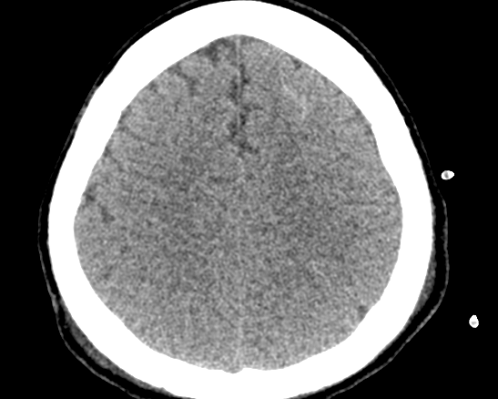
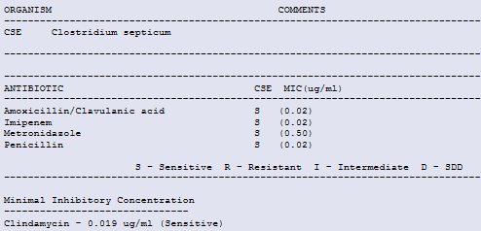
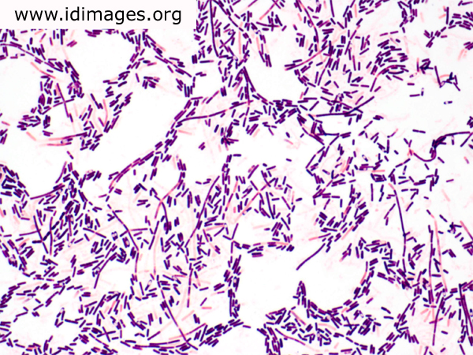
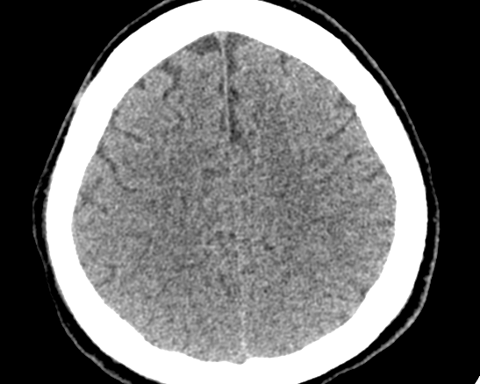
APPENDix
Figure 1: CT Brain (day 7) showed frontal lobe SAH

Figure 2: CT Brain (day 16) showed resolving frontal lobe SAH

Figure 3: Gram-positive rods on Gram stain
Figure 4: Formal report of blood culture confirmed Clostridium septicum

