Case Report

An incidental diagnosis of Krukenberg’s Tumor: Exploration beyond the Ovaries

.
ABSTRACT:

Krukenberg’s tumor are characterized by bilateral ovarian enlargement and a nodular pattern of infiltration on radiology in the absence of which there is usually no suspicion. The symptoms of the disease may be obscured and overshadowed by uterine leiomyomas. Under such circumstances, histopathology emerges as the sole hero which not only rescues the patient but also dictates the management and prognosis. Having said that, it is also essential to exclude its mimics especially tumor with mucinous differentiation using ancillary techniques like special stains, immunohistochemistry and previous historical details.

Keywords: Leiomyoma, Ovary, Krukenberg’s tumor

Introduction
Krukenberg’s tumor (KT) is defined as a metastatic signet-ring cell adenocarcinoma of the ovary morphologically characterized by mucin-rich signet-ring cells from gastrointestinal primary (70% of cases) and less commonly from colon, breast, appendix, and biliary tract primaries. The incidence rate in Asian countries is 1% to 21%. ^{[1]}The route of spread is commonly via lymphatics but can be hematogenous or through direct invasion, depending on the proximity of the primary cancer to the ovaries and lymph nodes.^{[2]} On occasion, the primary tumor is not found at all whilst in some scenarios, KT precedes the diagnosis of primary malignancy. KTs can be synchronous, where the metastasis is discovered within 3 months of the diagnosis of the primary tumor, or metachronous, where the metastasis is found after 3 months, frequently after the completion of initial therapy^{[3]} Radiological examination helps in early detection but the confirmation and ultimate diagnosis is obtained on histopathology.^{[3,4]} The case we present here is an incidentally detected krukenberg tumor, involving the entire uterus, uterine leiomyomas, bilateral ovaries and fallopian tubes without any gross enlargement or cystic change in ovaries. The patient was operated to alleviate the symptoms associated with multiple uterine fibroids detected on ultrasound. She underwent total abdominal hysterectomy with removal of both the adnexa along with myomectomy.

Case report
A 48 year old female was operated for total hysterectomy with bilateral salpingo-oophorectomy and the biopsy specimen was received for further histopathological examination. Grossly, the uterus was enlarged and measured 18x15x8cm. The endometrial cavity was dilated and filled with blood clots. Multiple intramural, subserosal and submucosal fibroids were identified varying in size from 1.0cm to 8.0cm, predominantly having a grey white firm whorled cut surface with focal hemorrhagic areas. (Figure 1)Right and left ovaries were normal in size, measured 3.0cm and 2.8cm in largest dimension respectively. Cut section was unremarkable. (Figure 2a, b)Both right and left fallopian tubes measured 4.0cm and 3.5cm respectively and were unremarkable too. Microscopic examination revealed a diffuse infiltration of endometrial stroma, myometrium, cervical stroma and all the fibroids by tumor cells arranged in cords, trabeculae and occasional sheets. (Figure3a, b)The tumor cells were predominantly monomorphic with moderate amount of clear to light basophilic cytoplasm, orthochromatic nuclei with inconspicuous nucleoli. Sections from both side ovaries and fallopian tubes revealed signet ring cells. (Figure 2c,d) Alcian blue staining at Ph 2.5 confirmed intracellular mucin in tumor cells. Mitotic activity was brisk. Lymphovascular emboli were seen (Figure 3c). The native tissue stroma was preserved variably and identifiable in all sections. On the basis of these findings, a diagnosis of diffuse involvement of female genital tract by a metastatic signet ring carcinoma was suggested. Following the diagnosis, a whole body CT scan was done which revealed multiple lytic/sclerotic lesions in ribs, vertebra and pelvic bones along with a bulky left adrenal gland consistent with metastasis. In addition to this, an asymmetric circumferential mural thickening was seen in the proximal jejunum along with suspicious soft tissue densities in bilateral retroareolar regions. The patient refused any further intervention and was referred to an oncology centre for further treatment and evaluation.

Figures & Images

Figure 1: Gross photograph of the specimen showing endometrial cavity filled with blood (red star), endometrial polyp (green arrow), intramural fibroid (blue star) and cervix (black arrow)

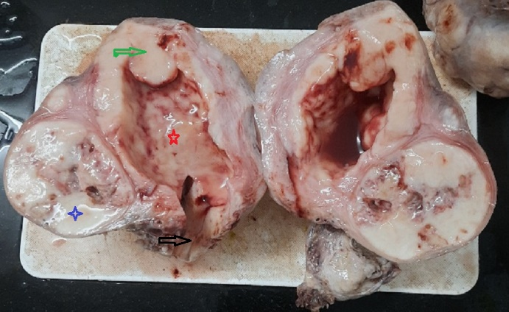

Figure 2: Gross photographs of right (a) and left (b) ovaries (black arrows) and fallopian tubes (red arrow) showing an unremarkable cut surface and normal size. High power view showing signet ring cells in section from ovary (c, black arrow) and tumor cells underneath ciliated columnar epithelium of fallopian tube(d, red arrow), 400X H&E
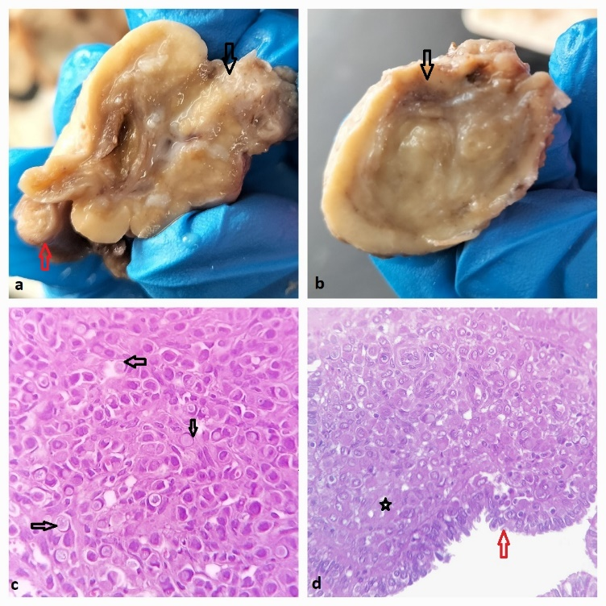

Figure 3: High power view of tumor cells in an infiltrating pattern in a) intramural fibroid and b) submucosal fibroid (red arrow showing the endometrial lining) along with c) lymphovascular tumor emboli (red arrow) (H&E 400X) . d) High power view showing tumor cells positively stained with Alcian blue (Alcian blue ph 2.5 400X)
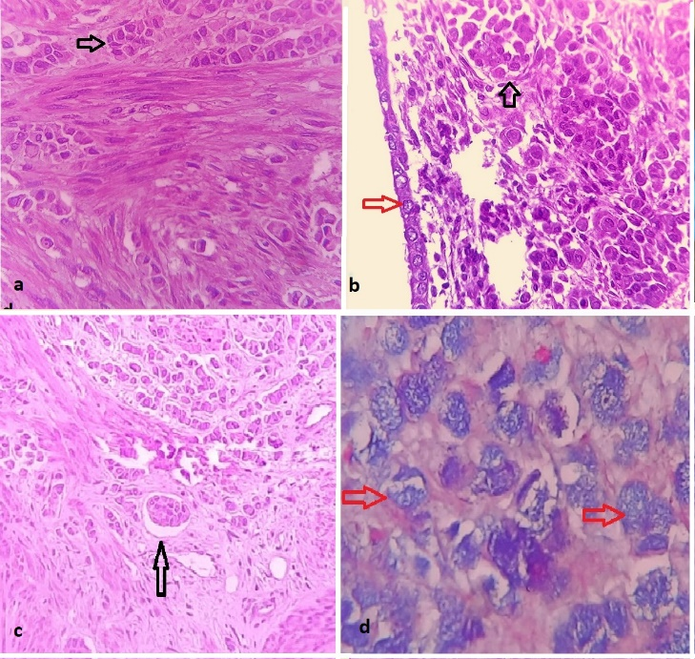
Discussion
The World Health Organization defines Krukenberg tumors as ovarian carcinomas characterised by the presence of stromal involvement, mucin-producing neoplastic signet ring cells, and ovarian stromal sarcomatoid proliferation. ^{[1]} The median age of patients at diagnosis is 48 years (range, 27–65 years). The younger age of a typical patient diagnosed with KT corresponds to a robust blood supply to the ovaries, supporting a mechanism for hematogenous spread. Moth-eaten ovaries with cystic formation on ultrasound is considered a characteristic feature of KT. ^{[1]} This case is unique because of the way it presented and the extent of metastasis which was detected incidentally on histopathology in a completely asymptomatic patient who had undergone surgery to alleviate the pain associated with multiple uterine fibroids. Secondly it is also unusual to find normal sized ovaries in case of Krukenberg’s tumor. Had there been any enlargement or nodularity, it shall not have gone unnoticed in the ultrasound. There are reports of incidentally detected krukenberg’s tumor in pregnant patients at the time of delivery or post-delivery because the enlarged ovaries were masked by the gravid uterus ^{[2,3]} During pregnancy, the hormonal milieu can facilitate cancer spread. Placental growth factor levels are elevated in gastric cancer and are associated with serosal invasion and lymph node metastases. In addition, the state of pregnancy may delay the cancer diagnosis as the enlarging abdomen is attributed to the pregnancy.^{[4,5]} But in our case, there was no ovarian enlargement or cystic change which could be picked on an ultrasound. The signs and symptoms of Krukenberg tumour are nonspecific and overlap with those of uterine fibroids. They include increased abdominal girth, fatigue, abdominal and pelvic pain and abnormal uterine bleeding. Ultrasound reveals solid, cystic, or mixed bilateral ovarian masses featuring well-defined margins. The main differential diagnoses of KT are primary stromal tumors of ovary with signet ring cell change, clear cell adenocarcinoma and primary ovarian mucinous carcinoma. ^{[4]} They have different radiological and histological features in comparison to KTs. On ultrasound, KTs appear as cystic, or mixed solid cystic bilateral ovarian masses with well-defined margins and a moth-eaten cystic appearance. In contrast, primary ovarian tumors tend to be poorly demarcated and show irregular thick septations^{. [6,7]} On histology, KTs show an infiltrative pattern unlike primary ovarian tumors which shows a diffuse or expansile pattern of involvement. ^{[7]} Signet ring cells in ovarian stromal tumors are negative for mucin, glycogen or fat and non-reactive for AB-PAS stain whereas the intracytoplasmic mucin of signet ring cells in KT are neutral and acidic and stain with Mayer mucicarmine, periodic acid-Schiff-Alcian blue stain with diastase digestion.^{[1]} Presence of lympho vascular emboli is another feature favoring metastasis. The basis for treatment in KT includes systemic chemotherapy and cytoreductive surgery. Because KT is thought to be more chemoresistant than metastases in other sites, metastasectomy allows for greater efficacy of chemotherapy for the remaining disease burden ^{[8.9]}

Conclusion
Thus, in the current case, there was no ovarian enlargement or cystic change which could be picked on an ultrasound. The only noteworthy finding was multiple uterine fibroids, hence, differential diagnosis of Krukenberg’s tumor becomes crucial as they may be asymptomatic and often mimic fibroids. Scenarios like this prove that pathologists with histopathology as a tool in their hands carve a path that navigates the clinician in the right direction of patient care and management.

Informed patient consent
Informed patient consent is taken from all patients as part of the test requisition form [TRF]

COMPETING INTERESTS DISCLAIMER:
Authors have declared that they have no known competing financial interests OR non-financial interests OR personal relationships that could have appeared to influence the work reported in this paper.

References

- Aziz M, Killeen RB, Kasi A. Krukenberg Tumor. [Updated 2023 Feb 21]. In: StatPearls [Internet]. Treasure Island (FL): StatPearls PublishiZulfiqar M, Koen J, Nougaret S, Bolan C, VanBuren W,
- Zulfiqar M, Koen J, Nougaret S, Bolan C, VanBuren W, McGettigan M, Menias C. Krukenberg Tumors: Update on Imaging and Clinical Features. AJR Am J Roentgenol. 2020 Oct;215(4):1020-1029. [PubMed] (ultrasound)
- Mendoza-Rosado F, Nunez-Isaac O, Espinosa-Marrón A, Lopez-Arjona K, Davila-Martinez F. Krukenberg tumor as an incidental finding in a full-term pregnancy: a case report. J Med Case Rep. 2021 May 29;15(1):304. [PMC free article] [PubMed]
- Yongke Zhang, Hui Du, Taili Li, Huan Li, Yuqing Deng, Ruifang Wu; Krukenberg Tumor of Gastric Origin in Pregnant Women with Preeclampsia. Case Rep Oncol 2023;16 (1):718–727
- Jha S, Mitra S, Patra S, Sethi P, Jena SK. Krukenberg Tumor of Ovary During Pregnancy: Learning From A Mistake. Int J Gynecol Pathol. 2021 Nov 01;40(6):617-620.
- Goidescu IG, Nemeti G, Preda A, Kovacs T, Surcel M, Eniu DT, Cruciat G, Mureșan D. Krukenberg tumor in pregnancy: a rare case and review of the literature. J Matern Fetal Neonatal Med. 2022 Dec;35(25):7290-7295. [PubMed]
- Dundr P, Singh N., Nožičková B. et al. Primary mucinous ovarian tumors vs. ovarian metastases from gastrointestinal tract, pancreas and biliary tree: a review of current problematics. Diagn Pathol 2021;16:20Fang J, Huang X, Chen X, Xu Q, Chai T, Huang L, Chen H, Chen H, Ye Z, Du Y, Yu P. Efficacy of chemotherapy combined with surgical resection for gastric cancer with synchronous ovarian metastasis: A propensity score matching analysis. Cancer Med. 2023 Aug;12(16):17126-1713.
- Cho JH, Lim JY, Choi AR, Choi SM, Kim JW, Choi SH, Cho JY. ERRATUM: Comparison of Surgery Plus Chemotherapy and Palliative Chemotherapy Alone for Advanced Gastric Cancer with Krukenberg Tumor. Cancer Res Treat. 2018 Jan;50(1):302.

