Molecular Identification of Blast Resistance Gene in Some Elite Rice (Oryza Sativa L.) Land Races and Varieties

.
ABSTRACT

Background: The greatest challenge facing rice productivity in rice producing regions of the World is the occurrence of blast diseases cause by Piricularia Oryzae. In reaction, affected plants develop disease resistance strategies one of which is the expression of resistance genes by systemic defence.
Aim: To identify resistance controlling gene (piz-6) against blast disease in two conventional cultivars (faro 67 and 44) and three elite landraces (CHI, IRON and C-Price). T
Study Design: The study involved laboratory experiment using PCR technique.
Place and Duration of Study: Two varieties of upland rice faro 44 and faro 67 were sourced from National Cereals Research Institute, Badeggi, Niger State, Nigeria while the three landraces (C-price, CHl and IRON) were obtained from Abakiliki, Ebonyi State Nigeria bet July, 2024 to October 2024.
Methodology: Genomic DNA was extracted from fresh plant tissue using the Quick-DNA™ Plant/Seed Miniprep Kit (Inqaba, US) following the manufacturer’s protocol.DNA purity and concentration were determined using NanoDrop Spectrophotometer 2000C while PCR amplification of the rice genomes was carried out using the PCR master mix, OneTaq Quick-Load 2X Master Mix (New England Biolabs, US) with specific Primer, RM8225.
Results: DNA concentration ranged from 74.1 to 126.9ng/µl with a purity index (absorbance ratio) ranging from 1.73 to 1.79. The study detected blast resistance gene in one conventional variety; faro 44 and one landrace; CHI. A distribution frequency of 40% of the resistance gene was obtained in the entire varieties studied. The sequences of the two varieties revealed the presence of the allele for the resistance gene (piz-6).
Conclusion: The findings of this study have revealed that both conventional and landrace rice cultivars harbour blast resistance gene. However, there need for identification of more blast resistance genes in other varieties especially in our landraces and even the weedy relatives. The exploitation and utilization of new resistance genes in addition to the monitoring of virulence genes of blast fungus will better Aid understanding of resistance in rice defence mechanisms.
Keywords: Polymerase chain reaction (PCR), Blast resistance gene, Oryza saliva L., Molecular identification.

1. INTRODUCTION

Rice (Oryza sativa L.) is the most important staple food crop of the world. This is because it is the major source of calories of more than half of the total global population and occupies almost one-fifth of the total land area covered under cereals (Sasaki,1999; Vaughan et al, 2003). The centre of origin of rice is believed to be South East Asia for Oryza sativa and Africa for Oryza glaberrima (IRRI 2008). Rice belongs to the grass family Oryzeae and is one of the leading food crops in the world, especially in Asia, and it provides 20% of the per capita energy, and 13% of the protein consumed worldwide (Juliano,1994). Approximately 11% of the worlds arable land is planted with rice annually and ranks next to wheat. Rice is grown in more than 100 countries under widely differing climatic conditions and is particularly productive in tropical regions. However, one of the most significant factors in the vegetative and reproductive stages that hinders the growth and production of rice is arable soil salinity (Majakkir et al; 2015). Stalinization has a detrimental effect on agricultural production, farmers loving conditions, the economy at various levels and ecosystem balance including the quality of natural resources (FAO 2019).

Salinity decreases the ability of plants to absorb water, resulting in growth reduction. Mukta et al (2017) and Yichie et al (2018) reported that modern rice varieties are highly sensitive to salinity- thereby reducing the production of rice. Rice yield in salt affected land is significantly reduced with an estimation of 30-50% yield losses annually (Enyard et al 2005). Salinity can lead to sterility in rice, particularly if imposed during pollen development and fertilization, hence, high yielding salt tolerant rice varieties must have tolerance at the reproductive stage. Technologies that minimize the spread of salinization decrease salinity levels in crop fields or increase the salt tolerance of crops. To enhance the salt tolerance of crops, including rice, plants will have to undergo a variety of changes from physiological adaptations to gene expressions hence new genetic sources of tolerance (Khuat et al., 2017). Salinity tolerance breeding was possible after identifying Quantitative trait loci (QTLS) which allowed first integration of traits into modern high yielding varieties. Recent advancement in the field of molecular markers have made it possible to identify the individual salinity tolerance control genes which could promote rice selection especially for low inherited traits such as salinity (Aliyu et al, 2011). Saline tolerance of rice is derived from the genes that limit the rate of salt uptake from the soil, and transport the salt throughout the plants. This adjusts the ionic, and osmotic balance of cells in roots and shoots and regulate leaf development and the onset of senescence (Munns 2005). SRWD (salt responsive WD 40 protein genes have been identified to be involved in rice salt tolerance. The SRWD2 sub family is highly expressed in the ovary, embryo, endosperm and seed-(Huang et al., 2008). Other genes in rice have also been identified to confer salinity tolerance in rice such as salt-L, RSSL, SCKL, Saltol etc. it is then relevant to develop salt tolerant genotype(s) that can sustain optimum yield level in saline stressed environment. The aim of the study is to identify prospective genotypes tolerant to salinity by using SSR primers, screen the varieties for the presence of resistant gene-SRWD2.

2. MATERIALS AND METHODS
2.1. Study Location
Nursery-raised rice seedlings were transplanted into polybags and subsequently established in the field at the Teaching and Research Farm, Faculty of Agriculture, Imo State University, Owerri, Nigeria. The experimental site is situated within the southeastern rainforest agroecological zone, bounded by latitudes 4°45′N–7°15′N and longitudes 6°50′E–7°25′E (NIMET, 2009). The region is characterized by a humid tropical climate, with an average annual rainfall of approximately 2500 mm, mean relative humidity of 85%, and an annual temperature range between 26 and 28 °C (with mean at 27 °C). Leaf tissues were harvested from established plants after three months of growth and transported to the Biotechnology and Bioresources Research Centre, University of Port Harcourt, Rivers State, Nigeria, for subsequent molecular analyses.
2.2. Plant Material
Two improved upland rice varieties, FARO 44 and FARO 67, were obtained from the National Cereals Research Institute (Badeggi, Nigeria). In addition, three indigenous landraces, namely C-Price, CHL, and IRON, which were commonly cultivated in Abakaliki, Ebonyi State, Nigeria, were obtained from local farmers’ markets.
2.3. Genomic DNA Extraction
Genomic DNA was isolated from fresh leaf tissue of the five rice cultivars using the Zymo Quick-DNA Plant/Seed Miniprep Kit (Zymo Research, USA) following the manufacturer’s protocol with minor modifications. For improved cell lysis, β-mercaptoethanol was added into the genomic lysis buffer at a final concentration of 0.5% (v/v; 500 µL per 100 mL). Approximately 150 mg of finely cut leaf tissue was homogenized in 750 µL of BashingBead™ Buffer in a 1.5 mL microcentrifuge tube and centrifuged at 10,000 × g for 1 min. The resulting supernatant (400 µL) was transferred into a Zymo-Spin™ IIIF filter, centrifuged at 800 × g for 1 min, and the flow-through recovered. Thereafter, 1200 µL of Genomic Lysis Buffer was added, and the mixture passed through a Zymo-Spin™ IIC column at 10,000 × g for 1 min. DNA bound to the column was washed with 500 µL DNA Wash Buffer, and elution was carried out with 60 µL of DNA Elution Buffer.
DNA quality and concentration were determined using agarose gel electrophoresis (1.5%) and visualized under UV transillumination with the help of a Gel Documentation System (Cleaver Scientific Ltd, UK). Quantification and purity assessment were carried out on a NanoDrop 2000c spectrophotometer (Thermo Fisher Scientific, USA) at 260 nm, and the A260/A280 absorbance ratio was used to estimate DNA purity.
2.4. DNA Amplification by PCR
Polymerase chain reaction (PCR) was carried using the OneTaq® Quick-Load PCR Master Mix (New England Biolabs, USA) at a final reaction volume of 12.5 µL. The amplification conditions of initial denaturation at 94 °C for 5 min, followed by 35 cycles of denaturation at 94 °C for 30 s, annealing at 50 °C for 1 min, and extension at 72 °C for 2 min, with a final elongation at 72 °C for 5 min were used. The reactions were held at 4 °C until retrieval.
A single SSR primer pair (RM8225) targeting the rice blast resistance gene was used in this study, with the following sequences: forward 5′-ATGCGTGTTCA GAAATTAGG-3′ and reverse 5′-TTGTTGTATACCTCATCGACAG-3′, generating an expected amplicon size of ~200 bp (Hanafiah et al., 2012; Singh et al., 2020). Primers were custom-synthesized by Inqaba Biotec (West Africa). Primer specificity was validated in silico using the NCBI Primer-BLAST tool (http://www.ncbi.nlm.nih.gov/tools/primer-blast/) to minimize non-specific amplification.
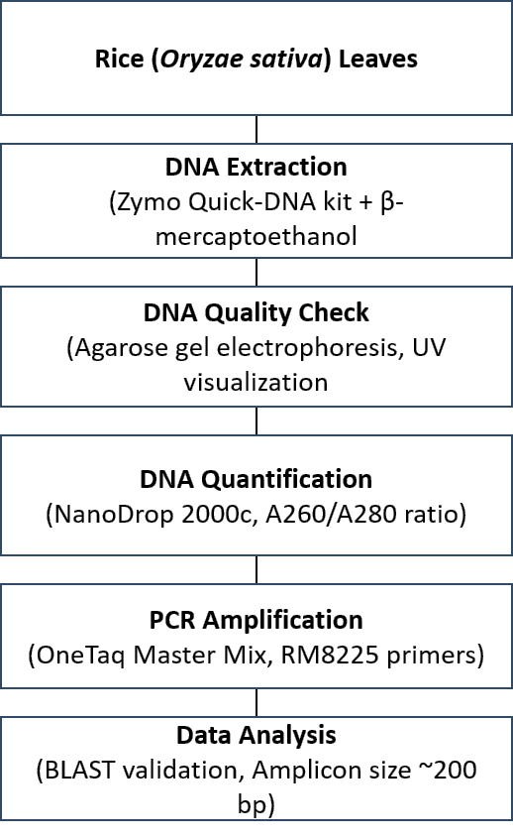
Figure 1: Workflow for molecular characterization of rice cultivars, including sampling, DNA extraction, quality assessment, quantification, and PCR amplification with RM8225 primers.
3. RESULTS AND DISCUSSION
3.1. DNA Isolation and Quality Assessment
High-molecular-weight gDNA was extracted successfully from the five rice cultivars used in this study. Visualization on a 1.5% agarose gel showed distinct, intact bands of DNA just below the wells, with minimal degradation and the absence of smearing (Figure 2). The presence of single, well-defined bands across all samples confirmed that the gDNA was of high integrity and suitable for downstream PCR amplification.

Spectrophotometric analysis further supported the gel electrophoresis results. DNA yields ranged between 71.4 and 126.9 ng/µL, while the A260/A280 ratios were between 1.73 and 1.79, consistent with high-quality DNA free of protein contamination (Table 1). These purity indices fall within the accepted range for molecular applications (1.7–2.0), confirming that the extracted DNA was of high quality sufficient for PCR analysis.

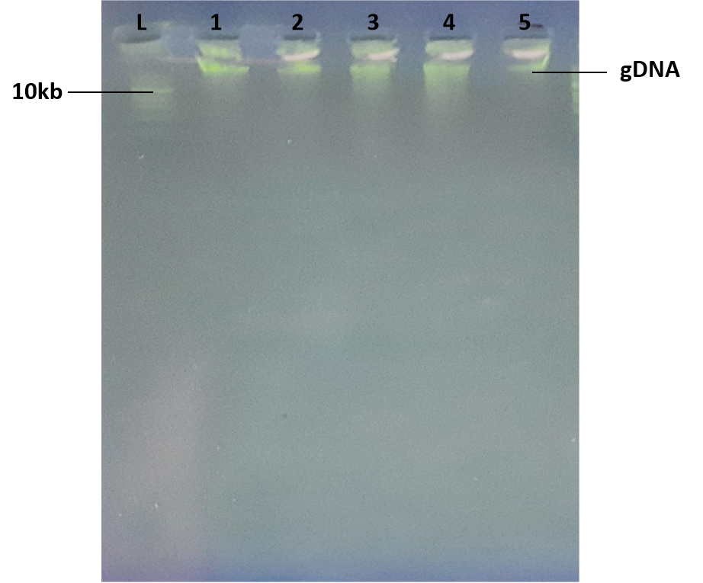
Figure 2. Agarose gel electrophoresis of genomic DNA from five rice varieties. Lane L: 1 kb DNA ladder; lanes 1–5: FARO 67, FARO 44, C-Price, CHI, and IRON, respectively.
Table 1. Quantitative and qualitative parameters of genomic DNA isolated from rice varieties.
S/N | Variety | DNA conc. (ng/µL) | A260 | A280 | A260/A280
1 | FARO 67 | 71.4 | 1.427 | 0.811 | 1.76
2 | FARO 44 | 95.6 | 1.912 | 1.105 | 1.73
3 | C-Price | 90.5 | 1.809 | 1.022 | 1.77
4 | CHI | 91.5 | 1.829 | 1.028 | 1.78
5 | IRON | 126.9 | 2.537 | 1.417 | 1.79
These findings are consistent with previous reports where optimized plant DNA isolation protocols yielded intact, PCR-grade DNA with comparable purity indices (Singh et al., 2020; Hanafiah et al., 2012).
3.2. Detection of Blast Resistance Genes
PCR amplification based on the SSR marker RM8225, targeting the blast resistance gene, Piz-6, generated distinct amplicons at approximately 200 bp in two of the five tested varieties (FARO 44 and CHI) (Figure 3). However, the other three cultivars (FARO 67, C-Price, and IRON) did not produce the expected resistant-specific band, suggesting absence of such gene-indicating susceptibility to blast disease.
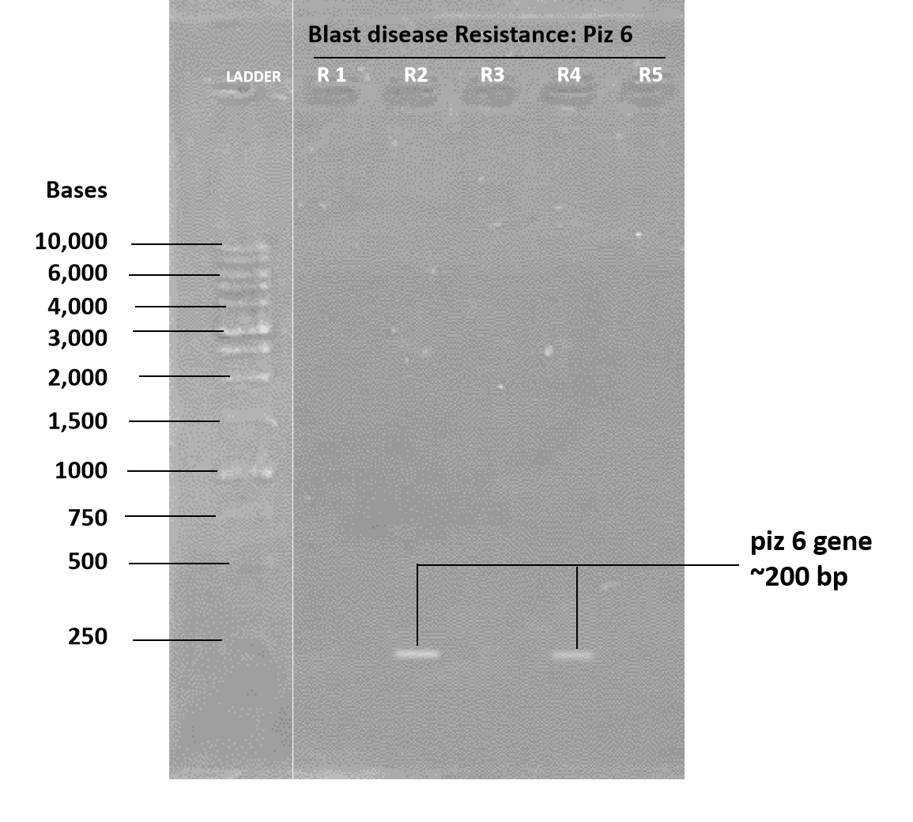
Figure 3. PCR amplification of the blast resistance gene Piz-6 (RM8225 primer) in rice. Lanes R1–R5 represent FARO 67, FARO 44, C-Price, CHI, and IRON, respectively. Resistant alleles amplified at ~200 bp.
Overall, 40% of the varieties harboured the Piz-6 gene, whereas 60% did not show any detectable resistance, highlighting considerable diversity in blast resistance within these cultivars. This uneven distribution of resistance genes corroborates previous studies reporting heterogeneity among rice accessions. For instance, Hanum et al. (2019) identified variable presence of Pidz, Pup1, Pita2, Pi37, Piz, and Pib genes across 15 rice accessions, with Pidz, Pi-z, and Pib consistently present, while Pup1 and Pita2 were observed at frequencies of 93% and 87%, respectively. In a similar study, Hanafiah et al. (2022) demonstrated that multi-locus PCR assays were sufficient to effectively discriminate resistant and susceptible alleles across several biotic stress markers, with band sizes ranging between 160 and 700 bp.
The current findings also agree with Susan et al. (2018), who reported regional variation in the frequency of 18 major blast resistance genes, reinforcing the view that gene distribution may be influenced by local adaptation and breeding history. The partial presence of Piz-6 among the tested Nigerian cultivars suggests that while some genetic resources carry effective resistance, others remain vulnerable, underscoring the importance of marker-assisted selection in breeding programmes.
4. Conclusion

This study was successful in isolating high-quality genomic DNA from five rice cultivars, evidenced by intact bands on agarose gel electrophoresis and Nanodrop spectrophotometric purity indices (A260/A280 between 1.73 and 1.79). The results demonstrate that the extracted DNAs were free of significant contaminants and of sufficient concentration for downstream molecular applications. PCR analysis using the SSR primer RM8225 identified the blast resistance gene Piz-6 in two of the cultivars, one improved variety (FARO 44) and one landrace (CHI), corresponding to 40% of the total accessions analyzed. The presence of Piz-6 in these cultivars suggests their potential as valuable donor parents for marker-assisted selection and breeding programmes targeting blast resistance in rice production systems. When such resistant germplasm is incorporated into breeding pipelines, they can enhance the development of novel rice varieties well-adapted to blast-infested fields, thus contributing to improvement of rice yield and ultimately food security in affected regions.

Consent (where ever applicable)

Not applicable

COMPETING INTERESTS DISCLAIMER:
Authors have declared that they have no known competing financial interests OR non-financial interests OR personal relationships that could have appeared to influence the work reported in this paper.

References

Collard, B. C. Y., & Mackill, D. J. (2008). Marker-assisted selection: An approach for precision plant breeding in the twenty-first century. Philosophical Transactions of the Royal Society B: Biological Sciences, 363(1491), 557–572.
Gouda, P., Sakumar, S., Varma, C., Nagesh, K., Thipperwamy, S., Sishenoy, V., Ramesha, M., Shashidha, H., & Ahn, S. (2013). Marker-assisted breeding of Pi-1 and Piz-5 genes imparting resistance to rice blast in PRR78, restorer line of Pusa RH-10 basmati rice hybrid. Plant Breeding, 132(1), 60–69.
Hanum, S., Ummu, K. H., Riyanto, S., & Hestior, T. (2019). Identification of blast resistance genes in fifteen rice accessions (Oryza sativa L.) from North Sumatra. IOP Conference Series: Earth and Environmental Science, 305(1), 012076.
Khush, G. S., & Jena, K. K. (2009). Current status and future prospects for research on blast resistance in rice (Oryza sativa L.). In G. L. Wang & B. Valent (Eds.), Advances in genetics, genomics and control of rice blast disease (pp. 1–10). Dordrecht: Springer.
Liang, Y., Yang, T. L., Wen, T., Wu, J., Jiang, N., Li, Z., Dai, L., Wang, G., & Liu, X. (2013). Development of a molecular marker tightly linked with the broad-spectrum blast resistance gene Pi9 and its breeding practice in rice. Hybrid Rice, 28(3), 63–74.
Liu, R., Liu, B., Zhu, X., et al. (2013). Fine mapping and molecular characterization of Pi56(t), a NBS-LRR gene conferring broad-spectrum resistance to Magnaporthe oryzae in rice. Theoretical and Applied Genetics, 126(4), 985–998.
Mohd Hanafiah, D. S., Mispan, N., Lim, M. S., & Baisakh, N. (2021). Low-cost, high-resolution genotyping assay for detecting multiple biotic stress resistance genes in rice (Oryza sativa). Plant Omics Journal, 14(2), 57–63.
Ogunbayo, S. A., Ojo, D. K., Geui, R. G., Oyelakin, O., & Sanni, K. A. (2005). Phylogenetic diversity and relationships among forty rice accessions using morphological and RAPD techniques. African Journal of Biotechnology, 4(11), 1234–1244.
Ribot, C., Hirsch, J., Balzergue, S., et al. (2008). Susceptibility of rice to the blast fungus Magnaporthe grisea. Journal of Plant Physiology, 165(1), 114–124.
Sanni, K. A., Fawole, I. A., Ogungbayo, S. A., Tia, D. D., Somado, E. A., Futakuchi, K., Sie, M., Nwilere, F. E., & Guei, R. G. (2012). Multivariate analysis of diversity of landrace rice germplasm. Crop Science, 52(2), 494–504.
Scheuermann, K., & Jia, Y. (2016). Identification of a Pi9-containing rice germplasm with a newly developed robust marker. Phytopathology, 106(7), 871–876.
Susan, A., Vadar, M. K., Kar, S., Aravidan, S., Ngangkham, U., et al. (2018). Molecular identification of blast resistance genes in rice landraces from north-eastern India. Plant Pathology, 68(3), 537–546.
Talbot, N. J. (2003). On the trail of a cereal killer: Exploring the biology of Magnaporthe grisea. Annual Review of Microbiology, 57, 177–202.
Yadav, M. K., Aravindhan, S., Ngangkham, U., et al. (2017). Use of molecular markers in identification and characterization of resistance to rice blast in India. PLoS ONE, 12(7), e0179467. https://doi.org/10.1371/journal.pone.0179467
Liang Yan, L., Yuan, Y. B., Liang, P. Y., et al. (2017). Molecular screening of blast resistance genes in rice germplasm resistant to Magnaporthe oryzae. Rice Science, 24(1), 41–47.

