Economic Evaluation of IoT-Based Irrigation Systems in South Korea

Abstract :
Rice, in particular, serves as a staple food for more than half of the global population and requires a substantial amount of water for cultivation. However, the increasing water demand in rice-producing countries, coupled with limited supply, poses a serious threat to food security. This study aims to examine the design and applicability of IoT-based smart irrigation systems and to propose approaches that can simultaneously improve agricultural water and energy efficiency. In this study, the paddy rice cultivation area and farmland area by province in South Korea in 2024 were investigated, and their effects on polished rice yield were analysed. The frequency of water management per week was less than three times in 37% of farms, three to six times in 39%, and six times or more in 10.5%, indicating that most farmers manage irrigation approximately three to six times weekly. Conventional rice cultivation practices have relied on continuous flooding of the entire paddy field. In contrast, IoT-based smart irrigation systems (MIS) employ soil moisture sensors, water-level sensors, automated valves, and remote monitoring systems to assess field moisture conditions and weather in real time, enabling optimized irrigation tailored to crop growth stages. IoT-based smart irrigation systems offer significant advantages in terms of water savings, labor and energy efficiency, and productivity enhancement. Future research should focus on overcoming these limitations. Specifically, integrating IoT technologies with AI, edge computing, and blockchain can enable more adaptive and predictive irrigation systems. Empirical validation across diverse agricultural environments, coupled with interdisciplinary collaboration, is needed to develop scalable solutions.

1. Introduction
Only about 0.01% of the water on Earth is readily available for use, highlighting the extreme scarcity of water resources. Consequently, water conservation in agriculture has become a critical challenge. Rice, in particular, serves as a staple food for more than half of the global population and requires a substantial amount of water for cultivation (Vijayakumar et al., 2022). However, the increasing water demand in rice-producing countries, coupled with limited supply, poses a serious threat to food security. With approximately 70% of global freshwater used for agriculture, groundwater exploitation and the associated energy consumption constitute a significant burden for farmers, especially in arid and semi-arid regions (Udimal et al., 2017; Sarker et al., 2021).
Since the pre-industrial era, atmospheric CO₂ concentrations have risen from 250–300 ppm to over 410 ppm after 2020. This increase in greenhouse gas concentrations drives climate change, directly affecting the availability of agricultural water through altered precipitation patterns and temperature changes, while also increasing the frequency of extreme weather events. Elevated temperatures enhance evaporation rates, reduce soil moisture, and may lead to more frequent droughts. Additionally, freshwater competition due to industrialization and urbanization, water pollution, and land-use changes negatively impact water supply (Teng et al., 2011; Surendran et al., 2021; Vijayakumar et al., 2021).
Traditionally, irrigation in paddy fields has been managed manually, with farmers opening and closing water gates on-site. This method poses challenges, particularly during hot summers, where organized water management is difficult. Conflicts may arise when farmers attempt to draw more water than others, and accidents can occur during field visits, especially during the rainy season when drainage is required. Moreover, rice cultivation has been identified as a major source of methane emissions—a greenhouse gas with a global warming potential more than 25 times that of CO₂. Methane production increases with deeper water levels, emphasizing the need to maintain optimal water depth to mitigate emissions.
In this context, the development of IoT-based smart irrigation systems, which allow farmers to manage irrigation and optimize water levels remotely, has attracted considerable attention. These systems deliver precise amounts of water according to crop requirements, improving irrigation efficiency while simultaneously reducing water and energy consumption. IoT sensors enable real-time monitoring of environmental factors such as soil moisture, temperature, and humidity, allowing farmers to control irrigation devices remotely. Compared to conventional irrigation methods, automated smart irrigation can reduce water waste by up to 95%, whereas traditional systems reportedly waste 20–70% of water (Pernapati, 2018; Rajkumar et al., 2017).
However, the effective adoption and dissemination of smart irrigation technologies depend on farmer acceptance, cost-effectiveness, and designs tailored to regional climate and soil characteristics. Comprehensive evaluation and optimization studies are therefore necessary (García et al., 2020; Mallareddy et al., 2023). Recent advancements in IoT technologies have significantly increased the potential for developing smart irrigation systems by enabling real-time data collection and analysis of crops and agricultural facilities, thereby supporting efficient resource management and optimized water and energy use (López et al., 2021).
Given this background, this study aims to examine the design and applicability of IoT-based smart irrigation systems and to propose approaches that can simultaneously improve agricultural water and energy efficiency. Through this, practical solutions for establishing sustainable agricultural production systems and addressing the global challenges of climate change and limited water resources can be explored.

2. Current Status of Rice Cultivation and Irrigation Management and Prospects for Smart Irrigation Adoption
2.1. Status of Paddy Rice Cultivation Area and Farmland Area by Province
In this study, the paddy rice cultivation area and farmland area by province in South Korea in 2024 were investigated (Fig. 1), and their effects on polished rice yield were analyzed (Fig. 2). The analysis revealed that Jeollanam-Do, Chungcheongnam-Do, and Jeollabuk-Do are regions with concentrated rice cultivation. The provinces with the largest cultivation and farmland areas were Jeollanam-Do (cultivation area: 147,714 ha, 129,000 ha(2025); farmland area: 161,878 ha), followed by Chungcheongnam-Do (cultivation area: 129,786 ha; farmland area: 139,686 ha) and Jeollabuk-Do (cultivation area: 104,343 ha; farmland area: 121,610 ha) (KOSIS, 2024). Correlation analysis showed a coefficient of 0.9945 between farmland area and polished rice yield, and 0.9955 between cultivation area and yield, indicating a clear trend that larger cultivation areas are associated with higher production.
A comparison of major provinces revealed that in regions such as Jeollanam-Do, Chungcheongnam-Do, and Jeollabuk-Do, more than 85% of the farmland is devoted to paddy rice cultivation, maintaining a rice-centered agricultural structure. These regions demonstrate high productivity due to favorable soil, water resources, climate conditions, and infrastructure suited for rice cultivation. Conversely, urban areas or Jeju Island, with smaller cultivation areas and lower farmland utilization, do not exhibit a rice-centered agricultural structure.
A large rice cultivation area implies high irrigation demand, making efficient water management directly linked to agricultural economic performance. Rice farming generally requires substantial freshwater irrigation, during which inefficient water use, over-irrigation, and methane emissions may occur. As previously mentioned, smart irrigation techniques have been reported to reduce water wastage by up to 95% compared to traditional irrigation methods. Similar trends have been observed in ongoing water management studies in Uiryeong, Gyeongsangnam-Do, where conventional irrigation reportedly wastes 20–70% of water (Pernapati, 2018).
In South Korea, the typical size of paddy fields is approximately 2,700 m² or 5,000 m². For large-scale fields of 5,000 m², the introduction of IoT-based irrigation systems is expected not only to reduce water and labor costs but also to significantly increase yield potential. In small- to medium-scale fields, 3–4 fields can be managed per unit using level differences, or in flat terrain, 3–4 fields can be managed with a single water gate. By employing sensor-based real-time soil moisture monitoring, automated irrigation control, and growth-stage-specific water management, unnecessary irrigation can be minimized while labor and water use are reduced, maintaining or even enhancing productivity.
In regions with extensive rice cultivation, such as Jeollanam-Do and Chungcheongnam-Do, smart irrigation technology can contribute to both water conservation and the realization of carbon-neutral agriculture. Furthermore, IoT-based systems can be integrated with Alternate Wetting and Drying (AWD) and precision water management techniques, evolving into climate-resilient agricultural technologies.
Fig. 1. Status of paddy rice cultivation area and farmland area by province in South Korea, 2024

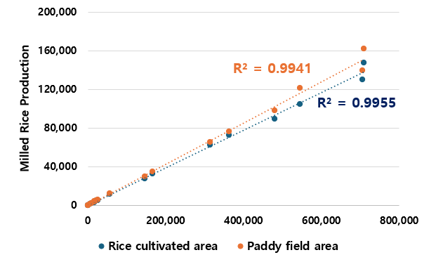
Fig. 2. Correlation between cultivation/farmland area and polished rice yield by province.

2.2. Current Status of Water Management and Prospects for Smart Irrigation Adoption
Analysis of paddy water usage by province in 2022 (Fig. 3) showed that Jeollanam-Do had the highest usage at 2,294,306 × 1,000 m³ year⁻¹, followed by Chungcheongnam-Do at 1,847,975 × 1,000 m³ year⁻¹, and Jeollabuk-Do at 1,671,375 × 1,000 m³ year⁻¹(KOSIS, 2022). This indicates that regions with larger cultivation and farmland areas consume more irrigation water.
Figure 4 presents the number of water management events and the time spent per week(KOSIS, 2024). The frequency of water management per week was less than three times in 37% of farms, three to six times in 39%, and six times or more in 10.5%, indicating that most farmers manage irrigation approximately three to six times weekly. Regarding the time required for water management, 43.5% of farms spent one to three hours per week, followed by three to five hours (16%) and five to ten hours (12%). Some farms required six or more events or extended durations exceeding 20 hours, demonstrating that the burden of water management varies according to region and field size.
During the cultivation period, the average labor required for water control in paddy fields was measured at 15.2 days per person per hectare, accounting for approximately 11.7% of total work hours (Jung et al., 1995). For upland crops, studies report that irrigation requires an average of 8.5 labor hours per unit area, indirectly supporting the notion that rice cultivation also demands substantial labor input (Heitkämper et al., 2015).
Therefore, in regions with large cultivation and farmland areas, both water use and labor demand are high, making efficient water management critical for agricultural profitability and productivity. The adoption of sensor-based real-time soil moisture monitoring, automated irrigation control, and growth-stage-specific water management can reduce unnecessary irrigation, decrease labor and water consumption, and maintain or even improve crop productivity.
Fig. 3. Paddy water usage by province.
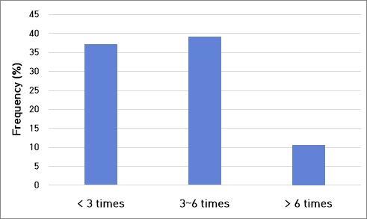
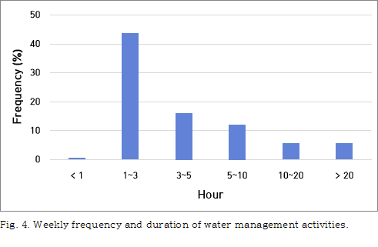
Fig. 4. Weekly frequency and duration of water management activities.
2.3. Evolution of Irrigation and Drainage Systems in Korean Rice Cultivation
In the past, farmers manually created water channels on paddy bunds using shovels or other tools, and with the advent of chemical products and nylon, fertilizer bags or plastic sheets were also used for irrigation and drainage management. However, these methods required excessive labor and made water-level control difficult. Until about a decade ago, more modern systems using stainless steel water gates were employed. Recently, IoT-based systems utilizing remote sensing have been developed and tested, enabling a single farmer to manage irrigation and drainage for a minimum of 20 and up to 100 paddy fields simultaneously.
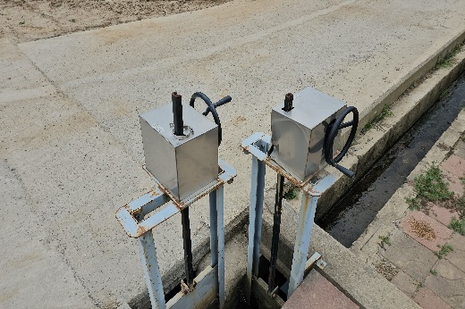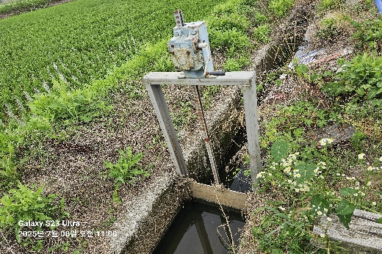
Fig. 5. Conventional mid-season irrigation system.

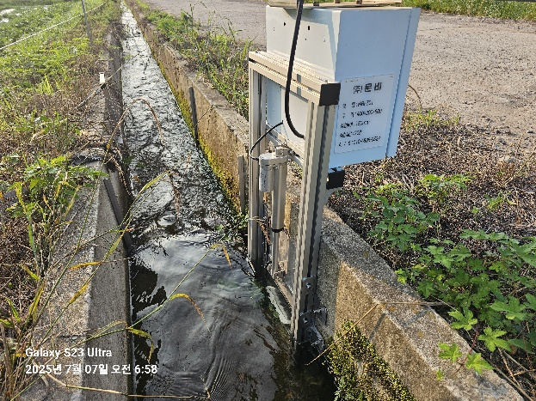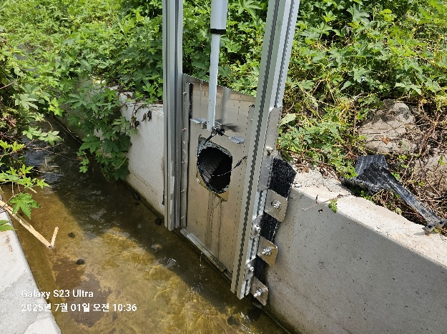
Fig. 6. Smart irrigation and drainage system
3. Efficiency, Economic, and Environmental Benefits of IoT-Based Smart Irrigation Systems
Conventional rice cultivation practices have relied on continuous flooding of the entire paddy field. Although familiar to farmers, these methods consume excessive water, labor, and energy, resulting in low irrigation efficiency and high cost relative to productivity (Kumar et al., 2019). Unnecessary flooding also increases fuel use, labor requirements, and greenhouse gas emissions (Siopongco et al., 2013; Nalley et al., 2015).
In contrast, IoT-based smart irrigation systems (MIS) employ soil moisture sensors, water-level sensors, automated valves, and remote monitoring systems to assess field moisture conditions and weather in real time, enabling optimized irrigation tailored to crop growth stages. By minimizing unnecessary irrigation, water use can be reduced by 20–50% compared to conventional practices (Kazuyuki Yagi et al., 1996), and fuel consumption per growing season can be reduced by up to 30 L ha⁻¹ (Siopongco et al., 2013). Automated water management further reduces labor time by 82–88% for flush irrigation and up to 57% under continuous flooding, significantly alleviating labor burdens (Binayao et al., 2024; Smarter Irrigation for Profit, 2021).
Economic analyses indicate that despite the initial investment in IoT devices, savings in water, labor, and energy costs offset these expenditures, resulting in reduced operational costs and improved profitability in the long term (Palis et al., 2004; Kumar et al., 2019). This is particularly relevant in regions where water scarcity and energy costs are significant, making smart irrigation a more economical alternative to traditional practices. Furthermore, by reducing excessive flooding and associated methane emissions, IoT-based irrigation contributes to climate-smart agriculture (Siopongco et al., 2013; Nalley et al., 2015; Bwire et al., 2024).
Empirical studies support these findings. Laphatphakkhanut et al. (2021) reported that MIS reduced water use while increasing yield by approximately 39% compared to conventional continuous flooding. The water footprint per unit yield was 2,343 m³ ton⁻¹ under MIS, about 29% lower than the 3,310 m³ ton⁻¹ observed with traditional irrigation. This improvement is attributed to the reduction of unnecessary water loss through real-time data analysis and maintenance of optimal water levels even during high-temperature periods, enhancing both productivity and resource efficiency.
The introduction of automated IoT irrigation systems also provides clear economic advantages in rice cultivation. In traditional gravity-fed surface irrigation, farmers spend roughly 40% of their daily labor hours maintaining water levels, increasing seasonal labor demand and costs (Sekozawa, 2010). Automated and remotely controlled systems significantly reduce these repetitive management tasks, lowering labor costs.
Automated systems such as BayDrive or FarmConnect® enhance water-use efficiency and reduce unnecessary runoff, thereby decreasing irrigation-related costs (Gonçalves et al., 2011; Smith et al., 2016). For example, the Australian cotton industry reported annual water savings of approximately 28.5 × 10⁶ m³ and a 10% improvement in overall water-use efficiency following the adoption of BayDrive systems (BDA Group, 2007; Smith et al., 2016). These industrial outcomes align with MIS studies in rice cultivation, which reported a 29% reduction in water footprint and a 39% increase in yield (Laphatphakkhanut et al., 2021), demonstrating both research-based and practical economic benefits.
Additionally, real-time monitoring and automated alerts allow farmers to detect and respond to irrigation issues promptly, reducing extra costs from management failures. Dependence on field labor is decreased, and optimal water management improves crop yield and quality. Consequently, automated irrigation systems play a critical role not only in saving labor, water, and energy but also in securing long-term farm profitability (Masseroni et al., 2017).
Overall, IoT-based smart irrigation systems offer clear economic and environmental advantages over traditional irrigation methods, including water savings, reduced labor and energy use, increased productivity, and enhanced climate resilience. These systems demonstrate substantial potential as a key solution for sustainable rice cultivation and agricultural water management.
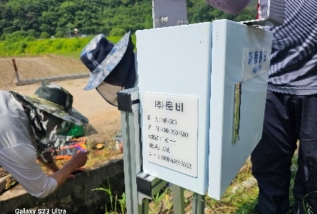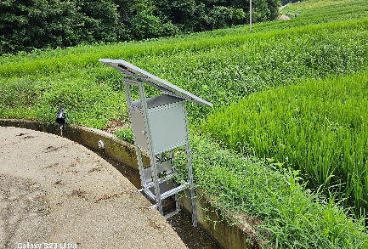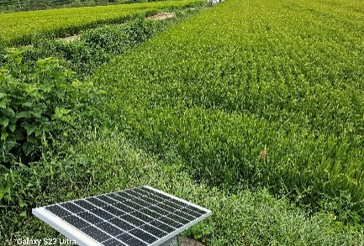
Fig. 7. Installation of IoT-based irrigation systems in Geochang, Uiryeong, and Hamyang.
4. Limitations of IoT-Based Smart Irrigation Systems and Future Research Directions
IoT-based smart irrigation systems offer significant advantages in terms of water savings, labor and energy efficiency, and productivity enhancement. However, several limitations remain. Existing studies are largely concentrated in specific countries such as India, China, and the United States, leaving the applicability of these systems across diverse agricultural environments insufficiently verified (Abdelmoneim et al., 2025). Most research has focused on technical components, including sensor technologies, communication protocols, and automation systems.
IoT-based decision-making relies heavily on large volumes of accurate data. In some regions, limited availability of soil moisture, weather, and crop growth data can reduce prediction accuracy. High initial costs for IoT devices, sensors, communication infrastructure, and computing resources may hinder adoption by small-scale farmers. Installation and maintenance are technically complex, requiring specialized knowledge for effective operation. Sensor power limitations, battery lifespan, and unstable electricity or internet connectivity in remote fields further complicate continuous operation. Additionally, unpredictable factors such as extreme climate events or pest outbreaks can limit AI-based prediction accuracy and irrigation efficiency, and compatibility issues with existing irrigation infrastructure must also be considered. Finally, the connectivity of IoT devices to the internet raises concerns regarding cybersecurity, data protection, and privacy (Villa-Henriksen et al., 2020; Obaideen et al., 2022; Ghareeb et al., 2023).
Future research should focus on overcoming these limitations. Specifically, integrating IoT technologies with AI, edge computing, and blockchain can enable more adaptive and predictive irrigation systems. Empirical validation across diverse agricultural environments, coupled with interdisciplinary collaboration, is needed to develop scalable solutions. Furthermore, evaluating the impacts of IoT-based irrigation on crop physiology, nutrition, and soil health, while continuously improving water and energy efficiency, is essential for sustainable water resource management. These efforts will contribute to the practical application of smart irrigation technologies and the long-term sustainability of agricultural production.

References

Abdelmoneim, A. A., Kimaita, H. N., Al Kalaany, C. M., Derardja, B., Dragonetti, G., & Khadra, R. (2025). IoT sensing for advanced irrigation management: A systematic review of trends, challenges, and future prospects. Sensors (Basel, Switzerland), 25(7), 2291.
A. Villa-Henriksen, G. T. Edwards, L. A. Pesonen, O. Green, and C. A. G. Sørensen, "Internet of Things in arable farming: Implementation, applications, challenges and potential," Biosystems engineering, vol. 191, pp. 60-84, 2020.
BDA Group. 2007. Cost benefit analyses of research funded by the CRDC. Report to Cotton Research and Development Corporation, BDA Group, Manuka, ACT, Australia. Available from: http://www.crdc.com.au/sites/default/files/pdf/BDA% 20FINAL%20Hero%20Report%20(5-11).pdf
Binayao, R. P., Mantua, P. V. L., Namocatcat, H. R. M. P., Seroy, J. K. K. B., Sudaria, P. R. A. B., Gumonan, K. M. V. C., & Orozco, S. M. M. (2024). Smart water irrigation for rice farming through the Internet of Things. arXiv preprint arXiv:2402.07917.
Bwire, D., Saito, H., Sidle, R. C., & Nishiwaki, J. (2024). Water management and hydrological characteristics of paddy-rice fields under alternate wetting and drying irrigation practice as climate smart practice: a review. Agronomy, 14(7), 1421.
Champness, M., Vial, L., Ballester, C., & Hornbuckle, J. (2023). Evaluating the performance and opportunity cost of a smart-sensed automated irrigation system for water-saving rice cultivation in temperate Australia. Agriculture, 13(4), 903.
Garcia, L.; Parra, L.; Jimenez, J.M.; Lloret, J.; Lorenz, P. IoT-based smart irrigation systems: An overview on the recent trends on sensors and IoT systems for irrigation in precision agriculture. Sensors 2020, 20, 1042.
Ghareeb, A. Y., Gharghan, S. K., Mutlag, A. H., & Nordin, R. (2023). Wireless sensor network-based artificial intelligent irrigation system: Challenges and limitations. Journal of Techniques, 5(3), 26-41.
Gillies M.H., Smith R.J. 2015. SISCO: surface irrigation calibration and optimisation. Irrig. Sci. 33:339-55.
Gonçalves J.M., Pereira L.S. 2009. Decision support system for surface irrigation design. J. Irrig. Drain. Eng. 135:343-56.
Heitkämper, K., Stehle, T., & Schick, M. (2015). Working time requirement for different field irrigation methods. International Journal of Agricultural Management, 4(2), 50-54.
Kazuyuki Yagi, Ken-ichi Kanda and Katsuyuki Minami,1996. Effect of water management on methane emission from a Japanese rice paddy field: Automated methane monitoring. Global biogeochemical cycles.10 (2): 255-267.
K. Obaideen, B. A. Yousef, M. N. AlMallahi, Y. C. Tan, M. Mahmoud, H. Jaber, and M. Ramadan, "An overview of smart irrigation systems using IoT," Energy Nexus, p. 100124, 2022.
Kumar, K. A., & Rajitha, G. (2019). Alternate wetting and drying (AWD) irrigation-a smart water saving technology for rice: a review. International Journal of Current Microbiology and Applied Sciences, 8(3), 2561-2571.
Lampayan, M.R.; Yadav, S.; Humphreys, E. Saving Water with Alternate Wetting Drying (AWD). International Rice Research Institute (IRRI). 2005. Available online: http://www.knowledgebank.irri.org/training/fact-sheets/water-management/savingwater-alternate-wetting-drying-awd (accessed on 3 February 2023).
Laphatphakkhanut, R., Puttrawutichai, S., Dechkrong, P., Preuksakarn, C., Wichaidist, B., Vongphet, J., & Suksaroj, C. (2021). IoT-based smart crop-field monitoring of rice cultivation system for irrigation control and its effect on water footprint mitigation. Paddy and Water Environment, 19(4), 699-707.
López-Morales, J. A., Martínez, J. A., & Skarmeta, A. F. (2021). Improving energy efficiency of irrigation wells by using an iot-based platform. Electronics, 10(3), 250.
Masseroni, D., Uddin, J., Tyrrell, R., Mareels, I., Gandolfi, C., & Facchi, A. (2017). Towards a smart automated surface irrigation management in rice-growing areas in Italy. Journal of Agricultural Engineering, 47(585), 42-48.
Nalley, L.L.; Linquist, B.; Kovacs, K.F.; Anders, M.M. The economic viability of alternate wetting and drying irrigation in Arkansas rice production. Agron. J. 2015, 107, 579–587.
Palis, F.G., Cenas, P.A., Bouman, B.A.M., Lampayan, R.M., Lactaoen, A.T., Norte, T.M., Vicmudo, V.R., Hossain, M and Castillo, G.T. 2004. A farmer participatory approach in the adaptation and adoption of controlled irrigation for saving water: a case study in Canarem, Victoria, Tarlac, Philippines. Philippine Journal of Crop Science. 29(3): 280-288.
Pernapati, K. (2018, April). IoT based low cost smart irrigation system. In 2018 Second International Conference on Inventive Communication and Computational Technologies (ICICCT) (pp. 1312-1315). IEEE.
Rajkumar, M. N., Abinaya, S., & Kumar, V. V. (2017, March). Intelligent irrigation system—An IOT based approach. In 2017 International Conference on Innovations in Green Energy and Healthcare Technologies (IGEHT) (pp. 1-5). IEEE.
Sarker, B.; Keya, K.N.; Mahir, F.I.; Nahiun, K.M.; Shahida, S.; Khan, R.A. Surface and ground water pollution: Causes and effects of urbanization and industrialization in South Asia. Sci. Rev. 2021, 7, 32&#8211;41.
Sekozawa T. 2010. A fully automated water management system for large rice paddies. Proceedings of the 14th WSEAS International Conference on Systems: part of the 14th WSEAS CSCC multiconference. World Scientific and Engineering
Academy and Society (WSEAS), Stevens Point, WI, USA, I:325-330.
Siopongco, J.D.L.C.; Wassmann, R.; Sander, B.O. Alternate Wetting and Drying in Philippine Rice Production: Feasibility Study for a Clean Development Mechanism; IRRI Technical Bulletin No. 17; International Rice Research Institute: Los Banos, Philippines, 2013; 18p.
Smarter Irrigation for Profit. Smart Irrigation Control in Rice Growing Systems. Smarter Irrigation for Profit Phase II Fact Sheet:Rice. Available online: https://smarterirrigation.com.au/wp-content/uploads/2021/08/Smart-Irrigation-control-inrice-growing-systems_Case-Study_July-2021.pdf (accessed on 6 June 2022).
Smith R.J., Uddin J.M, Gillies M.H., Moller P., Clurey K. 2016. Evaluating the performance of automated bay irrigation. Irrig. Sci. [In press].
정하우, 이남호, 김성준, 최진용, 한형근 & 김대식. (1995). 자동물꼬의 개발. 한국농공학회지, 37(1), 49-54
Surendran, U.; Raja, P.; Jayakumar, M.; Subramoniam, S.R. Use of efficient water saving techniques for production of rice in India under climate change scenario: A critical review. J. Clean. Prod. 2021, 309, 127272.
Takayoshi, Y.; Tuan, L.M.; Kazunori, M.; Shigeki, Y. Alternate Wetting and Drying (AWD) Irrigation Technology Uptake in Rice Paddies of the Mekong Delta, Vietnam: Relationship between Local Conditions and the Practiced Technology. Asian Afr. Area Stud. 2016, 15, 234–256.
Teng, Y.; Yang, J.; Zuo, R.; Wang, J. Impact of urbanization and industrialization upon surface water quality: A pilot study of Panzhihua mining town. J. Earth Sci. 2011, 22, 658&#8211;668.
Touil, S., Richa, A., Fizir, M., Argente Garcia, J. E., & Skarmeta Gomez, A. F. (2022). A review on smart irrigation management strategies and their effect on water savings and crop yield. Irrigation and Drainage, 71(5), 1396-1416.
Udimal, T.B.; Jincai, Z.; Ayamba, E.C.; Owusu, S.M. China’s water situation; the supply of water and the pattern of its usage. Int. J. Sustain. Built Environ. 2017, 6, 491&#8211;500.
Van der Lelij, A. Causes and Effect of Deep Percolation Losses in the Murrumbidgee Region. In Irrigation Efficiency Seminar; Australian National Committee International Commission on Irrigation and Drainage: Sydney, Australia, 1979; pp. 1-8
Vijayakumar, S.; Nayak, A.K.; Ramaraj, A.P.; Swain, C.K.; Geethalakshmi, V.; Pazhanivelan, S.; Tripathi, R.; Sudarmanian, N.S. Rainfall and temperature projections and their impact assessment using CMIP5 models under different RCP scenarios for the eastern coastal region of India. Curr. Sci. 2021, 121, 222.
Vijayakumar, S.; Kumar, D.; Ramesh, K.; Jinger, D.; Rajpoot, S.K. Effect of Potassium fertilization on water productivity, irrigation water use efficiency, and grain quality under direct seeded rice-wheat cropping system. J. Plant Nutr. 2022, 45, 2023&#8211;2038.

