Exploring the roles of textile in cultural expression and heritage preservation

Abstract
Textiles are a powerful representation of culture and identity, but their role has evolved over time. While historically textiles often had a more functional purpose for instance, in the production of clothing and home furnishings in recent years they have been increasingly used as a form of cultural expression. The aim of this study is to explore the role of textile in cultural expression and heritage preservation. It examines the changing roles of textiles, with a particular focus on the historical significance of African textiles, symbolism in African textile art, modern adaptations of African textiles in contemporary culture and African textiles in global fashion. Textiles play an integral role in the fabric of different cultures around the world, having been used for thousands of years to signify one’s identity, status, and even ethnicity. Some cultures utilize textiles as a way of celebrating their past histories or family heritage. African textiles, in particular, hold a deep cultural significance, with roots that trace back to ancient civilizations. These textiles are profoundly symbolic, with colors, patterns, and materials chosen with care to convey specific messages. Traditional textile crafts like ikat, batik, tie-dye and block printing are incredibly diverse and vibrant. Reviving traditional textile designs gives us a chance to explore and attire the history and nuances of each craft, while bringing it up to date with contemporary sensibilities.

Keywords: African textiles, heritage, ready-to-wear clothing, cultural identity, block printing

Introduction

History of Textiles in Cultural Traditions
Textiles have a long and fascinating history in many cultures around the world. For thousands of years, weaving has been used to represent identity, commemorate historical events, and even tell stories. From traditional kimonos in Japan to wax-print clothing from West Africa, textiles are a powerful way to express culture and heritage.
No matter where in the world you look, textiles have been used to express cultural ideals and shared experiences.
In India, cultural textiles like traditional saris are often worn as part of ceremonial practices such as weddings. Similarly, Navajo tribes in the United States have used intricate weavings for centuries to tell stories about landscapes and animals. Also in Pakistan shalwar-kameez is the national dress and wore as a cultural traditions and show personal identity of an area. These rich tradition is still carried on today through modern artistic techniques such as machine-based embroidery or hand dyeing.
While textiles provide an important link between generations of cultures from around the world, they also remain relevant in contemporary life. Today, more people than ever before are using cultural textiles to express themselves and create unique pieces that reflect their personal identity. Therefore, it’s important not only to appreciate the historical significance of textiles but also their growing role as a means of creative self expression.

The Changing Roles of Textiles Over Time
Textiles are a powerful representation of culture and identity, but their role has evolved over time. While historically textiles often had a more functional purpose for instance, in the production of clothing and home furnishings in recent years they have been increasingly used as a form of cultural expression. With the advent of modern technology, such as digital printing and dye sublimation, textiles can be crafted to reflect contemporary ideas, trends and beliefs. They can be used to tell stories or promote political messages.
In some cultures, particularly those with strong weaving traditions, textiles are an important part of religious ceremonies and rituals. The fabrics used often signify important life events, such as marriage or the transition from childhood to adulthood. Aside from ritual use, cultural textiles may also be used to represent the identities of different ethnic groups or create a sense of unity within a community.

In short, textiles are more than just fabrics:
They are powerful carriers of cultural identity and serve as a visual representation of how cultures change over time. Whether it be for expression or ritual purposes, weaved fabrics continue to be an influential part of society today.

Decorative Uses:

Using Cultural Textiles to Adorn a Space
Textiles aren’t just used for clothing and shelter, they’re also used to adorn a space, in a way that displays and reflects identity. But how do textiles do this? From colors to designs, every aspect of textiles can be used to “craft” an identity.

Colors:
Colors are a huge part of culture, with different colors having various meanings in different cultures. In some cultures, red is a symbol of luck and prosperity, or yellow is a royalty color. You can use colors to express any kind of emotion and identity conveyance through textiles.

Textiles as Symbols of Identity and Pride:
Textiles play an integral role in the fabric of different cultures around the world, having been used for thousands of years to signify one’s identity, status, and even ethnicity. As times have changed, cultural textiles remain deeply entrenched within societies to celebrate cultural pride. Many different civilizations have used textiles as a communicate their values and beliefs through patterns, motifs, iconography and embroidery.

Embarrassing Cultural Heritage:
Some cultures utilize textiles as a way of celebrating their past histories or family heritage. For example, the Chadar of Kashmir is often used in cultural performances to tell stories from generations past while simultaneously providing women with a sense of belonging and empowerment. Similarly in Zimbabwe the Chidenge is a colorful wrap skirt worn by some Shona women that represent where they came from and their ancestral identity.

Celebrating Customary Traditions
Cultural textiles can also be used to symbolize great life events or customs within cultures. In Hmong culture for example, special cultural fabric garments are traditionally made for the bride in shades of blue for her wedding day celebration despite being a very colorful culture overall. These garments not only signify marriage but also family lineage and provide social structure particularly within rural communities where this practice is still held strong today.
In short, textiles are inextricably linked with many different cultures around the world and serve as powerful symbols of identity, heritage, pride and tradition that remain deeply embedded in today’s cultural societies.

Textiles as Markers of Milestones
As you explore different cultures and their use of textiles, you may find that they play a role in more than just esthetics. Textiles can be used to mark special milestones in life like rites of passage. From bar and bat mitzvahs (Jewish traditions) to quinceaneras (Latin American tradition), special attire or fabric embellishments are often used as an important part of the celebration.
This is because cultural textiles can also be used to symbolize great life events or customs within cultures. In Hmong culture for example, special cultural fabric garments are traditionally made for the bride in shades of blue for her wedding day celebration despite being a very colorful culture overall. These garments not only signify marriage but also family lineage and provide social structure particularly within rural communities where this practice is still held strong today.
have the power to signify status, identity, and even spiritual connection in many cultures. For instance, special hand woven fabrics may be given to a person upon their initiation into adulthood or marriage. This can be seen through Japanese braided cords with decorative tassels called “Hakama” an important wardrobe item for those in martial arts.
Overall, textiles act as a way to physically represent the transformation that takes place during a rite of passage, lasting throughout adulthood and beyond as an essential item within a culture’s wardrobe. It also acts as a meaningful symbol that transcends generations and brings people together by connecting them to shared cultural identities.
Cultural textiles can be more than just an expression of identity they can be a way to revive and tap into a rich historical tradition. Traditional textile crafts like ikat, batik, tie-dye and block printing are incredibly diverse and vibrant. They are perfect for reinterpreting traditional culture with modern style.
These crafts have always been part of cultural identity, but in the past decades they have been reimagined into something fresh:
- Ikat has grown in popularity—it’s the perfect blend of traditional technique combined with updated design elements.
- Batik is being used to create bold and beautiful fabrics, which can be turned into clothing or wall hangings.
- Tie-dye has seen a resurgence as artist’s use it to create one-of-a-kind pieces that make a statement.
- Block printing has also found its modern niche as people look for ways to infuse fabrics with unique patterns and designs.

Historical Significance of African Textiles
African textiles are an integral part of the continent’s cultural history, with deep roots that trace back to ancient civilizations. Far more than mere fabric, these textiles tell stories of the people who made them, reflecting societal hierarchies, regional histories, religious beliefs, and artistic prowess. The art of textile production across Africa varies greatly, from weaving techniques to dyeing methods, each of which holds special significance and is often region-specific. By examining the history behind African textiles, we gain valuable insights into the continent’s rich cultural tapestry and the role of these textiles in preserving it.
The term African textile is broad, encompassing a range of fabrics, from woven materials like Kente in Ghana to intricate, hand-dyed Adire from Nigeria. These textiles have been more than adornments or practical items; they have often been used as currency, symbols of status, and means of communication. In ancient societies across the continent, textiles played a role in trade, with some fabrics, such as the coveted Kente cloth, symbolizing wealth and power. Textiles were not only used within communities but also traded widely, showing the historical significance of African fabrics in global commerce.
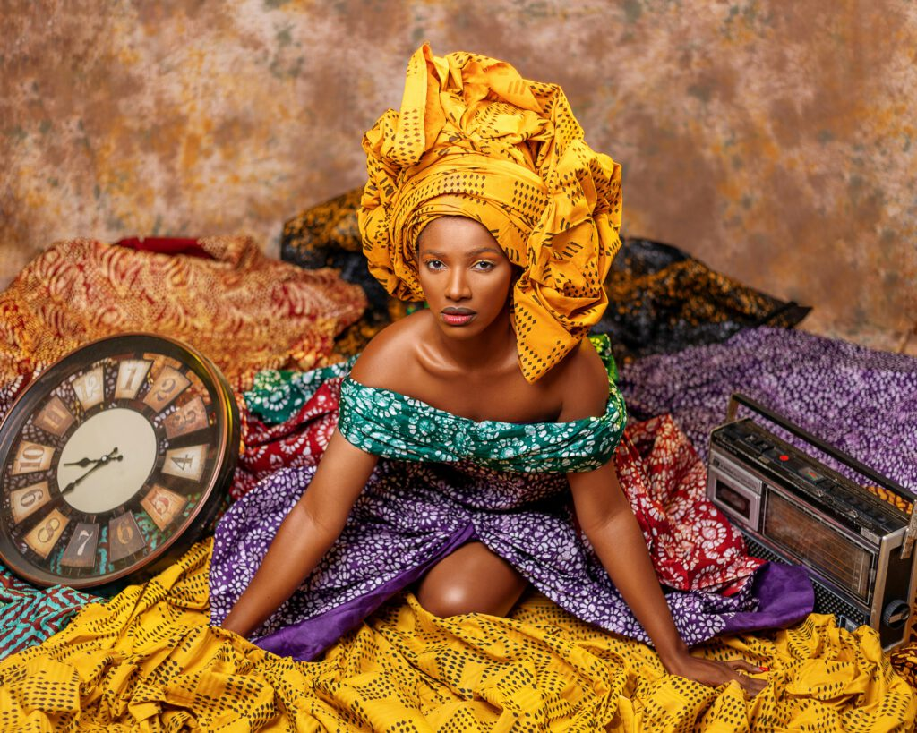
FIG 1. Kente cloth, an African textile artistry
One of the most renowned examples of African textile artistry is Kente cloth, which originated with the Ashanti people in present-day Ghana. Kente weaving involves a complex process where artisans create intricate patterns using narrow strips of fabric. Traditionally, this fabric was woven from silk, a luxurious material that was difficult to procure, adding to Kente’s status as a fabric for the elite. Today, Kente cloth has come to symbolize Ghanaian pride and identity, with each pattern carrying distinct meanings. Colors in Kente are also symbolic: yellow often represents wealth, green denotes fertility, black signifies spiritual maturity, and blue stands for peace. While modern versions of Kente may use different materials, the traditional patterns and symbolic meanings remain intact.
The significance of Kente cloth extends beyond its material beauty; it has cultural and spiritual connotations. Historically, only royalty or individuals of high status could afford or were permitted to wear Kente, as it was reserved for special occasions and ceremonies. The process of weaving Kente was considered a sacred art, with each cloth carrying messages that connected the wearer to their ancestors, spirituality, and community. The elaborate designs in Kente serve as a visual language, one that continues to be celebrated in modern Ghanaian society and beyond. For more on Kente cloth and its origins, the National Museum of African Art provides detailed resources.
In West Africa, another iconic African textile is Adire cloth from the Yoruba people of Nigeria. Adire is made using resist-dyeing techniques, where parts of the cloth are covered to resist dye, creating distinctive patterns. This fabric is typically dyed with indigo, a natural dye extracted from plants that has a long history in African textile production. Adire patterns can be simple or highly intricate, depending on the dyeing method used. The indigo dye not only gives Adire its deep, rich color but also has symbolic significance. Indigo is associated with longevity and stability, and Yoruba artisans often use it to convey messages related to resilience and the continuity of life.
Creating Adire is a communal effort, where men typically weave the fabric, and women take on the dyeing process. This collaboration reflects the shared cultural values and community spirit within Yoruba society. Adire patterns are often inspired by nature, spirituality, and social values. For example, certain designs may represent prosperity, good fortune, or protection, and the patterns themselves can convey information about the wearer’s status, profession, or clan. The process of making Adire is labor-intensive, but the result is a textile that is not only beautiful but also rich in meaning. Today, Adire cloth is celebrated internationally, showcasing the skill and creativity of Yoruba artisans.
In East Africa, the Kikoi cloth from Kenya and Tanzania represents a different style of African textile. Kikoi, traditionally worn by men, is a rectangular piece of cloth made from cotton, often in striped patterns. This cloth has historically been used as a garment, headwrap, or multipurpose item. The Kikoi reflects the culture and lifestyle of the Swahili people along the East African coast, an area known for its trade links with the Arab world and India. These influences are evident in the vibrant colors and patterns of Kikoi, which are distinct from textiles found elsewhere in Africa. The simplicity of the Kikoi contrasts with the complex weaving techniques of Kente and the intricate dyeing of Adire, but it serves as a symbol of identity and tradition for the people of East Africa.
Similarly, the Mudcloth, or Bogolanfini, from Mali represents a unique approach to textile art in West Africa. This African textile is made using fermented mud, which creates earthy tones and allows for distinct, symbolic designs. Each Mudcloth piece is handmade, and the symbols often represent proverbs, historical events, or significant spiritual beliefs. Mudcloth is a labor-intensive art form, requiring careful attention to detail. The production of Mudcloth is a deeply spiritual process, and the patterns are intended to protect the wearer from harm or to symbolize important life transitions, such as marriage or childbirth. The global popularity of Mudcloth today underscores the timeless appeal of African textile traditions.
Beyond personal adornment, textiles in Africa were also used in ceremonial contexts and for home decor, further reinforcing their cultural significance. For instance, during important rites of passage such as weddings, childbirth, and funerals, specific fabrics are chosen to reflect the gravity of the event. Textiles were often passed down through generations, preserving family and community histories. The artistry in these textiles was not just a means of creative expression but a way to maintain cultural continuity.
In North Africa, fabrics like the Tuareg Tagelmust (or cheche) hold cultural importance for the desert-dwelling Tuareg people. This indigo-dyed headscarf serves as protection against the harsh desert climate, but it also symbolizes identity and resilience. The blue dye, which often rubs off onto the skin, gives the Tuareg people their nickname, “the Blue People of the Sahara.” The indigo staining is seen as a mark of pride and signifies a connection to the harsh but beautiful desert environment that defines the Tuareg way of life. In this way, African textiles serve not only practical purposes but also spiritual and symbolic ones, linking people to their land and heritage.

Symbolism in African Textile Art
African textiles are profoundly symbolic, with colors, patterns, and materials chosen with care to convey specific messages. In African societies, textiles do more than just cover the body; they communicate, represent identity, mark significant events, and convey social status, beliefs, and spirituality. These unique designs are shaped by generations of artisans who pass down skills and techniques that embody the values, histories, and worldviews of their communities. In this section, we will explore how African textile art communicates meaning, focusing on the symbolism in the colors, patterns, and materials used in various fabrics.

Symbolic Meanings of Colors in African Textiles
In African textile art, colors are not chosen randomly; each one holds distinct significance. For example:
- Black is often associated with maturity, wisdom, and spiritual energy. It symbolizes ancestral reverence and a deep respect for the past. In many communities, black can also represent mystery and the unknown, making it a color frequently used in ceremonial attire.
- White symbolizes purity, peace, and cleanliness. It is a color often associated with positive spiritual energy and is used in rituals and celebrations for purity and blessings. Many African communities use white for newborn ceremonies or celebrations of life events to promote harmony and invoke the ancestors’ protection.
- Red signifies life, energy, and power, often connected to blood, vitality, and sacrifice. In several cultures, red is worn during initiation ceremonies or by warriors as a symbol of courage and resilience. It’s also used in attire for rituals that honor ancestors and express passion or spiritual force.
- Green is a universal symbol of growth, fertility, and renewal. In African textiles, it represents prosperity and the natural world, frequently used in agricultural societies to celebrate a fruitful harvest season.
The meaning of colors may vary across regions but remains integral to understanding the message within each textile piece. For example, in Ghana, the Ashanti people believe that Kente cloth colors hold individual meanings that reflect the wearer’s mood or represent an occasion. A combination of black, red, and green in Kente may symbolize harmony and a balanced community, while an arrangement of gold and white may symbolize wealth and royalty.

Geometric Patterns and Symbols in African Textiles
African textiles are also distinguished by their intricate patterns, with many designs serving as visual metaphors. These patterns are often geometrically complex, showcasing African artisans’ technical expertise and aesthetic sense. Here are a few examples of specific patterns and their meanings across various cultures:
- Kuba Cloth Patterns, KANTE: The Kuba cloth from the Democratic Republic of the Congo is celebrated for its bold, geometric patterns that represent ideas of spirituality, growth, and community unity. Kuba cloth patterns are created through a collaborative effort; men weave the raffia base cloth, while women embroider and applique geometric designs. Patterns in Kuba cloth often reflect daily life, religious beliefs, or the natural environment. For instance, the “squares” pattern symbolizes social order, reflecting how individuals within the community uphold their roles and respect hierarchy. Similarly, the “checkerboard” pattern reflects unity and equality, as the uniform shapes symbolize harmony among community members.

- Adinkra Symbols in Ghana: Adinkra cloth from Ghana uses symbols known as “Adinkra” to convey specific messages. These symbols are deeply rooted in Akan culture, each carrying a distinct meaning. For example, the “Gye Nyame” symbol, meaning “Except for God,” reflects the Akan people’s faith and belief in divine protection. The “Sankofa” symbol, shaped like a heart or a bird with its head turned backward, means “Go back and fetch it,” representing the value of learning from the past to inform the future. These Adinkra symbols turn textiles into visual storytelling tools, passing down ancestral wisdom.

- Mudcloth (Bogolanfini) Patterns: Mudcloth, or Bogolanfini, from Mali is a traditional fabric dyed with fermented mud and plant dyes. Each symbol on the cloth has its own meaning, and the symbols are often chosen based on the wearer’s personal story or the message they want to convey. For instance, certain motifs may signify a rite of passage, such as entering adulthood, marriage, or childbirth. The “fishbone” pattern, frequently seen in Mudcloth, symbolizes good fortune, while the “ladder” pattern represents growth and ambition. Because these symbols can reflect personal achievements or life events, Mudcloth pieces are unique to the individuals who wear or use them, adding a layer of personal identity to the fabric.

Spirituality and Rituals in African Textile Art
In African cultures, textiles are deeply intertwined with spirituality, and specific fabrics are often reserved for rituals or ceremonies. Many African communities believe textiles serve as a bridge between the physical and spiritual worlds. By wearing certain patterns, individuals invoke ancestral protection, seek blessings, or connect with the spiritual realm.
For example, in Nigeria, the Yoruba people create “Aso Oke,” a ceremonial textile woven from silk or cotton, used in significant events such as weddings, funerals, and initiation ceremonies. The specific colors and patterns on Aso Oke cloth depend on the purpose of the event; white is used for traditional ceremonies, while brighter colors are worn during celebrations to symbolize joy and abundance. Aso Oke serves as a sacred garment that connects individuals to the divine and emphasizes the wearer’s cultural roots and spiritual connections.
Similarly, in the East African culture of the Maasai, African textile art plays a significant role in spiritual practices. The Maasai wear Shúkà, a traditional cloth, during rites of passage such as circumcision or elder ceremonies. The colors on the Shúkà often represent the different phases of life, reinforcing cultural values around growth, honor, and community solidarity.
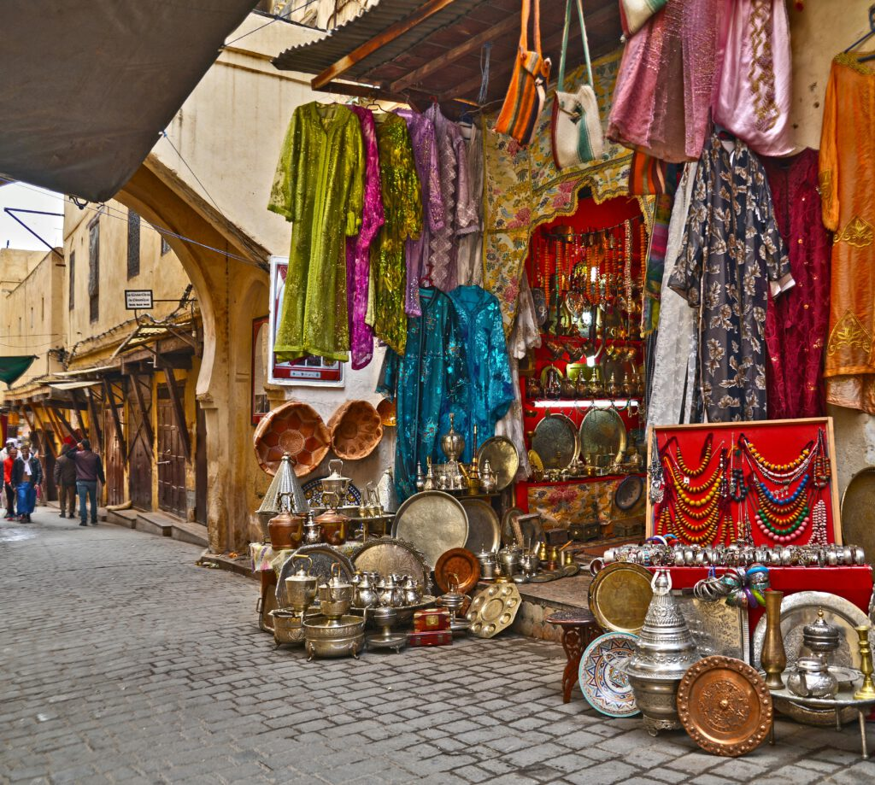

FIG 2. A market stall displaying colourful cloths and luxury items

Social Status and Identity in African Textiles
The unique symbolism in African textiles also helps signify the wearer’s social status, wealth, and identity. In many African societies, textiles are considered luxury items, with finer materials and intricate designs being indicators of higher social status. This practice is evident in the use of Kente cloth, which historically was reserved for Ghanaian royalty and elites. Today, wearing Kente is still associated with respect, pride, and a strong sense of identity, and it’s worn during significant events to celebrate heritage and unity.
Similarly, in Cameroon, the Bamileke people wear “Ndop” cloth, which is traditionally hand-dyed using indigo. Ndop is a marker of prestige and is often worn by tribal leaders and respected figures within the community. The patterns on Ndop represent aspects of Bamileke history, heritage, and values, such as courage, strength, and resilience. The fabric’s color and pattern indicate the wearer’s status and honor, connecting the individual to both their community and the legacy of their ancestors.
Another example is the Tuareg people of the Sahara Desert, who use veils and robes dyed with indigo as status symbols. The indigo dye gives the fabric a distinctive blue tint, which is highly valued and often associated with wealth. The darker the blue, the higher the status of the wearer, as the indigo dye is both expensive and time-consuming to produce. For the Tuareg, wearing blue-dyed fabric is a way to display social rank, wealth, and identity within the tribe.

Modern Adaptations of African Textiles in Contemporary Culture
In recent years, African textiles have experienced a resurgence, attracting global interest and inspiring a new wave of designers, artists, and cultural enthusiasts. As fashion, interior design, and visual arts continue to explore and incorporate African textiles, the essence of African culture, tradition, and heritage is celebrated and preserved in fresh and innovative ways. This section explores how African textile art is not only adapted in contemporary design but also how it shapes identity, fosters economic growth, and bridges cultural gaps worldwide.
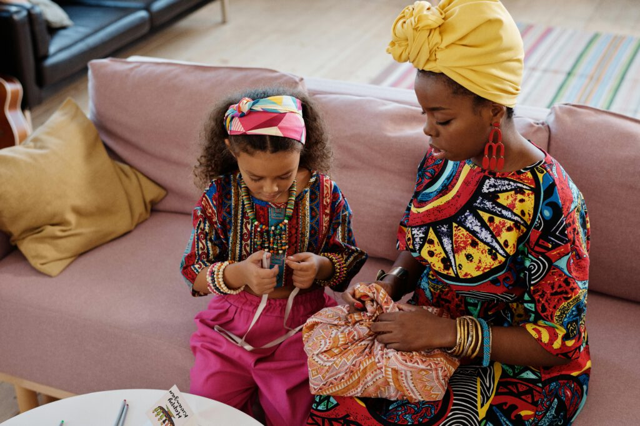
FIG 3. Ankara fabric, with its bold and colourful patterns, is a popular choice for clothing

African Textiles in Global Fashion
Fashion designers around the globe are increasingly incorporating African textiles into their collections, showcasing the intricate beauty, vibrant colors, and unique patterns that these fabrics offer. This embrace of African textile patterns on the global stage allows for a deep appreciation of African culture and craftsmanship. Iconic fabrics like Ankara, Kente, Adire, and Mudcloth are now seen in high fashion and ready-to-wear clothing, as well as in casual streetwear.
For example, Ankara, with its bold and colorful patterns, has become a popular choice for clothing and accessories in mainstream fashion. Its origins are often associated with West Africa, where it has been worn for generations as a symbol of pride and cultural identity. Although the design technique was originally influenced by Indonesian batik, Ankara has evolved to carry distinct African motifs, often reflecting the region’s unique stories and traditions. By including Ankara fabrics in global fashion, designers emphasize its cultural roots while making it accessible to a modern, international audience. African and non-African designers alike now create Ankara-inspired collections that resonate with wearers who value both style and heritage.
Similarly, Kente cloth, traditionally worn by royalty in Ghana, has also made its way into contemporary fashion. Known for its vibrant colors and complex patterns, Kente was once reserved for special ceremonies, such as weddings and funerals. Each pattern and color in a Kente cloth holds symbolic meaning; gold often signifies wealth, green represents growth, and blue symbolizes peace. Modern designers have found innovative ways to integrate Kente into their work, from couture dresses to casual wear, creating pieces that honor the fabric’s traditional significance while allowing it to evolve in a modern context.
A great example of a designer who bridges tradition with contemporary fashion is Laduma Ngxokolo, a South African fashion designer and founder of the luxury brand Maxhosa Africa. Ngxokolo’s designs incorporate patterns inspired by Xhosa beadwork, a traditional craft associated with his cultural heritage. His knitwear collections have received international acclaim, transforming traditional Xhosa designs into contemporary fashion pieces. Through his work, Ngxokolo not only showcases the beauty of African textiles but also raises awareness of African culture, making it visible and respected in the global fashion industry.
African textiles have also gained popularity in streetwear, a style of casual clothing often associated with urban youth culture. Streetwear brands around the world now feature African-inspired patterns and fabrics in their collections, making cultural heritage a part of everyday style. For example, brands like Daily Paper, a Dutch label founded by African-born designers, draw inspiration from their heritage and incorporate African textiles and designs into their clothing. This trend allows African textiles to reach younger audiences, bridging the gap between traditional culture and modern fashion trends.
The influence of African textiles is not limited to fashion. Designers and homeowners are increasingly drawn to African textiles in home décor, adding elements of cultural significance, warmth, and bold color to interior spaces. From throw pillows and wall hangings to upholstery and bed linens, African textiles such as Adire, Mudcloth, and Kente bring rich textures and patterns to modern interiors.
African textiles in interior design contribute to a unique, eclectic style that combines the richness of tradition with the aesthetics of modern design. These textiles provide a way for people to express their appreciation for African culture and history while adding warmth, depth, and personality to their homes.

Cultural Exchange and Bridging the Gap
The use of African textiles in global fashion and design also promotes cultural exchange and understanding. When people wear or decorate with African textiles, they not only appreciate the beauty of the fabric but also engage with the cultural narratives embedded within the designs. By learning about the meanings behind colors, patterns, and symbols, people gain a deeper understanding of African traditions, values, and worldviews.
As African textiles gain popularity, they also challenge misconceptions and stereotypes about Africa. Many people outside Africa have limited exposure to the continent’s diverse cultures, often viewing Africa as a monolithic entity. However, the intricate patterns and unique designs of African textiles showcase the diversity of African cultures, highlighting the differences in artistic expression, spiritual beliefs, and historical experiences among African communities.
The widespread adoption of African textiles in contemporary culture promotes a more nuanced understanding of Africa and its people. This appreciation of African art and heritage fosters respect for African cultures, helping to build connections across geographical and cultural boundaries. Through African textiles, people around the world can celebrate the continent’s diversity and resilience, creating a shared sense of cultural pride and global unity.
The modern adaptations of African textiles in fashion, interior design, and the global market illustrate how these fabrics serve as cultural ambassadors, bridging the gap between African heritage and contemporary style. The increased visibility and appreciation for African textile art provide economic benefits to local artisans, promote cultural exchange, and ensure the preservation of traditional crafts. As African textiles continue to inspire and influence modern design, they remain powerful symbols of cultural identity, carrying forward the stories, values, and beauty of Africa.
Have you ever found yourself connecting to a shirt or scarf that looks exotic and new?
Textiles are often a form of expression for more than just fashion. They are used by different cultures around the world as a way to communicate and express centuries old traditions and beliefs. In this article, we’ll explore how handcrafted cultural textiles can play an integral role in our understanding of other societies and how they define their own identities.
We’ll talk about how textiles are used to create stories with symbols and color palettes that convey ancient values, while still incorporating modern trends. We’ll also discuss how textiles stand at the intersection between cultures, bringing us closer together through their beauty and vibrancy while honoring traditions passed down through generations.

Celebrating Customary Traditions
Cultural textiles can also be used to symbolize great life events or customs within cultures. In Hmong culture for example, special cultural fabric garments are traditionally made for the bride in shades of blue for her wedding day celebration despite being a very colorful culture overall. These garments not only signify marriage but also family lineage and provide social structure particularly within rural communities where this practice is still held strong today.
In short, textiles are inextricably linked with many different cultures around the world and serve as powerful symbols of identity, heritage, pride and tradition that remain deeply embedded in today’s cultural societies.

Textiles as Markers of Milestones
As you explore different cultures and their use of textiles, you may find that they play a role in more than just esthetics. Textiles can be used to mark special milestones in life like rites of passage. From bar and bat mitzvahs (Jewish traditions) to quinceaneras (Latin American tradition), special attire or fabric embellishments are often used as an important part of the celebration.
This is because cultural textiles can also be used to symbolize great life events or customs within cultures. In Hmong culture for example, special cultural fabric garments are traditionally made for the bride in shades of blue for her wedding day celebration despite being a very colorful culture overall. These garments not only signify marriage but also family lineage and provide social structure particularly within rural communities where this practice is still held strong today.
have the power to signify status, identity, and even spiritual connection in many cultures. For instance, special hand woven fabrics may be given to a person upon their initiation into adulthood or marriage. This can be seen through Japanese braided cords with decorative tassels called “Hakama” an important wardrobe item for those in martial arts.
Overall, textiles act as a way to physically represent the transformation that takes place during a rite of passage, lasting throughout adulthood and beyond as an essential item within a culture’s wardrobe. It also acts as a meaningful symbol that transcends generations and brings people together by connecting them to shared cultural identities.

Revival and Reimagining of Traditional

Textile Crafts
Cultural textiles can be more than just an expression of identity they can be a way to revive and tap into a rich historical tradition. Traditional textile crafts like ikat, batik, tie-dye and block printing are incredibly diverse and vibrant. They are perfect for reinterpreting traditional culture with modern style.
These crafts have always been part of cultural identity, but in the past decades they have been reimagined into something fresh:
- Ikat has grown in popularity—it’s the perfect blend of traditional technique combined with updated design elements.
- Batik is being used to create bold and beautiful fabrics, which can be turned into clothing or wall hangings.
- Tie-dye has seen a resurgence as artist’s use it to create one-of-a-kind pieces that make a statement.
- Block printing has also found its modern niche as people look for ways to infuse fabrics with unique patterns and designs.

Reviving traditional textile designs gives us a chance to explore and attire the history and nuances of each craft, while bringing it up to date with contemporary sensibilities. It’s a great way to honor these practices while creating something beautiful in the process.

COMPETING INTERESTS DISCLAIMER:
Authors have declared that they have no known competing financial interests OR non-financial interests OR personal relationships that could have appeared to influence the work reported in this paper.

References
American Institute for Conservation (AIC). (2020). Conservation Terminology. Retrieved from https://www.culturalheritage.org
Appelbaum, B. (2007). Conservation Treatment Methodology. Butterworth-Heinemann.
Ashley-Smith, J. (1999). Risk Assessment for Object Conservation. Butterworth-Heinemann.
Avrami, E., Mason, R. and Torre, M. (2000). Values and heritage conservation. Getty Conservation Institute.
Barber, E. J. W. (1994). Women's Work: The First 20,000 Years. W. W. Norton.
Brimblecombe, P. (2014). Environmental monitoring and control for cultural heritage. Heritage Science, 2(1), 1-10.
British Museum. (2018). Textile conservation: Challenges and innovations. https://www.britishmuseum.org
Burnham, D. K. (1980). Cut My Cote. Royal Ontario Museum. • Cameron, F. and Kenderdine, S. (2007). Theorizing digital cultural heritage: A critical discourse. MIT Press. • Canadian Conservation Institute. (2016). Agents of deterioration. Retrieved from https://www.canada.ca/en/conservationinstitute/services/agents-deterioration.html •
Caple, C. (2011). Conservation skills: Judgement, method and decision making (2nd ed.). Routledge. •
Eastaugh, N., Walsh, V., Chaplin, T. and Siddall, R. (2008). Pigment compendium: A dictionary and optical microscopy of historical pigments. Elsevier. •
Eastop, D. and Brooks, M. M. (1996). Handbook of Textile Conservation. Routledge. • Eicher, J. B. and Ross, D. (2010). Encyclopedia of World Dress and Fashion. Oxford University Press. •
Florian, M. L. (2002). Fungal Facts: Solving Fungal Problems in Heritage Collections. Archetype Publications. • Flury-Lemberg, M. (1988). Textile conservation and research: A documentation of the textile department on the occasion of the twentieth anniversary of the Abegg Foundation. Abegg-Stiftung.
Getty Conservation Institute. (2017). Education and training in conservation: Models and approaches.
Getty Conservation Institute. (2021). Science for conservation: Tools and innovation. • Gillow, J. and Sentance, B. (2004). World Textiles: A Visual Guide to Traditional Techniques. Thames & Hudson.
Hacke, M. (2006). Wet cleaning of early textiles: The application of microemulsions to the cleaning of 18th-century tapestries . Studies in Conservation, 51:3–10.
ICCROM. (2020). Funding mechanisms for cultural heritage preservation. https://www.iccrom.org •
ICOM (International Council of Museums) (2013). Key Concepts of Museology. • ICOM-CC. (2018). Textile Working Group: State of the field report. International Council of Museums.
ICOM-CC. (2008). Terminology to characterize the conservation of tangible cultural heritage. International Council of Museums – Committee for Conservation.
ICOMOS. (2019). Sustaining heritage: Funding and policy perspectives. Retrieved from https://www.icomos.org
Kalay, Y. E., Kvan, T. and Affleck, J. (2008). New heritage: New media and cultural heritage. Routledge.
Landi, S. (1998). The textile conservator’s manual (2nd ed.). Butterworth-Heinemann.
Leona, M. (2009). Microanalysis of organic pigments and dyes in artworks: An overview of methods and recent applications. Accounts of Chemical Research, 43(6), 794–801
Lunning, E. and Perrault, K. (2006). Textile conservation: Advances in practice. In M. Ballard (Ed.), Twentieth-century materials. Getty Conservation Institute, pp. 45–58.
Padfield, T. (1966). The Deterioration of Museum Objects Caused by Moisture. British Museum.
Pearce, S. M. (1992). Museums, Objects and Collections: A Cultural Study. Smithsonian Institution Press.
Pinniger, D. B. (2001). Pests in museums: Prevention and management. Archetype Publications.
Rivers, S. and Umney, N. (2007). Conservation of furniture. Routledge.
Rizzo, A. (2014). Digital tools in heritage conservation. Journal of Cultural Heritage, 15(2), 144–150.
Sease, C. (1994). Conservation and restoration: Ethics and guidelines. Journal of the American Institute for Conservation, 33(1), 1–7.
Smithsonian Institution. (2021). Museum Conservation Institute: Emerging Technologies in Conservation. https://www.si.edu/mci
Staniforth, S. (2011). Conservation: Principles, Dilemmas and Uncomfortable Truths. Routledge. Stanley-Price, N. (2009). Cultural heritage in postwar recovery: Papers from the ICCROM Forum. ICCROM.
Tétreault, J. (2003). Airborne Pollutants in Museums, Galleries, and Archives. Canadian Conservation Institute.
Textile Conservation Centre. (2000). Conservation of textiles. University of Southampton. • Thomson, G. (1986). The museum environment (2nd ed.). Butterworth-Heinemann.
Timar-Balazsy, A. and Eastop, D. (1998). Chemical principles of textile conservation. Butterworth-Heinemann.

