Short communication

Phytochemical Screening and FT-IR & GC-MS Analysis of Syzygium haemisphericum Leaf Extract

ABSTRACT

Syzygium haemisphericum, a medicinal plant native to the Western Ghats of India, is traditionally utilized for the management of diabetes and kidney stones due to its hypoglycemic and bioactive properties. This research examines the phytochemical analysis, Fourier Transform Infrared (FT-IR) spectroscopy, and Gas Chromatography-Mass Spectrometry (GC-MS) of the methanol leaf extract. Phytochemical analysis revealed the presence of carbohydrates, tannins, alkaloids, vitamin C, terpenoids, and resins. The FT-IR analysis identified functional groups including alcohols, esters, carboxylic acids, ketones, and aromatic amines. GC-MS study identified six bioactive compounds, including neophytadiene, hexadecanoic acid, and globulol. The findings corroborate the notion that the plant possesses medicinal capabilities and indicate the necessity for further investigation to identify and characterize its bioactive constituents.

Keywords: Phytochemicals, Syzygium haemisphericum , FT-IR spectroscopy , GC-MS.
INTRODUCTION
India is globally recognized for its extensive array of medicinal plants, which are vital for culture, the economy, and health. Approximately 80% of individuals in developing nations utilize traditional medicine as their primary form of health treatment [1]. Syzygium haemisphericum, commonly referred to as the "Hemispheric Rose-apple," is recognized for its therapeutic properties. This plant is located in the Western Ghats, a UNESCO World Heritage site, as well as in regions such as Maharashtra and Sri Lanka. It is utilized in traditional medicine for its capacity to reduce blood glucose levels, particularly in the treatment of diabetes mellitus and nephrolithiasis. It is a significant component of holistic health therapies due to its accessibility, affordability, and little adverse effects [2].
Examining the bioactive constituents of S. haemisphericum is essential to validate its therapeutic potential. Phytochemical study elucidates the medicinal properties of a plant by identifying the compounds responsible for biological action. FT-IR spectroscopy and GC-MS are two analytical techniques that examine the chemical composition and functional groups in plant extracts with precision.[3] These approaches are essential in elucidating the phytochemical composition, hence facilitating novel applications in medicinal and natural product research [4-5]. The green synthesis of ZnO nanoparticles using Syzygium hemisphericum bark extract via a solution combustion method established. Compared to ZnO NPs, the crude bark extract showed stronger antioxidant and antidiabetic activity (α-amylase, α-glucosidase inhibition) and was less toxic in hemolysis assays. ZnO NPs, however, exhibited notable antibacterial and anticancer effects against A431 carcinoma cells, indicating complementary biomedical applications [6].This work focuses on the phytochemical investigation of S. haemisphericum leaf extract, emphasizing its bioactive constituents and their potential therapeutic properties by FT-IR and GC-MS techniques.
MATERIALS AND METHODS
1.1 Acquiring and Designating Plant Material
We obtained leaves from the Syzygium haemisphericum plant in the Thiruvananthapuram area of Kerala, India. A botanist verified the authenticity of the plant, and voucher specimens were deposited in the herbarium of the PG & Research Department of Chemistry at Jamal Mohamed College. The leaves were shade-dried for 7 to 10 days, thereafter milled into a fine powder, and stored in sealed containers for future analysis.
1.2 Extraction of Plant Material
We employed methanol (500 mL) as the solvent for a duration of 6 hours to conduct a Soxhlet extraction on the powdered leaves (100 g) to ensure the complete extraction of all bioactive constituents. A rotary evaporator was employed to concentrate the extract under reduced pressure, and the percentage yield was determined as follows:
Yield (%) = (Mass of extract / Mass of desiccated leaves) × 100
Qualitative Phytochemical Examination
Conventional techniques were employed for first phytochemical analysis to identify phytoconstituents such as carbohydrates, proteins, amino acids, alkaloids, tannins, flavonoids, glycosides, terpenoids, resins, and vitamin C.

1.3 Examination of GC-MS analysis
We employed a Thermo Scientific Trace 1300 Gas Chromatograph in conjunction with an ISQ-QD Mass Spectrometer and a TG-5MS column (30 m × 0.25 mm, 0.25 µm film thickness) for the GC-MS study. The carrier gas utilized was helium, flowing at a rate of 1 mL/min. The oven was calibrated to the specified temperature:
• Initial temperature: 60°C (maintained for 2 minutes)
• Heating ramp: 10°C/min to 280°C (maintained for 10 minutes)
We utilized the NIST 17 library to analyze the mass spectra and identify the chemicals.
1.4 Examination of FT-IR Spectroscopy
We utilized a PerkinElmer Spectrum. Two instruments for conducting FT-IR analysis. We centrifuged, filtered, and analyzed the methanol leaf extract in the range of 4000 to 400 cm−1 to identify functional groups. We examined the peaks to ascertain the associated chemical bonds.
Section 2: Results and Discussion
2.1 Extract Yield Percentage
The methanol extraction yielded 18% of the dried leaf material, indicating its efficacy. Due to its polarity, methanol may solubilize both polar and non-polar compounds. This enables the separation of several phytochemicals, including alkaloids, tannins, terpenoids, and secondary metabolites. The substantial yield indicates that S. haemisphericum leaves contain numerous bioactive chemicals, hence affirming their potential therapeutic utility. The yield is influenced by factors such as the extraction method, solvent polarity, and phytochemical composition. Methanol is effective for this plant.

RESULTS AND DISCUSSION
3.1 Phytochemical Analysis
Initial screening indicated the presence of several bioactive compounds (Table 1):
• Carbohydrates: They serve as energy reserves and provide structural support, indicating potential health benefits.
Tannins are polyphenolic compounds that facilitate wound healing and promote gastrointestinal health. They possess antioxidant, antimicrobial, and anti-inflammatory properties.
Alkaloids are compounds that may alleviate pain, treat malaria, and combat cancer.
• Vitamin C: An antioxidant that facilitates collagen synthesis, enhances immunological function, and safeguards against oxidative stress.
• Terpenoids: These substances exhibit anti-inflammatory, antibacterial, and anticancer properties, while also contributing to the plant's aroma and therapeutic attributes.
• Resins: Historically utilized for the treatment of infections and wounds, they possess antibacterial and anti-inflammatory attributes.

Phytochemical | Presence
Carbohydrates | +
Proteins | –
Amino acids | –
Alkaloids | +
Tannins | +
Flavonoids | –
Glycosides | –
Terpenoids | +
Resins | +
Vitamin C | +
Note: + = Present, – = Absent
Table 1. Phytochemical constituents detected in Syzygium haemisphericum methanol leaf extract
These results suggest that S. haemisphericum leaves have diverse therapeutic potential, including antimicrobial, anti-inflammatory, and antioxidant activities.

GC-MS Analysis
GC-MS analysis identified six major bioactive compounds in the methanol extract (Table .2)
- Neophytadiene (RT: 13.156 min, 2.695%): Exhibits antioxidant and antimicrobial properties, neutralizing free radicals.
- Hexadecanoic acid, 3, 7,11,15-tetramethyl-2-hexadecenyl ester (RT: 14.375 min, 50.174%): A fatty acid ester with anti-inflammatory and antioxidant activities, supporting cell membrane integrity [? ].
- 3-Buten-2-one, 3-methyl-4-(1, 3,3-trimethyl-7-oxabicyclo[4.1.0]heptan-1-yl) (RT: 14.594 min, 10.612%): Likely possesses antimicrobial properties, suitable for natural preservatives.
- Humulane-1,6-dien-3-ol (RT: 14.772 min, 17.637%): A sesquiterpene alcohol with anti-inflammatory and antioxidant effects, potentially useful for arthritis and cardiovascular conditions.
- Globulol (RT: 15.650 min, 18.881%): Known for strong antimicrobial, anti-inflammatory, and antioxidant activities, common in essential oils .
- Epiglobulol (not quantified): Likely shares similar bioactivities with globulol, contributing to the extract’s therapeutic potential.

Compound | Retention Time (min) | Area (%) | Bioactivity
Neophytadiene | 13.156 | 2.695 | Antioxidant, Antimicrobial
Hexadecanoic acid ester | 14.375 | 50.174 | Anti-inflammatory, Antioxidant
3-Buten-2-one derivative | 14.594 | 10.612 | Antimicrobial
Humulane-1,6-dien-3-ol | 14.772 | 17.637 | Anti-inflammatory, Antioxidant
Globulol | 15.650 | 18.881 | Antimicrobial, Anti-inflammatory
Epiglobulol | – | – | Antimicrobial, Anti-inflammatory
Table 2. Bioactive compounds identified by GC-MS in Syzygium haemisphericum methanol leaf extract
These compounds highlight the plant’s potential for treating conditions involving inflammation, infections, and oxidative stress.

Figure 1. GCMS Spectra for Syzygium haemisphericum methanol leaf extract

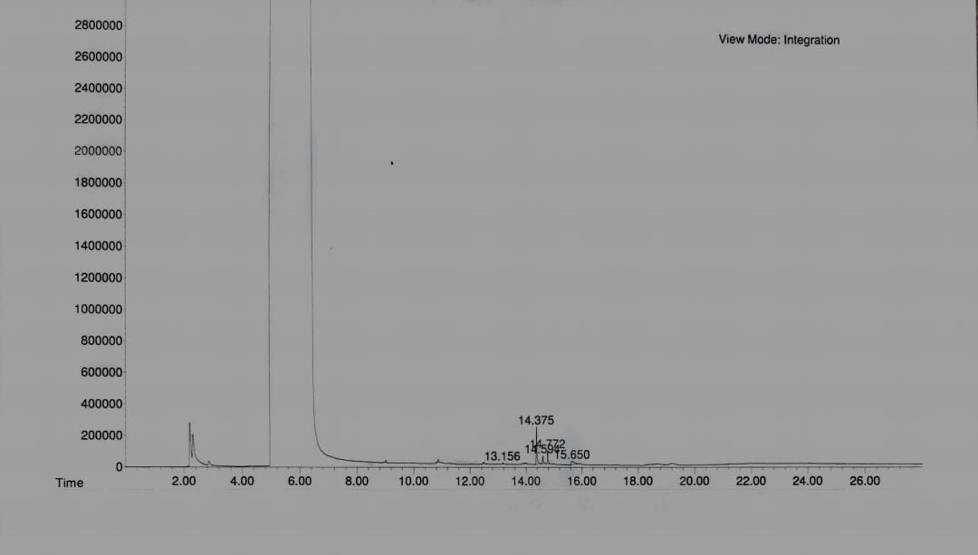

 | S.No | RT |  | Area% |  | Name Of The Compound |  | Molecular Weight |  | Molecular Formula |  | Structure
1 |  | 13.1 | 2.7% |  | Neophytadiene |  | 278 |  | C₂₀H₃₈ |  | 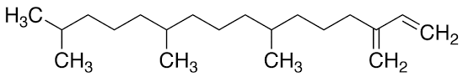
2 |  | 14.3 | 50.1% |  | Hexadecanoic Acid,3,7,11,15-tetramethyl-2-hexadecenylester |  | 534 |  | C₃₆H₇₀O₂
3 |  | 14.5 | 10.6% |  | 3-Buten-2-one,3-methyl-4-  (1,3,3 trimethyl-7-oxabicyclo[4.1.0] heptan-1-yl |  | 222 |  | C₁₄H₂₂O₂ |  | 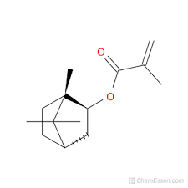
4 |  | 14.7 | 17.6% |  | Humulane-1,6-dien-3-ol |  | 222 |  | C₁₅H₂₆O
5 |  | 15.6 | 18.8% |  | Globulol |  | 222 |  | C₁₅H₂₆O
6 |  | - | - |  | Epiglobulol |  | 222 |  | C₁₅H₂₆O
Table 3. GC-MS Analysis of methanol extract of syzygium hemisphericum leaves

3.3 FT-IR Spectroscopy Analysis
FT-IR spectroscopy revealed key functional groups in the methanol extract (Table 3):
- O-H Stretch (3411.58 cm−¹): Indicates hydroxyl groups in alcohols and carboxylic acids, contributing to antioxidant properties.
- C=O Stretch (1735.63 cm−¹): Characteristic of esters and ketones, associated with anti-inflammatory and antioxidant activities.
- C-H Stretch (2949.23 cm−¹): Typical of alkanes in fatty acids, supporting cell membrane integrity.
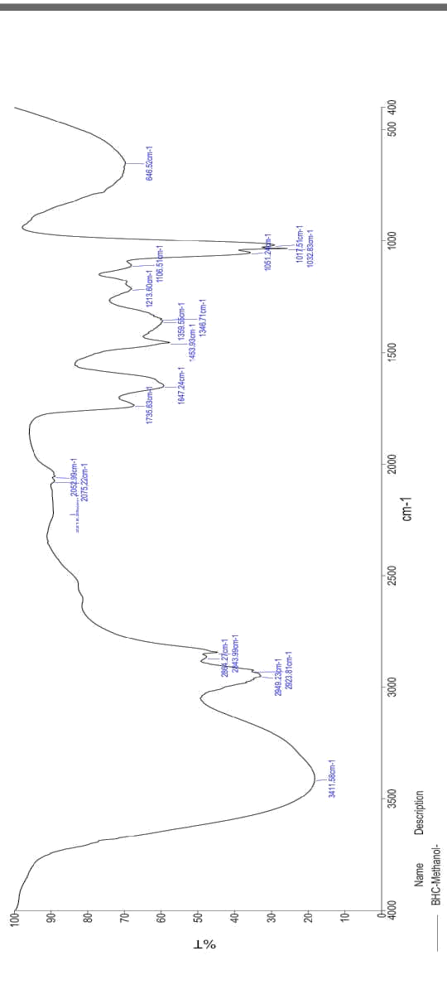
- C-N Stretch (1204.62 cm−¹): Indicates amines in alkaloids, linked to analgesic, antimicrobial, and anticancer activities.

Wavenumber (cm−¹) | Functional Group
3411.58 | O-H Stretch (Alcohols, Carboxylic acids)
2949.23 | C-H Stretch ( Alkanes )
1735.63 | C=O Stretch (Esters, Ketones)
1204.62 | C-N Stretch ( Amines )

Table 4. FT-IR spectral peaks and corresponding functional groups

Figure 2.FT IT spectra for methanol extract of syzygium hemisphericum leaves
These functional groups confirm the presence of bioactive compounds responsible for the plant’s medicinal potential.

CONCLUSION
The leaves of Syzygium haemisphericum are abundant in bioactive chemicals possessing various therapeutic characteristics. The 18% yield of the methanol extract, together with the presence of carbohydrates, tannins, alkaloids, vitamin C, terpenoids, and resins, highlights its therapeutic potential. GC-MS analysis showed significant substances including neophytadiene, hexadecanoic acid ester, and globulol, whilst FT-IR spectroscopy validated the presence of functional groups such as alcohols, esters, and amines. These findings corroborate the plant's historical application in the treatment of diabetes and nephrolithiasis, and indicate potential uses in antibacterial, anti-inflammatory, and antioxidant therapy. Subsequent investigations should concentrate on isolating and characterizing these bioactive chemicals to clarify their modes of action and to formulate innovative plant-derived medicines.

COMPETING INTERESTS DISCLAIMER:
Authors have declared that they have no known competing financial interests OR non-financial interests OR personal relationships that could have appeared to influence the work reported in this paper.

REFERENCES
- Krishna, C. S. Chandra, R. Khaleel, K. M. (2017). Phytochemical screening and GC–MS Studies of Syzygium dhaneshiana Leaf and Bark Extracts. Int. J. Pharm. Sci. Res., 8 (5), 2277–2281. https://doi.org/10.13040/IJPSR.0975-8232.8(5).2277-81.
- Rahim, E. N. A. A. Ismail, A. Omar, M. N. Rahmat, U. N. Ahmad, W. A. N. W. (2018). GC–MS Analysis of Phytochemical Compounds in Syzygium polyanthum Leaves Extracted Using Ultrasound-Assisted Method. Pharmacogn. J., 10 (1), 110–119. https://doi.org/10.5530/pj.2018.1.20.
- Deepikaa, N. Saranyaa, J. Eganathana, P. Puthiyapurayila.(2014) S. Antimicrobial Activity of Syzygium zeylanicum (L.) DC. and Syzygium hemisphericum (Walp.) Alston. J. Biol. Act. Prod. Nat., 4 (2), 120–124. https://doi.org/10.1080/22311866.2014.890065.
- Rameshkumar, K. B. Aravind, A. P. A. Vinodkumar, T. G.(2015). Leaf Essential Oil Composition of Six Syzygium Species from the Western Ghats, South India. Rec. Nat. Prod , 9 (4), 592–596.
- Narayanan, R. Shareef, S. M. Shaju, T. Sivu, A. R. Sujana, K. A.; Nandakumar, M. K. Satheesh, K.(2014). T. A New Species of Syzygium (Myrtaceae) from the Southern Western Ghats of Kerala. Int. J. Adv. Res, 2 (3), 1055–1058.
- Sushmitha, C.H., Krishnakumar, G. & Navada, K.M.(2024). Solution combustion method for synthesis of ZnO NPs from Syzygium hemisphericum bark extract and a comparative analysis of the same with the crude bark extract for biomedical applications. Chem. Pap. 78, 3443–3462. https://doi.org/10.1007/s11696-024-03319-3

