Obstructive Laryngeal Sarcoidosis Mimicking a Benign Cyst: Clinical, Radiologic, and Surgical Insights – A Case Report

Abstract
Laryngeal sarcoidosis is an uncommon manifestation of systemic sarcoidosis, accounting for less than 5% of otolaryngological cases. We report the case of a 24-year-old woman, with no prior medical history, presenting with progressive dysphonia of four months’ duration, later complicated by exertional dyspnea and dysphagia. Flexible laryngoscopy revealed a cystic-appearing mass arising from the right aryepiglottic fold, with normal morphology and mobility of the vocal cords. Cervical CT scan demonstrated a well-defined cystic lesion of heterogeneous liquid density, benign in appearance, measuring 18 × 14.7 × 26 mm. The lesion partially obstructed the laryngeal lumen, extended posteriorly to the level of the esophageal inlet, and compressed it, explaining the associated dysphagia. Complete excision of the lesion was achieved with CO₂ laser surgery. Histopathological examination showed chronic inflammatory changes with non-caseating epithelioid granulomas, without giant cells or necrosis. GeneXpert testing for Mycobacterium tuberculosis was negative. The postoperative course was uneventful, with immediate resolution of dyspnea and dysphagia, and marked improvement of dysphonia. Endoscopic follow-up at one month confirmed a normal laryngeal appearance with free vocal cord mobility. Systemic evaluation for sarcoidosis involvement in other organs was negative. This case highlights a rare cystic presentation of laryngeal sarcoidosis and underlines the importance of histopathology in guiding diagnosis and management.
Keywords: Laryngeal sarcoidosis, Dysphonia, Dyspnea, Dysphagia, CO₂ laser, Granulomatous disease.

Introduction
Sarcoidosis is a multisystem granulomatous disease of unknown cause, histologically characterized by non-caseating epithelioid granulomas. Although the respiratory tract is most commonly affected, head and neck manifestations occur in about 10% of cases. Laryngeal involvement is rare, with a reported frequency of less than 5%, but it carries significant morbidity due to potential upper airway obstruction. We describe an unusual presentation of laryngeal sarcoidosis mimicking a benign cystic lesion and manifesting with a triad of dysphonia, dyspnea, and dysphagia.

Case Report
A 24-year-old woman, with no relevant past medical history, presented with a four-month history of progressive dysphonia, subsequently complicated by exertional dyspnea and dysphagia.
- Endoscopic findings: A cystic lesion of the right aryepiglottic fold was identified, while the vocal cords appeared normal in shape and mobility.
- Imaging: Cervical CT scan revealed a cystic lesion with heterogeneous fluid density, benign in appearance, measuring 18 mm (transverse) × 14.7 mm (anteroposterior) × 26 mm (height). The mass was located within the right supraglottic larynx, closely related to the aryepiglottic fold, partially filling the right vallecula and narrowing the laryngeal lumen. Superiorly, it extended to the level of C3 and inferiorly to the C5–C6 disc, reaching posteriorly to the esophageal inlet and causing compressive dysphagia.
- Management: Complete removal of the lesion was performed using a CO₂ laser.
- Histopathology: Examination showed chronic inflammatory mucosa with epithelioid granulomas, without necrosis or giant cells.
- Microbiology: GeneXpert PCR assay for Mycobacterium tuberculosis was negative.
- Postoperative course: Recovery was uneventful, with immediate resolution of dyspnea and dysphagia and marked improvement of voice quality. A nasogastric tube was maintained postoperatively to support wound healing and prevent secondary infection, combined with a short course of corticosteroids to reduce edema. Oral feeding was resumed after tube removal, and the patient was discharged on postoperative day 4.
- Follow-up: At one-month endoscopic evaluation, the larynx appeared normal, with free supraglottic margins and mobile vocal cords. Systemic work-up for sarcoidosis showed no evidence of extra-laryngeal disease.
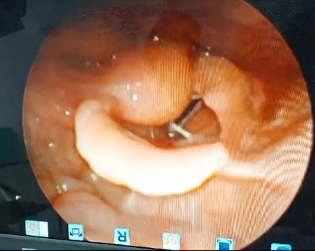
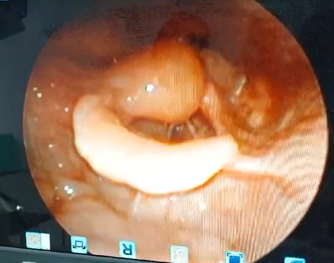
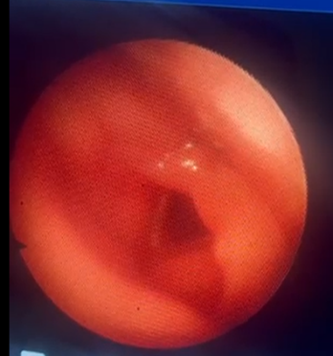
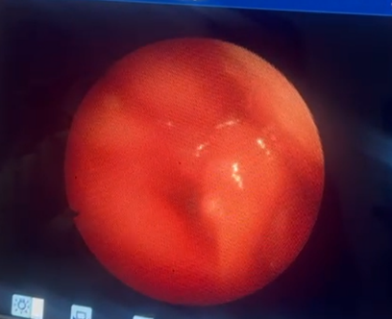
Figure 1: pre operative endoscopic view of the laryngeal cyst, on the left the glottis is closed and open on the right
Figure 2: one month post operative endoscopic view of the laryngeal vestibule, showing normal and mobile vocal cords

Discussion
Laryngeal sarcoidosis remains a rare entity, representing approximately 1% of systemic sarcoidosis cases. The supraglottis, particularly the epiglottis and aryepiglottic folds, is the most commonly affected region. In our patient, the disease presented atypically as a cystic lesion, producing simultaneous dysphonia, dyspnea, and dysphagia — the latter being an uncommon initial symptom, explained by compression of the esophageal inlet.
Differential diagnoses include benign laryngeal cysts, inflammatory lesions, neoplasms, and other granulomatous conditions such as tuberculosis and fungal infections. Histopathological confirmation of non-caseating granulomas and the exclusion of tuberculosis through GeneXpert testing were crucial to establish the diagnosis.
While systemic corticosteroids are the cornerstone of sarcoidosis treatment, surgical intervention may be necessary in obstructive cases. CO₂ laser excision, as performed in our case, provides a minimally invasive and precise therapeutic approach with good functional outcomes.

Conclusion
Laryngeal sarcoidosis is an uncommon but potentially serious manifestation of sarcoidosis, with risk of airway and digestive tract compromise. This case illustrates a rare cystic form causing upper airway obstruction and esophageal compression. Histological analysis is essential for diagnosis, while CO₂ laser excision represents an effective therapeutic option in obstructive presentations. Long-term follow-up is necessary to monitor for systemic involvement or recurrence.
Disclaimer (Artificial Intelligence)
Author(s) hereby declares that NO generative AI technologies such as Large Language Models (ChatGPT, COPILOT, etc.) and text-to-image generators have been used during the writing or editing of this manuscript.

COMPETING INTERESTS DISCLAIMER:
Authors have declared that they have no known competing financial interests OR non-financial interests OR personal relationships that could have appeared to influence the work reported in this paper.

References
- James DG, Neville E. Sarcoidosis: an overview. BMJ. 2003;327:1350–1354.
- Newman LS, Rose CS, Maier LA. Sarcoidosis. N Engl J Med. 1997;336:1224–1234.
- Iannuzzi MC, Rybicki BA, Teirstein AS. Sarcoidosis. N Engl J Med. 2007;357:2153–2165.
- Yilmaz T, Gursel B, Yazicioglu F. Laryngeal sarcoidosis: review of 35 cases. Eur Arch Otorhinolaryngol. 2006;263:1030–1036.
- Shimizu Y, Nakayama M, Takahashi H, et al. Sarcoidosis presenting as a laryngeal mass: a case report. Case Rep Otolaryngol. 2017;2017:1234567.
- Statement on Sarcoidosis. American Thoracic Society. Am J Respir Crit Care Med. 1999;160:736–755.

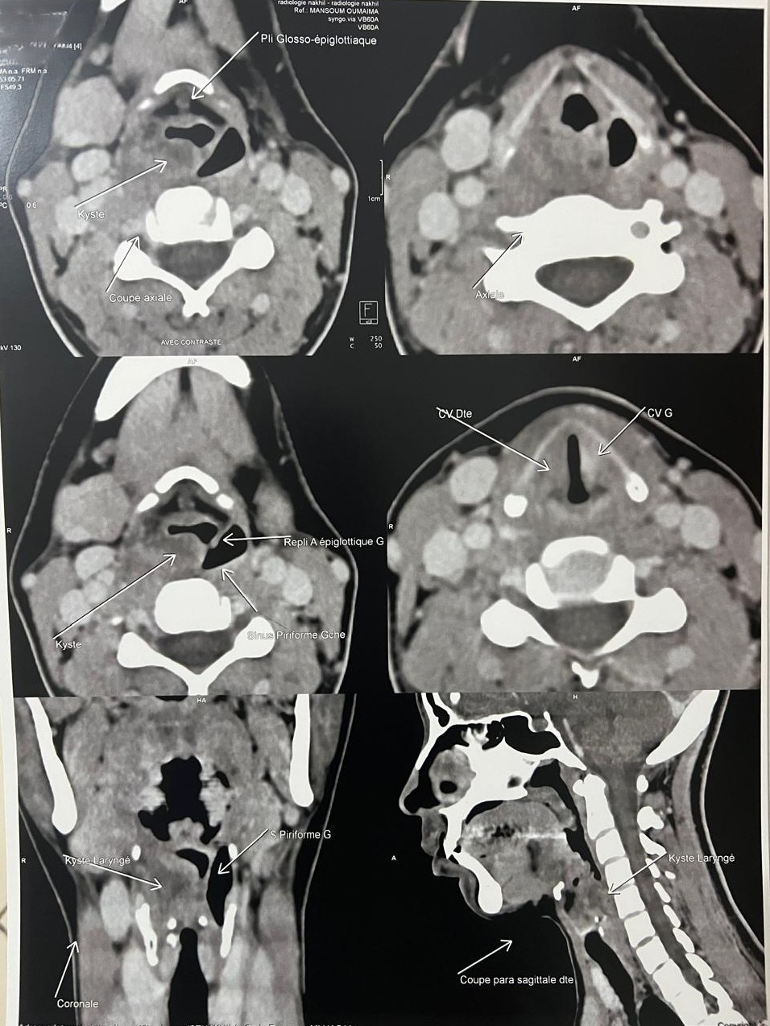
Figure 4: Coronal CT scan showing the right laryngeal cyst occupying the aryepiglottic fold and partially obstructing the ipsilateral piriform sinus.
Figure 5: Axial CT scan at the level of the supraglottic larynx showing a well-defined cystic lesion of fluid density occupying the right aryepiglottic fold, partially narrowing the laryngeal lumen.
Figure 3: Right parasagittal CT scan demonstrating the vertical extension of the laryngeal cyst (approximately 26 mm in height) with posterior extension compressing the esophageal inlet.lumen.

