Hepatic cystadenocarcinoma: a case report and literature review

Abstract
Hepatic cystadenocarcinoma is a rare malignant cystic tumor of the liver, characterized by diagnostic and therapeutic challenges and an unpredictable prognosis. This clinical entity deserves attention due to its rarity and the nonspecific nature of its clinical presentation. Imaging has helped overcome this issue in approximately 80% of cases.
Through the case we report and in light of the available literature, we aimed, on one hand, to highlight the diagnostic difficulties of hepatic cystadenocarcinoma due to its clinical latency in most cases reported in the literature and its lack of specificity, especially considering that cystic liver lesions are predominantly hydatid cysts. On the other hand, we emphasize the importance of radical surgical treatment to prevent the risk of distant metastases and recurrence.

Introduction
Hepatic cystadenocarcinomas are rare malignant cystic tumors, accounting for less than 5% of intrahepatic cystic lesions, with a more favorable prognosis than other malignant liver tumors [1,2]. Their pathogenesis remains poorly understood: they may result from the malignant transformation of a preexisting hepatobiliary cystadenoma, although cases have also been reported without any prior lesion [2,3]. They can also be associated with congenital biliary tract anomalies, such as choledochal cysts or congenital hepatic fibrosis [3].
Clinically, the presentation is nonspecific, most commonly including right upper quadrant pain or a tumoral syndrome [1]. The absence of distinctive clinical or biological signs complicates the diagnosis, which relies primarily on imaging techniques (ultrasound, CT, MRI) [4]. Definitive diagnosis is histopathological, established after surgical resection [2].
Given their rarity and similarity to other hepatic cystic lesions, particularly hydatid liver cysts (HLC), a literature review is necessary to better characterize this entity and to update the recommended therapeutic principles for optimal management.

Case Report
The patient is a 67-year-old woman, married with seven children, unemployed, with a history of two hepatic surgeries in 2013 and 2015 for a cyst initially presumed to be hydatid but with negative serology, treated by resection of the prominent dome. In 2018, she presented with a recurrent cystic lesion for which a left hepatectomy was performed; histopathological examination concluded a biliary cystadenoma with high-grade dysplasia containing two foci of invasive adenocarcinoma.
In February 2019, the patient consulted for severe right upper quadrant pain. Physical examination was unremarkable, and biological and tumor marker assessments were normal. Imaging (CT and MRI) revealed two cystic masses in the left lobe, measuring 7 cm and 4 cm, with thickened, irregular walls showing enhancement and diffusion restriction, suggestive of tumor recurrence. A diagnosis of recurrent cystadenocarcinoma was established.
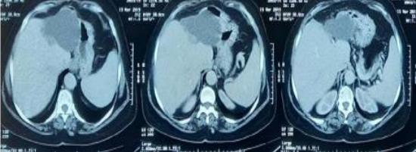
Figure 1: Axial non-contrast abdominal CT images showing two cystic masses located in the left hepatic lobe; they exhibit soft-tissue density, homogeneous content, and well-defined walls, without septations or mural nodules, suggestive of tumor recurrence.
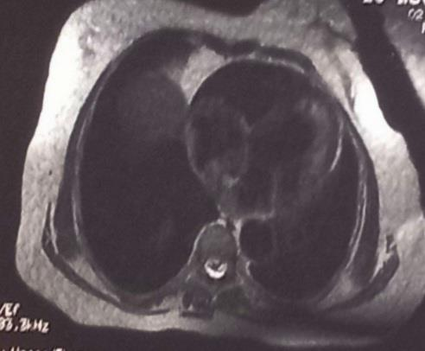
Figure 2: Axial T2-weighted hepatic MRI showing a 7 cm cystic lesion contiguous with another 4 cm lesion, the latter exhibiting a thick, irregularly enhancing wall with diffusion restriction, consistent with tumor recurrence.
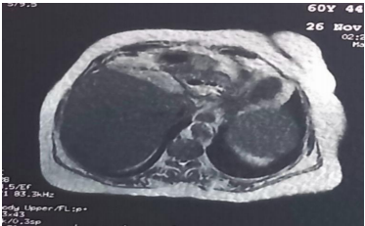
Figure 3: Axial hepatic MRI after gadolinium injection showing part of one of the two cystic liver lesions: a fluid-signal mass, heterogeneous, without internal mural nodules; adjacent to the liver, located at the hepatic dome, with peripheral enhancement..

Surgical exploration revealed a cystic mass adherent to the stomach, necessitating resection of the gastric serosa, along with completion of the left hepatectomy to remove the lesions en bloc. Histopathological examination confirmed invasive mucinous hepatic cystadenocarcinoma.
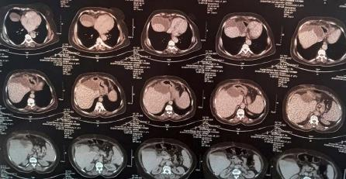
Six months later, the patient presented with a new recurrence and deterioration of general condition. Chemotherapy with Gemox (Gemcitabine + Oxaliplatin) was initiated; however, the course was complicated by severe hepatic cytolysis, cholestasis, and markedly elevated tumor markers (CA 19-9 at 12,000 IU/ml). Morphological assessment (CT, MRI, 18-FDG PET) revealed a locally advanced recurrence with hepato-gastric involvement, duodenal invasion, and pulmonary metastatic dissemination. The disease course resulted in the patient’s death four months after the initiation of chemotherapy.

Figure 4: Axial non-contrast abdominopelvic CT showing a bilobed cystic mass with homogeneous content and a thickened wall containing calcifications; without mural nodules or septations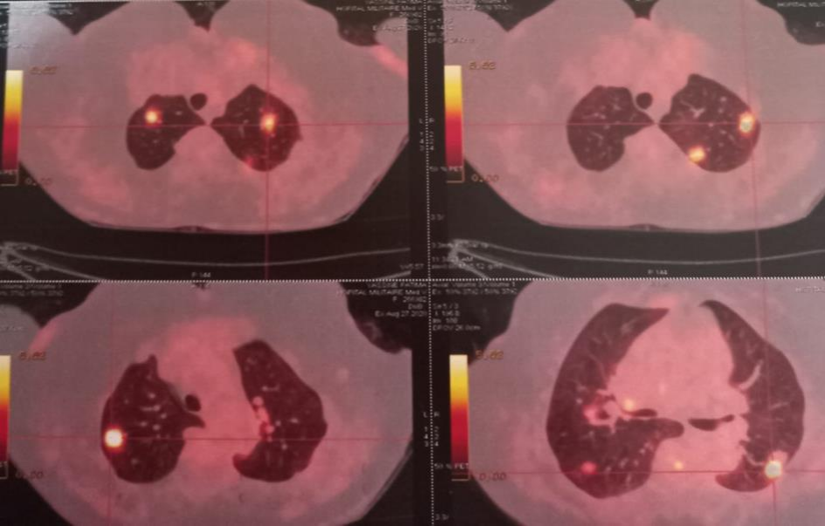
Figure 5: Axial 18-FDG PET images of the thorax showing multiple pathologically hypermetabolic pulmonary parenchymal foci, ranging from 5 mm to 24 mm, with heterogeneous uptake, involving both lungs.

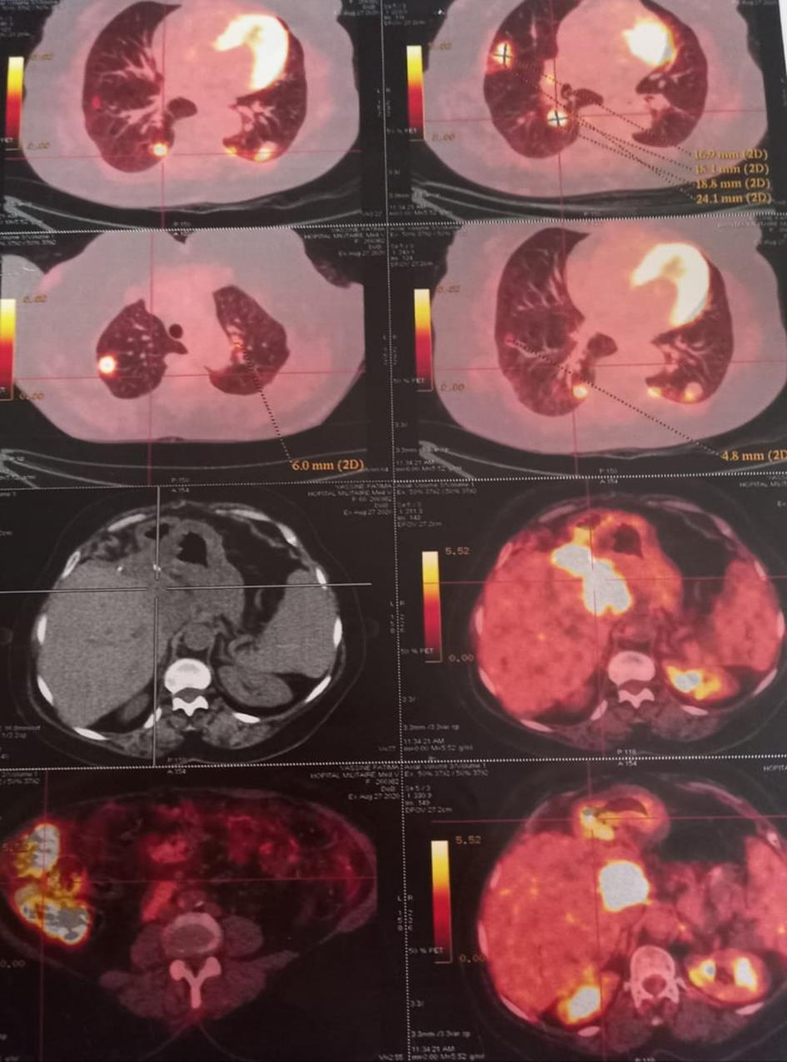
Figure 6: Axial 18-FDG PET images of the thoraco-abdomino-pelvic region showing multiple pathologically hypermetabolic pulmonary parenchymal foci, ranging from 5 mm to 24 mm with heterogeneous uptake, involving both lungs, and intense pathological hepatic hypermetabolism (SUVmax = 17.7) overlying the surgical clips; extending as a contiguous area in the hepato-gastric region (84 × 44 mm in transverse axes), at the hepatic hilum and involving the posterior duodenal wall (D1-D2); highly suspicious (compared to hepatic background uptake SUVmax = 3.7) and with diffuse pathological right colonic hypermetabolism (SUVmax = 12.9).

Top of Form
Discussion
Hepatic cystadenocarcinoma is a rare malignant cystic tumor, with only about fifty cases reported. Its prevalence is very low, and it most often results from the malignant transformation of a hepatobiliary cystadenoma, although it may also arise in association with congenital biliary tract anomalies or in the absence of preexisting pathology [5]. Our patient, who had no congenital anomaly but a history of cystadenoma, illustrates the likelihood of malignant transformation.
This tumor typically affects adults over 60 years of age, with no sex predilection, reflecting the long latency required for malignant degeneration. The clinical presentation is nonspecific, most commonly right upper quadrant pain and sometimes a palpable mass. Jaundice is rare, and laboratory findings are often normal, with tumor markers (CEA, AFP, CA 19-9) usually within normal limits.
Imaging (ultrasound, CT, MRI) is essential for guiding diagnosis, revealing uni- or multilocular cystic lesions with thickened walls, internal septations, and sometimes papillary projections or calcifications. The differential diagnosis is broad and includes hydatid cysts, cystadenomas, complicated biliary cysts, hematomas, abscesses, and cystic tumors [6,7,8]. Percutaneous cytological aspiration is rarely performed because of the risk of peritoneal dissemination. Definitive confirmation relies on histopathological examination, which distinguishes between invasive and non-invasive forms [9,10].
The treatment of choice is surgical, consisting of formal hepatectomy with 1–2 cm margins. Simple enucleation is not recommended. Chemotherapy, radiotherapy, immunotherapy, and targeted therapies are reserved for advanced or metastatic cases [11]. Five-year survival after complete resection ranges from 65% to 70%, with a better prognosis for non-invasive forms. The absence of mesenchymal stroma is associated with more aggressive behavior and rapid dissemination.

Conclusion
Hepatic cystadenocarcinoma is a rare tumor, occurring predominantly in middle-aged women but also observed in men. Its etiology remains poorly understood, and its progression is typically slow. Clinical presentation is nonspecific, limited to abdominal pain or a palpable mass. Imaging (ultrasound, CT, MRI) plays a key role, usually showing a unilocular or multilocular cystic mass with septations or papillary structures, but the differential diagnosis remains challenging in contexts where hydatid liver cysts and biliary cystadenomas are more common.
Cytological aspiration is not recommended; definitive diagnosis relies on histopathological examination of the surgical specimen. Treatment is surgical, consisting of partial hepatectomy with safety margins, to prevent recurrence and metastatic spread. Any recurrence of a hepatic cyst after surgery should raise suspicion of cystadenocarcinoma.
Prognosis is favorable in non-invasive forms following complete resection but remains unpredictable for invasive forms.

COMPETING INTERESTS DISCLAIMER:
Authors have declared that they have no known competing financial interests OR non-financial interests OR personal relationships that could have appeared to influence the work reported in this paper.

References
1] Valérie Vilgrain ; Radiology. Beaujon Hospital, 92118. Clichy Cedex. Gastroenterol. Clin. Biol 2001; 25: B167-B177. Mason; Paris ; 2001. Journée de Gastroenterologie ; Paris-11 January 2013.
[2] 2005 Elsevier Masson SAS, EM Consulte. Journal of Radiology. About a case of hepatobiliary cystadenocarcinoma.
[3] Manouras A, Markogiannikis H, Lagon Dianakis E, Katergiannakis.
[4] Feuillets de Radiologie 2007, 47, n°8, 396-400.
[5] Hepato-biliary cystadenoma and cystadenocarcinoma : a single Center experience. Tumori, 99:261-265, 2013.86 Xin Li, Jia-Lin Zhang, Yong-Hong Wang, Shao-Wei Song, Feng-Shan Wang, Rui Shi, and Yong- Feng Liu. Department of General Surgery, the First Affiliated Hospital, China.Medical University, Shenyang. 110001, Liaoning Province, China.
[6] Radiology Key : Hepatobiliary cystadenocarcinoma; the fastest radiology engine. 16 November 2016/ Published by Admin in GASTRO-INTESTINAL IMAGE
[7] Ultrasound findings in hydatid disease of the liver.
[8] Hydatid cyst of the liver: comparison of computed tomography and MRI.
[9] Seo JK, Kim SH, Lee SH, Park JK, Woo SM, Jeong JB, et al. Appropriate diagnosis of biliary cystic tumors: Comparison with atypical hepatic simple cysts. Eur J Gastroenterol Hepatol. 2010 ; 22:989–96.
[10] Alobaidi M, Shirkhoda A: Malignant cystic and necrotic li ver lesions: a pattern approach to discrimination. Curr Probl Diagn.
[11] Preoperative and postoperative care of liver resection. 693 : 384-393.

